Real Estate Capital Market Analysis

In-Class Mid-Term Exam Answers - March 4, 2026
__________________________________________________

Question 1: Scheduled Balances at End of Year 5 (10 points)
Method: The scheduled balance of a fixed-rate mortgage at any time equals the present value of the remaining payments discounted by the mortgage rate.
Formula:
- Monthly Payment: $PMT = P \times \frac{r(1+r)^n}{(1+r)^n - 1}$
- Balance at month t: $Balance_t = PMT \times \frac{1-(1+r)^{-(n-t)}}{r}$

Mortgage A: $100,000 at 8%
- Monthly rate: $r = 0.08/12 = 0.00667$
- Monthly payment: **$733.76**
- Balance at end of year 5 (month 60): **$95,069.86**

Mortgage B: $90,000 at 7%
- Monthly rate: $r = 0.07/12 = 0.00583$
- Monthly payment: **$598.77**
- Balance at end of year 5 (month 60): **$84,718.43**
__________________________________________________

Question 2: 15-Year Mortgage with Discount Points (20 points)
Loan Terms: $200,000, 15-year, 6% with 2 discount points

2a. Monthly Payment (5 points)
Using the standard mortgage payment formula:
$$PMT = 200,000 \times \frac{0.005(1.005)^{180}}{(1.005)^{180} - 1}$$
Answer: $1,687.71

2b. APR (5 points)
- Net proceeds after 2 points: $200,000 × (1 - 0.02) = **$196,000**
- APR is the rate that equates net proceeds to PV of all payments
- Using IRR calculation over 180 months
Answer: 6.3170%

2c. Effective Cost if Repaid at Year 5 (10 points)
- Balance at end of year 5: **$152,018.20**
- Cash flows: Receive $196,000 at t=0, pay $1,687.71 for 60 months, pay balance at month 60
- Effective cost = IRR of these cash flows × 12
Answer: 6.5253%
_Note: The effective cost increases when the loan is repaid early because the upfront points are amortized over a shorter period._
__________________________________________________

Question 3: Mortgage Monthly Payment Calculations (20 points)
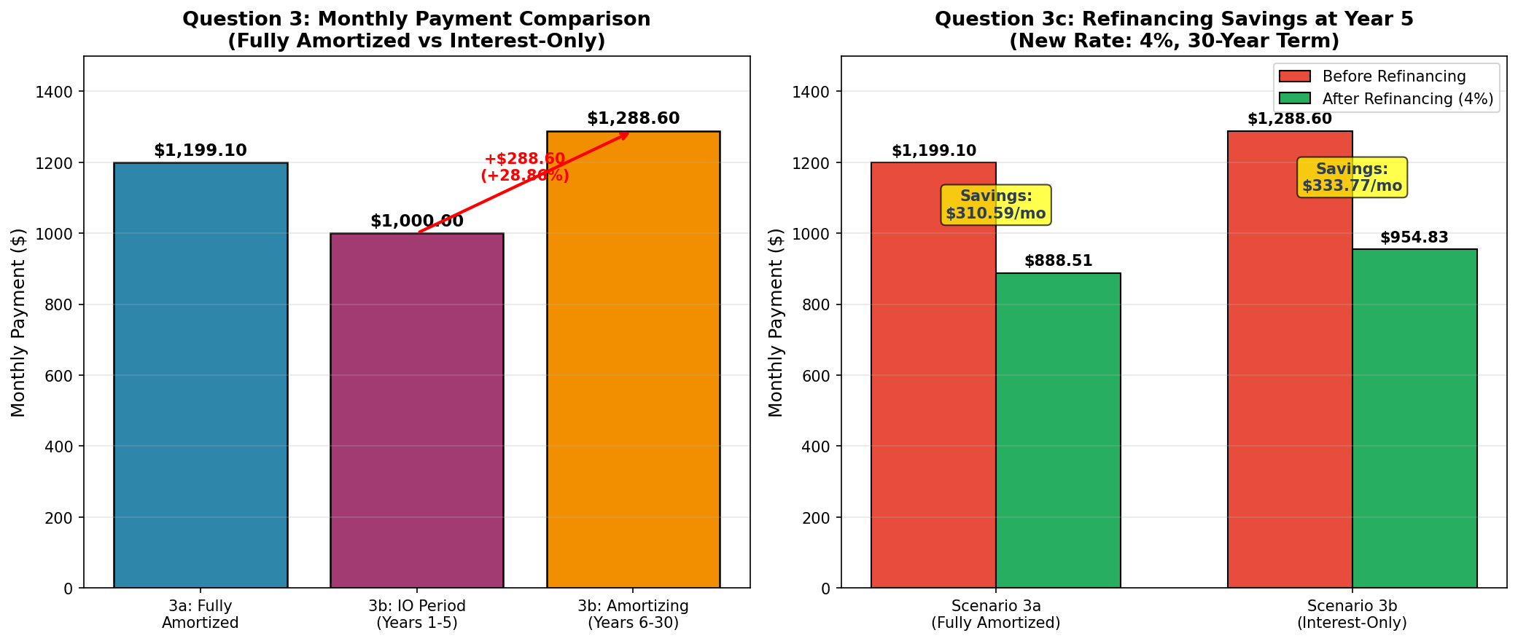

3a. 30-Year Fully Amortized Mortgage (5 points)
Terms: $200,000, 6.00%, 30 years
$$PMT = 200,000 \times \frac{0.005(1.005)^{360}}{(1.005)^{360} - 1}$$
Answer: $1,199.10

3b. Interest-Only Mortgage (5 points)
Terms: $200,000, 6.00%, interest-only for 5 years, then 25-year amortization
Interest-only payment (first 5 years):
$$PMT_{IO} = 200,000 \times 0.005 = \textbf{\$1,000.00}$$
Amortizing payment (remaining 25 years):
$$PMT = 200,000 \times \frac{0.005(1.005)^{300}}{(1.005)^{300} - 1} = \textbf{\$1,288.60}$$
Payment increase:
- Dollar increase: **$288.60**
- Percentage increase: **28.86%**

3c. Refinancing at 4% after 5 Years
From Scenario 3a:
- Balance at end of year 5: **$186,108.71**
- New payment after refinancing (30-year at 4%): **$888.51**
- **Monthly savings: $310.59**
From Scenario 3b:
- Balance at end of year 5: **$200,000.00** (no principal paid during IO period)
- New payment after refinancing (30-year at 4%): **$954.83**
- **Monthly savings: $333.77**
_Note: The IO loan has higher savings in absolute dollars because it refinances a larger balance at the lower rate._
__________________________________________________

Question 4: Interest Rate Risk of Mortgage Loan (20 points)
Original Loan: 30-year FRM, $100,000, 8%, purchased at par
- Monthly payment: **$733.76**

4-1a. Rate Increases to 8.5%, Held to Full Term (4 points)
Market value = PV of remaining payments at new rate 8.5%
$$MV = 733.76 \times \frac{1-(1.00708)^{-360}}{0.00708} = \$95,428.76$$
Estimated loss: $4,571.24

4-1b. Rate Increases to 8.5%, Payoff at Year 3 (4 points)
- Balance at month 36: **$97,280.15**
- Market value = PV of 36 payments + PV of balloon payment at 8.5%
$$MV = 733.76 \times \frac{1-(1.00708)^{-36}}{0.00708} + \frac{97,280.15}{(1.00708)^{36}} = \$98,696.06$$
Estimated loss: $1,303.94

4-1c. Analysis (4 points)
Higher loss scenario: Full term (4,571 vs 1,304)
Key Learning:
- Longer duration mortgages have **higher interest rate risk**
- When rates rise, holding the mortgage longer exposes the investor to more discounting periods at the higher rate
- Early payoff limits the investor's exposure to the rate change
- This demonstrates the concept of **duration** - longer duration = more sensitivity to rate changes

4-2a. Rate Decreases to 7.5%, Held to Full Term (4 points)
$$MV = 733.76 \times \frac{1-(1.00625)^{-360}}{0.00625} = \$104,941.27$$
Estimated gain: $4,941.27

4-2b. Effective Duration (4 points)
$$Duration = \frac{P_{down} - P_{up}}{2 \times P_0 \times \Delta y} = \frac{104,941.27 - 95,428.76}{2 \times 100,000 \times 0.005}$$
Effective Duration: 9.51 years
_Interpretation: A 1% change in interest rates will cause approximately a 9.51% change in the mortgage's market value._
__________________________________________________

Question 5: WAL (Weighted Average Life) (10 points)

Question 5-1: Average Life Calculations
Loan 1: $200,000, 6.50%, 30-year, held to maturity
- Monthly payment: **$1,264.14**
- Average Life is calculated as the weighted average time of principal payments
$$AL_1 = \frac{\sum_{t=1}^{360} t \times Principal_t}{Total\ Principal}$$
Loan 1 Average Life: 19.62 years
Loan 2: $100,000, 6.00%, 30-year amortization, payoff at year 5
- Monthly payment: **$599.55**
- Balance at payoff (year 5): **$93,054.36**
$$AL_2 = \frac{\sum_{t=1}^{60} t \times Principal_t + 60 \times Balloon}{Total\ Principal}$$
Loan 2 Average Life: 4.84 years

Question 5-2: Weighted Average Life of Combined Portfolio
$$WAL = \frac{AL_1 \times Balance_1 + AL_2 \times Balance_2}{Balance_1 + Balance_2}$$
$$WAL = \frac{19.62 \times 200,000 + 4.84 \times 100,000}{200,000 + 100,000} = \frac{3,924,000 + 484,000}{300,000}$$
WAL of combined loans: 14.69 years
__________________________________________________

Question 6: MBS Risk and Return Measures (20 points)
_Reference: CUSIP 314M7GU9 as of 1/30/2026, Coupon 5%, WAC 5.83_

Question 6-1: Price vs Curve Shift Chart (5 points)
Using actual data from Chart 6-2 (base price = 100 at par):
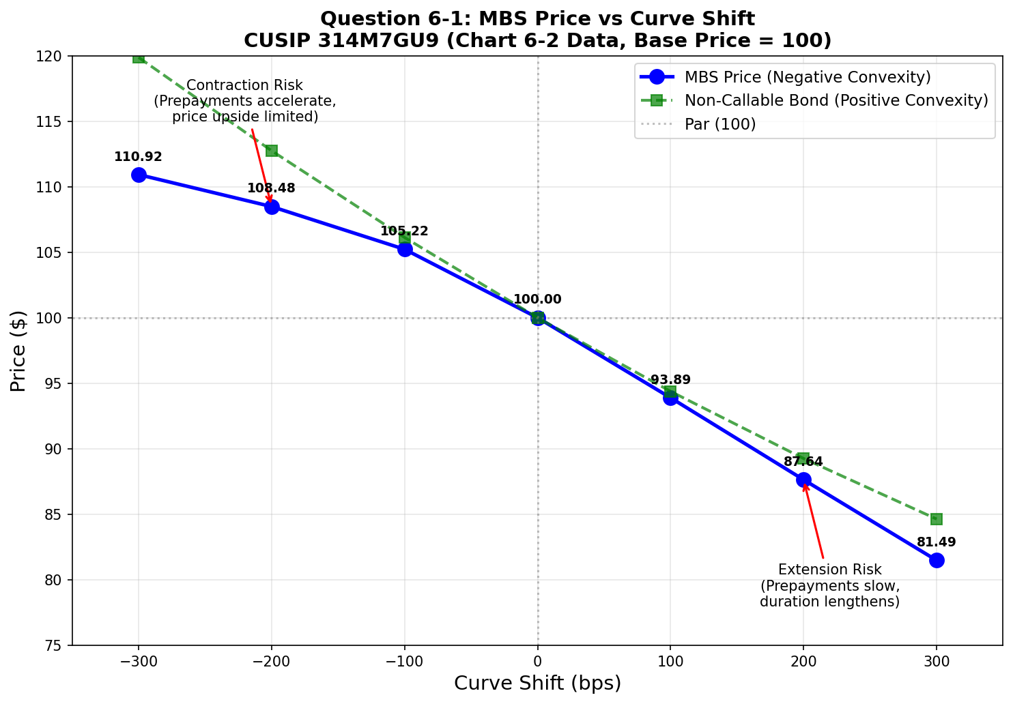
Chart 6-2 Price Data:
Curve Shift (bps) | Price | Change from Par
-300 | 110.92 | +10.92%
-200 | 108.48 | +8.48%
-100 | 105.22 | +5.22%
0 | 100.00 | Base
+100 | 93.89 | -6.11%
+200 | 87.64 | -12.36%
+300 | 81.49 | -18.51%
Key Observations:
1. Negative Convexity: The MBS price curve bends downward compared to a non-callable bond (green dashed line), demonstrating negative convexity
2. Asymmetric Price Response: Prices rise less when rates fall (contraction risk) than they decline when rates rise (extension risk)
3. Contraction Risk (left side): When rates fall, prepayments accelerate, limiting price appreciation
4. Extension Risk (right side): When rates rise, prepayments slow, extending duration and amplifying price decline

Question 6-2: Contraction and Extension Risk Analysis (5 points)
Chart 6-2 Risk Measures Across Curve Shifts:
Measure | -300 bps | -200 bps | -100 bps | 0 bps | +100 bps | +200 bps | +300 bps
**OAD** | 2.04 | 2.37 | 4.06 | 5.87 | 6.64 | 7.11 | 7.41
**OAC** | -0.51 | -0.55 | -2.36 | -0.87 | -0.16 | 0.17 | 0.44
**WAL** | 3.61 | 4.71 | 6.72 | 8.50 | 9.63 | 10.50 | 11.28
**Life CPR** | 22.91% | 17.43% | 11.46% | 8.14% | 6.54% | 5.49% | 4.65%
Analysis:
Measure | When Rates FALL (Contraction Risk) | When Rates RISE (Extension Risk)
**OAD** | Decreases sharply (5.87 → 2.04) as prepayments accelerate | Increases (5.87 → 7.41) as prepayments slow
**OAC** | Highly negative at -100bp (-2.36), showing maximum negative convexity | Becomes positive (+0.44 at +300bp)
**WAL** | Decreases (8.50 → 3.61 years) - principal returns faster | Increases (8.50 → 11.28 years) - principal extends
**Life CPR** | Increases dramatically (8.14% → 22.91%) - refinancing boom | Decreases (8.14% → 4.65%) - prepayments slow
Contraction Risk: When rates fall, borrowers refinance, returning principal to investors who must reinvest at lower rates. The MBS "contracts" (shortens in duration) precisely when you want longer duration exposure.
Extension Risk: When rates rise, prepayments slow dramatically, extending the MBS duration when you want shorter duration exposure to limit losses.

Question 6-3: Why Yield Remains Constant Across Curve Shifts (5 points)
The yield shown (5.0524%) is constant across all scenarios because it represents the yield at the BASE price of 100 (par).
Explanation:
1. The Yield shown is the pass-through rate/coupon yield of the MBS when purchased at par
2. Chart 6-2 is a sensitivity analysis showing how PRICE and risk metrics change when market rates shift
3. The "Yield" column is displaying the original purchase yield for reference purposes, not recalculating yield for each scenario
4. If yield were recalculated, it would change with each scenario - but that's not what this table is showing
5. The purpose is to show: "If I bought at this yield, what happens to my investment value as rates change?"

Question 6-4: Premium MBS at Price 105 (5 points)
a) Why WAL and Life CPR are the same as Chart 6-2:
WAL and Life CPR are independent of purchase price because:
- They depend on the **interest rate environment** and prepayment expectations
- The prepayment model uses current market rates (not purchase price) to project prepayments
- Since the rate shift scenarios are identical in both charts, the prepayment projections are identical
- Purchase price affects YIELD, not prepayment behavior
b) Why Yield increases when curve shifts up and decreases when curve shifts down:
When purchasing at a premium (105):
Curve Shift | What Happens | Effect on Yield
**UP (+bps)** | Prepayments slow (extension), premium amortizes slower, higher coupon received longer | **Yield increases**
**DOWN (-bps)** | Prepayments accelerate (contraction), premium amortizes faster, principal returned early at par | **Yield decreases**
This demonstrates the asymmetric risk profile of premium MBS:
- Premium investors **lose when rates fall** (contraction risk) because they paid above par but receive par at prepayment
- Premium investors **benefit less when rates rise** compared to discount MBS
- This is the essence of **negative convexity** - losses in both directions, but particularly when rates fall
__________________________________________________

Summary of Key Answers
Question | Answer
1A Balance | $95,069.86
1B Balance | $84,718.43
2a Monthly Payment | $1,687.71
2b APR | 6.3170%
2c Effective Cost | 6.5253%
3a Monthly Payment | $1,199.10
3b IO Payment | $1,000.00
3b Amortizing Payment | $1,288.60
3c Savings (3a) | $310.59/month
3c Savings (3b) | $333.77/month
4-1a Loss | $4,571.24
4-1b Loss | $1,303.94
4-2a Gain | $4,941.27
4-2b Duration | 9.51 years
5-1 Loan 1 AL | 19.62 years
5-1 Loan 2 AL | 4.84 years
5-2 Combined WAL | 14.69 years

