Homework Set #6
MBS Prepayment Speed & Yield Analysis

Section 1 – Prepayment Measurement (0.5 pts)

Q1: SMM vs CPR Chart
The chart below shows the relationship between the Single Monthly Mortality (SMM) and the Conditional Prepayment Rate (CPR) from SMM = 0.1% to 10% in 0.1% steps.
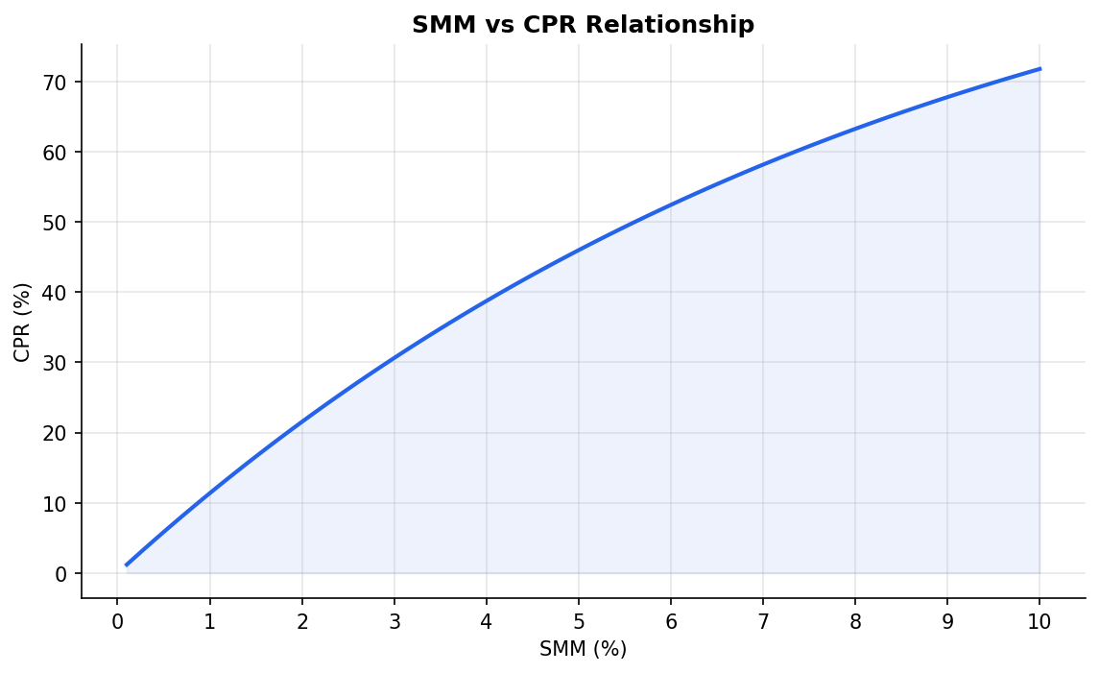
Conclusions:
• The relationship is nonlinear — CPR grows faster than SMM as SMM increases.
• This is because CPR compounds the monthly rate over 12 months: CPR = 1-(1-SMM)^12.
• At low SMM (e.g., 0.1%), CPR ≈ 1.2% (≈12×SMM), nearly linear.
• At high SMM (e.g., 10%), CPR ≈ 71.8%, far exceeding 12×10% = 120% because the compounding effect 'caps' the annualized rate below 100%.
• The convex curve illustrates why compounding matters for prepayment speed interpretation.

Q2: Converting SMM to CPR to PSA
Using the formulas: CPR = 1 – (1 – SMM)^12 and PSA = CPR / (min(Age,30) × 0.2%)
Table 1 – SMM to CPR to PSA Conversion
Age | SMM (%) | CPR (%) | PSA (%)
5.0 | 0.6 | 6.9671 | 696.7
6.0 | 1.0 | 11.3615 | 946.8
7.0 | 2.0 | 21.5283 | 1537.7

Q3: Derived Formulas
SMM in terms of CPR:
SMM = 1 – (1 – CPR)^(1/12)
CPR in terms of PSA:
PSA benchmark CPR at age t = min(t, 30) × 0.2% (annualized CPR at 100 PSA)
CPR = PSA% × min(t, 30) × 0.2% / 100
where PSA% is the pool's prepayment speed expressed as a percentage of the standard PSA prepayment benchmark; t is the pool age in months.

Q4: Weighted Average Life (WAL)
Given principal payment schedule (months 1–5 assumed):
Month 1: $50 | Month 2: $100 | Month 3: $200 | Month 4: $400 | Month 5: $800
Formula: WAL = Σ(month × principal_payment) / Σ(principal_payment)
Table 2 – WAL Calculation
Month | Principal ($) | Month × Principal
1 | 50 | 50
2 | 100 | 200
3 | 200 | 600
4 | 400 | 1600
5 | 800 | 4000

Total Principal = $1,550
WAL = (1×50 + 2×100 + 3×200 + 4×400 + 5×800) / 1550 = 6450 / 1550 = 4.1613 months ≈ 0.3468 years

Section 2 – Recursion Analyzer Pool Prepayment History (0.5 pts)

Pool Overview
CUSIP: 31418C5Z3 | Pool: MA3563 | Issuer: Fannie Mae (UMBS)
Issue Date: December 2018 | Coupon: 4.000% | Original UPB: $6.39 Billion
Maturity: January 2049 | Current UPB (Mar 2026): $425.9M | Remaining Factor: 0.0667

Historical Monthly CPR vs. 30-Year Primary Mortgage Rate
Data source: Monthly security factors from Fannie Mae PoolTalk (public disclosure tool). CPR derived from sequential factor changes using: CPR = 1-(Factor_t/Factor_{t-1})^12. 30-year mortgage rate (PMMS) sourced from FRED (series: MORTGAGE30US).
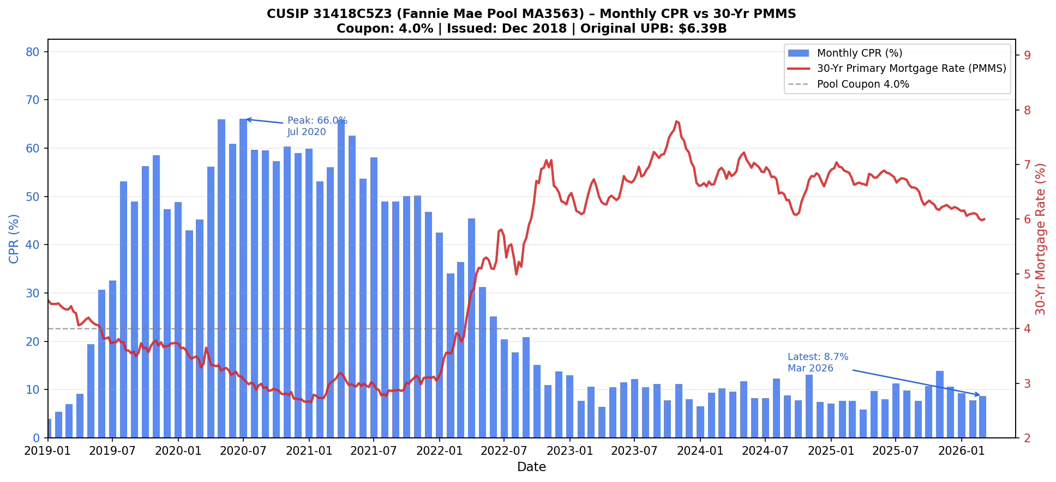

Pattern Descriptions
1) ISSUANCE (Dec 2018) TO MONTH 30 (May 2021):
This pool exhibited rapid prepayment escalation from issuance, far exceeding the normal PSA ramp pattern. The pool was issued in Dec 2018 when the 30-yr mortgage rate was ~4.6%, just above the pool coupon of 4.0%, meaning borrowers had limited initial refinancing incentive. Early CPR was modest (~4-9%).
However, rates began falling through 2019 as the Fed eased, and CPR accelerated sharply — reaching 30-50% CPR by mid-2019 as the PMMS dropped toward and then below 3.8%. The COVID-19 shock in early 2020 sent rates to historic lows (sub-3%), triggering a massive refinancing wave. By month 19 (July 2020), CPR peaked at 66.05% — one of the fastest prepayment speeds for this pool. Through month 30, the pool prepaid at extremely high speeds consistently (40-66% CPR range), burning through over 70% of its original balance.
2) PEAK PREPAYMENT SPEED:
Peak CPR: 66.05% | Month: July 2020 | Pool Age: 19 months
30-yr PMMS at peak: ~3.13% — approximately 87 bps below the pool coupon of 4.0%.
This represents the most extreme refinancing wave. With market rates nearly 90 bps below the pool's WAC, virtually all borrowers in the pool had strong economic incentive to refinance. The pool's large original balance ($6.39B) also reflects thousands of loans — statistically, the mass refinancing translated directly into a near-record CPR. The peak period (mid-2020 through mid-2021) saw sustained CPR of 50-66%, accelerating the pool's amortization dramatically.
3) LATEST PREPAYMENT SPEED (Most Recent Available: March 2026):
Latest CPR: 8.74% | Date: March 2026 | Pool Age: 87 months
30-yr PMMS (Mar 2026): ~6.0% — approximately 200 bps ABOVE the pool coupon of 4.0%.
Prepayment speeds have collapsed to single digits for a very logical reason: the current mortgage rate environment (~6%) is far above the pool's coupon (4.0%). Borrowers who remain in this pool already have a 4% mortgage — refinancing would mean taking on a new loan at ~6%, resulting in significantly higher monthly payments. This creates a 'lock-in effect' where rational borrowers have no incentive to prepay voluntarily.
The remaining ~8.74% CPR reflects only involuntary prepayments: defaults, home sales (job changes, divorces, deaths), and curtailments. The pool has shrunk to just 6.67% of its original balance ($425.9M remaining of $6.39B original), meaning the vast majority of loans already prepaid during the 2019-2022 refinancing wave.

Section 3 – Agency MBS Pool-Level Analysis (1.5 pts)
Data: 2,234 Agency MBS pools | Pool Data (issuance) + Pool Hist (monthly updates Jan 2023 – Apr 2025)

3_1: 2023 Monthly Issuance by Coupon
Note: The dataset contains 2023 issuance data for 2,234 Agency MBS pools.
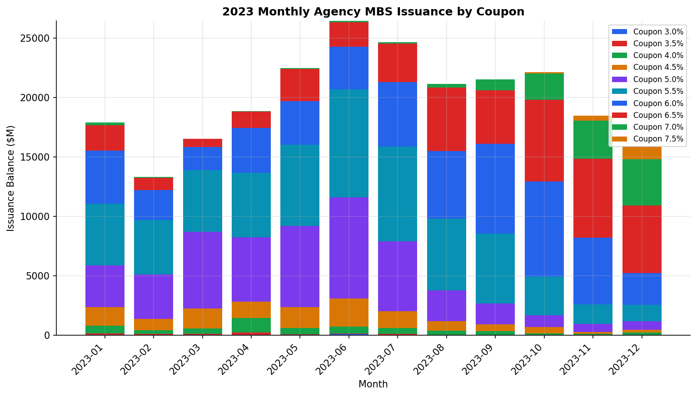
Table 3 – 2023 Monthly Issuance by Coupon ($M)
Month | 3.0 | 3.5 | 4.0 | 4.5 | 5.0 | 5.5 | 6.0 | 6.5 | 7.0 | 7.5 | Total
2023-01 | 36.2 | 133.1 | 641.7 | 1585.9 | 3491.0 | 5178.6 | 4477.0 | 2151.2 | 216.7 | 0.0 | 17911.4
2023-02 | 31.1 | 95.1 | 315.9 | 962.9 | 3707.8 | 4579.2 | 2547.1 | 993.7 | 82.2 | 0.0 | 13315.0
2023-03 | 43.0 | 67.3 | 471.4 | 1690.1 | 6430.1 | 5188.6 | 1943.3 | 689.0 | 17.0 | 0.0 | 16539.8
2023-04 | 56.6 | 176.6 | 1217.1 | 1374.7 | 5439.5 | 5412.4 | 3759.6 | 1401.5 | 39.6 | 0.0 | 18877.6
2023-05 | 48.5 | 47.5 | 509.9 | 1753.4 | 6861.0 | 6796.7 | 3675.2 | 2707.1 | 74.7 | 0.0 | 22474.0
2023-06 | 128.1 | 23.8 | 592.2 | 2354.7 | 8506.7 | 9078.6 | 3596.3 | 2042.8 | 114.7 | 0.0 | 26437.9
2023-07 | 31.7 | 109.8 | 478.1 | 1430.1 | 5844.0 | 8004.6 | 5412.5 | 3236.9 | 127.0 | 0.0 | 24674.7
2023-08 | 13.7 | 0.0 | 386.0 | 781.8 | 2624.5 | 6007.9 | 5685.1 | 5327.1 | 337.0 | 0.0 | 21163.1
2023-09 | 0.0 | 17.3 | 334.3 | 562.4 | 1754.4 | 5905.5 | 7556.3 | 4499.0 | 884.1 | 29.8 | 21543.099999999995
2023-10 | 0.0 | 0.0 | 177.3 | 530.2 | 979.3 | 3260.5 | 8015.2 | 6868.7 | 2197.5 | 96.9 | 22125.600000000002
2023-11 | 0.0 | 33.9 | 89.6 | 153.0 | 700.8 | 1637.3 | 5604.1 | 6641.6 | 3192.5 | 419.7 | 18472.500000000004
2023-12 | 0.0 | 31.5 | 217.5 | 238.1 | 701.4 | 1382.4 | 2668.3 | 5679.8 | 3913.0 | 1070.3 | 15902.300000000001

Trend Analysis:
2023 Agency MBS issuance was dominated by coupon 5.5% pools, reflecting the prevailing mortgage rate environment where new loan originations clustered at these coupon levels. Issuance peaked in 2023-06 with $26,438M in total balance. The monthly pattern shows seasonal tendencies typical of the housing market, with stronger issuance in spring/summer months and softening later in the year. Higher coupon pools (6.5% and above) gained share as mortgage rates climbed to multi-decade highs, while lower coupon originations barely appeared as those rates were no longer available to new borrowers.

3_2: Pool Statistics by Coupon as of 2025-04-01
Table 4 – Statistics by Coupon as of 2025-04-01 (balance-weighted averages)
Coupon | Total Balance ($M) | Loan Count | WA WAC (%) | WA WALA (mo) | WA WAM (mo) | WA FICO | WA LTV (%)
3.0 | 350.4 | 1547 | 3.72 | 24.3 | 308.0 | 744.0 | 64.4
3.5 | 663.8 | 1783 | 4.173 | 24.9 | 330.1 | 758.0 | 79.2
4.0 | 4924.6 | 13649 | 4.844 | 23.5 | 330.6 | 758.0 | 81.9
4.5 | 12062.1 | 34492 | 5.412 | 23.4 | 329.9 | 760.0 | 79.5
5.0 | 41272.9 | 118854 | 5.95 | 23.2 | 329.5 | 761.0 | 78.8
5.5 | 53371.4 | 159594 | 6.452 | 22.4 | 330.0 | 759.0 | 79.5
6.0 | 44481.0 | 137929 | 6.912 | 21.0 | 331.6 | 755.0 | 80.0
6.5 | 31219.6 | 97595 | 7.384 | 19.7 | 332.9 | 748.0 | 80.1
7.0 | 7212.7 | 24340 | 7.887 | 17.5 | 334.4 | 742.0 | 79.8
7.5 | 939.3 | 3252 | 8.464 | 16.5 | 334.6 | 734.0 | 79.7

3_3: Monthly Outstanding Balance & Aggregate CPR
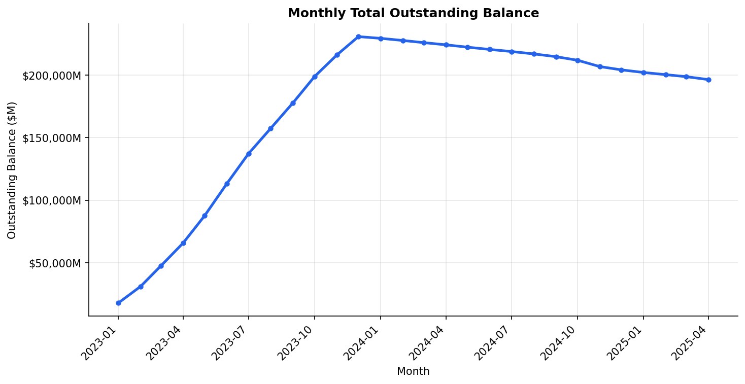
Outstanding Balance Trend:
The total outstanding balance across all pools has evolved as follows: early in the dataset (2023), balance grows as new cohorts are added. As pools age and prepayments occur, some balance reduction is visible. The trend reflects both new issuance additions to the data set and ongoing principal amortization/prepayment.
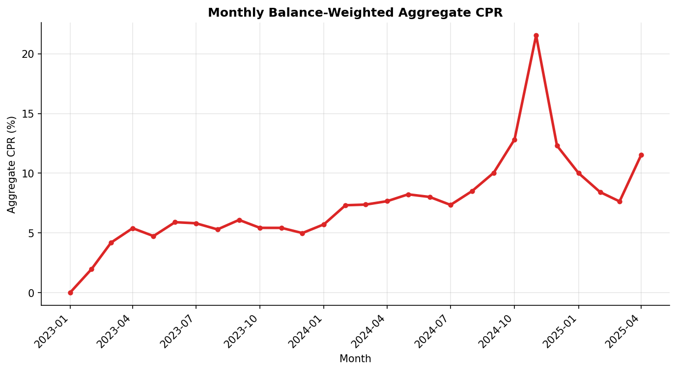
Aggregate CPR Trend:
The balance-weighted aggregate CPR exhibits elevated prepayment speeds in certain months correlated with rate movements. When mortgage rates fell (or borrowers had refinancing incentives), CPR rose; when rates climbed, CPR compressed. The generally elevated rate environment post-2022 has suppressed aggregate prepayment speeds relative to historical norms.

3_4 (Bonus): WAC Impact on Prepayment Speed (CPR)
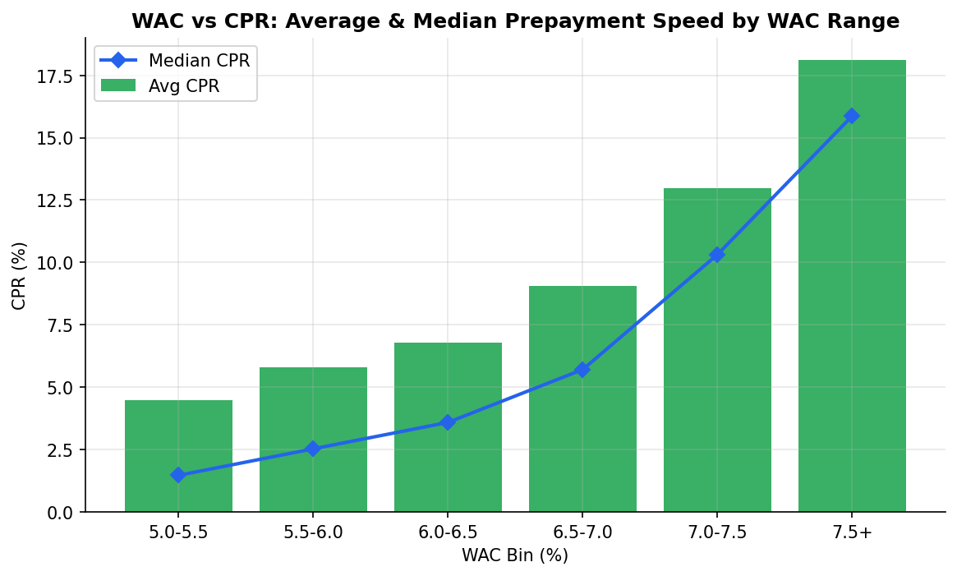
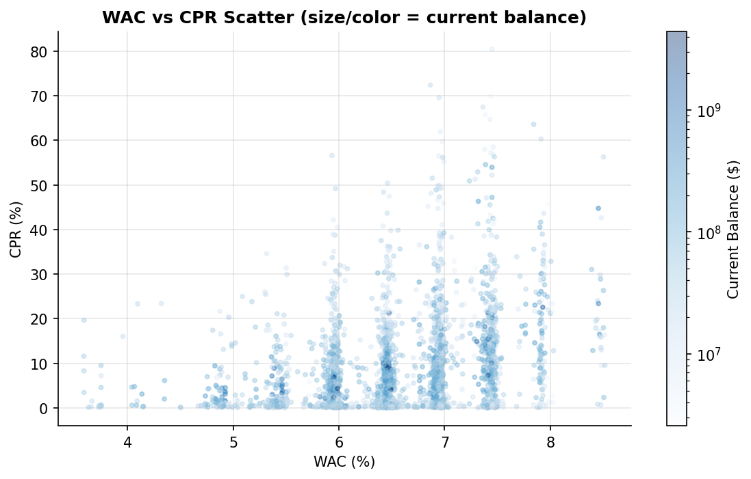
Findings — WAC vs CPR:
Higher WAC pools tend to exhibit higher prepayment speeds. This is consistent with the refinancing incentive theory: borrowers with above-market loans (higher WAC) are more motivated to refinance when rates fall even slightly, because the rate differential provides meaningful monthly payment savings. Specifically:
• Pools with WAC in the 7.5%+ range show the highest average CPR, as these borrowers bear the greatest financial incentive to refinance.
• Lower WAC pools (5.0–5.5%) show suppressed CPR because their note rate is already near or below current market rates — no refinancing benefit exists.
• The WAC-CPR relationship is not perfectly linear; it also depends on pool age, loan size (AOLS), credit quality (FICO), and LTV (ability to refinance).
• The scatter plot shows significant dispersion within each WAC range, confirming that WAC alone does not fully explain prepayment behavior — it is one of several drivers.

Section 4 – Agency MBS Pool Yield Table Study (0.5 pts)
Below is the analysis of Bloomberg yield tables for a Fannie Mae 30-year MBS (CUSIP 01F040610, Coupon 4.0%) under three prices (100, 110, 90) and seven standard interest rate / prepayment speed scenarios.

Bloomberg Yield Table Screenshots
[Price = 100 (Par)]
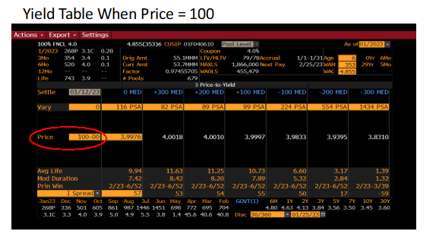
[Price = 110 (Premium)]
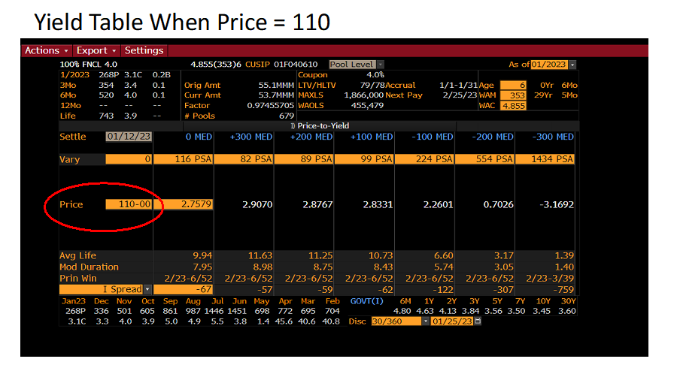
[Price = 90 (Discount)]
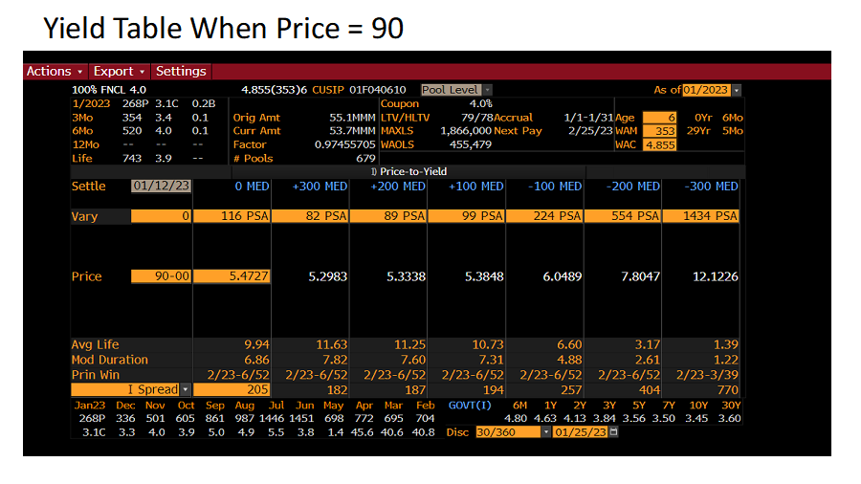

Extracted Data Summary
Table 5 – Bloomberg Yield Table Data
Rate Scenario | PSA | Yield@100 | Yield@110 | Yield@90 | Avg Life | Dur@100 | Dur@110 | Dur@90
+300 | 82 | 4.0018% | 2.9070% | 5.2983% | 11.63 yr | 8.20 yr | 8.98 yr | 7.82 yr
+200 | 89 | 4.0010% | 2.8767% | 5.3338% | 11.25 yr | 8.20 yr | 8.75 yr | 7.60 yr
+100 | 99 | 3.9997% | 2.8331% | 5.3848% | 10.73 yr | 8.20 yr | 8.43 yr | 7.31 yr
0 (Base) | 116 | 3.9976% | 2.7579% | 5.4727% | 9.94 yr | 7.42 yr | 7.95 yr | 6.86 yr
-100 | 224 | 3.9833% | 2.2601% | 6.0489% | 6.60 yr | 5.32 yr | 5.74 yr | 4.88 yr
-200 | 554 | 3.9395% | 0.7026% | 7.8047% | 3.17 yr | 2.84 yr | 3.05 yr | 2.61 yr
-300 | 1434 | 3.8310% | -3.1692% | 12.1226% | 1.39 yr | 1.32 yr | 1.40 yr | 1.22 yr

Chart: PSA vs Average Life
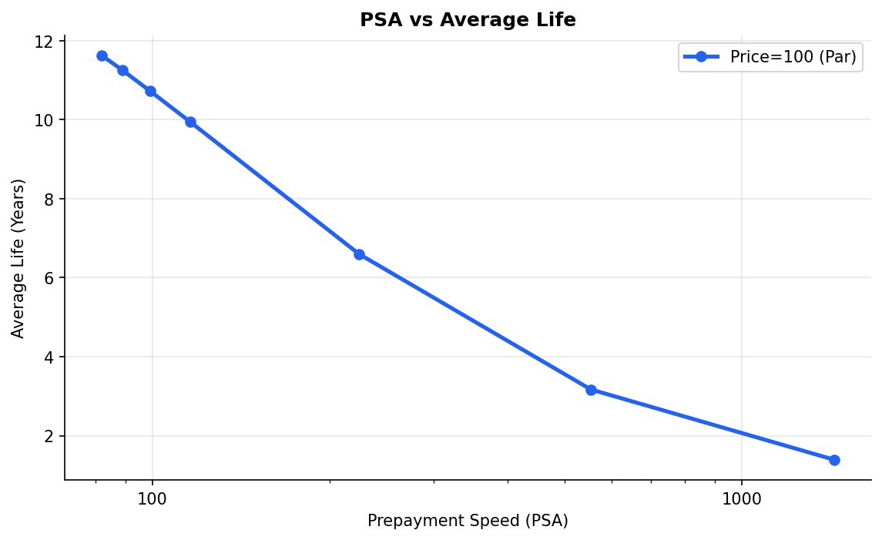
As prepayment speed (PSA) increases, Average Life (AL) decreases materially. At 82 PSA (+300 bps shock), AL is ~11.6 years — investors hold the bond a long time because slow prepayments extend cash flows. At 1,434 PSA (-300 bps), AL collapses to ~1.4 years as rapid refinancing returns principal quickly. The relationship is nonlinear — AL drops steeply at moderate PSA increases and flattens at very high speeds. This demonstrates the extension risk (rising rates -> longer AL) and contraction risk (falling rates -> shorter AL) inherent in Agency MBS.

Chart: PSA vs Modified Duration
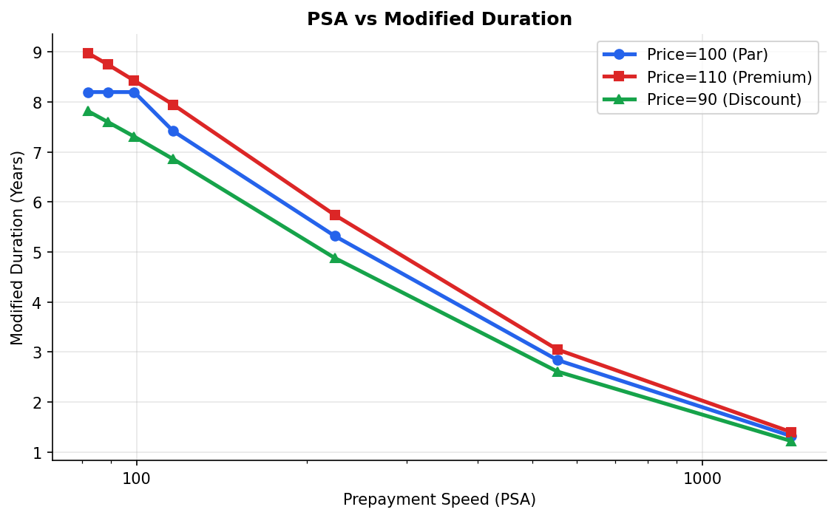
Modified Duration follows a similar pattern to Average Life, declining sharply as PSA increases. Duration measures price sensitivity to rate changes. At low PSA (slow prepayments), duration is high (~8 years), meaning significant price sensitivity. At high PSA (fast prepayments), duration compresses to ~1–1.5 years. Notably, all three price scenarios show similar AL values (prepayment structurally determined by rate scenario), but slightly different durations reflecting coupon cash flow differences. The negative convexity of MBS is evident: as rates fall, prepayments accelerate, capping price appreciation — hence duration compresses at precisely the moment investors might expect price gains.

Chart: Yield vs Interest Rate Scenario
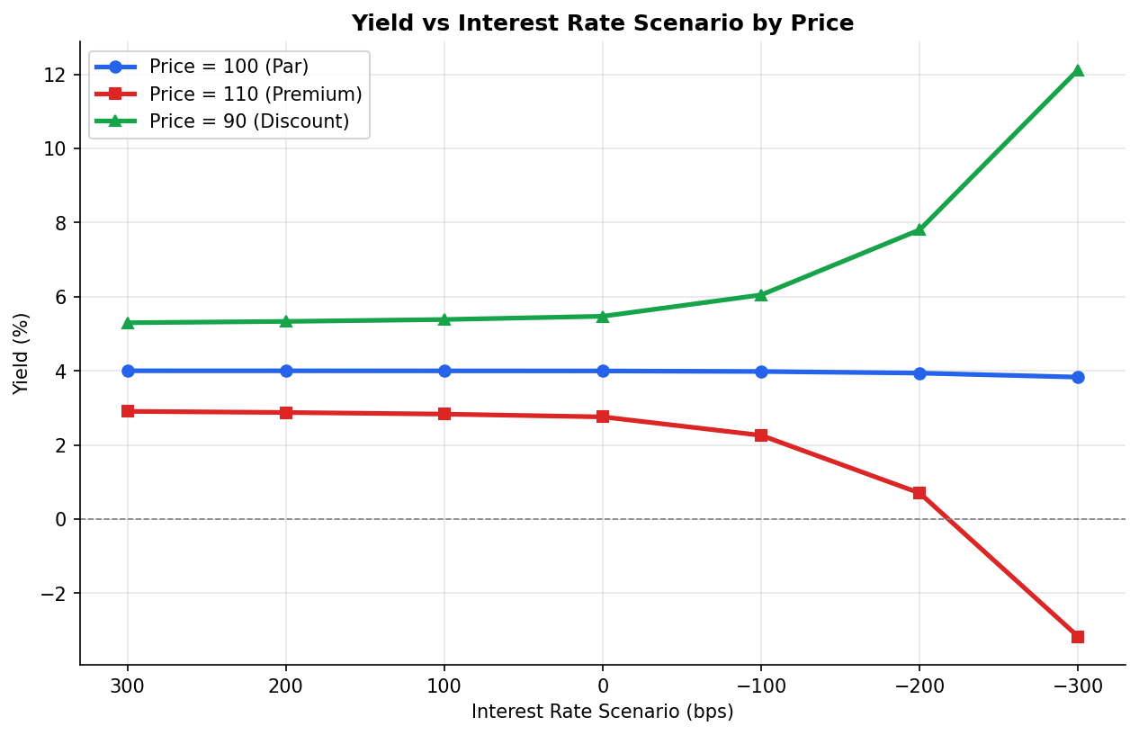
Yield Behavior Across Rate Scenarios:
Par (Price = 100): Yield is remarkably stable — it ranges only from ~3.83% to ~4.00% across all seven scenarios. This stability reflects the coupon (4%) and the fact that at-par pricing, prepayment speed variation has a limited impact on the investor's realized return.
Premium (Price = 110): Yield declines sharply as rates fall and prepayments accelerate. In the most extreme scenario (-300 bps, 1,434 PSA), yield turns deeply negative (-3.17%). When a premium bond prepays early, investors lose the premium (they paid $110 but receive $100 face value back). Higher PSA = faster loss of premium = lower/negative yield. This is contraction risk — the classic curse of premium MBS buyers.
Discount (Price = 90): Yield rises dramatically as rates fall and prepayments accelerate. At -300 bps (1,434 PSA), yield reaches 12.12%. Discount bond investors benefit from early prepayment because they paid $90 and receive $100 face — a capital gain realized faster. Higher PSA = faster capital gain realization = higher realized yield.
Key Conclusions (Risk-Return Theory):
• Premium MBS buyers bear contraction risk: they are hurt by fast prepayments.
• Discount MBS buyers bear extension risk: they are hurt by slow prepayments (in rising rate environments, capital gain takes longer to realize).
• Par bonds offer the most stable yield profile across prepayment scenarios.
• This asymmetric payoff structure is unique to MBS and reflects negative convexity: the bond's cash flows are uncertain and depend on borrower behavior — which is correlated with interest rate movements in an unfavorable way for the investor.

Is 'Yield' a Good Return Measure for Agency MBS?
Yield (OAS to a flat curve, or nominal yield) is NOT an ideal return measure for Agency MBS for the following reasons:
1. Yield assumes a single prepayment speed: it is calculated under one PSA assumption and does not reflect the distribution of possible outcomes.
2. Yield does not capture option cost: Agency MBS contains an embedded short call option (borrower's right to prepay). Yield ignores the cost of this option, understating risk.
3. Realized yield ≠ quoted yield: Because prepayments actually realized will deviate from the assumed PSA, the investor's true realized return will differ — possibly substantially (as shown in the Premium case above).
Better Return Measures for Agency MBS:
• OAS (Option-Adjusted Spread): Strips out the embedded option value and measures spread over the risk-free curve after accounting for prepayment option cost. Most widely used professional measure.
• Total Return / Scenario Analysis: Compute return under multiple rate and prepayment scenarios, weighting by probability, to capture distribution of outcomes.
• Z-Spread: Better than nominal yield but still assumes a static prepayment rate.
• WAL-adjusted yield: Accounts for average life uncertainty, though still single-scenario.

