

MICROSOFT WORD PRACTICAL EXERCISE

UNIT CODE: COMP 110

UNIT TITLE: INTRODUCTION TO COMPUTER SCIENCE

NAME: EMMANUEL CHESIRE

ADMISSION NUMBER: CS/N/0466/01/21

MY LIFE AT KABARAK UNIVERSITY

I was admitted to **Kabarak University** on January 2021 to study **Bachelors in computer science**, I found it relatively easy decide which course to choose, it was where to go which I found it harder to choose, I later found about Kabarak University which suited me perfectly. The main reason to go to the university is to get an academic excellence but it comes in handy with the social part of life. The good thing about this university is that you get more freedom and less restrictions of which we all want here, you also get to socialize with other people from different parts of the country and religion background which you may perhaps be friends. I would say my life here at Kabarak University has been good so far and I hope it goes that way.

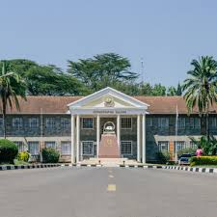

***Kabarak university administration block***