**CF assignment 3**

**A1691850**

**2019/3/23**

**Q1.**

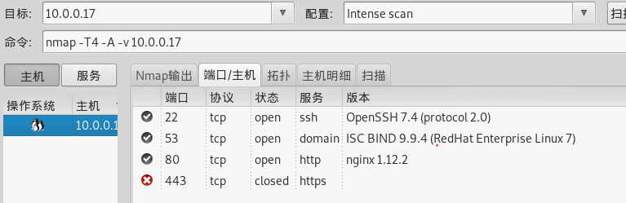

**Q2.**

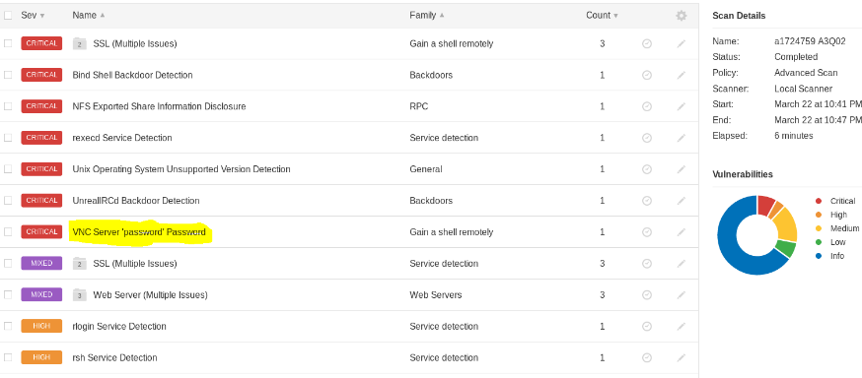

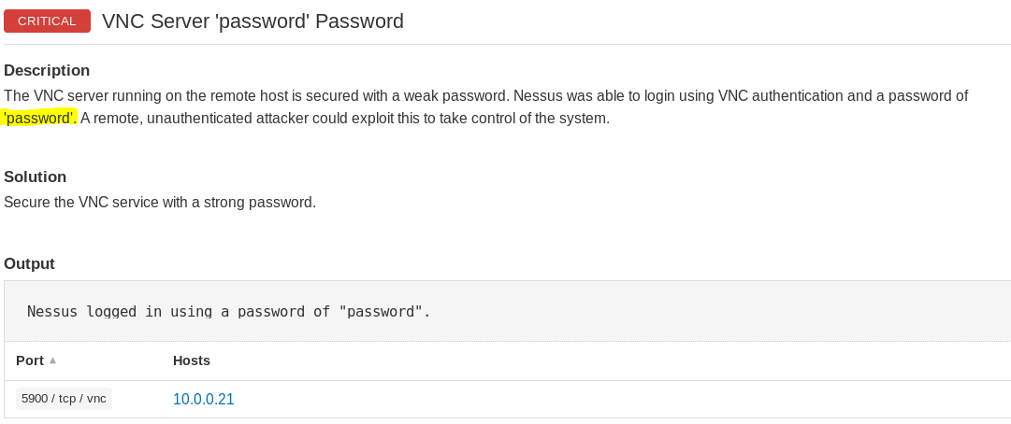

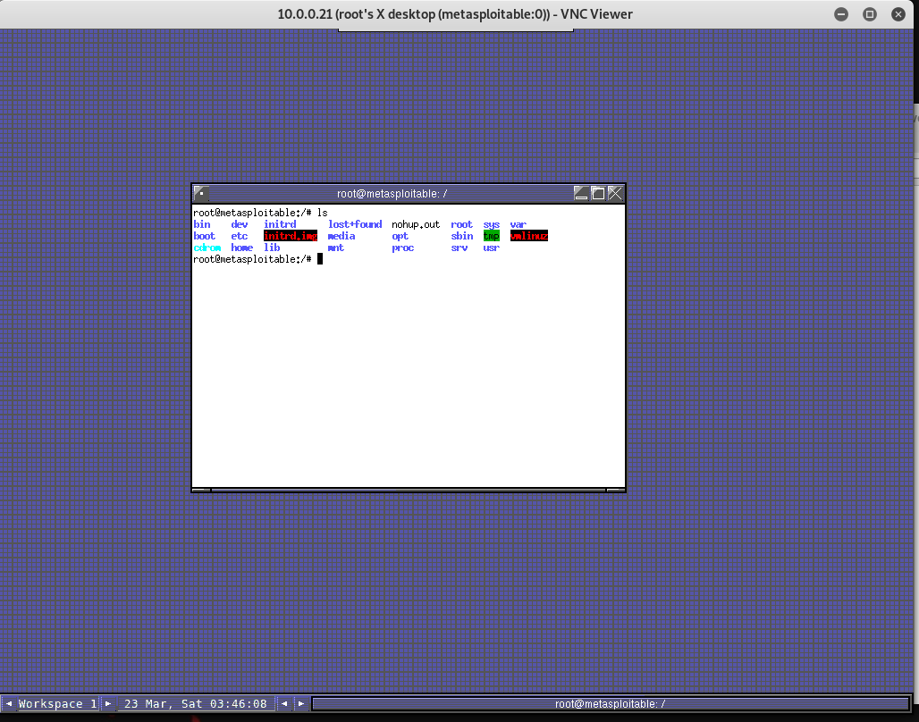

**Q3**.

**How could the decoy option be useful for a black hat hacker?**

Causes a decoy scan to be performed, which makes it appear to the remote host that the host(s) you specify as decoys are scanning the target network too. Thus, their IDS might report 5–10 port scans from unique IP addresses, but they won't know which IP was scanning them and which were innocent decoys. While this can be defeated through router path tracing, response-dropping, and other active mechanisms, it is generally an effective technique for hiding your IP address.

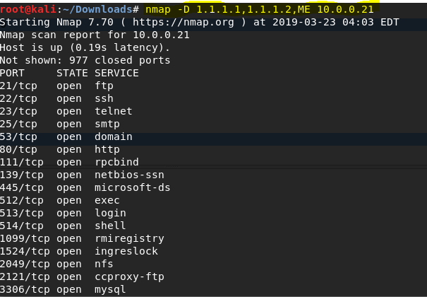

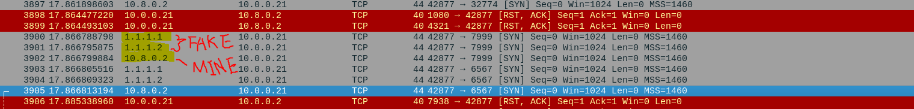

**Q4.**

Btw, i set-up seven flag bits to 1.

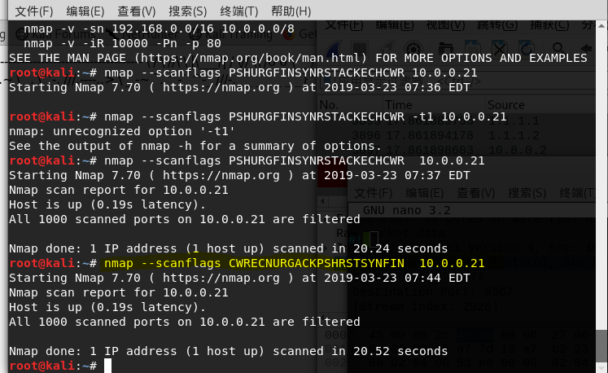

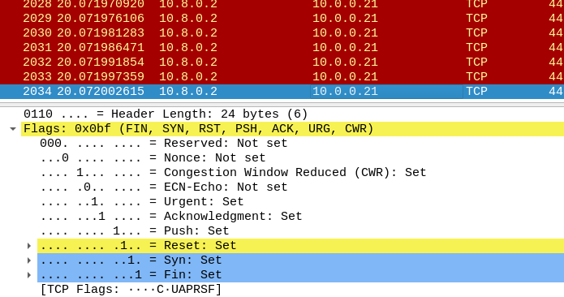

**Q5.**



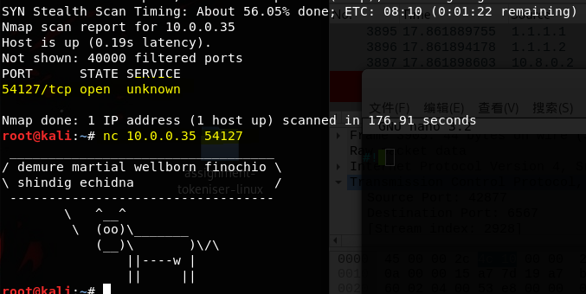

**Q6.**

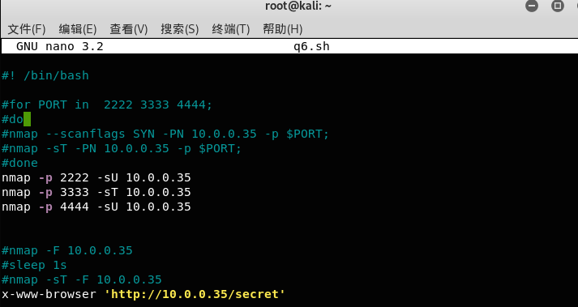

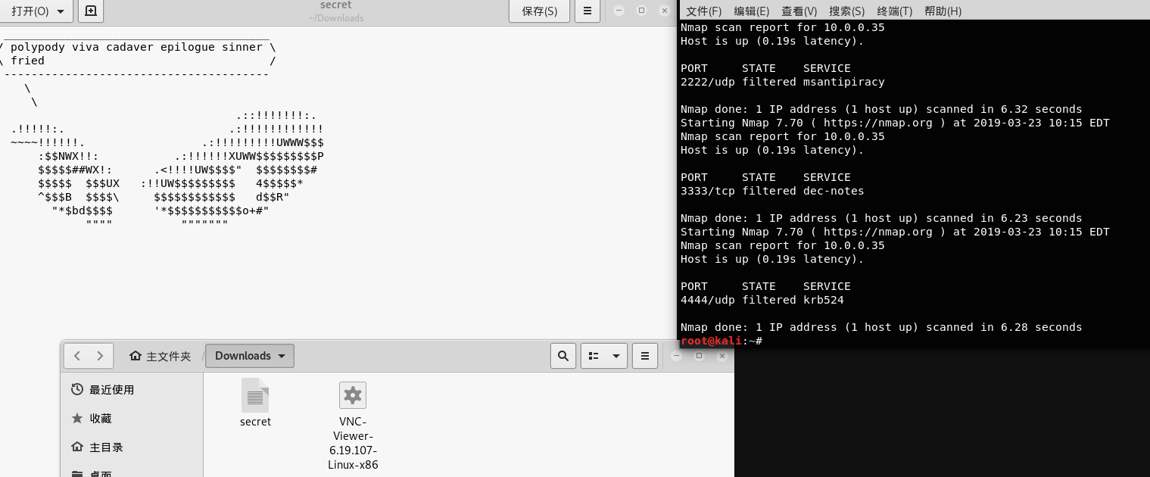

**Q7.**

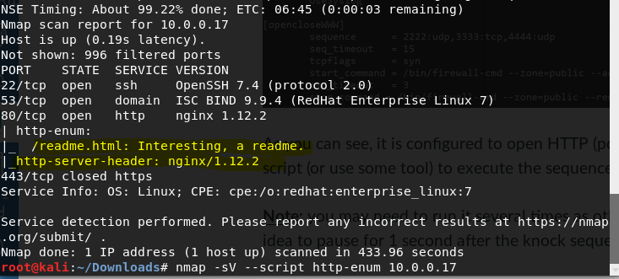



**Q8.**

