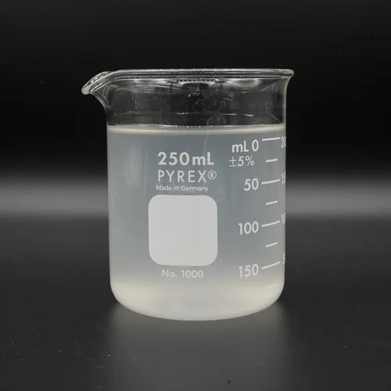

Product of Zeolf technologies Ltd manufactured in Rwanda ©2023. [Contact@zeolf.com](mailto:Contact@zeolf.com). Tel: +250791566545

Sodium Silicate solution

grade 50

wt% Silica 27.9% and wt% Sodium monoxide 14.25. weight ratio 1.85.

* Building Materials and Construction
* Paints and Coating
* Water Treatment

**Application**

* Detergent and Cleaning Product
* Adhesive and Binder
* Pulp and paper

LiquiSilicate®

**G50**