Combined Cycle
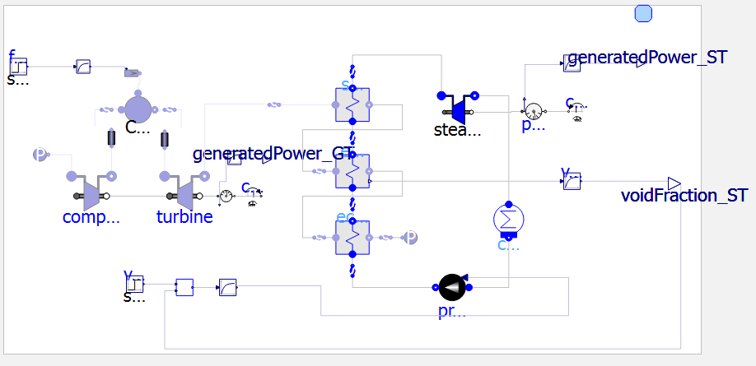
Rankine Cycle which consists of four primary components: a feedwater pump, a boiler (evaporator), a steam turbine, and a condenser.

- Turbine Inlet Temperature (TIT): stateOutletCC.T. This determines your absolute maximum efficiency.
- Compressor Pressure Ratio: Found by dividing stateInletCC.p / 1.01e5. Modern plants run at a PR of 20 to 30.
- Stack Exhaust Temperature: stateGasOutlet.T. Crucial! This tells you exactly how much heat is being wasted into the atmosphere. Generally, operators want this to drop as close to 100°C as safely possible without condensing corrosive water in the exhaust stack.
- HRSG Pinch Point: The temperature difference between the gas and water inside the evaporator. If this gets too small, the heat transfer fundamentally stops.

The density $ρ$ of an ideal gas is given by:
$$ρ=\frac{P}{R⋅T}$$
where:
- $P$ = absolute pressure
- $T$ = absolute temperature
- $R$ = specific gas constant for air (depends on units)

Convert Density Factor Formula to Readable Format
We need to address the user's query. The user originally gave a calculation of "density factor" as P/T (with units bar/K). They now present the ideal gas law: ρ = P/(R T). They are likely questioning the earlier "density factor" concept. The user wants to convert the earlier formulas to a readable form, possibly incorporating the gas constant.
We need to explain that the "density factor" they used (P/T) is proportional to density, missing the gas constant R. If they want actual density, they need to include R and proper units. We should provide clear formulas.
I'll respond with an explanation, showing the relationship, and offer to convert their numbers to actual density if they specify units (e.g., bar, K, and R in appropriate units). I'll also note that in the original, they used a fixed volumetric flow rate to get mass flow, so we can show how density relates.
Keep it helpful and concise.
Yes, exactly. The density $ρ$ of an ideal gas is given by:
$$ρ=\frac{P}{R⋅T}$$
where:
- $P$ = absolute pressure
- $T$ = absolute temperature
- $R$ = specific gas constant for air (depends on units)
Your earlier density factor $\frac{P}{T}$ (in bar/K) is simply $ρ×R$. So it is proportional to density, but missing $R$.

To convert your numbers to actual density
You need $R$ for air in consistent units. Common values:
- In SI: $R=287.05\text{ J/(kg}⋅\text{K)}=287.05 {\text{m}}^{2}/{\text{(s}}^{2}⋅\text{K)}$
Pressure must be in Pa (1 bar = ${10}^{5}$ Pa)
- Or using bar, kg/m³, K:
$R=0.28705\text{ kJ/(kg}⋅\text{K)}=287.05\text{ J/(kg}⋅\text{K)}$, but pressure in Pa.

Example for your cases (using SI)
Thin aircraft air
$$P_{1}=0.34\text{ bar}=34,000\text{ Pa} \\ T_{1}=244\text{ K}$$
$$ρ_{1}=\frac{34000}{287.05×244}≈\frac{34000}{70040}≈0.485 {\text{kg/m}}^{3}$$
Tropical heavy air
$$P_{2}=1.01\text{ bar}=101,000\text{ Pa} \\ T_{2}=301\text{ K}$$
$$ρ_{2}=\frac{101000}{287.05×301}≈\frac{101000}{86400}≈1.169 {\text{kg/m}}^{3}$$

Mass flow relation
If the volumetric flow rate $\dot{V}$ (m³/s) is the same in both cases, then:
$$\dot{m}=ρ⋅\dot{V}$$
So the ratio you had using $P/T$ is the same as the density ratio (since $R$ cancels):
$$\frac{{\dot{m}}_{2}}{{\dot{m}}_{1}}=\frac{ρ_{2}}{ρ_{1}}=\frac{P_{2}/T_{2}}{P_{1}/T_{1}}$$
In your numbers:
$$\frac{1.01/301}{0.34/244}=\frac{0.003355}{0.001393}≈2.41$$
So the tropical air would have about 2.41 times the mass flow rate for the same volumetric flow rate.

Let me know if you’d like the formulas rearranged for a specific variable or if you need them in a different unit system.
Tropical Heavy Air (1.01 bar / 301 K): Density factor = $1.01 \div 301 = 0.00335$
We need to understand the user's request. They originally had a formula "Density factor = P / T" and they gave two examples. They then asked about the ideal gas density formula ρ = P/(R T). I explained that and gave actual densities. Now they've posted just one line: "Tropical Heavy Air (1.01 bar / 301 K): Density factor = $1.01 \div 301 = 0.00335$". It seems they are repeating that line perhaps to ask something else, or they are confirming. Possibly they want me to show the conversion of that density factor to actual density using R. I should respond helpfully.
The user's original goal: "can u help me to convert all the formular format above to the formular that i can read/". I already reformatted and explained. Now they might be asking specifically about this one line: how to turn that density factor into a proper formula. I'll provide a concise answer showing the formula with R.
I'll assume they want the formula that relates their "density factor" (P/T) to actual density, and maybe they want the actual density value for tropical heavy air. I'll also note that their factor has units bar/K, and to get kg/m^3 we multiply by 100000/R (since 1 bar = 100000 Pa) and R=287.05 J/(kg·K). I'll show that.
I'll keep it clear and simple.
You're showing the density factor again:
$$\frac{P}{T}=\frac{1.01\text{ bar}}{301\text{ K}}=0.00335\text{ bar/K}$$
To get the actual density $ρ$ in kg/m³, you use the ideal gas law including the gas constant $R$:
$$ρ=\frac{P}{R⋅T}$$
Where:
- $P$ must be in Pa (pascals). $1\text{ bar}={10}^{5}\text{ Pa}$
- $R=287.05\text{ J/(kg}⋅\text{K)}$ for dry air
So:
$$ρ=\frac{1.01×{10}^{5}}{287.05×301}≈1.169 {\text{kg/m}}^{3}$$

Grid Lock (Constant Volume): t will mechanically suck in 206 m³ of air every second whether you add fuel or not!
The physics formula is: Mass Flow (kg/s) = Volumetric Flow (m³/s) × Density of the Air (kg/m³) = 241 kg/s.
The ratio is nearly 40:1! The massive excess of "useless" oxygen and nitrogen simply acts as a gas coolant that dilutes the fire, keeping the Turbine Inlet Temperature down to a safe, sustainable 1370K to 1600K.
OpenLoop
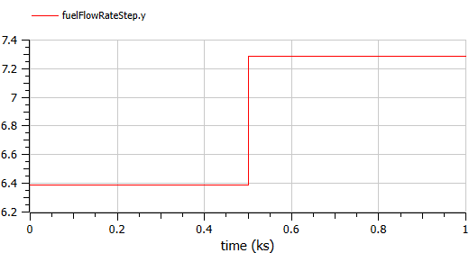  Fuelflowrate steps from 6.4kg/s to 7.3kg/s.  Turbine Inlet Temperature (TIT): Modern turbines fire at 1600 K to 1700 K.  In your model's CombustionChamber1, the parameter HH (Heating Value) is defined as 41.6e6 J/kg (41.6 Megajoules per kg), which is a standard value for Natural Gas.  The Formula: Thermal Power Input (W) = Fuel Mass Flow (kg/s) × Heating Value (J/kg).  - At 2.13 kg/s: 266MW of heat.  - At 2.43 kg/s: 303MW of heat. | 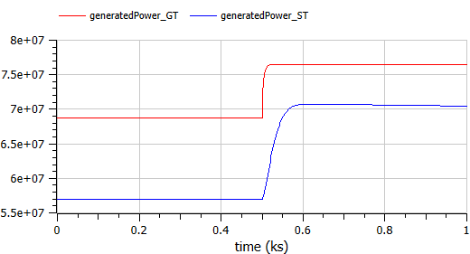  We can now calculate your Gas Turbine's standalone efficiency using the formula: Efficiency = Electrical Power Output / Thermal Power Input.  - At 7.3 kg/s fuel: 76MW / 303 MW = 25%  This 16.6% efficiency is very poor for a modern Gas Turbine (which usually sit around 35-40%).  The combinecycleplant efficiency:  - At 2.43 kg/s fuel: (76MW + 71MW) / 303 MW = 50%
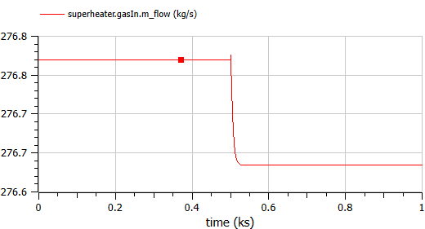  This parameter always constant. | 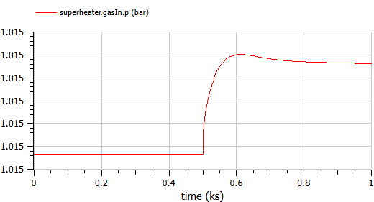  You noticed superheater.gasIn.p stays around 1.015 regardless of the transient. This is because it is the exhaust gas. The end of the entire HRSG system is connected to sinkP_gas(the atmosphere), which is rigidly fixed at 1 atm (1.01325 bar). Since it dumps straight into the atmosphere, the pressure of the exhaust gas can never get much higher than atmospheric pressure! The tiny transient you see (e.g., 1.0151 to 1.0158) is just the minuscule pressure drop required to push the slightly higher flow of gas through the HRSG pipes.
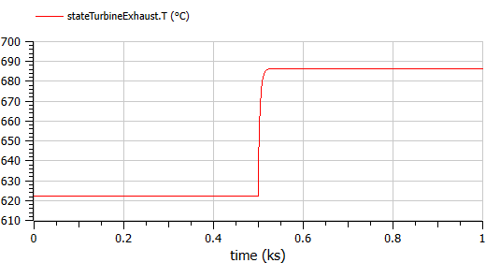  stateTurbineExhaust.T (620°C to 690°C): This is the incredibly hot blast of gas leaving the massive Turbine and entering the front of the HRSG (the steam boilers). When you step up the fuel to 7.3 kg/s, the fire burns hotter, so this exhaust temperature increases to 690°C. | 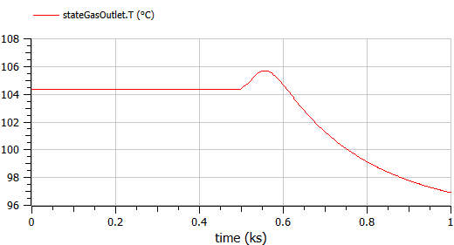  stateGasOutlet.T (104°C dropping to 98°C): This is the Stack Exhaust Temperature. This is the gas leaving the very end of the HRSG and venting into the sky! By the time the gas reaches here, it has passed through the Superheater, Evaporator, and Economizer, giving nearly all of its thermal energy into your steam pipes. Because when you add fuel, the gas turbine spins up more power, causing the Steam Cycle to aggressively pump far more cold feed-water into the Economizer to boil more steam. All that extra cold incoming water rapidly absorbs the remaining heat from the gas, cooling the final exhaust stack down to 98°C!  the Acid Dew Point.  In a real power plant, natural gas and coal contain traces of sulfur and water. If the plant operators let the exhaust gas drop below 120°C, the sulfur and water vapor will condense together into liquid sulfuric acid inside the chimney. It will literally rain acid inside the pipes and eat the metal alive in a matter of months.
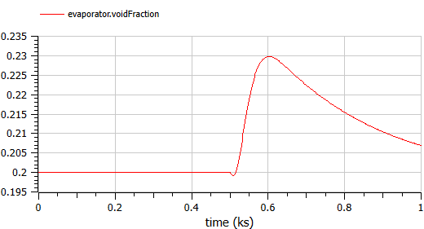 | 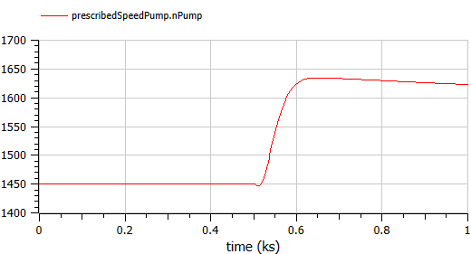  Pump is used to main the voidFraction to 0.2.

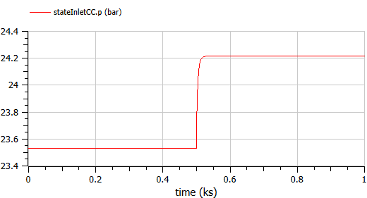  Compressor Pressure Ratio: Found by dividing stateInletCC.p / 1.01e5. Modern plants run at a PR of 20 to 30. | 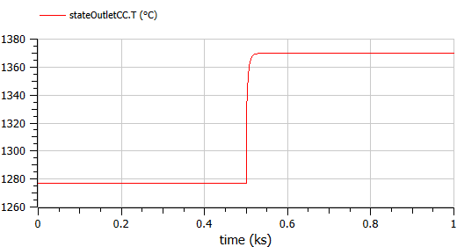  Want to see the true Combustion Chamber fire?  If you want to see the 1400°C+ temperatures inside the engine heart where the fuel is actually burning before it hits the turbine, you must specifically expand stateOutletCC (stateOutletCC.T_degC). That will show you the exact Turbine Inlet Temperature (TIT) pushing the Megawatts!

The easiest and most physically accurate way to plot the exact MW of heat the HRSG successfully absorbed from the gas turbine is by measuring the energy gained by the water.
In thermodynamics: Heat (Watts) = Mass Flow × (Enthalpy Out - Enthalpy In).
Look in your variable browser and you can calculate it using your state readers: Heat absorbed by HRSG (Watts) = stateWaterSuperheater_out.m_flow * (stateWaterSuperheater_out.h - stateWaterEconomizer_in.h)
(If you divide this number by 1,000,000, you will get the exact Megawatts (MW) of thermal energy that the thick, hot exhaust gas transferred into your steam pipes!)

