Department of Animal Production & Health, Federal University of Agriculture,
Abeokuta, Ogun State Nigeria.
09/06/2023

To
The Vice Chancellor Sir,

REQUEST FOR FIRST INSTALLMENT PAYMENT FOR BROILER PRODUCTION
Sir, I hereby write to request for the release of sum of six hundred and fifty thousand (650, 000) naira for Jimoh Akeem, one of the beneficiaries of the British American Tobacco Foundation Agriprenuership program for commencement of the second phase of broilers production.

COST ESTIMATION OF BROILER PRODUCTION FOR A DURATION OF 4 TO 6 WEEKS

Items | Unit price per inputs (₦) | Quantity | Total cost  (₦)
Broiler finisher | 10,000 | 62 | 620,000
Medication and vaccination |  |  | 30,000
Total |  |  | 650,000

Sir, the money should be forwarded to the account below:

Yusuf Azeez O
00509308660
Gtbank

Thanks for the usual support and cooperation.

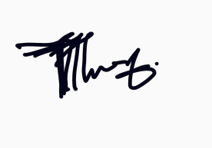
Sincerely yours,

Yusuf AO (PhD)

