📚 Lesson 4.3: Scent Engineering at the Picogram Scale
Phase 4: Spatial Volume, Tension & Trace Chemistry (Sulfur Dynamics)
Difficulty: Advanced | Estimated Time: 120 Minutes (60m Lecture, 60m Hands-on) Required Organ Materials: Dimethyl Sulfide (0.1%), cis-Galbanum Oxathiane (Oxane) (1%), 2-Isopropyl-4-methylthiazole (0.1%), 2-Isobutyl Thiazole (0.1%), Sulfurol (10%), Buchu Mercaptan (0.01%) or Grapefruit Mercaptan (0.01%), Methyl Pamplemousse (10% in Ethanol).
🎯 Learning Objectives
By the end of this lesson, students will be able to: 1. Explain the Olfactory Paradox of Sulfur and why offensive compounds are essential for natural realism in fine fragrances. 2. Differentiate between the seven main structural classes of sulfur-containing aroma chemicals (thiols, sulfides, thioesters, disulfides, thiophenes, oxathianes, thiazoles) and map them to their corresponding odor profiles. 3. Understand the extreme impact of olfactory detection thresholds and calculate dilution profiles down to parts-per-trillion (ppt) concentrations. 4. Execute safe dilution and clean-up protocols (bleach oxidation) to prevent laboratory contamination.
🧠 1. Core Theory Lecture: Scent Engineering at the Picogram Scale
🌋 1.1 The Olfactory Paradox: Stench as the Backbone of Realism
In classical organic chemistry, sulfur is synonymous with rot, gas leaks, and decay. Pure hydrogen sulfide smells of rotten eggs, and simple alkyl thiols smell of skunk spray or rotting cabbage. However, in modern perfumery, sulfur is the secret engine of natural realism. Without trace sulfur, synthetic fruit, green, and floral accords feel flat, plastic, and artificial. This is because natural botanical extracts contain tiny, trace quantities of volatile sulfur compounds that define their characteristic 'sparkle' or 'bite'.
📏 1.2 Olfactory Thresholds: The Sensitivity of Human Receptors
Human olfactory receptors are uniquely tuned to sulfur. Evolutionarily, this sensitivity helped humans detect decaying food, water contamination, and predators. Because of this, many sulfur compounds have some of the lowest olfactory detection thresholds of any molecules in existence. Working with molecules at the ppt (parts-per-trillion) level requires a paradigm shift. An overdose of just a few parts per million will completely ruin a formula, turning a delicate tropical perfume into a bin of rotting onions.
Compound & CAS | Detection Threshold in Water | Visual Metaphor
Linalool (78-70-6) | 6 ppb (parts per billion) | A drop of food coloring in a bathtub.
Dimethyl Sulfide (75-18-3) | 0.3 ppb (parts per billion) | A drop of food coloring in a residential swimming pool.
Grapefruit Mercaptan (71159-90-5) | 0.00002 ppb (0.02 ppt) | A single drop of liquid in an Olympic-sized swimming pool.
🍳 1.3 Beyond Fruit: The Savory, Meaty & Toasted Frontiers (The Food/Drink Zone)
Historically, fine fragrance restricted itself to sweet, floral, woody, and fresh profiles. Modern perfumery has shattered these borders by moving deep into the Food & Drink Zone, where sulfur compounds are the ultimate architects of savory realism:
☕ 1. The Coffee & Cocoa Scent Engine (The Sulfur-Nitrogen Coffee Synergy): The roasted, bitter, complex reality of coffee is built on furan-sulfur molecules like Furfuryl Mercaptan, Difurfuryl Disulfide, and Furfuryl Thioacetate. In nature, coffee's sulfur notes are supported by a massive matrix of alkyl pyrazines (nitrogen compounds). While furfuryl mercaptan provides the volatile, hot-brewed sulfur 'steam', pyrazines supply the dry, woody, roasted-peanut, and soil-like base. Combining them (e.g., 5 ppm Furfuryl Mercaptan with 50 ppm 2-acetylpyrazine) is essential for realism.
🥓 2. The Meaty & Toasted Protein Frontiers (Maillard & Thiazole Chemistry): Thermal breakdown of amino acids and sugars via the Maillard Reaction yields nitrogen- and sulfur-containing heterocycles. Popcorn Thiazoline creates a warm, roasted, buttery, toasted-protein grain effect, while Sulfurol brings a rich, warm milk, broth, or baked bread creaminess. Combining Popcorn Thiazoline with 2-Acetylpyrazine creates popcorn/bread realism, and combining 2-Isobutyl Thiazole with 2-Isobutyl Pyridine replicates green tomato leaf vine-sap.
🧄 3. The Durian Paradox: Alliaceous & Nitrogen Tension: Recreating durian requires balancing a massive, sweet custard/creamy base (ethyl butyrate, lactones, vanilla) with a violent, pungent sulfur puncture of Dimethyl Disulfide (DMDS) and garlic/onion profiles. Recreating this custard link requires combining garlic/onion sulfurs with trace alkyl pyrazines for a roasted-nutty custard backdrop and trace pyridines to suggest the decaying vegetal sheath.
🔬 2. Material Spotlight: The Sulfur Spectrum
🧪 1. Dimethyl Sulfide (Aliphatic Sulfide)
CAS Number: 75-18-3 Olfactory Family: Oceanic / Savory SMILES: CSC Description: At 100%, a repulsive stench of rotting cabbage and sea-decay. When diluted to 0.1% or 0.01% in DPG, it becomes highly diffusive and fresh, smelling of canned sweet corn, wild radish, and the salty spray of a windy ocean. Role in Composition: Acts as a powerful top note modifier. In trace amounts, it adds marine breeze realism to oceanic accords and provides the juicy 'pulpy' texture to citrus top notes.
🧪 2. cis-Galbanum Oxathiane (Heterocyclic S/O - 'Oxane')
CAS Number: 59323-76-1 Olfactory Family: Sulfurous / Green / Galbanum / Tropical Fruit SMILES: O1CC[C@@H](S[C@@H]1C)CCC Description: At 100%, a sharp, choking, sulfurous stench with onion-like nuances. When diluted to 0.1% or 0.01% in DPG, it becomes highly diffusive, fresh, and radiant, revealing green galbanum, fresh passionfruit rind, grapefruit peel, and blackcurrant (cassis) bud. Role in Composition: Essential for creating natural galbanum green, cassis, passionfruit, and tropical citrus notes. In fine fragrance, trace amounts are widely used to add unique, radiant effects and natural bloom to floral creations like jasmine, rose, and lily of the valley, as well as green aldehydic perfumes.
🧪 3. 2-Isopropyl-4-methylthiazole (Heterocyclic S/N - 'Tropical Thiazole')
CAS Number: 15679-13-7 Olfactory Family: Roasted / Green / Nutty SMILES: CC1=CSC(=N1)C(C)C Description: Green, roasted hazelnut, yeasty, warm cereal, with a metallic peach-skin undertone. Role in Composition: Acts as a blender between heavy base notes and fruity top notes. Excellent for adding roasted, toasted, or nutty textures to gourmand and coffee accords, or for giving texture to a peach skin note.
🧪 4. Sulfurol (Heterocyclic S/N)
CAS Number: 137-00-8 Olfactory Family: Gourmet (Sweet / Creamy) SMILES: CC1=C(SC=N1)CCO Description: Warm, sweet, milky, buttery, meaty, resembling baked bread, hot milk, or chicken broth. Role in Composition: A highly substantive heart-base blender. Used in trace amounts to build creamy, buttery lactonic accords, sandalwood extensions, and warm gourmand notes (baked pastry, vanilla cream).
🧪 5. Grapefruit Mercaptan (Thiol)
CAS Number: 71159-90-5 Olfactory Family: Citrus / Sulfurous SMILES: CC1=CCC(CC1)C(C)(C)S Description: Sulfur-citrus, sharp grapefruit rind, extremely radiant, herbal-woody. Role in Composition: Used at ultra-trace levels (0.001% or lower) to bring the authentic, bitter, mouth-watering zesty realism of fresh grapefruit pulp and skin to citrus accords.
🧪 6. Buchu Mercaptan (Ketone-Thiol)
CAS Number: 38462-22-5 Olfactory Family: Berry (Cassis) / Tropical Fruit / Minty SMILES: CC1CCC(C(=O)C1)C(C)(C)S Description: At 100%, an overpowering, sulfurous cat-urine odor. When diluted to 0.1% or 0.01% in DPG, it becomes highly diffusive, revealing an authentic blackcurrant (cassis) bud, boxwood, and green-minty berry note with a fuzzy peach-skin undertone. Role in Composition: Essential for cassis/blackcurrant accords, providing the characteristic sulfury-minty-berry volume. It is also used in trace amounts to add a realistic fuzzy skin texture to peach, apricot, and tropical fruit notes.
🧪 7. Furfuryl Mercaptan (Furan-Thiol)
CAS Number: 98-02-2 Olfactory Family: Roasted / Coffee / Meaty SMILES: SCc1ccco1 Description: Burnt match, roasted coffee beans, and cooked meat at high concentrations. In dilution (0.01% or lower), it exhibits a rich, warm, freshly brewed coffee aroma with toasted, nutty, and savory-meaty complexity. Role in Composition: The definitive compound for coffee accords. It is also used in traces to build realistic smoky, roasted facets in cocoa, chocolate, and toasted wood accords.
🧪 8. Difurfuryl Disulfide (Furan-Disulfide)
CAS Number: 4437-20-1 Olfactory Family: Roasted / Meaty / Coffee SMILES: C1=COC(=C1)CSSCC2=CC=CO2 Description: Heavy, sulfurous, roasted onion, garlic, and cooked meat. In extreme dilution, it develops a deep, nutty, roasted coffee bean character with savory-meaty undertones. Role in Composition: High-impact roasted modifier. Used in trace amounts to add savory warmth, crusty bread notes, and roasted depth to coffee, chocolate, and savory gourmand accords.
🧪 9. Furfuryl Thioacetate (Furan-Thioester)
CAS Number: 13678-68-7 Olfactory Family: Roasted / Chocolaty / Savory SMILES: CC(=O)SCC1=CC=CO1 Description: Sharp, sulfurous, burnt, and meaty. At trace levels, it displays a highly diffusive, roasted coffee, toasted nut, and dark chocolate character with sweet, savory-woody undertones. Role in Composition: Serves as a bridge between heavy roasted notes and sweet gourmands. Excellent for toasted nut, cocoa, dark chocolate, and roasted grain accords.
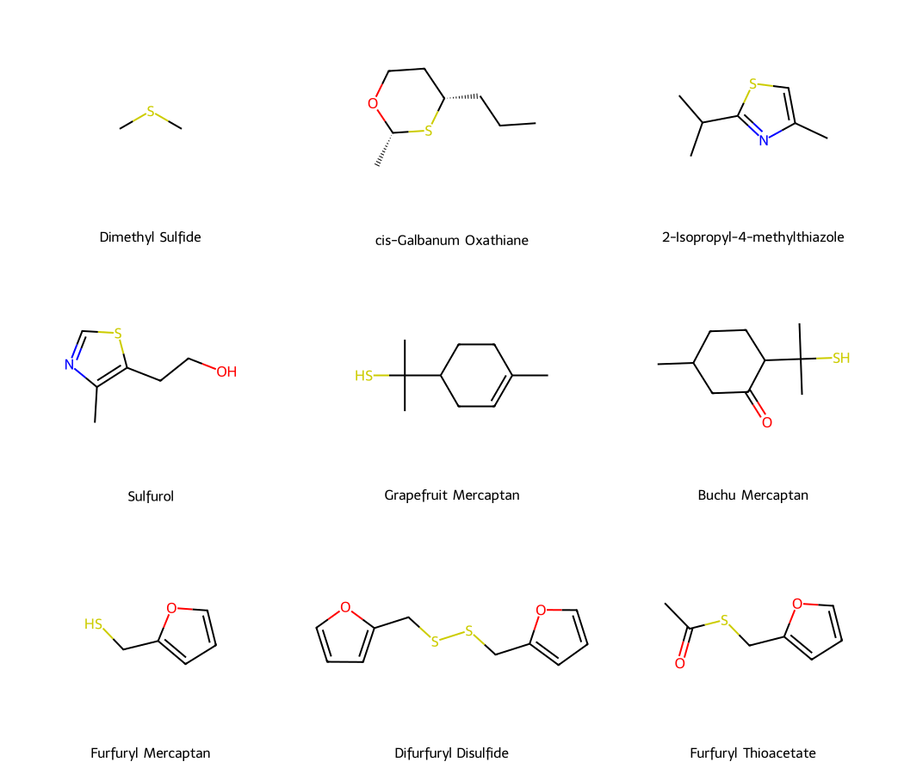
Figure 4.3: Chemically accurate 2D molecular structures of the nine spotlighted sulfur aroma chemicals, generated programmatically via RDKit.
📊 3. Comparison of Sulfur Molecular Structures
The following table compares the different kinds of sulfur structures used in modern perfumery, highlighting how molecular geometry shapes olfactory output.
Structural Class | Key Group | Typical Smells | Threshold | Perfumery Role | Examples
Thiols (Mercaptans) | Thiol (-SH) | Cassis, grapefruit rind, coffee, skunky | Extremely Low (0.02 ppt – 1 ppb) | High-impact citrus/fruity modifiers and coffee realistic notes | Grapefruit Mercaptan, Buchu Mercaptan, Furfuryl Mercaptan
Sulfides (Thioethers) | Sulfide (-S-) | Cabbage, garlic, truffle, cooked corn, ocean | Low (0.1 ppb – 10 ppb) | Marine/oceanic diffusers, savory modifiers, truffle accords | Dimethyl Sulfide, Truffle Sulfide, Methional
Thioesters | Thioester (-C(=O)-S-) | Pineapple, tropical fruit, cheesy, roasted coffee | Medium (1 ppb – 50 ppb) | Fruity/roasted modifiers, exotic top-note blenders | Tropical 3-thiobutyrate, Furfuryl Thioacetate, Isoamyl 3-methylthiopropionate
Disulfides | Disulfide (-S-S-) | Roasted onion, garlic, cabbage, roasted coffee | Low (0.1 ppb – 5 ppb) | Roasted/savory modifiers, coffee bean depth | Difurfuryl Disulfide, Dimethyl Disulfide
Thiophenes | Thiophene (Heterocyclic S-only) | Roasted bread, cherry, almond, caramel | Medium (10 ppb – 100 ppb) | Warm baker-like notes, gourmand/spicy modifiers | Bread Thiophene, 2-Acetyl-5-methylthiophene
Oxathianes | Oxathiane (Heterocyclic S & O) | Passionfruit, blackcurrant, sharp green | Low (0.1 ppb – 5 ppb) | Tropical fruit realism, boxwood green elements | cis-Galbanum Oxathiane (Oxane), 2-Methyl-4-propyl-1,3-oxathiane
Thiazoles | Thiazole (Heterocyclic S & N) | Popcorn, hazelnut, tomato leaf, warm milk | Low to Medium (1 ppb – 50 ppb) | Green top note modifiers, nutty/lactonic heart notes | 2-Isobutyl Thiazole, Sulfurol, 2-Isopropyl-4-methylthiazole
👩‍🏫 4. Instructor's Lab Guidance: Dilution Hygiene & Deodorization
Working with sulfur in a student laboratory environment requires strict discipline to prevent olfactory contamination of the entire workspace. Instructors must enforce the following protocols: 1. The Fume Hood Rule: Never open a bottle of neat sulfur compound outside a running exhaust fume hood. Even a brief opening will scent the room for days. 2. Serial Dilution Protocol: Students must perform serial dilutions (e.g., diluting neat to 10%, then 10% to 1%, then 1% to 0.1%, etc.) in sealed vials. Always discard pipettes immediately into the deactivating bath. 3. Chemical Deactivation (Bleach Oxidation): Thiols and sulfides are highly resistant to water wash, but they are easily oxidized into odorless sulfones and sulfoxides. Instructors must maintain a Deactivating Bath containing a 10% Sodium Hypochlorite (household bleach) solution. All pipettes, paper towels, and empty vials that touched sulfur must be submerged in this bleach bath for at least 15 minutes before disposal. 4. Disposal: Double-bag all deactivated waste before placing it in the trash.

