


Technical Safety Concept Lane Assistance
Document Version: 1.0
Template Version 1.0, Released on 2017-06-21



Document history
Date | Version | Editor | Description
12-27-18 | 1.0 | Nick Fiege

Table of Contents
Document history 2
Purpose of the Technical Safety Concept 2
Inputs to the Technical Safety Concept 3
Functional Safety Requirements 3
Refined System Architecture from Functional Safety Concept 3
Functional overview of architecture elements 4
Technical Safety Concept 5
Technical Safety Requirements 5
Refinement of the System Architecture 8
Allocation of Technical Safety Requirements to Architecture Elements 9
Warning and Degradation Concept 9

Purpose of the Technical Safety Concept
The purpose of a technical safety concept is to:
- Define technical safety requirements
- Allocate these requirements to the system architecture
These steps are in essence the same as for the functional safety concept. However the functional safety concept defines requirements on a system and sub-system level. Whereas the technical safety concept is more concrete and will define and allocate requirements at sensor, control unit and actuator level and define the requirements on the interactions between them.

Inputs to the Technical Safety Concept

Functional Safety Requirements
[Instructions: Provide the functional safety requirements derived in the functional safety concept ]

ID | Functional Safety Requirement | ASIL | Fault Tolerant Time Interval | Safe State
Functional Safety  Requirement 01-01 | The lane keeping item shall ensure that the lane departure oscillating torque amplitude is below mas_torque_amplitude. | C | 50 ms | Lane assistance system is turned off.
Functional Safety  Requirement 01-02 | The lane keeping item shall ensure that the lane departure oscillating torque frequency is below max_torque_frequency. | C | 50 ms | Lane assistance system is turned off.
Functional Safety  Requirement 02-01 | The Electronic Power Steering ECU shall ensure that the the applied torque used for maneuvering back to the center of the lane is applied for a maximum time defined by max_torque_duration. | B | 500 ms | Lane assistance system is turned off.

Refined System Architecture from Functional Safety Concept
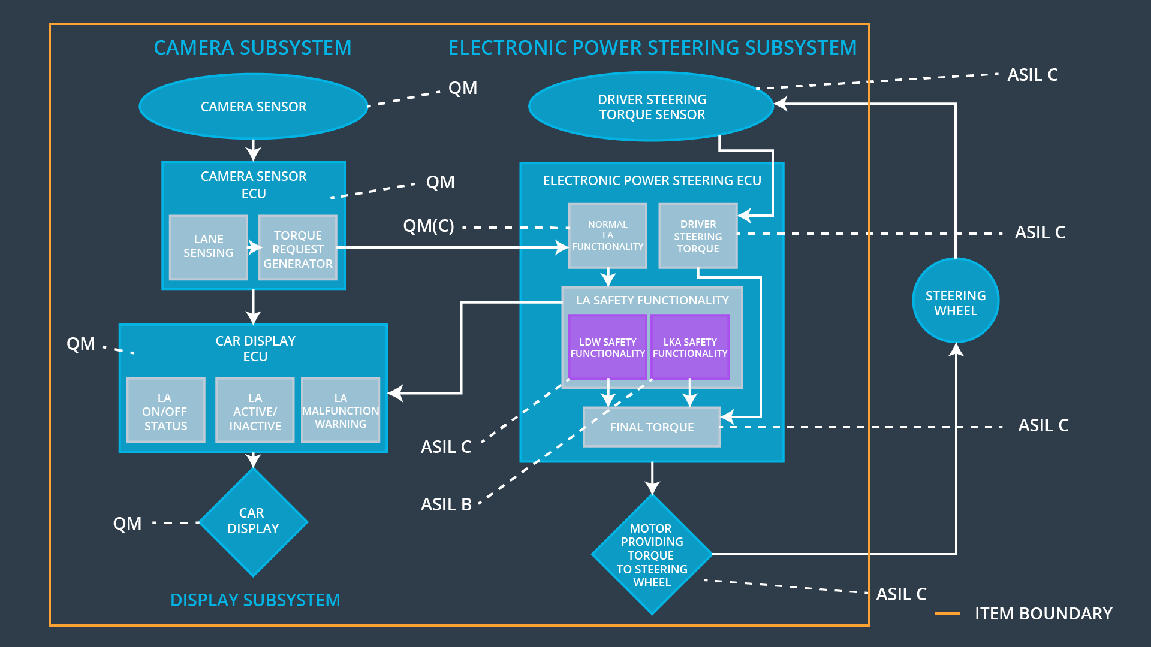

Functional overview of architecture elements
[Instructions: Provide a description for each functional safety element; what is each element's purpose in the lane assistance item? ]

Element | Description
Camera Sensor | Provides images which can be processed for lane assistance.
Camera Sensor ECU - Lane Sensing | Processes given images to determine vehicle odometry and lane boundarys.
Camera Sensor ECU - Torque request generator | Calculates target torque requests with using ego vehicle odometry and lane information and sends these to the Electronic Power Steering ECU.
Car Display | Displays warnings and general information for the driver.
Car Display ECU - Lane Assistance On/Off Status | Processes and stores requests from the system to control the light indicating that the system is turned on/off.
Car Display ECU - Lane Assistant Active/Inactive | Processes and stores requests from the system to control the light indicating that the system is active/inactive.
Car Display ECU - Lane Assistance malfunction warning | Processes and stores requests from the system to control the light indicating that the system is malfunctioning.
Driver Steering Torque Sensor | Detects exterted torque to the steering wheel.
Electronic Power Steering (EPS) ECU - Driver Steering Torque | Processes and stores the torque exerted on the steering wheel by the driver to calculate the additional torque which has to be applied by the system in order to match the required torque from the Camera Sensor ECU - Torque request generator.
EPS ECU - Normal Lane Assistance Functionality | Processes and stores torque requests from the Camera Sensor ECU - Torque request generator for further processing in the EPS ECU.
EPS ECU - Lane Departure Warning Safety Functionality | Ensures that the torque amplitude stored is below max_torque_amplitude and the torque frequency stored is below max_torque_frequency.
EPS ECU - Lane Keeping Assistant Safety Functionality | Ensures that the operation time of the lane keeping assistance torque application remains below max_torque_duration.
EPS ECU - Final Torque | Uses resulting (safe) torque request which are applied to the motor.
Motor | Applies the torque requested from the Electronic Power Steering ECU to the steering wheel.

Technical Safety Concept

Technical Safety Requirements

Lane Departure Warning (LDW) Requirements:
Functional Safety Requirement 01-01 with its associated system elements
(derived in the functional safety concept)
ID | Functional Safety Requirement | Electronic Power Steering ECU | Camera ECU | Car Display ECU
Functional  Safety  Requirement  01-01 | The lane keeping item shall ensure that the lane departure oscillating torque amplitude is below Max_Torque_Amplitude | X

Technical Safety Requirements related to Functional Safety Requirement 01-01 are:
ID | Technical Safety Requirement | ASIL | Fault Tolerant Time Interval | Architecture Allocation | Safe State
Technical Safety  Requirement 01 | The LDW safety component shall ensure that the amplitude of the 'LDW_Torque_Request' sent to the 'Final electronic power steering Torque' component is below 'Max_Torque_Amplitude. | C | 50 ms | LDW Safety | LDW sets torque request to zero.
Technical Safety  Requirement 02 | On deactivation of the LDW function, the LDW Safety shall send a signal to the display ECU to turn on a warning indicator. | C | 50 ms | LDW safety | LDW sets torque request to zero.
Technical Safety  Requirement 03 | On error detection, the LDW safety shall deactivate the LDW function and the requested torque shall be set to zero. | C | 50 ms | LDW safety | LDW sets torque request to zero.
Technical Safety  Requirement 04 | The validity and integrity of the data transmission for torque request signals shall be ensured. | C | 50 ms | LDW safety | LDW sets torque request to zero.
Technical Safety  Requirement 05 | A initialization memory test routine shall be conducted at start up of the EPS ECU to check for any faults in memory. | B | Initialization/Ignition cycle | Data transmission integrity check | LDW sets torque request to zero.

Functional Safety Requirement 01-2 with its associated system elements
(derived in the functional safety concept)
ID | Functional Safety Requirement | Electronic Power Steering ECU | Camera ECU | Car Display ECU
Functional  Safety  Requirement  01-02 | The lane keeping item shall ensure that the lane departure oscillating torque frequency is below Max_Torque_Frequency | X

Technical Safety Requirements related to Functional Safety Requirement 01-02 are:
ID | Technical Safety Requirement | ASIL | Fault Tolerant Time Interval | Architecture Allocation | Safe State
Technical Safety Requirement 01 | The LDW safety component shall ensure that the frequency of the 'LDW_Torque_Request' sent to the 'Final electronic power steering Torque' component is below 'Max_Torque_Frequency. | C | 50 ms | LDW safety | LDW sets torque request to zero.
Technical Safety  Requiremen 02 | On deactivation of the LDW function, the LDW Safety shall send a signal to the display ECU to turn on a warning indicator. | C | 50 ms | LDW safety | LDW sets torque request to zero.
Technical Safety  Requirement 03 | On error detection, the LDW safety shall deactivate the LDW function and the requested torque shall be set to zero. | C | 50 ms | LDW safety | LDW sets torque request to zero.
Technical Safety  Requirement 04 | The validity and integrity of the data transmission for torque request signals shall be ensured. | C | 50 ms | LDW safety | LDW sets torque request to zero.
Technical Safety  Requirement 05 | A initialization memory test routine shall be conducted at start up of the EPS ECU to check for any faults in memory. | A | Initialization/Ignition cycle | Data transmission integrity check | LDW sets torque request to zero.

Lane Keeping Assistance (LKA) Requirements:
Functional Safety Requirement 02-1 with its associated system elements
(derived in the functional safety concept)

ID | Functional Safety Requirement | Electronic Power Steering ECU | Camera ECU | Car Display ECU
Functional  Safety  Requirement  02-01 | The lane keeping item shall ensure that the lane keeping assistance torque is applied for only Max_Duration | X

Technical Safety Requirements related to Functional Safety Requirement 02-01 are:
ID | Technical Safety Requirement | ASIL | Fault Tolerant Time Interval | Allocation to Architecture | Safe State
Technical Safety  Requirement 01 | The Electronic Power Steering ECU shall ensure that the the applied torque used for maneuvering back to the center of the lane is applied for a maximum time defined by max_torque_duration. | B | 500 ms | LKA safety | LKA sets torque request to zero.
Technical Safety  Requirement 02 | On deactivation of the LDW function, the LDW Safety shall send a signal to the display ECU to turn on a warning indicator. | B | 500 s | LKA safety | LKA sets torque request to zero.
Technical Safety  Requirement 03 | On error detection, the LDW safety shall deactivate the LDW function and the requested torque shall be set to zero. | B | 500 ms | LKA safety | LKA sets torque request to zero.
Technical Safety  Requirement 04 | The validity and integrity of the data transmission for torque request signals shall be ensured. | B | 500 ms | LKA safety | LKA sets torque request to zero.
Technical Safety  Requirement 05 | A initialization memory test routine shall be conducted at start up of the EPS ECU to check for any faults in memory. | A | Initialization/Ignition cycle | Data transmission integrity check | LKA sets torque request to zero.

Refinement of the System Architecture

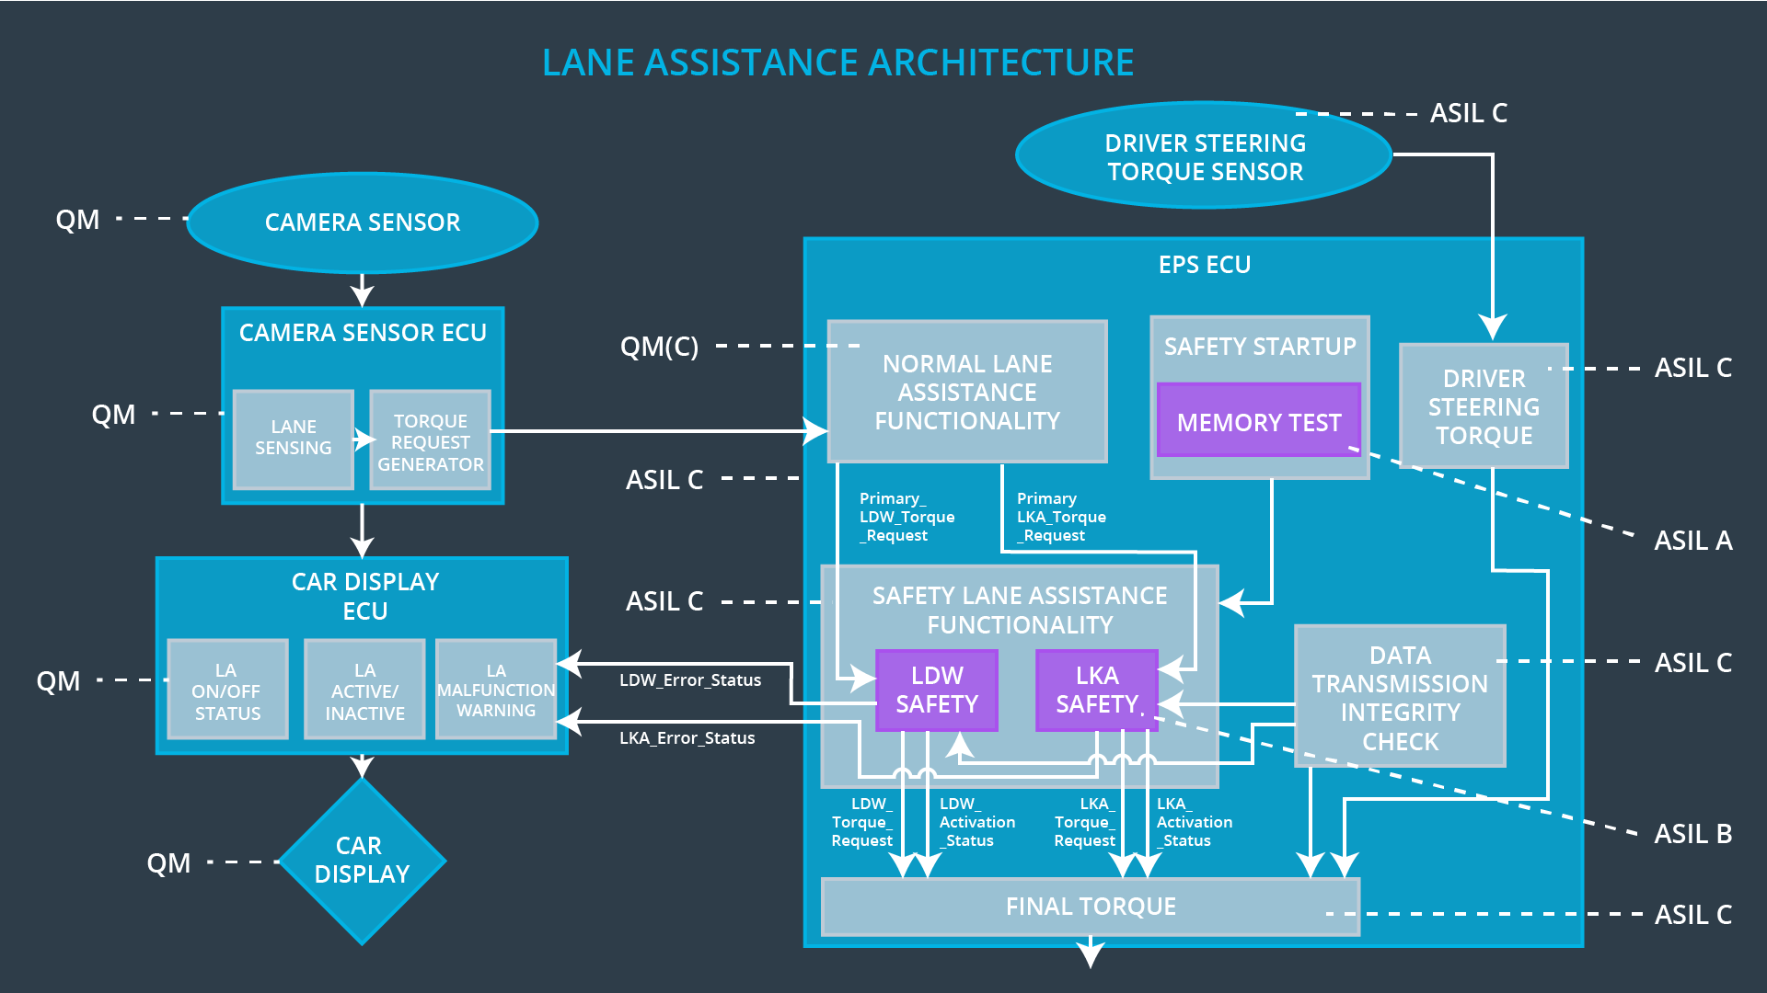

Allocation of Technical Safety Requirements to Architecture Elements

ID | Functional Safety Requirement | Electronic Power Steering ECU | Camera ECU | Car Display ECU
Functional  Safety  Requirement  01-01 | The lane keeping item shall ensure that the lane departure oscillating torque amplitude is below mas_torque_amplitude. | x
Functional  Safety  Requirement  01-02 | The lane keeping item shall ensure that the lane departure oscillating torque frequency is below max_torque_frequency. | x
Functional  Safety  Requirement  02-01 | The Electronic Power Steering ECU shall ensure that the the applied torque used for maneuvering back to the center of the lane is applied for a maximum time defined by max_torque_duration. | x

Warning and Degradation Concept
ID | Degradation Mode | Trigger for Degradation Mode | Safe State invoked? | Driver Warning
WDC-01 | Lane assistance system is turned off. | Malfunction_01  Malfunction_02  Malfunction_03  Malfunction_04 | Yes | Dashboard warning light, Display warning

