


Software Safety Requirements and Architecture

Lane Assistance
Document Version: 1.0
Template Version 1.0, Released on 2017-06-21



Document history
Date | Version | Editor | Description
12-27-2018 | 1.0 | Nick Fiege

Table of Contents
Document history 2
Purpose 2
Inputs to the Software Requirements and Architecture Document 3
Technical safety requirements 3
Refined Architecture Diagram from the Technical Safety Concept 4
Software Requirements 5
Refined Architecture Diagram 10

Purpose

The purpose of this document is to identify requirements for the system at software component level based on the technical safety requirements specified in earlier documents.
Requierements defined in here will be more specific to details of the actual software module implementation.

Inputs to the Software Requirements and Architecture Document

Technical safety requirements
Technical Safety Requirements related to Functional Safety Requirement 01-01 are:
ID | Technical Safety Requirement | ASIL | Fault Tolerant Time Interval | Architecture Allocation | Safe State
Technical Safety  Requirement 01 | The LDW safety component shall ensure that the amplitude of the 'LDW_Torque_Request' sent to the 'Final electronic power steering Torque' component is below 'Max_Torque_Amplitude. | C | 50 ms | LDW Safety | LDW sets torque request to zero.
Technical Safety  Requirement 02 | On deactivation of the LDW function, the LDW Safety shall send a signal to the display ECU to turn on a warning indicator. | C | 50 ms | LDW safety | LDW sets torque request to zero.
Technical Safety  Requirement 03 | On error detection, the LDW safety shall deactivate the LDW function and the requested torque shall be set to zero. | C | 50 ms | LDW safety | LDW sets torque request to zero.
Technical Safety  Requirement 04 | The validity and integrity of the data transmission for torque request signals shall be ensured. | C | 50 ms | LDW safety | LDW sets torque request to zero.
Technical Safety  Requirement 05 | A initialization memory test routine shall be conducted at start up of the EPS ECU to check for any faults in memory. | B | Initialization/Ignition cycle | Data transmission integrity check | LDW sets torque request to zero.

Refined Architecture Diagram from the Technical Safety Concept
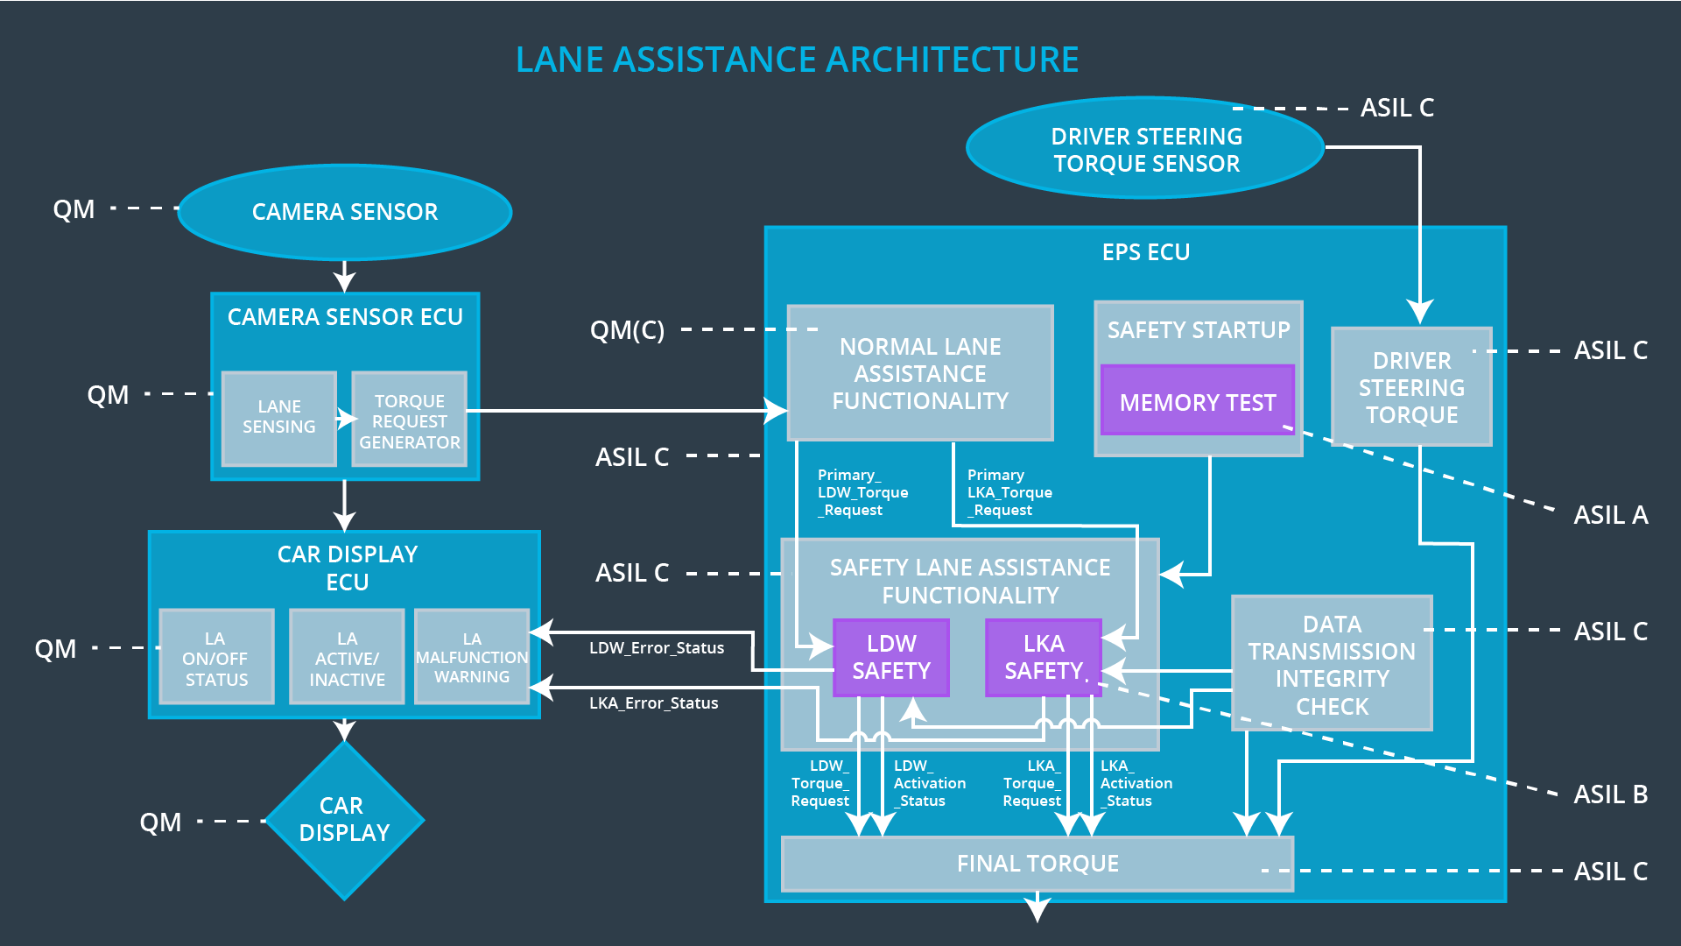

Software Requirements
Lane Departure Warning (LDW) Amplitude Malfunction Software Requirements:

ID | Technical Safety Requirement | ASIL | Fault Tolerant Time Interval | Allocation to Architecture | Safe State
Technical Safety  Requirement 01 | The LDW safety component shall ensure that the amplitude of the 'LDW_Torque_Request' sent to the 'Final electronic power steering Torque' component is below 'Max_Torque_Amplitude. | C | 50 ms | LDW Safety | LDW sets torque request to zero.

ID | Software Safety Requirement | ASIL | Allocation Software Elements | Safe State
Software Safety  Requirement 01-01 | The input signal ‘Primary_LDW_Torq_Req’ shall be read and stored to determine the torque request coming from the Normal Lane Assistance Functionality. The buffered input signal shall be named ‘Processed_LDW_Torq_Req’. | C | LDW_SAFETY_INPUT_PROCESSING | Processed_Torque_request = 0
Software Safety Requirement 01-02 | In case the’ processed_torque_request’ signal has a greater value than “max_torque_amplitude_LDW” the signal ‘Limited_LDW_Torq_Req ’ shall be set to 0, else ‘Limited_LDW_Torq_Req’ shall take the value of ‘Processed_LDW_Torq_Req’. | C | TORQUE_LIMITER | Limited_LDW_Torq_Req = 0
Software Safety Requirement 01-03 | The signal ‘Limited_LDW_Torq_Req’ shall be processed into ‘LDW_Torq_Req’ which is suitable to be received by the ‘Final Torque’ component. | C | LDW_SAFETY_OUTPUT_GENERATOR | LDW_Torq_Req = 0

ID | Technical Safety Requirement | ASIL | Fault Tolerant Time Interval | Allocation to Architecture | Safe State
Technical Safety  Requirement 02 | On deactivation of the LDW function, the LDW Safety shall send a signal to the display ECU to turn on a warning indicator. | C | 50 ms | LDW safety | LDW sets torque request to zero.

ID | Software Safety Requirement | ASIL | Allocation Software Elements | Safe State
Software Safety Requirement 02-01 | When the LDW function is deactivated (activation_status set to 0), the activation_status shall be sent to the ‘CAR DISPLAY ECU’. | C | ‘LDW_SAFETY_ACTIVATION’ -> ‘CAR DISPLAY ECU’ | None

ID | Technical Safety Requirement | ASIL | Fault Tolerant Time Interval | Allocation to Architecture | Safe State
Technical Safety  Requirement 03 | On error detection, the LDW safety shall deactivate the LDW function and the requested torque shall be set to zero. | C | 50 ms | LDW safety | LDW sets torque request to zero.

ID | Software Safety Requirement | ASIL | Allocation Software Elements | Safe State
Software Safety Requirement 03-01 | Every element shall generate a signal to indicate errors with it’s own execution.  ‘LDW_SAFETY_INPUT_PROCESSING’ shall therefore generate the ‘error_status_input’ signal.  ‘TORQUE_LIMITER’ shall therefore generate the ‘error_status_torque_limiter’ signal  ‘LDW_SAFETY_OUTPUT_GENERATOR’ shall therefore generate the ‘error_status_output_gen’ signal. | C | ‘LDW_SAFETY_INPUT_PROCESSING’ ‘TORQUE_LIMITER’, ‘LDW_SAFETY_OUTPUT_GENERATOR’  -> ‘LDW_SAFETY_ACTIVATION’ | None
Software Safety Requirement 03-02 | A software element shall evaluate all of the error signals and indicates an error if any ‘1’ is received. It shall deactivate the LDW feature by setting the ‘activation_status’ to ‘0’ and therefore dactivate the LDW functionality. | C | LDW_SAFETY_ACTIVATION | ‘activation_status’ = 0
Software Safety Requirement 03-03 | When no errors are detected, the status of the LDW feature shall be activated by setting ‘activation_status’ to ‘1’. | C | LDW_SAFETY_ACTIVATION | None
Software Safety Requirement 03-04 | Once the LDW functionality has been deactivated, it shall stay deactivated until the ignition is switched from off to on again. | C | LDW_SAFETY_ACTIVATION | ‘activation_status’ = 0

ID | Technical Safety Requirement | ASIL | Fault Tolerant Time Interval | Architecture Allocation | Safe State
Technical Safety  Requirement 04 | The validity and integrity of the data transmission for torque request signals shall be ensured. | C | 50 ms | LDW safety | LDW sets torque request to zero.

ID | Software Safety Requirement | ASIL | Allocation Software Elements | Safe State
Software Safety Requirement 04-01 | Data transmitted from/to the ‘LDW_Safety_Activation’ component and the ‘LDW_SAFETY_OUTPUT_GENERATOR’ shall be protected by an end to end(E2E) protection mechanism | C | E2ECalc | ‘LDW_Torq_Req’ = 0
Software Safety Requirement 04-02 | The E2E protection protocol shall contain protection data like an alive counter (SQC) and CRC of the data transmitted. | C | E2ECalc | ‘LDW_Torq_Req’ = 0

ID | Technical Safety Requirement | ASIL | Fault Tolerant Time Interval | Allocation to Architecture | Safe State
Technical Safety  Requirement 05 | A initialization memory test routine shall be conducted at start up of the EPS ECU to check for any faults in memory. | B | Initialization/Ignition cycle | Data transmission integrity check | LDW sets torque request to zero.

ID | Software Safety Requirement | ASIL | Allocation Software Elements | Safe State
Software Safety Requirement 05-01 | On each system initialization(ignition), a CRC verification check of source code inside the flash memory shall be done. | A | MEMORYTEST | ‘activation_status’ = 0
Software Safety Requirement 05-02 | Tests to check RAM, address/data bus and device integrity shall be done on each system initialization(ignition). | A | MEMORYTEST | ‘activation_status’ = 0
Software Safety Requirement 05-03 | The test result of the RAM or Flash memory shall be indicated to the LDW_Safety component via the memory_status” signal | A | MEMORYTEST | ‘activation_status’ = 0
Software Safety Requirement 05-04 | A negative (0) ‘memory_status” signal in the ‘INPUT_LDW_PROCESSING’ component shall set the signal ‘error_status_input’ to ‘1’, so that the LDW functionality is deactivated safely. | A | LDW_SAFETY_INPUT_PROCESSING | ‘activation_status’ = 0

Refined Architecture Diagram

