UNIT 1: BUSINESS CARD
- This business card is from Alice Morton.
- She is web Designer.
- Her mobile phone number is 077 997565648
- Her office is in 56 High street, in Riverdale in England.

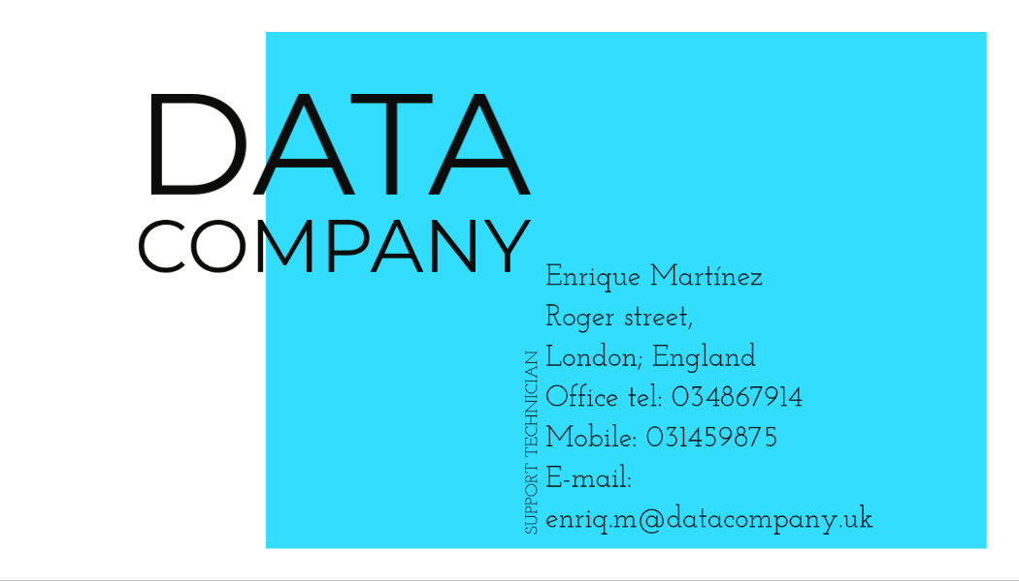Figura 1:

