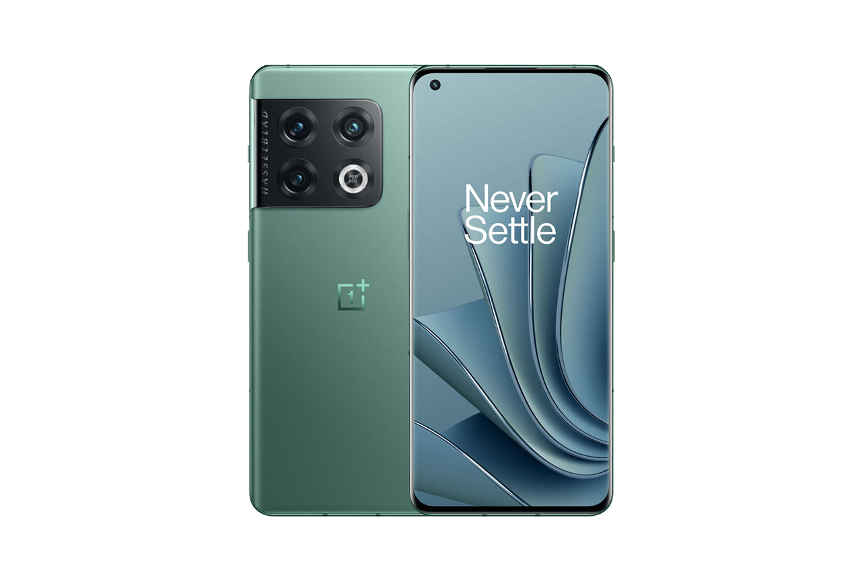 | The OnePlus 10 Pro is an excellent choice. It includes second generation camera and CPU Snapdragon 8 Gen 1.  The main advantage is Battery, with it 5000 mAh capacity.  Another positive feature is the size of the screen, which is 6.7 inches and Fluid AMOLED technology at 120Hz with LTPO.  This smartphone is the top-of-the-range from OnePlus.  It isn't as expensive as other phones with the same features.  It can run next generation games.  Acquiring the OnePlus 10 Pro is a safe bet, the best quality-price option.

