**Tables and Figures**

**FIGURE 1** Trimester total number of births by mothers’ years of schooling groups in Brazil (left) and Colombia (right) from 2015 to 2021. Red-dotted lines represent the expected number of births based on time- and seasonality trends from 2015 to 2019.

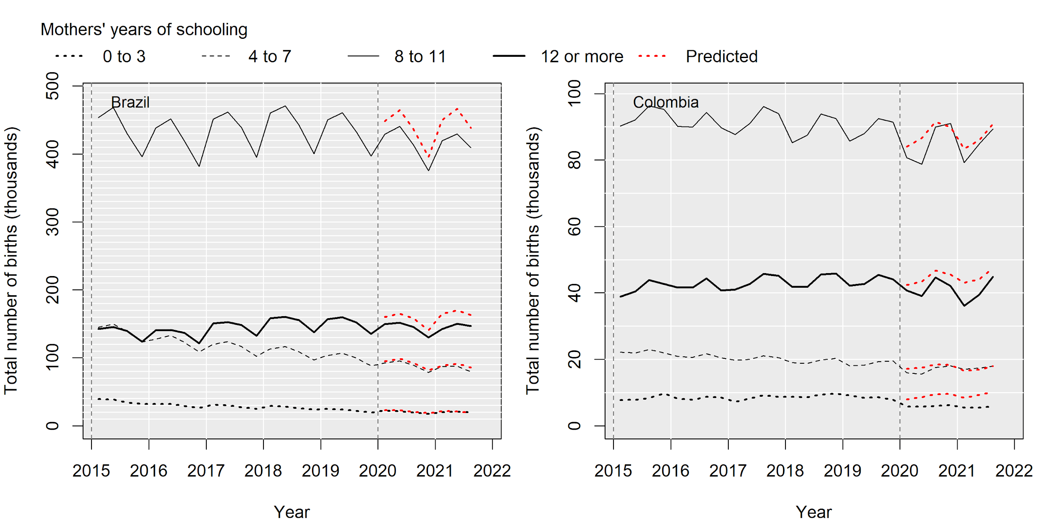

*Note:* Original educational attainment and years of schooling are as follows. Brazil: “Nehuma”, “One to three,” “Four to seven,” “Eight to 11,” “12 or more”, and “Unknown.” Colombia: “Pre-school,” “Primary,” “Secondary basic,” “Secondary academic,” “Technical,” “Normal,” “Technical professional,” “Technological,” “Professional,”, “Unknown,” and “Missing information.” Recoding files are available upon request from the corresponding author.

**FIGURE 2** Trimester p-score mortality trends by subnational levels in Brazil (left) and Colombia (right) from January 2020 to September 2021.

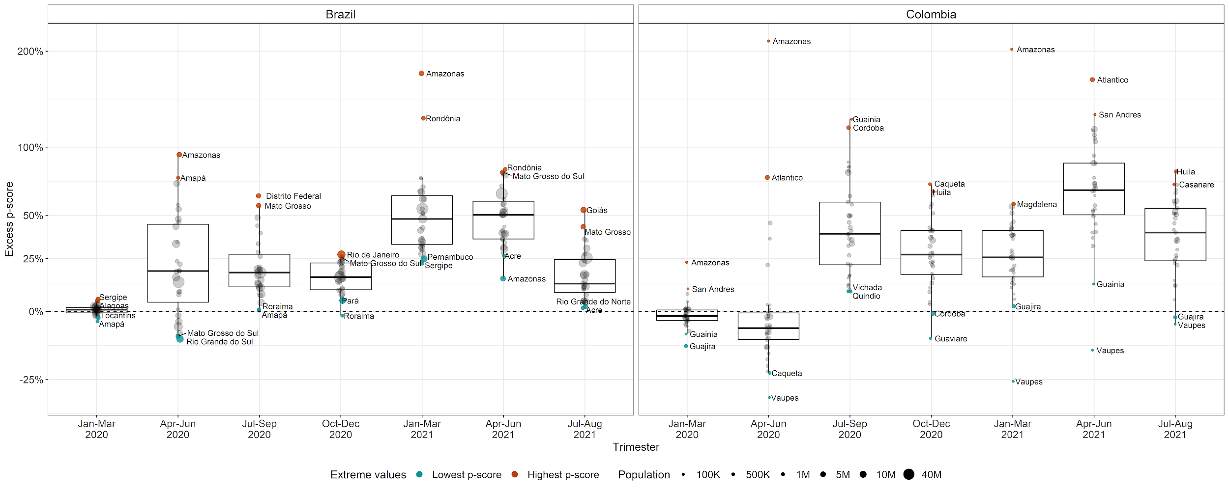

*Note:* p-scores of excess mortality capture departure from expected patterns of mortality. Higher p-scores indicate a particularly high risk of mortality in a given subnational area.

**FIGURE 3** Associations between current excess mortality and relative birth changes (*rbc*) in 2020 and 2021 across subnational areas by mothers’ age group, and mothers' years of schooling (y.s.) in Brazil (top) and Colombia (bottom)



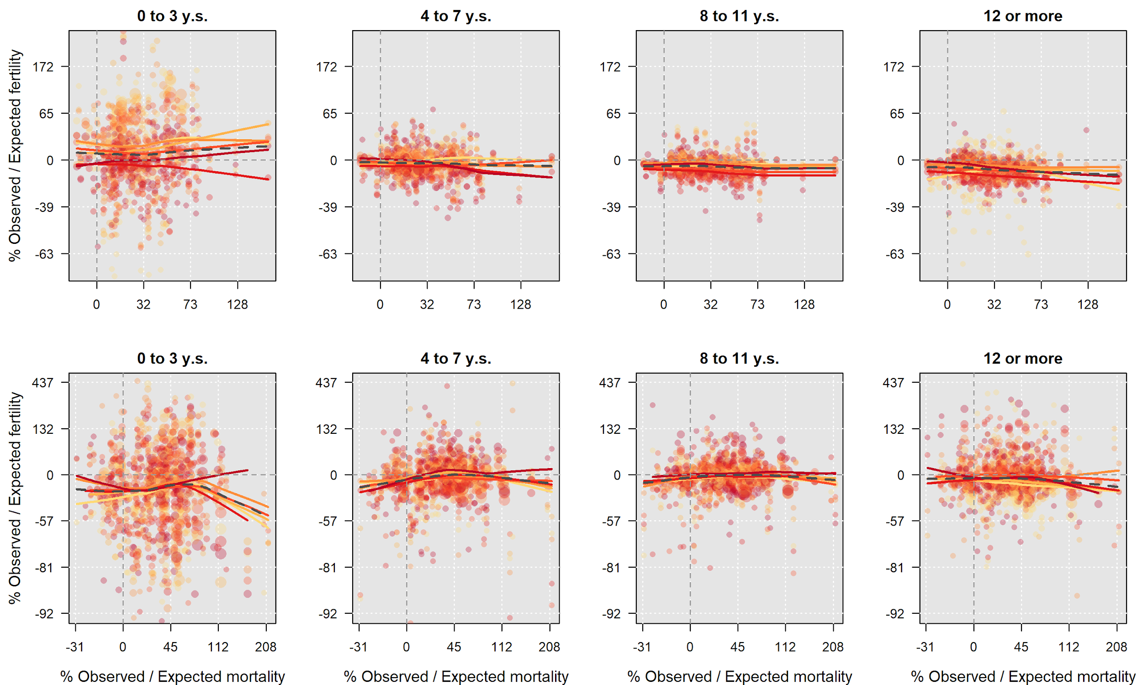

**TABLE 1** Associations between current excess mortality and lagged excess mortality, and the relative birth changes (*rcb*) according to four multivariate model specifications (M.S.) in Brazil and Colombia.

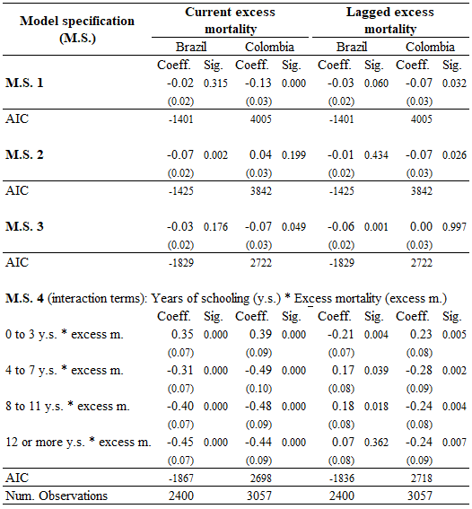

*Note:* Standard errors are reported in parenthesis beneath each coefficient. The number of observations corresponds to all combinations of subnational areas, age groups, years of schooling groups, and trimesters (from April 2020 to June 2021). *Model Specifications:* the M.S.s for current mortality control for lagged mortality, and vice versa. M.S. 1 includes dummy variables for mothers’ age groups and years of schooling. M.S. 2 adds the Subnational Human Development Index (SHDI). M.S. 3 substitutes the SHDI for dummy variables for each subnational area. M.S. 4 includes dummy variables for each subnational area and interaction between mothers’ years of schooling (y.s.) and the excess mortality (p-scores).

**Appendix**

**Detailed information on data sources and methods for retrieving information**

The pre-2020 information for Brazil was accessed via the ‘dataus’ R-statistical package [(Prado Siqueira 2019)](https://www.zotero.org/google-docs/?aMqsj8). This package allows us to retrieve the yearly total number of births by mothers’ five-year age groups, years of schooling (four groups), and state of occurrence. For 2020 and 2021, we downloaded individual birth records from the SINASC. This microdata allows us to separate births by trimester. In order to have the pre-2020 data by trimester, we use the distributions observed in 2020 to infer the distribution of births by trimester for the years before 2020. Specifically, for each subnational unit and year from 2010 to 2019, we multiply the total number of births in the year by a random draw from a multinomial distribution with four categories (i.e., one for each trimester) with multivariate mean equal to the observed distribution of births in 2020. This approach allows us to disaggregate yearly-series by trimester assuming no change in the seasonality of births from 2015 to 2020.

For Colombia, the pre-2020 information was processed from the individual birth records available from DANE’s Archivo Nacional de Datos [Colombian National Data Archive].[1] We aggregated these records by mothers’ age, years of schooling, and department of occurrence. The 2020 and 2021 data were taken from preliminary reports published by DANE. These reports come on a trimester basis, which in turn sets the minimum time unit for the disaggregation of our analysis.

**Excess mortality model**

The model is defined as

Where and refer to the deaths counts and population exposure for each region *r* in time *t*. indicate the intercept and the log-linear secular trend in mortality for each subnational division *r*. The term refers to a cyclic p-spline function applied to weeks *w* within a year (from 1 to 52 in regular years and to 53 in leap years) to account for mortality seasonality in each subnational division *r*. The model uses a logarithmic link function with quasi-Poisson distribution to account for overdispersion. We use the R package *mgcv* for fitting the models [(Wood 2017)](https://www.zotero.org/google-docs/?CeK7Ha). Excess deaths by trimester are obtained by adding the weekly excess deaths in each trimester, and fractionating the deaths of the overlapping weeks according to the days in each trimester.

We measure excess mortality using the p-score index, which indicates the percentage difference between the observed deaths relative to the mortality baseline (, where and are, respectively, the observed and expected deaths for each region *r* in time *t*).

Weekly death counts and annual population counts by subnational division are retrieved from DATASUS in Brazil and the DANE in Colombia. We obtain weekly population exposures at 1st July in each subnational division by dividing the annual population counts by the number of weeks in each year, and we compute the population exposures for the remaining weeks through cubic spline interpolation.

**FIGURE A1** Trimester total number of births by mothers’ years of schooling groups in Brazil (left) and Colombia (right) from 2015 to 2021. Red-dotted lines represent the expected number of births based on time- and seasonality trends from 2015 to 2019. Blue-dashed lines represent the trimester-specific average number of births from 2015 to 2019.

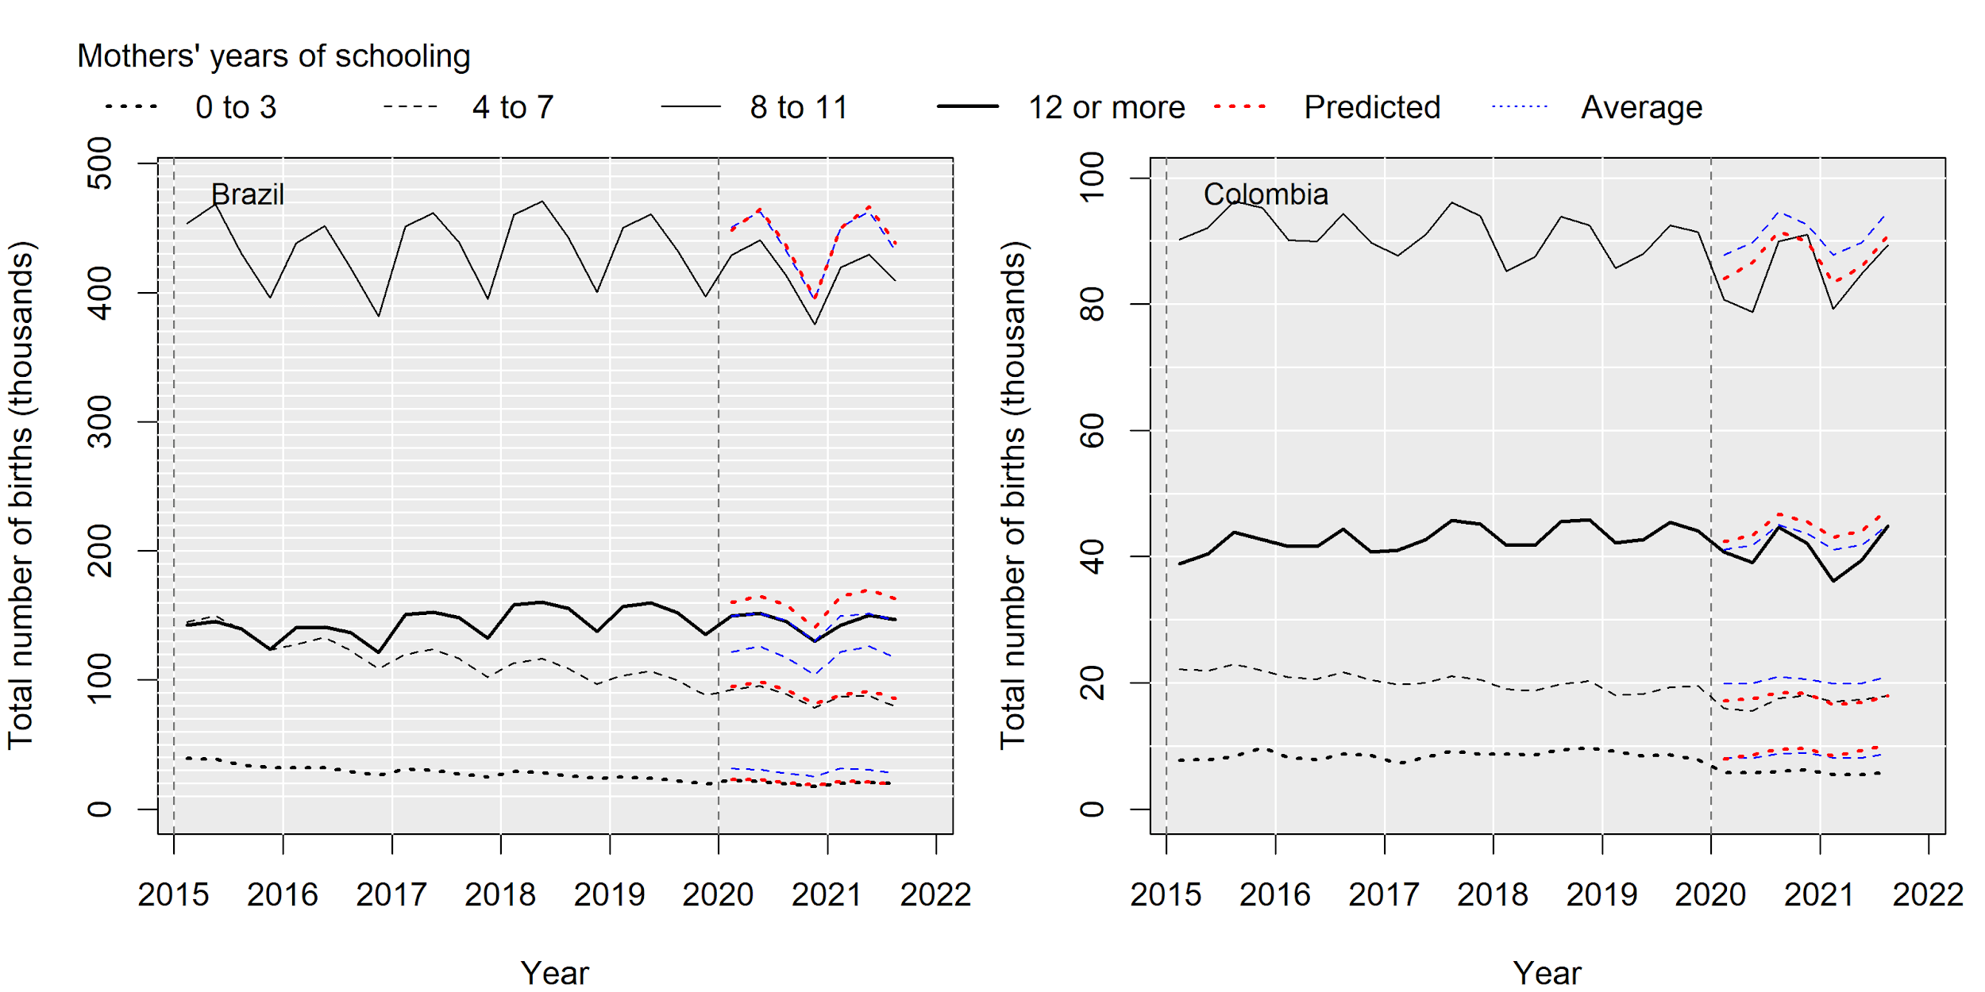

*Note:* Original educational attainment and years of schooling are as follows. Brazil: “Nehuma”, “One to three,” “Four to seven,” “Eight to 11,” “12 or more”, and “Unknown.” Colombia: “Pre-school,” “Primary,” “Secondary basic,” “Secondary academic,” “Technical,” “Normal,” “Technical professional,” “Technological,” “Professional,”, “Unknown,” and “Missing information.” Recoding files are available upon request from the corresponding author.

**FIGURE A2** Heterogeneous associations between two-trimester lagged excess mortality and the relative birth changes (*rbc*) across subnational areas by mothers' years of schooling in Brazil (top) and Colombia (bottom)



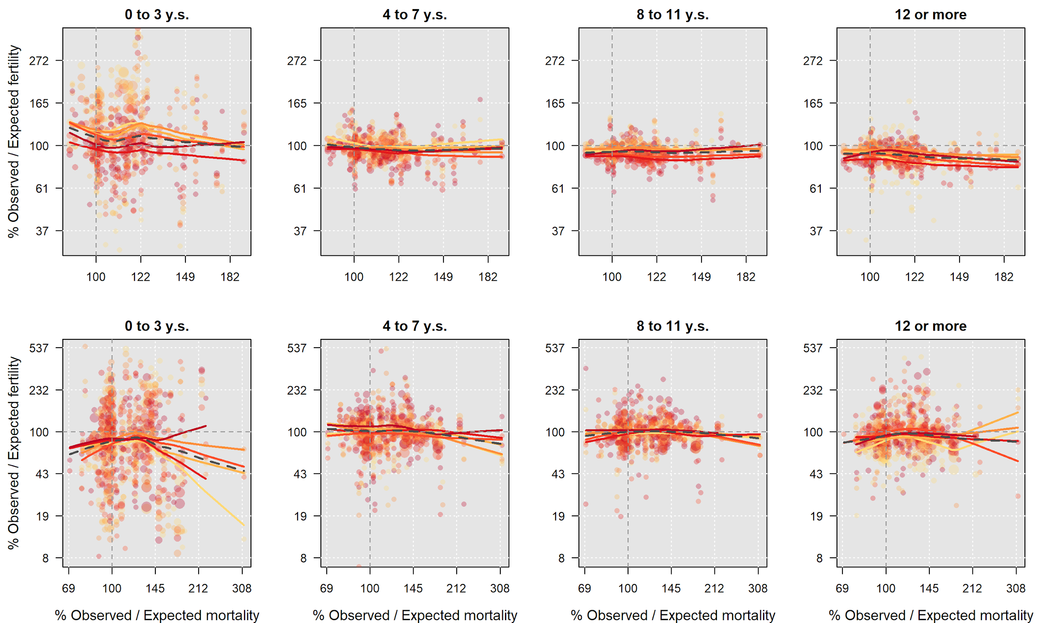

1. Source: Archivo Nacional de Datos. https://sitios.dane.gov.co/anda-index/