DSC5001 ? STATISTICAL MACHINE LEARNING
Can We Anticipate a
High-Risk AQHI Hour?
A comparative study of classification models on hourly monitoring data
TEAM OUTLIERS
Member | UID | Member | UID
Au Yeung Chun Ki | 60213119 | Cheung Chun Man | 60846734
Hu Qi | 60602703 | Ning Ke | 61118010

5 November 2026
One-hour-ahead prediction of whether a Hong Kong monitoring station will reach AQHI 7 or above.

01 / MOTIVATION | Why a supplementary early warning is worth testing

A fast-changing risk, a practical decision
Hong Kong?s Air Quality Health Index (AQHI) is reported hourly, and AQHI 7 or above denotes a high-risk level. A reliable one-hour-ahead signal could help public-health communicators and people sensitive to air pollution prepare for short-term deterioration. It would complement?not replace?the Environmental Protection Department?s official forecasts.
The prediction problem is challenging: high-risk hours are rare, observations from each station are temporally dependent, and an alerting system must balance missed warnings against false alarms. The value of a classifier therefore cannot be judged by accuracy alone; recall, precision and the operational cost of alerts matter.

Research questions
- RQ1. Can lagged station AQHI, time patterns and weather context predict whether the same station?s AQHI will be at least 7 in the next hour?
- RQ2. How do Logistic Regression, Random Forest and XGBoost compare on rare-event detection, and what precision?recall trade-offs do their alert thresholds create?
- RQ3. Which recent AQHI, temporal and station-type features are most informative, and how much confidence should users place in the reported results?
Scope This is a predictive, observational study. The reported model scores are exploratory because the current implementation selects thresholds using evaluation labels; a leakage-safe re-evaluation is needed before operational use.

02 / DATA | 617,799 station-hours, 27 predictors, four calendar years

Sources, unit and target
Hourly station AQHI records for January 2021?December 2024 were obtained from the EPD historical archive [1]. Daily mean temperature, relative humidity, rainfall and wet-bulb temperature came from Hong Kong Observatory (HKO) climate data [2]. The processed table contains 617,799 station-hour rows from 18 stations (15 general; 3 roadside) and 27 model predictors. The target is 1 when that same station?s next-hour AQHI is ?7; otherwise it is 0. There are 9,904 positive rows (1.60%).
Pipeline step | Rule / result
Raw AQHI | 48 monthly CSV files, 2021?2024; reshape station columns into station-hour records.
Eligibility | Drop rows with missing AQHI, required lagged AQHI, next-hour label, temperature or humidity.
Features | Station-wise AQHI lags/rolling features; calendar encodings; station type; daily HKO variables joined by date.
Remaining missing values | Rainfall filled with 0; wet-bulb temperature filled with its median; model loader also median-fills feature gaps.
Final modelling table | 617,799 rows; 27 predictors; 18 stations; 9,904 positive labels (1.60%).

The processing artifacts do not preserve intermediate row counts, so the number removed at each cleaning step cannot be reconstructed from the available outputs. No duplicated station-hour keys or missing weather predictors were found in the final table. Exact coverage is 1 Jan 2021 04:00 through 31 Dec 2024 22:00.

Important data-quality caveat
Daily weather values are merged onto every hour of the same date. Because the availability time of those daily summaries is not established, a value may contain information that would not yet be known at a forecast origin. These weather predictors are therefore not confirmed to be real-time-safe.

03 / EXPLORATORY ANALYSIS | Rare high-risk hours and a pronounced afternoon pattern shape the task

What the data show
Only 1.60% of next-hour labels are high-risk, so a majority-class classifier would miss every event. The AQHI distribution is concentrated below 7. Across the four-year sample, descriptive high-risk rates rise in the afternoon: they are highest at 16:00 (5.69%), followed by 17:00 (5.48%) and 15:00 (4.99%). These are associations in the observed sample, not causal effects.
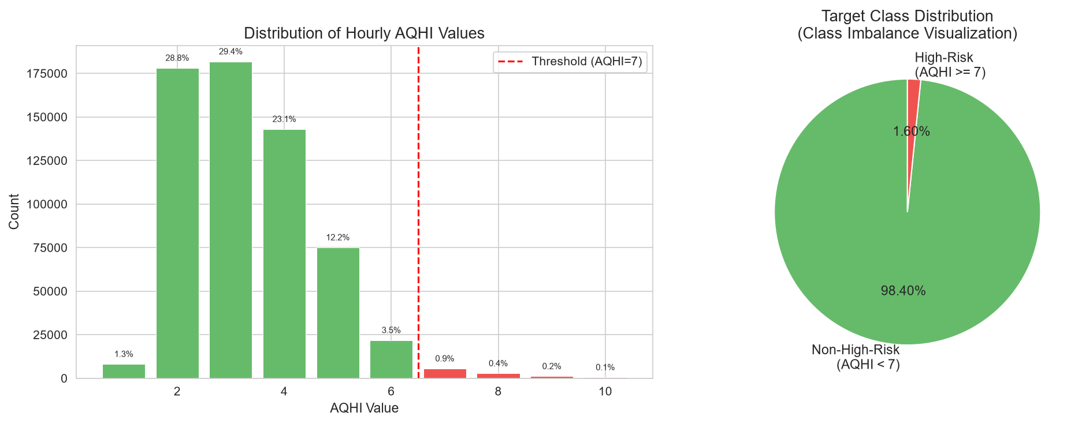
Figure 1. Observed AQHI distribution and the imbalanced next-hour target.
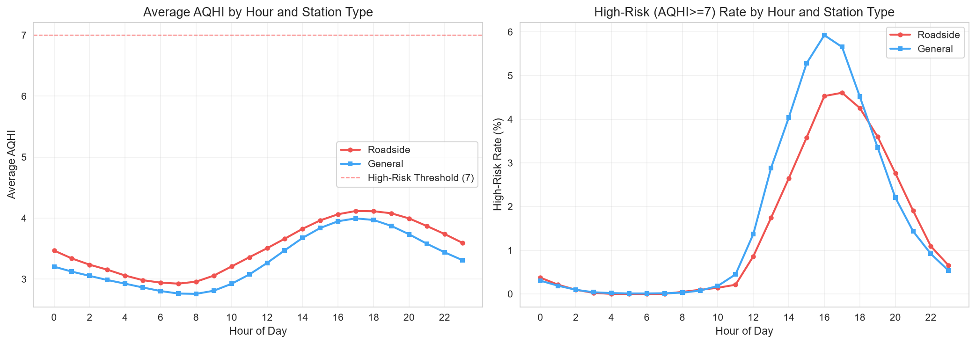
Figure 2. Mean AQHI and observed next-hour high-risk rate by hour and station type.
Modelling implication: use rare-event metrics and class-weighted learners, compare probability thresholds explicitly, and retain hour-of-day features. Hourly pattern charts are descriptive; they do not establish that the models generalize equally across station types.

04 / METHODS | A chronological model ladder; validation details limit the strength of inference

Features and learners
For each station, the feature pipeline creates AQHI lags of 1, 2, 3, 6, 12 and 24 hours; lagged 3- and 6-hour means; a 6-hour rolling standard deviation; and 1- and 3-hour differences. It adds hour, weekday and month encodings, weekend status, roadside status and four daily HKO weather variables. Lags and rolling statistics are computed within station using prior observations.
Learner | Configuration in saved run | Role
Majority / persistence | No fitted baseline results in saved output. | Required reference points; not quantified.
Logistic Regression | L2, C=1, balanced class weights; standardized inputs. | Interpretable linear benchmark.
Random Forest | 200 trees; max depth 15; balanced class weights. | Non-linear ensemble.
XGBoost | 300 rounds; depth 6; learning rate 0.1; positive-class weighting. | Gradient-boosted comparison.

Implemented validation and threshold selection
The training script sorts by timestamp, reserves the final 20% of rows for testing, and reports five expanding TimeSeriesSplit folds. At each evaluation stage it selects the threshold on the same validation/test labels used to report metrics, maximizing F1 subject to recall ?0.65. It also reports an illustrative FN:FP cost ratio of 5:1. This differs from a strict holdout design: thresholds must be selected inside training/validation data and then frozen before test evaluation.
Audit finding The row-based split divides timestamp 20 March 2024 17:00 between train and test (18 simultaneous station rows). Global feature median filling also occurs before splitting. In addition, the same-day daily weather availability is unknown. Scores should be treated as potentially optimistic.

05 / INTERPRETABLE MODEL | Recent AQHI dominates; logistic coefficients are conditional associations

What the linear model suggests
Among standardized Logistic Regression coefficients, AQHI_lag_1 (+1.158), the 3-hour rolling mean (+1.031), AQHI_lag_2 (+1.027) and AQHI_lag_3 (+0.844) have the strongest positive coefficients by absolute magnitude among recent pollution features. The 6-hour rolling mean has a large negative coefficient (?1.359), and hour_cos is also large (?1.316). Correlated lag and rolling features make individual coefficients difficult to interpret in isolation.
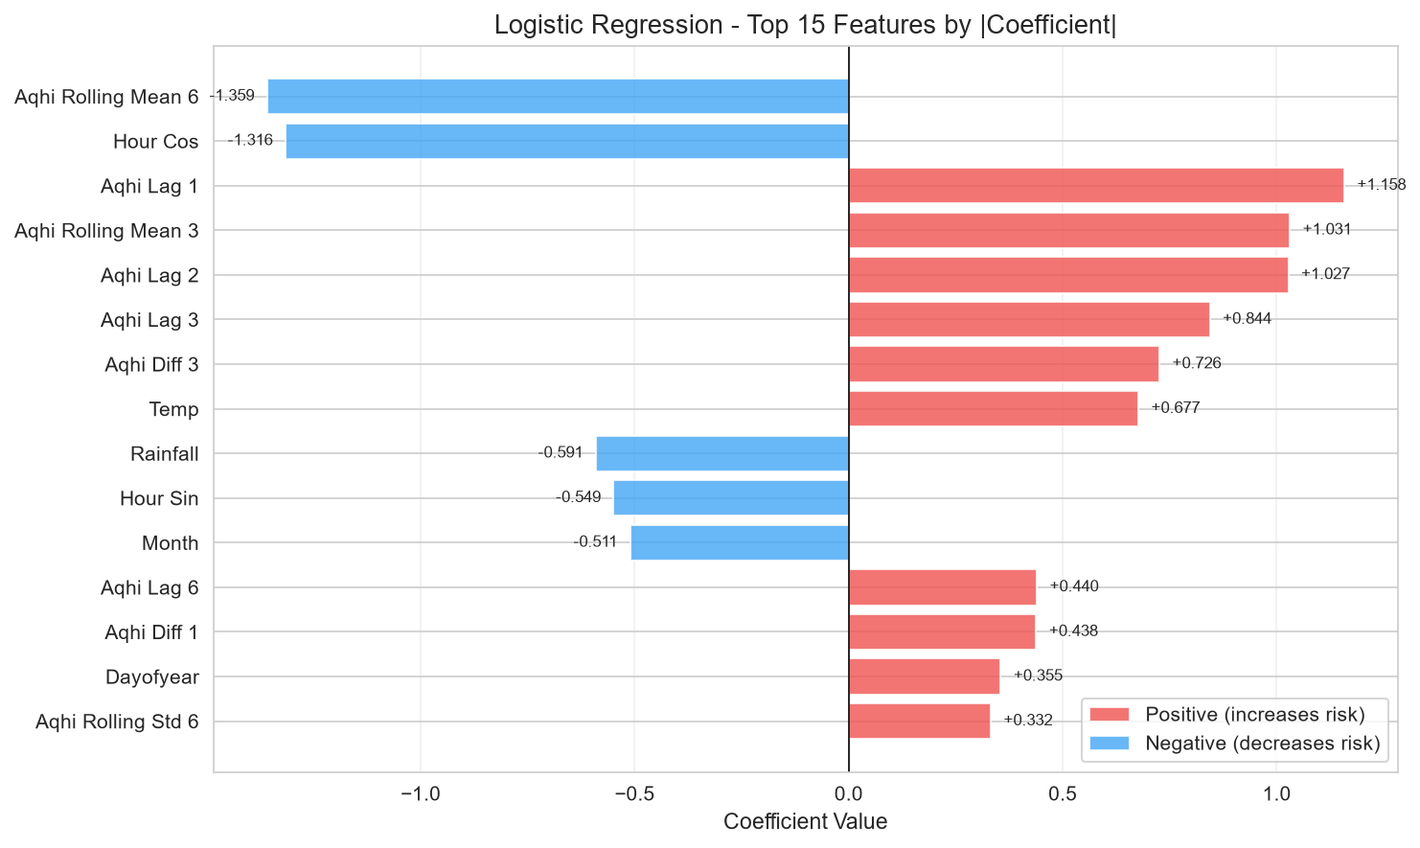
Figure 3. Largest Logistic Regression coefficients by absolute value (standardized features).
The coefficients describe the fitted model conditional on the other included variables; they are not causal effects. The counterintuitive negative rolling-mean coefficient alongside positive short lags may reflect collinearity and feature scaling, and should not be read as evidence that higher sustained AQHI reduces risk.
Interpretation The strongest and most consistent signal is recent station AQHI. Weather coefficients are not operationally interpretable until the timing of daily weather availability is verified.

06 / MODEL COMPARISON | Random Forest has the lowest reported alert cost, but the test threshold was not independent

Five-fold results and reported test operating points
Model | CV PR-AUC  mean ? SD | CV F1  mean ? SD | Test P / R / F1* | Test PR-AUC
Logistic Regression | 0.679 ? 0.101 | 0.616 ? 0.090 | 0.608 / 0.654 / 0.630 | 0.682
Random Forest | 0.663 ? 0.111 | 0.627 ? 0.080 | 0.542 / 0.738 / 0.625 | 0.683
XGBoost | 0.580 ? 0.104 | 0.550 ? 0.088 | 0.507 / 0.698 / 0.588 | 0.654

*Reported test scores at thresholds selected using those same test labels (LR 0.978; RF 0.893; XGBoost 0.748). They are not unbiased holdout estimates. CV thresholds were also selected per validation fold. No 95% confidence intervals or fit times are available.
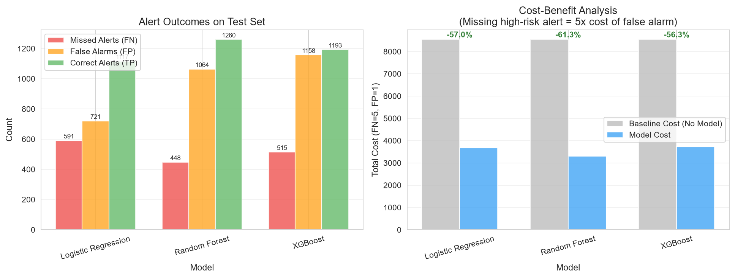
Figure 4. Saved test-set alert counts and illustrative cost reduction (FN cost=5, FP cost=1).
At those operating points, Random Forest recorded 448 missed events and 1,064 false alerts, giving a calculated cost of 3,304 versus 8,540 for an always-negative baseline (61.3% lower). Logistic Regression recorded 591 misses and 721 false alerts (cost 3,676; 57.0% lower); XGBoost recorded 515 and 1,158 (cost 3,733; 56.3% lower). These costs are calculated at F1-selected, test-tuned thresholds?not thresholds optimized for the 5:1 cost function.

07 / FEATURE INTERPRETATION | Tree models agree that recent AQHI carries most of their predictive signal

Importance is predictive, not causal
In the Random Forest, AQHI_lag_1 contributes 22.2% of reported impurity importance, the 3-hour rolling mean 16.1%, AQHI_lag_2 13.3%, and 6-hour rolling variability 11.6%. XGBoost assigns 42.6% to AQHI_lag_1 and 17.3% to the 3-hour rolling mean. Thus both tree models rely primarily on the latest measurement and short-term AQHI history.
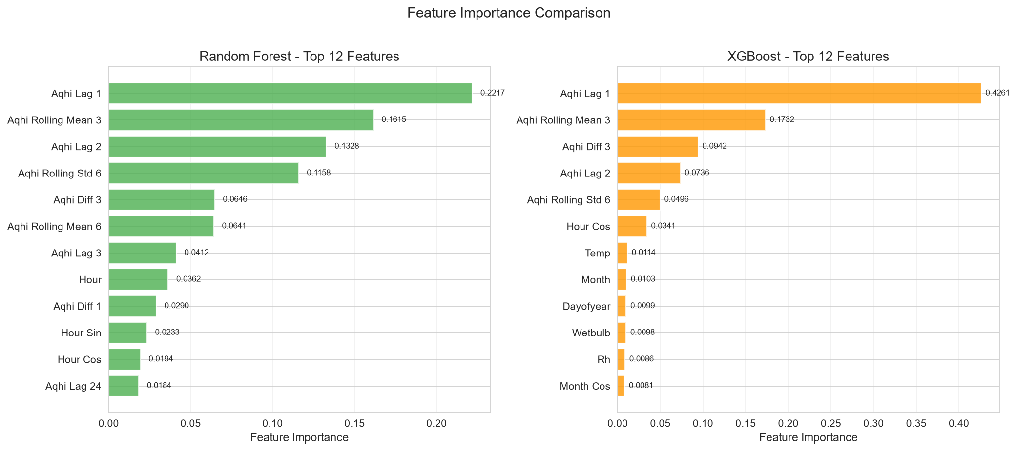
Figure 5. Saved tree-model feature importance (top predictors).
Time-of-day features contribute smaller amounts, while each weather variable is modest in the fitted tree models. Impurity-based importance can favor some feature types and distribute credit among correlated predictors; it does not estimate an intervention effect. Permutation importance, held-out partial dependence, and model performance broken out by roadside/general stations were not found in the saved analysis outputs.
Use in practice If subsequently validated, recent station AQHI is the most actionable input to monitor. Daily weather predictors should be retained only if their publication/availability time is compatible with a one-hour-ahead forecast.

08 / ROBUSTNESS & LIMITATIONS | Key checks remain outstanding before these comparisons can support deployment

Evidence and unresolved checks
Check | What the artifacts establish | Status
Subgroup performance | Descriptive hour-of-day plots by station type exist; no type-specific classifier metrics. | Incomplete
Alternative cleaning / weather timing | No alternative missing-data rules or real-time-safe weather comparison were run. | Not tested
Threshold robustness | A threshold-sensitivity figure exists; thresholds are selected using evaluation labels. | Exploratory only
Uncertainty | Five-fold mean ? SD is reported; test confidence intervals / block bootstrap are absent. | Incomplete
Leakage controls | Row split cuts a shared timestamp; global imputation and same-day weather timing require audit. | Needs correction

Limitations
- The 1.60% positive-class rate makes precision sensitive to small changes in false alerts; aggregate metrics can hide station-level differences.
- Daily HKO aggregates have lower temporal resolution and may not have been available at forecast time; HKO and EPD station coverage is spatially mismatched.
- The series ends in 2024 to avoid the AQHI methodology change in March 2025, limiting evidence about current-regime performance.
- Thresholds and preprocessing were not isolated from evaluation data, so reported test performance and cost reductions are likely optimistic.
A defensible re-analysis should group all station rows at each timestamp, split chronologically before fitting imputation, select thresholds within training folds only, exclude or lag weather until its release timing is confirmed, and evaluate a frozen model once on a later holdout. Then report station-type metrics and time-block confidence intervals.

09 / CONCLUSIONS | The signal is promising, but no model is ready for operational recommendation

Answers to the research questions
RQ1. The saved models rank high-risk hours above chance on the observed test period (PR-AUC 0.654?0.683 versus an approximately 0.014 test prevalence), but test thresholds and parts of preprocessing are not independent of evaluation data. Real-world predictive performance remains unconfirmed.
RQ2. In the reported five-fold summaries, Logistic Regression has the highest mean PR-AUC (0.679) and Random Forest the highest mean F1 (0.627). At the test-tuned operating points, Random Forest has the highest recall (73.8%) and calculated 5:1 cost reduction (61.3%). These model rankings are provisional pending leakage-safe validation.
RQ3. AQHI_lag_1 and short rolling AQHI summaries are the leading predictors in both tree models. The available results do not establish stable station-type effects or causal relationships.

Recommendations
- For EPD and public-health communicators: treat this as a feasibility study, not a deployed alert; first rerun the analysis with timestamp-grouped validation and frozen thresholds.
- For model users: choose an alert threshold using an explicit cost or recall target on training/validation data, then report precision, recall and false alerts on a later untouched period.
- For future work: use hourly, release-time documented weather and evaluate performance by station and station type with time-block uncertainty estimates.

References
[1] Environmental Protection Department, Hong Kong. Historical AQHI data by monitoring station, 2021?2024. https://www.aqhi.gov.hk/epd/ddata/html/history/2021/202101_Eng.csv (archive pattern; accessed 4 Nov 2026).
[2] Hong Kong Observatory. Daily climate data (temperature, relative humidity, rainfall, wet-bulb temperature). https://data.weather.gov.hk/weatherAPI/cis/csvfile/HKO/ALL/ (accessed 4 Nov 2026).
[3] Environmental Protection Department, Hong Kong. About the Air Quality Health Index. https://www.aqhi.gov.hk/en/what-is-aqhi/about-aqhi.html.
Reproducibility materials: project source scripts in src/; saved metrics in output/model_results.json; figures in figures/; supporting code appendix in output/DSC5001_Project_Appendix.pdf.

