電通二乙微處理器實驗 實驗結報

實驗名稱 | MCS Cloud
組別 | 28 | 組員 | 盧詠琪

- 實驗目的
控制LED並檢視狀態
- 實驗步驟
  - 修改 MCS_GET code, 加入 MCS Remote
  - 將 A0 電阻值上傳
- 程式碼
1.
#include <LWiFi.h>
#include <WiFiClient.h>
#include "MCS.h"

// Assign AP ssid / password here
#define _SSID "Kiki"
#define _KEY "lu169434"

// Assign device id / key of your test device
MCSDevice mcs("DbmhfUV0", "UhMqIovBq0RHwRyM");

// Assign channel id
// The test device should have 2 channel
// the first channel should be "Controller" - "On/Off"
// the secord channel should be "Display" - "On/Off"
MCSControllerOnOff led("LED_Control");
MCSDisplayOnOff remote("LED");

#define LED_PIN 7

void setup() {
// setup Serial output at 9600
Serial.begin(9600);

// setup LED/Button pin
pinMode(LED_PIN, OUTPUT);

// setup Wifi connection
while(WL_CONNECTED != WiFi.status())
{
Serial.print("WiFi.begin(");
Serial.print(_SSID);
Serial.print(",");
Serial.print(_KEY);
Serial.println(")...");
WiFi.begin(_SSID, _KEY);
}
Serial.println("WiFi connected !!");

// setup MCS connection
mcs.addChannel(led);
mcs.addChannel(remote);
while(!mcs.connected())
{
Serial.println("MCS.connect()...");
mcs.connect();
}
Serial.println("MCS connected !!");

// read LED value from MCS server
while(!led.valid())
{
Serial.println("read LED value from MCS...");
led.value();
}
Serial.print("done, LED value = ");
Serial.println(led.value());
digitalWrite(LED_PIN, led.value() ? HIGH : LOW);
}

void loop() {
// call process() to allow background processing, add timeout to avoid high cpu usage
Serial.print("process(");
Serial.print(millis());
Serial.println(")");
mcs.process(100);

// updated flag will be cleared in process(), user must check it after process() call.
if(led.updated())
{
Serial.print("LED updated, new value = ");
Serial.println(led.value());
digitalWrite(LED_PIN, led.value() ? HIGH : LOW);
if(!remote.set(led.value()))
{
Serial.print("Failed to update remote");
Serial.println(remote.value());
}
}

// check if need to re-connect
while(!mcs.connected())
{
Serial.println("re-connect to MCS...");
mcs.connect();
if(mcs.connected())
Serial.println("MCS connected !!");
}
}

2.
#include <LWiFi.h>
#include "MCS.h"

char _lwifi_ssid[] = "Kiki";
char _lwifi_pass[] = "lu169434";
MCSDevice mcs("DD1VmzWm", "CYen4rWG1zCCYiaH");

MCSDisplayInteger Temp("05050723");

void setup()
{
Serial.begin(9600);

Serial.println("Connect to Wifi");
while (WiFi.begin(_lwifi_ssid, _lwifi_pass) != WL_CONNECTED) {
Serial.println("Wifi Reconnecting..");
delay(1000);
}

Serial.println("Connect to MCS...");
while (!mcs.connected()) {
Serial.println("MCS Reconnecting..");
mcs.connect();
}
Serial.println("MCS Connected!");

mcs.addChannel(Temp);

}

void loop()
{
while (!mcs.connected()) {
mcs.connect();
if (mcs.connected()) {
Serial.println("MCS Reconnect");
}
}
mcs.process(1000);

int sensor = analogRead(A0);

Temp.set(sensor);
Serial.println("Add sensor value.");
delay(200);
}
- 實驗結果及分析
1.
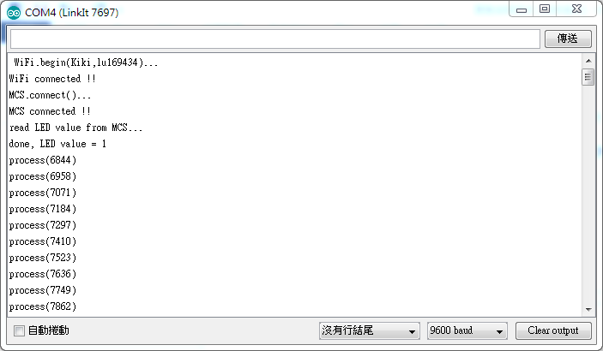

開 關
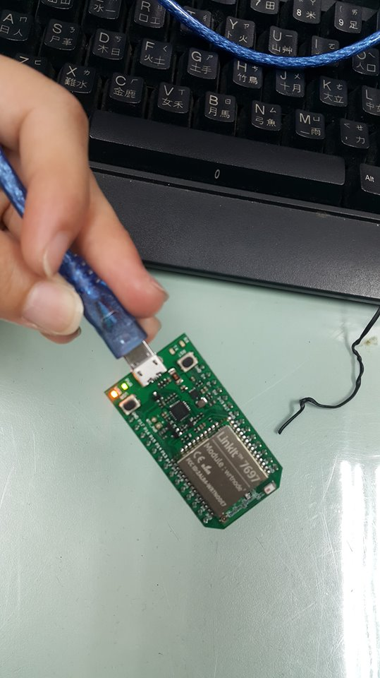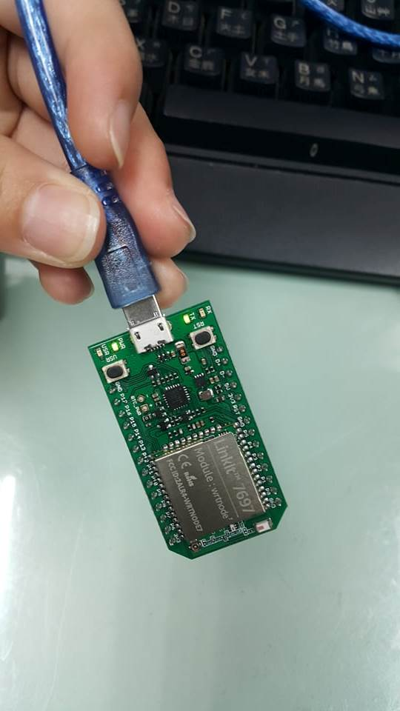

2.
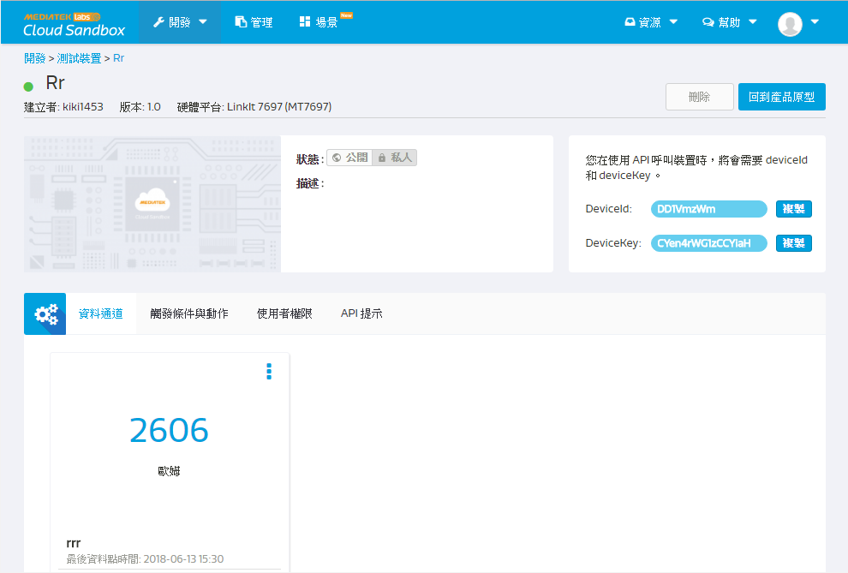
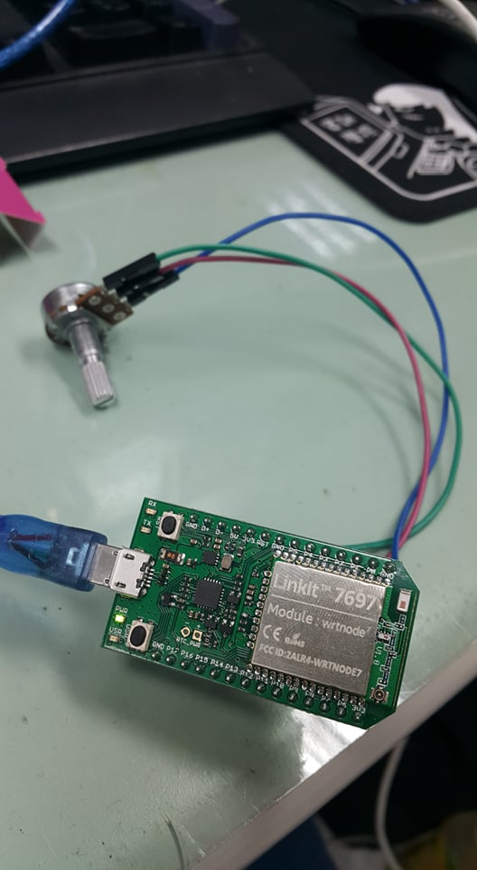
- 心得討論
這次的實驗是靠著手機跟程式碼和電腦一同進行，覺得很有趣，可以這麼簡單就用出基地台。

