实验二：HTML5 + CSS （三）
一、实验目的
1. 练习使用 background‐image 属性设置背景图像。
2. 练习使用 display 属性改变元素的显示方式，理解块元素和行内元素的显示方式。
3. 练习使用 column‐count 等属性对文字进行分栏。
4. 练习使用 text‐shadow 和 box‐shadow 属性为文字和对象添加阴影。
5. 练习使用 border‐collapse 等表格相关属性设置表格的外观。
6. 综合练习 CSS 页面布局。
二、实验内容
（此处写实验要求的代码，以及效果截图）
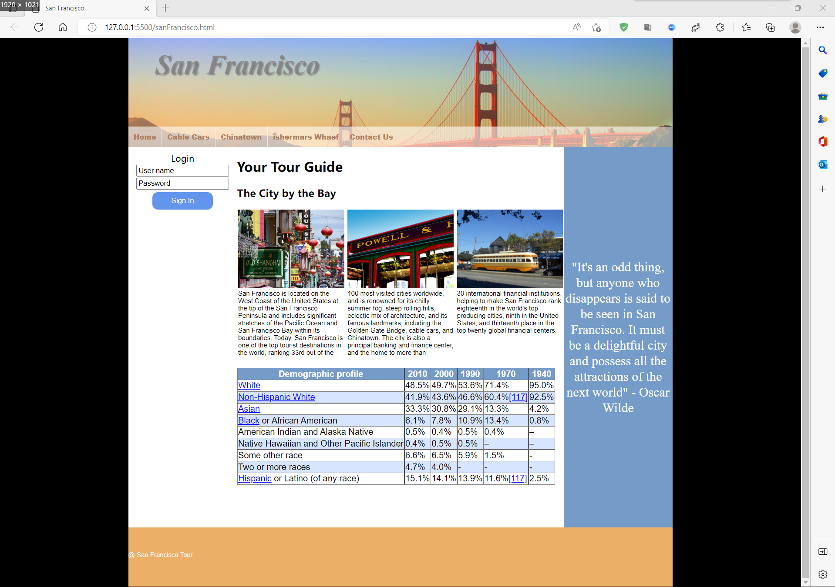
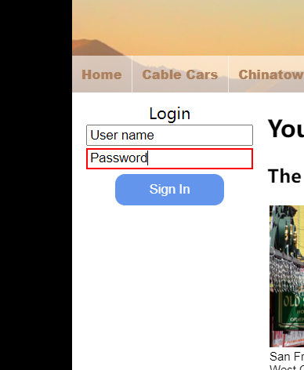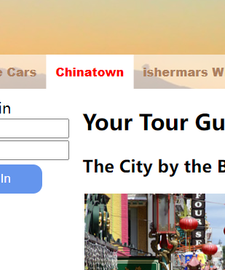
Html部分：
<body>
<div id="main">
<!-- 标题区 -->
<header class="v_header">
<img src="images/header_bg.jpg" alt="" width="1000px" height="200px">
<h1 id="text1">San Francisco</h1>
<div class="v_tile">
<span class="v_span">Home</span>
<span class="line"></span>
<span class="v_span" >Cable Cars</span>
<span class="line"></span>
<span class="v_span">Chinatown</span>
<span class="line"></span>
<span class="v_span">ishermars Whaef</span>
<span class="line"></span>
<span class="v_span">Contact Us</span>
</div>
</header>
<!-- 左侧菜单区 -->
<aside>
<div class="v_h">Login</div>
<div class="v_h1">
<input type="text" name="User name" size="20" value="User name">
<input type="text" name="Password" value="Password" size="20">
<button class="button">Sign In</button>
</div>
</aside>
<!-- 主内容区 -->
<article>
<h1>Your Tour Guide</h1>
<h3>The City by the Bay</h3>
<div>
<div class="v_photo1">
<img src="images/chinatown.jpg" alt="" width="195px" height="144.5px">
San Francisco is located on the West Coast of the United States at the tip of the San Francisco Peninsula and includes significant stretches of the Pacific Ocean and San Francisco Bay within its boundaries. Today, San Francisco is one of the top tourist destinations in the world, ranking 33rd out of the
</div>
<div class="v_photo2">
<img src="images/cablecar-closeup.jpg" alt=""width="195px" height="144.5">
100 most visited cities worldwide, and is renowned for its chilly summer fog, steep rolling hills, eclectic mix of architecture, and its famous landmarks, including the Golden Gate Bridge, cable cars, and Chinatown. The city is also a principal banking and finance center, and the home to more than
</div>
<div class="v_photo3">
<img src="images/market-street-car.jpg" alt="" width="195px" height="144.5">
30 international financial institutions, helping to make San Francisco rank eighteenth in the world's top producing cities, ninth in the United States, and thirteenth place in the top twenty global financial centers.
</div>
</div>
<br />
<br />
<br /><!-- 我就不信能空不出一行来 -->
<br />
<br />
<br />
<br />
<br />
<br />
<br />
<br />
<br />
<br />
<br />
<div>
<table border="1" style="border-collapse:collapse">
<tr class="table1">
<td>Demographic profile</td>
<td>2010</td>
<td>2000</td>
<td>1990</td>
<td>1970</td>
<td>1940</td>
</tr>
<tr>
<td class="table_2_1">White</td>
<td>48.5%</td>
<td>49.7%</td>
<td>53.6%</td>
<td>71.4%</td>
<td>95.0%</td>
</tr>
<tr class=" table_3">
<td class="table_2_1">Non-Hispanic White</td>
<td>41.9%</td>
<td>43.6%</td>
<td>46.6%</td>
<td>60.4%<span class="table_2_1">[117]</span></td>
<td>92.5%</td>
</tr>
<tr>
<td class="table_2_1">Asian</td>
<td>33.3%</td>
<td>30.8%</td>
<td>29.1%</td>
<td>13.3%</td>
<td>4.2%</td>
</tr>
<tr class=" table_3" >
<td><span class="table_2_1">Black</span> or African American</td>
<td>6.1%</td>
<td>7.8% </td>
<td>10.9% </td>
<td>13.4%</td>
<td>0.8%</td>
</tr>
<tr>
<td>American Indian and Alaska Native</td>
<td>0.5% </td>
<td>0.4%</td>
<td>0.5%</td>
<td>0.4%</td>
<td>–</td>
</tr>
<tr class=" table_3">
<td>Native Hawaiian and Other Pacific Islander</td>
<td>0.4%</td>
<td>0.5%</td>
<td>0.5%</td>
<td>–</td>
<td>–</td>
</tr>
<tr>
<td>Some other race</td>
<td>6.6%</td>
<td>6.5%</td>
<td>5.9%</td>
<td>1.5%</td>
<td>-</td>
</tr>
<tr class=" table_3">
<td>Two or more races</td>
<td>4.7%</td>
<td>4.0% </td>
<td>-</td>
<td>-</td>
<td>-</td>
</tr>
<tr>
<td><span class="table_2_1">Hispanic</span> or Latino (of any race)</td>
<td>15.1%</td>
<td>14.1%</td>
<td>13.9% </td>
<td>11.6%<span class="table_2_1">[117]</span></td>
<td>2.5%</td>
</tr>
</table>
</div>
</article>
<!-- 右侧菜单区 -->
<aside1>
<div class="middle">
"It's an odd thing, but anyone who disappears is said to be seen in San Francisco. It must be a delightful city and possess all the attractions of the next world" - Oscar Wilde
</div>
</aside1>
<!-- 页脚区 -->
<footer>
<div class="font_foot"><p>@ San Francisco Tour</p></div>
</footer>
</div>
</body>

Css部分：
body {
margin: 0px;
padding: 0px;
background-color: black;

}
#main {
margin: 0px auto; /*水平居中*/
width: 1000px;
}
.v_header {
height: 200px;
}
h1#text1 {
margin: 0px;
padding: 0px;
top: 20px;
position: absolute;
font-size: 50px;
font-family: 'Times New Roman', Times, serif;
font-style: italic;
font-weight: bolder;
text-shadow: 2px 2px 2px ;
color: rgba(128, 128, 128, 80%);
margin-left: 50px;
}
.v_tile {
margin: 0px;
padding: 0px;
top: 162px;
position: absolute;
height: 38px;
width: 1000px;
color: #ad805d;
background-color:rgba(255, 255, 255, 0.6);
}
.v_span {
display: block;
float: left;
height: 38px;
padding: 10px;
font-weight: 1000;
font-family: Arial, Helvetica, sans-serif;
font-size: small;
background-color:rgba(255, 255, 255, 0);
}
.v_span:hover {
border: none;
/* color: #fff; */
background-color:rgba(255, 255, 255, 1);
-webkit-transition: all .5s;
transition: all .5s;
color: red;
}
.line{
background-color:rgba(255, 255, 255, 0.6);
width:0.6px;/*设置宽高*/
height: 38px;
left:150px;
float:left;/*让此div与前面的并排显示*/
}

aside {
width: 20%;
float: left;
background-color: #fff;
margin-top: 0px;
height: 700px;
}
article {
width: 60%;
background-color: #fff;
float: left;
display: block;
height: 700px;
}
aside1 {
width: 20%;
background-color: #759bc9;
float: left;
font-family: 'Times New Roman', Times, serif;
height: 700px;
}
.middle {
position: relative;
line-height: 1.2em;
top: calc(50% - 1.2em * 5); /* 50% ‐ 行高 * 总行数/2 */
text-align: center;
color: #fff;
font-size: 24px;
}
.v_h {
text-align: center;
padding-top: 10px;
}
.v_h1 {
text-align: center;
}
/* //加上去除轮廓：outline */
input:focus
{
border: 2px solid red;
outline: none;/*去掉默认input焦点边框*/
}
.button {
background-color: cornflowerblue;
border: none;
color: #fff;
padding: 8px 35px;
margin: 5px;
border-radius: 10px;
}
.v_photo1 {
float: left;
margin-left: 2px;
width: 196px;
font-family: Arial, Helvetica, sans-serif;
font-size: 10px;
}
.v_photo2 {
float: left;
margin-left: 5px;
width: 196px;
font-family: Arial, Helvetica, sans-serif;
font-size: 10px;
}
.v_photo3 {
float: left;
width: 196px;
margin-left: 5px;
font-family: Arial, Helvetica, sans-serif;
font-size: 10px;
}
.float {
float: left;
}
table{
font-family: Arial, Helvetica, sans-serif;
}
.table1 {
color: #fff;
font-weight: bolder;
background-color: #759bc9;
text-align: center;
}
.table_2_1 {
color: blue;
text-decoration: underline;
}
.table_3 {
background-color:#d8e5ff;
}
footer {
width: 1000px;
height: 800px;
background-color: #ebaf67;
}
.font_foot {
height: 100px;
text-align: left;
color: #fff;
}
.font_foot p{
line-height: 100px;
font-size: 10px;
font-family: Arial, Helvetica, sans-serif;
}
三、实验总结
（主要写实验中遇到的问题及解决方案，还存在哪些问题以及自己对本次实验的体会）
不会解决浮动元素下的盒子与它下方的盒子的距离长度设置，通过写空行解决。有许多小知识点忘记需要及时百度或者查课本解决。

