代码：
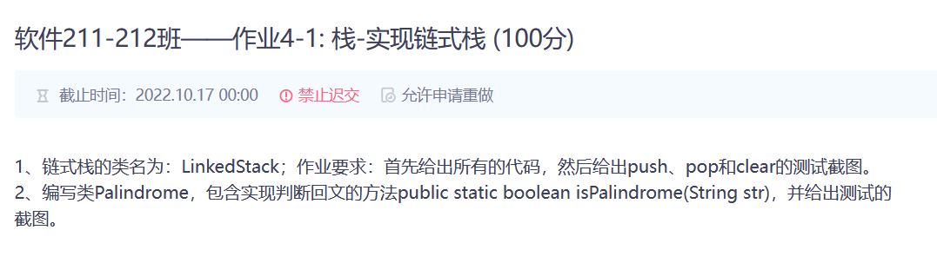
Linkedstack.java
package stack_01;
import java.util.Iterator;
public class LinkedStack<T> implements IStack<T>,Iterable<T> {
private Node<T> top;
private int size;
LinkedStack(){
top=null;
size=0;
}
//结点类描述
public class Node<T>{
public T data;
public Node<T> next;
public Node(T data,Node<T> next){
this.data=data;
this.next=next;
}
}
public int size(){
return size;
}
public void clear(){
top=null;
}
public boolean isEmpty(){
return top==null;
}
public void push(T x){
Node<T> p=new Node<>(x,null);
p.next=top;
top=p;
}
public Object pop(){
if (isEmpty()){
return null;
}
else {
Node p=top;
top=top.next;
return p.data;
}
}
public T peek(){
if (isEmpty()){
return null;
}
else {
return top.data;
}
}
//输出
public String toString() {
StringBuilder str = new StringBuilder();
for (T elem : this)// 利用了实现了的迭代器
str.append(elem + " ");
return str.toString();
}
public Iterator<T> iterator() {
return new Itr();
}
private class Itr implements Iterator<T> {
private Node<T> currentNode;
public Itr() {
currentNode = top;
}
//111
public boolean hasNext() {
return currentNode != null;
}
public T next() {
T data = currentNode.data;
currentNode = currentNode.next;
return data;
}
}
public static void main(String[] args) {
LinkedStack<Integer> sl = new LinkedStack<>();
sl.push(1);
sl.push(2);
sl.push(3);
sl.push(4);
sl.push(5);
sl.push(6);
System.out.println(sl);
System.out.println(sl.pop());
System.out.println(sl);
sl.clear();
if (sl.isEmpty())
System.out.println("empty");
else
System.out.println("Not empty");
sl.push(10);
sl.push(11);
sl.push(12);
sl.push(13);
sl.push(14);
sl.push(15);
System.out.println(sl);
}
}
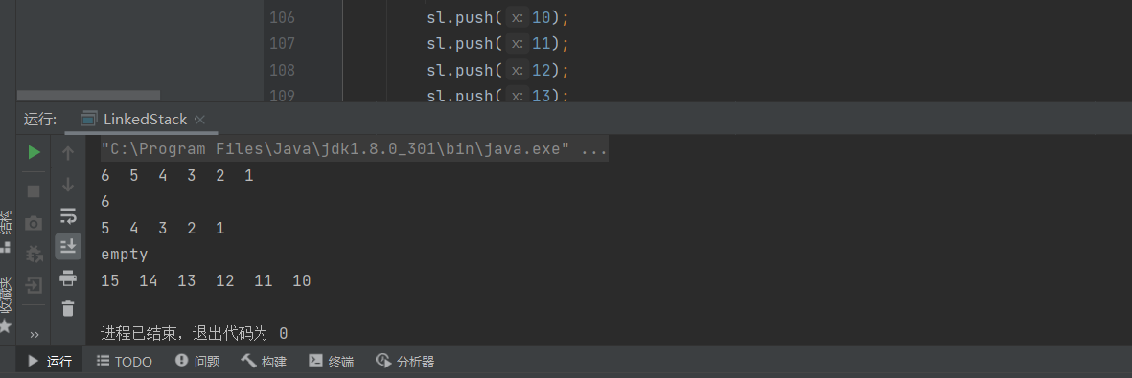
Palindrome.java
package stack_01;
public class Palindrome {
public static boolean isPalindrome(String str){
LinkedStack<Character> a=new LinkedStack<>();
for (int i=0;i<str.length();i++){
a.push(str.charAt(i));
}
for (int i=0;i<str.length();i++){
if (a.peek()==str.charAt(i) )
a.pop();
else
break;
}
if (a.isEmpty()){
return true;
}
else {
return false;
}
}
public static void main(String[] args) {
String str="abcdcbd";
boolean b=Palindrome.isPalindrome(str);
System.out.println(b);
String str1="abccba";
boolean c=Palindrome.isPalindrome(str1);
System.out.println(c);
}
}
