实验五 Activity的跳转及数据传递

实验目的及任务
1、 掌握Activity中页面跳转的方法
2、 掌握Activity中页面跳转的数据传递。

二、实验环境
- Jdk
- Android Studio
- Android SDK

实验步骤

实验结果展示：（图2位动态图，点击播放和暂停）
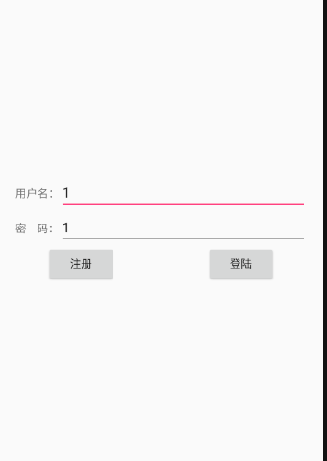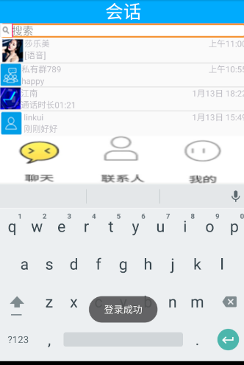
图1从登陆注册界面跳转到本界面

图2点击底部导航栏后的切换效果，聊天的listView后可以根据item（用户）的不同跳转到不同的会话
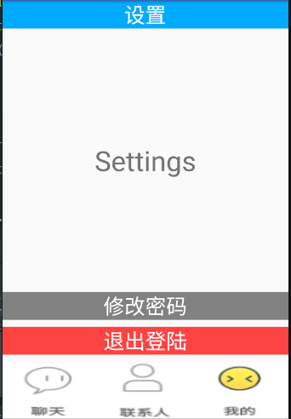
图3 我的（即设置）页面
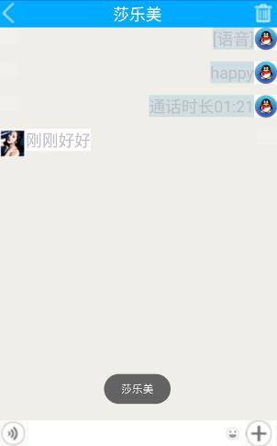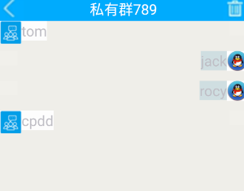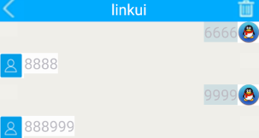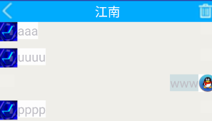
图4 不同用户对应的不同的会话

实现思路：根据不同的用户跳转到不同的会话
在【主界面】中载入【聊天】的碎片，单击【聊天】中的【listView】的某一行时，
/* 输入：监听每个listView的行
* 处理：每个行数所对应的选项 所包含的Talk对象的“对话对象的名字”“对话的细节” 绑定到bundle中
* 输出：带参传递给SessionActivity*/
数据的传递
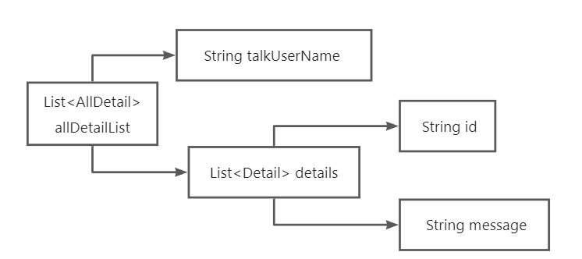

在【主界面】收到从【聊天】碎片传过来的数据后，带着刚刚传过来的数据，带参跳转到【对话】界面，并在对话界面进行展示
【talkFragment】数据的准备：
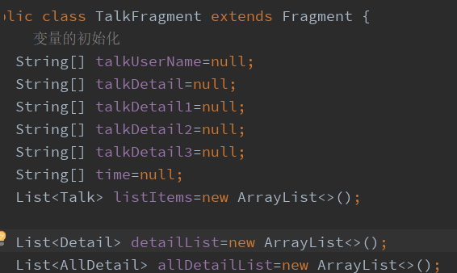将之前保存在文件中的数据赋予变量
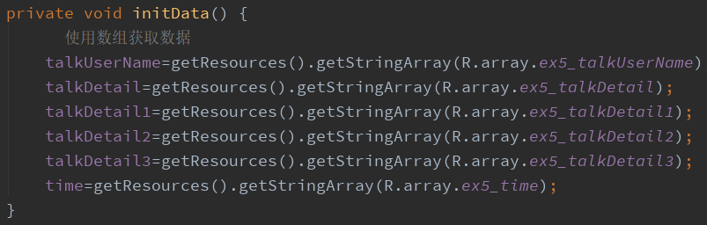
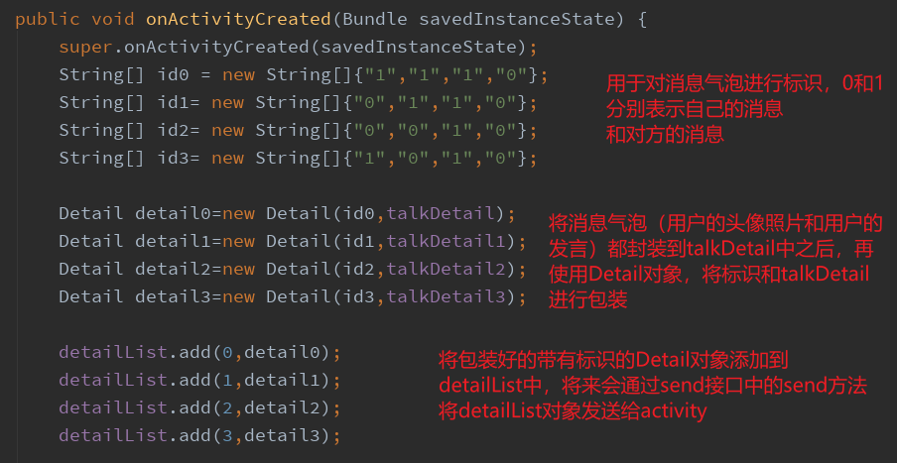
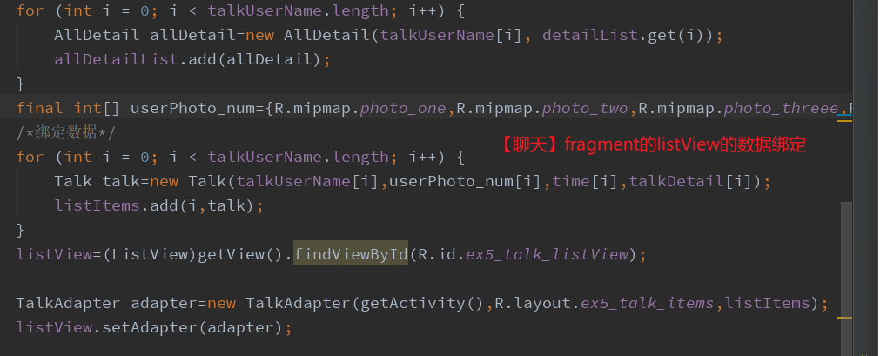
【talkFragment】数据的传递
给listView设置每一行选中后的监听事件。当listView的某一行被选中后，将该行中的
SendValue.send(talkUserName[position],userPhoto_num[position],time[position],talkDetail[position], allDetailList.get(position));
都传递给mainActivity，也就是间接的传递给【对话】的sesionActivity界面。
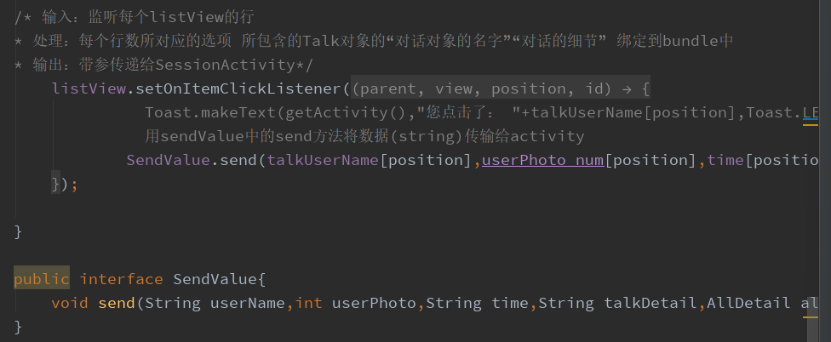
【mainActivity】数据的接受与带参跳转到sessionActivity
每当有fragment的参数传递过来（也就是talkFragemnt中的listView的列表项被点击后会触发此方法
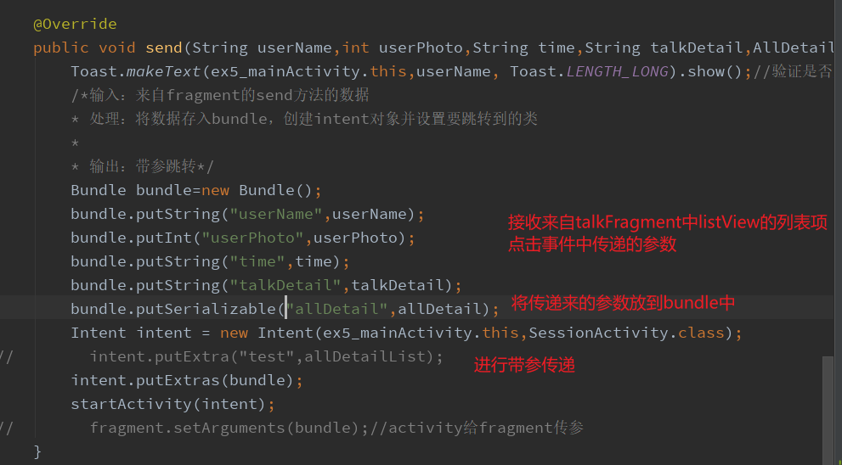
【sessionActivity】数据的绑定
将mainActivity从talkFragment接受到的数据在session里面再次接收。
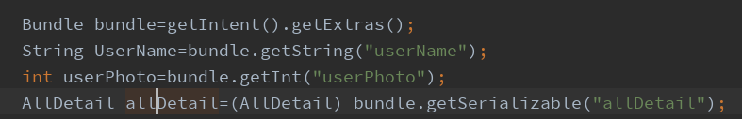
初始化两个List<~>来为绑定给listView做准备
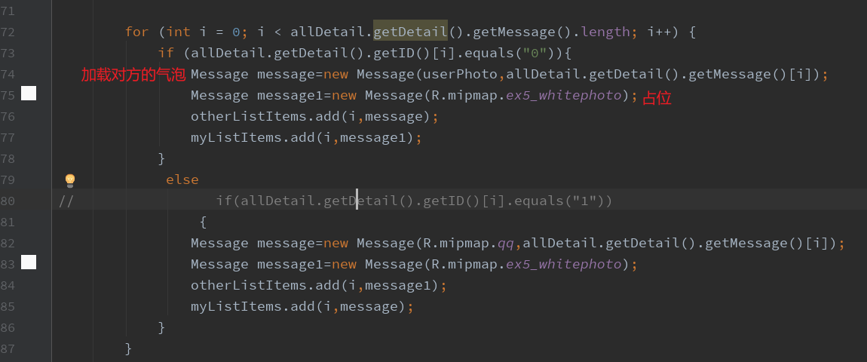
数据的绑定

实现思路：区别自己的消息和对方的消息
【对话】界面的布局文件中设置了两个listView，对方的消息会绑定到左边的listView，而自己的消息会绑定到右边的listView，
将对话详情存储为一个[{0,param},{1,param}]，用0和1来表示对方和自己。
参考添加实验三中添加评论的思路，0对应着对方的气泡，1代表着自己的气泡。这里的气泡指的是两种对象的形式。
（1）对数组进行fori遍历，i<数组大小；（2）在遍历中进行判断，如果是0，则new一个对方的气泡（可以使用白色的文字和白色的文字背景颜色；这样的话，如果符合情况，通过改变左边（对方）或者右边（自己）的消息框的文字颜色和文字背景颜色来让“消息”进行体现）并添加到list中；（3）如果是1，则new一个自己的气泡并添加到list中；将list绑定到适配器上，使用list.setAdapter()方法进行listView的显示。

//通过绑定的items样式不同来展现对话来自对方还是自己的；
/*在遍历赋值的过程中，如果赋值给与自己listView所对应的消息，
自己的消息就赋值属于自己消息的文字，如果碰到是对方的消息，则就setText=“”来进行站位。
这两个listView在赋值过程中对每个消息都要进行遍历，但是根据id的不同，赋值为空或者为detail*/

/*输入：聊天的item传给碎片的数据又传给主界面，主界面传给对话界面的数据，即从主界面拿到的数据
* 处理：将上面拿到的数据绑定到指定的控件*/
/*对于拿到的具体的对话，可以使用在java文件中创建控件的方式，
判断：如果传过来的数据是登陆的用户的就显示在右侧；如果是对话对象的就显示在左侧*/

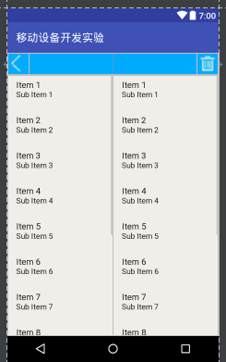

登陆后初始化和实现三个fragment的跳转
登陆后跳转，在loginActivity
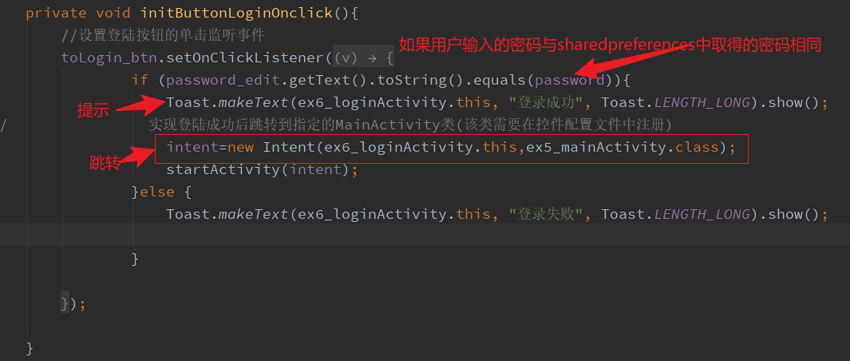
【聊天】碎片的初始化
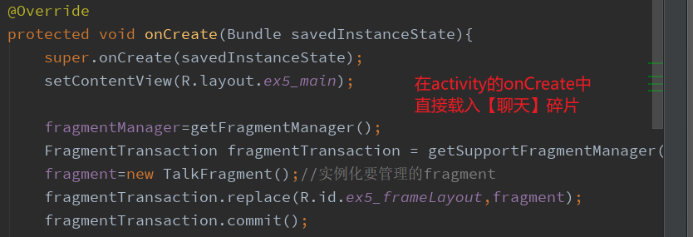
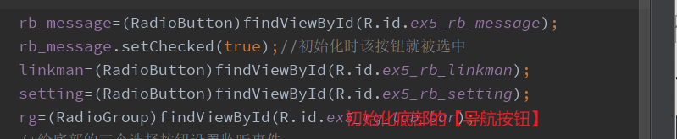
通过点击底部【导航按钮】进行调用fragmentTransaction.replace()方法进行相应的碎片布局的载入。
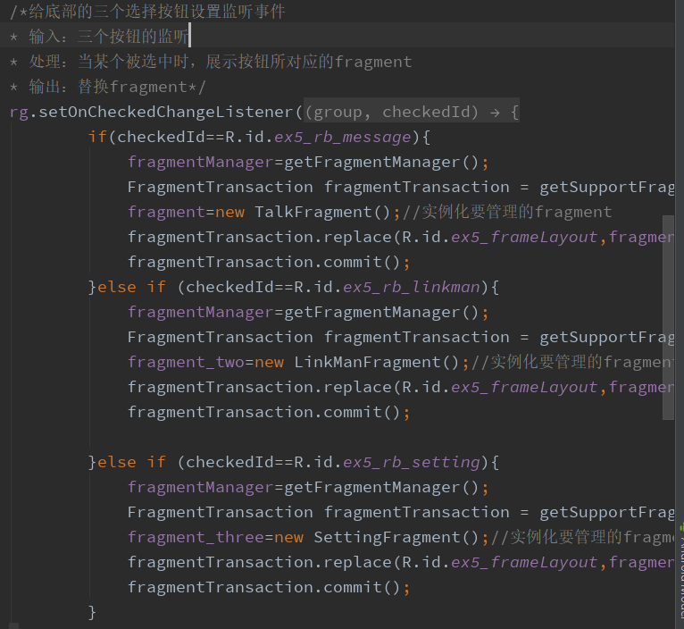

Java程序清单：
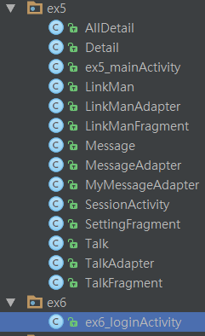
其中AllDetail和Detail（用于【聊天碎片】和【对话】绑定数据和【聊天&对话&主界面】之间传输数据），都实现了Serializable接口，参考博客：
(59条消息) Android activity之间传递自定义类型数据【Serializable实现】_zhouxiaoli521的博客-CSDN博客
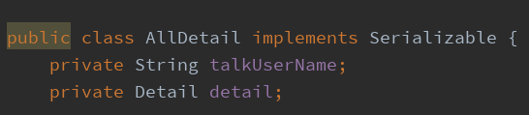
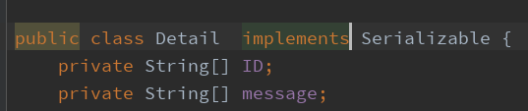
LinkMan（用于【联系人】页面中展示listView）、Message（用于【对话】中用户展示发送的消息的【消息气泡和用户头像】）、Talk（用于【聊天】fragment中的listView展示不同的用户有不同的聊天记录详情）均为实体类。
用于绑定给listView数据的适配器：LinkManAdapter、MyMessageAdapter、TalkFragment均继承了数组适配器。
Activity文件：ex5_mainActivity（【主界面】）、SeesionActivity（聊天列表中单击进入不同的用户所对应的对话的【对话】页面）、ex6_loginActivity（【登陆】界面，登陆后跳转到主界面）
Fragment文件：LinkManFragment（底部导航栏中的【联系人】）、SettingFragment（底部导航栏中的【我的】即【设置】）、TalkFragment（底部导航栏中的【聊天】）

布局文件清单：
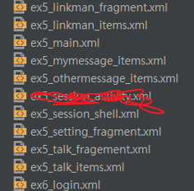
从上到下依次为：【联系人】页面、【联系人的listView中的items】样式、【主界面】、【对话】页面中来自【自己的消息的气泡】的样式、【对话】页面、【设置】页面、【聊天】页面、【聊天中的listView的item】、登陆界面。

数据文件：
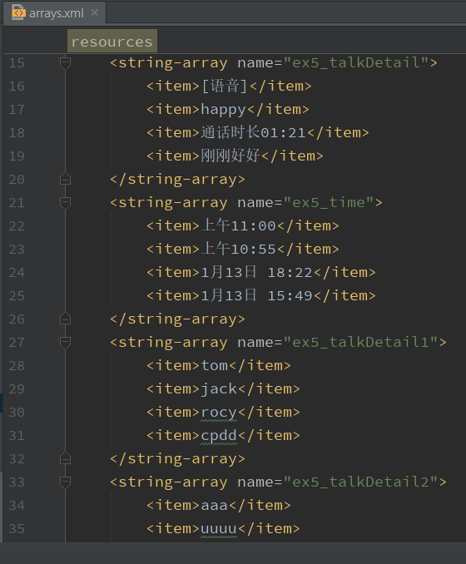
将不同的联系人所对应的对话详情存储到不同的字符串数组中。

四、实验报告
代码清单：

AllDetail.java
package com.xinguan.myapplication.ex5;
import java.io.Serializable;
/**
* Created by 27682 on 2022/10/29.
*/
public class AllDetail implements Serializable {
private String talkUserName;
private Detail detail;
public String getTalkUserName() {
return talkUserName;
}
public void setTalkUserName(String talkUserName) {
this.talkUserName = talkUserName;
}
public Detail getDetail() {
return detail;
}
public void setDetail(Detail detail) {
this.detail = detail;
}
public AllDetail(String talkUserName, Detail detail) {
this.talkUserName = talkUserName;
this.detail = detail;
}
@Override
public String toString() {
return "AllDetail{" +
"talkUserName='" + talkUserName + '\'' +
", detail=" + detail +
'}';
}
}

Detail.java
package com.xinguan.myapplication.ex5;
import java.io.Serializable;
import java.util.Arrays;
/**
* Created by 27682 on 2022/10/29.
*/
public class Detail implements Serializable {
private String[] ID;
private String[] message;
public String[] getID() {
return ID;
}
public void setID(String[] ID) {
this.ID = ID;
}
public String[] getMessage() {
return message;
}
public void setMessage(String[] message) {
this.message = message;
}
public Detail(String[] ID, String[] message) {
this.ID = ID;
this.message = message;
}
@Override
public String toString() {
return "Detail{" +
"ID=" + Arrays.toString(ID) +
", message=" + Arrays.toString(message) +
'}';
}
}

Ex5_mainActivity.java
package com.xinguan.myapplication.ex5;
import android.content.Intent;
import android.os.Bundle;
import android.support.v4.app.FragmentTransaction;
import android.support.v7.app.AppCompatActivity;
import android.widget.RadioButton;
import android.widget.RadioGroup;
import android.widget.Toast;
import com.xinguan.myapplication.R;
/**
* Created by 27682 on 2022/10/25.
*
*/
public class ex5_mainActivity extends AppCompatActivity implements TalkFragment.SendValue {
android.app.FragmentManager fragmentManager;
TalkFragment fragment;
LinkManFragment fragment_two;
SettingFragment fragment_three;
RadioButton rb_message;
RadioButton linkman;
RadioButton setting;
RadioGroup rg;
@Override
protected void onCreate(Bundle savedInstanceState){
super.onCreate(savedInstanceState);
setContentView(R.layout.ex5_main);
fragmentManager=getFragmentManager();
FragmentTransaction fragmentTransaction = getSupportFragmentManager().beginTransaction();
fragment=new TalkFragment();//实例化要管理的fragment
fragmentTransaction.replace(R.id.ex5_frameLayout,fragment);
fragmentTransaction.commit();
rb_message=(RadioButton)findViewById(R.id.ex5_rb_message);
rb_message.setChecked(true);//初始化时该按钮就被选中
linkman=(RadioButton)findViewById(R.id.ex5_rb_linkman);
setting=(RadioButton)findViewById(R.id.ex5_rb_setting);
rg=(RadioGroup)findViewById(R.id.ex5_rg_tab_bar);
/*给底部的三个选择按钮设置监听事件
* 输入：三个按钮的监听
* 处理：当某个被选中时，展示按钮所对应的fragment
* 输出：替换fragment*/
rg.setOnCheckedChangeListener(new RadioGroup.OnCheckedChangeListener(){
@Override
public void onCheckedChanged(RadioGroup group, int checkedId) {
if(checkedId==R.id.ex5_rb_message){
fragmentManager=getFragmentManager();
FragmentTransaction fragmentTransaction = getSupportFragmentManager().beginTransaction();
fragment=new TalkFragment();//实例化要管理的fragment
fragmentTransaction.replace(R.id.ex5_frameLayout,fragment);
fragmentTransaction.commit();
}else if (checkedId==R.id.ex5_rb_linkman){
fragmentManager=getFragmentManager();
FragmentTransaction fragmentTransaction = getSupportFragmentManager().beginTransaction();
fragment_two=new LinkManFragment();//实例化要管理的fragment
fragmentTransaction.replace(R.id.ex5_frameLayout,fragment_two);
fragmentTransaction.commit();
}else if (checkedId==R.id.ex5_rb_setting){
fragmentManager=getFragmentManager();
FragmentTransaction fragmentTransaction = getSupportFragmentManager().beginTransaction();
fragment_three=new SettingFragment();//实例化要管理的fragment
fragmentTransaction.replace(R.id.ex5_frameLayout,fragment_three);
fragmentTransaction.commit();
}
}
});
}
@Override
public void send(String userName,int userPhoto,String time,String talkDetail,AllDetail allDetail) {
Toast.makeText(ex5_mainActivity.this,userName, Toast.LENGTH_LONG).show();//验证是否成功接到TalkFragment的参数
/*输入：来自fragment的send方法的数据
* 处理：将数据存入bundle，创建intent对象并设置要跳转到的类
*
* 输出：带参跳转*/
Bundle bundle=new Bundle();
bundle.putString("userName",userName);
bundle.putInt("userPhoto",userPhoto);
bundle.putString("time",time);
bundle.putString("talkDetail",talkDetail);
bundle.putSerializable("allDetail",allDetail);
Intent intent = new Intent(ex5_mainActivity.this,SessionActivity.class);
// intent.putExtra("test",allDetailList);
intent.putExtras(bundle);
startActivity(intent);
// fragment.setArguments(bundle);//activity给fragment传参
}
}

LinkMan.java
package com.xinguan.myapplication.ex5;
/**
* Created by 27682 on 2022/10/28.
*/
public class LinkMan {
private String name_linkman;
private int photo_linkman;
public String getName_linkman() {
return name_linkman;
}
public void setName_linkman(String name_linkman) {
this.name_linkman = name_linkman;
}
public int getPhoto_linkman() {
return photo_linkman;
}
public void setPhoto_linkman(int photo_linkman) {
this.photo_linkman = photo_linkman;
}
public LinkMan(String name_linkman, int photo_linkman) {
this.name_linkman = name_linkman;
this.photo_linkman = photo_linkman;
}
}

LinkManAdapter.java
package com.xinguan.myapplication.ex5;
import android.content.Context;
import android.support.annotation.NonNull;
import android.support.annotation.Nullable;
import android.view.LayoutInflater;
import android.view.View;
import android.view.ViewGroup;
import android.widget.ArrayAdapter;
import android.widget.ImageView;
import android.widget.TextView;
import com.xinguan.myapplication.R;
import java.util.List;
/**
* Created by 27682 on 2022/10/28.
*/
public class LinkManAdapter extends ArrayAdapter<LinkMan>{
public LinkManAdapter(Context context, int resource, List<LinkMan> objects){
super(context, resource, objects);
}
public View getView(int positino, @Nullable View convertView, @NonNull ViewGroup parent){
LinkMan linkMan=getItem(positino);
View view= LayoutInflater.from(getContext()).inflate(R.layout.ex5_linkman_items,parent,false);
//初始化控件
ImageView photo=(ImageView)view.findViewById(R.id.ex5_linkman_photo);
TextView textView=(TextView)view.findViewById(R.id.ex5_linkman_username);
//给控件赋值
photo.setImageResource(linkMan.getPhoto_linkman());
textView.setText(linkMan.getName_linkman());
//将上面创建好的view对象返回
return view;
}
}

LinkManFragment.java
package com.xinguan.myapplication.ex5;
import android.content.Context;
import android.os.Bundle;
import android.support.annotation.Nullable;
import android.support.v4.app.Fragment;
import android.view.LayoutInflater;
import android.view.View;
import android.view.ViewGroup;
import android.widget.ListView;
import com.xinguan.myapplication.R;
import java.util.ArrayList;
import java.util.List;
/**
* Created by 27682 on 2022/10/28.
*/
public class LinkManFragment extends Fragment {
String[] talkUserName=null;
List<LinkMan> listItems=new ArrayList<>();
ListView listView=null;
@Override
public void onAttach(Context context){
super.onAttach(context);
initData();
}
private void initData() {
// 使用数组获取数据
talkUserName=getResources().getStringArray(R.array.ex5_talkUserName);
}
@Override
@Nullable
public View onCreateView(LayoutInflater inflater,
@Nullable ViewGroup container, @Nullable Bundle savedInstanceState) {
// TODO Auto-generated method stub
View view = inflater.inflate(R.layout.ex5_linkman_fragment, container,false);
return view;
}
public void onActivityCreated(Bundle savedInstanceState) {
super.onActivityCreated(savedInstanceState);
final int[] userPhoto_num={R.mipmap.photo_one,R.mipmap.photo_two,R.mipmap.photo_threee,R.mipmap.photo_four};
//
for (int i = 0; i < userPhoto_num.length; i++) {
LinkMan linkMan=new LinkMan(talkUserName[i],userPhoto_num[i]);
listItems.add(i,linkMan);
}
listView=(ListView)getView().findViewById(R.id.linkman_listView);
LinkManAdapter adapter=new LinkManAdapter(getActivity(),R.layout.ex5_linkman_items,listItems);
listView.setAdapter(adapter);
}
}

Message.java
package com.xinguan.myapplication.ex5;
/**
* Created by 27682 on 2022/10/29.
* 用于体现一个消息气泡
* 属性值：图片的id值（int），气泡内的消息文字（String）
*/
public class Message {
private int talkUserPhoto;
private String detail;
public Message(String detail) {
this.detail = detail;
}
@Override
public String toString() {
return "Message{" +
"talkUserPhoto=" + talkUserPhoto +
", detail='" + detail + '\'' +
'}';
}
public Message(int talkUserPhoto, String detail) {
this.talkUserPhoto = talkUserPhoto;
this.detail = detail;
}
public int getTalkUserPhoto() {
return talkUserPhoto;
}
public Message(int talkUserPhoto) {
this.talkUserPhoto = talkUserPhoto;
}
public void setTalkUserPhoto(int talkUserPhoto) {
this.talkUserPhoto = talkUserPhoto;
}
public Message() {
}
public String getDetail() {
return detail;
}
public void setDetail(String detail) {
this.detail = detail;
}
}

MessageAdapter.java
package com.xinguan.myapplication.ex5;
import android.content.Context;
import android.support.annotation.NonNull;
import android.support.annotation.Nullable;
import android.view.LayoutInflater;
import android.view.View;
import android.view.ViewGroup;
import android.widget.ArrayAdapter;
import android.widget.ImageView;
import android.widget.TextView;
import com.xinguan.myapplication.R;
import java.util.List;
/**
* Created by 27682 on 2022/10/29.
* 用于绑定对方的消息
*/
public class MessageAdapter extends ArrayAdapter<Message>{
public MessageAdapter(Context context, int resource, List<Message> objects){
super(context, resource, objects);
}
public View getView(int positino, @Nullable View convertView, @NonNull ViewGroup parent){
Message message=getItem(positino);
View view= LayoutInflater.from(getContext()).inflate(R.layout.ex5_othermessage_items,parent,false);
//初始化控件
TextView textView=(TextView)view.findViewById(R.id.ex5_linkman_username);
ImageView imageView=(ImageView)view.findViewById(R.id.ex5_linkman_photo);
//给控件赋值
textView.setText(message.getDetail());
imageView.setImageResource(message.getTalkUserPhoto());
//将上面创建好的view对象返回
return view;
}
}

MyMessageAdapter.java
package com.xinguan.myapplication.ex5;
import android.content.Context;
import android.support.annotation.NonNull;
import android.support.annotation.Nullable;
import android.view.LayoutInflater;
import android.view.View;
import android.view.ViewGroup;
import android.widget.ArrayAdapter;
import android.widget.ImageView;
import android.widget.TextView;
import com.xinguan.myapplication.R;
import java.util.List;
/**
* Created by 27682 on 2022/10/29.
* 用于绑定自己的消息
*/
public class MyMessageAdapter extends ArrayAdapter<Message> {
public MyMessageAdapter(Context context, int resource, List<Message> objects){
super(context, resource, objects);
}
public View getView(int positino, @Nullable View convertView, @NonNull ViewGroup parent){
Message message=getItem(positino);
View view= LayoutInflater.from(getContext()).inflate(R.layout.ex5_mymessage_items,parent,false);
//初始化控件
TextView textView=(TextView)view.findViewById(R.id.ex5_myMessageDetail);
ImageView imageView=(ImageView)view.findViewById(R.id.ex5_my_photo);
//给控件赋值
textView.setText(message.getDetail());
imageView.setImageResource(message.getTalkUserPhoto());
//将上面创建好的view对象返回
return view;
}
}

SessionActivity.java
package com.xinguan.myapplication.ex5;
import android.app.Activity;
import android.os.Bundle;
import android.support.annotation.Nullable;
import android.view.View;
import android.widget.ImageView;
import android.widget.ListView;
import android.widget.TextView;
import com.xinguan.myapplication.R;
import java.util.ArrayList;
import java.util.List;
/**
* Created by 27682 on 2022/10/25.
*/
public class SessionActivity extends Activity {
// String[] stalkUserName=null;
// String[] talkDetail=null;
// List<Talk> listItems=new ArrayList<>();
// List<Detail> detailList=new ArrayList<>();
// List<AllDetail> allDetailList=new ArrayList<>();
// TalkFragment.SendValue SendValue;
// ListView listView=null;
// 初始化变量
ListView otherListView=null;
ListView myListView=null;
TextView talkUserName;
android.app.FragmentManager fragmentManager;
ImageView imageView;
@Override
protected void onCreate(@Nullable Bundle savedInstanceState) {
super.onCreate(savedInstanceState);
setContentView(R.layout.ex5_session_shell);
myListView=(ListView)findViewById(R.id.ex5_myShell_listView);
otherListView=(ListView)findViewById(R.id.ex5_otherShell_listView);
// 点击位于activity左上角返回的图片，销毁当前activity
imageView=(ImageView)findViewById(R.id.ex5_backPhoto);
imageView.setOnClickListener(new View.OnClickListener() {
@Override
public void onClick(View view) {
SessionActivity.this.onBackPressed();
}
});
//通过绑定的items样式不同来展现对话来自对方还是自己的；
/*在遍历赋值的过程中，如果赋值给与自己listView所对应的消息，
自己的消息就赋值属于自己消息的文字，如果碰到是对方的消息，则就setText=“”来进行站位。
这两个listView在赋值过程中对每个消息都要进行遍历，但是根据id的不同，赋值为空或者为detail*/
talkUserName=(TextView)findViewById(R.id.ex5_sessionUserName);
fragmentManager=getFragmentManager();
/*输入：上面拿到的数据
* 处理：将上面拿到的数据绑定到指定的控件*/
/*对于拿到的具体的对话，可以使用在java文件中创建控件的方式，
判断：如果传过来的数据是登陆的用户的就显示在右侧；如果是对话对象的就显示在左侧*/
Bundle bundle=getIntent().getExtras();
String UserName=bundle.getString("userName");
int userPhoto=bundle.getInt("userPhoto");
AllDetail allDetail=(AllDetail) bundle.getSerializable("allDetail");
// System.out.println("测试测试"+allDetail);
talkUserName.setText(UserName);
List<Message> myListItems=new ArrayList<>();
List<Message> otherListItems=new ArrayList<>();
for (int i = 0; i < allDetail.getDetail().getMessage().length; i++) {
if (allDetail.getDetail().getID()[i].equals("0")){
Message message=new Message(userPhoto,allDetail.getDetail().getMessage()[i]);
Message message1=new Message(R.mipmap.ex5_whitephoto);
otherListItems.add(i,message);
myListItems.add(i,message1);
}
else
// if(allDetail.getDetail().getID()[i].equals("1"))
{
Message message=new Message(R.mipmap.qq,allDetail.getDetail().getMessage()[i]);
Message message1=new Message(R.mipmap.ex5_whitephoto);
otherListItems.add(i,message1);
myListItems.add(i,message);
}
}
MessageAdapter messageAdapter=new MessageAdapter(SessionActivity.this,R.layout.ex5_othermessage_items,otherListItems);
MyMessageAdapter myMessageAdapter=new MyMessageAdapter(SessionActivity.this,R.layout.ex5_mymessage_items,myListItems);
myListView.setAdapter(myMessageAdapter);
otherListView.setAdapter(messageAdapter);
}
}

SettingFragment.java
package com.xinguan.myapplication.ex5;
import android.content.Context;
import android.content.Intent;
import android.os.Bundle;
import android.support.annotation.Nullable;
import android.support.v4.app.Fragment;
import android.view.LayoutInflater;
import android.view.View;
import android.view.ViewGroup;
import android.widget.TextView;
import android.widget.Toast;
import com.xinguan.myapplication.R;
import com.xinguan.myapplication.ex2.ChangePasswordActivity;
import com.xinguan.myapplication.ex6.ex6_loginActivity;
/**
* Created by 27682 on 2022/10/28.
*/
public class SettingFragment extends Fragment {
TextView loginClear=null;
TextView changePassword=null;
@Override
public void onAttach(Context context){
super.onAttach(context);
}
@Override
@Nullable
public View onCreateView(LayoutInflater inflater,
@Nullable ViewGroup container, @Nullable Bundle savedInstanceState) {
// TODO Auto-generated method stub
View view = inflater.inflate(R.layout.ex5_setting_fragment, container,false);
return view;
}
public void onActivityCreated(Bundle savedInstanceState) {
super.onActivityCreated(savedInstanceState);
loginClear=(TextView)getView().findViewById(R.id.ex6_loginClear);
changePassword=(TextView)getView().findViewById(R.id.ex6_changePassword);
// 用跳转到登陆界面来实现 退出登陆
loginClear.setOnClickListener(new TextView.OnClickListener(){
@Override
public void onClick(View view) {
Intent intent = new Intent(getActivity(), ex6_loginActivity.class);
startActivity(intent);
Toast.makeText(getActivity(),"退出成功",Toast.LENGTH_LONG).show();
}
});
// 跳转到修改密码的界面
changePassword.setOnClickListener(new TextView.OnClickListener(){
@Override
public void onClick(View view) {
Intent intent = new Intent(getActivity(), ChangePasswordActivity.class);
startActivity(intent);
}
}
);
}
}

Talk.java
package com.xinguan.myapplication.ex5;
/**
* Created by 27682 on 2022/10/25.
*/
public class Talk {
private String talkUserName;
private int talkUserPhoto;
private String talkTime;
private String talkDetail;
@Override
public String toString() {
return "Talk{" +
"talkUserName='" + talkUserName + '\'' +
", talkUserPhoto=" + talkUserPhoto +
", talkTime='" + talkTime + '\'' +
", talkDetail='" + talkDetail + '\'' +
'}';
}
public Talk(String talkUserName, int talkUserPhoto, String talkTime, String talkDetail) {
this.talkUserName = talkUserName;
this.talkUserPhoto = talkUserPhoto;
this.talkTime = talkTime;
this.talkDetail = talkDetail;
}
public String getTalkUserName() {
return talkUserName;
}
public void setTalkUserName(String talkUserName) {
this.talkUserName = talkUserName;
}
public int getTalkUserPhoto() {
return talkUserPhoto;
}
public void setTalkUserPhoto(int talkUserPhoto) {
this.talkUserPhoto = talkUserPhoto;
}
public String getTalkTime() {
return talkTime;
}
public void setTalkTime(String talkTime) {
this.talkTime = talkTime;
}
public String getTalkDetail() {
return talkDetail;
}
public void setTalkDetail(String talkDetail) {
this.talkDetail = talkDetail;
}
}

TalkAdapter.java
package com.xinguan.myapplication.ex5;
import android.content.Context;
import android.support.annotation.NonNull;
import android.support.annotation.Nullable;
import android.view.LayoutInflater;
import android.view.View;
import android.view.ViewGroup;
import android.widget.ArrayAdapter;
import android.widget.ImageView;
import android.widget.TextView;
import com.xinguan.myapplication.R;
import java.util.List;
/**
* Created by 27682 on 2022/10/25.
*/
public class TalkAdapter extends ArrayAdapter<Talk> {
public TalkAdapter(Context context, int resource, List<Talk> objects){
super(context, resource, objects);
}
@NonNull
@Override
public View getView(int position, @Nullable View convertView, @NonNull ViewGroup parent) {
Talk talk=getItem(position);
View view= LayoutInflater.from(getContext()).inflate(R.layout.ex5_talk_items,parent,false);
// 初始化控件
ImageView userPhoto=(ImageView)view.findViewById(R.id.ex5_talkUserPhoto);
TextView talkUserName=(TextView)view.findViewById(R.id.ex5_talkUserName);
TextView talkTime=(TextView)view.findViewById(R.id.ex5_talkTime);
TextView talkDetail=(TextView)view.findViewById(R.id.ex5_talkDetail);
// 给控件的一些属性赋值
userPhoto.setImageResource(talk.getTalkUserPhoto());
talkUserName.setText(talk.getTalkUserName());
talkTime.setText(talk.getTalkTime());
talkDetail.setText(talk.getTalkDetail());
return view;
}
}

TalkFragment.java
package com.xinguan.myapplication.ex6;
import android.content.Context;
import android.content.Intent;
import android.content.SharedPreferences;
import android.os.Bundle;
import android.support.v7.app.AppCompatActivity;
import android.view.View;
import android.widget.Button;
import android.widget.EditText;
import android.widget.Toast;
import com.xinguan.myapplication.R;
import com.xinguan.myapplication.ex2.RegisterActivity;
import com.xinguan.myapplication.ex5.ex5_mainActivity;
/**
* Created by 27682 on 2022/10/30.
*/
public class ex6_loginActivity extends AppCompatActivity{
private Intent intent=null;//用于控件之间的跳转
private Button toLogin_btn;
private Button toRegister_btn;
private EditText username_edit;
private EditText password_edit;
String password;
//声明Sharedpreferenced对象
private SharedPreferences sp ;
@Override
protected void onCreate(Bundle savedInstanceState){
super.onCreate(savedInstanceState);
setContentView(R.layout.ex6_login);
initView();//控件初始化
initButtonLoginOnclick();//登录按钮监听
initButtonRegisterOnclick();//注册按钮监听
sp = getSharedPreferences("User", Context.MODE_PRIVATE);
if(sp.getString("phoneNum","").equals("")){
}else {
String phoneNum=sp.getString("phoneNum","");
password=sp.getString("password","");
username_edit.setText(phoneNum);
password_edit.setText(password);
}
}
private void initView() {
toLogin_btn=(Button)findViewById(R.id.ex6_to_main);
toRegister_btn=(Button)findViewById(R.id.ex6_to_register);
username_edit=(EditText)findViewById(R.id.ex6_username);
password_edit=(EditText)findViewById(R.id.ex6_password);
}
private void initButtonLoginOnclick(){
//设置登陆按钮的单击监听事件
toLogin_btn.setOnClickListener(new View.OnClickListener(){
@Override
public void onClick(View v) {
if (password_edit.getText().toString().equals(password)){
Toast.makeText(ex6_loginActivity.this, "登录成功", Toast.LENGTH_LONG).show();
// 实现登陆成功后跳转到指定的MainActivity类(该类需要在控件配置文件中注册)
intent=new Intent(ex6_loginActivity.this,ex5_mainActivity.class);
startActivity(intent);
}else {
Toast.makeText(ex6_loginActivity.this, "登录失败", Toast.LENGTH_LONG).show();
}
}
});
}
private void initButtonRegisterOnclick(){
//设置注册按钮的单击监听事件
toRegister_btn.setOnClickListener(new View.OnClickListener(){
@Override
public void onClick(View v) {
Toast.makeText(ex6_loginActivity.this, "开始注册", Toast.LENGTH_LONG).show();
// 跳转到指定的RegisterActivity类(该类需要在控件配置文件中注册)
intent=new Intent(ex6_loginActivity.this,RegisterActivity.class);
startActivity(intent);
}
});
}
}

Ex6_loginActivity
package com.xinguan.myapplication.ex6;
import android.content.Context;
import android.content.Intent;
import android.content.SharedPreferences;
import android.os.Bundle;
import android.support.v7.app.AppCompatActivity;
import android.view.View;
import android.widget.Button;
import android.widget.EditText;
import android.widget.Toast;
import com.xinguan.myapplication.R;
import com.xinguan.myapplication.ex2.RegisterActivity;
import com.xinguan.myapplication.ex5.ex5_mainActivity;
/**
* Created by 27682 on 2022/10/30.
*/
public class ex6_loginActivity extends AppCompatActivity{
private Intent intent=null;//用于控件之间的跳转
private Button toLogin_btn;
private Button toRegister_btn;
private EditText username_edit;
private EditText password_edit;
String password;
//声明Sharedpreferenced对象
private SharedPreferences sp ;
@Override
protected void onCreate(Bundle savedInstanceState){
super.onCreate(savedInstanceState);
setContentView(R.layout.ex6_login);
initView();//控件初始化
initButtonLoginOnclick();//登录按钮监听
initButtonRegisterOnclick();//注册按钮监听
sp = getSharedPreferences("User", Context.MODE_PRIVATE);
if(sp.getString("phoneNum","").equals("")){
}else {
String phoneNum=sp.getString("phoneNum","");
password=sp.getString("password","");
username_edit.setText(phoneNum);
password_edit.setText(password);
}
}
private void initView() {
toLogin_btn=(Button)findViewById(R.id.ex6_to_main);
toRegister_btn=(Button)findViewById(R.id.ex6_to_register);
username_edit=(EditText)findViewById(R.id.ex6_username);
password_edit=(EditText)findViewById(R.id.ex6_password);
}
private void initButtonLoginOnclick(){
//设置登陆按钮的单击监听事件
toLogin_btn.setOnClickListener(new View.OnClickListener(){
@Override
public void onClick(View v) {
if (password_edit.getText().toString().equals(password)){
Toast.makeText(ex6_loginActivity.this, "登录成功", Toast.LENGTH_LONG).show();
// 实现登陆成功后跳转到指定的MainActivity类(该类需要在控件配置文件中注册)
intent=new Intent(ex6_loginActivity.this,ex5_mainActivity.class);
startActivity(intent);
}else {
Toast.makeText(ex6_loginActivity.this, "登录失败", Toast.LENGTH_LONG).show();
}
}
});
}
private void initButtonRegisterOnclick(){
//设置注册按钮的单击监听事件
toRegister_btn.setOnClickListener(new View.OnClickListener(){
@Override
public void onClick(View v) {
Toast.makeText(ex6_loginActivity.this, "开始注册", Toast.LENGTH_LONG).show();
// 跳转到指定的RegisterActivity类(该类需要在控件配置文件中注册)
intent=new Intent(ex6_loginActivity.this,RegisterActivity.class);
startActivity(intent);
}
});
}
}

Ex5_linkman_fragment.xml
<?xml version="1.0" encoding="utf-8"?>
<LinearLayout xmlns:android="http://schemas.android.com/apk/res/android"
android:orientation="vertical" android:layout_width="match_parent"
android:layout_height="match_parent">
<LinearLayout
android:layout_width="match_parent"
android:layout_height="wrap_content"
android:orientation="horizontal"
android:background="#00abfd">
<RelativeLayout
android:layout_width="match_parent"
android:layout_height="match_parent"
>
<TextView style="@style/textview3"
android:textColor="@color/bg_white"
android:background="#00abfd"
android:gravity="center"
android:textSize="30dp"
android:text="通讯录"
android:layout_centerInParent="true"
/>
<TextView style="@style/textview3"
android:text="+"
android:textSize="30dp"
android:background="#00abfd"
android:gravity="right"
android:textColor="@color/bg_white"
android:layout_alignParentRight="true"
android:layout_centerVertical="true"
/>
</RelativeLayout>
</LinearLayout>
<EditText
android:layout_width="match_parent"
android:layout_height="wrap_content"
android:drawableLeft="@mipmap/search"
android:hint="搜索"/>
<ListView
android:id="@+id/linkman_listView"
android:layout_width="match_parent"
android:layout_height="wrap_content">
</ListView>
</LinearLayout>

Ex5_linkman_fragment.xml
<?xml version="1.0" encoding="utf-8"?>
<LinearLayout xmlns:android="http://schemas.android.com/apk/res/android"
android:orientation="vertical" android:layout_width="match_parent"
android:layout_height="match_parent"
android:descendantFocusability="blocksDescendants"
>
<!--左右先分栏，左边是一个显示头像的IamgeView；右边是两行文字
右边第一行再分两栏，为左对齐的用户名和右对齐的时间，第二行为会话的详情-->
<LinearLayout
android:layout_width="match_parent"
android:layout_height="wrap_content"
android:orientation="horizontal">
<!--联系人的头像照片-->
<ImageView
android:id="@+id/ex5_linkman_photo"
android:layout_width="wrap_content"
android:layout_height="wrap_content" />
<!--联系人的名字-->
<TextView
android:id="@+id/ex5_linkman_username"
android:layout_width="wrap_content"
android:layout_height="wrap_content"
android:text=""
android:textColor="#bfbec5"
android:textSize="20dp"
/>
</LinearLayout>
</LinearLayout>

Ex5_main.xml
<?xml version="1.0" encoding="utf-8"?>
<RelativeLayout
xmlns:android="http://schemas.android.com/apk/res/android"
xmlns:tools="http://schemas.android.com/tools"
android:layout_width="match_parent"
android:layout_height="match_parent"
android:background="@color/bg_gray"
>
<!-- 下面的RadioGroup是导航栏，有3个选项，分别用四个RadioButton实现，其位置为贴近容器的底部 -->
<RadioGroup
android:id="@+id/ex5_rg_tab_bar"
android:layout_width="match_parent"
android:layout_height="80dp"
android:layout_alignParentBottom="true"
android:background="#2c2e30"
android:orientation="horizontal" >
<RadioButton
android:id="@+id/ex5_rb_message"
style="@style/ex5_tab_menu_item"
android:background="@drawable/ex5_talk_selector"
android:textColor="@color/bg_white"/>
<RadioButton
android:id="@+id/ex5_rb_linkman"
style="@style/ex2_tab_menu_item"
android:background="@drawable/ex5_lianxiren_selector"
android:textColor="@color/bg_white"/>
<RadioButton
android:id="@+id/ex5_rb_setting"
style="@style/ex2_tab_menu_item"
android:background="@drawable/ex5_wode_selector"
android:textColor="@color/bg_white" />
</RadioGroup>
<!-- android:background="@color/div_white" -->
<!-- 下面的FrameLayout是容器，用于盛放Fragment，其位置为中间的工作区，即蓝线的上面，标题信息的下面 -->
<FrameLayout
android:id="@+id/ex5_frameLayout"
android:layout_width="match_parent"
android:layout_height="match_parent"
android:layout_below="@+id/ly_top_bar"
android:layout_alignParentLeft="true"
android:layout_alignParentStart="true">
</FrameLayout>
</RelativeLayout>

Ex5_mymessage_items.xml
<?xml version="1.0" encoding="utf-8"?>
<LinearLayout xmlns:android="http://schemas.android.com/apk/res/android"
android:orientation="vertical" android:layout_width="match_parent"
android:layout_height="match_parent"
android:descendantFocusability="blocksDescendants"
>
<!--左右先分栏，左边是一个显示头像的IamgeView；右边是两行文字
右边第一行再分两栏，为左对齐的用户名和右对齐的时间，第二行为会话的详情-->
<RelativeLayout
android:layout_width="match_parent"
android:layout_height="50dp"
android:orientation="horizontal"
>
<!--联系人的头像照片-->
<ImageView
android:layout_alignParentRight="true"
android:id="@+id/ex5_my_photo"
android:layout_width="wrap_content"
android:layout_height="wrap_content" />
<!--联系人的名字-->
<TextView
android:layout_toLeftOf="@+id/ex5_my_photo"
android:id="@+id/ex5_myMessageDetail"
android:layout_width="wrap_content"
android:layout_height="wrap_content"
android:text="1111111"
android:textColor="#bfbec5"
android:textSize="24dp"
android:background="#cfdee1"
android:layout_gravity="bottom"
/>
</RelativeLayout>
</LinearLayout>

Ex5_othermessage_items.xml
<?xml version="1.0" encoding="utf-8"?>
<LinearLayout xmlns:android="http://schemas.android.com/apk/res/android"
android:orientation="vertical" android:layout_width="match_parent"
android:layout_height="match_parent"
android:descendantFocusability="blocksDescendants"
>
<!--左右先分栏，左边是一个显示头像的IamgeView；右边是两行文字
右边第一行再分两栏，为左对齐的用户名和右对齐的时间，第二行为会话的详情-->
<LinearLayout
android:layout_width="match_parent"
android:layout_height="50dp"
android:orientation="horizontal">
<!--联系人的头像照片-->
<ImageView
android:id="@+id/ex5_linkman_photo"
android:layout_width="wrap_content"
android:layout_height="wrap_content"
/>
<!--联系人的名字-->
<TextView
android:id="@+id/ex5_linkman_username"
android:layout_width="wrap_content"
android:layout_height="wrap_content"
android:text="11111"
android:textColor="#bfbec5"
android:textSize="24dp"
android:background="#fdfdfd"
/>
</LinearLayout>
</LinearLayout>

Ex5_session_shell.xml
<?xml version="1.0" encoding="utf-8"?>
<LinearLayout xmlns:android="http://schemas.android.com/apk/res/android"
android:orientation="vertical" android:layout_width="match_parent"
android:layout_height="match_parent"
android:background="#efeee9">
<RelativeLayout xmlns:android="http://schemas.android.com/apk/res/android"
android:layout_width="match_parent"
android:layout_height="wrap_content"
>
<!--会话的头部显示talkUserName-->
<TextView
android:id="@+id/ex5_sessionUserName"
android:layout_width="match_parent"
android:layout_height="40dp"
android:textSize="24dp"
android:gravity="center"
android:text=""
android:background="#00abfd"
android:textColor="@color/bg_white"
android:layout_centerInParent="true"
/>
<ImageView
android:layout_width="40dp"
android:layout_height="40dp"
android:src="@mipmap/ex5_shanchu"
android:layout_alignParentRight="true"/>
<ImageView
android:id="@+id/ex5_backPhoto"
android:layout_width="40dp"
android:layout_height="40dp"
android:src="@mipmap/ex5_back"
android:layout_alignParentLeft="true"/>
</RelativeLayout>
<LinearLayout
android:layout_width="match_parent"
android:layout_height="wrap_content"
android:orientation="horizontal"
>
<!--对话的listView-->
<!--对方的消息-->
<ListView
android:id="@+id/ex5_otherShell_listView"
android:layout_width="wrap_content"
android:layout_height="wrap_content"
android:divider="@null"
android:layout_weight="1">
</ListView>
<!--自己的消息-->
<ListView
android:id="@+id/ex5_myShell_listView"
android:layout_width="wrap_content"
android:layout_height="wrap_content"
android:divider="@null"
android:layout_weight="1">
</ListView>
</LinearLayout>
<!--底部输入自左向右：图片，输入框，图片，图片-->
<LinearLayout
android:layout_width="match_parent"
android:gravity="bottom"
android:orientation="horizontal"
android:layout_height="0dp"
android:layout_weight="1"
>
<ImageView
android:layout_width="wrap_content"
android:layout_height="40dp"
android:src="@mipmap/sound"
android:layout_weight="0.08"
android:background="@color/bg_white"/>
<EditText
android:layout_width="wrap_content"
android:layout_height="40dp"
android:layout_weight="1"
android:drawableRight="@mipmap/smile"
android:background="@color/bg_white"/>
<ImageView
android:id="@+id/imageView3"
android:layout_width="wrap_content"
android:layout_height="40dp"
android:layout_weight="0.10"
android:gravity="right"
android:src="@mipmap/circle_sum"
android:background="@color/bg_white"/>
</LinearLayout>
</LinearLayout>

Ex5_setting_fragment.xml
<?xml version="1.0" encoding="utf-8"?>
<LinearLayout xmlns:android="http://schemas.android.com/apk/res/android"
android:orientation="vertical" android:layout_width="match_parent"
android:layout_height="match_parent">
<LinearLayout
android:layout_width="match_parent"
android:layout_height="match_parent"
android:orientation="vertical">
<TextView
android:layout_width="match_parent"
android:layout_height="wrap_content"
android:textColor="@color/bg_white"
android:background="#00abfd"
android:gravity="center"
android:textSize="30dp"
android:text="设置"
/>
<TextView
android:layout_width="match_parent"
android:layout_height="380dp"
android:text="Settings"
android:textSize="40dp"
android:gravity="center_vertical|center"
/>
<TextView
android:id="@+id/ex6_changePassword"
android:layout_width="match_parent"
android:layout_height="wrap_content"
android:textColor="#fff"
android:background="#818181"
android:gravity="center"
android:layout_gravity="bottom"
android:textSize="30dp"
android:text="修改密码"
android:layout_marginBottom="10dp"
/>
<TextView
android:id="@+id/ex6_loginClear"
android:layout_width="match_parent"
android:layout_height="wrap_content"
android:textColor="@color/bg_white"
android:background="#fc4442"
android:gravity="center"
android:layout_gravity="bottom"
android:textSize="30dp"
android:text="退出登陆"
/>
</LinearLayout>
<LinearLayout
android:layout_width="match_parent"
android:layout_height="match_parent"
android:orientation="horizontal">
</LinearLayout>
</LinearLayout>

Ex5_talk_fragment.xml
<?xml version="1.0" encoding="utf-8"?>
<LinearLayout xmlns:android="http://schemas.android.com/apk/res/android"
android:orientation="vertical" android:layout_width="match_parent"
android:layout_height="match_parent">
<TextView
android:layout_width="match_parent"
android:layout_height="wrap_content"
android:textColor="@color/bg_white"
android:background="#00abfd"
android:gravity="center"
android:textSize="30dp"
android:text="会话"
/>
<EditText
android:layout_width="match_parent"
android:layout_height="wrap_content"
android:drawableLeft="@mipmap/search"
android:background="@drawable/ex4_editview_selector"
android:hint="搜索"/>
<ListView
android:id="@+id/ex5_talk_listView"
android:layout_width="match_parent"
android:layout_height="wrap_content"></ListView>
</LinearLayout>

Ex5_talk_items.xml
<?xml version="1.0" encoding="utf-8"?>
<LinearLayout xmlns:android="http://schemas.android.com/apk/res/android"
android:orientation="vertical" android:layout_width="match_parent"
android:layout_height="match_parent"
android:descendantFocusability="blocksDescendants"
>
<!--左右先分栏，左边是一个显示头像的IamgeView；右边是两行文字
右边第一行再分两栏，为左对齐的用户名和右对齐的时间，第二行为会话的详情-->
<LinearLayout
android:layout_width="match_parent"
android:layout_height="wrap_content"
android:orientation="horizontal">
<!--头像的图片-->
<ImageView
android:id="@+id/ex5_talkUserPhoto"
android:layout_width="wrap_content"
android:layout_height="wrap_content" />
<LinearLayout
android:layout_width="match_parent"
android:layout_height="wrap_content"
android:orientation="vertical">
<LinearLayout
android:layout_width="match_parent"
android:layout_height="wrap_content"
android:orientation="horizontal">
<TextView
android:id="@+id/ex5_talkUserName"
android:layout_width="wrap_content"
android:layout_height="wrap_content"
android:text=""
android:textColor="#bfbec5" />
<TextView
android:id="@+id/ex5_talkTime"
android:layout_width="match_parent"
android:layout_height="wrap_content"
android:gravity="right"
android:text=""
android:textColor="#bfbec5" />
</LinearLayout>
<TextView
android:id="@+id/ex5_talkDetail"
android:layout_width="wrap_content"
android:layout_height="wrap_content"
android:text=""
android:textColor="#bfbec5" />
</LinearLayout>
</LinearLayout>
</LinearLayout>

Ex6_login.xml
<?xml version="1.0" encoding="utf-8"?>
<RelativeLayout xmlns:android="http://schemas.android.com/apk/res/android"
android:orientation="vertical" android:layout_width="match_parent"
android:layout_centerInParent="true"
android:layout_height="match_parent">
<LinearLayout
android:layout_marginLeft="40dp"
android:layout_width="match_parent"
android:layout_height="wrap_content"
android:orientation="vertical"
android:layout_centerInParent="true"
>
<LinearLayout
android:layout_width="match_parent"
android:orientation="horizontal"
android:layout_centerInParent="true"
android:layout_height="wrap_content">
<TextView
android:layout_width="wrap_content"
android:layout_height="wrap_content"
android:text="用户名："/>
<EditText
android:id="@+id/ex6_username"
android:layout_width="match_parent"
android:layout_height="wrap_content" />
</LinearLayout>
<LinearLayout
android:layout_width="match_parent"
android:orientation="horizontal"
android:layout_centerInParent="true"
android:layout_height="wrap_content">
<TextView
android:layout_width="wrap_content"
android:layout_height="wrap_content"
android:text="密 码："/>
<EditText
android:id="@+id/ex6_password"
android:layout_width="match_parent"
android:layout_height="wrap_content" />
</LinearLayout>
<RelativeLayout
android:layout_width="match_parent"
android:layout_height="wrap_content"
android:orientation="horizontal"
>
<Button
android:layout_marginLeft="40dp"
android:text="注册"
android:id="@+id/ex6_to_register"
android:layout_width="wrap_content"
android:layout_height="wrap_content"
android:layout_alignParentLeft="true"
/>
<Button
android:layout_marginRight="40dp"
android:text="登陆"
android:id="@+id/ex6_to_main"
android:layout_width="wrap_content"
android:layout_height="wrap_content"
android:layout_alignParentRight="true"
/>
</RelativeLayout>
</LinearLayout>
</RelativeLayout>

Values/Arrays.xml
<?xml version="1.0" encoding="utf-8"?>
<resources>
<string-array name="cityList">
<item>北京</item>
<item>上海</item>
<item>天津</item>
<item>广东</item>
</string-array>
<string-array name="ex5_talkUserName">
<item>莎乐美</item>
<item>私有群789</item>
<item>江南</item>
<item>linkui</item>
</string-array>
<string-array name="ex5_talkDetail">
<item>[语音]</item>
<item>happy</item>
<item>通话时长01:21</item>
<item>刚刚好好</item>
</string-array>
<string-array name="ex5_time">
<item>上午11:00</item>
<item>上午10:55</item>
<item>1月13日 18:22</item>
<item>1月13日 15:49</item>
</string-array>
<string-array name="ex5_talkDetail1">
<item>tom</item>
<item>jack</item>
<item>rocy</item>
<item>cpdd</item>
</string-array>
<string-array name="ex5_talkDetail2">
<item>aaa</item>
<item>uuuu</item>
<item>www</item>
<item>pppp</item>
</string-array>
<string-array name="ex5_talkDetail3">
<item>6666</item>
<item>8888</item>
<item>9999</item>
<item>888999</item>
</string-array>
</resources>

五、实验总结

