实验五 Activity的跳转及数据传递

一、实验目的及任务
- 掌握Activity中页面跳转的方法。
- 掌握Activity中页面跳转的数据传递。

二、实验环境
- Jdk
- Android Studio
- Android SDK

三、实验步骤
从登陆注册界面跳转到APP主界面。点击不同的RadioButton上对应不同的Activity。
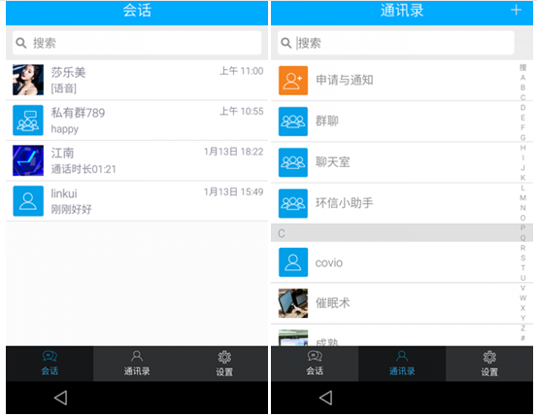

要求：
- 从登陆注册界面跳转到本界面。
- 根据不同的用户，展示不同的会话。把数据存入List即可。

实验报告
- 从登陆注册界面跳转到本界面。根据不同的用户，展示不同的会话。把数据存入List即可。下图为跳转.以及将登录输入的数据拿到后台list输出。
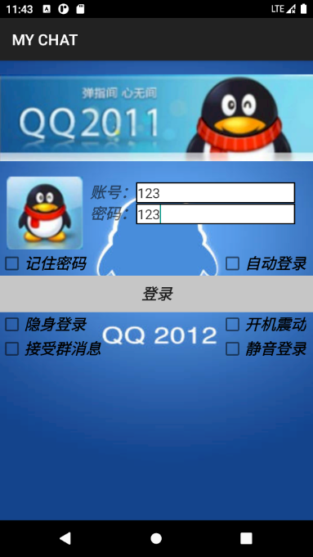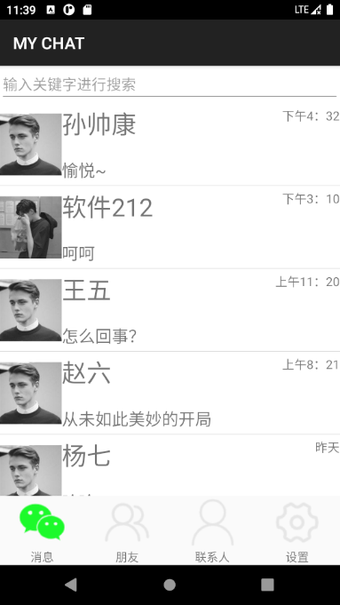
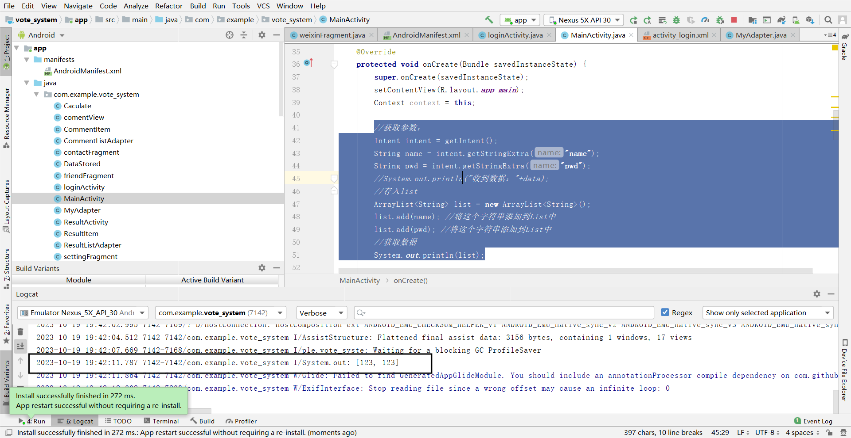
2.利用intent实现页面跳转
@Override
protected void onCreate(Bundle savedInstanceState) {
super.onCreate(savedInstanceState);
setContentView(R.layout.activity_login);
//获得按钮并监听
Button ok = this.findViewById(R.id.login);
ok.setOnClickListener(new ButtonListener());
}
//实现页面跳转
private class ButtonListener implements View.OnClickListener{
@Override
public void onClick(View v){
EditText editText1 = (EditText)findViewById (R.id.et_username);
EditText editText2 = (EditText)findViewById (R.id.et_password);
String str1= editText1.getText().toString();
String str2= editText2.getText().toString();
Intent intent=new Intent(loginActivity.this,MainActivity.class);//设置切换对应activity
intent.putExtra("name",str1);
intent.putExtra("pwd",str2);
startActivity(intent);//开始切换
}}
- 利用fragment实现点击不同的RadioButton上对应不同的Activity。
- 编写4个相对应的fragment
ContactFragment、friendFragment、settingFragment、weixinFragment
package com.example.vote_system;
import android.os.Bundle;
import android.view.LayoutInflater;
import android.view.View;
import android.view.ViewGroup;
import androidx.fragment.app.Fragment;
public class contactFragment extends Fragment {
@Override
public View onCreateView(LayoutInflater inflater, ViewGroup container,
Bundle savedInstanceState) {
// Inflate the layout for this fragment
return inflater.inflate(R.layout.fragment_contact, container, false);
}
}
package com.example.vote_system;
import android.os.Bundle;
import android.view.LayoutInflater;
import android.view.View;
import android.view.ViewGroup;
import androidx.fragment.app.Fragment;
public class friendFragment extends Fragment {
@Override
public View onCreateView(LayoutInflater inflater, ViewGroup container,
Bundle savedInstanceState) {
// Inflate the layout for this fragment
return inflater.inflate(R.layout.fragment_friend, container, false);
}
}
package com.example.vote_system;
import android.os.Bundle;
import android.view.LayoutInflater;
import android.view.View;
import android.view.ViewGroup;
import androidx.fragment.app.Fragment;
public class settingFragment extends Fragment {
@Override
public View onCreateView(LayoutInflater inflater, ViewGroup container,
Bundle savedInstanceState) {
// Inflate the layout for this fragment
return inflater.inflate(R.layout.fragment_setting, container, false);
}
}

weixinFragment实现聊天消息列表界面
package com.example.vote_system;
import android.os.Bundle;
import android.view.LayoutInflater;
import android.view.View;
import android.view.ViewGroup;
import androidx.fragment.app.Fragment;
import androidx.recyclerview.widget.LinearLayoutManager;
import androidx.recyclerview.widget.RecyclerView;
import java.util.ArrayList;
import java.util.HashMap;
import java.util.List;
import java.util.Map;
public class weixinFragment extends Fragment {
private List<Map<String, Object>> data = new ArrayList<Map<String, Object>>();
private View view;
private RecyclerView recyclerView;
private MyAdapter myAdapter;
@Override
public View onCreateView(LayoutInflater inflater, ViewGroup container,
Bundle savedInstanceState) {
view = inflater.inflate(R.layout.fragment_weixin, container, false);
initRecyclerView();
initData();
// Inflate the layout for this fragment
return view;
}
private void initData() {
String[] imgSrc = {"https://uploadfile.huiyi8.com/2015/0610/20150610023414897.jpg",
"https://tupian.qqw21.com/article/UploadPic/2020-10/2020102118172486410.jpg",
"https://tse1-mm.cn.bing.net/th/id/R-C.f06917566447b07f1fd02df8d2b90afe?rik=gcK32hcXo%2fECSQ&riu=http%3a%2f%2fwww.fzlol.com%2fupimg%2fallimg%2f140321%2f1_19401130B.jpg&ehk=4tikPQlp0d5wKQ1m1Y%2fuK0giIpiRn6Cp1pb6lfJwl8I%3d&risl=&pid=ImgRaw&r=0",
"https://tupian.qqw21.com/article/UploadPic/2012-9/2012928918625.jpg",
"https://tse1-mm.cn.bing.net/th/id/R-C.b9c66bc2c06e04ea70aa694cd270661e?rik=8cfGRPR073C6AQ&riu=http%3a%2f%2ftouxiang.vipyl.com%2fattached%2fimage%2f20130222%2f20130222152219531953.jpg&ehk=rECfEJntkfPQN2acCWpC6PqeI8xP1%2bGs59IOEKCd2tQ%3d&risl=&pid=ImgRaw&r=0&sres=1&sresct=1",
"https://tse1-mm.cn.bing.net/th/id/R-C.60c49ed1f68019e00572dd33dff274f4?rik=eOWqUDbxEyvn%2fQ&riu=http%3a%2f%2fscimg.jianbihuadq.com%2f202008%2f202008282115115.jpg&ehk=upxZxNKo1zee4RtaKIAgzk%2b7rdB0t084DdNXO6o8V%2fE%3d&risl=&pid=ImgRaw&r=0&sres=1&sresct=1",
"https://tse1-mm.cn.bing.net/th/id/R-C.a13d84b340cd08244268db8f8f8b1922?rik=Z0t8GBFlkY4Mhg&riu=http%3a%2f%2fscimg.jianbihuadq.com%2f202010%2f2020101711593861.jpg&ehk=yfqLWJ5S5%2fBHEzqv0YaZcSXYqFDpw6I8kKaRBoh%2fxcI%3d&risl=&pid=ImgRaw&r=0&sres=1&sresct=1",
"https://tse2-mm.cn.bing.net/th/id/OIP-C.eQ-HYGnNOjgSAvllNDVS4AAAAA?w=150&h=150&c=7&r=0&o=5&pid=1.7"
};
String[] cttName = {"张三", "李四", "王五","赵六","杨七","李八","刘XX","周十"};
String[] cttTime = {"下午4：32","下午3：10","上午11：20","上午8：21","昨天","昨天","3月21日","2021年12月10日"};
String[] cttMsg = {"愉悦~","呵呵","怎么回事？","从未如此美妙的开局","哈哈","也许不过如此","在哪里碰头？","万丈高楼平地起"};
for (int i = 0; i < imgSrc.length; i++) {
Map<String, Object> itemData = new HashMap<String, Object>();
itemData.put("key1", imgSrc[i]);
itemData.put("key2", cttName[i]);
itemData.put("key3",cttTime[i]);
itemData.put("key4",cttMsg[i]);
data.add(itemData);
}
}
private void initRecyclerView () {
recyclerView = view.findViewById(R.id.recyclerView);
recyclerView.getItemAnimator().setChangeDuration(500);
recyclerView.getItemAnimator().setMoveDuration(500);
myAdapter = new MyAdapter(getActivity(), data);
LinearLayoutManager manager = new LinearLayoutManager(getActivity());
manager.setOrientation(RecyclerView.VERTICAL);
recyclerView.setAdapter(myAdapter);
recyclerView.setLayoutManager(manager);
}
}
- MainAcivity.java中实现fragment，点击下方导航栏切换小页面，也就是切换fragment
package com.example.vote_system;
import android.content.Context;
import android.os.Bundle;
import android.view.View;
import android.widget.ImageView;
import android.widget.LinearLayout;
import androidx.appcompat.app.AppCompatActivity;
import androidx.fragment.app.Fragment;
import androidx.fragment.app.FragmentManager;
import androidx.fragment.app.FragmentTransaction;
import androidx.recyclerview.widget.RecyclerView;
public class MainActivity extends AppCompatActivity implements View.OnClickListener{
private Fragment weixinFragment = new weixinFragment();
private Fragment friendFragment = new friendFragment();
private Fragment contactFragment = new contactFragment();
private Fragment settingFragment = new settingFragment();
private FragmentManager fm;
private LinearLayout tab01,tab02,tab03,tab04;
private ImageView tab01_img;
private ImageView tab02_img;
private ImageView tab03_img;
private ImageView tab04_img;
private RecyclerView recyclerView;
@Override
protected void onCreate(Bundle savedInstanceState) {
super.onCreate(savedInstanceState);
setContentView(R.layout.app_main);
Context context = this;
//获取参数：
Intent intent = getIntent();
String name = intent.getStringExtra("name");
String pwd = intent.getStringExtra("pwd");
//System.out.println("收到数据："+data);
//存入list
ArrayList<String> list = new ArrayList<String>();
list.add(name); //将这个字符串添加到List中
list.add(pwd); //将这个字符串添加到List中
//获取数据
System.out.println(list);
weixinFragment = new weixinFragment();
friendFragment = new friendFragment();
contactFragment = new contactFragment();
settingFragment = new settingFragment();
tab01 = findViewById(R.id.tab01);
tab02 = findViewById(R.id.tab02);
tab03 = findViewById(R.id.tab03);
tab04 = findViewById(R.id.tab04);
fm = getSupportFragmentManager();
initialfragment();
tab01_img = findViewById(R.id.tab01_img);
tab02_img = findViewById(R.id.tab02_img);
tab03_img = findViewById(R.id.tab03_img);
tab04_img = findViewById(R.id.tab04_img);
tab01.setOnClickListener(this);
tab02.setOnClickListener(this);
tab03.setOnClickListener(this);
tab04.setOnClickListener(this);
}
private void initialfragment(){
FragmentTransaction transaction = fm.beginTransaction();
transaction.add(androidx.appcompat.R.id.content,weixinFragment);
transaction.add(androidx.appcompat.R.id.content,friendFragment);
transaction.add(androidx.appcompat.R.id.content,contactFragment);
transaction.add(androidx.appcompat.R.id.content,settingFragment);
Hide(transaction);
transaction.show(weixinFragment);
transaction.commit();
}
@Override
public void onClick(View view) {
switch (view.getId()){
case R.id.tab01: show(1); reset(); tab01_img.setImageResource(R.drawable.weixin_pressed); break;
case R.id.tab02: show(2); reset(); tab02_img.setImageResource(R.drawable.friend_pressed); break;
case R.id.tab03: show(3); reset(); tab03_img.setImageResource(R.drawable.contact_pressed); break;
case R.id.tab04: show(4); reset(); tab04_img.setImageResource(R.drawable.setting_pressed); break;
default: break;
}
}
private void show(int i) {
FragmentTransaction transaction = fm.beginTransaction();
Hide(transaction);
switch (i){
case 1:transaction.show(weixinFragment);break;
case 2:transaction.show(friendFragment);break;
case 3:transaction.show(contactFragment);break;
case 4:transaction.show(settingFragment);break;
default:break;
}
transaction.commit();
}
private void Hide(FragmentTransaction transaction) {
transaction.hide(weixinFragment);
transaction.hide(friendFragment);
transaction.hide(contactFragment);
transaction.hide(settingFragment);
}
private void reset(){
tab01_img.setImageResource(R.drawable.weixin);
tab02_img.setImageResource(R.drawable.friend);
tab03_img.setImageResource(R.drawable.contact);
tab04_img.setImageResource(R.drawable.setting);
}
}
- 布局文件的实现
- App_main.xml将底部中部顶部结合
<?xml version="1.0" encoding="utf-8"?>
<LinearLayout xmlns:android="http://schemas.android.com/apk/res/android"
xmlns:app="http://schemas.android.com/apk/res-auto"
xmlns:tools="http://schemas.android.com/tools"
android:layout_width="match_parent"
android:layout_height="match_parent"
android:orientation="vertical"
tools:context=".MainActivity">
<include layout="@layout/top" />
<FrameLayout
android:id="@+id/content"
android:layout_width="match_parent"
android:layout_height="wrap_content"
android:layout_weight="1"></FrameLayout>
<include layout="@layout/bottom" />
</LinearLayout>
- Bottom.xml、top.xml底部实现导航栏，顶部实现搜索框
<?xml version="1.0" encoding="utf-8"?>
<LinearLayout xmlns:android="http://schemas.android.com/apk/res/android"
xmlns:app="http://schemas.android.com/apk/res-auto"
android:layout_width="match_parent"
android:layout_height="wrap_content"
android:orientation="horizontal">
<LinearLayout
android:id="@+id/tab01"
android:layout_width="wrap_content"
android:layout_height="wrap_content"
android:layout_weight="1"
android:orientation="vertical">
<ImageView
android:id="@+id/tab01_img"
android:layout_width="match_parent"
android:layout_height="wrap_content"
app:srcCompat="@drawable/weixin_pressed" />
<TextView
android:id="@+id/textView1"
android:layout_width="match_parent"
android:layout_height="wrap_content"
android:gravity="center"
android:text="消息" />
</LinearLayout>
<LinearLayout
android:id="@+id/tab02"
android:layout_width="wrap_content"
android:layout_height="wrap_content"
android:layout_weight="1"
android:orientation="vertical">
<ImageView
android:id="@+id/tab02_img"
android:layout_width="match_parent"
android:layout_height="wrap_content"
app:srcCompat="@drawable/friend" />
<TextView
android:id="@+id/textView2"
android:layout_width="match_parent"
android:layout_height="wrap_content"
android:gravity="center"
android:text="朋友" />
</LinearLayout>
<LinearLayout
android:id="@+id/tab03"
android:layout_width="wrap_content"
android:layout_height="wrap_content"
android:layout_weight="1"
android:orientation="vertical">
<ImageView
android:id="@+id/tab03_img"
android:layout_width="match_parent"
android:layout_height="wrap_content"
app:srcCompat="@drawable/contact" />
<TextView
android:id="@+id/textView3"
android:layout_width="match_parent"
android:layout_height="wrap_content"
android:gravity="center"
android:text="联系人" />
</LinearLayout>
<LinearLayout
android:id="@+id/tab04"
android:layout_width="wrap_content"
android:layout_height="wrap_content"
android:layout_weight="1"
android:orientation="vertical">
<ImageView
android:id="@+id/tab04_img"
android:layout_width="match_parent"
android:layout_height="wrap_content"
app:srcCompat="@drawable/setting" />
<TextView
android:id="@+id/textView4"
android:layout_width="match_parent"
android:layout_height="wrap_content"
android:gravity="center"
android:text="设置" />
</LinearLayout>
</LinearLayout>
<?xml version="1.0" encoding="utf-8"?>
<LinearLayout xmlns:android="http://schemas.android.com/apk/res/android"
android:layout_width="match_parent"
android:layout_height="wrap_content"
android:background="@color/white"
>
<EditText
android:id="@+id/editTextSearch"
android:layout_width="match_parent"
android:layout_height="wrap_content"
android:hint="输入关键字进行搜索" />
</LinearLayout>
- Item.xml每一条消息
<?xml version="1.0" encoding="utf-8"?>
<LinearLayout xmlns:android="http://schemas.android.com/apk/res/android"
xmlns:tools="http://schemas.android.com/tools"
android:id="@+id/Clicked"
android:layout_width="match_parent"
android:layout_height="wrap_content"
android:background="@drawable/underline"
android:clickable="true"
android:orientation="vertical">
<LinearLayout
android:layout_width="match_parent"
android:layout_height="100dp"
android:gravity="center"
android:orientation="horizontal">
<ImageView
android:id="@+id/photo"
android:layout_width="75dp"
android:layout_height="75dp"
android:layout_gravity="center" />
<LinearLayout
android:layout_width="wrap_content"
android:layout_height="wrap_content"
android:layout_weight="1"
android:orientation="vertical">
<LinearLayout
android:layout_width="match_parent"
android:layout_height="wrap_content"
android:orientation="horizontal">
<TextView
android:id="@+id/cctName"
android:layout_width="match_parent"
android:layout_height="40dp"
android:layout_weight="1"
android:gravity="left"
android:text="姓名"
android:textSize="30sp" />
<TextView
android:id="@+id/time"
android:layout_width="match_parent"
android:layout_height="wrap_content"
android:layout_gravity="right"
android:layout_weight="1"
android:gravity="right"
android:text="时间"
android:textSize="15sp" />
</LinearLayout>
<TextView
android:id="@+id/cctMsg"
android:layout_width="match_parent"
android:layout_height="50dp"
android:layout_gravity="center"
android:gravity="bottom"
android:text="内容"
android:textSize="20sp" />
</LinearLayout>
</LinearLayout>
<LinearLayout
android:id="@+id/detail"
android:layout_width="match_parent"
android:layout_height="80dp"
android:background="@color/black"
android:orientation="vertical"
android:visibility="gone">
<TextView
android:id="@+id/detail_text"
android:layout_width="wrap_content"
android:layout_height="wrap_content"
android:text="展开内容"
android:textSize="20sp" />
</LinearLayout>
</LinearLayout>
- Fragment_contact.xml,fragment_friend.xml,fragment_setting.xml
<?xml version="1.0" encoding="utf-8"?>
<LinearLayout xmlns:android="http://schemas.android.com/apk/res/android"
xmlns:tools="http://schemas.android.com/tools"
android:layout_width="match_parent"
android:layout_height="match_parent"
android:orientation="horizontal"
tools:context=".weixinFragment">
<!-- TODO: Update blank fragment layout -->
<TextView
android:layout_width="match_parent"
android:layout_height="match_parent"
android:textSize="50sp"
android:gravity="center"
android:text="这是朋友界面" />
</LinearLayout>
- Fragment_weixin.xml实现列表放消息条
<?xml version="1.0" encoding="utf-8"?>
<LinearLayout xmlns:android="http://schemas.android.com/apk/res/android"
xmlns:tools="http://schemas.android.com/tools"
android:layout_width="match_parent"
android:layout_height="match_parent"
android:orientation="horizontal"
tools:context=".weixinFragment">
<!-- TODO: Update blank fragment layout -->
<androidx.recyclerview.widget.RecyclerView
android:id="@+id/recyclerView"
android:layout_width="match_parent"
android:layout_height="match_parent">
</androidx.recyclerview.widget.RecyclerView>
</LinearLayout>

五、实验总结
实验过程中遇到的问题：
- 图片（https）加载不出来，不显示。
- 跳转报错。
- 实现不了数据的传输。
解决方案：
- 通过看ppt学习解决数据传输、跳转不成功问题，原因的跳转和传输的语句顺序错误。
2.图片加载不出来是因为我的AndroidManifest.xml里面没有添加联网权限，添加<uses-permission android:name="android.permission.INTERNET" />即可。

