实验八 SQLite的使用

实验目的及任务
- 熟悉数据库SQLite的操作方法
- SQLiteDatabase操作类，SQLiteOpenHelper辅助类的使用

二、实验环境
- Jdk
- Android Studio
- Android SDK

三、实验步骤
1. 做一个教师管理系统。要求：
（1）使用Sqlite数据库，创建TeacherDB，包含teacher表，表中字段：教师号、姓名、性别、工资。
（2）包括增加、删除、修改、查询按钮。
（3）包括教师号、姓名、性别、工资4个输入框。
（4）当单击增加按钮时，将输入的教师号、姓名、性别、工资插入到teacher表中。
（5）当单击删除按钮时，根据输入的教师号则从数据库中删除此条记录。
（6）当单击修改按钮时，根据输入的教师号、姓名、性别、工资修改到教师号对应的记录上，其中教师号不允许修改。
（7）当单击查询按钮时，根据教师号、姓名、性别模糊查询，并将结果显示到下面的文本区中。

四、实验报告
实现思路
1.ex8_teacher_ms.xml用于实现这个教师管理系统的主页面布局（editview、button、listview）
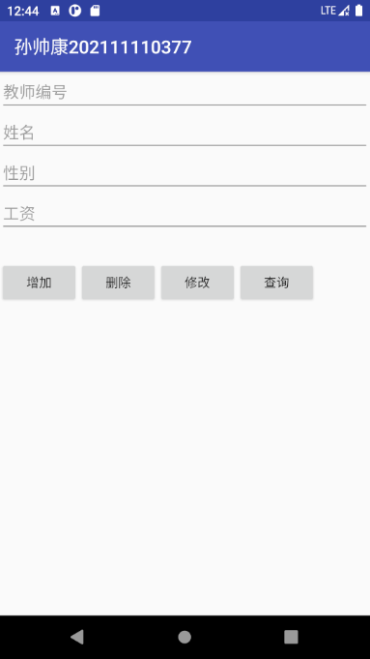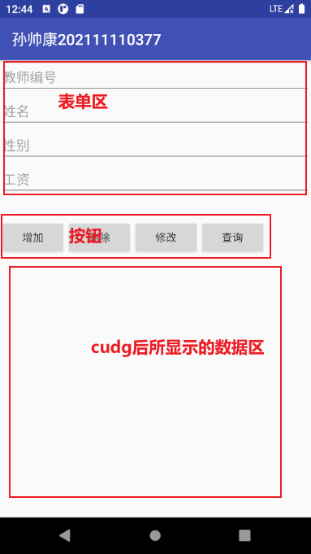
2.ex8_item.xml用于实现数据区显示cudp后的每一条数据
ex8_head_item.xml用于显示数据区的表头，后只需java中加入即可，无需动态。
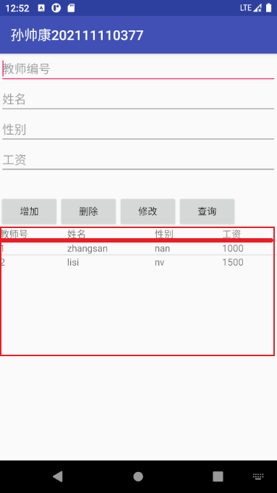
3.manage_system.java用于实现初始化按钮、编辑框控件。并给ex8_teacher_ms.xml中listview添加表头，和每一条记录。并对每一个按钮和记录设置监听。
4.MyDatabaseHelper.java这是一个数据库辅助类，用于定义常量，如数据库名，数据库版本，数据库表名。并执行所建表的表名，表结构。
5.teacher.java这是一个老师实体类，用于实现老师的get、set构造方法，字符串输出形式。
6.TeacherDao_withoutCreateTable.java用于实现对教师的增删改查（模糊查询）。
源码
- ex8_teacher_ms.xml
<?xml version="1.0" encoding="utf-8"?>
<LinearLayout xmlns:android="http://schemas.android.com/apk/res/android"
android:orientation="vertical" android:layout_width="match_parent"
android:layout_height="match_parent">
<!-- 设置四行编辑框-->
<EditText
android:id="@+id/ex8_edit_teacherNo"
android:hint="教师编号"
android:layout_width="match_parent"
android:layout_height="wrap_content"
/>
<EditText
android:id="@+id/ex8_edit_name"
android:hint="姓名"
android:layout_width="match_parent"
android:layout_height="wrap_content" />
<EditText
android:id="@+id/ex8_edit_gender"
android:hint="性别"
android:layout_width="match_parent"
android:layout_height="wrap_content" />
<EditText
android:id="@+id/ex8_edit_salary"
android:hint="工资"
android:layout_width="match_parent"
android:layout_height="wrap_content" />
<!--空白-->
<LinearLayout
android:layout_width="match_parent"
android:layout_height="30dp"></LinearLayout>
<!--设置四个水平按钮-->
<LinearLayout
android:layout_width="match_parent"
android:layout_height="wrap_content"
android:orientation="horizontal">
<Button
android:id="@+id/ex8_btn_add"
android:text="增加"
android:layout_width="wrap_content"
android:layout_height="wrap_content" />
<Button
android:id="@+id/ex8_btn_delete"
android:text="删除"
android:layout_width="wrap_content"
android:layout_height="wrap_content" />
<Button
android:id="@+id/ex8_btn_update"
android:text="修改"
android:layout_width="wrap_content"
android:layout_height="wrap_content" />
<Button
android:id="@+id/ex8_btn_get"
android:text="查询"
android:layout_width="wrap_content"
android:layout_height="wrap_content" />
</LinearLayout>
<!--展示teacher表信息的listView-->
<ListView
android:id="@+id/ex8_listView_teacher"
android:layout_width="match_parent"
android:layout_height="wrap_content">
</ListView>
</LinearLayout>
- ex8_head_item.xml
<?xml version="1.0" encoding="utf-8"?>
<LinearLayout xmlns:android="http://schemas.android.com/apk/res/android"
android:orientation="horizontal" android:layout_width="match_parent"
android:layout_height="match_parent">
<!--用于listView的表头，将来实体化一个view-->
<!-- 第一行表头-->
<TextView
android:text="教师号"
android:layout_width="100dp"
android:layout_height="wrap_content" />
<TextView
android:text="姓名"
android:layout_width="130dp"
android:layout_height="wrap_content" />
<TextView
android:text="性别"
android:layout_width="100dp"
android:layout_height="wrap_content" />
<TextView
android:text="工资"
android:layout_width="100dp"
android:layout_height="wrap_content" />
</LinearLayout>
- ex8_item.xml
<?xml version="1.0" encoding="utf-8"?>
<LinearLayout xmlns:android="http://schemas.android.com/apk/res/android"
android:orientation="horizontal" android:layout_width="match_parent"
android:layout_height="match_parent">
<!--用于listView的表头，将来实体化一个view-->
<TextView
android:id="@+id/ex8_items_no"
android:text=""
android:layout_width="100dp"
android:layout_height="wrap_content" />
<TextView
android:id="@+id/ex8_items_name"
android:text=""
android:layout_width="130dp"
android:layout_height="wrap_content" />
<TextView
android:id="@+id/ex8_items_gender"
android:text=""
android:layout_width="100dp"
android:layout_height="wrap_content" />
<TextView
android:id="@+id/ex8_items_salary"
android:text=""
android:layout_width="100dp"
android:layout_height="wrap_content" />
</LinearLayout>
- manage_system.java
package com.example.myapplication_001.ex8;
import android.os.Bundle;
import android.view.LayoutInflater;
import android.view.View;
import android.widget.AdapterView;
import android.widget.Button;
import android.widget.EditText;
import android.widget.ListView;
import android.widget.TextView;
import androidx.annotation.Nullable;
import androidx.appcompat.app.AppCompatActivity;
import com.example.myapplication_001.R;
import java.util.List;
import java.util.Map;
public class ManageSystem extends AppCompatActivity {
Button btn_add=null;
Button btn_delete=null;
Button btn_update=null;
Button btn_get=null;
EditText edit_teacherNo=null;
EditText edit_name=null;
EditText edit_gender=null;
EditText edit_salary=null;
ListView listViewTeacher=null;
// TeacherDao teacherDao=new TeacherDao(ManageSystem.this);
@Override
protected void onCreate(@Nullable Bundle savedInstanceState) {
super.onCreate(savedInstanceState);
setContentView(R.layout.ex8_teacher_ms);
// 初始化控件
btn_add=(Button)findViewById(R.id.ex8_btn_add);
btn_delete=(Button)findViewById(R.id.ex8_btn_delete);
btn_update=(Button)findViewById(R.id.ex8_btn_update);
btn_get=(Button)findViewById(R.id.ex8_btn_get);
edit_gender=(EditText)findViewById(R.id.ex8_edit_gender);
edit_name=(EditText)findViewById(R.id.ex8_edit_name);
edit_salary=(EditText)findViewById(R.id.ex8_edit_salary);
edit_teacherNo=(EditText)findViewById(R.id.ex8_edit_teacherNo);
listViewTeacher=(ListView)findViewById(R.id.ex8_listView_teacher);
//给listView添加表头
View view= LayoutInflater.from(this).inflate(R.layout.ex8_head_item,null,true);
listViewTeacher.addHeaderView(view);
// 初始化按钮的事件监听
initAddButtonOnclick();//添加
initDeleteButtonOnclick();//删除
initUpdateButtonOnclick();//修改
initGetButtonOnclick();//查询(包括查询全部和根据输入的三个输入框的字段以模糊查询)
initListViewOnclick();//点击列表每个列表项
}
private void initListViewOnclick() {
listViewTeacher.setOnItemClickListener(new AdapterView.OnItemClickListener() {
@Override
public void onItemClick(AdapterView<?> parent, View view, int position, long id) {
TextView no = (TextView) view.findViewById(R.id.ex8_items_no);
TextView name = (TextView) view.findViewById(R.id.ex8_items_name);
TextView gender = (TextView) view.findViewById(R.id.ex8_items_gender);
TextView salary = (TextView) view.findViewById(R.id.ex8_items_salary);
String sno = no.getText().toString();
edit_teacherNo.setText(sno);
edit_name.setText(name.getText().toString());
edit_gender.setText(gender.getText().toString());
edit_salary.setText(salary.getText().toString());
// 给教师编号输入框禁止获取焦点的限制，直到按下更新按钮再解除限制
edit_teacherNo.setFocusable(false);
edit_teacherNo.setFocusableInTouchMode(false);
}
});
}
private void initGetButtonOnclick() {
btn_get.setOnClickListener(new View.OnClickListener() {
@Override
public void onClick(View view) {
/*根据教师号、姓名、性别输入框是否都为Null，有两种情况，全部查询与模糊查询
* getAll:当输入框中的文本为空的时候，点击查询会在listView中显示所有的teacher
* getBy xxx:当输入框有教师号、姓名、性别的输入时，也就是非空，进行模糊查询*/
String teacherNo=edit_teacherNo.getText().toString();
String name=edit_name.getText().toString();
String gender=edit_gender.getText().toString();
// getAll
if (edit_teacherNo.getText().toString().equals("")&&edit_name.getText().toString().equals("")&&edit_gender.getText().toString().equals("")){
List<Map<String,String>> teacherList=TeacherDao_withoutCreateTable.getAllTeacher(ManageSystem.this);
// List<Map<String,String>> teacherList=teacherDao.getAllTeacher();
TeacherAdapter teacherAdapter=new TeacherAdapter(ManageSystem.this,teacherList,R.layout.ex8_items,new String[]{ "no","name","gender","salary"},new int[]{R.id.ex8_items_no,R.id.ex8_items_name,R.id.ex8_items_gender,R.id.ex8_items_salary});
listViewTeacher.setAdapter(teacherAdapter);
}
// getBy xxx
else{
List<Map<String,String>> teacherList=TeacherDao_withoutCreateTable.getTeacherBy(ManageSystem.this,teacherNo,name,gender);
// List<Map<String,String>> teacherList=teacherDao.getTeacherBy(teacherNo,name,gender);
TeacherAdapter teacherAdapter=new TeacherAdapter(ManageSystem.this,teacherList,R.layout.ex8_items,new String[]{ "no","name","gender","salary"},new int[]{R.id.ex8_items_no,R.id.ex8_items_name,R.id.ex8_items_gender,R.id.ex8_items_salary});
listViewTeacher.setAdapter(teacherAdapter);
}
}
});
}
/*如果教师的编号被改变，则不执行更新
* 给教师编号的输入框设置一个监听事件，如果被手动修改，则点击更新按钮时不执行更新方法*/
private void initUpdateButtonOnclick() {
btn_update.setOnClickListener(new View.OnClickListener() {
@Override
public void onClick(View view) {
String teacherNo=edit_teacherNo.getText().toString();
String name=edit_name.getText().toString();
String gender=edit_gender.getText().toString();
String sSalary=edit_salary.getText().toString();
Integer salary=Integer.parseInt(sSalary);
// teacherDao.update(name,gender,salary,teacherNo);
TeacherDao_withoutCreateTable.update(ManageSystem.this,name,gender,salary,teacherNo);
List<Map<String,String>> teacherList=TeacherDao_withoutCreateTable.getAllTeacher(ManageSystem.this);
// List<Map<String,String>> teacherList=teacherDao.getAllTeacher();
TeacherAdapter teacherAdapter=new TeacherAdapter(ManageSystem.this,teacherList,R.layout.ex8_items,new String[]{ "no","name","gender","salary"},new int[]{R.id.ex8_items_no,R.id.ex8_items_name,R.id.ex8_items_gender,R.id.ex8_items_salary});
listViewTeacher.setAdapter(teacherAdapter);
// 更新完毕，解除对教师编号输入框的限制
edit_teacherNo.setFocusable(true);
edit_teacherNo.setFocusableInTouchMode(true);
}
});
}
private void initDeleteButtonOnclick() {
btn_delete.setOnClickListener(new View.OnClickListener() {
@Override
public void onClick(View view) {
String teacherNo=edit_teacherNo.getText().toString();
// teacherDao.delete(teacherNo);
TeacherDao_withoutCreateTable.delete(ManageSystem.this,teacherNo);
List<Map<String,String>> teacherList=TeacherDao_withoutCreateTable.getAllTeacher(ManageSystem.this);
// List<Map<String,String>> teacherList=teacherDao.getAllTeacher();
TeacherAdapter teacherAdapter=new TeacherAdapter(ManageSystem.this,teacherList,R.layout.ex8_items,new String[]{ "no","name","gender","salary"},new int[]{R.id.ex8_items_no,R.id.ex8_items_name,R.id.ex8_items_gender,R.id.ex8_items_salary});
listViewTeacher.setAdapter(teacherAdapter);
}
});
}
private void initAddButtonOnclick() {
btn_add.setOnClickListener(new View.OnClickListener() {
@Override
public void onClick(View view) {
String teacherNo=edit_teacherNo.getText().toString();
String name=edit_name.getText().toString();
String gender=edit_gender.getText().toString();
String sSalary=edit_salary.getText().toString();
Integer salary=Integer.parseInt(sSalary);
// Teacher teacher=new Teacher(teacherNo,name,gender,salary);
// teacherDao.insert(teacher);
// teacherDao.insert(teacherNo,name,gender,salary);
TeacherDao_withoutCreateTable.insert(ManageSystem.this,teacherNo,name,gender,salary);
List<Map<String,String>> teacherList=TeacherDao_withoutCreateTable.getAllTeacher(ManageSystem.this);
// List<Map<String,String>> teacherList=teacherDao.getAllTeacher();
TeacherAdapter teacherAdapter=new TeacherAdapter(ManageSystem.this,teacherList,R.layout.ex8_items,new String[]{ "no","name","gender","salary"},new int[]{R.id.ex8_items_no,R.id.ex8_items_name,R.id.ex8_items_gender,R.id.ex8_items_salary});
listViewTeacher.setAdapter(teacherAdapter);
}
});
}
}
- MyDatabaseHelper.java
package com.example.myapplication_001.ex8;
import android.content.Context;
import android.database.sqlite.SQLiteDatabase;
import android.database.sqlite.SQLiteOpenHelper;
/**
* 数据库辅助类
*/
public class MyDatabaseHelper extends SQLiteOpenHelper {
// 定义常量
private static final String DATABASENAME="TeacherDB.db";//使用Sqlite数据库，创建TeacherDB，包含teacher表
public static final int DATABASEVERSION=1;
public static final String TABLENAME="teacher";
// 构造方法
public MyDatabaseHelper(Context context){
super(context,DATABASENAME,null,DATABASEVERSION);
}
// 建表的sql语句定义和执行。表中字段：教师号、姓名、性别、工资。
@Override
public void onCreate(SQLiteDatabase sqLiteDatabase) {
String CREATE_TABLE = "create table " + TABLENAME + " (id integer primary key autoincrement, " + "no text not null, " + "name text not null, " + "gender text," + "salary integer);";
sqLiteDatabase.execSQL(CREATE_TABLE);
}
// 更新数据库版本的sql语句的定义和执行
@Override
public void onUpgrade(SQLiteDatabase sqLiteDatabase, int i, int i1) {
String sql="Drop table if exists"+TABLENAME;
sqLiteDatabase.execSQL(sql);
this.onCreate(sqLiteDatabase);
}
}
- teacher.java
package com.example.myapplication_001.ex8;
public class Teacher {
private String no;
private String name;
private String sex;
private int salary;
public String getNo() {
return no;
}
@Override
public String toString() {
return "老师：Teacher{" +
"no=" + no +
", name='" + name + '\'' +
", sex='" + sex + '\'' +
", salary=" + salary +
'}';
}
public void setNo(String no) {
this.no = no;
}
public String getName() {
return name;
}
public void setName(String name) {
this.name = name;
}
public String getSex() {
return sex;
}
public void setSex(String sex) {
this.sex = sex;
}
public int getSalary() {
return salary;
}
public void setSalary(int salary) {
this.salary = salary;
}
public Teacher() {
}
public Teacher(String no, String name, String sex, int salary) {
this.no = no;
this.name = name;
this.sex = sex;
this.salary = salary;
}
}
- teacherAdapter.java
package com.example.myapplication_001.ex8;
import android.content.Context;
import android.view.View;
import android.view.ViewGroup;
import android.widget.SimpleAdapter;
import java.util.ArrayList;
import java.util.List;
import java.util.Map;
public class TeacherAdapter extends SimpleAdapter {
private ArrayList<Map<String,String>> mData;
public ArrayList<Map<String,String>> getmData(){
return mData;
}
public TeacherAdapter(Context context, List<? extends Map<String,?>> data,int resource,String[] from,int[] to){
super(context,data,resource,from,to);
this.mData=(ArrayList<Map<String,String>>)data;
}
@Override
public View getView(int position, View convertView, ViewGroup parent){
final int mPosition =position;
return super.getView(position, convertView,parent);
}
}
- TeacherDao_withoutCreateTable.java
package com.example.myapplication_001.ex8;
import android.content.ContentValues;
import android.content.Context;
import android.database.Cursor;
import android.database.sqlite.SQLiteDatabase;
import java.util.ArrayList;
import java.util.Arrays;
import java.util.HashMap;
import java.util.List;
import java.util.Map;
public class TeacherDao_withoutCreateTable {
public static long insert(Context context,Teacher entity) {
MyDatabaseHelper helper=new MyDatabaseHelper(context);
SQLiteDatabase db=helper.getWritableDatabase();
ContentValues values = new ContentValues();
values.put("no", entity.getNo());
values.put("name", entity.getName());
values.put("gender", entity.getSex());
values.put("salary", entity.getSalary());
long id = db.insert("teacher", null, values);
db.close();
return id;
}
public static void insert(Context context, String no, String name, String gender, Integer salary){
MyDatabaseHelper helper=new MyDatabaseHelper(context);
SQLiteDatabase db=helper.getWritableDatabase();
String insertSql="insert into teacher(no,name,gender,salary) values(?,?,?,?)";//因为教师的编号不可以被更改，所以sql语句中没有set教师编号
db.execSQL(insertSql,new Object[]{no,name,gender,salary});
}
public static void update(Context context,String name,String gender,Integer salary,String no) {
MyDatabaseHelper helper=new MyDatabaseHelper(context);
SQLiteDatabase db=helper.getWritableDatabase();
String updateSql="update teacher set name=?,gender=?,salary=? where no=?";//因为教师的编号不可以被更改，所以sql语句中没有set教师编号
db.execSQL(updateSql,new Object[]{name,gender,salary,no});
db.close();
}
public static void delete(Context context,String no) {
MyDatabaseHelper helper=new MyDatabaseHelper(context);
SQLiteDatabase db=helper.getWritableDatabase();
String deleteSql="delete from teacher where no=?";
db.execSQL(deleteSql,new Object[]{no});
db.close();
}
/*getAll*/
public static List<Map<String ,String>> getAllTeacher(Context context){
List<Map<String,String>> teacherList=new ArrayList<>();
String selectSql="select no,name,gender,salary from teacher";
MyDatabaseHelper helper=new MyDatabaseHelper(context);
SQLiteDatabase db=helper.getWritableDatabase();
Cursor cursor=db.rawQuery(selectSql,null);
while (cursor.moveToNext()){
Map<String,String> map=new HashMap<>();
map.put("no",cursor.getString(0));
map.put("name",cursor.getString(1));
map.put("gender",cursor.getString(2));
map.put("salary",cursor.getString(3));
teacherList.add(map);
}
return teacherList;
}
/*getBy xxx 模糊查询
* 输入：教师号no，姓名name，性别gender，均为String
* 输出：simpleAdapter进行数据绑定需要的teacherList*/
public static List<Map<String ,String>> getTeacherBy(Context context,String no,String name,String gender){
List<Map<String,String>> teacherList=new ArrayList<>();
String selectSql="select no,name,gender,salary from teacher where 1=1 ";
// 创建一个集合用来存储查询的参数
List<String> list =new ArrayList<String>();
// 如果输入参数不为空，则进行字符串拼接
if (no!=""){
selectSql +="and no like ?";
list.add("%"+no+"%");
}
if(name!=""){
selectSql +="and name like ?";
list.add("%"+name+"%");
}
if (gender!=""){
selectSql+="and gender like ?";
list.add("%"+gender+"%");
}
// 将集合转化成数组
Object[] params =list.toArray();
// Object[]转化成String[]
String stringArray[]= Arrays.asList(params).toArray(new String[0]);
MyDatabaseHelper helper=new MyDatabaseHelper(context);
SQLiteDatabase db=helper.getWritableDatabase();
// 调用db对象的rawQuery查询方法，并将集合返回
Cursor cursor=db.rawQuery(selectSql,stringArray);
while (cursor.moveToNext()){
Map<String,String> map=new HashMap<>();
map.put("no",cursor.getString(0));
map.put("name",cursor.getString(1));
map.put("gender",cursor.getString(2));
map.put("salary",cursor.getString(3));
teacherList.add(map);
}
return teacherList;
}
}

五、实验总结
实验过程中遇到的问题：
对于sqlite数据库的操作方法使用不正确，出现报错。对于增删改查方法的编写不明确，最终选用sql语句的方法实现，无需建表只需进行增删改查操作。对于游标cursor的使用不会。
解决方案：查找ppt学习得知游标（Cursor）是处理数据的一种方法，为了查看或者处理结果集中的数据，游标提供了在结果集中一次一行或者多行前进或向后浏览数据的能力。把游标当作一个指针，它可以指定结果中的任何位置，然后允许用户对指定位置的数据进行处理。

