实验九 ContentProvider

实验目的及任务
1、ContentProvider的使用
2、Uri的使用
3、ContentResolover的使用
4、ContentObserver的使用

二、实验环境
- Jdk
- Android Studio

实验步骤
目录结构：
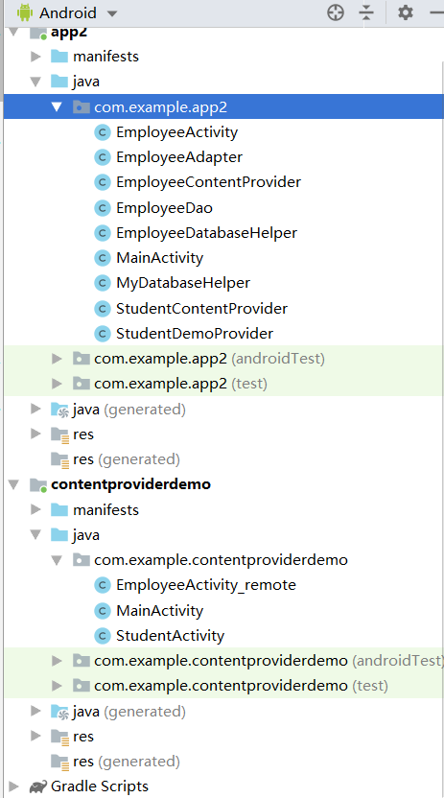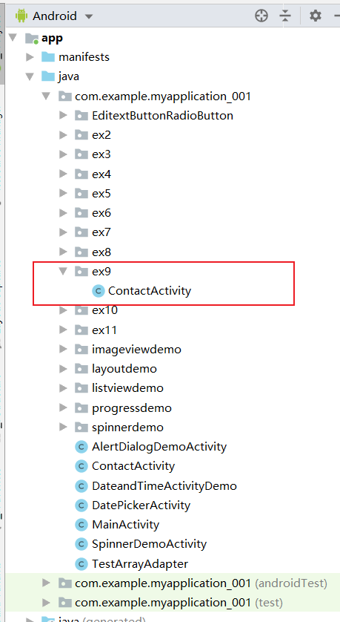

员工信息界面（Module app2）

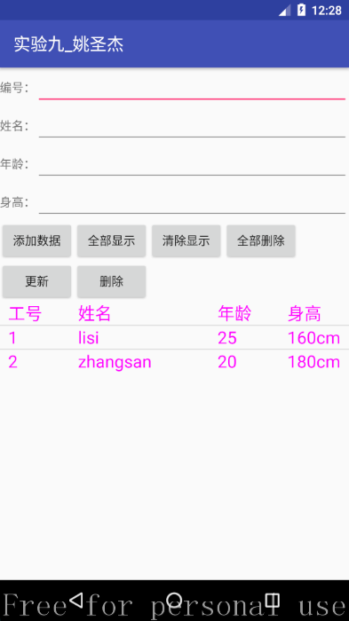
图1 员工信息录入界面

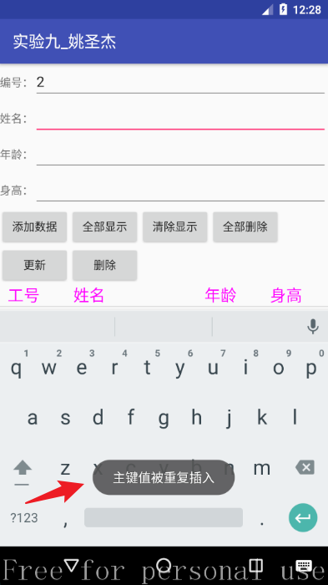
图2 重复添加编号相同的员工失败提示

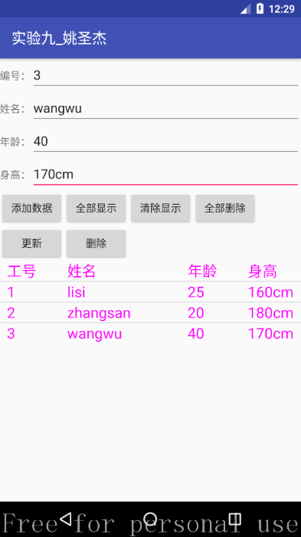
图3 成功添加的页面

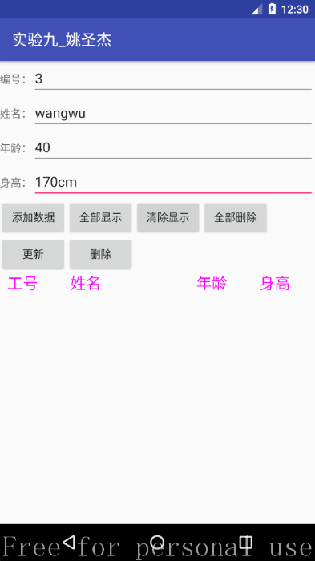
图4 清除显示

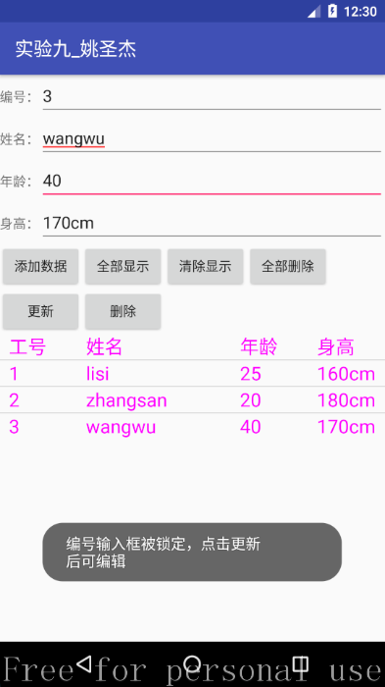
图5 选择列表项的效果

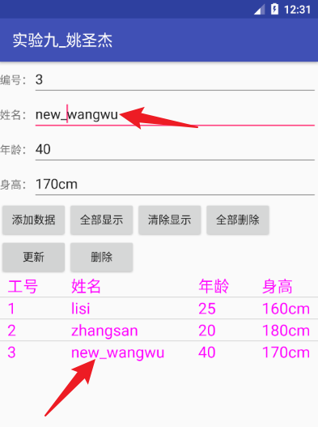
图6 修改成功效果

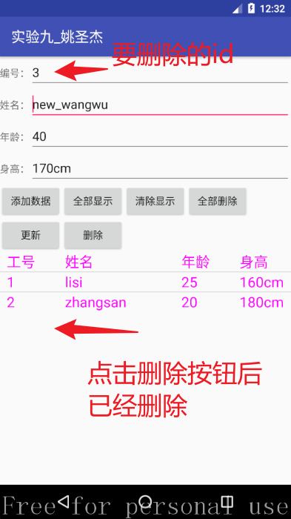
图7 删除成功效果


图8 全部删除

另一个应用程序的界面（Module contentproviderdemo）

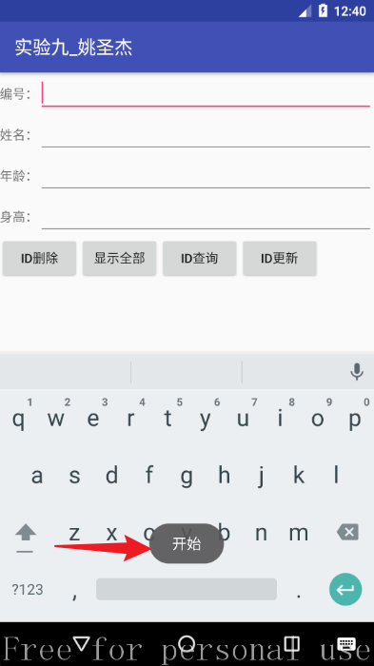
图9 初始化效果（“开始”提示）

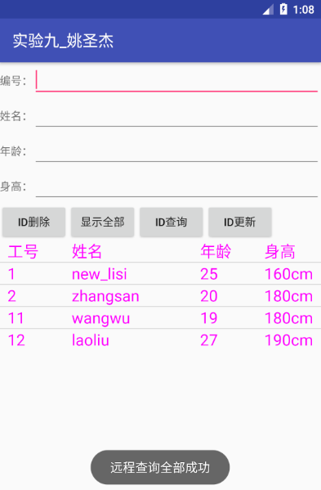
图10 远程查询

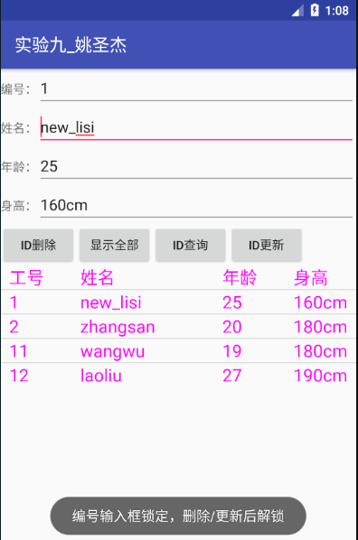
图11 点击列表项的效果

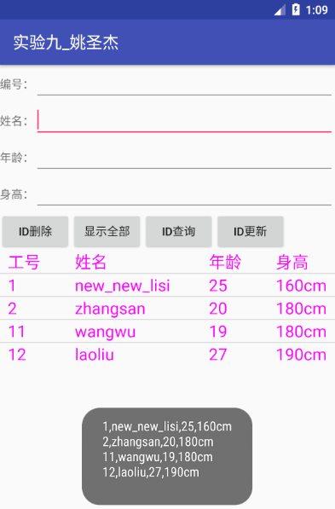
图12 更新后的效果

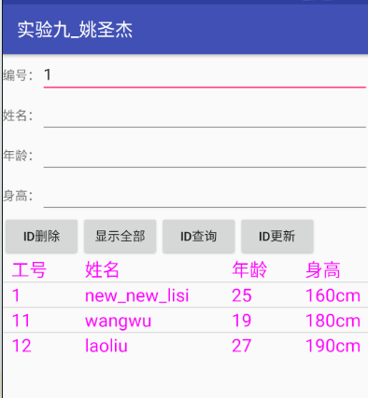
图13 模糊查询编号含1的员工

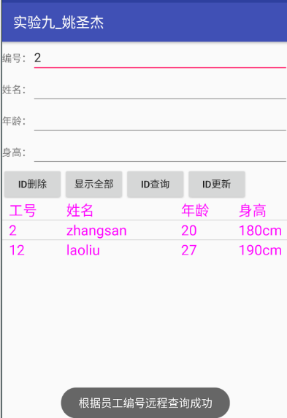
图14 模糊查询员工编号含2的员工

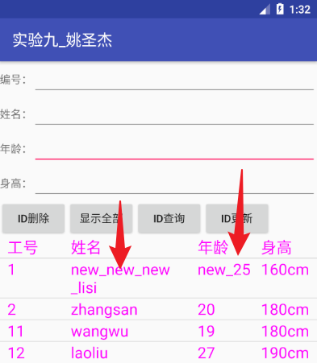
图15 更新的效果

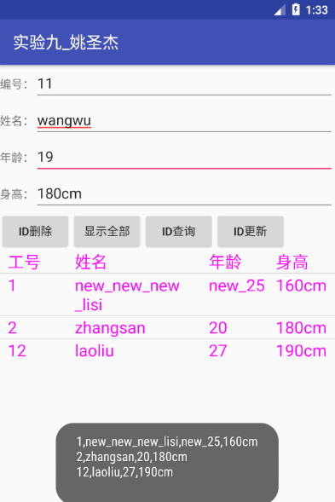
图16 远程删除的效果

2、调用系统URI查询、添加、删除、修改联系人。

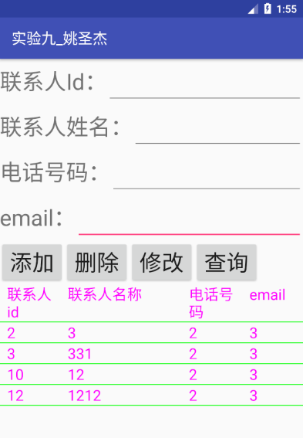
图17 当联系人姓名为空时，查询所有联系人

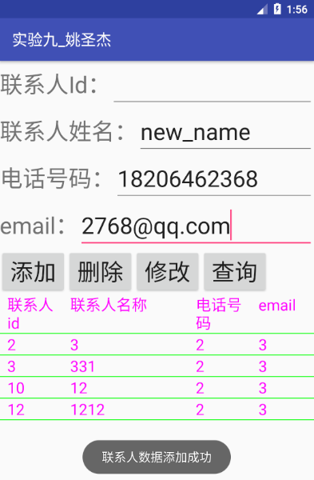
图18 添加联系人成功效果

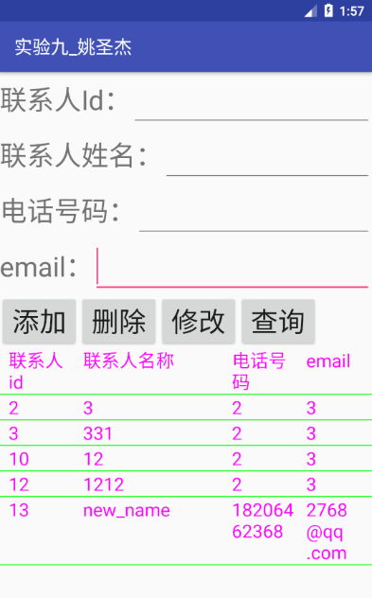
图20 添加联系人后，查询全部联系人

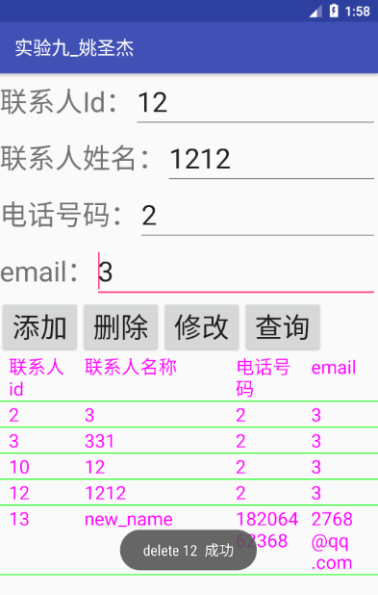
图21 删除联系人

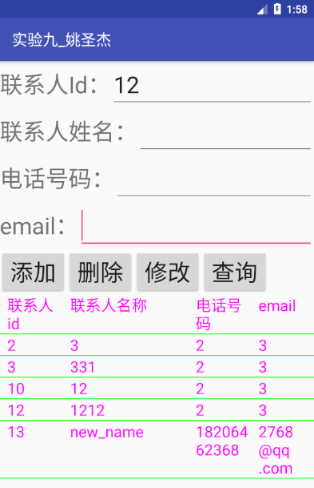
图22 删除联系人后重新查询

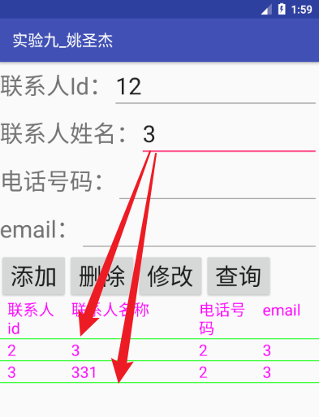
图23 根据联系人姓名3进行模糊查询

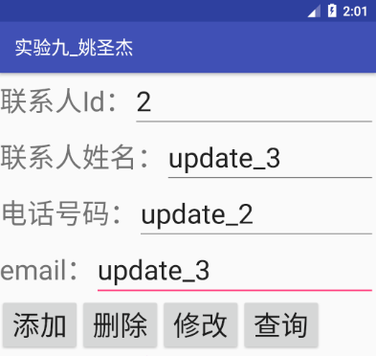
图24 修改联系人

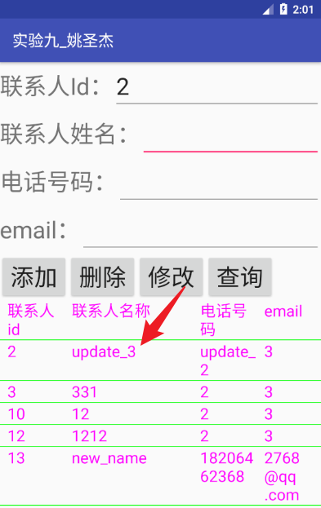
图25 修改联系人后查询所有
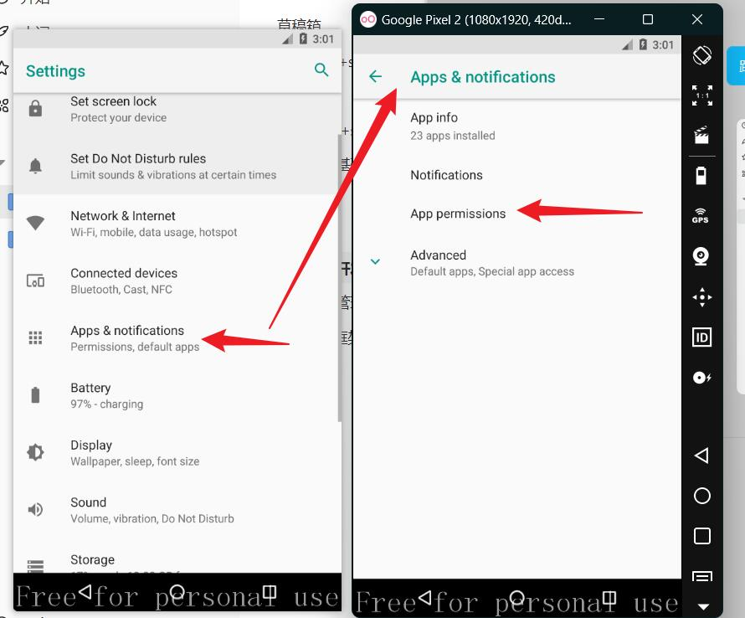
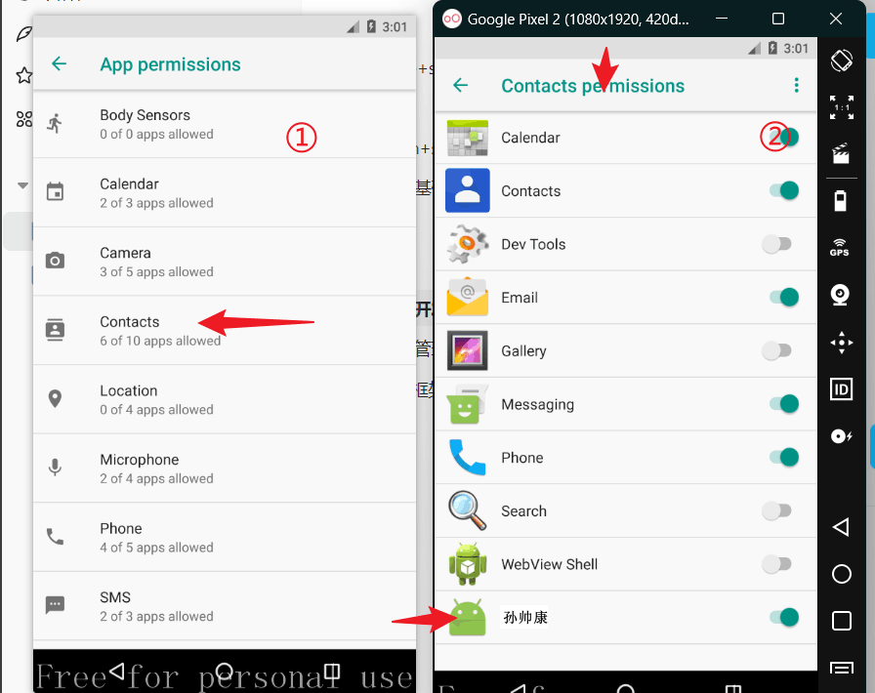
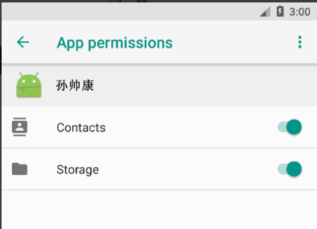
图26打开访问“联系人”权限的步骤

实验报告

第一部分：通过自定contentProvider远程操作

发出者

App2/AndroidManifest.xml（提供ContentProvider）
<activity android:name=".EmployeeActivity"
android:label="实验九_孙帅康">
<intent-filter>
<action android:name="android.intent.action.MAIN" />
<category android:name="android.intent.category.LAUNCHER" />
</intent-filter>
</activity>
<provider
android:name=".StudentContentProvider"
android:authorities="weili.org.myapplication.studenttest"
android:exported="true"
/>
<provider
android:authorities="com.example.employee"
android:name=".EmployeeContentProvider"
android:exported="true"
/>

EmployeeDao.java
public class EmployeeDao {
public static void insert(Context context, String id, String name, String age, String height){
EmployeeDatabaseHelper employeeDatabaseHelper=new EmployeeDatabaseHelper(context);
SQLiteDatabase db = employeeDatabaseHelper.getWritableDatabase();
String sql="insert into employee(employeeid,employeename,employeeage,employeeheight) values(?,?,?,?)";
db.execSQL(sql,new Object[]{id,name,age,height});
}
public static void delete(Context context,String id){
EmployeeDatabaseHelper employeeDatabaseHelper=new EmployeeDatabaseHelper(context);
SQLiteDatabase db=employeeDatabaseHelper.getWritableDatabase();
String sql="delete from employee where employeeid=?";
db.execSQL(sql,new Object[]{id});
}
public static void deleteAll(Context context){
EmployeeDatabaseHelper employeeDatabaseHelper=new EmployeeDatabaseHelper(context);
SQLiteDatabase db=employeeDatabaseHelper.getWritableDatabase();
db.delete("employee",null,null);
}
public static void update(Context context,String id, String name, String age, String height){
EmployeeDatabaseHelper employeeDatabaseHelper=new EmployeeDatabaseHelper(context);
SQLiteDatabase db=employeeDatabaseHelper.getWritableDatabase();
String sql="update employee set employeename=?,employeeage=?,employeeheight=? where employeeid=?";
db.execSQL(sql,new Object[]{name,age,height,id});
}
public static List<Map<String,String>> listAll(Context context){
EmployeeDatabaseHelper employeeDatabaseHelper=new EmployeeDatabaseHelper(context);
List<Map<String,String>> list=new ArrayList<>();
String sql="select employeeid,employeename,employeeage,employeeheight from employee";
SQLiteDatabase db=employeeDatabaseHelper.getReadableDatabase();
Cursor cursor=db.rawQuery(sql,null);
while (cursor.moveToNext()){
Map<String,String> map =new HashMap<>();
map.put("employeeid",cursor.getString(0));
map.put("employeename",cursor.getString(1));
map.put("employeeage",cursor.getString(2));
map.put("employeeheight",cursor.getString(3));
list.add(map);
}
return list;
}
}

EmployeeDatabaseHelper.java
/**
* Created by 27682 on 2022/11/27.
* 数据库辅助类，创建员工表
*/
public class EmployeeDatabaseHelper extends SQLiteOpenHelper {
private static final String DATABASENAME="employeeDB.db";//使用Sqlite数据库，创建TeacherDB，包含teacher表
public static final int DATABASEVERSION=1;
public static final String TABLENAME="employee";
public EmployeeDatabaseHelper(Context context, String name, SQLiteDatabase.CursorFactory factory, int version) {
super(context, name, factory, version);
}
public EmployeeDatabaseHelper(Context context) {
super(context,DATABASENAME,null,DATABASEVERSION);
}
@Override
public void onCreate(SQLiteDatabase db) {
String sqlCreateTableEmployee="create table employee(employeeid text primary key,employeename text,employeeage text,employeeheight text)";
db.execSQL(sqlCreateTableEmployee);
}
@Override
public void onUpgrade(SQLiteDatabase sqLiteDatabase, int i, int i1) {
String sqlCreateTableTeacher="create table teacher(teacherid text primary key,teachername text,sex text,age integer)";
if(i==1&&i1==2)//当是版本号是从1升级到2的时候执行下面的创建teacher表的操作
sqLiteDatabase.execSQL(sqlCreateTableTeacher);
}
}

【将员工的增删改查暴露出去】EmployeeContentProvider.java
public class EmployeeContentProvider extends ContentProvider {
private UriMatcher matcher=new UriMatcher(UriMatcher.NO_MATCH);
private EmployeeDatabaseHelper employeeDatabaseHelper;
final String AUTHORITY="com.example.employee";
public EmployeeContentProvider(){
System.out.println("EmployeeContentProvider构造方法()被调用");
}
@Override
public boolean onCreate() {
employeeDatabaseHelper=new EmployeeDatabaseHelper(this.getContext());
matcher.addURI(AUTHORITY,"updateemployee",1);//修改员工信息
matcher.addURI(AUTHORITY,"deletemployee/#",1);//删除单个员工，需要根据employeeid来判断
matcher.addURI(AUTHORITY,"deleteallemployee",2);//删除所有员工
matcher.addURI(AUTHORITY,"employeeall",1);//查询所有员工记录
matcher.addURI(AUTHORITY,"employees/*",2);//模糊查询多个员工
matcher.addURI(AUTHORITY, "employee/#", 3);//查询单个员工，需要根据employeeid来判断,#是数字通配符，将来可以匹配student/001,student/002等
matcher.addURI(AUTHORITY, "insertemployee", 1);//插入员工
matcher.addURI(AUTHORITY,"updateemployee",1);//更新员工
return true;
}
@Nullable
@Override
public Cursor query(@NonNull Uri uri, @Nullable String[] strings, @Nullable String s, @Nullable String[] strings1, @Nullable String s1) {
Cursor cursor=null;
SQLiteDatabase db=employeeDatabaseHelper.getReadableDatabase();
switch (matcher.match(uri)){
case 1://查询所有员工
cursor = db.query("employee", strings, s, strings1, "", "", s1);
break;
case 2://根据员工编号模糊查询
cursor=db.query("employee", strings, s, strings1, "", "", s1);
break;
case 3:
cursor=db.query("employee", strings, s, strings1, "", "", "");
break;
default:
System.out.println("调用query方法时，没有收到合适的uri");
}
return cursor;
}
@Nullable
@Override
public String getType(@NonNull Uri uri) {
return null;
}
@Nullable
@Override
public Uri insert(@NonNull Uri uri, @Nullable ContentValues contentValues) {
SQLiteDatabase db=employeeDatabaseHelper.getReadableDatabase();
switch (matcher.match(uri)){
case 1:
db.insert("employee",null,contentValues);
db.close();
break;
default:
throw new IllegalArgumentException("未知的uri");
}
db.close();
this.getContext().getContentResolver().notifyChange(Uri.parse("content://com.example.employee/insertemployee"),null);
return uri;
}
@Override
public int delete(@NonNull Uri uri, @Nullable String s, @Nullable String[] strings) {
int ret=-1;
SQLiteDatabase db=employeeDatabaseHelper.getReadableDatabase();
switch (matcher.match(uri)){
case 1:
ret = db.delete("employee",s,strings);
break;
case 2:
ret = db.delete("employee",null,null);
break;
default:
throw new IllegalArgumentException("未知的uri");
}
db.close();
this.getContext().getContentResolver().notifyChange(Uri.parse("content://com.example.employee/employeeall"),null);
return ret;
}
@Override
public int update(@NonNull Uri uri, @Nullable ContentValues contentValues, @Nullable String s, @Nullable String[] strings) {
int ret=-1;
SQLiteDatabase db=employeeDatabaseHelper.getReadableDatabase();
switch (matcher.match(uri)){
case 1:
ret=db.update("employee",contentValues,s,strings);
break;
case 2:
throw new IllegalAccessError("未知的uri");
}
db.close();
this.getContext().getContentResolver().notifyChange(Uri.parse("content://com.example.employee/employeeall"),null);
return ret;
}
}

EmployeeAdapter.java
public class EmployeeAdapter extends SimpleAdapter {
private ArrayList<Map<String,String>> mData;
public ArrayList<Map<String,String>> getmData(){
return mData;
}
public EmployeeAdapter(Context context, List<? extends Map<String, ?>> data, int resource, String[] from, int[] to) {
super(context, data, resource, from, to);
this.mData=(ArrayList<Map<String,String>>)data;
}
public View getView(int position, View convertView, ViewGroup parent){
final int mPosition =position;
return super.getView(position, convertView,parent);
}
}

EmployeeActivity.java
/**
* Created by 27682 on 2022/11/27.
* 设计一个员工信息录入界面，当用户录入员工工号，姓名，身高等信息后支持数据的添加、删除、更新和查询等基本操作。
* 自定义一个ContentProvide，将这些数据暴露出去。
*/
public class EmployeeActivity extends AppCompatActivity {
Button btnAdd,btnListAll,btnClearAll,btnDeleteAll,btnDelete,btnUpdate;
EditText editId,editName,editAge,editHeight;
ListView listView;
String currentEmployeeId;
protected void onCreate(@Nullable Bundle savedInstanceState) {
super.onCreate(savedInstanceState);
setContentView(R.layout.ex9_employee_activity);
btnDelete=(Button)findViewById(R.id.ex9btn_employee_delete);
btnUpdate=(Button)findViewById(R.id.ex9btn_employee_update);
btnAdd=(Button)findViewById(R.id.ex9btn_employee_add);
btnClearAll=(Button)findViewById(R.id.ex9btn_employee_clearAll);
btnDeleteAll=(Button)findViewById(R.id.ex9btn_employee_deleteAll);
btnListAll=(Button)findViewById(R.id.ex9btn_employee_listAll);
editAge=(EditText)findViewById(R.id.ex9edit_employee_age);
editId=(EditText)findViewById(R.id.ex9edit_employee_id);
editHeight=(EditText)findViewById(R.id.ex9edit_employee_height);
editName=(EditText)findViewById(R.id.ex9edit_employee_name);
listView=(ListView)findViewById(R.id.ex8_listView_employee);
View view= LayoutInflater.from(this).inflate(R.layout.employee_item_header,null);
listView.addHeaderView(view);
listView.setOnItemClickListener(new AdapterView.OnItemClickListener() {
@Override
public void onItemClick(AdapterView<?> parent, View view, int position, long id) {
if(position==0) {//=0表示点击的是表头，不是内容，不用显示。否则表头也会显示到上面的输入框中
editAge.setText("");
editId.setText("");
editHeight.setText("");
editName.setText("");
return;
}
TextView employeeId=(TextView)view.findViewById(R.id.employeeId);
TextView employeeName=(TextView)view.findViewById(R.id.employeeName);
TextView employeeAge=(TextView)view.findViewById(R.id.employeeAge);
TextView employeeHeight=(TextView)view.findViewById(R.id.employeeHeight);
editAge.setText(employeeAge.getText().toString());
editId.setText(employeeId.getText().toString());
editHeight.setText(employeeHeight.getText().toString());
editName.setText(employeeName.getText().toString());
currentEmployeeId=employeeId.getText().toString();//把当前studentId保存下来，当修改时当做原来的studentId使用
Toast.makeText(EmployeeActivity.this,"编号输入框被锁定，点击更新后可编辑",Toast.LENGTH_LONG).show();
editId.setFocusable(false);//锁定编号输入框
editId.setFocusableInTouchMode(false);
}
});
btnClearAll.setOnClickListener(new View.OnClickListener() {
@Override
public void onClick(View view) {
List<Map<String,String>> list=new ArrayList<Map<String, String>>();
EmployeeAdapter adapter=new EmployeeAdapter(EmployeeActivity.this,list,R.layout.employee_item_header,new String[]{ "employeeid","employeename","employeeage","employeeheight"},new int[]{R.id.employeeId,R.id.employeeName,R.id.employeeAge,R.id.employeeHeight});
listView.setAdapter(adapter);
}
});
btnDeleteAll.setOnClickListener(new View.OnClickListener() {
@Override
public void onClick(View view) {
/*根据编号进行删除*/
// String id=editId.getText().toString();
// EmployeeDao.delete(EmployeeActivity.this,id);
/*删除全部*/
EmployeeDao.deleteAll(EmployeeActivity.this);
/*重新查询全部*/
List<Map<String,String>> list=EmployeeDao.listAll(EmployeeActivity.this);
EmployeeAdapter adapter=new EmployeeAdapter(EmployeeActivity.this,list,R.layout.employee_item_header,new String[]{ "employeeid","employeename","employeeage","employeeheight"},new int[]{R.id.employeeId,R.id.employeeName,R.id.employeeAge,R.id.employeeHeight});
listView.setAdapter(adapter);
}
});
btnListAll.setOnClickListener(new View.OnClickListener(){
@Override
public void onClick(View view) {
List<Map<String,String>> list=EmployeeDao.listAll(EmployeeActivity.this);
EmployeeAdapter adapter=new EmployeeAdapter(EmployeeActivity.this,list,R.layout.employee_item_header,new String[]{ "employeeid","employeename","employeeage","employeeheight"},new int[]{R.id.employeeId,R.id.employeeName,R.id.employeeAge,R.id.employeeHeight});
listView.setAdapter(adapter);
}
});
btnAdd.setOnClickListener(new View.OnClickListener(){
@Override
public void onClick(View view) {
String id=editId.getText().toString();
String name=editName.getText().toString();
String age=editAge.getText().toString();
String height=editHeight.getText().toString();
try {
EmployeeDao.insert(EmployeeActivity.this,id,name,age,height);
}catch (Exception e){
e.getMessage();
if(e.getMessage().equals("UNIQUE constraint failed: employee.employeeid (code 1555)")){
System.out.println("主键值被重复插入");
Toast.makeText(EmployeeActivity.this,"主键值被重复插入",Toast.LENGTH_LONG).show();
}
System.out.println(e.getMessage());
}
List<Map<String,String>> list=EmployeeDao.listAll(EmployeeActivity.this);
EmployeeAdapter adapter=new EmployeeAdapter(EmployeeActivity.this,list,R.layout.employee_item_header,new String[]{ "employeeid","employeename","employeeage","employeeheight"},new int[]{R.id.employeeId,R.id.employeeName,R.id.employeeAge,R.id.employeeHeight});
listView.setAdapter(adapter);
}
});
btnUpdate.setOnClickListener(new View.OnClickListener() {
@Override
public void onClick(View view) {
String id=editId.getText().toString();
String name=editName.getText().toString();
String age=editAge.getText().toString();
String height=editHeight.getText().toString();
EmployeeDao.update(EmployeeActivity.this,id,name,age,height);
/*重新查询并绑定*/
List<Map<String,String>> list=EmployeeDao.listAll(EmployeeActivity.this);
EmployeeAdapter adapter=new EmployeeAdapter(EmployeeActivity.this,list,R.layout.employee_item_header,new String[]{ "employeeid","employeename","employeeage","employeeheight"},new int[]{R.id.employeeId,R.id.employeeName,R.id.employeeAge,R.id.employeeHeight});
listView.setAdapter(adapter);
editId.setFocusable(true);//解除限制，更新完毕后可以对编号进行修改
editId.setFocusableInTouchMode(true);
}
});
btnDelete.setOnClickListener(new View.OnClickListener() {
@Override
public void onClick(View view) {
/*获取要删除的编号*/
String id=editId.getText().toString();
/*根据获取到的编号进行删除*/
EmployeeDao.delete(EmployeeActivity.this,id);
/*重新查询并绑定*/
List<Map<String,String>> list=EmployeeDao.listAll(EmployeeActivity.this);
EmployeeAdapter adapter=new EmployeeAdapter(EmployeeActivity.this,list,R.layout.employee_item_header,new String[]{ "employeeid","employeename","employeeage","employeeheight"},new int[]{R.id.employeeId,R.id.employeeName,R.id.employeeAge,R.id.employeeHeight});
listView.setAdapter(adapter);
editId.setFocusable(true);//解除限制，更新完毕后可以对编号进行修改
editId.setFocusableInTouchMode(true);
}
});
}
}

（布局文件）ex9_employee_activity.xml
<?xml version="1.0" encoding="utf-8"?>
<LinearLayout xmlns:android="http://schemas.android.com/apk/res/android"
android:orientation="vertical" android:layout_width="match_parent"
android:layout_height="match_parent">
<LinearLayout
android:layout_width="match_parent"
android:layout_height="wrap_content"
android:orientation="horizontal">
<TextView
android:layout_width="wrap_content"
android:layout_height="wrap_content"
android:text="编号："/>
<EditText
android:id="@+id/ex9edit_employee_id"
android:layout_width="match_parent"
android:layout_height="wrap_content" />
</LinearLayout>
<LinearLayout
android:layout_width="match_parent"
android:layout_height="wrap_content"
android:orientation="horizontal">
<TextView
android:layout_width="wrap_content"
android:layout_height="wrap_content"
android:text="姓名："/>
<EditText
android:id="@+id/ex9edit_employee_name"
android:layout_width="match_parent"
android:layout_height="wrap_content" />
</LinearLayout>
<LinearLayout
android:layout_width="match_parent"
android:layout_height="wrap_content"
android:orientation="horizontal">
<TextView
android:layout_width="wrap_content"
android:layout_height="wrap_content"
android:text="年龄："/>
<EditText
android:id="@+id/ex9edit_employee_age"
android:layout_width="match_parent"
android:layout_height="wrap_content" />
</LinearLayout>
<LinearLayout
android:layout_width="match_parent"
android:layout_height="wrap_content"
android:orientation="horizontal">
<TextView
android:layout_width="wrap_content"
android:layout_height="wrap_content"
android:text="身高："/>
<EditText
android:id="@+id/ex9edit_employee_height"
android:layout_width="match_parent"
android:layout_height="wrap_content" />
</LinearLayout>
<LinearLayout
android:layout_width="match_parent"
android:layout_height="wrap_content"
android:orientation="horizontal">
<Button
android:id="@+id/ex9btn_employee_add"
android:layout_width="wrap_content"
android:layout_height="wrap_content"
android:text="添加数据"
/>
<Button
android:id="@+id/ex9btn_employee_listAll"
android:layout_width="wrap_content"
android:layout_height="wrap_content"
android:text="全部显示"
/>
<Button
android:id="@+id/ex9btn_employee_clearAll"
android:layout_width="wrap_content"
android:layout_height="wrap_content"
android:text="清除显示"
/>
<Button
android:id="@+id/ex9btn_employee_deleteAll"
android:layout_width="wrap_content"
android:layout_height="wrap_content"
android:text="全部删除"
/>
</LinearLayout>
<LinearLayout
android:layout_width="match_parent"
android:layout_height="wrap_content"
android:orientation="horizontal">
<Button
android:id="@+id/ex9btn_employee_update"
android:layout_width="wrap_content"
android:layout_height="wrap_content"
android:onClick="btnUpdate"
android:text="更新"
/>
<Button
android:id="@+id/ex9btn_employee_delete"
android:layout_width="wrap_content"
android:layout_height="wrap_content"
android:onClick="btnDelete"
android:text="删除"
/>
</LinearLayout>
<ListView
android:id="@+id/ex8_listView_employee"
android:layout_width="match_parent"
android:layout_height="wrap_content"></ListView>
</LinearLayout>

（listView的布局文件）employee_item_header
<?xml version="1.0" encoding="utf-8"?>
<LinearLayout xmlns:android="http://schemas.android.com/apk/res/android"
android:orientation="horizontal"
android:layout_width="match_parent"
android:layout_height="match_parent">
<!-- 设控件的宽度为0，然后设置layout_weight，让他们按比例瓜分整个这一行的宽度,从而保证每一行的各列宽度都一样 -->
<TextView
android:id="@+id/employeeId"
android:text="工号"
android:layout_width="0dp"
android:layout_height="wrap_content"
android:textSize="20dp"
android:textColor="#f0f"
android:paddingLeft="10dp"
android:layout_weight="1"/>
<TextView
android:id="@+id/employeeName"
android:text="姓名"
android:layout_width="0dp"
android:layout_height="wrap_content"
android:textSize="20dp"
android:textColor="#f0f"
android:paddingLeft="10dp"
android:layout_weight="2"/>
<TextView
android:id="@+id/employeeAge"
android:text="年龄"
android:layout_width="0dp"
android:layout_height="wrap_content"
android:textSize="20dp"
android:textColor="#f0f"
android:paddingLeft="10dp"
android:layout_weight="1"/>
<TextView
android:id="@+id/employeeHeight"
android:text="身高"
android:layout_width="0dp"
android:layout_height="wrap_content"
android:textSize="20dp"
android:textColor="#f0f"
android:paddingLeft="10dp"
android:layout_weight="1"/>
</LinearLayout>

接收者

Contentproviderdemo/ AndroidManifest.xml（接收）
<!--ContentProvider的案例：调用另外一个应用程序（app2中）自定义的ContentProvider -->
<activity android:name=".StudentActivity">
</activity>
<activity android:name=".EmployeeActivity_remote"
android:label="实验九_孙帅康">
<intent-filter>
<action android:name="android.intent.action.MAIN" />
<category android:name="android.intent.category.LAUNCHER" />
</intent-filter>
</activity>

第二部分：通过系统contentProvider远程操作手机联系人

ContactActivity.java
/*
* 使用系统ContentProvider，实验九的第二题，调用系统的uri查看手机通讯录
* */
public class ContactActivity extends AppCompatActivity {
EditText txtContactId,txtContactName,txtPhoneNumber,txtEmail;
//Button btnAdd,btnUpdate,btnDelete,btnQuery;
ListView listViewContact;
ContentResolver contentResolver;
//Uri contactUri= Uri.parse("content://com.android.contacts/contacts");//联系人信息 Uri
Uri contactUri=ContactsContract.Contacts.CONTENT_URI;//联系人信息 Uri 推荐使用这种方式
//Uri phoneUri=Uri.parse("content://com.android.contacts/data/phones");//联系人电话 Uri
Uri phoneUri=ContactsContract.CommonDataKinds.Phone.CONTENT_URI;//联系人电话 Uri
//Uri emailUri=Uri.parse("content://com.android.contacts/data/emails");//联系人email Uri
Uri emailUri=ContactsContract.CommonDataKinds.Email.CONTENT_URI;//联系人email Uri
@Override
protected void onCreate(Bundle savedInstanceState) {
super.onCreate(savedInstanceState);
setContentView(R.layout.activity_contact);
listViewContact=(ListView)findViewById(R.id.listViewContact);
txtContactId=(EditText)findViewById(R.id.txtContactId);
txtContactName=(EditText)findViewById(R.id.txtContactName);
txtPhoneNumber=(EditText)findViewById(R.id.txtPhoneNumber);
txtEmail=(EditText)findViewById(R.id.txtEmail);
contentResolver=getContentResolver();
//下面开始给listViewContact添加header。先把布局文件contact_item_header实例化为一个view对象
View headerView= LayoutInflater.from(this).inflate(R.layout.contact_item_header,null);
listViewContact.addHeaderView(headerView);
listViewContact.setOnItemClickListener(new AdapterView.OnItemClickListener() {
@Override
public void onItemClick(AdapterView<?> parent, View view, int position, long id) {
if(position==0) {//=0表示点击的是表头，不是内容，不用显示。否则表头也会显示到上面的输入框中
txtContactId.setText("");
txtContactName.setText("");
txtPhoneNumber.setText("");
txtEmail.setText("");
return;
}
TextView contactId=(TextView)view.findViewById(R.id.contactId);
TextView contactName=(TextView)view.findViewById(R.id.contactName);
TextView phoneNumber=(TextView)view.findViewById(R.id.phoneNumber);
TextView email=(TextView)view.findViewById(R.id.email);
txtContactId.setText(contactId.getText().toString());
txtContactName.setText(contactName.getText().toString());
txtPhoneNumber.setText(phoneNumber.getText().toString());
txtEmail.setText(email.getText().toString());
}
});
}
public void btnAddClick(View view){
//先向ContactsContract.RawContacts.CONTENT_URI插入一个空值，
// 或者Uri uri = Uri.parse("content://com.android.contacts/raw_contacts"); 就是raw_contacts对应的uri
// 目的是获得一个rawContactId（实际是raw_contact表的_id字段的值，是自增的），
// 后面要基于该rawContactId，插入其他字段值
ContentValues values=new ContentValues();
Uri rawContactUri=contentResolver.insert(ContactsContract.RawContacts.CONTENT_URI,values);//先得到一个id，id在联系人表中是自增的
long rawContactId= ContentUris.parseId(rawContactUri);
//开始准备插入联系人名字
values.clear();
//插入联系人的id
values.put(ContactsContract.Data.RAW_CONTACT_ID,rawContactId);//联系人的Id
//插入内容类型：联系人姓名
values.put(ContactsContract.Data.MIMETYPE, ContactsContract.CommonDataKinds.StructuredName.CONTENT_ITEM_TYPE);//表示联系人姓名
//联系人名字
values.put(ContactsContract.CommonDataKinds.StructuredName.GIVEN_NAME,txtContactName.getText().toString().trim());
//插入联系人名字
contentResolver.insert(ContactsContract.Data.CONTENT_URI,values);
// 下面开始准备插入联系人电话号码
values.clear();
values.put(ContactsContract.Data.RAW_CONTACT_ID,rawContactId);
//插入内容类型：联系人电话号码
values.put(ContactsContract.Data.MIMETYPE, ContactsContract.CommonDataKinds.Phone.CONTENT_ITEM_TYPE);//表示电话号码
values.put(ContactsContract.CommonDataKinds.Phone.NUMBER,txtPhoneNumber.getText().toString().trim());
//电话号码的类型
values.put(ContactsContract.CommonDataKinds.Phone.TYPE, ContactsContract.CommonDataKinds.Phone.TYPE_MOBILE);//移动电话
contentResolver.insert(ContactsContract.Data.CONTENT_URI,values);
//下面开始准备插入email
values.clear();
values.put(ContactsContract.Data.RAW_CONTACT_ID,rawContactId);
//插入内容的类型：email
values.put(ContactsContract.Contacts.Data.MIMETYPE, ContactsContract.CommonDataKinds.Email.CONTENT_ITEM_TYPE);//表示Email
values.put(ContactsContract.CommonDataKinds.Email.DATA,txtEmail.getText().toString().trim());
// 设置该电子邮件的类型
values.put(ContactsContract.CommonDataKinds.Email.TYPE, ContactsContract.CommonDataKinds.Email.TYPE_WORK);
contentResolver.insert(ContactsContract.Data.CONTENT_URI,values);
Toast.makeText(this, "联系人数据添加成功", Toast.LENGTH_SHORT).show();
}
public void btnUpdateClick(View view){
/* (1)不需要更新raw_contacts，只需要更新data表；
(2)uri=content://com.android.contacts/data 表示对data表进行操作；
*/
Uri uri=Uri.parse("content://com.android.contacts/data");
ContentValues values=new ContentValues();
values.put("data1",txtContactName.getText().toString().trim());
contentResolver.update(uri,values,"mimetype=? and raw_contact_id=?",new String[]{"vnd.android.cursor.item/name",txtContactId.getText().toString()});
values.clear();
values.put(ContactsContract.CommonDataKinds.Phone.NUMBER,txtPhoneNumber.getText().toString().trim());
values.put(ContactsContract.Data.MIMETYPE, ContactsContract.CommonDataKinds.Phone.CONTENT_ITEM_TYPE);
values.put(ContactsContract.CommonDataKinds.Phone.TYPE, ContactsContract.CommonDataKinds.Phone.TYPE_MOBILE);//移动电话
contentResolver.update(uri,values,"mimetype=? and raw_contact_id=?",new String[]{"vnd.android.cursor.item/phone_v2",txtContactId.getText().toString()});
values.clear();
values.put("data1",txtEmail.getText().toString().trim());
//或者values.put(ContactsContract.CommonDataKinds.Email.DATA,txtEmail.getText().toString().trim());
values.put(ContactsContract.Contacts.Data.MIMETYPE, ContactsContract.CommonDataKinds.Email.CONTENT_ITEM_TYPE);//MIMETYPE=1,表示Email
values.put(ContactsContract.CommonDataKinds.Email.TYPE, ContactsContract.CommonDataKinds.Email.TYPE_WORK);
contentResolver.update(uri,values,"mimetype=? and raw_contact_id=?",new String[]{"vnd.android.cursor.item/email_v2",txtEmail.getText().toString()});
}
public void btnDeleteClick(View view){
String contactId=txtContactId.getText().toString().trim();
//删除数据，把raw_contact表中id等于要删除的id值的记录删除即可。
//因而uri使用ContactsContract.RawContacts.CONTENT_URI，跟增加联系人是一样的uri
if(contentResolver.delete(ContactsContract.RawContacts.CONTENT_URI,ContactsContract.RawContacts._ID+"="+contactId,null)>=1){
Toast.makeText(ContactActivity.this,"delete "+contactId+" 成功",Toast.LENGTH_LONG).show();
}
}
public void btnQueryClick(View view){
Cursor cursor;
List<Map<String,String>> listContact=new ArrayList<Map<String,String>>();
String contactId;
StringBuffer sb=new StringBuffer();//用来临时保存联系人的多个电话和多个email
String name=txtContactName.getText().toString().trim();
cursor=contentResolver.query(contactUri,new String[]{ContactsContract.Contacts._ID,ContactsContract.Contacts.DISPLAY_NAME},ContactsContract.Contacts.DISPLAY_NAME+ " like '%"+name+"%'",null,null);
while(cursor.moveToNext()){//遍历所有联系人表，有2个字段，一个id，一个displayName，分别用ContactsContract.Contacts._ID和ContactsContract.Contacts.DISPLAY_NAME代表
//1得到联系人表的id和displayName
contactId=cursor.getString(cursor.getColumnIndex(ContactsContract.Contacts._ID));
String contactName=cursor.getString(cursor.getColumnIndex(ContactsContract.Contacts.DISPLAY_NAME));
//2查询该id对应的电话表中的电话号码，电话号码字段是ContactsContract.CommonDataKinds.Phone.NUMBER所代表的值表示的
Cursor phones=contentResolver.query(phoneUri,new String[]{ContactsContract.CommonDataKinds.Phone.NUMBER},ContactsContract.CommonDataKinds.Phone.CONTACT_ID+"="+contactId,null,null);
while (phones.moveToNext()){
sb.append(phones.getString(phones.getColumnIndex(ContactsContract.CommonDataKinds.Phone.NUMBER)));
sb.append(" ");//每个号码之间用两个空格隔开
}
phones.close();
String phoneNumber=sb.toString().trim();//去掉最后的一个电话号码之后加上的2个空格
//3查询该id对应email表中的email，email字段是ContactsContract.CommonDataKinds.Email.DATA所代表的值表示的
sb.delete(0,sb.length()-1);
Cursor emails=contentResolver.query(emailUri,new String[]{ContactsContract.CommonDataKinds.Email.DATA},ContactsContract.CommonDataKinds.Email.CONTACT_ID+"="+contactId,null,null);
while(emails.moveToNext()){
sb.append(emails.getString(emails.getColumnIndex(ContactsContract.CommonDataKinds.Email.DATA)));
sb.append(" ");
}
emails.close();
String email=sb.toString().trim();//去掉最后的一个email之后加上的2个空格
sb.delete(0,sb.length()-1);
//下面开始生成Map对象
Map<String,String> map=new HashMap<String,String>();
map.put("contactId",contactId);
map.put("contactName",contactName);
map.put("phoneNumber",phoneNumber);
map.put("email",email);
listContact.add(map);
}
cursor.close();
//联系人遍历完毕，也生成了联系人列表listContact，每一行联系人包括4项：联系人id、联系人名称、电话号码、email
//开始生成SimpleAdapter对象
SimpleAdapter adapter=new SimpleAdapter(ContactActivity.this,listContact,R.layout.contact_item,new String[]{"contactId","contactName","phoneNumber","email"},new int[]{R.id.contactId,R.id.contactName,R.id.phoneNumber,R.id.email});
listViewContact.setAdapter(adapter);
System.out.println("查询联系列表结束，并显示到了listViewContact上");
}
static void setEditTextReadOnly(EditText editText){
editText.setCursorVisible(false);//设置光标不可见
editText.setFocusable(false);//设置得不到输入焦点
editText.setFocusableInTouchMode(false);//设置触摸时也得不到焦点
}
static void setEditTextEditable(EditText editText){
editText.setCursorVisible(true);//设置光标可见
editText.setFocusable(true);//设置可以得到输入焦点
editText.setFocusableInTouchMode(true);//设置触摸时也可以得到焦点
}
}

（布局文件）ex9_employee_activity.xml
<?xml version="1.0" encoding="utf-8"?>
<LinearLayout xmlns:android="http://schemas.android.com/apk/res/android"
android:orientation="vertical" android:layout_width="match_parent"
android:layout_height="match_parent">
<LinearLayout
android:layout_width="match_parent"
android:layout_height="wrap_content"
android:orientation="horizontal">
<TextView
android:layout_width="wrap_content"
android:layout_height="wrap_content"
android:text="编号："/>
<EditText
android:id="@+id/ex9edit_employee_id"
android:layout_width="match_parent"
android:layout_height="wrap_content" />
</LinearLayout>
<LinearLayout
android:layout_width="match_parent"
android:layout_height="wrap_content"
android:orientation="horizontal">
<TextView
android:layout_width="wrap_content"
android:layout_height="wrap_content"
android:text="姓名："/>
<EditText
android:id="@+id/ex9edit_employee_name"
android:layout_width="match_parent"
android:layout_height="wrap_content" />
</LinearLayout>
<LinearLayout
android:layout_width="match_parent"
android:layout_height="wrap_content"
android:orientation="horizontal">
<TextView
android:layout_width="wrap_content"
android:layout_height="wrap_content"
android:text="年龄："/>
<EditText
android:id="@+id/ex9edit_employee_age"
android:layout_width="match_parent"
android:layout_height="wrap_content" />
</LinearLayout>
<LinearLayout
android:layout_width="match_parent"
android:layout_height="wrap_content"
android:orientation="horizontal">
<TextView
android:layout_width="wrap_content"
android:layout_height="wrap_content"
android:text="身高："/>
<EditText
android:id="@+id/ex9edit_employee_height"
android:layout_width="match_parent"
android:layout_height="wrap_content" />
</LinearLayout>
<LinearLayout
android:layout_width="match_parent"
android:layout_height="wrap_content"
android:orientation="horizontal">
<Button
android:id="@+id/ex9btn_employee_delete"
android:layout_width="wrap_content"
android:layout_height="wrap_content"
android:onClick="btnDeleteClick"
android:text="ID删除"
/>
<Button
android:id="@+id/ex9btn_employee_listAll"
android:layout_width="wrap_content"
android:layout_height="wrap_content"
android:onClick="btnListAllClick"
android:text="显示全部"
/>
<Button
android:id="@+id/ex9btn_employee_query"
android:layout_width="wrap_content"
android:layout_height="wrap_content"
android:onClick="btnQueryClick"
android:text="ID查询"
/>
<Button
android:id="@+id/ex9btn_employee_update"
android:layout_width="wrap_content"
android:layout_height="wrap_content"
android:onClick="btnUpdateClick"
android:text="ID更新"
/>
</LinearLayout>
<ListView
android:id="@+id/ex8_listView_employee"
android:layout_width="match_parent"
android:layout_height="wrap_content"></ListView>
</LinearLayout>

五、实验总结
实验内容分成三个部分，第一和第二部分别分围绕着将本地的操作使用自定义ContentProvide的暴露和远程操作。第三部分为
在进行第一部分对本地操作的添加数据，全部显示，清除显示，全部删除等功能的实现过程中，对SQLite的使用有了进一步的掌握。实现思路大致为：新建EmployeeDatabaseHelper，建表"create table employee(employeename text primary key,employeeage,employeeheight)"；新建EmployeeContentProvider，实现CRUD方法。
在自定义ContentProvider时，对extends ContentProvider时需要重新的方法进行了编写的练习，对使用入参的方式操作SQLite数据库的方式有了进一步的练习和掌握。使用matcher.addURI()进行了Uri的注册。
在第二部分，使用第一部分所暴露出的ContentProvider进行远程的数据库操作。使用contentResolver.registerContentObserver，Uri.parse，contentResolver.query，contentResolver.query等方法与已经注册的Uri进行匹配。并根据进行远程操作的activity的editText提供的入参进行操作。
第三部分，
通过在manifests中进行权限的注册和在acitivity中调用系统Uri对联系人进行增删改查。
打开访问“联系人”权限的步骤：设置-应用与通知-应用权限中的自定义app的通讯录权限需要开放，才可以调用通讯录的ContentProvider。

