作业三 服务提供者
- 使用 MyBatis 实现数据库查询

新建数据库，并创建表
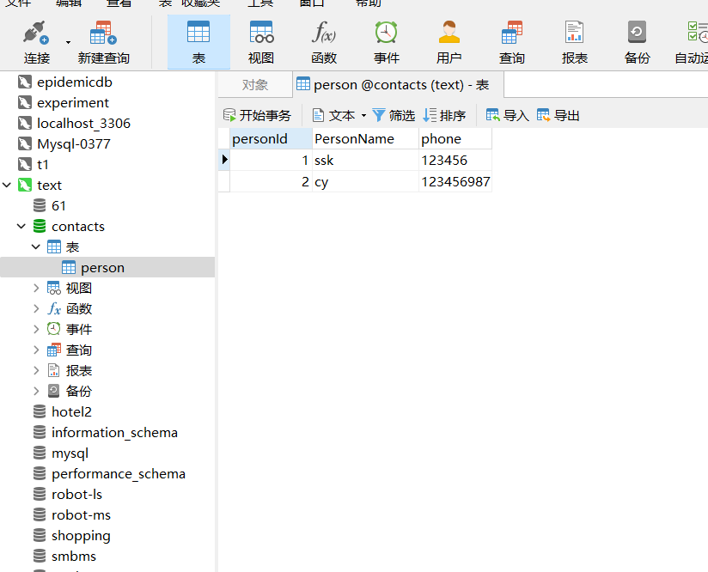
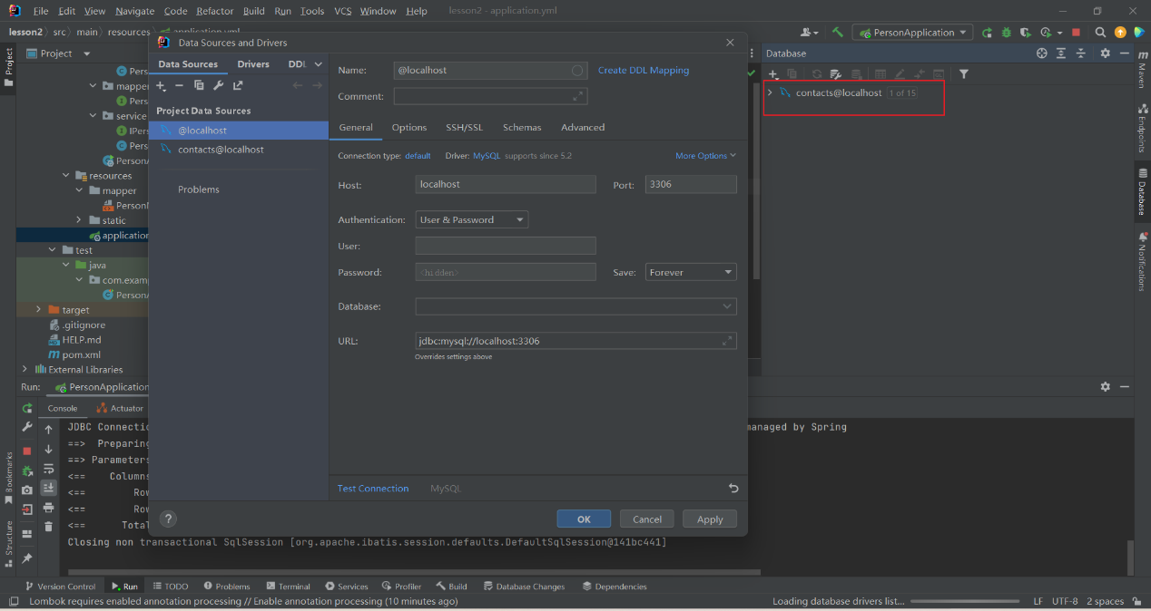

新建Spring Boot项目
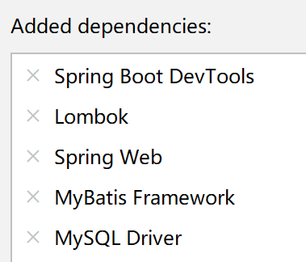

3.pom.xml：添加依赖如下
<?xml version="1.0" encoding="UTF-8"?>
<project xmlns="http://maven.apache.org/POM/4.0.0" xmlns:xsi="http://www.w3.org/2001/XMLSchema-instance"
xsi:schemaLocation="http://maven.apache.org/POM/4.0.0 https://maven.apache.org/xsd/maven-4.0.0.xsd">
<modelVersion>4.0.0</modelVersion>
<parent>
<groupId>org.springframework.boot</groupId>
<artifactId>spring-boot-starter-parent</artifactId>
<version>3.2.2</version>
<relativePath/> <!-- lookup parent from repository -->
</parent>
<groupId>com.example</groupId>
<artifactId>springBootSelectDemo</artifactId>
<version>0.0.1-SNAPSHOT</version>
<name>springBootSelectDemo</name>
<description>springBootSelectDemo</description>
<properties>
<java.version>17</java.version>
</properties>
<dependencies>
<dependency>
<groupId>org.springframework.boot</groupId>
<artifactId>spring-boot-starter-web</artifactId>
</dependency>
<dependency>
<groupId>org.mybatis.spring.boot</groupId>
<artifactId>mybatis-spring-boot-starter</artifactId>
<version>3.0.3</version>
</dependency>
<dependency>
<groupId>org.springframework.boot</groupId>
<artifactId>spring-boot-devtools</artifactId>
<scope>runtime</scope>
<optional>true</optional>
</dependency>
<dependency>
<groupId>com.mysql</groupId>
<artifactId>mysql-connector-j</artifactId>
<scope>runtime</scope>
</dependency>
<dependency>
<groupId>org.projectlombok</groupId>
<artifactId>lombok</artifactId>
<optional>true</optional>
</dependency>
<dependency>
<groupId>org.springframework.boot</groupId>
<artifactId>spring-boot-starter-test</artifactId>
<scope>test</scope>
</dependency>
<dependency>
<groupId>org.mybatis.spring.boot</groupId>
<artifactId>mybatis-spring-boot-starter-test</artifactId>
<version>3.0.3</version>
<scope>test</scope>
</dependency>
</dependencies>
<build>
<plugins>
<plugin>
<groupId>org.springframework.boot</groupId>
<artifactId>spring-boot-maven-plugin</artifactId>
<configuration>
<excludes>
<exclude>
<groupId>org.projectlombok</groupId>
<artifactId>lombok</artifactId>
</exclude>
</excludes>
</configuration>
</plugin>
</plugins>
</build>
</project>

application.yml
server:
port: 80
spring:
application:
name: person
datasource:
driver-class-name: com.mysql.cj.jdbc.Driver
url: jdbc:mysql://localhost:3306/contacts
username: root
password: root
mybatis:
mapper-locations: classpath*:mapper/*Mapper.xml
configuration:
map-underscore-to-camel-case: true
log-impl: org.apache.ibatis.logging.stdout.StdOutImpl
type-aliases-package: com.example.person.entity

自动生成的PersonApplication.java
package com.example.person;
import org.springframework.boot.SpringApplication;
import org.springframework.boot.autoconfigure.SpringBootApplication;
@SpringBootApplication
public class PersonApplication {
public static void main(String[] args) {
SpringApplication.run(PersonApplication.class, args);
}
}

分别创建包entity、mapper、service、controller和文件
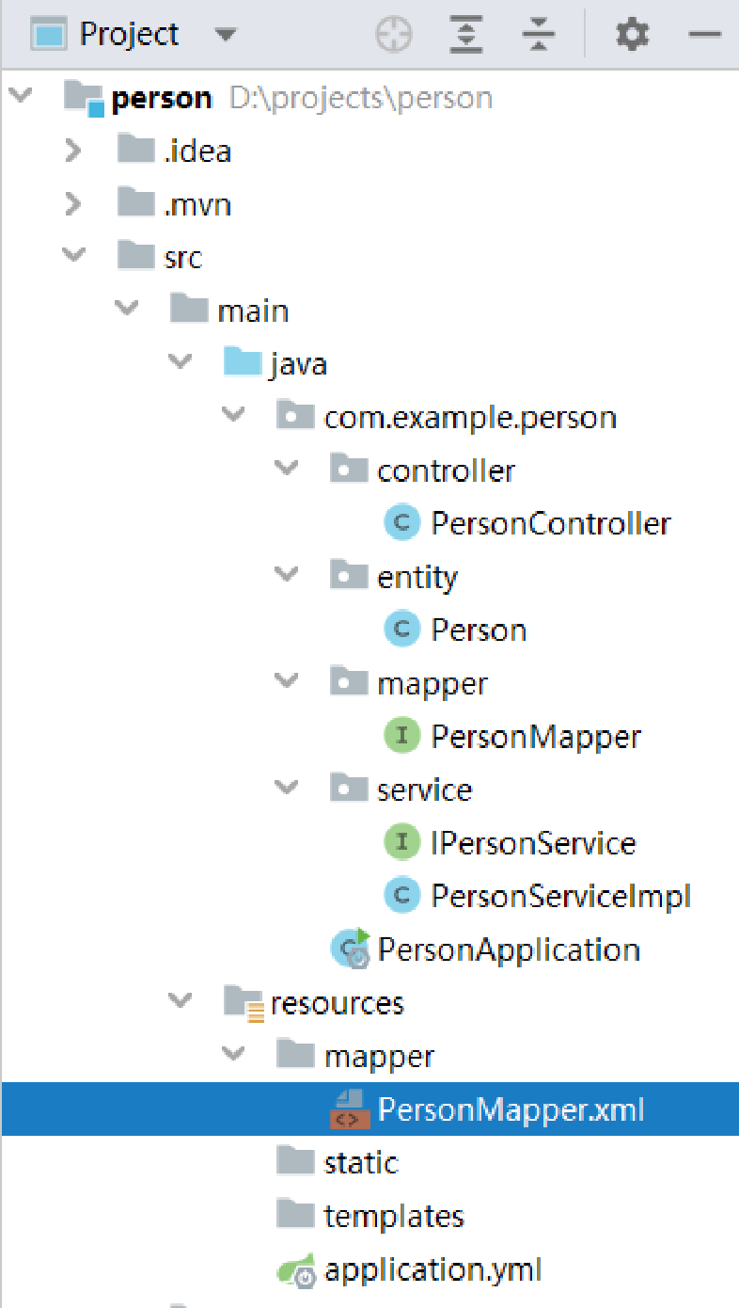

Person.java
package com.example.person.entity;
import lombok.Data;
@Data
public class Person {
private Integer personId;
private String personName;
private String phone;
}

PersonMapper.java
package com.example.person.mapper;
import com.example.person.entity.Person;
import org.apache.ibatis.annotations.Mapper;
import org.apache.ibatis.annotations.Select;
import java.util.List;
@Mapper
public interface PersonMapper {
// @Select("SELECT * FROM person")
List<Person> getPersonList();
}

PersonMapper.xml
<?xml version="1.0" encoding="UTF-8" ?>
<!DOCTYPE mapper
PUBLIC "-//mybatis.org//DTD Mapper 3.0//EN"
"http://mybatis.org/dtd/mybatis-3-mapper.dtd">
<mapper namespace="com.example.person.mapper.PersonMapper">
<select id="getPersonList" resultType="Person">
SELECT * FROM person
</select>
</mapper>

测试PersonApplicationTests.java
package com.example.person;
import com.example.person.mapper.PersonMapper;
import org.junit.jupiter.api.Test;
import org.springframework.beans.factory.annotation.Autowired;
import org.springframework.boot.test.context.SpringBootTest;
@SpringBootTest
class PersonApplicationTests {
@Autowired
private PersonMapper personMapper;
@Test
void testGetPersonList() {
personMapper.getPersonList().forEach(System.out::println);
}
@Test
void contextLoads() {
}
}

IPersonService.java
package com.example.person.service;
import com.example.person.entity.Person;
import java.util.List;
public interface IPersonService {
List<Person> getPersonList();
}

PersonServiceImpl.java
package com.example.person.service;
import com.example.person.entity.Person;
import com.example.person.mapper.PersonMapper;
import org.springframework.beans.factory.annotation.Autowired;
import org.springframework.stereotype.Service;
import java.util.List;
@Service
public class PersonServiceImpl implements IPersonService{
@Autowired
private PersonMapper personMapper;
@Override
public List<Person> getPersonList() {
return personMapper.getPersonList();
}
}

PersonController.java
package com.example.person.controller;
import com.example.person.entity.Person;
import com.example.person.service.PersonServiceImpl;
import org.springframework.beans.factory.annotation.Autowired;
import org.springframework.web.bind.annotation.RequestMapping;
import org.springframework.web.bind.annotation.RequestMethod;
import org.springframework.web.bind.annotation.RestController;
import java.util.List;
@RestController
public class PersonController {
@Autowired
private PersonServiceImpl personService;
@RequestMapping(value = "/getPersonList", method = RequestMethod.GET)
public List<Person> getPersonList() {
return personService.getPersonList();
}
}

运行结果

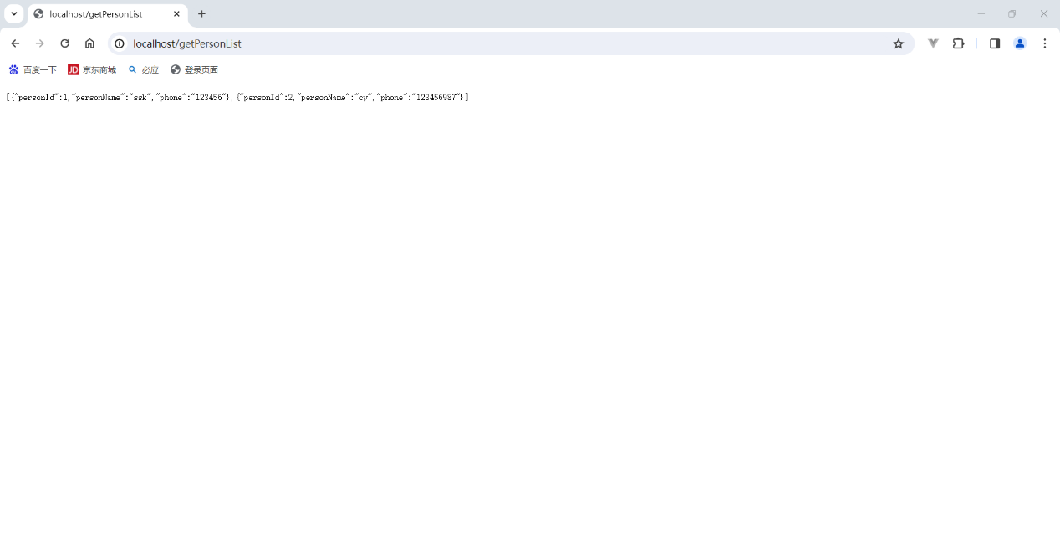代码分享：https://gitee.com/zhang-jike-kang/lesson2.git

- 通过RestTemplate实现服务调用
1. 配置 pom 文件，添加 spring-boot-starter-web / spring-cloud-starter-alibaba-nacos-discovery / springboot-starter-actuator / spring-cloud-starter-loadbalancer 四个依赖
2. 对 application.yml，进行配置
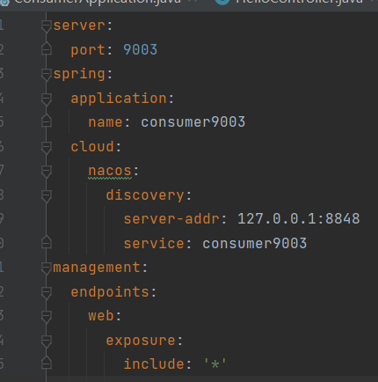
3. 创建 ConsumerApplication，使用注释@SpringBootApplication，注释@EnableDiscoveryClient 可不添加
4. 创建 controller.HellowControllrt 类，注意 url 使用服务名
注：类中的@RestController 相当于@ResponseBody 和@Controller 这两个注解的集合。
@RestController 是一个用于定义 RESTful Web 服务的控制器的特殊注解。
@Controller 是 Spring 框架中用于标识一个类是控制器组件的注解。
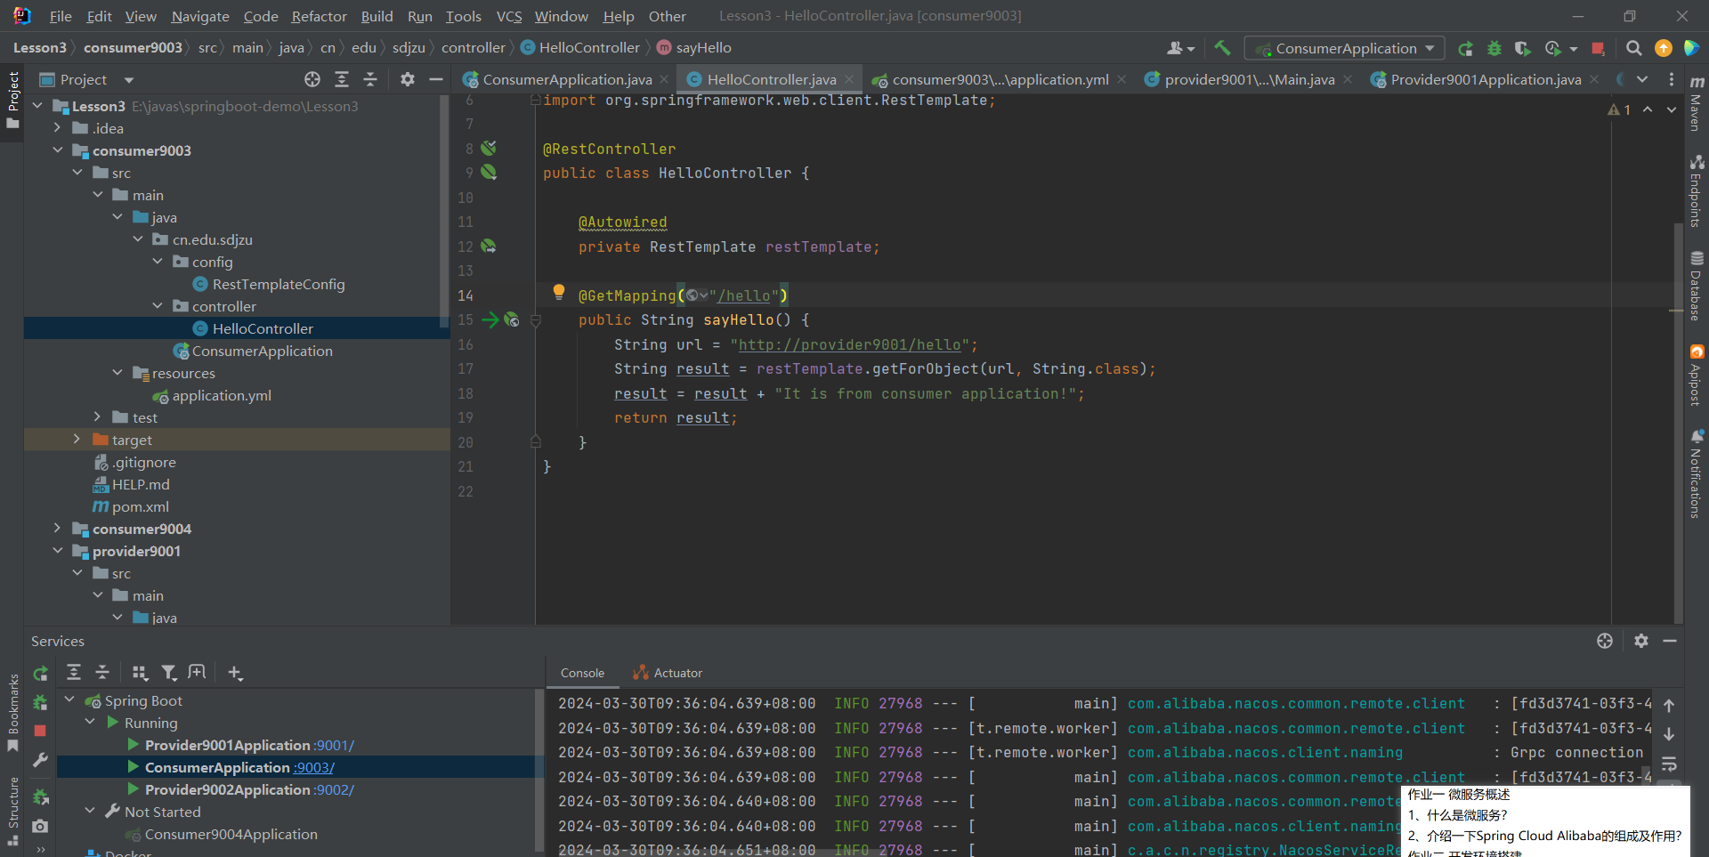
5. 创建 config.RestTemplateConfig 类
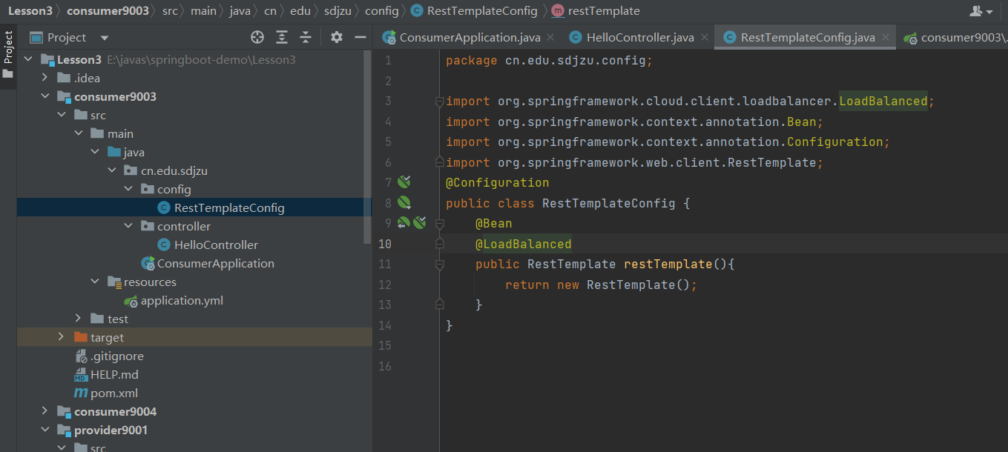
6. 打开 Nacos，运行 9001，9002，9003
