实验七 服务容错（限流、熔断降级）
一、实验目的
理解服务熔断技术
掌握 Sentinel 组件的使用以及使用 Sentinel 实现服务的限流与熔断
- 实验内容
启动nacos
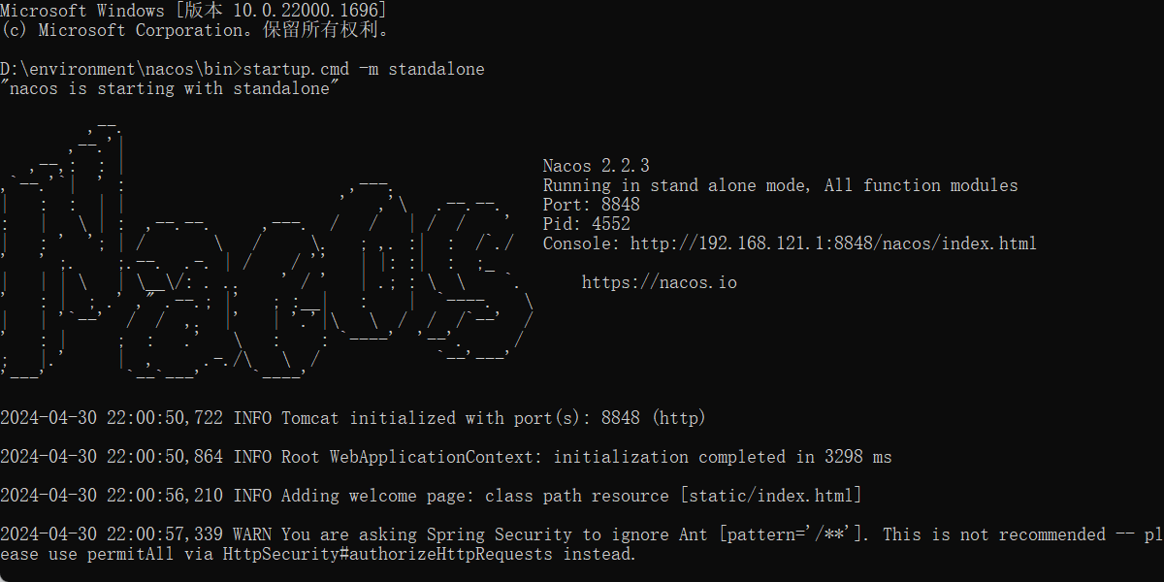
- 运行sentinel
- 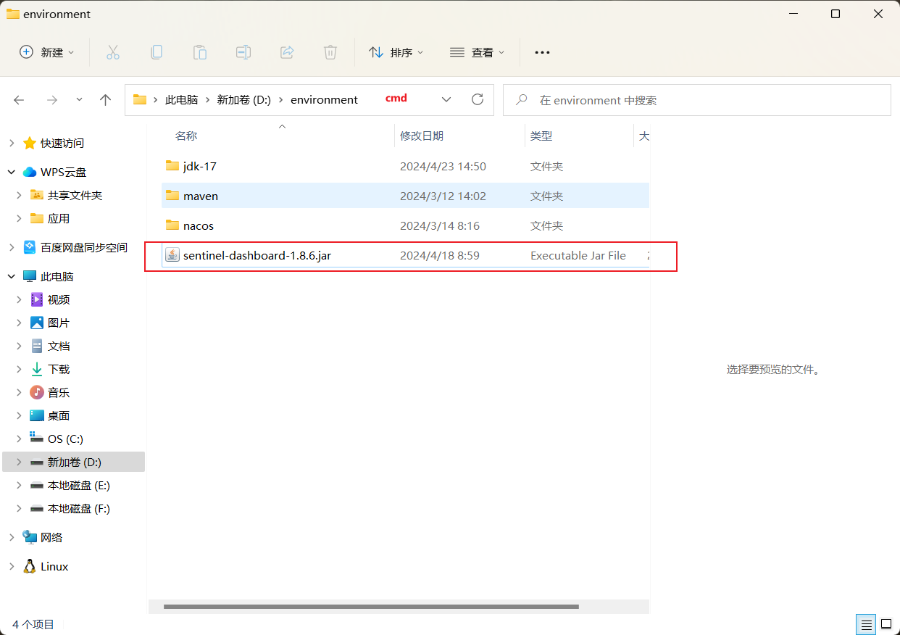
启动指令
java -Dserver.port=9090 -Dcsp.sentinel.dashboard.server=localhost:9090 -Dproject.name=sentinel-dashboard -jar sentinel-dashboard-1.8.6.jar
- 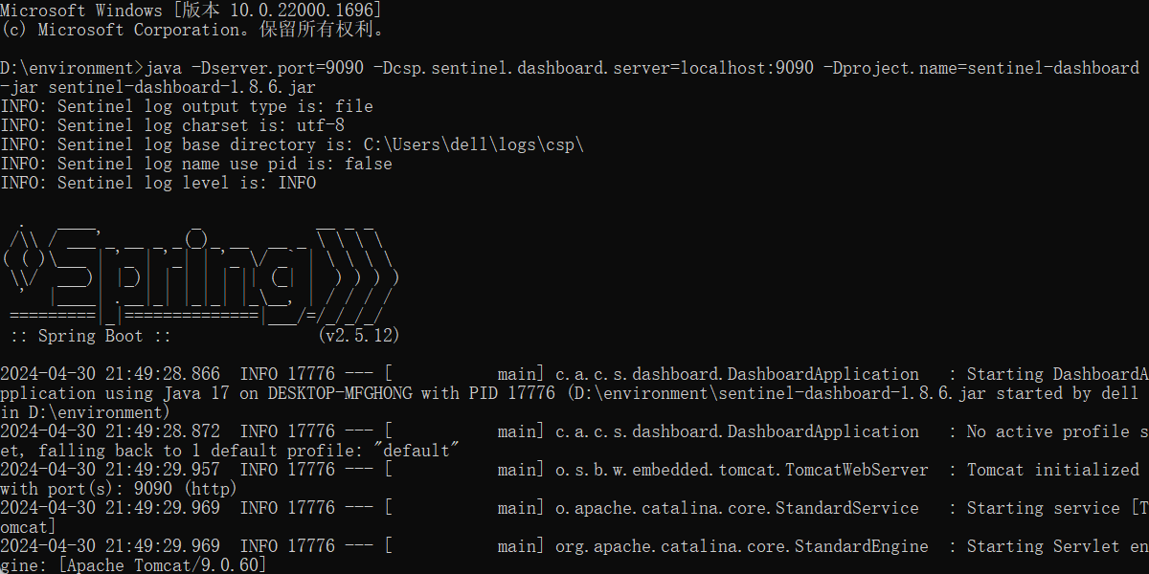
- 登录进入
- 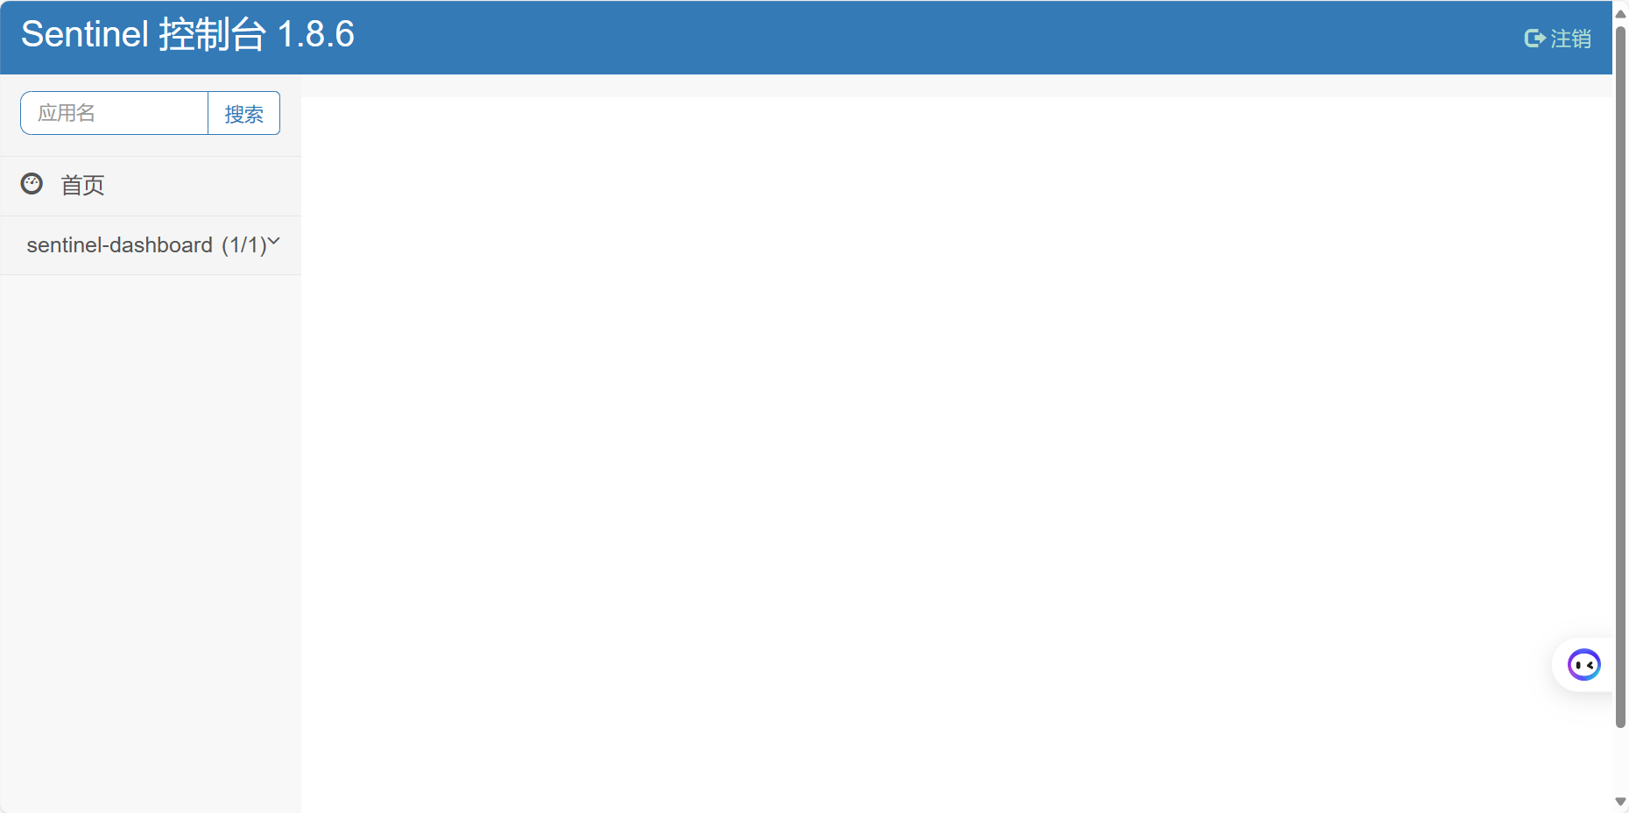
- 创建模块
- 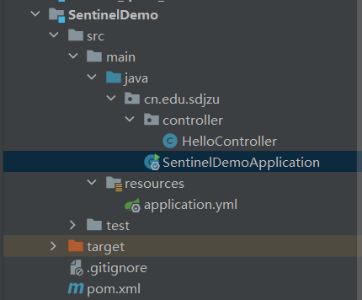
- pom文件
<dependencies>
<dependency>
<groupId>com.alibaba.cloud</groupId>
<artifactId>spring-cloud-starter-alibaba-sentinel</artifactId>
</dependency>
<dependency>
<groupId>org.springframework.boot</groupId>
<artifactId>spring-boot-starter-web</artifactId>
</dependency>
<dependency>
<groupId>com.alibaba.cloud</groupId>
<artifactId>spring-cloud-starter-alibaba-nacos-discovery</artifactId>
</dependency>
</dependencies>
- application.yml文件
server:
port: 80
spring:
application:
name: SentinelDemo
cloud:
# application:
# name: SentinelDemo
nacos:
discovery:
server-addr: localhost:8848
# service: SentinelDemo
sentinel:
transport:
dashboard: localhost:8080
- 控制类
import com.alibaba.csp.sentinel.annotation.SentinelResource;
import com.alibaba.csp.sentinel.slots.block.BlockException;
import org.springframework.web.bind.annotation.GetMapping;
import org.springframework.web.bind.annotation.RestController;
@RestController
public class HelloController {
@GetMapping("/hello")
// @SentinelResource(value = "hello1",blockHandler = "exceptHandler")
public String hello(){
return "hello";
}
// public String exceptHandler(BlockException e){
// return "系统繁忙，请稍后";
// }
}
- 启动类
import org.springframework.boot.SpringApplication;
import org.springframework.boot.autoconfigure.SpringBootApplication;

@SpringBootApplication
public class SentinelDemoApplication {
public static void main(String[] args) {
SpringApplication.run(SentinelDemoApplication.class,args);
}
}
- 打开控制台运行程序
- 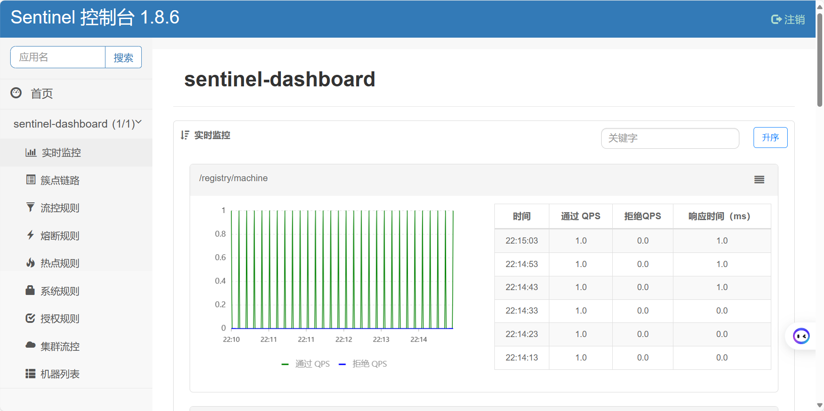
- 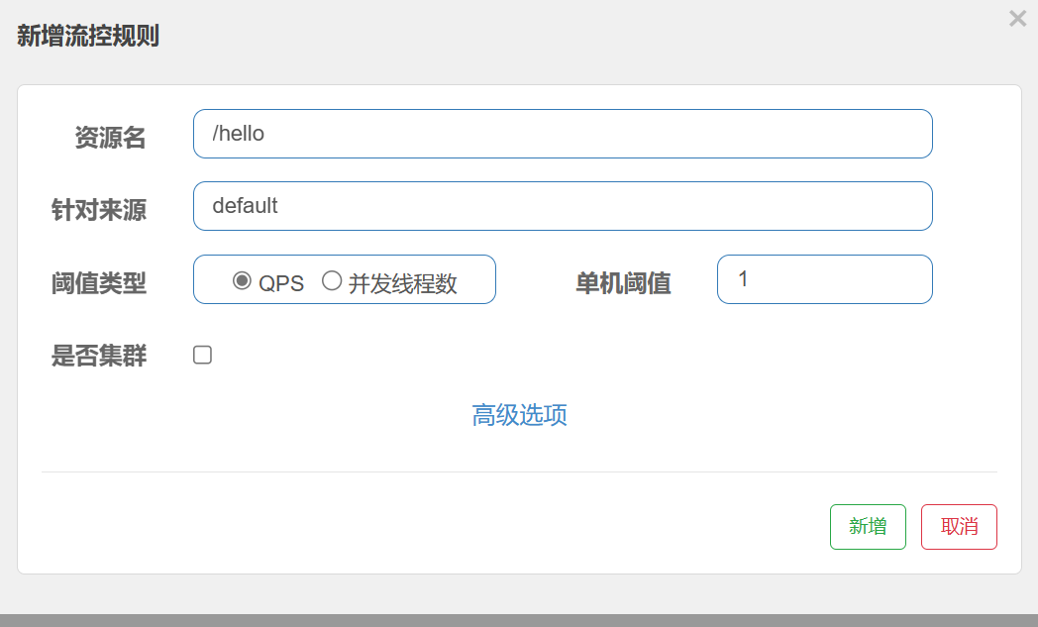
- 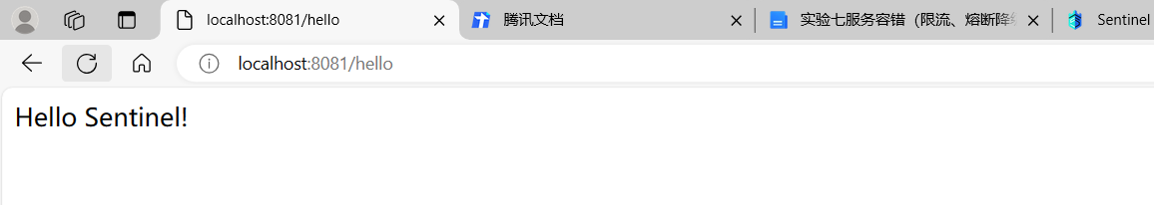
- 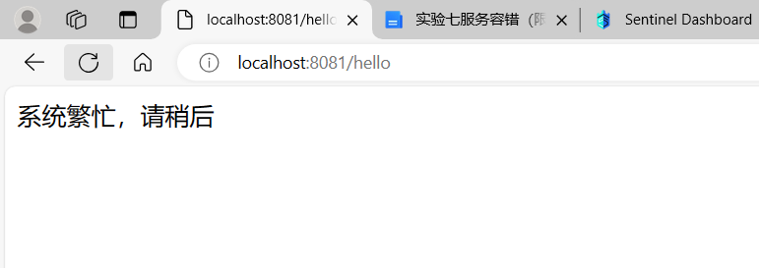
- 利用jmeter测试
- 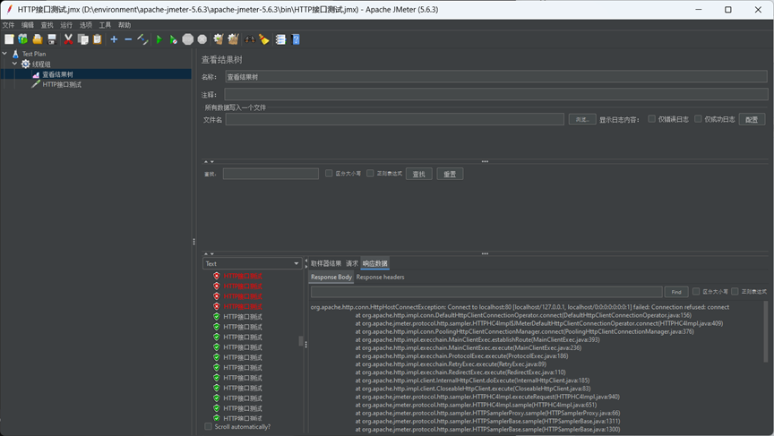
- 实验总结
本次实验掌握了Sentinel 组件的使用以及使用 Sentinel 实现服务的限流与熔断，学会使用jmeter进行测试。

