实验三 服务调用

一、实验目的
掌握远程服务调用的方法。
二、实验内容
通过 restTemplate 实现远程调用。

启动nacos
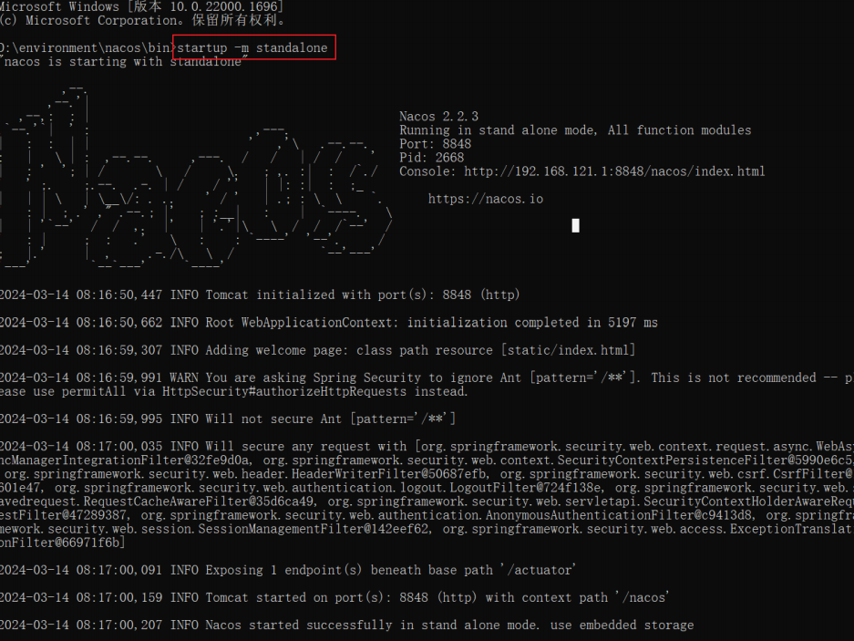

2.建立项目，对pom.xml文件进行配置
添加依赖
<dependencyManagement>
<dependencies>
<dependency>
<groupId>org.springframework.boot</groupId>
<artifactId>spring-boot-dependencies</artifactId>
<version>3.0.2</version>
<type>pom</type>
<scope>import</scope>
</dependency>
<dependency>
<groupId>org.springframework.cloud</groupId>
<artifactId>spring-cloud-dependencies</artifactId>
<version>2022.0.0</version>
<type>pom</type>
<scope>import</scope>
</dependency>
<dependency>
<groupId>com.alibaba.cloud</groupId>
<artifactId>spring-cloud-alibaba-dependencies</artifactId>
<version>2022.0.0.0</version>
<type>pom</type>
<scope>import</scope>
</dependency>
<dependency>
<groupId>com.mysql</groupId>
<artifactId>mysql-connector-j</artifactId>
<version>8.3.0</version>
</dependency>
<dependency>
<groupId>org.mybatis.spring.boot</groupId>
<artifactId>mybatis-spring-boot-starter</artifactId>
<version>3.0.3</version>
</dependency>
<dependency>
<groupId>org.projectlombok</groupId>
<artifactId>lombok</artifactId>
<version>1.18.24</version>
</dependency>
</dependencies>
</dependencyManagement>
<build>
<plugins>
<plugin>
<groupId>org.springframework.boot</groupId>
<artifactId>spring-boot-maven-plugin</artifactId>
<configuration>
<excludes>
<exclude>
<groupId>org.projectlombok</groupId>
<artifactId>lombok</artifactId>
</exclude>
</excludes>
</configuration>
</plugin>
</plugins>
</build>

3.在项目下建立模块provider9001
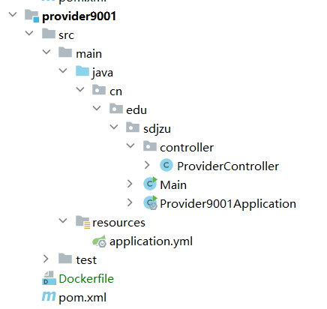

4.对provider9001的pom文件进行配置
添加依赖：
<dependencies>
<dependency>
<groupId>com.alibaba.cloud</groupId>
<artifactId>spring-cloud-starter-alibaba-nacos-discovery</artifactId>
</dependency>
<dependency>
<groupId>org.springframework.boot</groupId>
<artifactId>spring-boot-starter-actuator</artifactId>
</dependency>
<dependency>
<groupId>org.springframework.boot</groupId>
<artifactId>spring-boot-starter-web</artifactId>
<version>3.0.2</version>
</dependency>
</dependencies>

5.在resources文件夹下建立application.yml文件
server:
port: 9001
spring:
application:
name: provider9001
cloud:
nacos:
discovery:
server-add: 192.168.23.1:8848
service: provider
management:
endpoints:
web:
exposure:
include: '*'

6.建立主程序Provider9001Application.java文件
package cn.edu.sdjzu;
import org.springframework.boot.autoconfigure.SpringBootApplication;
import org.springframework.boot.builder.SpringApplicationBuilder;
@SpringBootApplication
public class Provider9001Application {
public static void main(String[] args){
new SpringApplicationBuilder(Provider9001Application.class).run(args);
}
}

7.新建包controller在包下建立ProviderController.java文件
package cn.edu.sdjzu.controller;
import org.springframework.web.bind.annotation.GetMapping;
import org.springframework.web.bind.annotation.RestController;
import org.springframework.web.bind.annotation.RequestMapping;
import org.springframework.web.bind.annotation.RequestMethod;
@RestController
public class ProviderController {
@RequestMapping(value="/hello",method = RequestMethod.GET)
public String hello(){
return "hello world,provider9001";
}
}

8.用同样的方法步骤建立provider9002模块

9.建立模块consumer9003
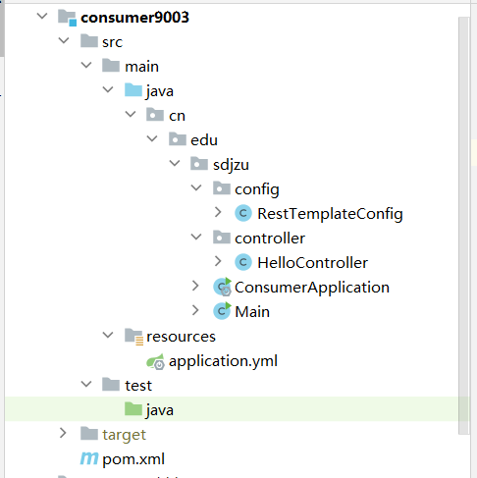

10.对pom.xml文件进行配置
<dependencies>
<dependency>
<groupId>com.alibaba.cloud</groupId>
<artifactId>spring-cloud-starter-alibaba-nacos-discovery</artifactId>
</dependency>
<dependency>
<groupId>org.springframework.boot</groupId>
<artifactId>spring-boot-starter-actuator</artifactId>
</dependency>
<dependency>
<groupId>org.springframework.boot</groupId>
<artifactId>spring-boot-starter-web</artifactId>
<version>3.0.2</version>
</dependency>
<dependency>
<groupId>org.springframework.cloud</groupId>
<artifactId>spring-cloud-starter-loadbalancer</artifactId>
</dependency>
</dependencies>

11.在resources文件夹下建立application.yml文件
server:
port: 9003
spring:
application:
name: consumer9003
cloud:
nacos:
discovery:
server-add: 192.168.23.1:8848
service: consumer
management:
endpoints:
web:
exposure:
include: '*'

12.建立主程序ConsumerApplication.java文件
package cn.edu.sdjzu;
import org.springframework.boot.SpringApplication;
import org.springframework.boot.autoconfigure.SpringBootApplication;
import org.springframework.cloud.client.discovery.EnableDiscoveryClient;
@SpringBootApplication
//@EnableDiscoveryClient
public class ConsumerApplication {
public static void main(String[] args){
SpringApplication.run(ConsumerApplication.class,args);
}
}

13.建立包config在包下建立RestTemplateConfig.java文件
package cn.edu.sdjzu.config;
import org.springframework.cloud.client.loadbalancer.LoadBalanced;
import org.springframework.context.annotation.Bean;
import org.springframework.context.annotation.Configuration;
import org.springframework.web.client.RestTemplate;
@Configuration
public class RestTemplateConfig {
@Bean
@LoadBalanced
public RestTemplate restTemplate(){
return new RestTemplate();
}
}

14.建立包controller在包下建立HelloController.java文件
package cn.edu.sdjzu.controller;
import org.springframework.beans.factory.annotation.Autowired;
import org.springframework.web.bind.annotation.GetMapping;
import org.springframework.web.bind.annotation.RestController;
import org.springframework.web.client.RestTemplate;
@RestController
public class HelloController {
@Autowired
private RestTemplate restTemplate;
@GetMapping("/hello")
public String sayHello(){
String url = "http://provider/hello";
String result =restTemplate.getForObject(url,String.class);
result = result +" It is from consumer application!";
return result;
}
}

15.浏览器效果显示：
点击刷新会两个程序交错运行
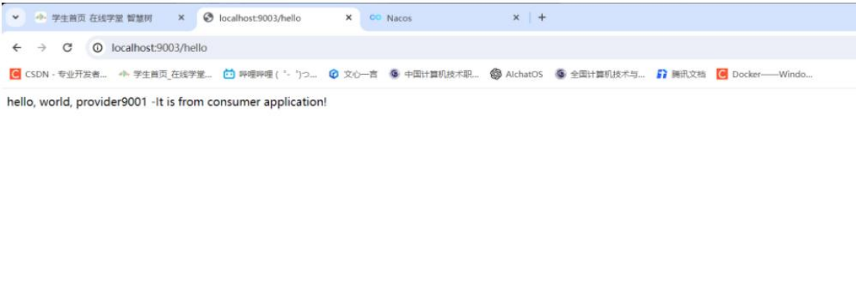

nacos显示
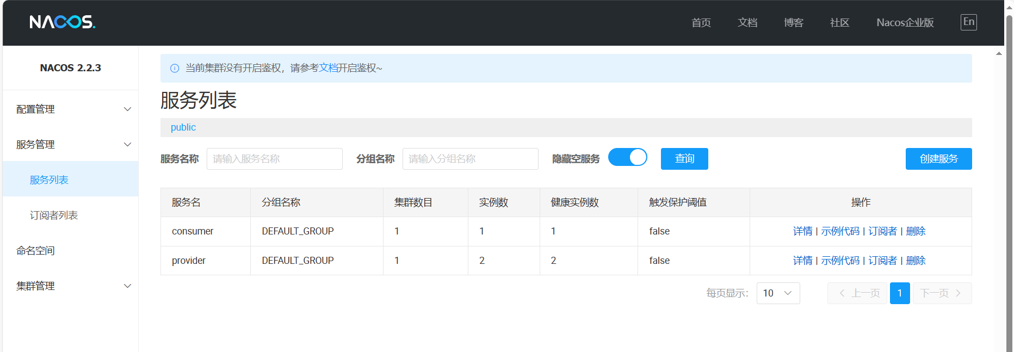

三、实验总结
通过本次实验学会了服务调用，负载均衡。学会了通过 restTemplate 实现远程调用。

