实验四 负载均衡
一、实验目的
掌握负载均衡的配置实现方法。
二、实验内容
通过 OpenFeign 实现远程调用
通过Openfeign实现服务调用

启动nacos
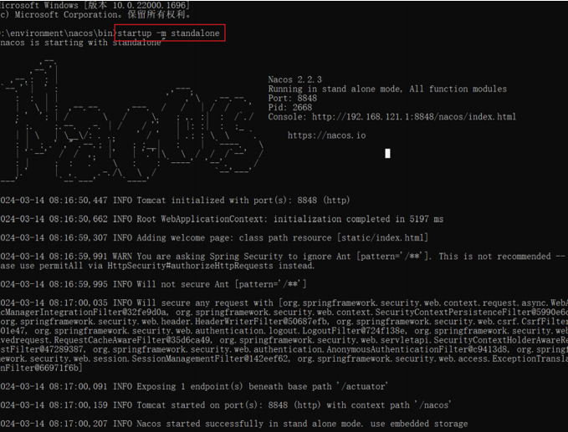

2.建立项目，对pom.xml文件进行配置
添加依赖
<dependencyManagement>
<dependencies>
<dependency>
<groupId>org.springframework.boot</groupId>
<artifactId>spring-boot-dependencies</artifactId>
<version>3.0.2</version>
<type>pom</type>
<scope>import</scope>
</dependency>
<dependency>
<groupId>org.springframework.cloud</groupId>
<artifactId>spring-cloud-dependencies</artifactId>
<version>2022.0.0</version>
<type>pom</type>
<scope>import</scope>
</dependency>
<dependency>
<groupId>com.alibaba.cloud</groupId>
<artifactId>spring-cloud-alibaba-dependencies</artifactId>
<version>2022.0.0.0</version>
<type>pom</type>
<scope>import</scope>
</dependency>
<dependency>
<groupId>com.mysql</groupId>
<artifactId>mysql-connector-j</artifactId>
<version>8.3.0</version>
</dependency>
<dependency>
<groupId>org.mybatis.spring.boot</groupId>
<artifactId>mybatis-spring-boot-starter</artifactId>
<version>3.0.3</version>
</dependency>
<dependency>
<groupId>org.projectlombok</groupId>
<artifactId>lombok</artifactId>
<version>1.18.24</version>
</dependency>
</dependencies>
</dependencyManagement>
<build>
<plugins>
<plugin>
<groupId>org.springframework.boot</groupId>
<artifactId>spring-boot-maven-plugin</artifactId>
<configuration>
<excludes>
<exclude>
<groupId>org.projectlombok</groupId>
<artifactId>lombok</artifactId>
</exclude>
</excludes>
</configuration>
</plugin>
</plugins>
</build>

3.在项目下建立模块module 命名为provider9001
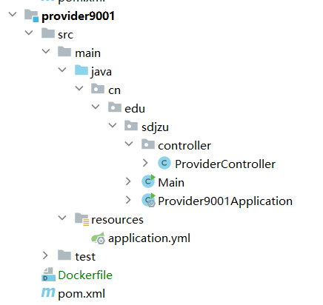

4.对provider9001的pom文件进行配置
添加依赖：
<dependencies>
<dependency>
<groupId>com.alibaba.cloud</groupId>
<artifactId>spring-cloud-starter-alibaba-nacos-discovery</artifactId>
</dependency>
<dependency>
<groupId>org.springframework.boot</groupId>
<artifactId>spring-boot-starter-actuator</artifactId>
</dependency>
<dependency>
<groupId>org.springframework.boot</groupId>
<artifactId>spring-boot-starter-web</artifactId>
<version>3.0.2</version>
</dependency>
</dependencies>

5.在resources文件夹下建立application.yml文件
server:
port: 9001
spring:
application:
name: provider9001
cloud:
nacos:
discovery:
server-add: 192.168.23.1:8848
service: provider
management:
endpoints:
web:
exposure:
include: '*'

6.建立主程序Provider9001Application.java文件
package cn.edu.sdjzu;
import org.springframework.boot.autoconfigure.SpringBootApplication;
import org.springframework.boot.builder.SpringApplicationBuilder;
@SpringBootApplication
public class Provider9001Application {
public static void main(String[] args){
new SpringApplicationBuilder(Provider9001Application.class).run(args);
}
}

7.新建包controller在包下建立ProviderController.java文件
package cn.edu.sdjzu.controller;
import org.springframework.web.bind.annotation.GetMapping;
import org.springframework.web.bind.annotation.RestController;
import org.springframework.web.bind.annotation.RequestMapping;
import org.springframework.web.bind.annotation.RequestMethod;
@RestController
public class ProviderController {
@RequestMapping(value="/hello",method = RequestMethod.GET)
public String hello(){
return "hello world,provider9001";
}
}

8.用同样的方法步骤建立provider9002模块

建立新的module 命名为consumer9004
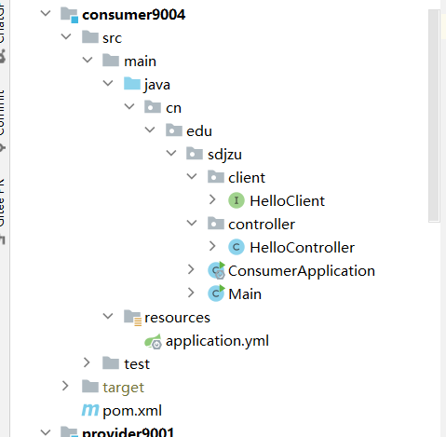

1.对pom文件进行配置
<dependencies>
<dependency>
<groupId>com.alibaba.cloud</groupId>
<artifactId>spring-cloud-starter-alibaba-nacos-discovery</artifactId>
</dependency>
<dependency>
<groupId>org.springframework.boot</groupId>
<artifactId>spring-boot-starter-actuator</artifactId>
</dependency>
<dependency>
<groupId>org.springframework.boot</groupId>
<artifactId>spring-boot-starter-web</artifactId>
<version>3.0.2</version>
</dependency>
<dependency>
<groupId>org.springframework.cloud</groupId>
<artifactId>spring-cloud-starter-loadbalancer</artifactId>
</dependency>
<dependency>
<groupId>org.springframework.cloud</groupId>
<artifactId>spring-cloud-starter-openfeign</artifactId>
</dependency>
</dependencies>

2.在resources文件夹下建立application.yml文件
server:
port: 9004
spring:
application:
name: consumer9004
cloud:
nacos:
discovery:
server-add: 192.168.23.1:8848
service: ${spring.application.name}
management:
endpoints:
web:
exposure:
include: '*'

3.建立主程序ConsumerApplication.java文件
package cn.edu.sdjzu;
import org.springframework.boot.SpringApplication;
import org.springframework.boot.autoconfigure.SpringBootApplication;
import org.springframework.cloud.openfeign.EnableFeignClients;
@SpringBootApplication
@EnableFeignClients
public class ConsumerApplication {
public static void main(String[] args){
SpringApplication.run(ConsumerApplication.class,args);
}
}

4.建立包client在包下建立接口文件HelloClient
package cn.edu.sdjzu.client;
import org.springframework.cloud.openfeign.FeignClient;
import org.springframework.web.bind.annotation.GetMapping;
@FeignClient("provider")
public interface HelloClient {
@GetMapping("/hello")
String sayHello();
}

5.建立包controller在包下建立HelloController.java文件
package cn.edu.sdjzu.controller;
import cn.edu.sdjzu.client.HelloClient;
import org.springframework.beans.factory.annotation.Autowired;
import org.springframework.web.bind.annotation.GetMapping;
import org.springframework.web.bind.annotation.RestController;
@RestController
public class HelloController {
@Autowired
private HelloClient helloClient;
@GetMapping("/hello")
public String sayHello(){
return helloClient.sayHello();
}
}
运行provider9001，和provider9002，consumer9004文件

6.结果显示：
点击刷新，会交错显示

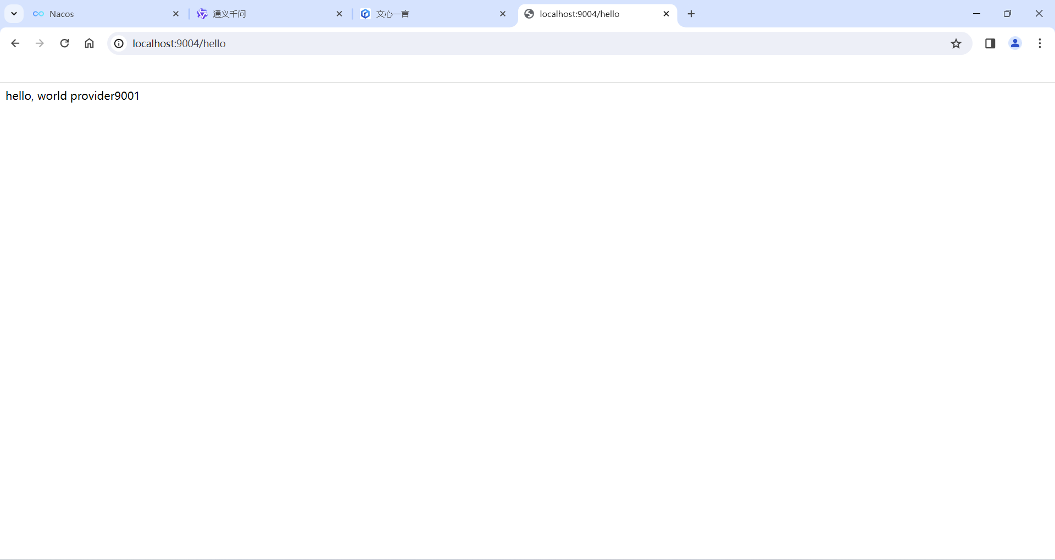
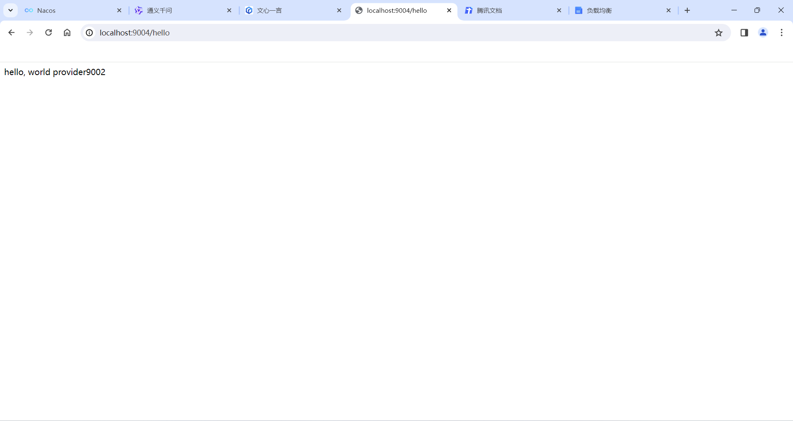
三、实验总结
通过本次实验学会了通过OpenFeign实现负载均衡，注意调用的方法与注解。

