实验二 mybatis结果映射

一、实验目的及任务
通过该实验，掌握mybatis映射文件中结果映射resultMap的配置方法。
通过该实验，掌握mybatis映射文件中关联association配置方法和集合collection配置方法。
通过该实验，掌握利用mybatis进行数据库表的增删改查的方法。

二、实验环境及条件
主机操作系统为Windows11，Tomcat8以上，JDK8及以上，开发工具为IDEA。

三、实验实施步骤
0 实验步骤（略）不用写。
1 实验任务一:实现订单表的增删改查
订单查询：在3.1需求一第4步中，运行测试用例test包下的cn.smbms.dao.bill里的BillMapperTest，在方法testGetBillList右键运行run as -jUnit Test修改代码，要求查询条件设定 productName ，providerId ，isPayment 等参数。
将自己敲入的相关代码和在控制台查询出的结果截屏，粘贴到这里。
private Provider provider;
public void setProvider(Provider provider) {
this.provider = provider;
}
public Provider getProvider() {
return provider;
}

public List<Bill> getBillList(@Param("productName")String productName,
@Param("providerId")Integer providerId,
@Param("isPayment")Integer isPayment);
<?xml version="1.0" encoding="UTF-8" ?>
<!DOCTYPE mapper
PUBLIC "-//mybatis.org//DTD Mapper 3.0//EN"
"http://mybatis.org/dtd/mybatis-3-mapper.dtd">
<mapper namespace="cn.smbms.dao.bill.BillMapper">
<resultMap type="cn.smbms.pojo.Bill" id="billList">
<result property="id" column="id"/>
<result property="billCode" column="billCode" />
<result property="productName" column="productName" />
<result property="totalPrice" column="totalPrice" />
<result property= "isPayment" column= "isPayment" />
<association property="provider" javaType="Provider" resultMap="providerResult"/>
</resultMap>
<resultMap type="Provider" id="providerResult" >
<id property="id" column="p_id"/>
<result property="proCode" column="proCode"/>
<result property="proName" column="proName"/>
<result property="proContact" column="proContact"/>
<result property="proPhone" column="proPhone"/>
</resultMap>
<!-- 根据条件查询订单表-->
<select id="getBillList" resultMap="billList">
select b.*,p.id as p_id,p.proCode,p.proName,p.proContact,p.proPhone
from smbms_bill b,smbms_provider p
where b.productName like CONCAT ('%',#{productName},'%')
and b.providerId = #{providerId}
and b.isPayment = #{isPayment}
and b.providerId = p.id
</select>
@Test
public void testGetBillList() {
SqlSession sqlSession = null;
List<Bill> billList = new ArrayList<Bill>();
try {
sqlSession = MyBatisUtil.createSqlSession();
Bill bill = new Bill();
bill.setIsPayment(2);
bill.setProductName("油");
bill.setProviderId(7);
billList = sqlSession.getMapper(BillMapper.class).getBillList(bill.getProductName(), bill.getProviderId(), bill.getIsPayment());
} catch (Exception e) {
// TODO: handle exception
e.printStackTrace();
}finally{
MyBatisUtil.closeSqlSession(sqlSession);
}
for(Bill bill: billList){
System.out.println("testGetBillList id: " + bill.getId() +
" and BillCode: " + bill.getBillCode() +
" and ProductName: " + bill.getProductName() +
" and totalPrice: " + bill.getTotalPrice() +
" and isPayment: " + bill.getIsPayment() +
" , Provider : " + bill.getProvider().getId() +
" and providerCode: " + bill.getProvider().getProCode() +
" and providerName: " + bill.getProvider().getProName()+
" and proContact: " + bill.getProvider().getProContact()+
" and proPhone:" + bill.getProvider().getProPhone());
}
}
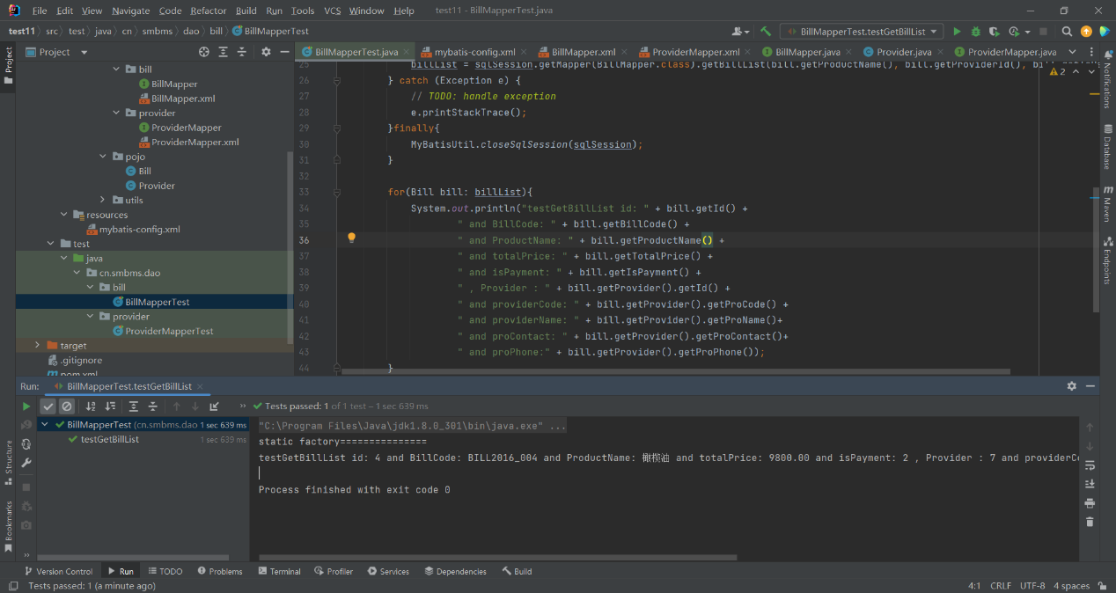
订单增删改：将 第3步中 订单的增删改 中的BillMapper.java，及BillMapper.xml中的内容粘贴到这里，并给出结果截图。
/**
* 增加订单信息
*
* */
public int add(Bill bill);
/**
* 修改订单信息
*
* */
public int modify(Bill bill);
/**
* 删除订单
*
* */
public int deleteBillById(@Param("id") Integer delId);
<!--添加账单信息-->
<insert id="add" parameterType="cn.smbms.pojo.Bill">
insert into smbms_bill
(billCode, productName, productDesc, productUnit, productCount, totalPrice, isPayment, creationDate, modifyDate)
VALUES
(#{billCode}, #{productName}, #{productDesc}, #{productUnit}, #{productCount}, #{totalPrice}, #{isPayment}, now(), now())
</insert>
<!--修改账单信息-->
<update id="modify" parameterType="cn.smbms.pojo.Bill">
update smbms_bill
set billCode = #{billCode},
productName = #{productName},
productDesc = #{productDesc},
productUnit = #{productUnit},
productCount = #{productCount},
totalPrice = #{totalPrice},
isPayment = #{isPayment},
modifyDate = now()
where id = #{id}
</update>
<!-- 根据账单id删除-->
<delete id="deleteBillById" parameterType="Integer">
delete from smbms_bill where id=#{id}
</delete>
@Test
public void testBillAdd(){
System.out.println("testBillAdd !===================");
SqlSession sqlSession = null;
int count = 0;
try {
sqlSession = MyBatisUtil.createSqlSession();
Bill bill = new Bill();
bill.setBillCode("BILL2024_018");
bill.setProductName("产品名称添加测试");
bill.setProductDesc("新增测试描述");
bill.setProductUnit("商品单位测试");
BigDecimal productCount = new BigDecimal("100");
bill.setProductCount(productCount);
BigDecimal totalPrice = new BigDecimal("98000");
bill.setTotalPrice(totalPrice);
bill.setIsPayment(1);
count = sqlSession.getMapper(BillMapper.class).add(bill);
//模拟异常，进行回滚
//int i = 2/0;
sqlSession.commit();
} catch (Exception e) {
// TODO: handle exception
e.printStackTrace();
sqlSession.rollback();
count = 0;
}finally{
MyBatisUtil.closeSqlSession(sqlSession);
}
System.out.println("testBillAdd count: " + count);
}
@Test
public void testBillModify(){
System.out.println("testBillModify !===================");
SqlSession sqlSession = null;
int count = 0;
try {
sqlSession = MyBatisUtil.createSqlSession();
Bill bill = new Bill();
bill.setId(20);
bill.setBillCode("BILL2024_018");
bill.setProductName("产品名称修改测试");
bill.setProductDesc("修改测试描述");
bill.setProductUnit("修改商品单位测试");
BigDecimal productCount = new BigDecimal("123");
bill.setProductCount(productCount);
BigDecimal totalPrice = new BigDecimal("12134");
bill.setTotalPrice(totalPrice);
count = sqlSession.getMapper(BillMapper.class).modify(bill);
sqlSession.commit();
} catch (Exception e) {
// TODO: handle exception
e.printStackTrace();
sqlSession.rollback();
count = 0;
}finally{
MyBatisUtil.closeSqlSession(sqlSession);
}
System.out.println("testBillModify count: " + count);
}
@Test
public void testDeleteBillById() {
System.out.println("testDeleteBillById !===================");
SqlSession sqlSession = null;
Integer delId = 20;
int count = 0;
try {
sqlSession = MyBatisUtil.createSqlSession();
count = sqlSession.getMapper(BillMapper.class).deleteBillById(delId);
sqlSession.commit();
} catch (Exception e) {
// TODO Auto-generated catch block
e.printStackTrace();
sqlSession.rollback();
count = 0;
}finally{
MyBatisUtil.closeSqlSession(sqlSession);
}
System.out.println("testDeleteBillById count =================== " + count);
}

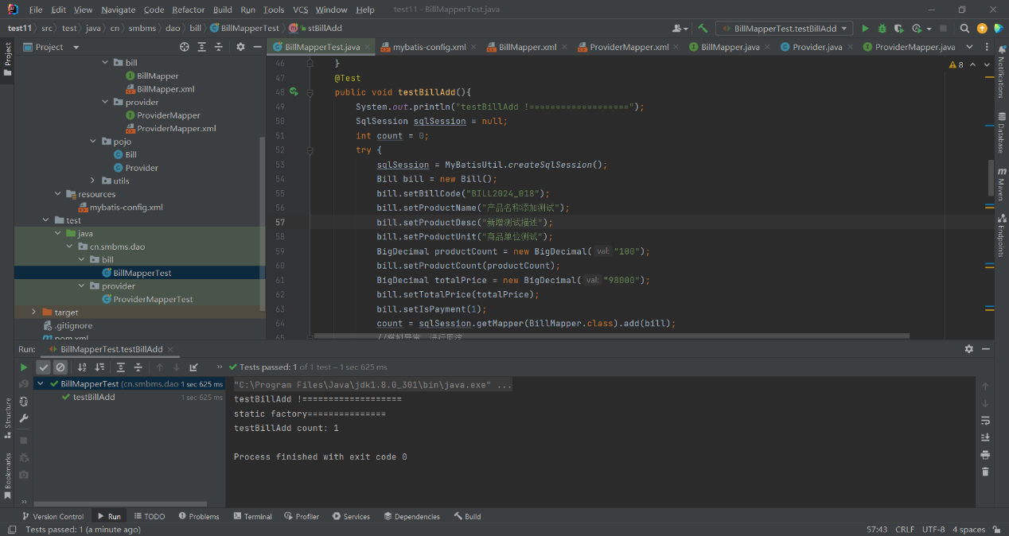

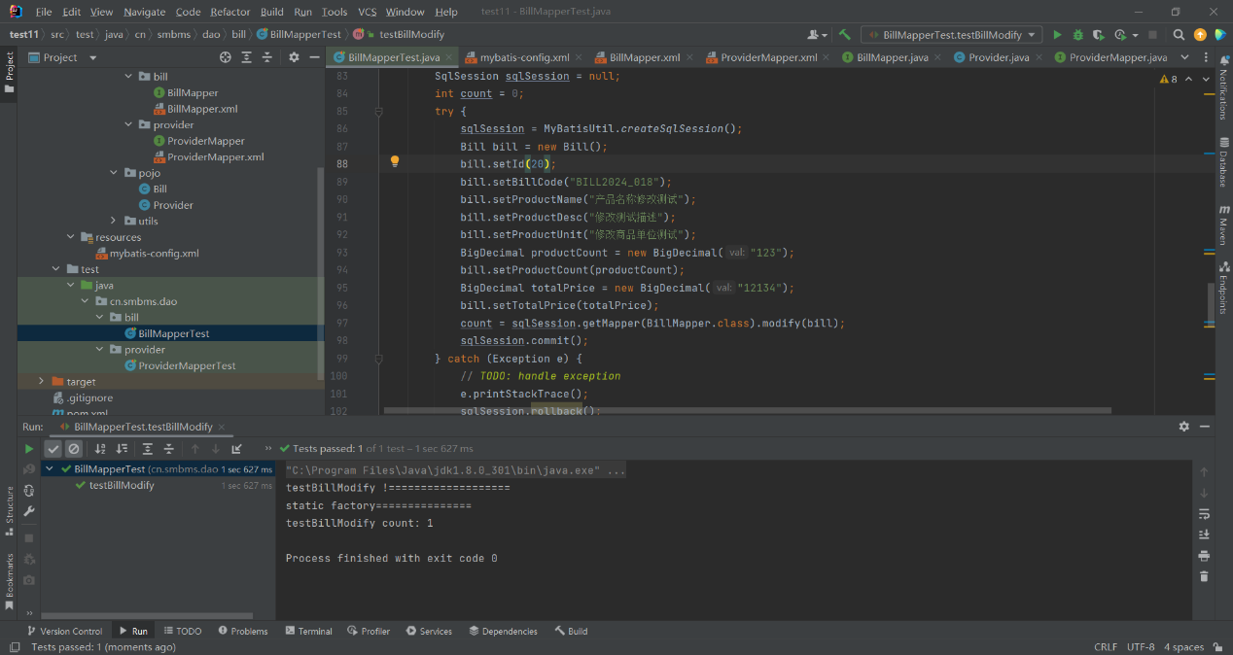
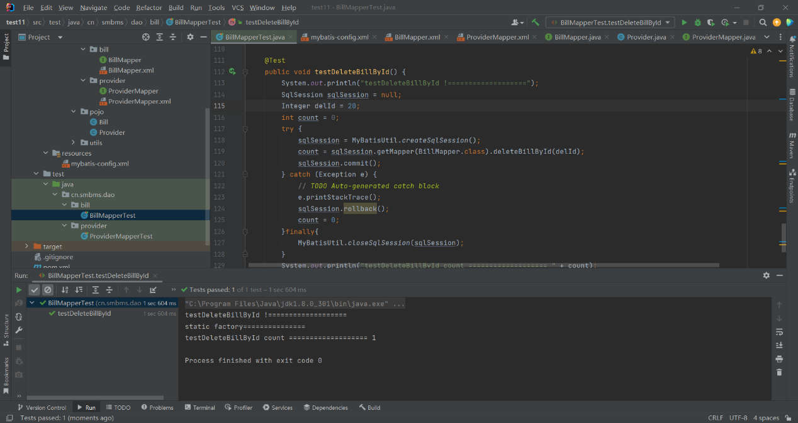

2 实验任务二:供应商增删改及其订单列表查询
根据供应商id查询其订单：在4.1需求二第4步中，运行测试用例test包下的cn.smbms.dao.provider里的ProviderMapperTest，在方法testGetBillListByProviderId右键运行run as -jUnit Test。修改该测试方法中的供应商ID，在控制台查看查询结果，并截图。
将相关代码和在控制台输出的相关结果截屏，粘贴到这里。
public void setBillList(List<Bill> billList) {
this.billList = billList;
}
public List<Bill> getBillList() {
return billList;
}
//collection
private List<Bill> billList;//订单列表
/**
*获取指定供应商的订单列表（collection）
* @param providerId
* @return
*/
public Provider getBillListByProviderId(@Param("id")Integer providerId);
<!-- 获取指定供应商的订单列表（provider表-bill表：1对多关系）collection start-->
<resultMap id="providerBillResult" type="Provider">
<id property="proCode" column="proCode"/>
<result property="proName" column="proName"/>
<result property="proContact" column="proContact"/>
<result property="proPhone" column="proPhone"/>
<collection property="billList" ofType="Bill" resultMap="billResult"/>
</resultMap>
<resultMap id="billResult" type="Bill">
<id property="id" column="b_id"/>
<result property="billCode" column="billCode"/>
<result property="productName" column="proPhone"/>
<result property="totalPrice" column="totalPrice"/>
<result property="isPayment" column="isPayment"/>
</resultMap>
<select id="getBillListByProviderId" parameterType="Integer" resultMap="providerBillResult">
select p.*,b.id as b_id,b.billCode,b.productName,b.totalPrice,b.isPayment
from smbms_provider p LEFT JOIN smbms_bill b ON p.id = b.providerId
where p.id = #{id}
</select>
@Test
public void testGetBillListByProviderId(){
SqlSession sqlSession = null;
Provider provider = null;
Integer providerId = 1;
try {
sqlSession = MyBatisUtil.createSqlSession();
provider = sqlSession.getMapper(ProviderMapper.class).getBillListByProviderId(providerId);
} catch (Exception e) {
// TODO: handle exception
e.printStackTrace();
}finally{
MyBatisUtil.closeSqlSession(sqlSession);
}
if(null != provider){
System.out.println("provider(include:billlist) =====> proCode: " + provider.getProCode()
+ ", proName: " + provider.getProName() + ", proContact: " + provider.getProContact()
+ ", proPhone: " + provider.getProPhone());
if(provider.getBillList().size() > 0){
for(Bill bill : provider.getBillList()){
System.out.println("bill ----> id: " + bill.getId() + ", billCode: " + bill.getBillCode()
+ ", productName: " + bill.getProductName() + ", totalPrice: " + bill.getTotalPrice()
+ ", isPayment: " + bill.getIsPayment());
}
}else{
System.out.println("该供应商下无订单");
}
}else{
System.out.println("查无此供应商！");
}
}
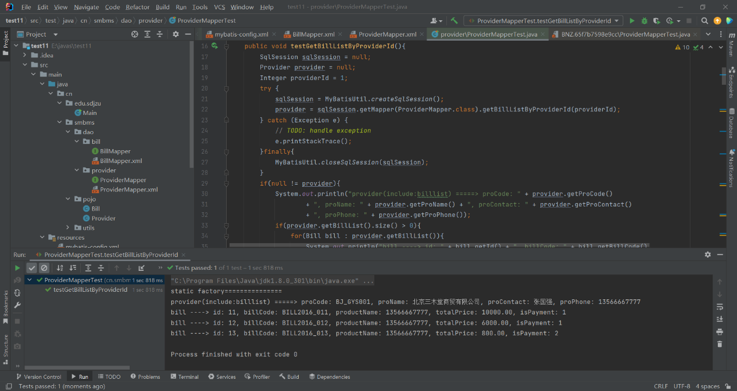
供应商增删改：将 第4步中 订单的增删改 中的ProviderMapper.java，及ProviderMapper.xml中的内容粘贴到这里，并给出运行结果截图。
/**
*增加供应商
*@param provider*@return
*/
public int add (Provider provider) ;/**
*修改供应商信息
*@param provider*@return
*/
public int modify(Provider provider);/**
*根据供应商ID删除供应商信息*@param delId
*@return
*/
public int deleteProviderById(@Param( "id" )Integer delId);
<!--添加供应商信息-->
<insert id="add" parameterType="cn.smbms.pojo.Provider">
insert into smbms_provider (proCode, proName, proDesc, proContact, proPhone,
proAddress, proFax, createdBy, creationDate)
values (#{proCode}, #{proName}, #{proDesc}, #{proContact}, #{proPhone},
#{proAddress}, #{proFax}, #{createdBy},now())
<!-- #{creationDate}-->
</insert>
<!--修改供应商信息-->
<update id="modify" parameterType="cn.smbms.pojo.Provider">
UPDATE smbms_provider
SET proCode = #{proCode},
proName = #{proName},
proDesc = #{proDesc},
proContact = #{proContact},
proPhone = #{proPhone},
proAddress = #{proAddress},
proFax = #{proFax},
modifyBy = #{modifyBy},
modifyDate = #{modifyDate}
WHERE id = #{id}
</update>
<!-- 根据供应商id删除-->
<delete id="deleteProviderById" parameterType="Integer">
delete from smbms_provider where id=#{id}
</delete>
@Test
public void testAdd(){
System.out.println("testAdd !===================");
SqlSession sqlSession = null;
int count = 0;
try {
sqlSession = MyBatisUtil.createSqlSession();
Provider provider = new Provider();
provider.setProCode("BJ_GYS111");
provider.setProName("供应商测试");
provider.setProContact("张三");
provider.setProAddress("供应商测试地址");
provider.setProPhone("13566667777");
provider.setCreatedBy(1);
provider.setCreationDate(new Date());
provider.setProFax("010-588876565");
provider.setProDesc("供应商测试描述");
count = sqlSession.getMapper(ProviderMapper.class).add(provider);
//模拟异常，进行回滚
//int i = 2/0;
sqlSession.commit();
} catch (Exception e) {
// TODO: handle exception
e.printStackTrace();
sqlSession.rollback();
count = 0;
}finally{
MyBatisUtil.closeSqlSession(sqlSession);
}
System.out.println("testAdd count: " + count);
}
@Test
public void testModify(){
System.out.println("testModify !===================");
SqlSession sqlSession = null;
int count = 0;
try {
sqlSession = MyBatisUtil.createSqlSession();
Provider provider = new Provider();
provider.setId(16);
provider.setProCode("BJ_GYS123");
provider.setProName("供应商测试修改");
provider.setProContact("李四");
provider.setProAddress("供应商测试地址修改");
provider.setProPhone("13500002222");
provider.setModifyBy(1);
provider.setModifyDate(new Date());
provider.setProFax("010-588876565");
provider.setProDesc("供应商测试描述修改");
count = sqlSession.getMapper(ProviderMapper.class).modify(provider);
//模拟异常，进行回滚
//int i = 2/0;
sqlSession.commit();
} catch (Exception e) {
// TODO: handle exception
e.printStackTrace();
sqlSession.rollback();
count = 0;
}finally{
MyBatisUtil.closeSqlSession(sqlSession);
}
System.out.println("testModify count: " + count);
}
@Test
public void testDeleteProviderById() {
System.out.println("testDeleteProviderById !===================");
SqlSession sqlSession = null;
Integer delId = 16;
int count = 0;
try {
sqlSession = MyBatisUtil.createSqlSession();
count = sqlSession.getMapper(ProviderMapper.class).deleteProviderById(delId);
sqlSession.commit();
} catch (Exception e) {
// TODO Auto-generated catch block
e.printStackTrace();
sqlSession.rollback();
count = 0;
}finally{
MyBatisUtil.closeSqlSession(sqlSession);
}
System.out.println("testDeleteProviderById count =================== " + count);
}

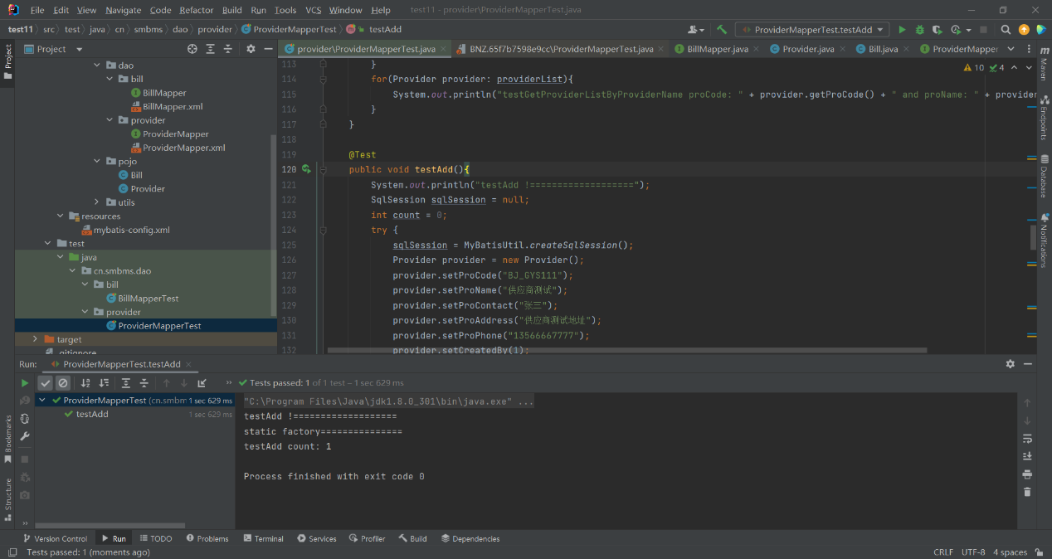
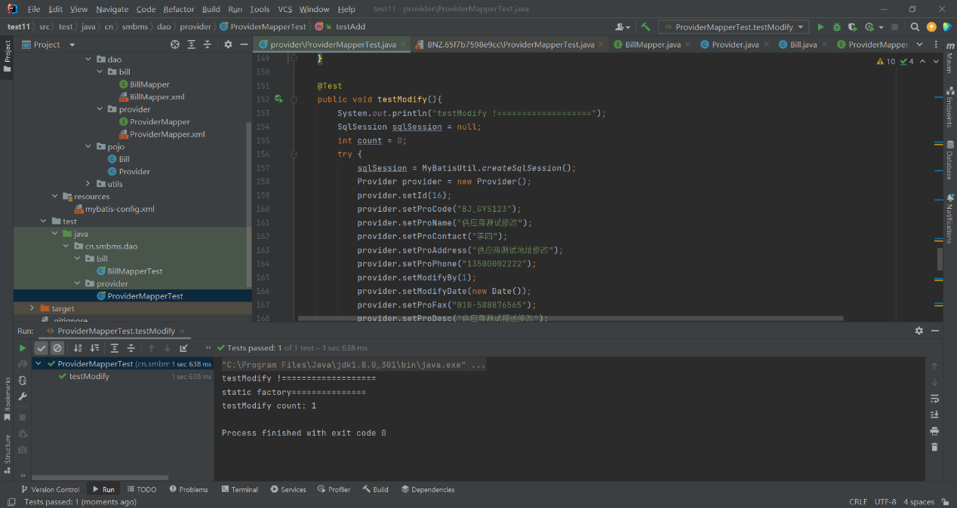
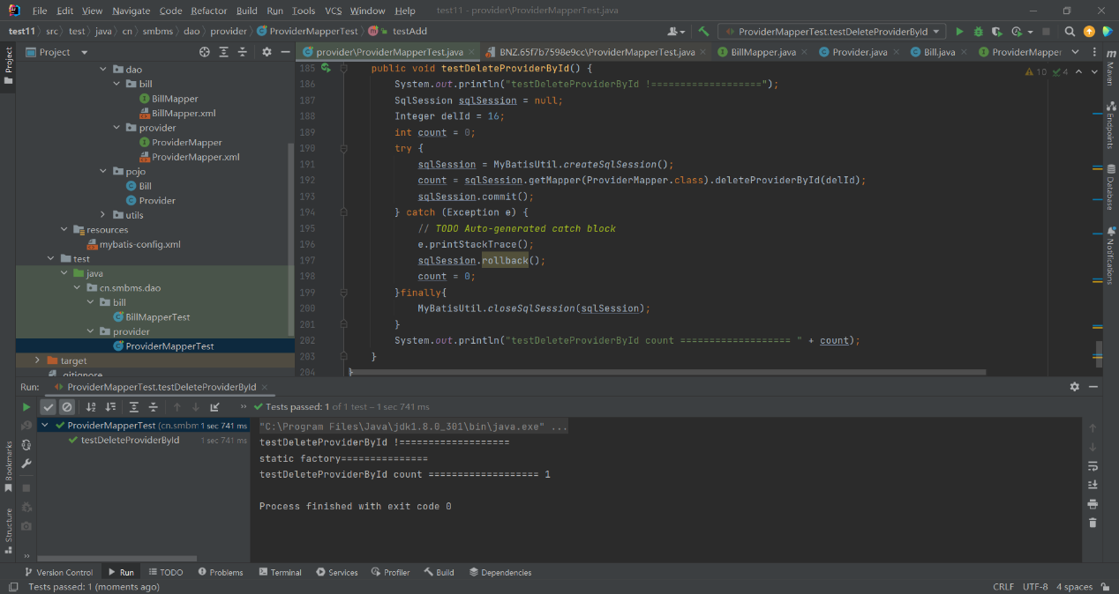

四、 你遇到了什么问题，如何解决的。
在本次实验中，掌握了mybatis映射文件中配置结果映射resultMap的方法。并且关联association配置方法，以及利用mybatis进行数据库的增删改查的方法，掌握了配置文件的细节。实验按照指导书进行过程较顺利。

