山东建筑大学 计算机学院 实验报告

班级：_软件212___姓名：_孙帅康___学 号：__202111110377_实验成绩：__________

课程：_移动设备开发实例____________ 同组者：_______ 实验日期：_2024/4/2_______

实验二：Android 移动信息系统初步编程

一、实验目的
1.熟悉Android移动信息系统的基本架构。
2.熟练掌握Android移动信息系统的基本编程方法。
二、实验环境
PC系列微机，Windows。
Android Studio。
三、源程序
运行” ServerThread.java”文件，控制台显示“start on 8888”信息
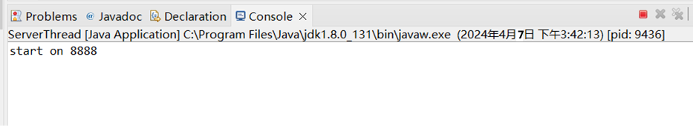
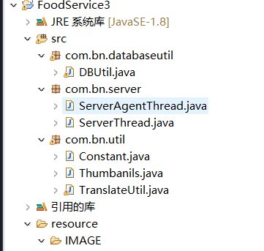

前端：
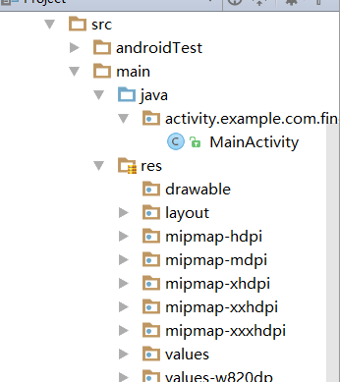
关键代码：

HomeFragmentTest.java
public class HomeFragmentTest extends Fragment implements OnClickListener,
PullToRefreshView.OnHeaderRefreshListener {
String timediver = "now()"; // 查询时间点
private Handler mHandler; // //handlrer更新
final int DISCON = 0; //断网
final int CLOCK = 4; // 定时器
final int REFRESH = 5; //刷新
List<String[]> menuInfo; // 菜谱推荐信息
ImageDownLoader imageLoader;
private TextView menu_add;
private MyGridView menu_ll;
private PullToRefreshView mPullToRefreshView;
private FrameLayout fl;
private ProgressBar pb;
private LinearLayout again_ll;
MyToast toast;
public void onCreate(Bundle savedInstanceState) {
super.onCreate(savedInstanceState);
mHandler = new Handler() {
@Override
public void handleMessage(Message msg) {
super.handleMessage(msg);
switch (msg.what) {
case REFRESH: //刷新，每刷新一次，都重新加载一下最新信息
pb.setVisibility(View.VISIBLE);
again_ll.setVisibility(View.GONE);
mPullToRefreshView.onHeaderRefreshComplete();
initExcellentMenu(); //在界面上加载精品菜谱
fl.setVisibility(View.GONE);
break;
case DISCON:
toast.showToast("网络已中断,请联网后重试");
fl.setVisibility(View.VISIBLE);
pb.setVisibility(View.GONE);
again_ll.setVisibility(View.VISIBLE);
break;
}
}
};
new Thread() {
public void run() {
while (true) {
try {
sleep(2000);
mHandler.sendEmptyMessage(CLOCK);
} catch (Exception e) {
e.printStackTrace();
}
}
}
}.start();
}
@Override
public View onCreateView(LayoutInflater inflater, ViewGroup container, Bundle savedInstanceState) {
FrameLayout home_ll=(FrameLayout) inflater.inflate(R.layout.hometest,null);
toast=new MyToast(getActivity());
imageLoader = new ImageDownLoader();
mPullToRefreshView = (PullToRefreshView)home_ll.findViewById(R.id.main_pull_refresh_view);
mPullToRefreshView.lockFooter(); //锁住上拉
mPullToRefreshView.lockHead();
//获取精品菜单到menu_ll
menu_ll = (MyGridView) mPullToRefreshView.findViewById(R.id.menu_ll);
mPullToRefreshView = (PullToRefreshView) mPullToRefreshView.findViewById(R.id.main_pull_refresh_view);
mPullToRefreshView.setOnHeaderRefreshListener(this);
again_ll=(LinearLayout) home_ll.findViewById(R.id.again_ll);
pb=(ProgressBar) home_ll.findViewById(R.id.pb);
fl=(FrameLayout) home_ll.findViewById(R.id.home_nonet);
Button again=(Button) home_ll.findViewById(R.id.nonet_again);
again.setOnClickListener(
new OnClickListener()
{
@Override
public void onClick(View v) {
if (Utils.isNewWork(getActivity())) {
new Refresh().start();
}else
{
mHandler.sendEmptyMessage(DISCON);
}
}
});
again.performClick();
return home_ll;
}
// /刷新线程
private class Refresh extends Thread {
@Override
public void run() {
try {
timediver = "now()";
menuInfo = NetInfoUtil.getExcellentMenu(); //从数据库中获取精彩菜品
System.out.println("=============1=============");
for(int i=0;i<menuInfo.size();i++){
System.out.println(Arrays.toString(menuInfo.get(i)));
}
mHandler.sendEmptyMessage(REFRESH); //发送“刷新”消息，激活hanlder继续刷新
} catch (Exception e) {
e.printStackTrace();
}
}
}
//在界面上加载精品菜谱
private void initExcellentMenu()
{
BaseAdapter ba=new BaseAdapter()
{
@Override
public int getCount() {
// TODO Auto-generated method stub
return menuInfo.size();
}
@Override
public Object getItem(int position) {
// TODO Auto-generated method stub
return null;
}
@Override
public long getItemId(int position) {
// TODO Auto-generated method stub
return 0;
}
@Override
public View getView(int position, View convertView, ViewGroup parent) {
String[] strs=menuInfo.get(position);
String name=strs[1];
//primaryPic为菜品图片名
String primaryPic=strs[2];
String like=strs[3];
String collection=strs[4];
String pinglun=strs[5];
//先获取LayoutInflater对象，再装载列表项布局到布局变量menu_item
LinearLayout menu_item=(LinearLayout) LayoutInflater.from(getActivity()).inflate(R.layout.hometest_menu_item, null);
int width=Utils.getScreenWidth(getActivity())*7/15;
//LinearLayout.LayoutParams用于动态设置控件的布局参数
//其第一个参数为宽的设置，第二个参数为高的设置。
LinearLayout.LayoutParams params=new LinearLayout.LayoutParams(width, width);
ImageView iv=(ImageView) menu_item.findViewById(R.id.image);
iv.setLayoutParams(params);
//从缓存或SD卡或服务器获取图片并设置到图片控件iv上
imageLoader.thumbnailExcute(iv, primaryPic);
TextView cname=(TextView) menu_item.findViewById(R.id.name);
cname.setText(name);
return menu_item;
}
};
menu_ll.setAdapter(ba);
menu_ll.setSelector(new ColorDrawable(Color.TRANSPARENT));
menu_ll.setOnItemClickListener(
new OnItemClickListener()
{ @Override
public void onItemClick(AdapterView<?> arg0, View arg1,int arg2, long arg3) {
String[] strs=menuInfo.get(arg2);
String id=strs[0];
//Intent intent = new Intent(getActivity(),Menushow.class);
Intent intent = new Intent(getActivity(), MenushowTest.class);
intent.putExtra("menu_id", id);
startActivity(intent);
}
});
}
@Override
public void onClick(View v) {
}
@Override
public void onHeaderRefresh(PullToRefreshView view) {
mPullToRefreshView.postDelayed(new Runnable() {
@Override
public void run() {
if (Utils.isNewWork(getActivity())) {
new Refresh().start();
}else
{
mHandler.sendEmptyMessage(DISCON);
}
}
}, 1000);
}
@Override
public void onDestroy() {
// TODO Auto-generated method stub
super.onDestroy();
imageLoader.cancelTask();
}
}

MenushowTest.java
/*
* 菜谱详细信息界面
*/
public class MenushowTest extends Activity {
String menu_id;
Handler mHandler;
String uid;
private TextView tv_desc_long;
ImageDownLoader imageDownLoader;
@Override
protected void onCreate(Bundle savedInstanceState) {
// TODO Auto-generated method stub
super.onCreate(savedInstanceState);
setContentView(R.layout.menushowtest);
//Bundle可以理解为Android中用来传递数据的一个容器
Bundle bundle = this.getIntent().getExtras();
menu_id = bundle.getString("menu_id", null);
imageDownLoader = new ImageDownLoader();
mHandler = new Handler() {
@Override
public void handleMessage(Message msg) {
super.handleMessage(msg);
Bundle bundle = msg.getData();
String[] str = bundle.getStringArray("str");
if ( str != null) {
if (!str.equals(Constant.NO_MESSAGE)) {
//加载菜谱主信息
loadReady(str);
}
}
}
};
new Thread() {
@Override
public void run() {
try {
String[] str = null; // 信息数组
//向服务器请求并返回菜谱主信息
String mmsg = NetInfoUtil.getMenuDetC(menu_id);
System.out.println("=======================");
System.out.println(mmsg);
str = mmsg.split("<#>");
Bundle bundle = new Bundle();
bundle.putStringArray("str", str);
Message msg = new Message();
msg.setData(bundle);
//向handler发送消息
mHandler.sendMessage(msg);
} catch (Exception e) {
e.printStackTrace();
}
}
}.start();
}
private void loadReady(String[] str) {
String primary = str[0];
final String uidP = str[16];
uid = str[1];
String[] vice = new String[] { str[4], str[5], str[6], str[7], str[8] };
String[] food = (str[9] + "%" + str[10]).split("%");
loadVice(vice);
tv_desc_long = (TextView) this.findViewById(R.id.tv_desc_long);
TextView menu_name = (TextView) this.findViewById(R.id.menu_name);
menu_name.setText(str[2]);
tv_desc_long.setText(str[3]);
ImageView primaryIv = (ImageView) this.findViewById(R.id.primary_iv);
imageDownLoader.imgExcute(primaryIv, primary);
}
// 口味等信息
private void loadVice(String[] vice) {
LinearLayout tl = (LinearLayout) this.findViewById(R.id.vice_info);
String[] name = new String[] { "口味", "工艺", "厨具", "困难度", "时间" };
for (int i = 0; i < vice.length;) {
if (vice[i].equals("null")) {
i++;
continue;
}
LinearLayout ll = (LinearLayout) LayoutInflater.from(this).inflate(R.layout.text_text2, null);
TextView name1 = (TextView) ll.findViewById(R.id.name);
TextView value1 = (TextView) ll.findViewById(R.id.value);
name1.setText(name[i]);
value1.setText(vice[i]);
i++;
if (i < vice.length) {
TextView name2 = (TextView) ll.findViewById(R.id.name2);
TextView value2 = (TextView) ll.findViewById(R.id.value2);
name2.setText(name[i]);
value2.setText(vice[i++]);
}
tl.addView(ll);
}
}
@Override
protected void onDestroy() {
// TODO Auto-generated method stub
super.onDestroy();
imageDownLoader.cancelTaskNow();
}
}
四、运行结果
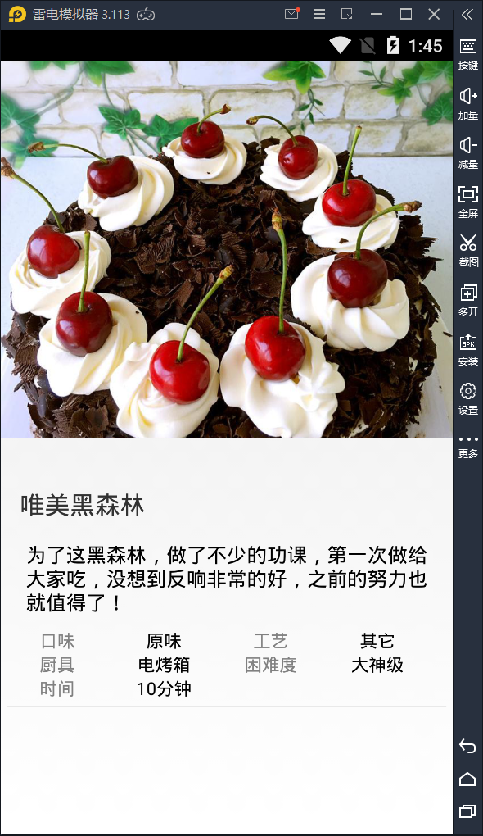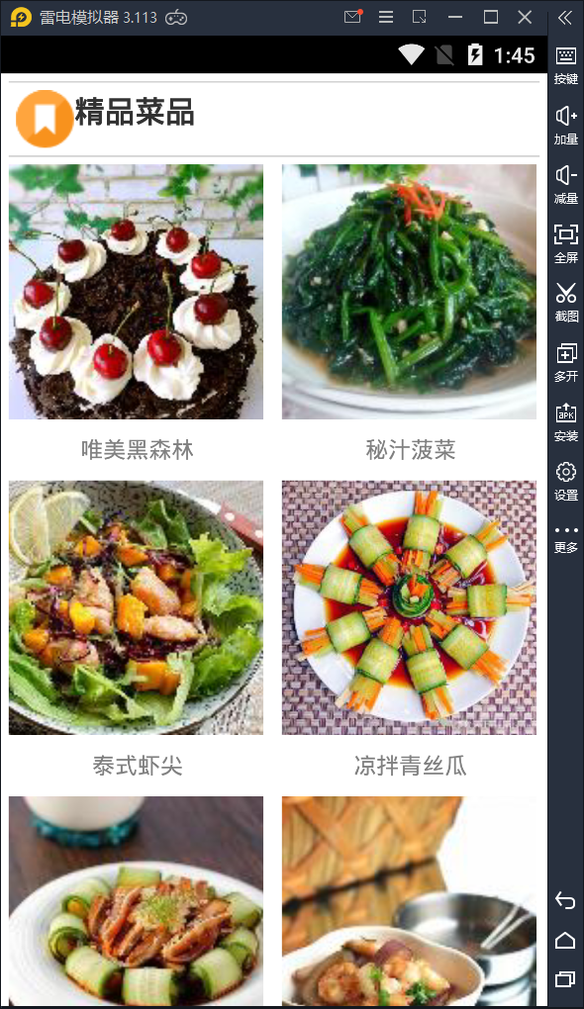
实验题:

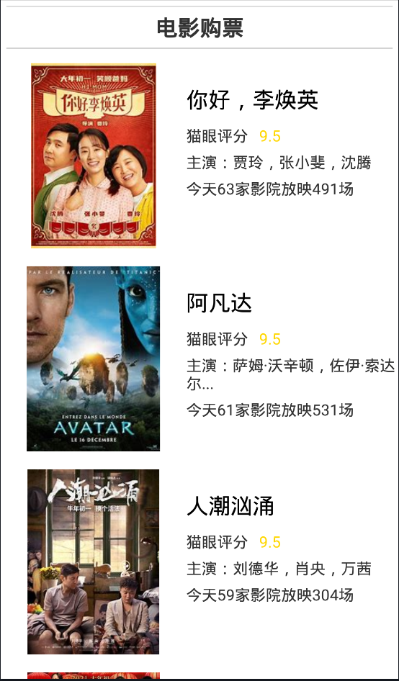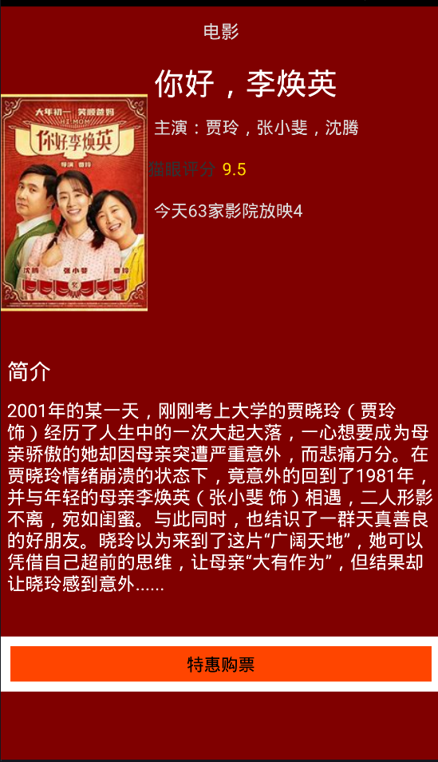
五、实验体会

通过本次实验，加深了对于Android开发的理解。熟悉了Android移动信息系统的基本架构。掌握Android移动信息系统的基本编程方法。

