-- 例3.49 查询每个学生及其选修课程的情况
SELECT student.*,sc.*
FROM student,sc
WHERE student.Sno=sc.Sno
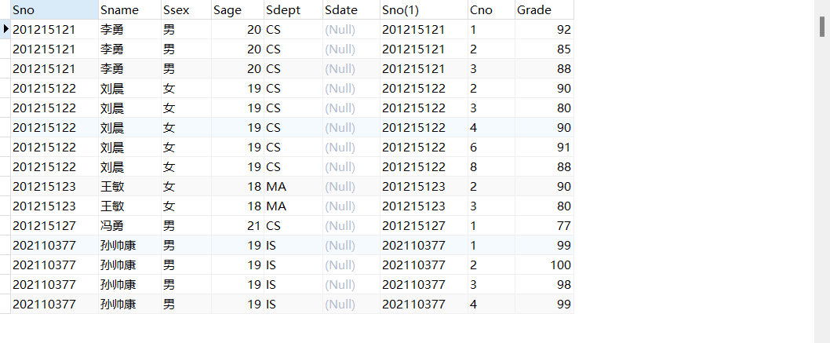
-- 例3.50 对例3.49用自然连接完成
SELECT student.Sno，Sname，Ssex,Sage,Sdept,Cno,Grade
FROM student,sc
WHERE student.Sno=sc.Sno;
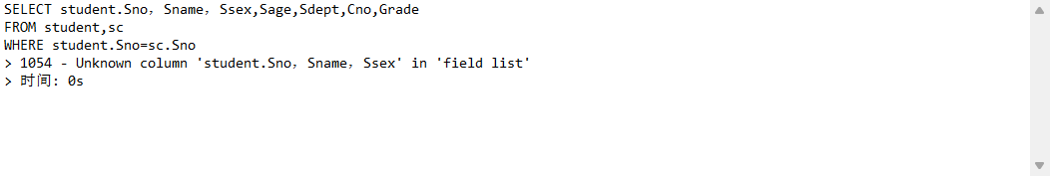
-- 例3.51 查询选修2号课程且成绩在90分以上的所有学生的学号和姓名
SELECT student.Sno,Sname
FROM student,sc
WHERE student.Sno=sc.Sno AND sc.Cno='2'AND sc.Grade>90;
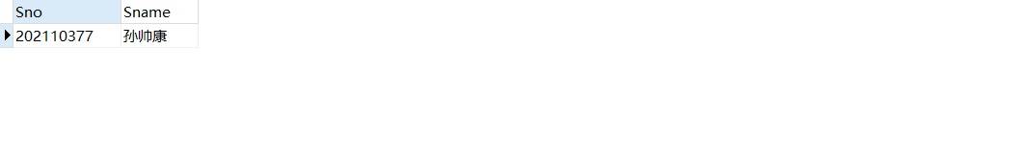
-- 例3.52 查询每一门课的间接先修课（即先修课的先修课）
SELECT FIRST.Cno,SECOND.Cpno
FROM course FIRST,course SECOND
WHERE FIRST.Cpno=SECOND.Cno;
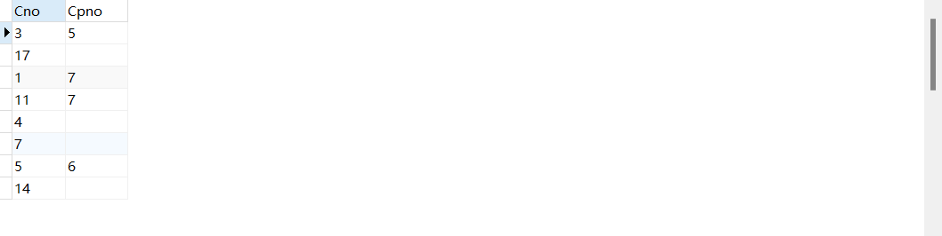
-- 例3.53 外连接
SELECT student.Sno,Sname,Ssex,Sage,Sdept,Cno,Grade
FROM student LEFT OUTER JOIN SC ON (student.Sno=sc.Sno);
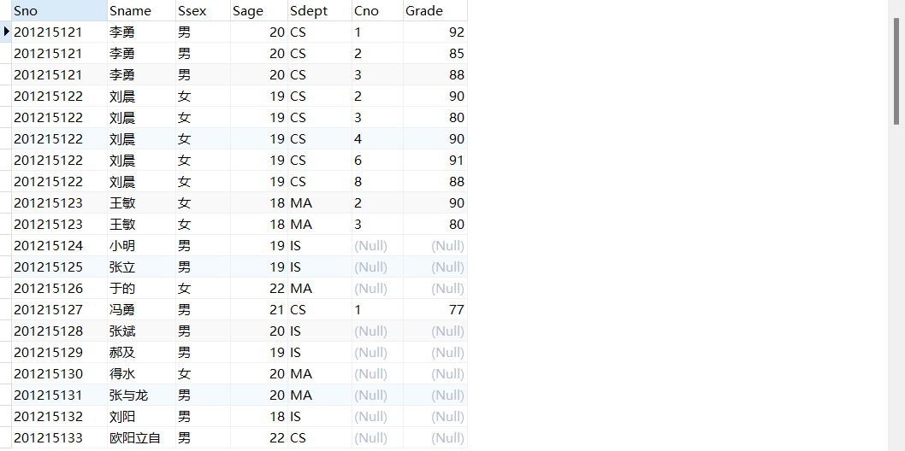
-- 例3.54 查询每个学生的学号、姓名、选修的课程名及成绩
SELECT student.Sno,Sname,Cname,Grade
FROM student,sc,course
WHERE student.Sno=sc.Sno AND course.Cno=sc.Cno;
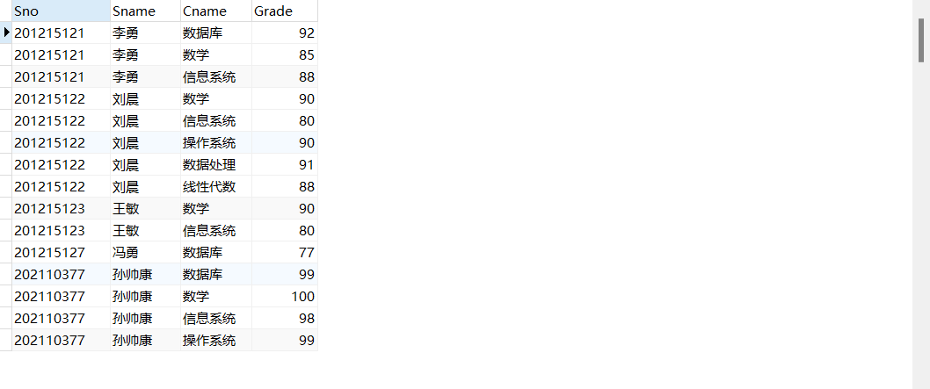
-- 例3.55 查询与“刘晨”在同一个系学习的学生
-- 解法一 嵌套查询
SELECT Sno，Sname，Sdept
FROM student
WHERE Sdept IN (
SELECT Sdept
FROM student
WHERE Sname='刘晨'
);

-- 解法二 自身连接
SELECT S1.Sno,S1.Sname,S1.Sdept
FROM student S1,student S2
WHERE S1.Sdept=S2.Sdept AND S2.Sname='刘晨';
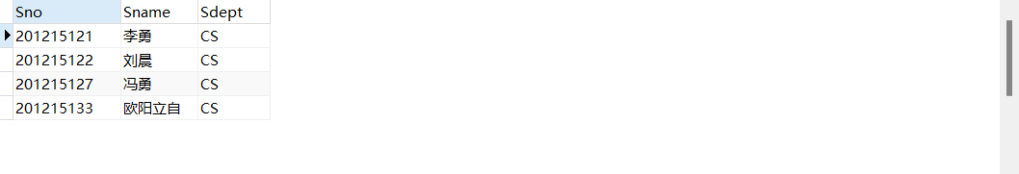
-- 例3.56 查询了选修了课程名为“信息系统”的学生学号和姓名
SELECT Sno,Sname
FROM student
WHERE Sno IN(
SELECT Sno
FROM sc
WHERE Cno IN(
SELECT Cno
FROM course
WHERE Cname='信息系统'
)
);
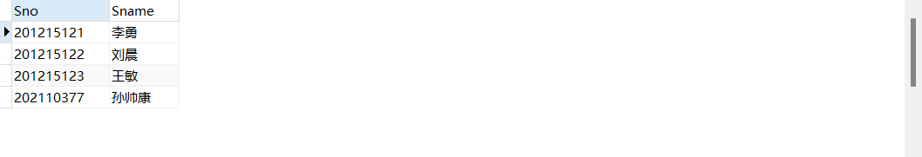
-- 例3.57 找出每个学生超过他自己选修课程平均成绩的课程号
SELECT Sno,Cno
FROM sc x
WHERE Grade >= (SELECT AVG(Grade)
FROM sc y
WHERE y.Sno=x.Sno);
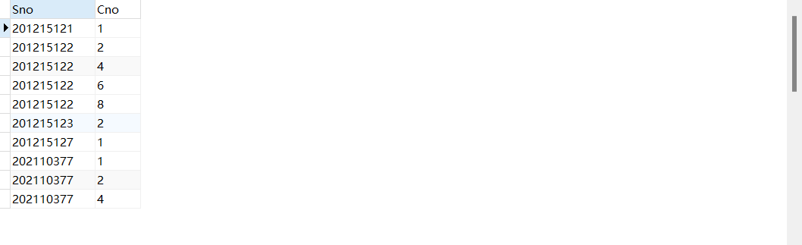
-- 例3.58 查询非CS系中比CS系任意一个学生年龄小的学生姓名和年龄
SELECT Sname,Sage
FROM student
WHERE Sage<ANY(SELECT Sage
FROM student
WHERE Sdept='CS')
AND Sdept <>'CS';
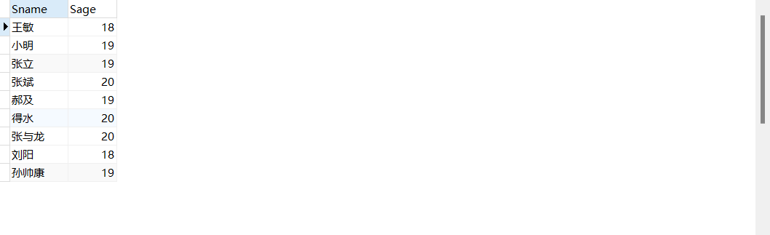
-- 例3.59 查询非CS系中比CS系中所有学生年龄都小的学生姓名及年龄
SELECT Sname,Sage
FROM student
WHERE Sage<ALL
(
SELECT Sage
FROM student
WHERE Sdept='CS'
)
AND Sdept <>'CS';
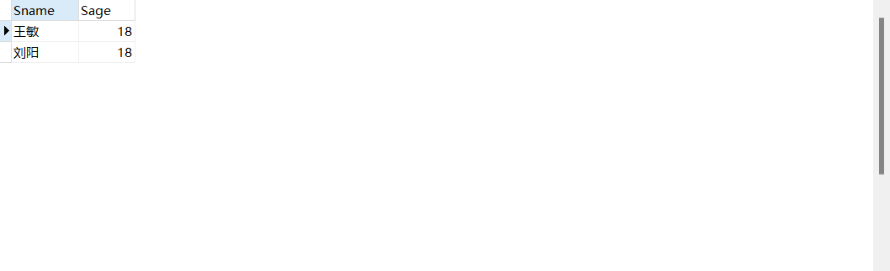
-- 例3.60 查询所有选修了1号课程的学生姓名
SELECT Sname
FROM student
WHERE EXISTS
(
SELECT *
FROM sc
WHERE Sno=student.Sno AND Cno='1'
);
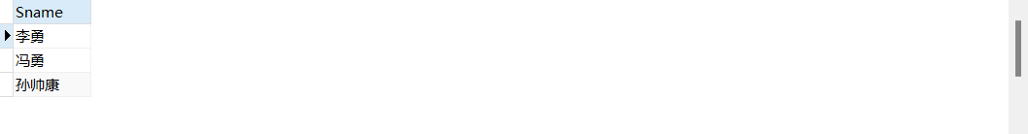
-- 例3.61 查询没有选修1号课程的学生姓名
SELECT Sname
FROM student
WHERE NOT EXISTS(
SELECT *
FROM sc
WHERE Sno=student.Sno AND Cno='1'
);
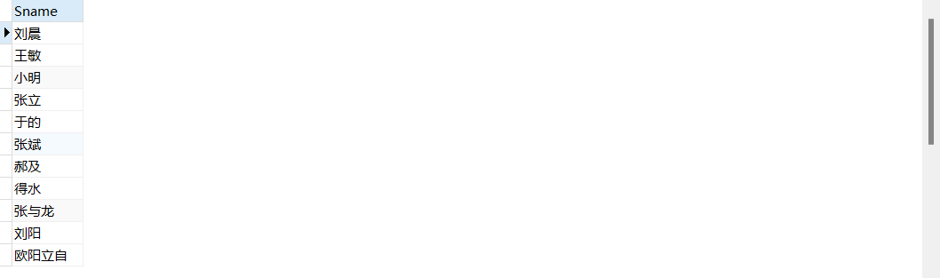
-- 例3.62 查询选修了全部课程的学生姓名
SELECT Sname
FROM student
WHERE NOT EXISTS(
SELECT *
FROM course
WHERE NOT EXISTS(
SELECT *
FROM sc
WHERE Sno=student.Sno
AND Cno=course.Cno
)
);
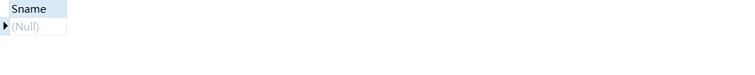
-- 例3.63 查询至少选修学生201215122选修的全部课程的学生号码
SELECT DISTINCT Sno
FROM sc SCX
WHERE NOT EXISTS
(
SELECT *
FROM sc SCY
WHERE SCY.Sno='201215122' AND
NOT EXISTS(
SELECT *
FROM sc SCZ
WHERE SCZ.Sno=SCX.Sno AND SCZ.Cno=SCY.Cno
)
);
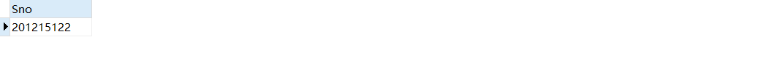
-- 例3.64 查询CS系的学生及年龄不大于19岁的学生
SELECT *
FROM student
WHERE Sdept='CS'
UNION
SELECT *
FROM student
WHERE Sage<=19;
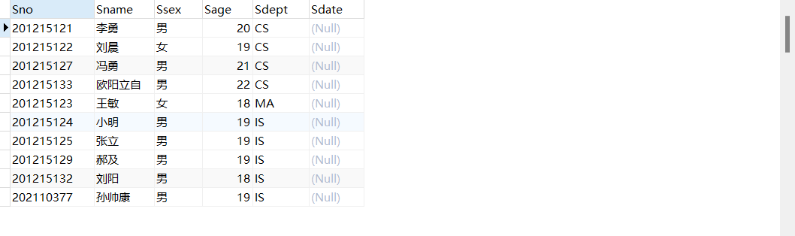
-- 例3.65 查询了选修课程1或者选修了课程2的学生
SELECT Sno
FROM sc
WHERE Cno='1'
UNION
SELECT Sno
FROM sc
WHERE Cno='2';
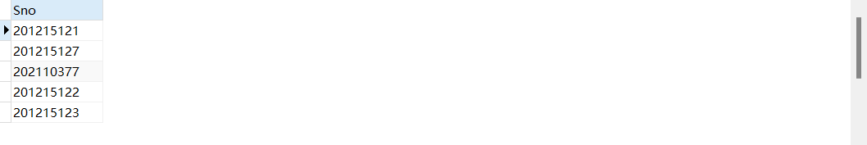
-- 例3.66 查询CS系的学生与年龄不大于19岁的学生的交集
SELECT *
FROM student
WHERE Sdept='CS' AND Sage<=19
-- 例3.67 查询既选修了课程1又选修了课程2的学生。就是查询选修课程1的学生集合与选修课程2的学生集合的交集
SELECT Sno
FROM sc
WHERE Cno='1' AND Sno IN (
SELECT Sno
FROM sc
WHERE Cno='2'
);
-- 例3.68 查询CS系的学生与年龄不大于19岁的学生的差集
SELECT *
FROM student
WHERE Sdept='CS' AND Sage>19;
