实验1：

1. 安装Sublime Text 3
2. HTML:5 Ctrl+e生成HTML5的基本标签

实验2 基本文本标签的使用

（1）summary标签

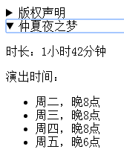

（2）使用符合语义的标签写出下图中的内容：

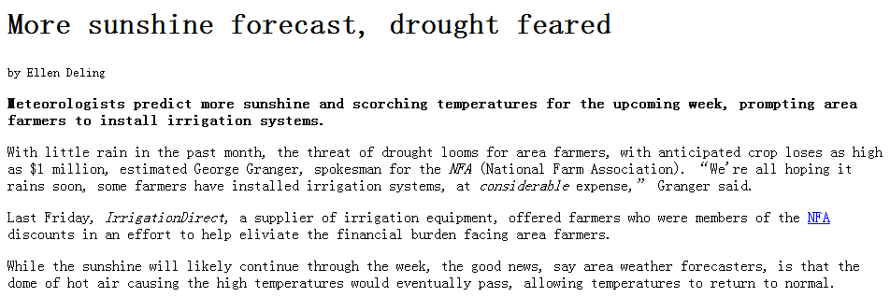

文字部分内容：

More sunshine forecast, drought feared

by Ellen Deling

Meteorologists predict more sunshine and scorching temperatures for the upcoming week, prompting area farmers to install irrigation systems.

With little rain in the past month, the threat of drought looms for area farmers, with anticipated crop loses as high as $1 million, estimated George Granger, spokesman for the NFA (National Farm Association). We're all hoping it rains soon, some farmers have installed irrigation systems, at considerable expense, Granger said.

Last Friday, IrrigationDirect, a supplier of irrigation equipment, offered farmers who were members of the NFA discounts in an effort to help eliviate the financial burden facing area farmers.

While the sunshine will likely continue through the week, the good news, say area weather forecasters, is that the dome of hot air causing the high temperatures would eventually pass, allowing temperatures to return to normal.

实验3：列表标签的使用

（1）使用列表标签写出下图中的列表：

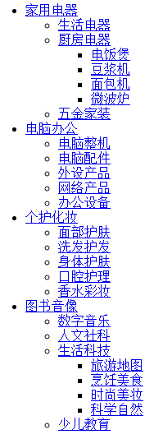

（2）定义列表

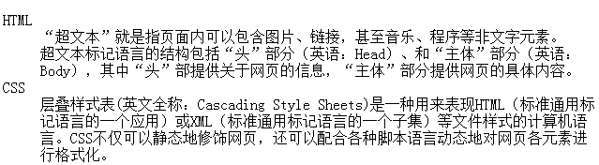

实验4：图片标签

1. 能够使用基于文档的相对路径插入图片
2. 能够写出图片地图

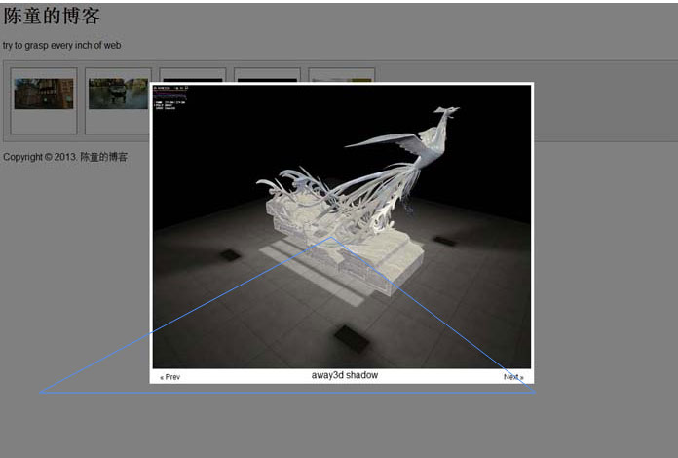

（3）figure

实验5：链接标签

能够写出链接到网址的链接、本地网的链接、邮箱链接和下载链接

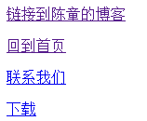

实验6：表格标签

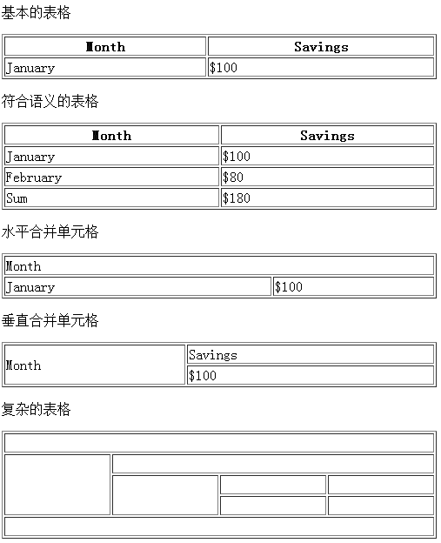

实验7：表单标签

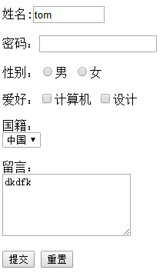

实验7：标签语义化练习

