Home Services Booking Platform
Final Year Project Report

Department of Computer Science
Section: French | Group: 3 Students

Students:
Jessica Said – ID: 62051
Christelle Nasr – ID: 61413
Charbel Sayah – ID: 61490
Supervisor: Dr. Joseph Merhej

Academic Year 2025 – 2026

Visit Our Website
https://universalsoftwaresolutions.com

Github Repository
https://github.com/CS-Studios89/Home-Services-Platform

1. Abstract

The Home Services Booking Platform is a full-stack web application that connects residential clients with vetted home-service professionals across categories such as cleaning, plumbing, babysitting, and home cooking. The core problem addressed is the fragmented and unreliable process by which households currently discover, schedule, and pay for trusted service providers.
The proposed solution is a three-role platform — Client, Provider, and Admin — built on a React.js frontend, a Node.js/Express.js REST API backend, and a PostgreSQL relational database. Clients browse and filter offerings, add them to a multi-item cart, pay online, and track bookings in real time. Providers manage their service listings, configure availability, and accept or reject incoming requests. Admins govern platform quality through user management, provider vetting, service-category administration, and a full audit log.
The system implements JWT-based session authentication with server-side token validation, atomic database transactions to prevent double-bookings, a running weighted-average rating engine, and a JSONB-backed audit trail. The achieved result is a secure, scalable, and user-friendly booking platform that meaningfully reduces the friction of engaging home services.

2. Introduction

The proliferation of on-demand digital marketplaces — from ride-hailing to food delivery — has raised consumer expectations for every category of personal service. Home services, however, remain underserved: most transactions still rely on word-of-mouth referrals, unverified classified listings, or phone directories, leaving clients uncertain about provider quality and providers without a reliable channel to reach new customers.

2.1 Motivation
This project was motivated by the desire to apply modern full-stack web-development techniques to a tangible real-world problem. A structured online marketplace creates value on both sides: clients gain transparent pricing, verified provider profiles, and a paper trail of their bookings; providers gain broader visibility and a professional workflow for managing their schedule.

2.2 Problem Statement
Three pain points were identified through analysis of the domain:
- Discovery difficulty — clients cannot efficiently search, filter, and compare providers by service type, location, price, or rating.
- Scheduling friction — agreeing on a time slot typically requires multiple phone calls and offers no protection against double-booking.
- Trust deficit — without a review system or vetting process, clients have no objective basis for evaluating a provider’s reliability.

2.3 Project Objectives
The platform was designed to satisfy the following measurable objectives:
- Implement a secure, role-based registration and authentication system using JWT and bcrypt.
- Provide a searchable, filterable catalogue of service offerings linked to provider profiles and real-time availability.
- Build a shopping-cart and checkout pipeline that detects time-slot conflicts at both cart and payment stages.
- Deliver an atomic payment flow that simultaneously records the transaction, creates bookings, and blocks provider calendar slots.
- Enable providers to accept or reject bookings and manage manual busy periods, with automatic slot release on rejection or cancellation.
- Implement a five-star review system that updates provider ratings in real time using a running weighted mean.
- Provide administrators with full user lifecycle management, provider approval workflows, service-category CRUD, and an immutable audit log.

2.4 Scope and Limitations
The system encompasses the following scope: web-browser access only (no native mobile application), simulated payment processing (no live payment gateway integration in the academic prototype), a curated set of service categories managed by administrators, and English-language interface. Future versions could address mobile apps, real payment gateways (e.g. Stripe), push notifications, and multi-language support.

2.5 Report Roadmap
Section 3 surveys related platforms and technologies. Section 4 presents the full system analysis: requirements, UML diagrams, and use scenarios. Section 5 details the development environment, architecture, API design, and screen descriptions. Section 6 concludes with outcomes and future work. The Appendix provides the Visual Paradigm project file reference.

3. State of the Art

Several commercial platforms occupy the home-services marketplace space. Understanding their design decisions informed the architecture choices made in this project.

3.1 Existing Platforms
Platform | Model | Strengths | Limitations
UrbanClap (Urban Company) | Curated two-sided marketplace | Strong provider vetting, in-app payment, ratings | Limited to major cities; closed ecosystem
Handy | Subscription + on-demand booking | Transparent pricing, background checks | US/UK only; provider earnings disputes
TaskRabbit | Freelance task marketplace | Flexible tasker profiles, real-time chat | High service fees; variable quality
This Project | Academic full-stack prototype | Open, extensible, fully documented REST API; atomic booking engine | Simulated payments; browser only
Table 1: Comparison of Home-Service Platforms

3.2 Technology References
The following technologies and standards underpin this project:
- React.js 18 — component-based frontend library enabling reactive UI with hooks and context.
- Node.js 22 with Express.js 4 — non-blocking, event-driven HTTP server providing the REST API layer.
- PostgreSQL 16 — ACID-compliant relational database supporting JSON(B) columns, foreign-key constraints, and performant index scans on time_slots.
- JSON Web Tokens (RFC 7519) — compact, URL-safe bearer tokens for stateless authentication, verified server-side against the sessions table on every protected request.
- bcrypt — adaptive password-hashing function resistant to brute-force and rainbow-table attacks.
- Visual Paradigm 17 — UML modelling suite used to produce the use case, class, and activity diagrams.

4. Analysis

4.1 Business Rules & Requirements
Functional Requirements
ID | Requirement | Description
FR-01 | User Registration | Guests can create accounts as Client, Provider, or Admin. Providers require admin approval before operating.
FR-02 | Authentication | Users authenticate via email/password. The system issues a signed JWT and stores the session server-side for revocability.
FR-03 | Service Browse & Filter | All visitors can browse services and offerings. Clients can apply filters (service type, rate, currency, provider rating).
FR-04 | Provider Availability | The system exposes free time windows for each provider, computed by diffing current time_slots against a future horizon.
FR-05 | Shopping Cart | Clients can add multiple offerings to a cart with conflict detection. Cart items are time-stamped and priced at insertion.
FR-06 | Order & Checkout | Checking out converts the active cart into an order (status: pending_payment) and freezes item prices.
FR-07 | Payment | Clients submit payment details; the system re-validates all slots, then atomically records the payment, creates bookings, and locks provider calendars.
FR-08 | Booking Management | Clients view and cancel bookings. Providers view pending requests and accept or reject them, with automatic slot release on rejection.
FR-09 | Reviews | After service delivery clients submit a star rating (1–5) and optional note. The provider’s rating_avg is updated via running weighted mean.
FR-10 | Provider Busy Slots | Providers can manually block calendar periods (e.g. holidays) without a linked booking. These slots are respected during conflict checks.
FR-11 | Admin Dashboard | Admins list, filter, enable/disable user accounts; approve or reject providers; manage service categories; read the audit log.
FR-12 | Audit Logging | Every admin action (user status change, provider approval, service CRUD) is persisted in admin_audit with actor, action, entity, and JSONB metadata.
Table 2: Functional Requirements

Non-Functional Requirements
ID | Category | Requirement
NFR-01 | Security | All passwords are hashed with bcrypt (10 salt rounds). JWTs are verified on every protected endpoint and revoked on logout or account disable.
NFR-02 | Data Integrity | All multi-step operations (registration, payment, cancellation) execute within PostgreSQL transactions with full rollback on failure.
NFR-03 | Concurrency | Time-slot conflict detection is re-run at payment time inside a transaction to prevent race-condition double-bookings.
NFR-04 | Performance | A composite index on time_slots(provider_id, start_at, end_at) ensures O(log n) availability queries regardless of booking volume.
NFR-05 | Usability | The REST API returns consistent JSON error shapes with appropriate HTTP status codes, enabling clear frontend error handling.
NFR-06 | Scalability | The stateless JWT design and connection-pool (pg) architecture allow horizontal scaling of the API tier behind a load balancer.
NFR-07 | Auditability | Every admin action is permanently recorded with actor identity, timestamp, entity reference, and extensible JSONB metadata.
Table 3: Non-Functional Requirements

4.2 Use Case Diagram & Scenarios
The use case diagram below captures the interactions between the four main actors of the Home Services Platform and the system’s functional capabilities. Guests may browse and register without authentication. Clients can manage their cart, place and pay for orders, track and cancel bookings, and submit reviews. Providers manage their service offerings, configure manual busy time slots, and accept or reject incoming booking requests. Admins exercise full control over user accounts, provider approvals, service categories, and audit logging.
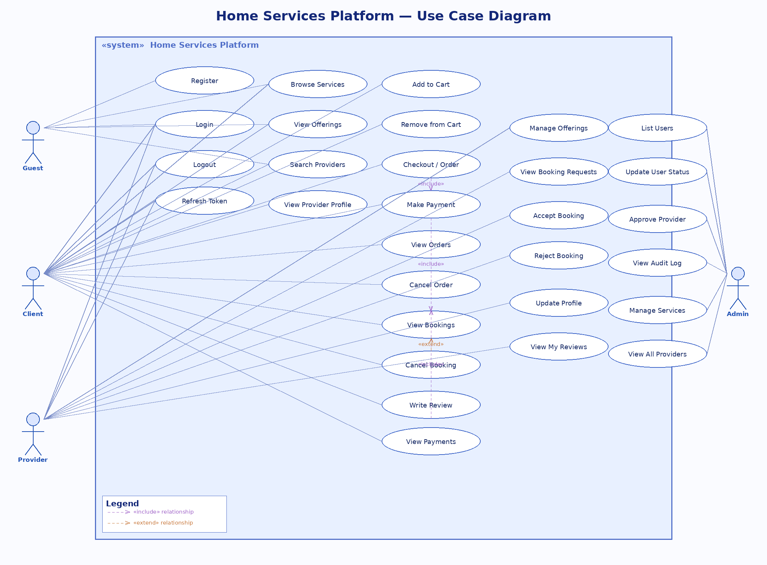
Figure 1: Use Case Diagram — Home Services Platform

4.2.1 Use Scenarios
The following table summarises the nine primary use scenarios. Each is elaborated with preconditions, postconditions, main flow, and alternate flows in the subsequent sub-sections.
ID | Scenario | Primary Actor | Goal
UC-01 | Guest Registration | Guest | Create a Client, Provider, or Admin account and receive a JWT session token.
UC-02 | User Login | Client / Provider / Admin | Authenticate with email and password; receive a fresh JWT; invalidate the previous session.
UC-03 | Browse & Search Services | Guest / Client | Discover offerings with filters, view provider profiles, and check real-time availability.
UC-04 | Add to Cart & Checkout | Client | Build a multi-item cart with conflict detection, then convert it to a payable order.
UC-05 | Make Payment | Client | Record payment, atomically create bookings, and lock provider calendar slots.
UC-06 | Accept / Reject Booking | Provider | Review incoming requests; rejected slots are freed automatically.
UC-07 | Cancel Booking | Client | Withdraw a booking and release the provider’s locked time slot.
UC-08 | Write a Review | Client | Submit a star rating and note; provider’s average rating is recalculated in real time.
UC-09 | Admin Approves Provider | Admin | Vet and approve or reject pending provider accounts; all actions are audit-logged.
Table 4: Use Scenario Summary

UC-01 — Guest Registration
Scenario ID | UC-01 — Guest Registration | Primary Actor | Guest
Trigger | Guest clicks ‘Sign Up’ and submits the registration form. | Frequency | Daily — high volume
Pre-condition | Guest is unauthenticated. Email address is not already registered. | Post-condition | New user row created. JWT session token returned (HTTP 201). Providers created with approved = ‘pending’.

Goal: Allow a new visitor to create a Client, Provider, or Admin account so they can access the platform.
Main Success Scenario
Step | Actor | Action / System Response
1 | Guest | Sends POST /api/v1/auth/signup with: name, email, password, role, and address. Providers also supply a bio.
2 | System | Validates all required fields are present and role ∈ {client, provider, admin}.
3 | System | Queries the users table to confirm the email is unique.
4 | System | Inserts a new row in addresses (if address provided) to obtain an addr_id.
5 | System | Hashes the password with bcrypt (10 salt rounds).
6 | System | Inserts the user into users with status = ‘active’. For providers, inserts into providers with approved = ‘pending’.
7 | System | Signs a JWT with the user_id payload and stores it in sessions with a 24-hour expiry.
8 | System | Returns HTTP 201 with { token }. The guest is now authenticated under their chosen role.
Alternate & Exception Flows
Condition | Alternate / Exception Flow
Email already registered | HTTP 409 — ‘Email already exists’. Transaction rolled back.
Missing required fields | HTTP 400 — ‘Please fill all required fields’.
Invalid role value | HTTP 400 — ‘Invalid role’.
Admin without correct passkey | HTTP 400 — ‘Invalid Admin Password’.
Provider missing address or bio | HTTP 400 — all provider-specific fields are mandatory.
DB error during transaction | Full rollback; no user, address, provider, or session rows created.
Business Rules & Notes
- Passwords are never stored in plain text — only the bcrypt hash is persisted.
- Provider accounts remain in ‘pending’ approval state until an Admin explicitly approves them (UC-09).
- Admin registration requires a matching ADMIN_PASSKEY environment variable, preventing unauthorised admin creation.

UC-02 — User Login
Scenario ID | UC-02 — User Login | Primary Actor | Client / Provider / Admin
Trigger | User submits email and password on the login screen. | Frequency | Multiple times daily
Pre-condition | User has a registered account with status = ‘active’. | Post-condition | Fresh JWT session created. Previous session deleted. HTTP 200 returned with { token }.

Goal: Authenticate a returning user and issue a new JWT session token, invalidating any prior session.
Main Success Scenario
Step | Actor | Action / System Response
1 | User | Sends POST /api/v1/auth/login with { email, password }.
2 | System | Queries users by email; retrieves hashed password and account status.
3 | System | Verifies account status is ‘active’.
4 | System | Runs bcrypt.compare against the stored hash.
5 | System | Opens a transaction: deletes all existing sessions for the user_id, then inserts a new session row with the new JWT and expires_at (+24 h).
6 | System | Commits and returns HTTP 200 with { token }.
Alternate & Exception Flows
Condition | Alternate / Exception Flow
Email not found | HTTP 401 — ‘Invalid credentials’ (deliberately vague to prevent enumeration).
Incorrect password | HTTP 401 — ‘Invalid credentials’.
Account disabled | HTTP 403 — ‘Your account has been disabled’.
DB error on commit | Transaction rolled back; old session preserved, no new token issued.
Business Rules & Notes
- Each login is a single-session design: logging in always revokes previous tokens.
- The token refresh endpoint (POST /auth/refresh) allows extending a session without re-entering credentials.
- Logout (POST /auth/logout) deletes the session row, immediately invalidating the token server-side.

UC-03 — Browse & Search Services
Scenario ID | UC-03 — Browse & Search Services | Primary Actor | Guest / Client
Trigger | User opens the services or offerings page, optionally with filter parameters. | Frequency | Very high — primary discovery flow
Pre-condition | At least one service category and one active offering exist in the database. | Post-condition | Filtered list of offerings returned. Provider availability windows available on demand.

Goal: Enable users to discover available home-service offerings, view provider details, and check real-time availability.
Main Success Scenario
Step | Actor | Action / System Response
1 | User | Calls GET /api/v1/services to retrieve all service categories with minimum rates.
2 | System | Returns an array of { service_id, name, minRate } computed via a GROUP BY aggregate on offerings.
3 | User | Calls GET /api/v1/offerings or POST /api/v1/offerings (with body { filters }) to retrieve offerings.
4 | System | Executes a parameterised SQL query joining offerings, providers, services, and users. Returns matching records.
5 | User | Selects an offering and calls GET /api/v1/offerings/available-time/:offeringId.
6 | System | Retrieves the provider’s time_slots, computes gaps between now and a +100-year horizon, and returns free [start, end] pairs.
7 | User | Views provider profile at GET /api/v1/provider/:providerId: name, bio, rating_avg, rating_count, address.
Alternate & Exception Flows
Condition | Alternate / Exception Flow
No offerings match filters | Empty array returned; frontend shows ‘No results found’.
Invalid offeringId | HTTP 400 — ‘No offering Id provided’.
Provider not found by providerId | HTTP 404 — ‘Provider not found’.
Business Rules & Notes
- Browse endpoints are fully public — no authentication header is required.
- Available-time checks scan the provider’s entire time_slots table (not just the selected offering) to prevent cross-offering conflicts.
- Offerings can be filtered client-side or server-side; server filtering is preferred to minimise payload size.

UC-04 — Add to Cart & Checkout
Scenario ID | UC-04 — Add to Cart & Checkout | Primary Actor | Client
Trigger | Client selects an offering, picks a time slot, and clicks ‘Add to Cart’. | Frequency | High — core transactional path
Pre-condition | Client is authenticated. The chosen offering is active. The desired time slot does not conflict with existing bookings. | Post-condition | Cart item persisted. Cart can contain multiple items. Checkout creates an order with status = ‘pending_payment’.

Goal: Allow a client to build a multi-item cart and convert it into a payable order.
Main Success Scenario
Step | Actor | Action / System Response
1 | Client | Sends POST /api/v1/cart with { cartItem: { offeringId, start_at, end_at } }.
2 | System | Authenticates JWT. Finds or auto-creates an active carts row for this user.
3 | System | Queries time_slots for the offering’s provider and applies six-way interval overlap logic to check for conflicts.
4 | System | If no conflict: computes hours = (end_at − start_at) / 3600000, price = hours × rate, total. Inserts a cart_items row.
5 | Client | Optionally repeats steps 1–4 to add further offerings.
6 | Client | Sends POST /api/v1/cart/checkout.
7 | System | Opens a transaction: creates an orders row (status = ‘pending_payment’), copies cart_items to order_items with frozen prices, marks the cart as ‘checked_out’. Commits.
8 | System | Returns the new order_id.
Alternate & Exception Flows
Condition | Alternate / Exception Flow
Time slot conflicts with existing booking | HTTP 409 — ‘Time slot not available’. Cart item is NOT created.
Cart does not yet exist | System auto-creates an active cart before inserting the item.
Missing required fields | HTTP 401 — ‘Please fill all required fields’.
Checkout on empty cart | Error returned; no order is created.
Business Rules & Notes
- Prices are locked at checkout time; subsequent changes to an offering’s rate do not affect existing orders.
- The six-way interval check covers all partial and full overlaps: start inside, end inside, and fully containing the existing slot.
- Multiple offerings from different providers can coexist in the same cart and order.

UC-05 — Make Payment
Scenario ID | UC-05 — Make Payment | Primary Actor | Client
Trigger | Client submits payment details for an order in pending_payment status. | Frequency | Same frequency as checkout
Pre-condition | Client owns the order. All ordered time slots are still available (no competing bookings since cart was built). | Post-condition | Payment recorded (status = ‘completed’). Order updated to ‘paid’. One booking per order_item created (status = ‘requested’). Provider calendar slots locked.

Goal: Securely record payment and atomically create bookings while locking provider time slots.
Main Success Scenario
Step | Actor | Action / System Response
1 | Client | Sends POST /api/v1/payments with { info: { order_id, method, type, amount, curr } }.
2 | System | Verifies client ownership of the order.
3 | System | Loads all order_items for the order, grouped by provider_id.
4 | System | Re-validates time slot availability for every order_item against live time_slots to catch race conditions.
5 | System | Opens a transaction: inserts a payments row (status = ‘completed’), updates order status to ‘paid’.
6 | System | For each order_item: inserts a bookings row (status = ‘requested’) and a time_slots row (provider_id, start_at, end_at, booking_id).
7 | System | Commits. Returns HTTP 200 with { success: true }.
8 | Client | Receives confirmation. Bookings await provider decisions.
Alternate & Exception Flows
Condition | Alternate / Exception Flow
Slot taken since cart build (race condition) | Transaction rolled back. HTTP 409. Client must choose a new time.
Client does not own the order | HTTP 400 — ‘You are not the owner of this order’.
Missing payment fields | HTTP 400 — ‘Fill all required fields’.
DB error during commit | Full rollback; no payment, booking, or time_slot records created.
Business Rules & Notes
- The double slot-check (at cart stage and again at payment stage) is the key anti-double-booking mechanism.
- Each booking maps 1-to-1 to an order_item, enforced by a UNIQUE constraint on bookings.order_item_id.
- The payments.ref column stores an external gateway reference for future integration with providers like Stripe.

UC-06 — Accept / Reject Booking
Scenario ID | UC-06 — Accept / Reject Booking | Primary Actor | Provider
Trigger | Provider views pending booking requests and takes an accept or reject action. | Frequency | Per booking received
Pre-condition | Provider is authenticated and has approved = ‘approved’. At least one booking with status = ‘requested’ exists for their offerings. | Post-condition | Accept: booking status → ‘accepted’. Reject: booking status → ‘rejected’; associated time_slot deleted.

Goal: Give the provider control over which jobs they take, and automatically free the calendar on rejection.
Main Success Scenario
Step | Actor | Action / System Response
1 | Provider | Calls GET /api/v1/booking/pending to list all ‘requested’ bookings for their offerings.
2 | System | Returns booking details: client name, service, dates, hours, total, address.
3 | Provider | Reviews a booking and decides.
4 | Provider | To accept: GET /api/v1/booking/:bookingId/accept.
5 | System | Verifies the provider owns the booking via isBookingProvider. Updates bookings.status → ‘accepted’. Returns { success: true }.
6 | Provider | To reject: DELETE /api/v1/booking/:bookingId/reject.
7 | System | Verifies ownership. Opens transaction: sets status → ‘rejected’, deletes the time_slots row for this booking. Commits.
Alternate & Exception Flows
Condition | Alternate / Exception Flow
Provider does not own the booking | HTTP 403 — ‘You are not the Provider for this booking’.
Booking not found | HTTP 404 or empty result.
DB error on reject | Rollback; booking unchanged, time_slot preserved.
Business Rules & Notes
- Deleting the time_slot on rejection is critical: it frees the window so another client can book the same period.
- Providers can also proactively block calendar time via POST /api/v1/provider/busy-slot (manual slots have booking_id = NULL).
- Manual busy slots can be deleted individually via DELETE /api/v1/provider/busy-slot/:slotId, but only if booking_id IS NULL.

UC-07 — Cancel Booking
Scenario ID | UC-07 — Cancel Booking | Primary Actor | Client
Trigger | Client decides to cancel a booking they placed. | Frequency | Occasional
Pre-condition | Client is authenticated and owns the booking. | Post-condition | Booking status → ‘Cancelled’. Associated time_slot deleted, freeing the provider’s calendar.

Goal: Allow a client to withdraw a booking and automatically release the provider’s locked time slot.
Main Success Scenario
Step | Actor | Action / System Response
1 | Client | Calls GET /api/v1/booking to view their full bookings list with statuses, dates, provider, and address.
2 | System | Returns all bookings for the authenticated user.
3 | Client | Identifies the booking to cancel and sends DELETE /api/v1/booking/:bookingId.
4 | System | Verifies the client owns the booking via isBookingOwner.
5 | System | Opens transaction: updates booking status → ‘Cancelled’, deletes the time_slot row for this booking_id. Commits.
6 | System | Returns { success: true }.
Alternate & Exception Flows
Condition | Alternate / Exception Flow
Client does not own the booking | HTTP 403 — ‘You are not the owner of this booking’.
DB error | Rollback; booking status and time_slot unchanged.
Business Rules & Notes
- A cancellation policy (e.g. no cancellation within 24 hours of the service) is a future business rule not yet enforced in the API.
- Refund logic would be integrated here in a production build by calling the payment gateway’s refund endpoint.

UC-08 — Write a Review
Scenario ID | UC-08 — Write a Review | Primary Actor | Client
Trigger | Client submits a star rating and optional note after a completed service. | Frequency | After each completed service
Pre-condition | Client is authenticated and owns the booking. No review already exists for this booking (UNIQUE constraint). | Post-condition | Review row created. Provider’s rating_avg and rating_count updated atomically.

Goal: Capture client feedback and update the provider’s public reputation score in real time.
Main Success Scenario
Step | Actor | Action / System Response
1 | Client | Sends POST /api/v1/reviews with { booking_id, rating (1–5), note }.
2 | System | Verifies JWT and confirms client owns the booking.
3 | System | Checks no review already exists for this booking_id.
4 | System | Opens transaction: inserts into reviews (booking_id, user_id, rating, note, created_at).
5 | System | Recalculates provider rating: new_avg = (old_avg × old_count + new_rating) / (old_count + 1). Updates providers.rating_avg and providers.rating_count. Commits.
6 | System | Returns { success: true, reviewId }.
7 | Client | Review is visible on the provider’s public profile and all related offering pages.
Alternate & Exception Flows
Condition | Alternate / Exception Flow
Review already exists for booking | HTTP 409 — one review per booking enforced by DB UNIQUE constraint.
Client does not own the booking | HTTP 403 — Forbidden.
Rating outside 1–5 range | HTTP 400 — validation error.
Business Rules & Notes
- The running weighted mean avoids re-reading all reviews on each update, keeping the operation O(1).
- Reviews can be listed per provider (GET /api/v1/reviews/provider/:providerId) or per offering (GET /api/v1/reviews/offering/:offeringId).

UC-09 — Admin Approves a Provider
Scenario ID | UC-09 — Admin Approves a Provider | Primary Actor | Admin
Trigger | Admin reviews the list of providers with approved = ‘pending’ and makes a decision. | Frequency | On each new provider registration
Pre-condition | Admin is authenticated with role = ‘admin’. At least one provider with approved = ‘pending’ exists. | Post-condition | Provider approval status updated. Admin action persisted in admin_audit.

Goal: Ensure only vetted service professionals can accept bookings on the platform.
Main Success Scenario
Step | Actor | Action / System Response
1 | Admin | Calls GET /api/v1/admin/providers?approved=pending to list all pending providers.
2 | System | Returns provider records including name, email, bio, rating, address, and approval status.
3 | Admin | Reviews the provider profile and decides.
4 | Admin | Sends PATCH /api/v1/admin/providers/:providerId/approval with { approved: ‘approved’ } or { approved: ‘rejected’ }.
5 | System | Validates the value ∈ {pending, approved, rejected}.
6 | System | Updates providers.approved. Calls logAdminAction to insert a row in admin_audit (action, entity_type = ‘provider’, entity_id, JSONB meta). Returns updated provider.
7 | Admin | Can view the full audit trail at GET /api/v1/admin/audit (paginated, ordered by id DESC).
Alternate & Exception Flows
Condition | Alternate / Exception Flow
Invalid approval value | HTTP 400 — ‘Invalid approved value’.
Provider not found | HTTP 404.
Non-admin calls this endpoint | HTTP 403 — requireAdmin middleware blocks before controller runs.
Business Rules & Notes
- Admins can also fully disable a provider via PATCH /admin/providers/:providerId/disable, which simultaneously sets the user status to ‘disabled’, sets approved to ‘rejected’, and deletes all active sessions.
- All admin actions (user status change, service CRUD, provider approval/disable) are immutably logged in admin_audit with JSONB metadata.
- Service categories can be created, renamed, and deleted by admins. Deletion is blocked (HTTP 409) while any offering still references the category.

4.3 Class Diagram
The entity-relationship diagram below presents the complete relational schema of the Home Services Platform. The schema comprises 13 tables. The central entity is users, which links to addresses (physical location), sessions (active JWT records), providers (professional profile), carts (shopping baskets), orders (confirmed purchase records), and bookings (scheduled service appointments). Providers are connected to offerings (service listings) and time_slots (calendar blocks). Orders contain order_items (line items with frozen prices) and are settled through payments. Each booking may receive exactly one review, enforced by a UNIQUE constraint. All administrative operations are permanently recorded in admin_audit with a JSONB metadata column for extensibility.
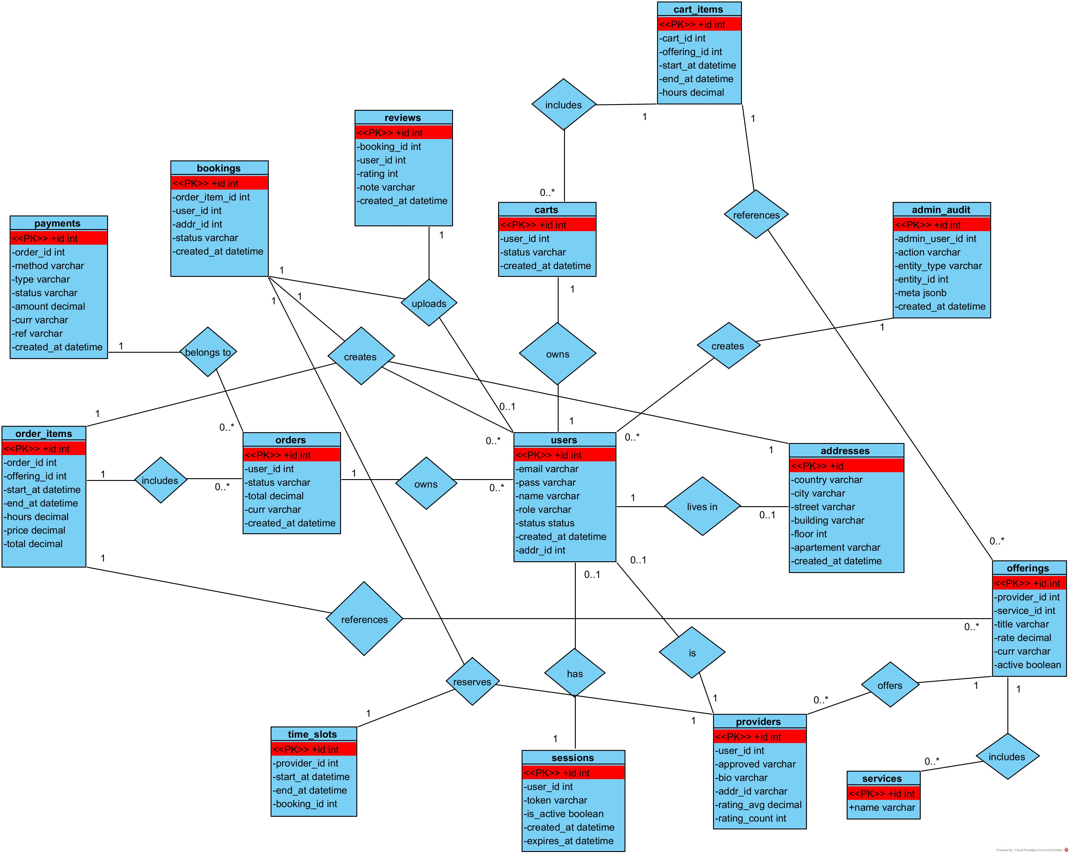
Figure 2: Class / Entity-Relationship Diagram — Home Services Platform

4.3.1 Key Design Decisions
- Addresses are normalised into their own table and referenced by both users and providers, avoiding duplication and enabling future multi-address support.
- time_slots acts as a unified calendar layer: rows with booking_id are created automatically at payment time; rows with booking_id = NULL are manual provider blocks. A composite index on (provider_id, start_at, end_at) ensures fast overlap queries.
- order_items store price and total at the time of checkout (historical snapshot), decoupling booking records from future rate changes on the offerings table.
- admin_audit uses a JSONB meta column so that any additional context (e.g. reason for disabling an account) can be stored without schema migrations.
- The UNIQUE constraint on bookings.order_item_id prevents duplicate bookings for the same line item even under concurrent payment requests.

4.4 Activity Diagram
The activity diagram below models the complete client booking flow across four swimlanes: Client, System/Server, Provider, and Admin. Starting from service discovery, the flow covers time-slot validation, cart management, order creation, atomic payment processing, provider accept/reject decisions, and post-service review submission. The Admin swimlane runs in parallel, showing the ongoing responsibilities of user management and provider vetting.
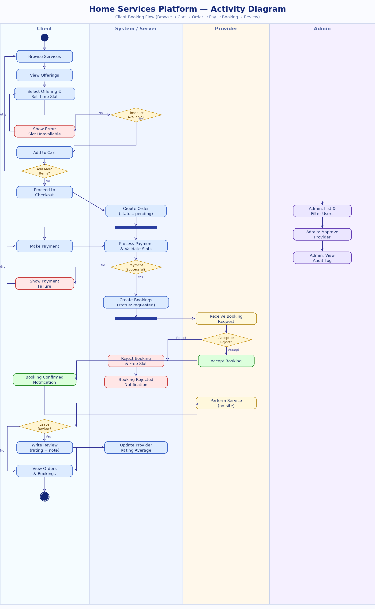
Figure 3: Activity Diagram — Client Booking Flow

5. Development

5.1 Technical Environment
Layer | Technology | Role in the System
Frontend | React.js 18 | Component-based SPA; hooks for state; React Router for navigation.
Backend | Node.js 22 + Express.js 4 | RESTful API server; middleware pipeline for auth, validation, error handling.
Database | PostgreSQL 16 | ACID-compliant relational store; 13 tables; composite index on time_slots.
Authentication | JWT (jsonwebtoken) | Signed bearer tokens; server-side session table for revocability.
Password Hashing | bcrypt | Adaptive hashing with 10 salt rounds; resistant to brute-force attacks.
API Testing | Postman | Request collections for all endpoints; environment variables for tokens.
Version Control | Git / GitHub | Feature-branch workflow; pull requests for code review.
IDE | Visual Studio Code | ESLint, Prettier, REST Client extension for inline API testing.
UML Modelling | Visual Paradigm 17 | Use case, class, and activity diagrams exported as PNG and .vpp.
Table 5: Technical Stack

5.2 System Architecture
The application follows a classic three-tier architecture:
- Presentation tier: React.js SPA served as static assets. All server communication is performed via the Fetch API against the REST endpoints.
- Application tier: Express.js API server. Each resource domain (auth, offerings, cart, orders, payments, bookings, reviews, providers, admin) is encapsulated in its own router and controller. Cross-cutting concerns (authentication, admin authorisation, error handling) are addressed by dedicated middleware.
- Data tier: PostgreSQL accessed via the node-postgres (pg) connection pool. All business-critical operations execute within explicit transactions (BEGIN / COMMIT / ROLLBACK).

5.3 API Design
The API follows REST conventions under the base path /api/v1. The table below lists all route groups, their authentication requirements, and their primary operations.
Route Group | Auth Required | Key Operations
/auth | Partial | POST /login, /signup (public); POST /logout, /refresh (JWT required).
/profile | JWT | GET profile info; PATCH to update name and address fields.
/services | Public | GET all service categories with minimum rates.
/offerings | Partial | GET/POST (public browse); POST /me, PATCH /:id, DELETE /:id (provider JWT).
/provider | JWT (Provider) | GET provider details; POST/DELETE busy time slots.
/cart | JWT (Client) | GET cart items; POST add item; DELETE remove item; POST checkout.
/orders | JWT (Client) | GET orders; GET /:id/items; DELETE /:id (cancel order).
/payments | JWT (Client) | GET payment history; POST make payment.
/booking | JWT | GET bookings; DELETE cancel (Client); GET /pending, accept, reject (Provider).
/reviews | Partial | GET by booking/provider/offering (public); POST submit (JWT Client).
/admin | JWT (Admin) | Full CRUD on users, providers, service categories; GET audit log.
Table 6: API Route Summary

5.4 Security Implementation
Security is implemented at multiple layers:
- Authentication middleware (authMiddleware.js) verifies the JWT signature AND checks the sessions table for is_active = true and expires_at >= NOW(), ensuring tokens are immediately invalidatable server-side.
- Admin-only endpoints are protected by a second requireAdmin middleware that reads req.user.role from the JWT payload after authentication.
- All SQL queries use parameterised placeholders ($1, $2, ...) via the pg library, preventing SQL injection attacks.
- bcrypt with 10 salt rounds is used for password storage; even if the database is compromised, passwords cannot be trivially reversed.
- Disabling a user account automatically deletes all their active sessions, preventing continued access with stale tokens.

5.5 Navigation Structure
The frontend application is structured as a single-page application with the following main routes:
- / (Home): Landing page with platform overview and service category highlights.
- /services: Searchable and filterable listing of all active service offerings.
- /provider/:id: Public provider profile showing bio, rating, reviews, and offerings.
- /cart: Client shopping cart with conflict-checked time-slot selection.
- /checkout: Order summary and payment form.
- /dashboard: Client dashboard showing orders, bookings, and reviews.
- /provider/dashboard: Provider dashboard for managing offerings, busy slots, and booking requests.
- /admin: Admin control panel for users, providers, services, and audit log.

5.6 Key Screens
Screen | Description
Login / Register | Dual-purpose authentication screen. Role selector drives additional fields (bio for providers, admin passkey for admins).
Service Catalogue | Grid of service cards with minimum rate. Filter panel allows narrowing by category, price range, and provider rating.
Offering Detail | Full offering info with provider profile, real-time availability calendar, and Add to Cart action.
Shopping Cart | List of cart items with computed hours, price, and total. Slot conflicts highlighted before checkout.
Client Dashboard | Tabbed view: My Orders (status, total), My Bookings (provider, date, status), My Reviews.
Provider Dashboard | Tabs: My Offerings (CRUD), Pending Requests (accept/reject), Busy Slots (add/remove manual blocks).
Admin Panel | Four tabs: Users (filter, enable/disable), Providers (approve/reject/disable), Service Categories (CRUD), Audit Log.
Table 7: Key Application Screens

The following figures illustrate key user interface components of the Home Services platform. Each screen is designed to ensure usability, accessibility, and efficient interaction between users and the system.

Login page:
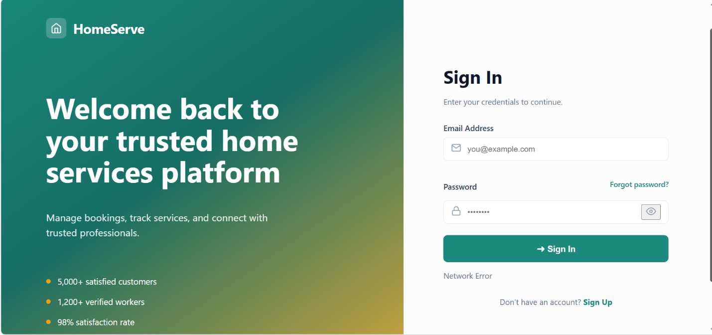
This screen represents the authentication interface of the platform. It allows registered users to securely access their accounts by entering their email and password. The design focuses on simplicity and usability, providing quick access while ensuring basic validation and error handling.

Signup page:
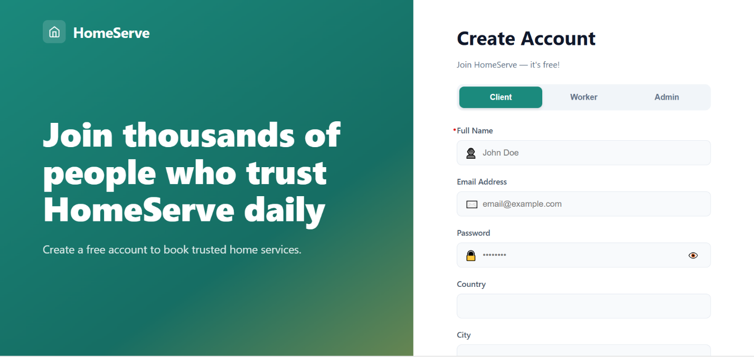
This screen allows new users (clients) to create an account on the platform. The form collects essential user information such as name, email, password, and location. It ensures proper data validation before submission and provides a smooth onboarding experience.
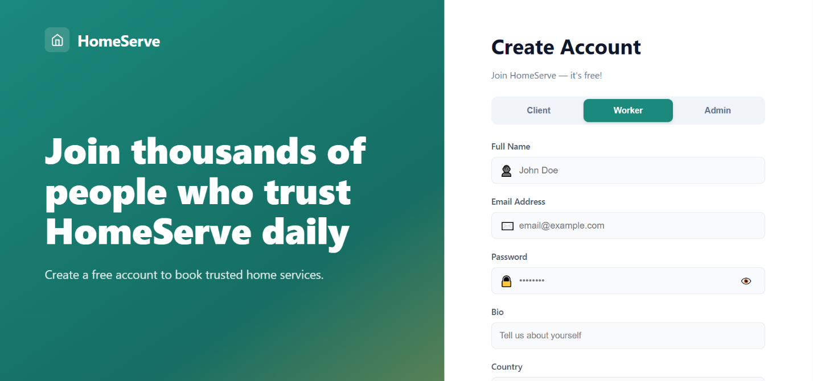
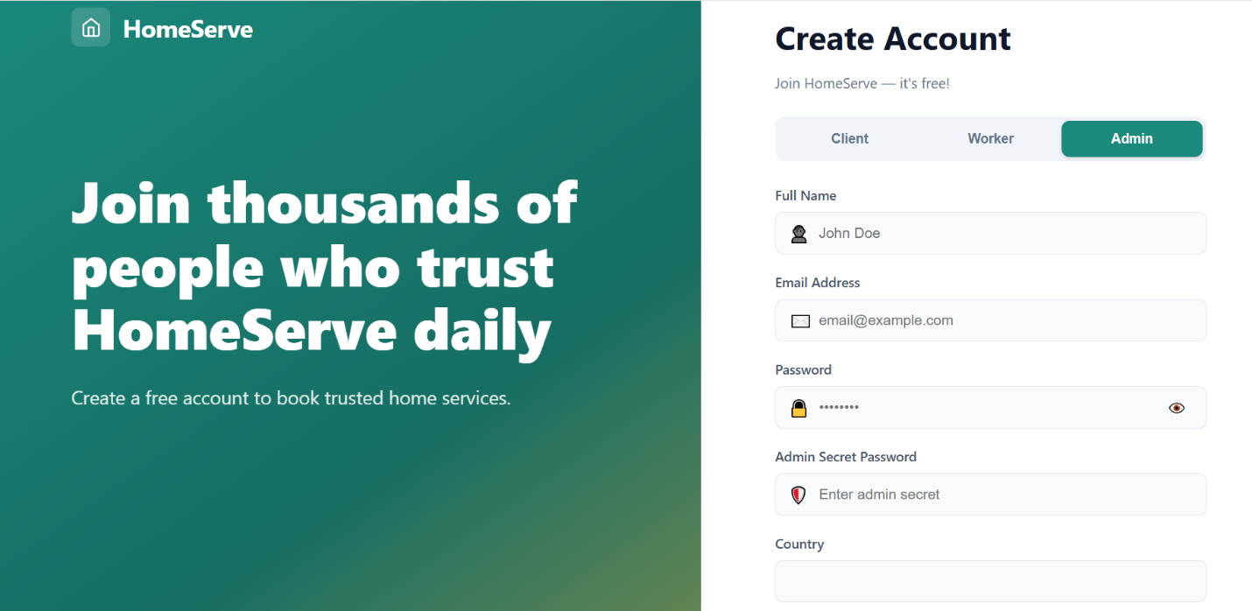

These screens extend the registration functionality to different user roles: workers and administrators. Each role has specific fields and permissions, ensuring that the system can differentiate between service providers and platform managers while maintaining role-based access control.

Home Page after sign in:

This is the main dashboard displayed after successful login. It provides users with an overview of the platform, including navigation to services, bookings, and user profile. The interface is designed to highlight key features and allow quick access to core functionalities.

Service Catalogue:
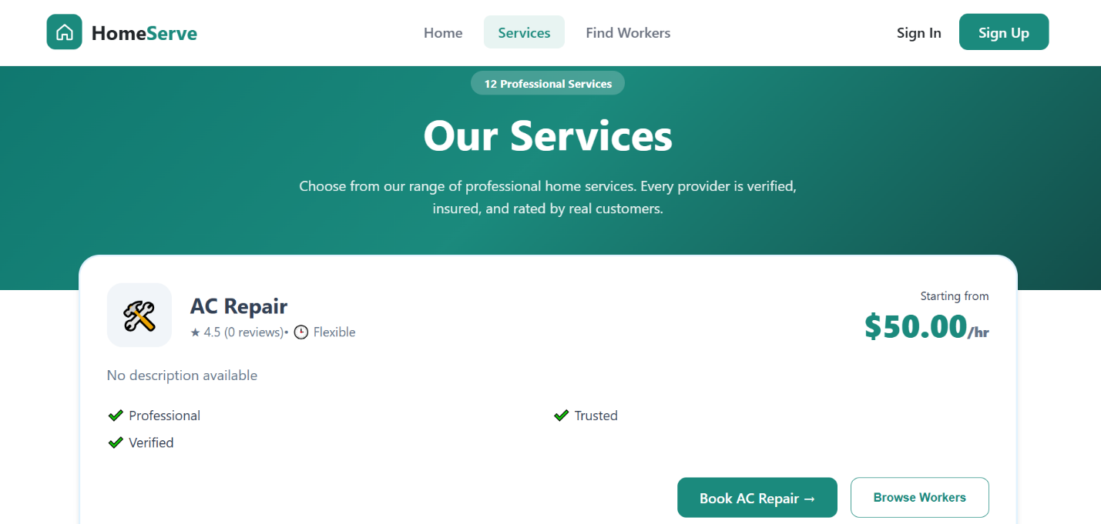
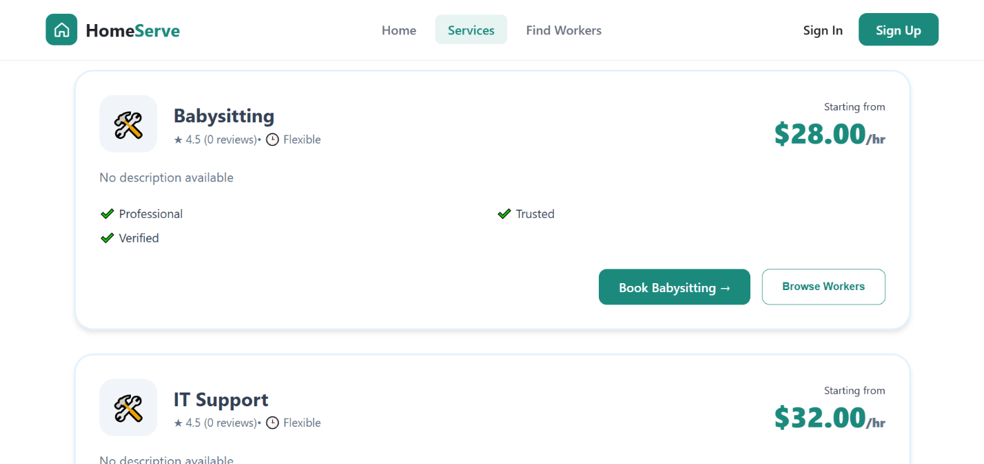
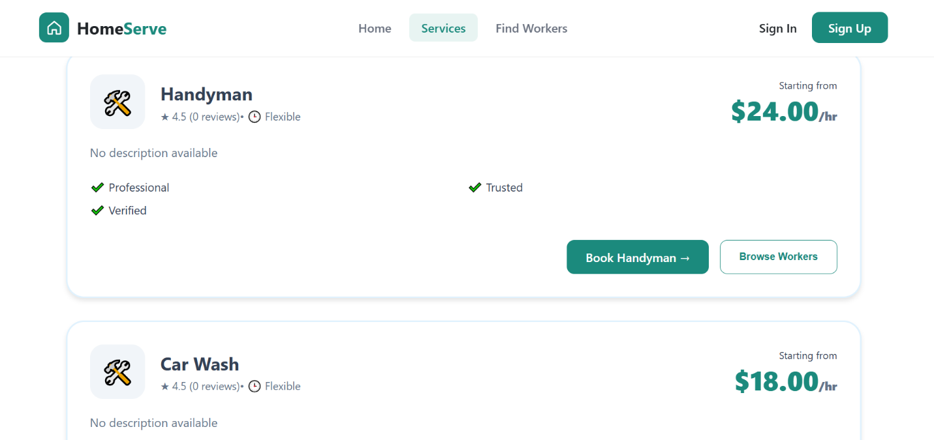…

This screen displays all available home services in a structured catalog format, allowing users to easily browse and select the service they need. The design improves accessibility and enhances the user experience by organizing services clearly.

Offerings Page:
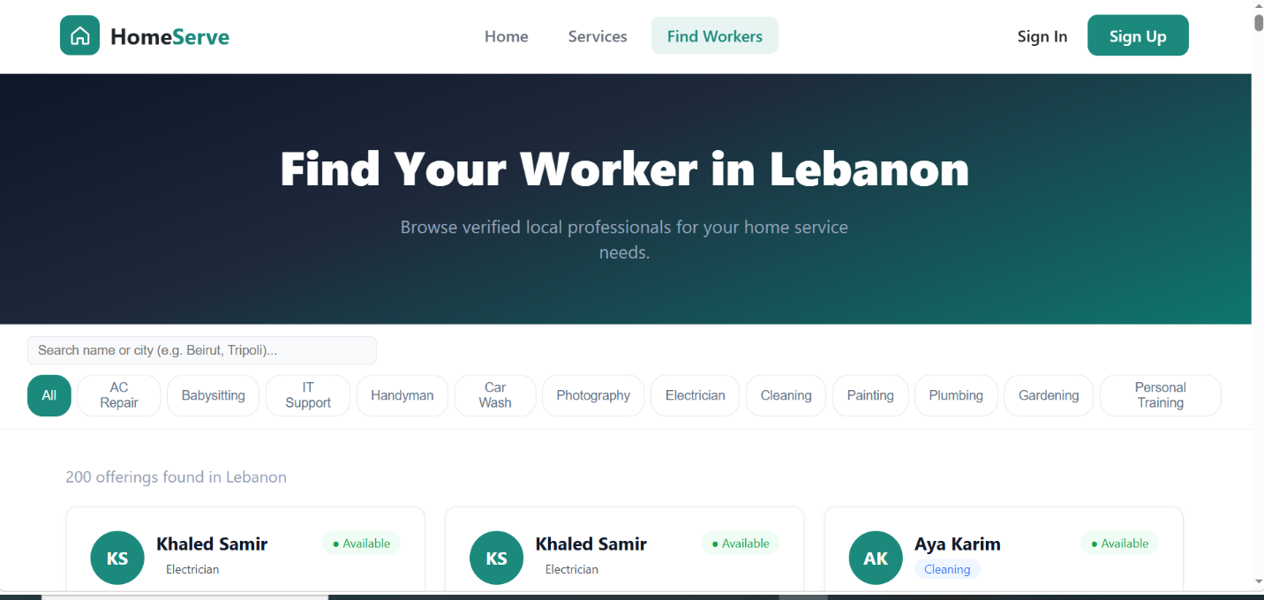

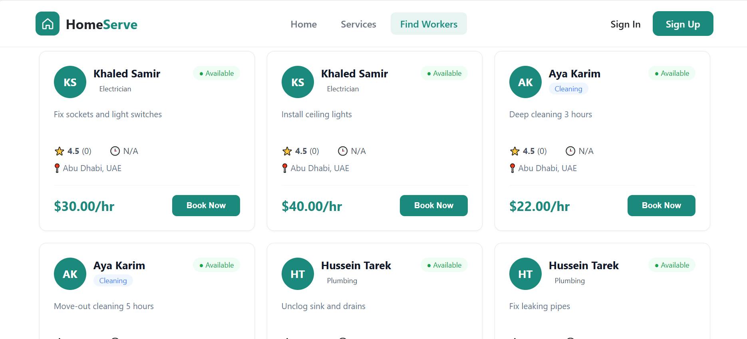
This screen enables users to search for and view available workers based on the selected service. It helps users compare workers and choose the most suitable professional for their requested task.
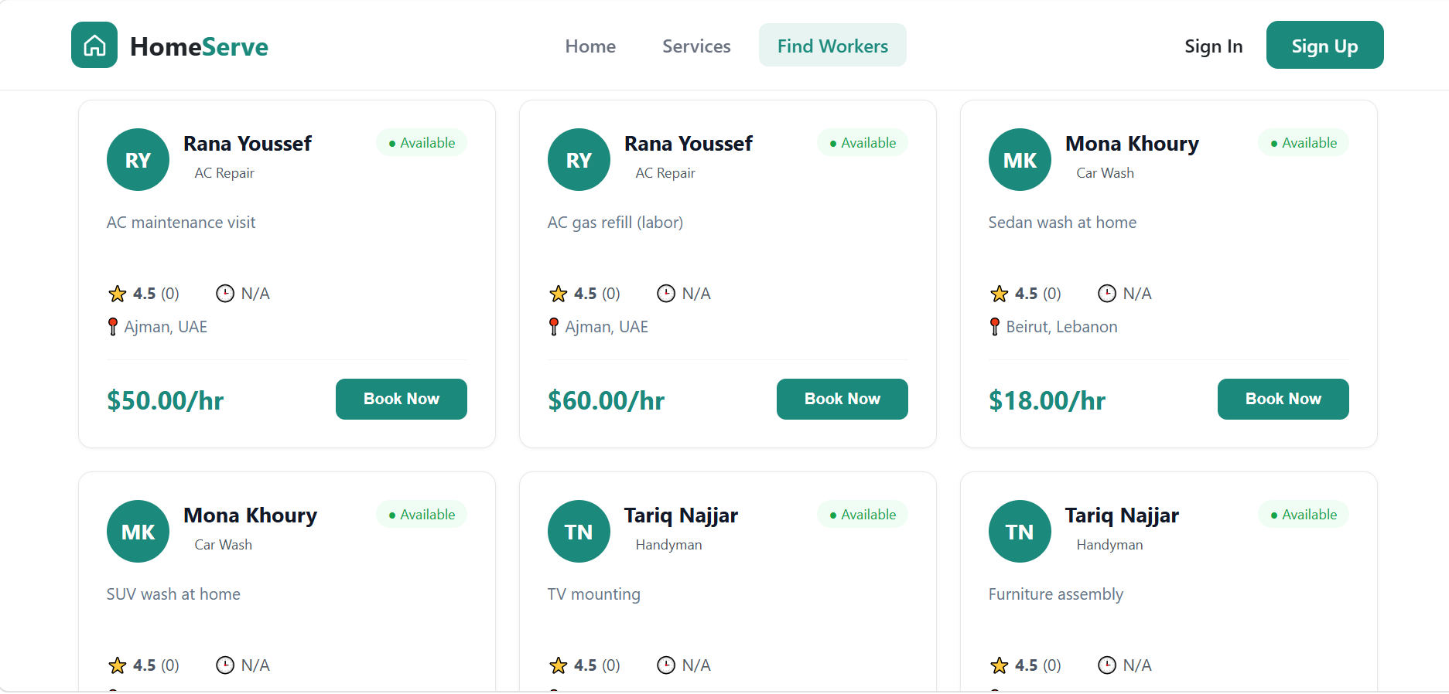

Shopping Cart:
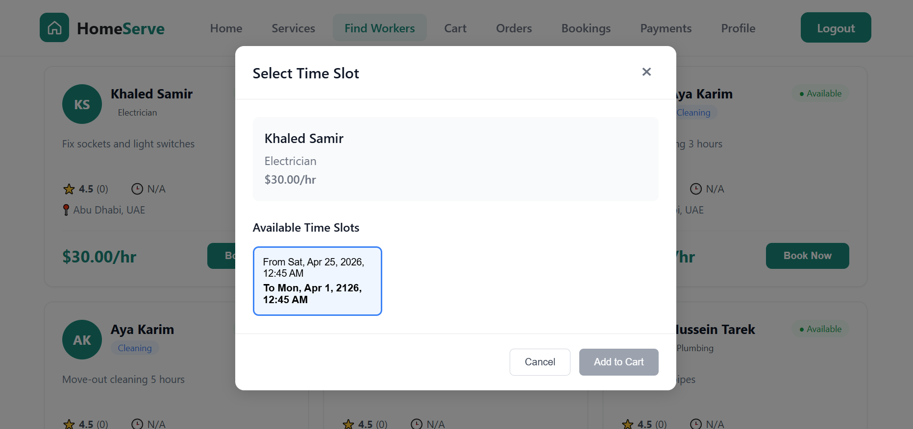
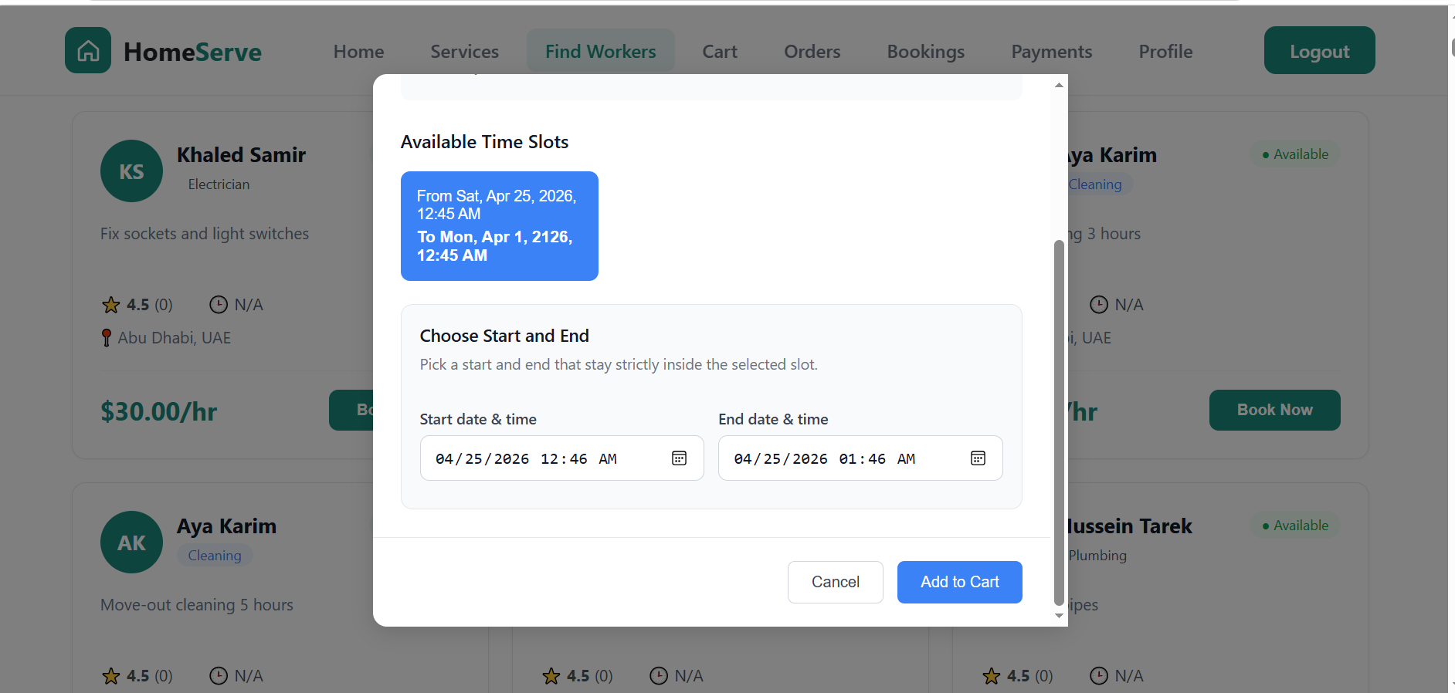
This screen allows users to review the services they have selected before proceeding with the booking process. Users can manage their selected items, verify booking details conveniently, and choose a suitable time from the available booking schedule before confirming their order.
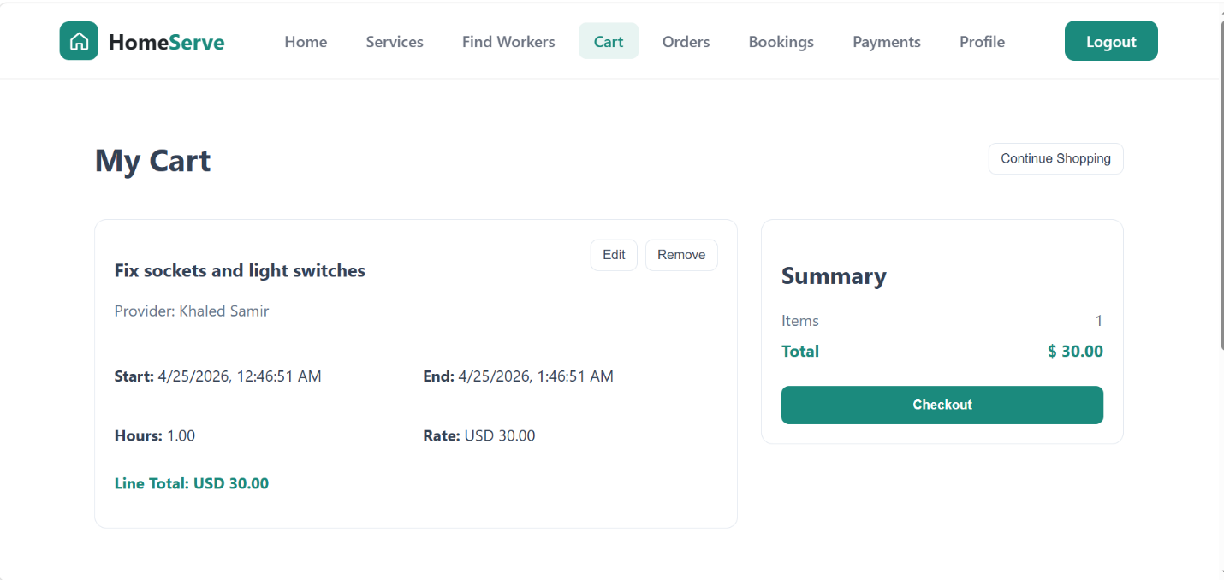
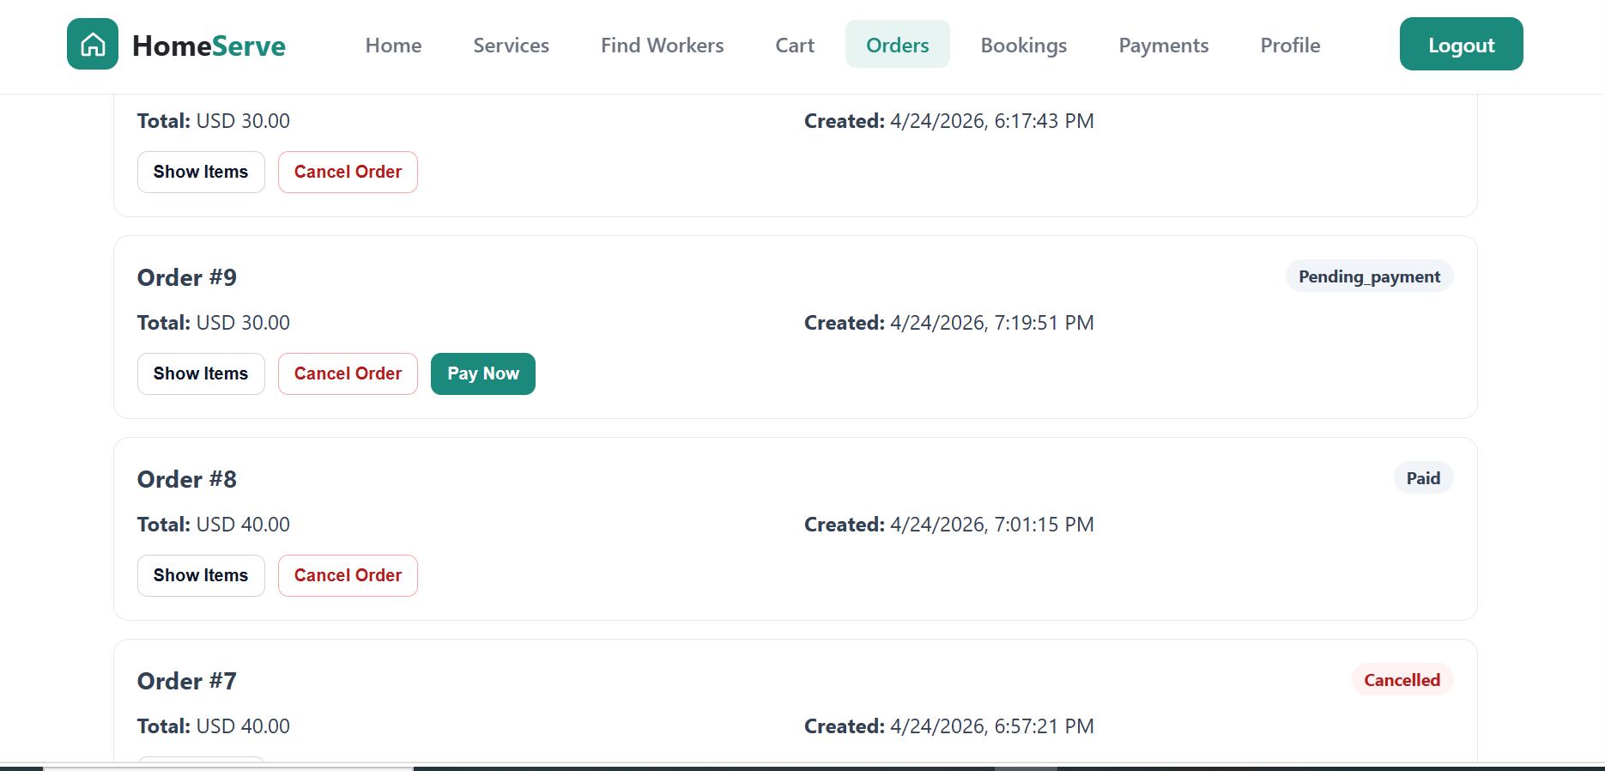
The order page provides users with an overview of their placed orders. It also allows them to cancel an order or proceed directly to payment, giving flexibility and better order management
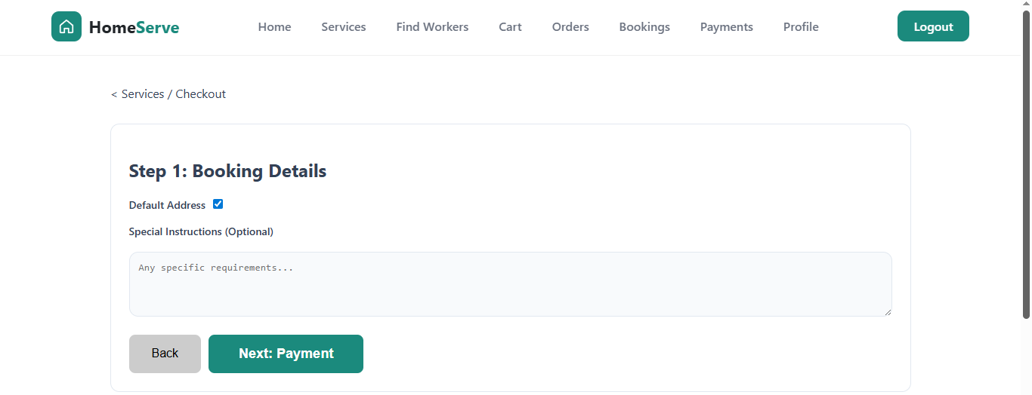

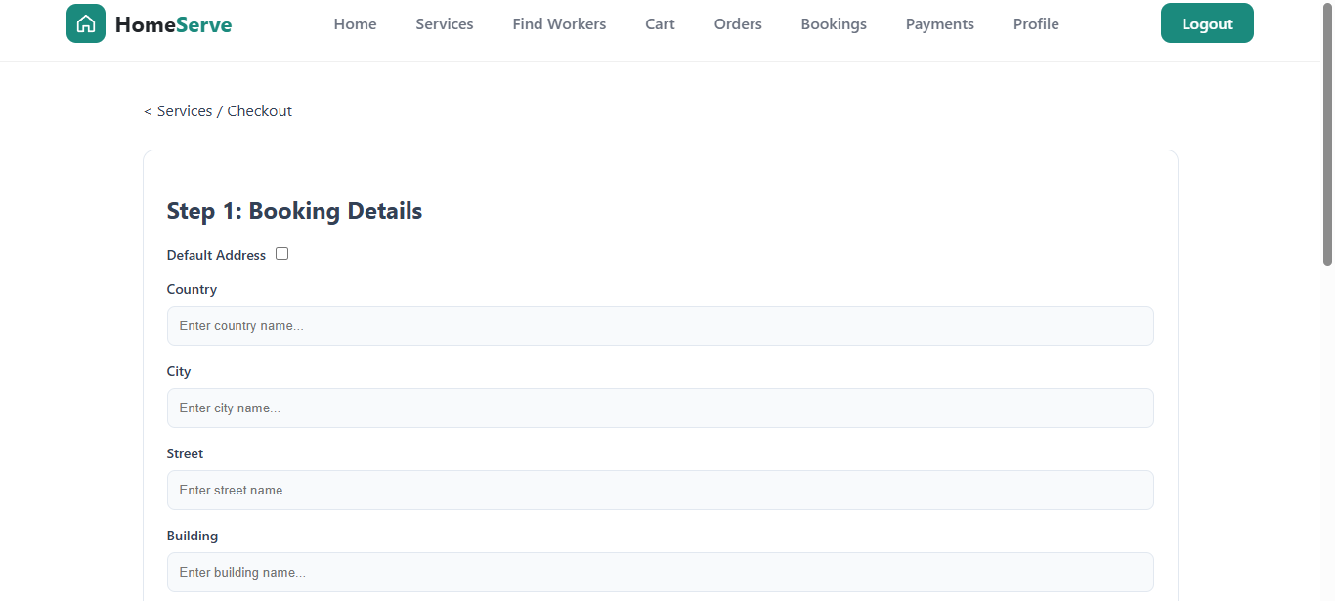

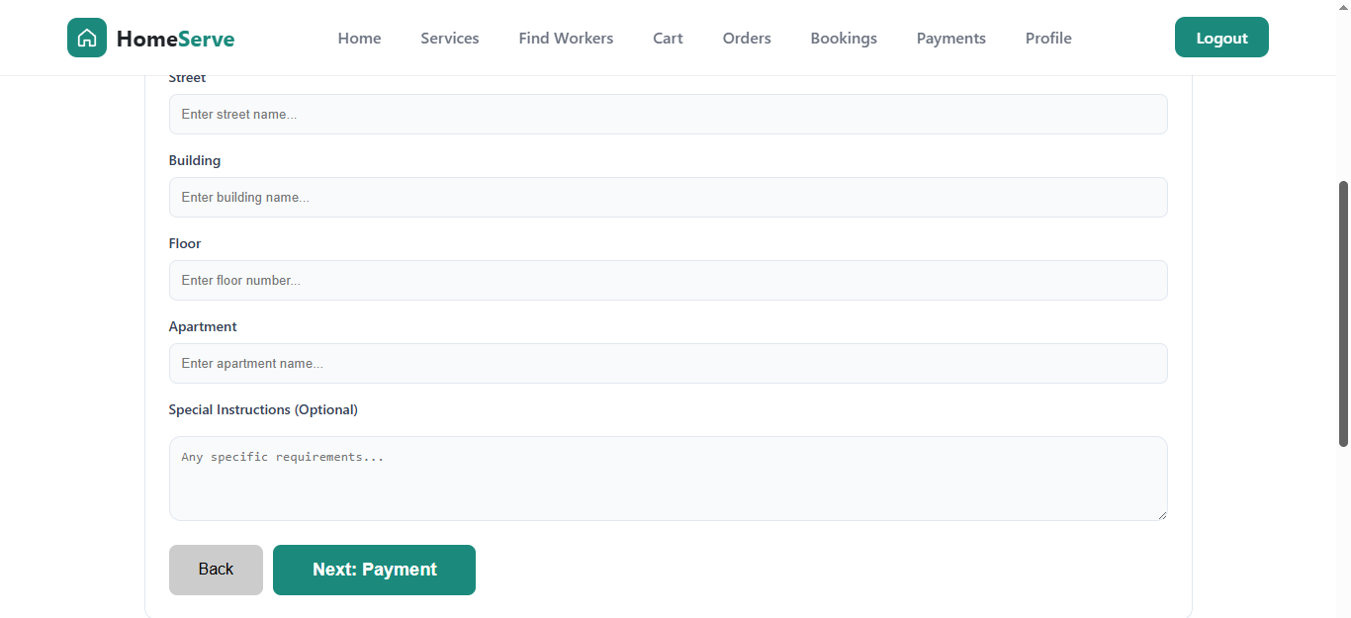

This screen collects booking-related information such as address details and service preferences. Users can add or manage addresses to ensure accurate service delivery.

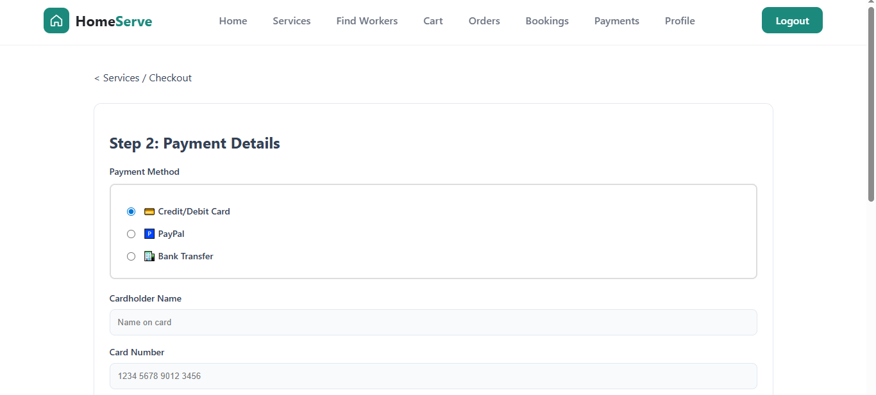

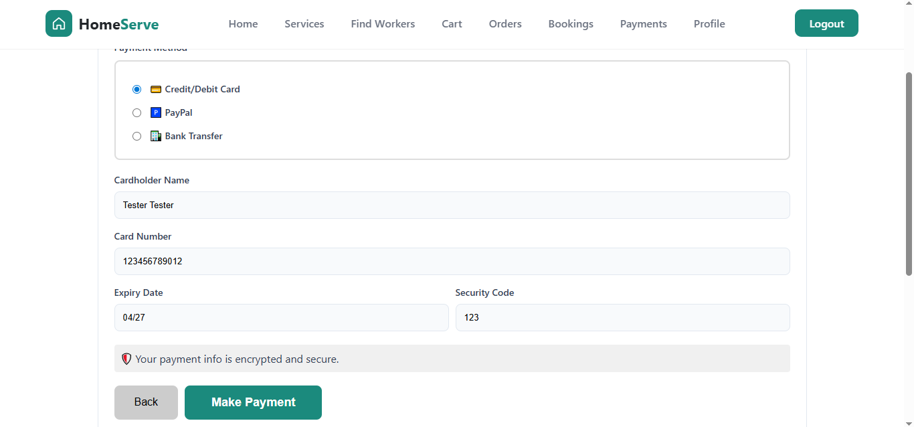

This screen allows users to select their preferred payment method and securely complete the payment process. It ensures a smooth and reliable transaction experience.

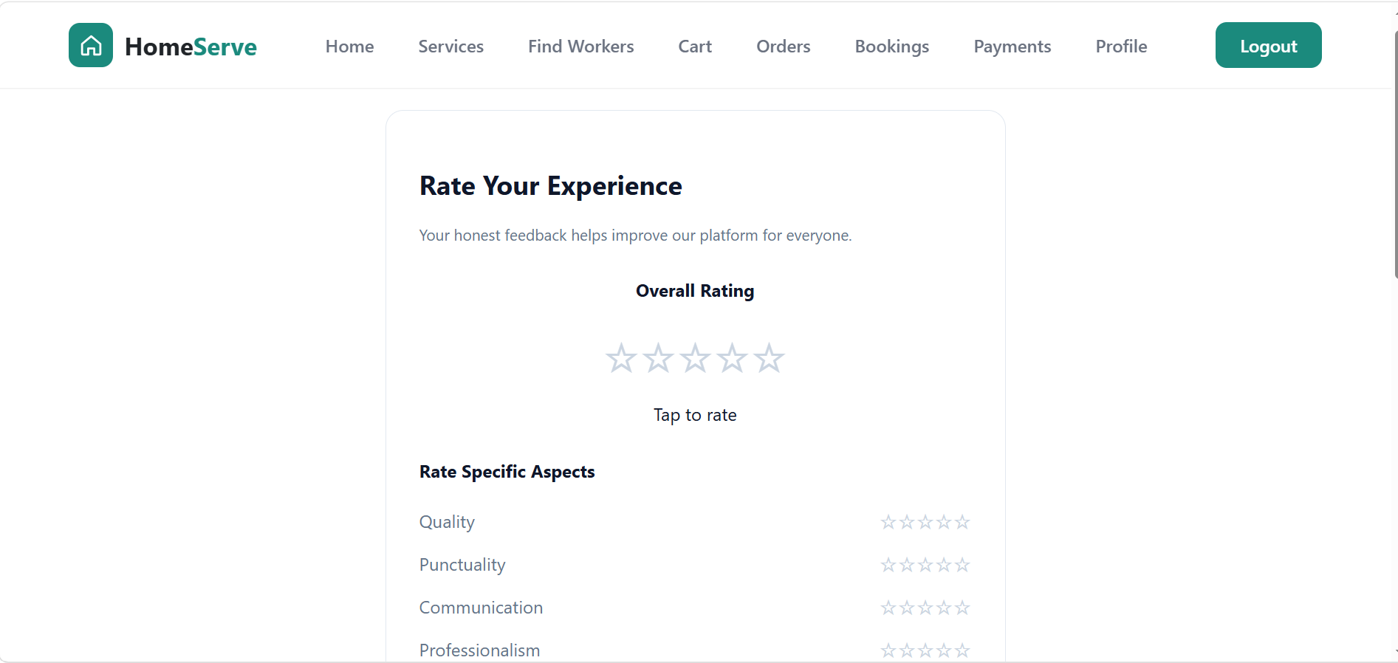
This screen enables users to rate their overall service experience
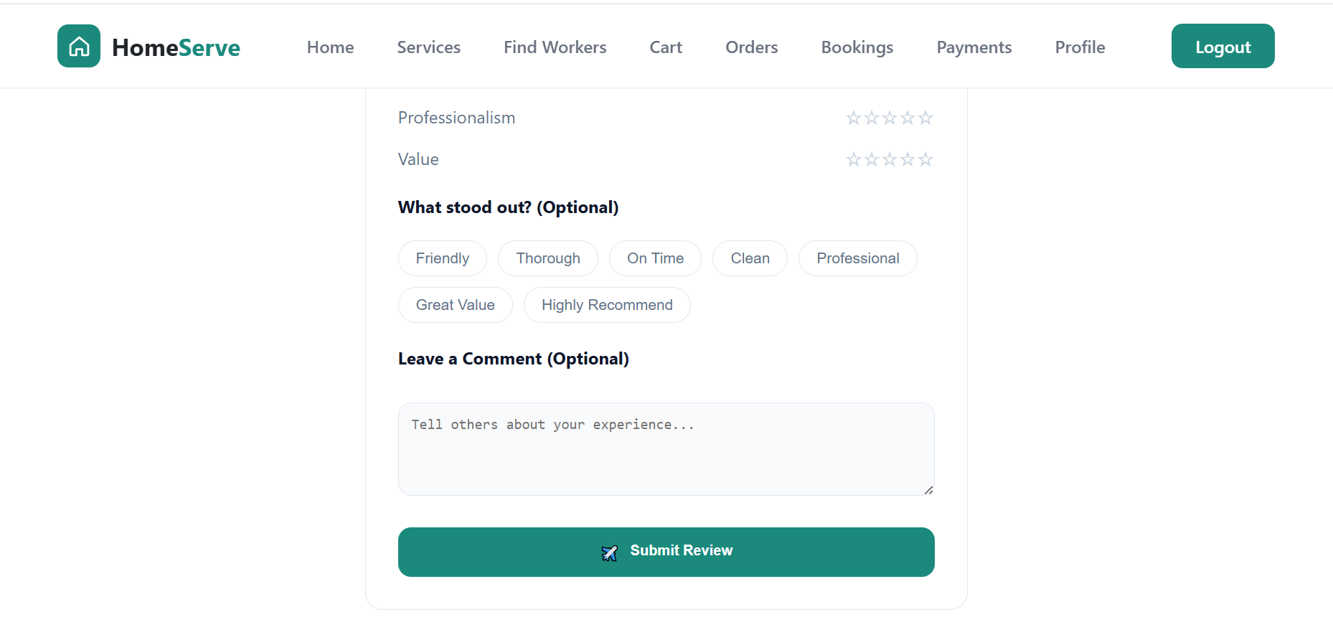
Profile Page:
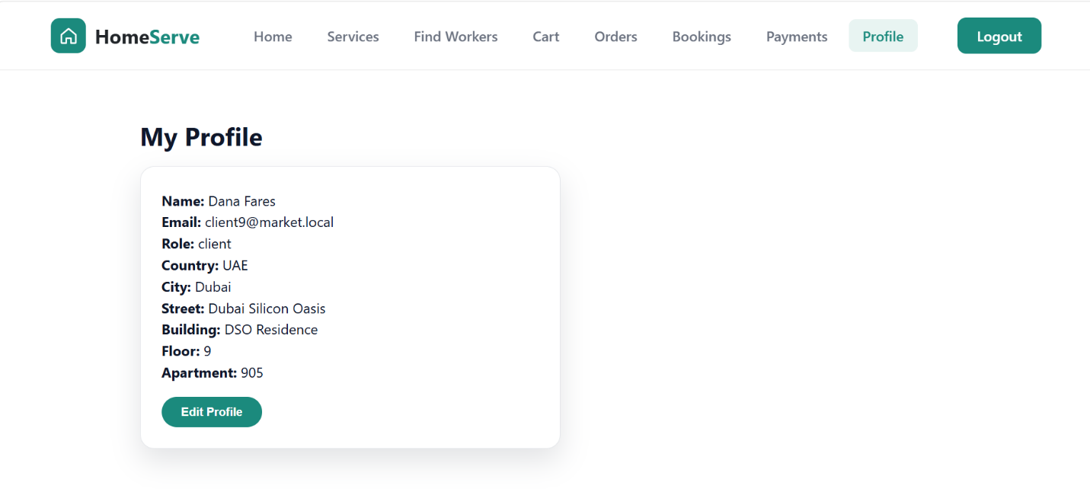
The profile page allows users to manage and update their personal information

Booking Page:
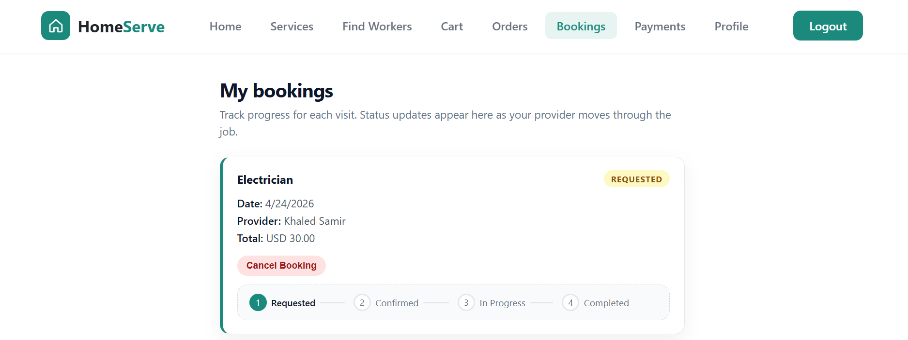

Admin Dashboard:
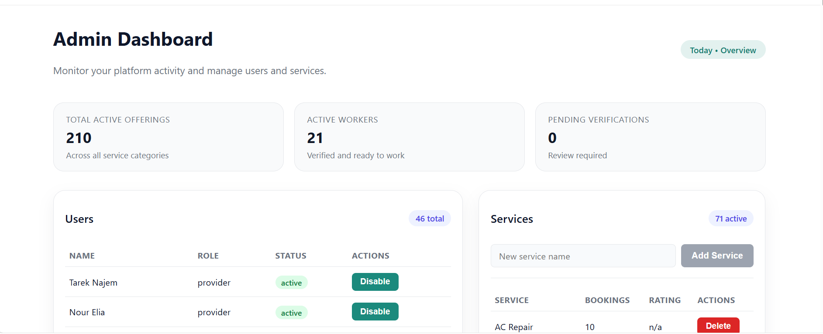
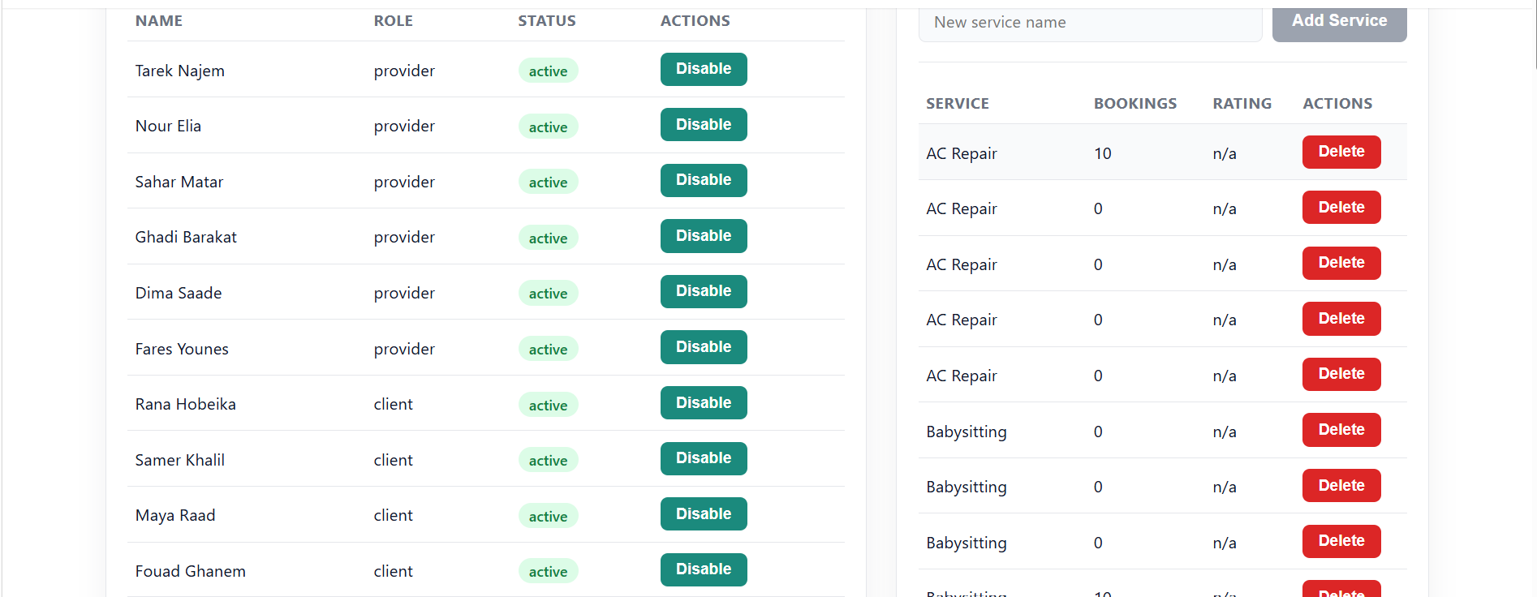

The admin dashboard provides administrators with tools to manage users, workers, services, bookings, and platform activities. It helps maintain system organization and monitor overall platform performance

Worker Dashboard:
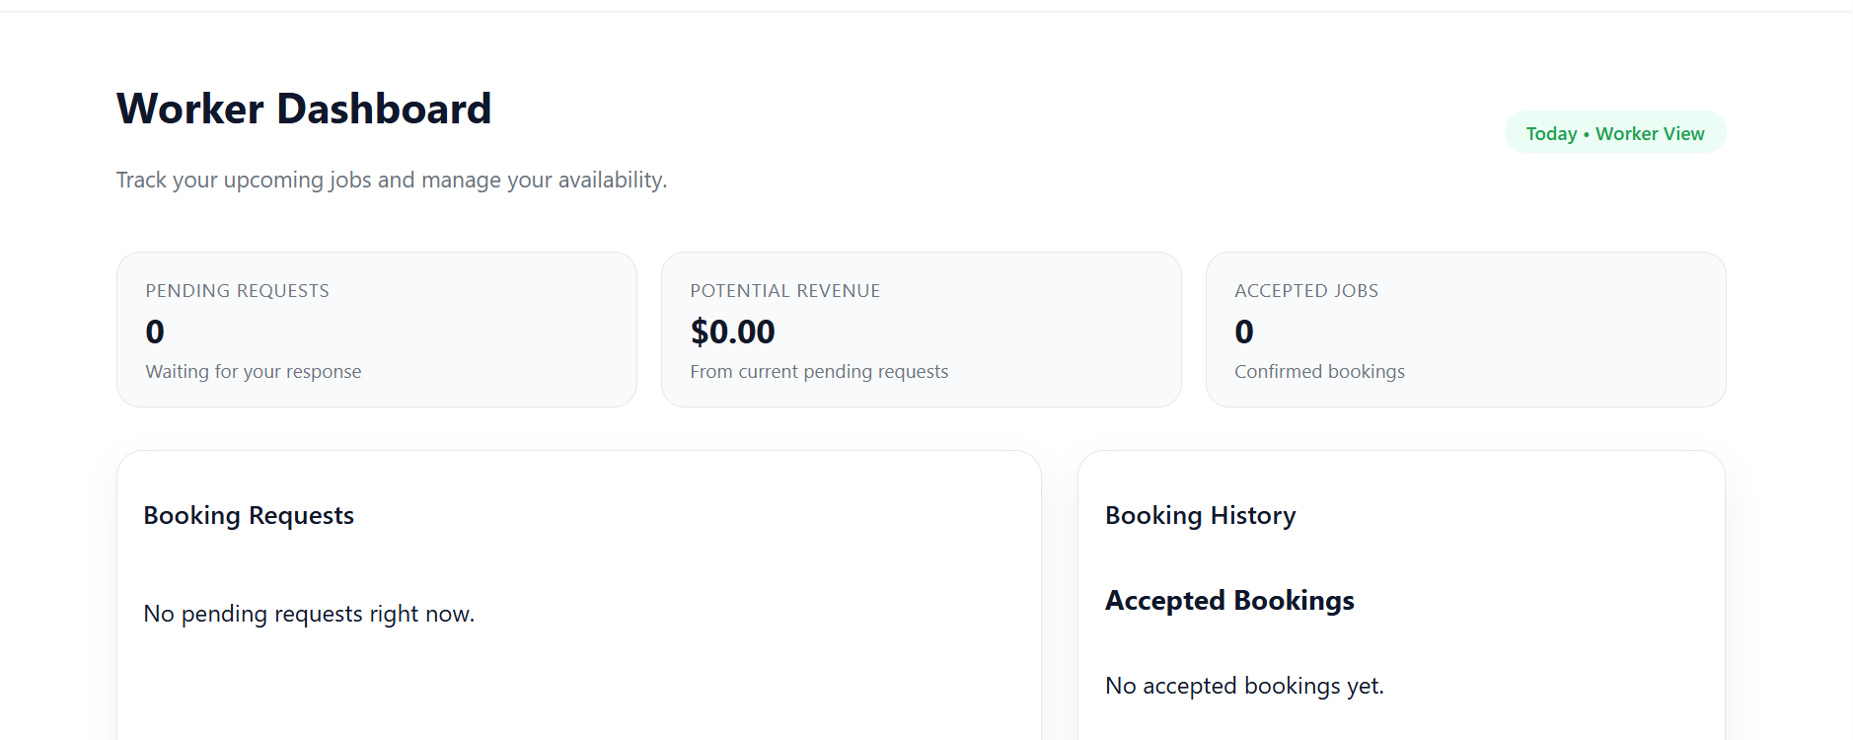

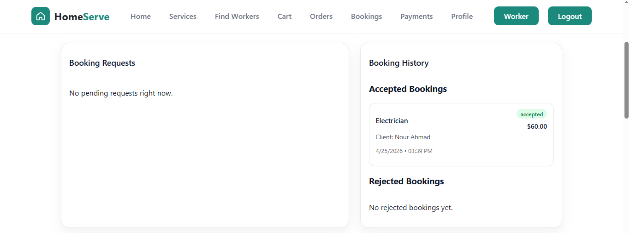

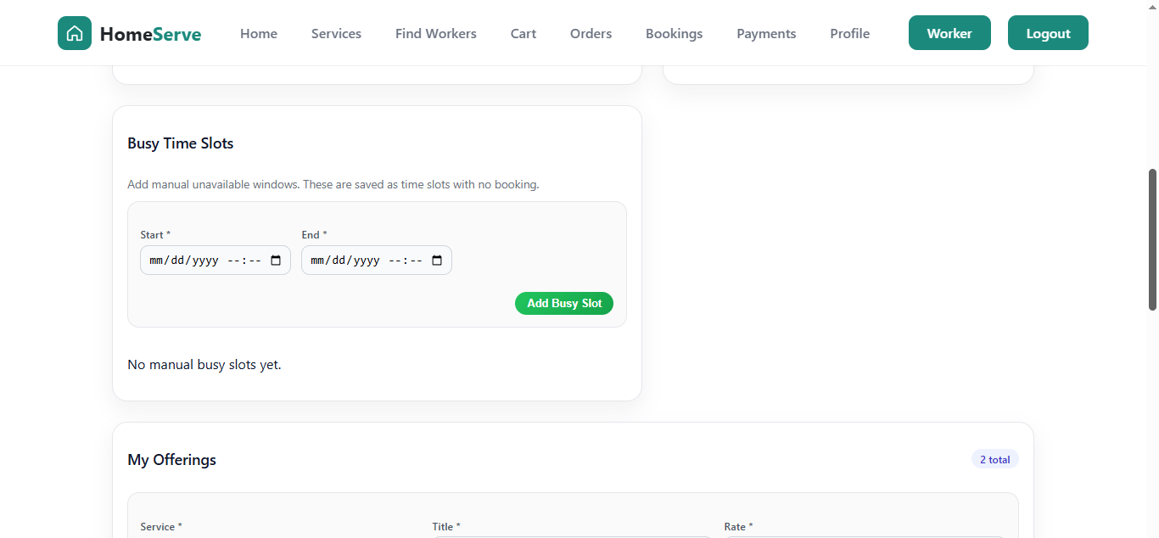

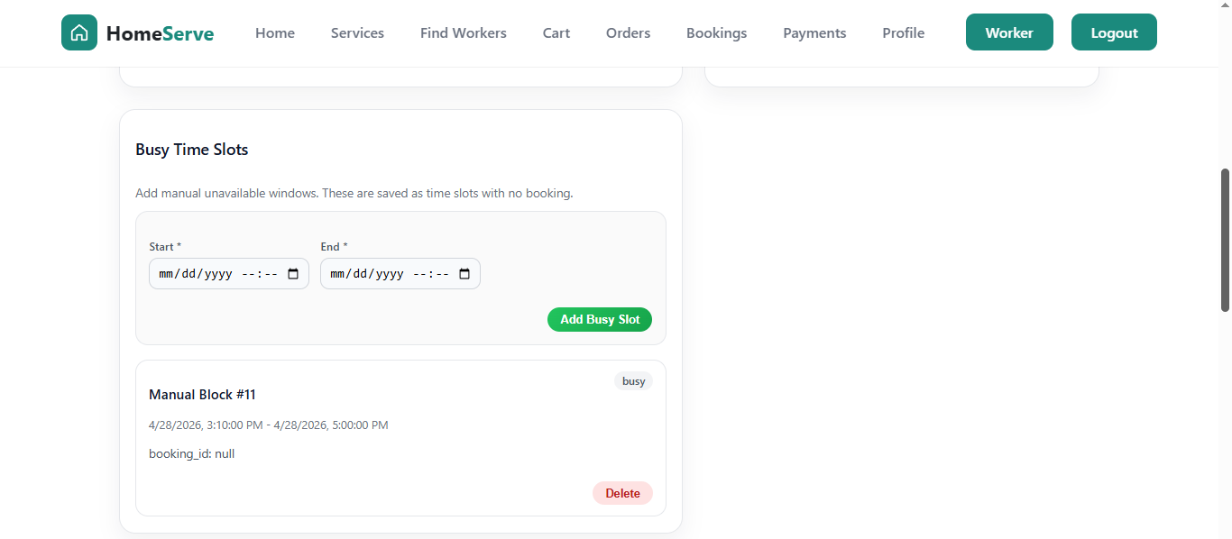

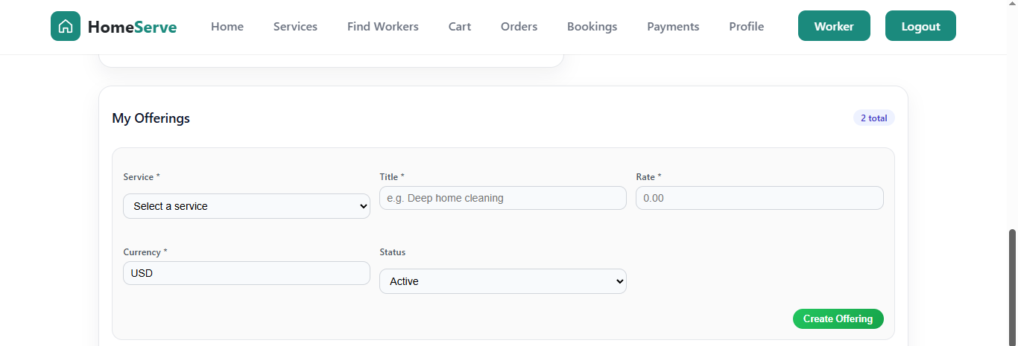

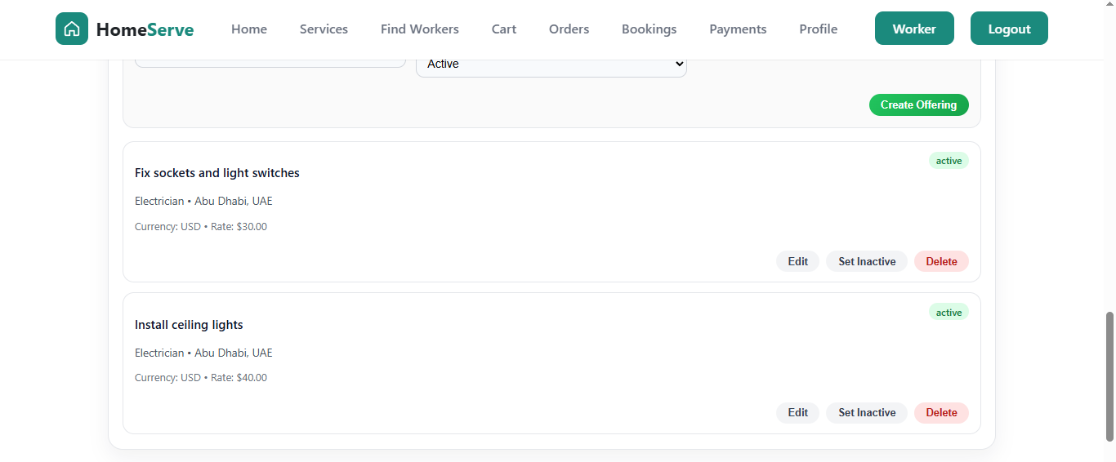

The worker dashboard allows service providers to manage assigned tasks, view booking requests, update availability, and track their work activities through the platform.

5.7 Tasks Distribution
Student | Responsibilities
Jessica Said | System Design (UML) – 80%  • Design and develop the Use Case Diagram representing system actors and interactions  • Design and develop Activity Diagrams illustrating core system workflows  Frontend Development – 85% of Frontend  • Design and implement major user interfaces including Authentication pages, Offerings, Cart, and Worker Dashboard, Booking-system, ui-components…  • Ensure responsive design and smooth user experience across all pages  Backend Development – 30% of Backend  • Develop and implement Admin functionalities (management and control features)  • Design and implement the Review System for bookings and services  • Implement Provider (Worker) Management, including availability handling and dashboard operations  API Development & Integration – 80%  • Develop and integrate core APIs including:  - Authentication (Sign In)  - Providers Dashboard  - Bookings Management  - Booking Review System & work in payment  - Worker Dashboard  - Offerings Management  Feature Implementation – 80%  • Develop Cart functionality with time-slot selection  • Implement Checkout workflow  • Implement Rating and Review features  • Enhance Worker Dashboard functionalities and usability  Testing & Debugging – 70%  • Perform functional testing of frontend and backend components  • Identify and resolve integration and logic issues  Documentation – 80% of Report  • Prepare and structure the project report  • Write and organize technical sections (system design, implementation, features)  • Integrate diagrams, screenshots, and explanations  Presentation – 50% of PowerPoint  • Contribute to the design and content of the presentation slides  • Prepare key sections explaining system architecture and features  Version Control & Collaboration – 75%  • Manage feature development using Gitflow workflow  • Push, update, and maintain feature branches on GitHub  • Collaborate with team members to ensure system consistency and stability
Christelle Nasr | Frontend Development (≈ 50–60%)  - Developed a large portion of the user interface using React.js, covering multiple core pages:  - Services browsing and filtering pages  - Offerings and provider profile pages  - Client dashboard (orders, bookings, reviews)  - Responsive navigation and layout components  - Integrated frontend with backend APIs using Fetch API, including:  - Authentication (login, signup, JWT handling)  - Fetching services and offerings  - Booking and order management  - Payment processing and status updates  - Implemented dynamic state management using React hooks (useState, useEffect) to handle:  - Real-time data updates  - API responses  - Error handling and user feedback  - Designed reusable components to improve code organization and maintainability  UI/UX Design & Responsiveness  - Designed clean and user-friendly interfaces focusing on: Easy navigation , Clear structure of information , Consistent styling across pages  - Ensured full responsive design:  - Adapted layouts for different screen sizes (desktop, tablet, mobile)  - Used flexible layouts (Flexbox / CSS Grid)  - Applied media queries for better user experience  - Improved user experience by adding:  - Loading states  - Error messages  - Interactive buttons and feedback  Feature Implementation & Enhancements  - Added and improved platform features such as:  - Viewing provider details and ratings  - Managing bookings and orders visually  - Suggested and designed enhancements to make the platform more professional:  - Clear separation between user roles (Client / Provider / Admin)  Version Control & Collaboration (Git / GitHub)  - Participated in team collaboration using Git & GitHub:  - pushing updates  - Testing features before integration  Database & System Understanding Contribution  - Contributed to understanding and working with the database structure:  - Tables relations (users, bookings, services, etc.)  - Data flow between frontend and backend  Assisted in backend testing and final system validation, identifying and fixing issues related to API responses and database consistency to ensure a stable and fully functional platform.  Presentation & Documentation  - Contributed to approximately 50% of the PowerPoint presentation:  - Structuring slides clearly  - Explaining frontend features and system flow  Simplifying technical concepts for presentation
Charbel Sayah | -Database Design  - Create UML Diagram  - Postgresql Implementation  -Automate Database  - Create JS scripts that automate creating Database and inserting Dummy Data for Testing  - Create Postman "Batch Signup" folder for creating multiple Dummy users by running the folder)  -Backend Development (80% of Backend)  - Rounting (80% of routes)  - Controllers (80% of controllers)  - Models  - DB connection Script  - DB Transaction Management  - Authentication Middleware  - Env file  -Backend Testing with Postman  - Create Postman Request For Every Route  - Test Routes and Fix Errors  - Export And Save Postman Collection After Each Change  -Frontend Partial Development  - Cart Page + API Integration  - Orders Page + API Integration  - Payments Page + API Integration  - Worker CRUD Offerings inside worker dashboard + API Integration  - Worker CRUD busy time-slots inside worker dashboard + API Integration  - Time-Slot selection inside offerings page  -Git and Github Management  - Create Proper Gitignore File  - Create Repository And Invite Team Members  - Implement "Gitflow" Workflow  - Review And Accept/Reject Pull Requests  - Provide Team Members With Exact Errors To be fixed before Pull Request Can be Merged  -Production Deployment  - Create and Mange the VPS using SSH  - Deploy Project on the VPS  - Configure Domain and Sub-domains  - Create SSL Certificates  - Run Nginx for Reverse Proxy  -Team Technical Support  - Helping Team Members When They Face Issues  - Providing Screen Recordings and Guides on Certain Topics When Needed
Table 8: Task Distribution

6. Conclusion

The Home Services Booking Platform successfully demonstrates how modern full-stack web technologies can be applied to a meaningful real-world problem. The system achieves all nine stated functional objectives: secure multi-role authentication, filterable service discovery, conflict-safe cart management, atomic payment and booking creation, provider accept/reject workflow with automatic slot release, real-time rating updates, and a fully audited admin dashboard.
From a technical standpoint, the most significant engineering challenges were the time-slot conflict detection algorithm — which must handle six distinct interval-overlap cases and be repeated at payment time to guard against race conditions — and the design of atomic multi-table transactions that ensure no partial state is ever persisted in the event of a failure.
The project also produced a comprehensive suite of UML artefacts (use case, class, and activity diagrams) and a detailed use scenario specification that directly traces each scenario to the backend source code, making the system straightforward to maintain and extend.

6.1 Future Improvements
- Live payment gateway integration (e.g. Stripe) with real refund flows on cancellation.
- Native iOS and Android mobile applications using React Native to extend the platform’s reach.
- Real-time notifications via WebSockets or push notifications to alert clients and providers of booking status changes.
- Provider earnings dashboard and payout management module.
- Multi-language (i18n) support to serve non-English-speaking markets, particularly relevant given the regional focus of home-service demand in Lebanon and the MENA region.
- Machine-learning-powered provider recommendation engine based on client location, preferred service categories, and past booking history.
- Automated integration and end-to-end test suite (e.g. Jest + Supertest for the API, Cypress for the frontend).

7. Appendix

7.1 UML Project File
The complete UML model (use case diagram, activity diagram, and class/ER diagram) is provided as a Visual Paradigm project file: FYP_DB_Design.vpp. This file can be opened in Visual Paradigm 17.0 or later and contains all diagram layers, element metadata, and relationship definitions in their original editable form.

7.2 Database Schema
The PostgreSQL DDL scripts that create all 13 tables, constraints, and indexes are maintained in the backend repository under backend/data/tables002.js. A seed script at backend/data/seed003.js populates the database with sample service categories, provider accounts, and offerings for development and demonstration purposes.

7.3 API Collection
A complete Postman collection covering all API endpoints (with environment variables for base URL and JWT token) is included in the repository under backend/postman_collections/. Import the collection into Postman 10+ and set the baseUrl and token environment variables to begin testing.

