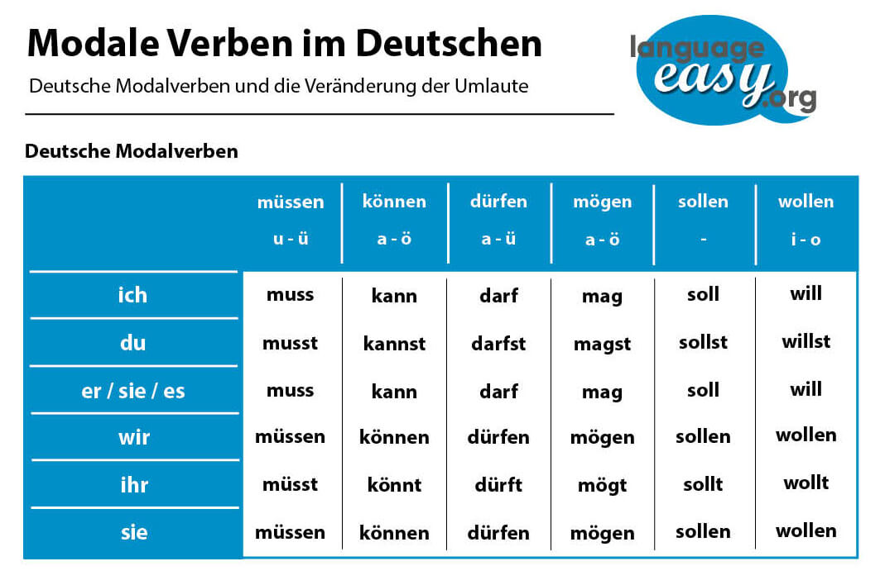

PERFEKT + MODAL VERBEN

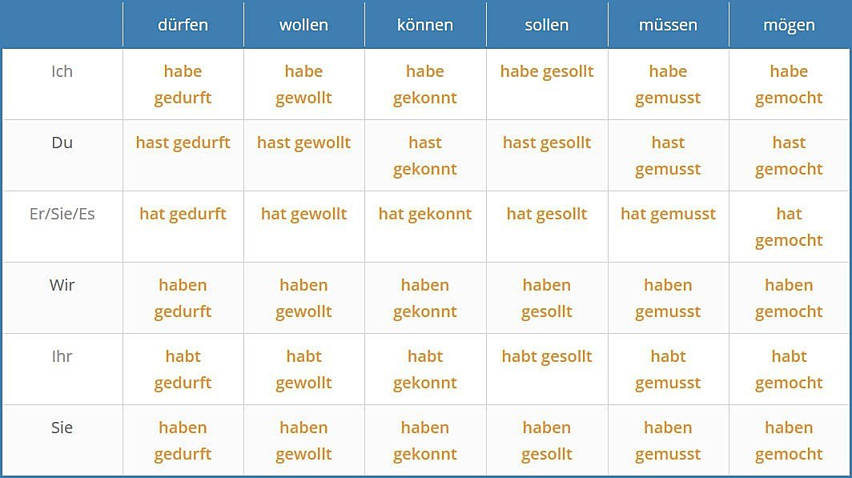



FUTURE + MODAL VERBEN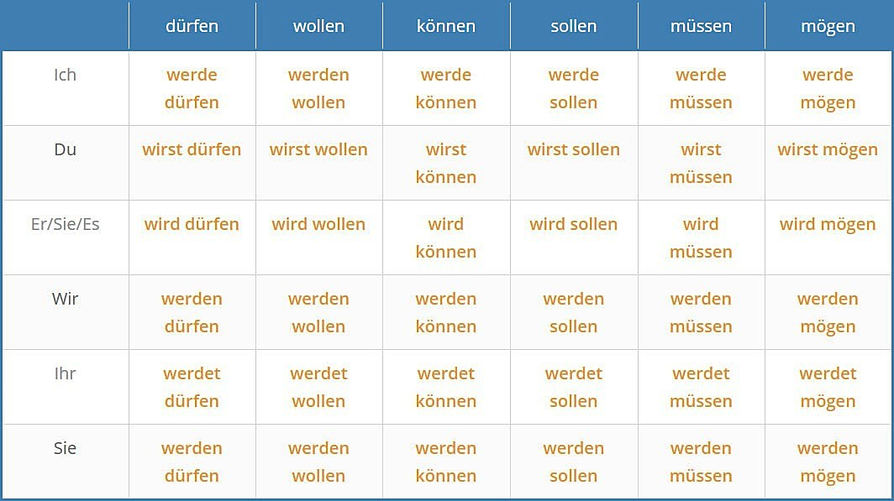

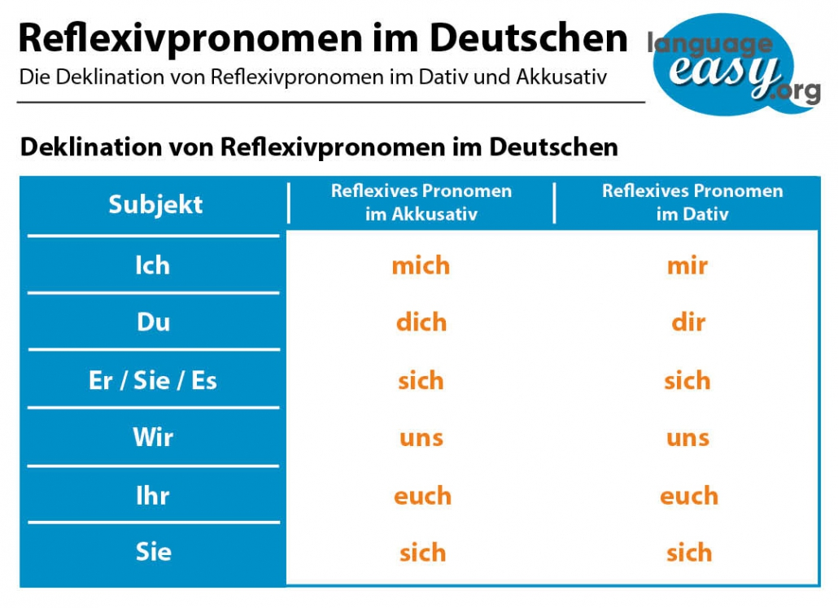

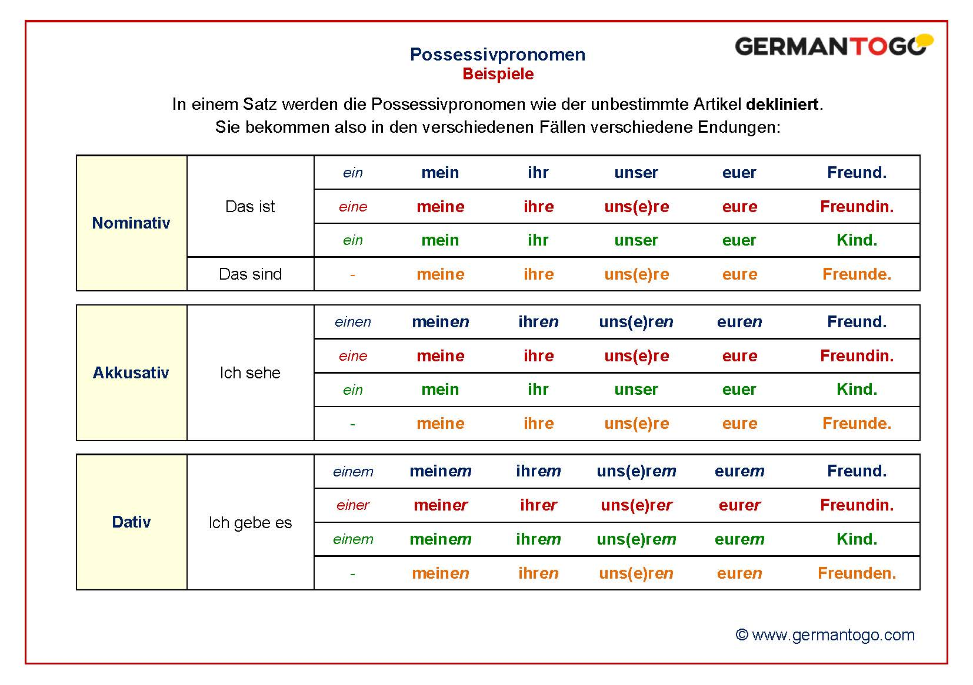

Now, there are conjunctions which change this word order. And, of course, there are some which don’t change anything. First, the ones that don’t influence the word order in German sentences are called **“coordinating conjunctions”**. Here you have some examples.

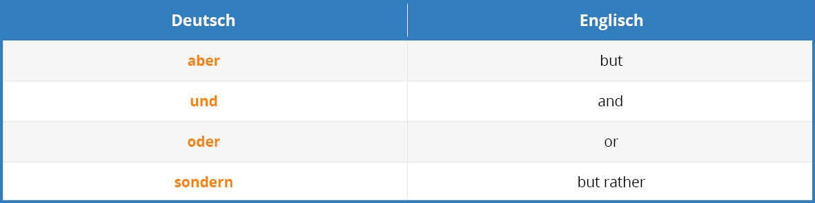

So, the conjunctions that do influence the word order are called “subordinating conjunctions”. In the following, I will show you another table with some examples for this kind of conjunctions.

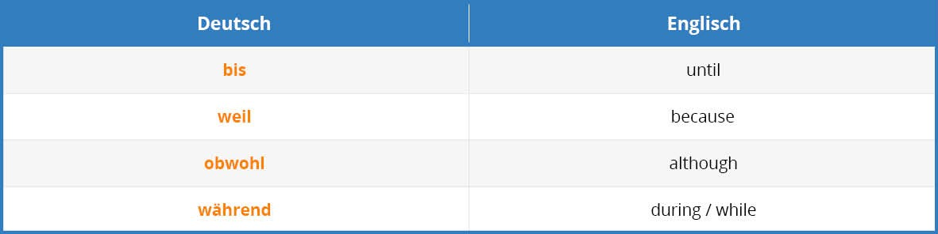

Now, let’s illustrate what I mean when I say that these conjunctions change the word order. So, generally you can say that the **verb gets moved to the end of the clause when a subordinate conjunction is used**.

1. Coordinate Conjunction: “**Aber er ist ein fauler Mann.”** – But he is a lazy man.
2. Subordinate Conjunction: “**Ich mag ihn nicht, weil er ein fauler Mann ist.”**– I don’t like him because he is a lazy man.

Although this case might seem rather complicated, you will master it with some practice. Let’s come to the next point, the position of the verb at the end of a German sentence.