417032467; Grupo 07

Final Proyect

GRAPHIC COMPUTING LABORATORY

ENG. CARLOS ALDAIR ROMAN BALBUENA

**Technical Manual**

**Objective**

The student must apply and demonstrate the knowledge acquired during the course.

**Gantt’s Diagram**

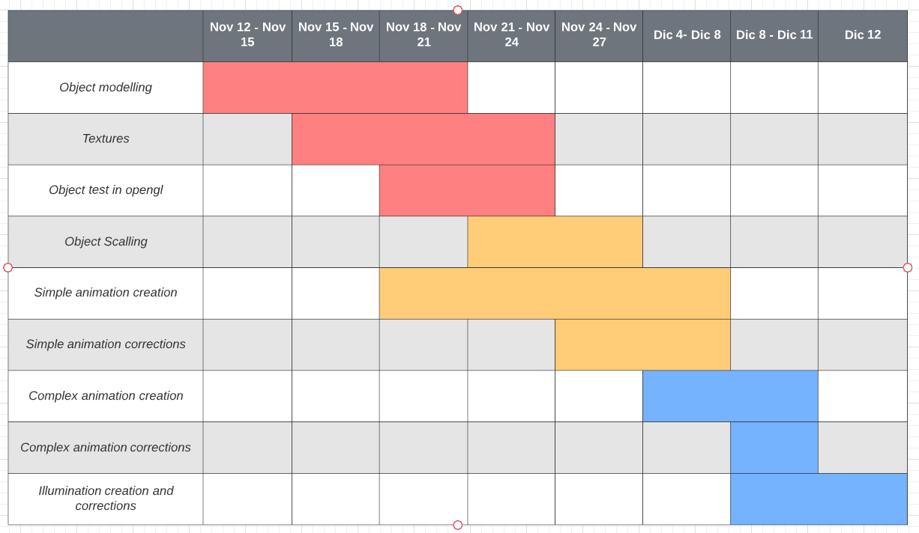

**Reach and limits:**

The project’s potential reach was stablished according to the knowledge acquired in the lab. The goal was to principally implement modelling, simple and complex animation and illumination. Also as secondary objectives there was the desire to implement transparency and camera usage.

As limits I found a lack or monetary resources to buy non free models and also a lack of knowledge in

order to create more complex models. Even thought these were not excuses to not fulfill the goal.

**Documentatión:**

In this section code camptures will be presented along their explanation of each of the code fragments in a sequential way determined by the code file.

**NOTE: The initial sections of the code where variables and headers are defined (pints 1 to 4) will have slight less detail compared to later parts of the code (from point 5).**

1. Libraries and headers:

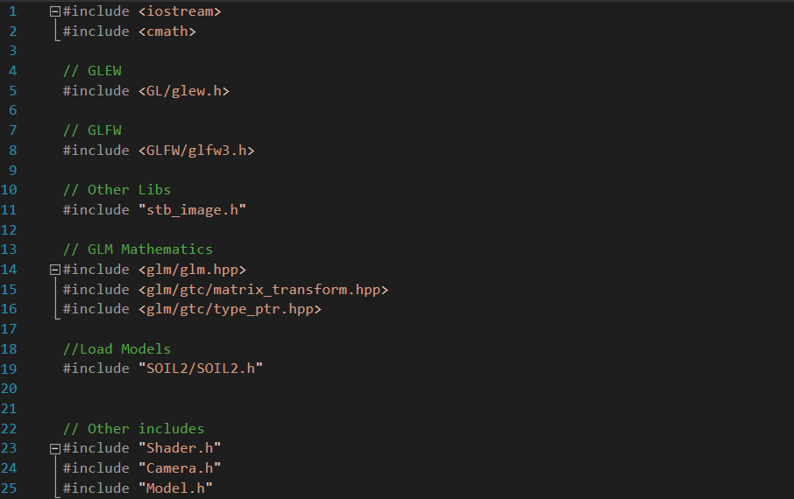

1. Function prototypes to animate and move the camera.

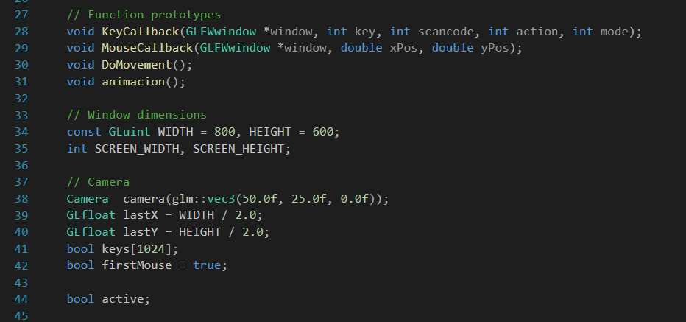

1. Variables to control timing and direction of animations.

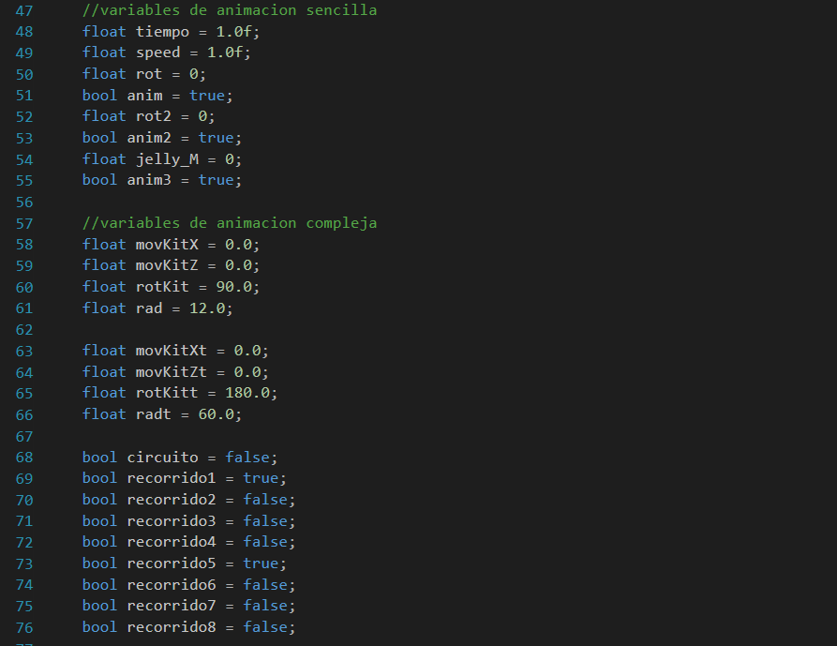

1. Point and spot light positions and their related objects.

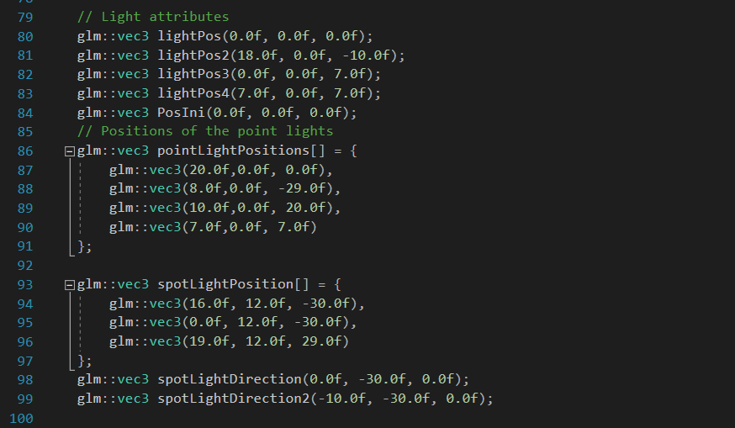

1. **From this point the document explains the code inside the main program.**
   1. Declaration of lightingShader modified slightly from the original code in order to accept more than one spotlight.
   2. lampShader declared in order to be used by elements that do not need ilumination.
   3. Anim and Anim2 shaders used to simulate water movement on the tank glass and on the algae.
   4. Model variables for the Aquarium and internal details, model variables for fish, turtle, jelly and algae, models for the building.

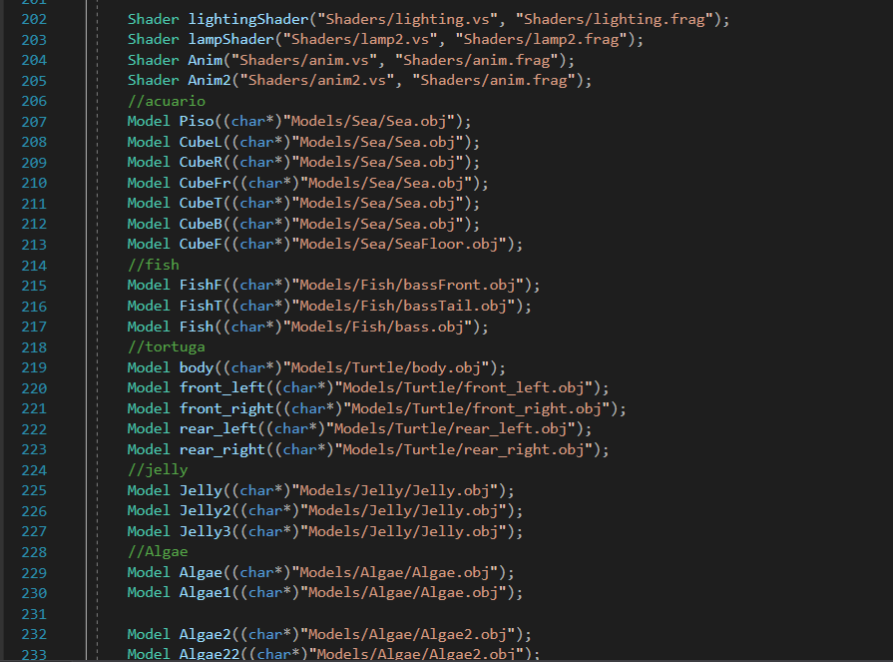

1. VAO and VBO setting.

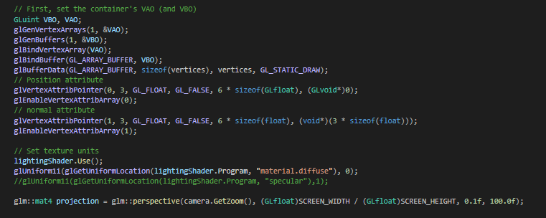

1. At this point we generate a cycle that stops once the program window ceases to exist.

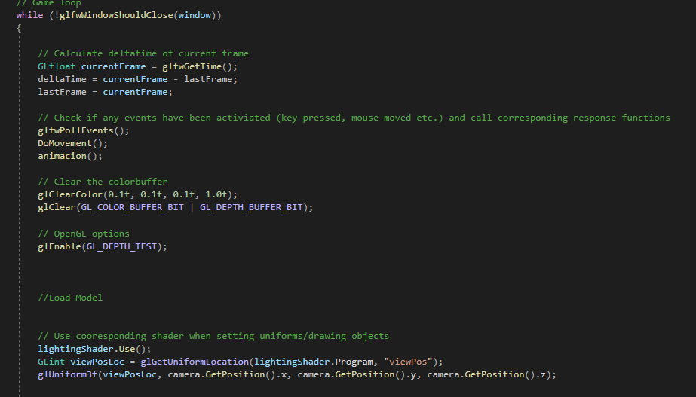

1. 3D vector variables for the point light colors and lightingShader parameters of light components including position, light components (Ambiental, diffuse and specular) and diffraction coefficients. This coefficients were modified and calculated using the folowing proportions:

Constant = 1; Linear = 1/distance; Quadratic = 1/distance^2

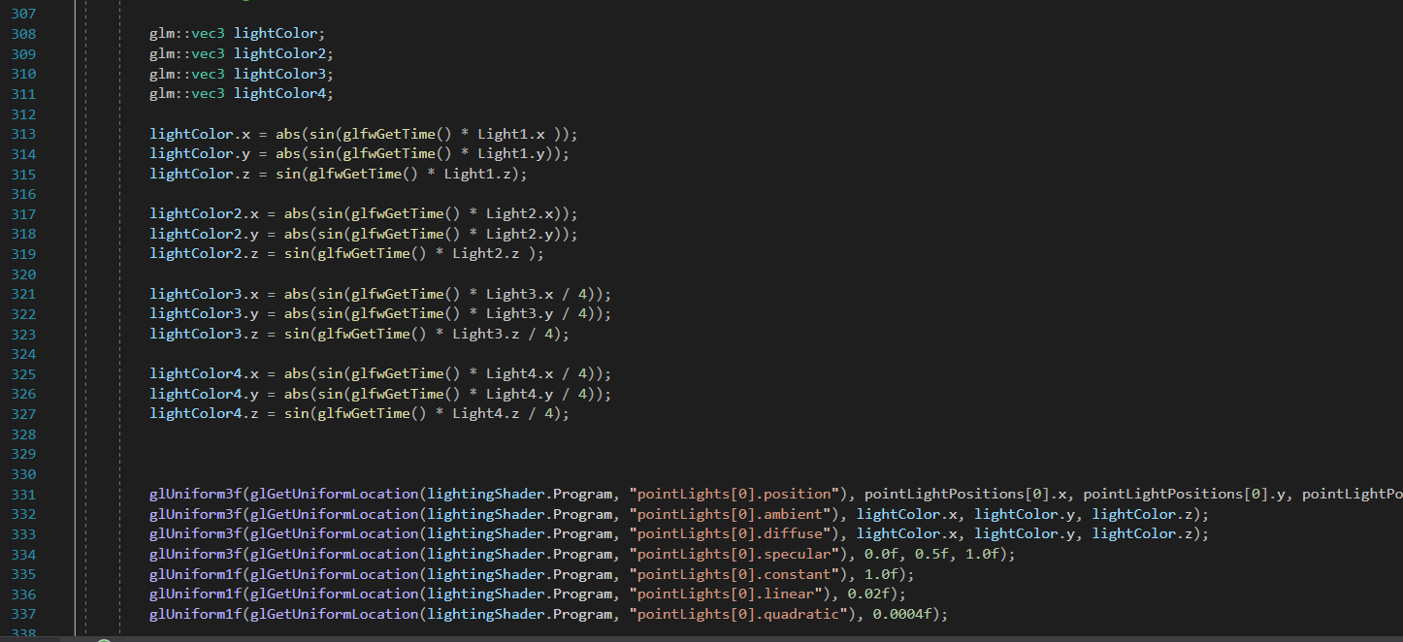

1. Parameter configuration for spotLights in lightingShader. They were configured similarly to the previous point but with grater coefficients due to requiring less distance for the lights.

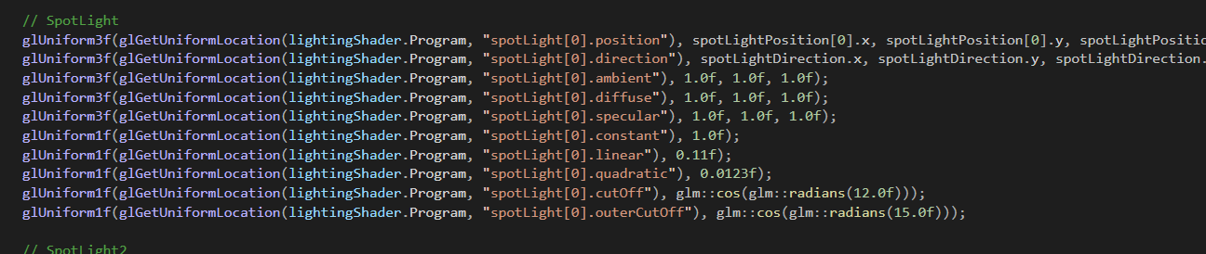

1. Loading of turtle elements including transformation processed by the functions described at the end of the document. The turtle has simple animations on its fins but also complex regarding its translation movement inside the tank. Later in the document the functions to do this are described.

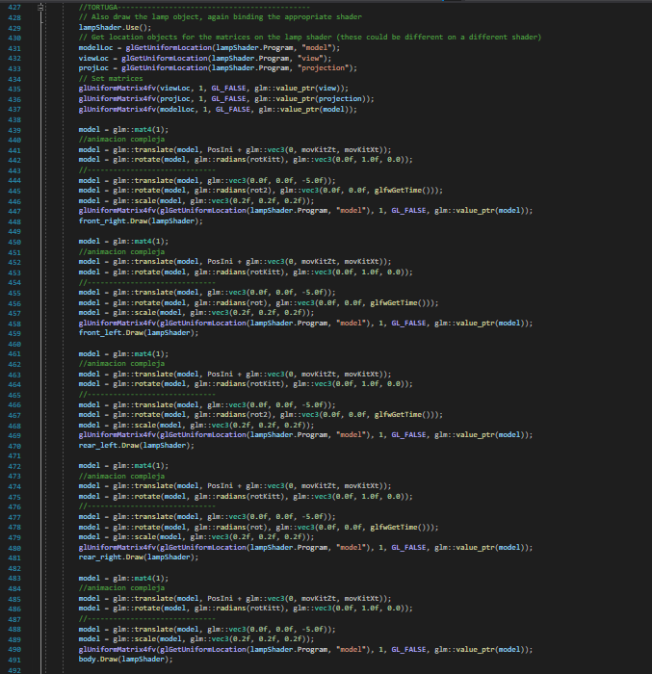

1. Building models, loaded with lightingShader i norder for them to be sensible to the lights inside them. The roof and front part of the outside were loaded using lampShader so they would look unaffected.

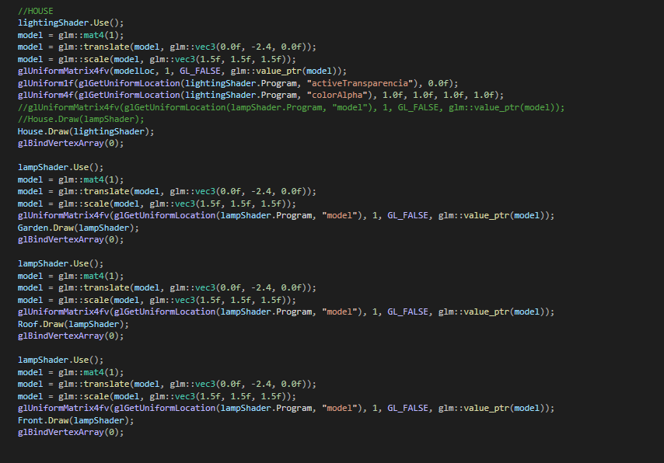

1. Jelly and fish models swimming in circles. This fishes use complex animation.

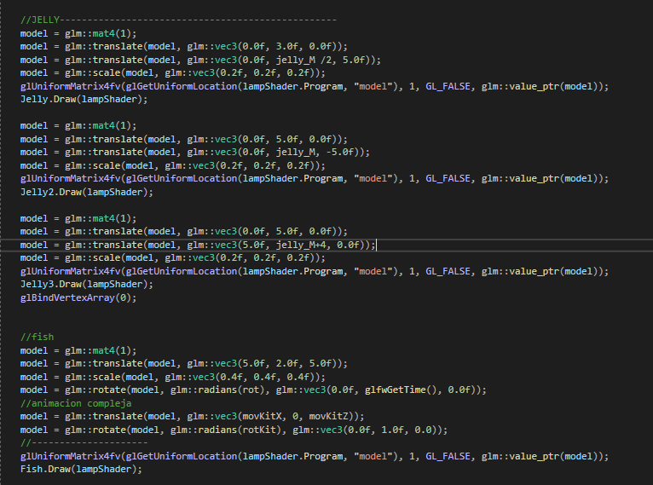

1. Segmented fishes and tank bottom. These fishes use simple animations and only move their rear fin. The tank uses Anim shader to simulate water movement

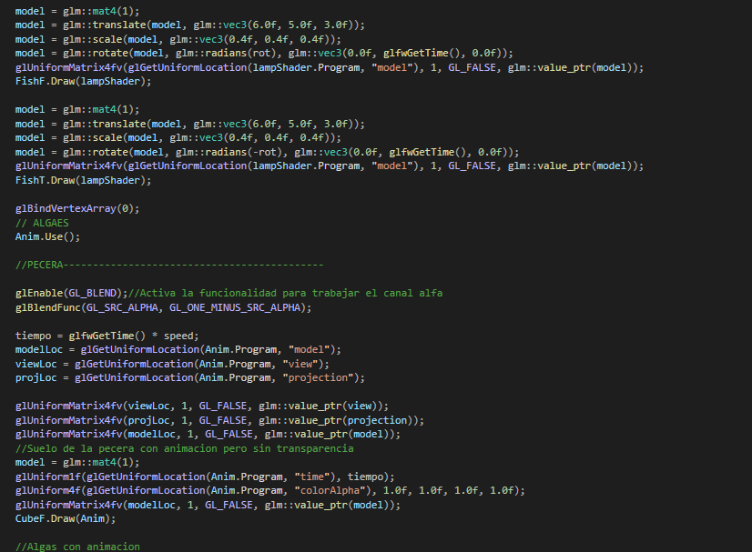

1. Algae and tank sides. Algae use Anim shader to simulate their movement inside water. The walls of the tank also use Anim, with the difference they also use transparency, Anim shader was modified in order to activate alpha channel.

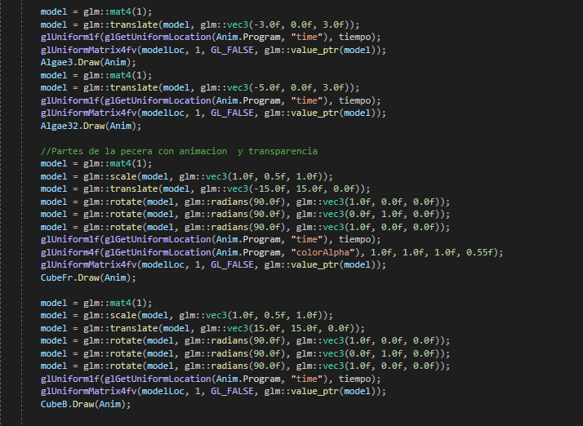

1. Loops to load puntual lights and spotlights.

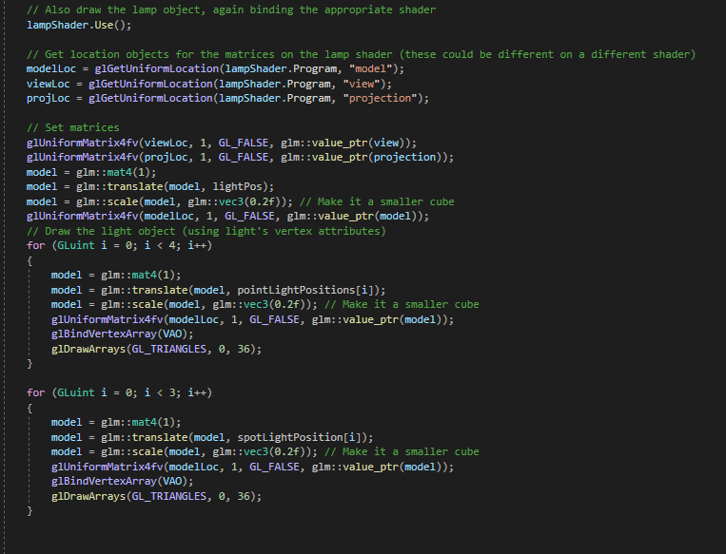

1. Camera control function.

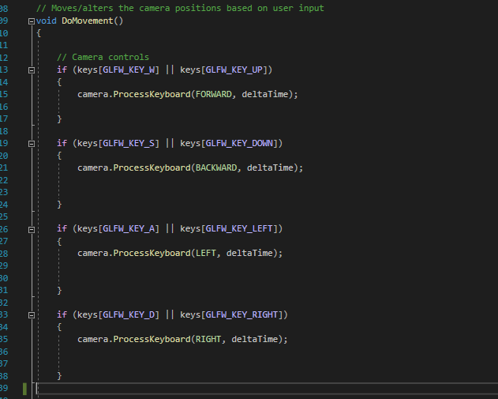

1. Simple animation function, it only augments a variable up to a limit and then it lowers it down to a lower limit cyclically. It is used for jellyfish, turtle fins and the static fish.

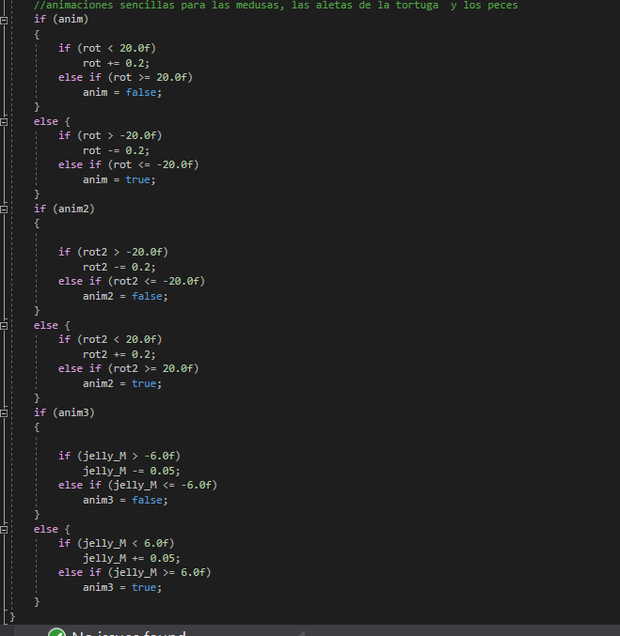

1. Callbacks for keyboard and mouse.

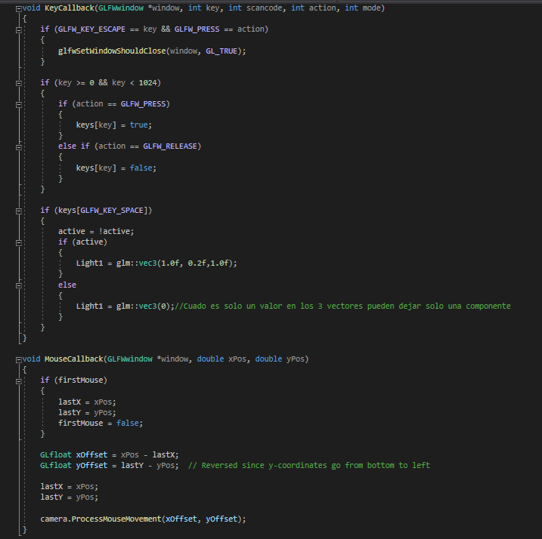

1. Complex animation movements. The fish movement is defined in stages 1 to 4. These were implemented using the following equation:

From this equation the variables were cleared to know in which proportion the coefficients needed to be augmented. Each of the 4 moves represents one of the quadrants of a circle in which the radius is defined at the beginning of the code. That’s why when the independent variable grows the dependent has its lower value giving the sense that the fishes deaccelerate. This was intended to simulate a whirlpool.

Moves from 5 to 8 represent turtle’s movement, on moves 5 and 7 the sine equation was used bounded from 0 to pi in order to obtain a parabola, giving the illusion of the turtle making an impulse to catch the jellyfish. Moves 6 and 8 turn the turtle 180 degrees.

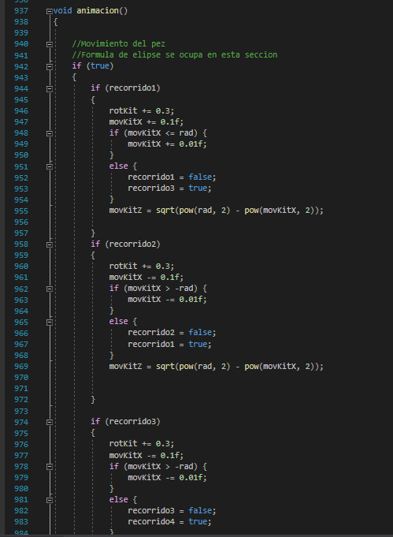

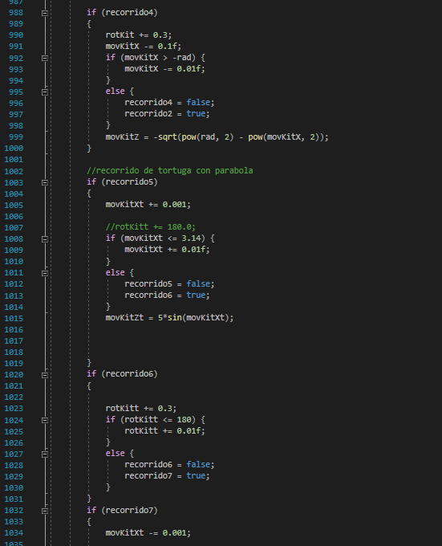

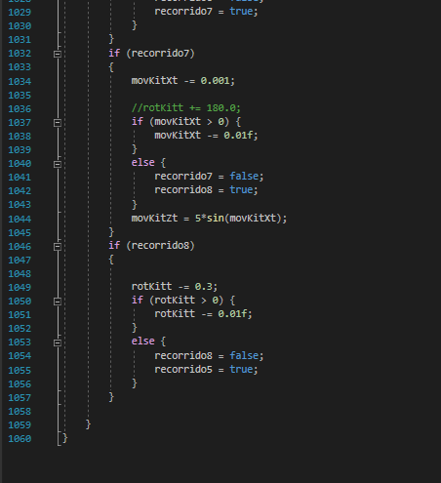

**Conclusion:**

This Project helped to understand and apply each one of the topics covered in the lab sessions. Many of the concepts were learned in a deeper way and also abilities to model object were acquired.

On a personal level I developed an interest for the topics presented in the course.