Weak prompts:
1. Explain regression
2. Help me understand SQL
3. Create a dataset

Strong improved prompts:
- Explain regression but use an example so I can recognize this in the future
- Help me understand SQL in a way that I can apply it to learning Data Analytics

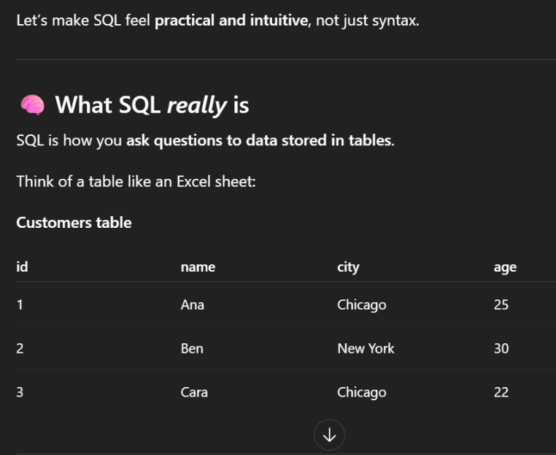
Answers:
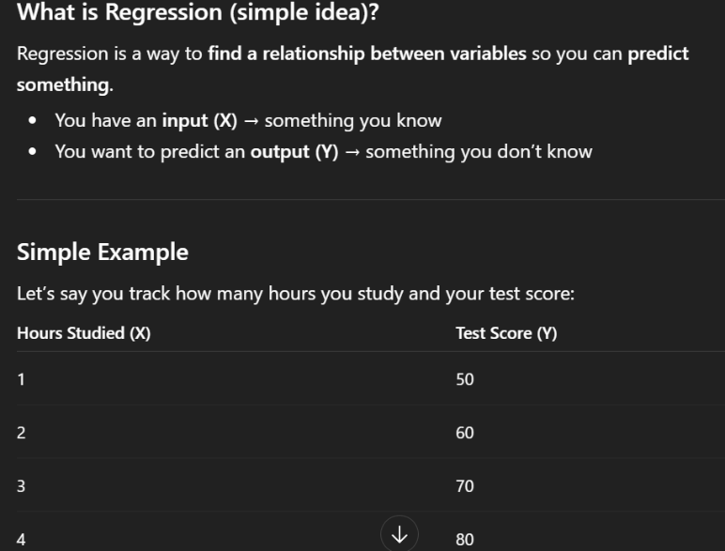
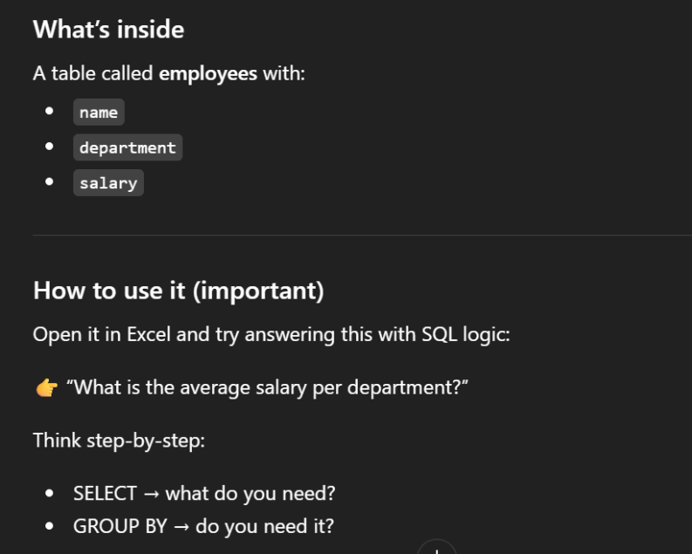
I feel like the revised prompts are better because they’re more direct and concise of the topic. whereas the questions before could be analyzed in a broader way if you don’t add simple details.

