A simplified explanation: 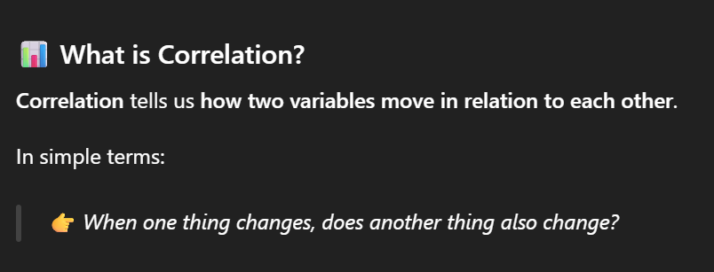
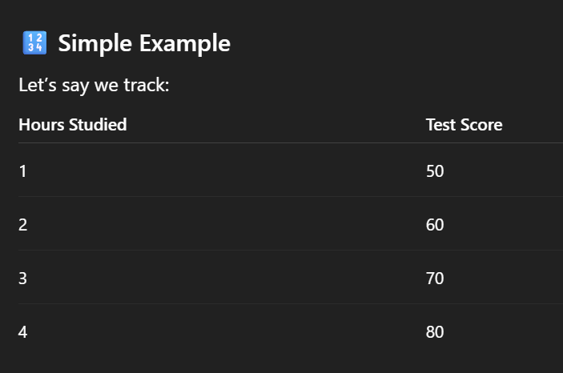
A small number example:

A follow-up question: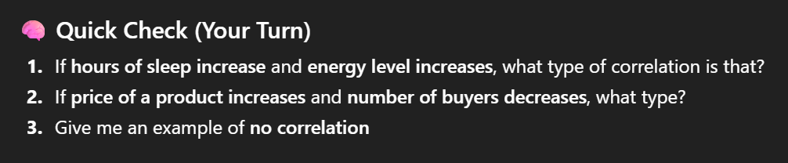

I think having the ai think or act as if it’s specifically a data analyst teacher really influenced the way it would answer. It gave me a bunch of ways to teach myself how to learn correlation in data analytics like a teacher would. It gave examples like a teacher would too. It also gave me a way to practice analyzing correlations just in my personal life as a follow up question as practice which I feel a teacher would also do. So overall, I think giving it a I guess character prompt would benefit also being used as a tool to learn when needed or allowed.

