­­­

Integrated Master’s in Informatics and Computer Engineering

**Information Systems 2020/2021  
360º Company Dashboard**December 2020

**Project Report**

Class 1 Group A

|  |  |
| --- | --- |
| **Student name** | **Student number** |
| Carlos Soeiro | 201706405 |
| Francisco Gonçalves | 201704790 |
| José Guerra | 201706421 |
| Luís Ramos | 201706253 |
| Martim Silva | 201705205 |

**Index**

Project Overview 3

Functionalities 4

Core Overview 4

Financial Report 5

Sales Report 6

Inventory Report 7

Procurement Report 8

Product View 9

Information Architecture 10

CORE_OVERVIEW 10

FINANCIAL_REPORT 11

SALES_REPORT 12

INVENTORY_REPORT 13

PROCUREMENT_REPORT 14

PRODUCT_VIEW 15

BPMN Flows 16

Sales BPMN 16

Suppliers BPMN 17

Manufacturing BPMN 18

Project Planning 19

Instructions 20

Pages 21

Final Considerations 23

**1. Project Overview**

This project consists of a web application capable of presenting important information, such as key performance indicators (KPIs) and data relevant to the business of **Tesla**.

Tesla, Inc. (formerly Tesla Motors, Inc.) is an American electric vehicle and clean energy company based in Palo Alto, California. Tesla's current products include electric cars (the Model S, Model 3, Model X, and Model Y), battery energy storage from home to grid scale (the Powerwall, Powerpack, and Megapack), solar products (solar panels and solar roof tiles) and related products and services.

After 11 years in the market, Tesla ranked as the world's best-selling plug-in and battery electric passenger car manufacturer in 2019, with a market share of 17% of the plug-in segment and 23% of the battery electric segment. Tesla global vehicle sales increased 50% from 245,240 units in 2018 to 367,849 units in 2019. In 2020, the company surpassed the 1 million mark of electric cars produced. The Model 3 ranks as the world's all-time best-selling plug-in electric car, with more than 500,000 delivered. Tesla cars accounted for 81% of the battery electric vehicles sold in the United States in the first half of 2020. Tesla sells cars and equipment both by stock or/and by order.

The use of a dashboard and drill down functionalities will allow information such as sales, finances, inventory and procurement to be displayed in a way that facilitates their understanding. The application will also be interoperable with Primavera Software.

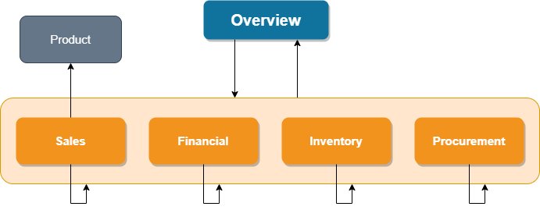

Fig 1 - Simplified site map

**2. Functionalities**

**2.1** Overview

|  |  |  |  |
| --- | --- | --- | --- |
| **Functionality** | **Description** | **Value** | **Associated Dashboard** |
| Sales Gross Total | Value representing annual sales gross total | Understand the grand total of all sales within a year | OVERVIEW |
| Sales Net Total | Value representing annual sales net total | Understand the gross sales minus 3 types of deductions, allowances, discounts and returns | OVERVIEW |
| Gross Profit Margin | Value representing annual gross profit margin | Give a general overview of the efficiency of the business | OVERVIEW |
| Net Profit Margin | Value representing annual net profit margin | Measures how much of a company’s net income (profit) is generated from revenue | OVERVIEW |
| EBITDA | Value representing the company’s overall financial performance | Represents the profitability of a business | OVERVIEW |
| Net Income | Value representing the income after taking taxes and deductions | Represents the revenue that exceeds the expenses of the company | OVERVIEW |
| Sales summary | Bar chart listing the sales volume for each month | To understand if and when there is more sales (seasonality) | OVERVIEW |
| Sales per Region | Circular chart to determine locations where we sell more products | Determine best locations where our products succeed the most | OVERVIEW |
| Balance sheet | Bars chart representing Assets, Equity and Liabilities | Check the balance sheet of the company and determine the health of the company | OVERVIEW |
| Top products | List of top selling products | Know the most popular products | OVERVIEW |

**2.2** Sales Report

|  |  |  |  |
| --- | --- | --- | --- |
| **Functionality** | **Description** | **Value** | **Associated Dashboard** |
| Gross Profit Margin | Line chart for each month representing the gross profit margin | Give a general overview of the efficiency of the business | SALES_REPORT |
| Net Profit Margin | Line chart for each month representing the net profit margin | Measures how much of a company’s net income (profit) is generated from revenue | SALES_REPORT |
| Average Order Value (AOV) | Value for AOV | Understand average order amount to understand better the business | SALES_REPORT |
| Cost of Goods Sold | Value for COGS | See how much the company is spending on labor and raw materials | SALES_REPORT |
| Sales per Region | Circular chart to determine locations where we sell more products | Determine best locations where our products succeed the most | SALES_REPORT |
| Top products | List of top selling products | Know the most popular products | SALES_REPORT |

**2.3** Financial Report

|  |  |  |  |
| --- | --- | --- | --- |
| **Functionality** | **Description** | **Value** | **Associated Dashboard** |
| Gross Profit Margin | Line chart for each month representing the gross profit margin | Give a general overview of the efficiency of the business | FINANCIAL_REPORT |
| Net Profit Margin | Line chart for each month representing the net profit margin | Measures how much of a company’s net income (profit) is generated from revenue | FINANCIAL_REPORT |
| Balance sheet - Assets | Bar representing the value of assets divided into noncurrent and current assets and tangible and intangible assets | Access to the total amount of assets and its divisions between different categories | FINANCIAL_REPORT |
| Balance sheet - Equity & Liabilities | Bar representing the value of Equity and Liabilities. Liabilities divided into noncurrent and current. | Access to the total amount of equity and liabilities and its divisions between different categories | FINANCIAL_REPORT |
| Revenue and Expenses - Revenue | Bar representing the total amount of revenue | Check the total amount of revenue | FINANCIAL_REPORT |
| Revenue and Expenses - Expenses | Bar representing the total amount of cost | Check the total costs | FINANCIAL_REPORT |
| EBITDA | Bar representing EBITDA subdivided into each category | View of net income with interest, taxes, depreciation and amortization | FINANCIAL_REPORT |
| EBITDA Margin | Value representing EBITDA Margin | Know the company operation profit as a percentage of its revenue | FINANCIAL_REPORT |
| VAT Paid / Deducted | Bar chart representing both values for each month | Understand how the company is paying taxes and deducting them | FINANCIAL_REPORT |

**2.4** Inventory Report

|  |  |  |  |
| --- | --- | --- | --- |
| **Functionality** | **Description** | **Value** | **Associated Dashboard** |
| Total Assets in Stock | Value to represent the value of the total assets in stock | Overview of the total asset the company has on stock | INVENTORY_REPORT |
| Monthly Inventory Turnover | Bar chart representing the inventory turnover for each month | Check how many times inventory has been sold and replaced, monthly | INVENTORY_REPORT |
| Monthly Average Inventory | Bar chart representing the average inventory for each month | Used to estimate the amount of inventory the company has, monthly. | INVENTORY_REPORT |
| Average Days to Sell Inventory | Value representing the average number of days to sell inventory | Understand how long it takes the company to turn its inventory into sales | INVENTORY_REPORT |
| Top products | List of top selling products | Know the most popular products | INVENTORY_REPORT |

**2.5** Procurement Report

|  |  |  |  |
| --- | --- | --- | --- |
| **Functionality** | **Description** | **Value** | **Associated Dashboard** |
| Types of Suppliers | Bar chart representing the number of short-, medium- and long-term suppliers | Understand how dependent the company is of certain suppliers | PROCUREMENT_REPORT |
| Product Order Cycle Time | Line chart representing the average purchase order cycle time from previous months | Give a general understanding on how fast the company can complete orders | PROCUREMENT_REPORT |
| Supplier Quality Rating | Bar chart representing the quality rating of each supplier | Know how reliable the products of a supplier are, in order to discuss future contracts | PROCUREMENT_REPORT |
| Suppliers | Circular chart to check all the suppliers and how much they supply the company | Give a general understanding on the biggest suppliers | PROCUREMENT_REPORT |
| Product Order Lead Time | Line chart representing the average lead time in days each month | Know how long it takes on average to fulfill an order | PROCUREMENT_REPORT |

**2.6** Product Page

|  |  |  |  |
| --- | --- | --- | --- |
| **Functionality** | **Description** | **Value** | **Associated Dashboard** |
| Product Information | Values representing the general product information | To check for general information regarding a product | PRODUCT_PAGE |
| Top Clients | Table with a list of top clients for a given product | To know the most reliable clients and understand the value they bring to the company | PRODUCT_PAGE |
| Gross Profit vs Net Profit | Line chart comparing the gross profit and net profit of a given product for each month | Compare how the two values stack against each other to analyze where improvements need to be made | PRODUCT_PAGE |
| Units in Stock | Value representing Units in stock for a given product | To check the inventory stock of a given stock | PRODUCT_PAGE |
| Units Sold | Value representing units sold of a given product | To check the number of sales of a given product | PRODUCT_PAGE |
| Annual Product Net Profit | Value representing the annual product net profit | To understand the annual net profitability of a given product at any time | PRODUCT_PAGE |

**3­­. Information Architecture**

**User and Business Goals**

* General company overview (Sales Gross total, Sales Net Total, Margins)
* Swift view of the company’s status
* Used as a management tool

|  |  |  |  |
| --- | --- | --- | --- |
|  | | **Elements of the core** | |
| KP1_06 | KPI | | Net Profit Margin |
| BAR_01 | Bar chart | | Sales Summary |
| BAR_02 | Bar chart | | Balance Sheet |
| CIR_01 | Pie chart | | Sales Per Region |
| LIST_01 | List | | Top products |

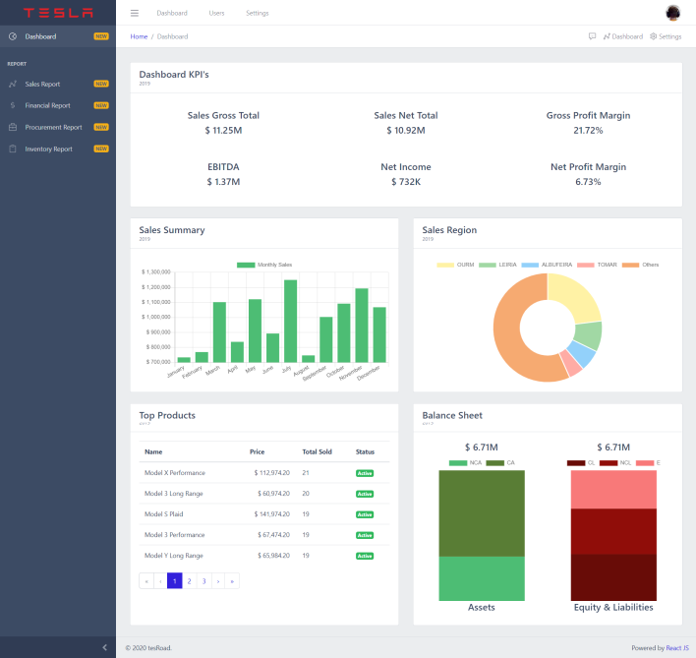**3.1** CORE_OVERVIEW

|  |
| --- |
| **Inward Paths / Trigger Words** |
| Aside navigation menus |

|  |
| --- |
| **Outward Paths / Calls to Action** |
| Provide the user with a broad view for a given year/**period** information about the company’s activity (sales, accounting, KPIs) | |
| Close look into the information of Products, Customers, all KPIs (ex: Top products) |

|  |  |  |  |
| --- | --- | --- | --- |
|  | **Elements of the core** | | |
| KPI_01 | | KPI | Sales Gross Total |
| KPI_02 | | KPI | Sales Net Total |
| KPI_03 | | KPI | Gross Profit Margin |
| KPI_04 | | KPI | Earning Growth |
| KPI_05 | | KPI | Revenue Growth Rate |

Fig 2 – Overview page

**3­­. Information Architecture**

**User and Business Goals**

* Sales overview (cost of goods sold, average order value, top products, sales per region)
* Detailed view of the company’s sales status
* Used as a management tool

**3.2** SALES_REPORT

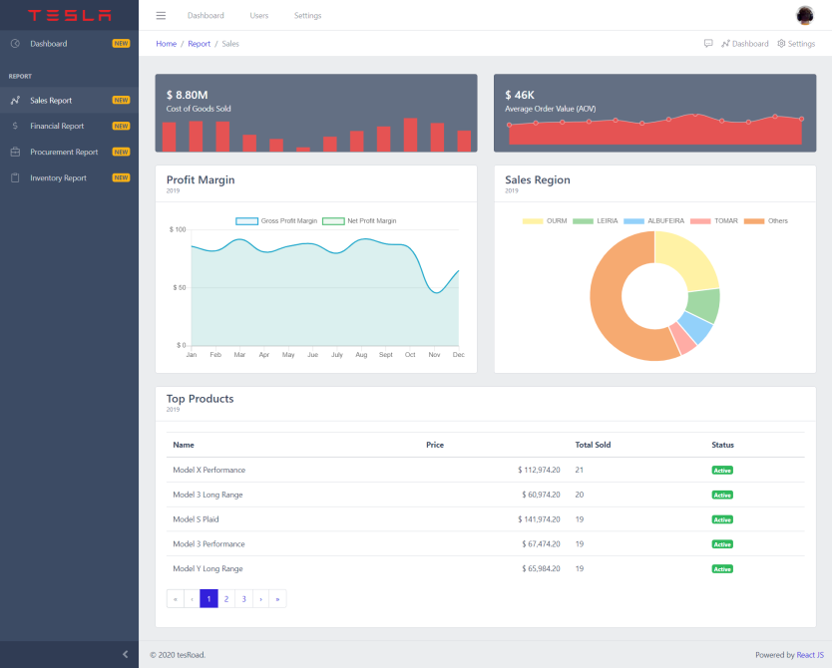

|  |
| --- |
| **Inward Paths / Trigger Words** |
| Aside navigation menus |

|  |
| --- |
| **Outward Paths / Calls to Action** |
| Provide detailed information about the company’s sales situation for a specific year/period (COGS, AOV, top products) |

|  |  |  |  |
| --- | --- | --- | --- |
|  | **Elements of the core** | | |
| KPI_01 | | KPI | Cost of Goods Sold |
| KPI_02 | | KPI | Average Order Value |
| LIST_01 | | List | Profit Margin |
| CIR_01 | | Pie chart | Sales Per Region |
| LINE_01 | | Line chart | Top Products |

Fig 3 – Sales page

**3­­. Information Architecture**

**User and Business Goals**

* Financial overview (VAT Paid/deducted, profit margin, balance sheet, profit and loss)
* Detailed view of the company’s financial status
* Used as a management tool

**3.3** FINANCIAL_REPORT

|  |  |  |  |
| --- | --- | --- | --- |
|  | **Elements of the core** | | |
| BAR_01 | | Bar chart | VAT Paid / Deducted |
| BAR_02 | | Bar chart | Balance Sheet |

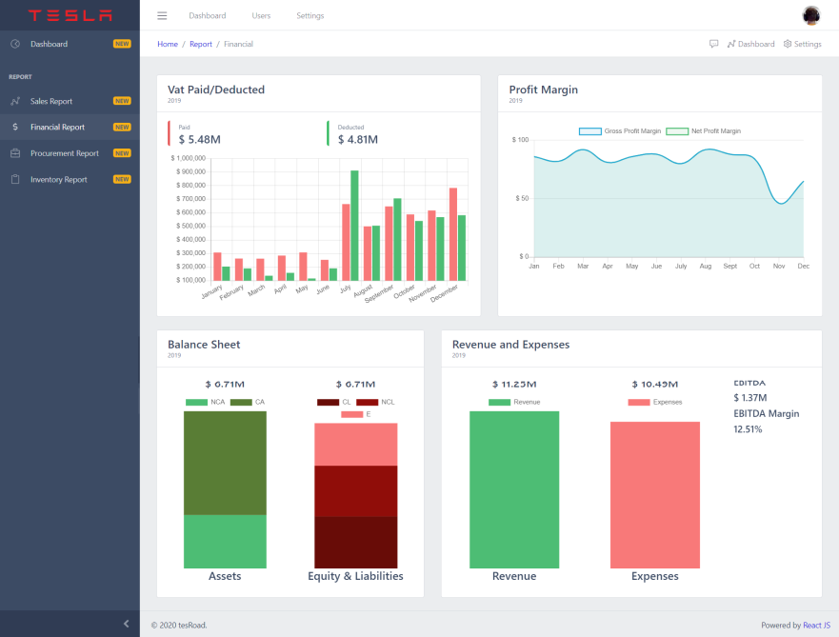

|  |  |  |  |
| --- | --- | --- | --- |
|  | | **Elements of the core** | |
| LINE_01 | Line chart | | Profit Margin |
| BAR_03 | Bar chart | | Revenue & Expenses |

|  |
| --- |
| **Inward Paths / Trigger Words** |
| Aside navigation menus |

|  |
| --- |
| **Outward Paths / Calls to Action** |
| Provide the user with a detailed view of the company’s financial state (sales, accounting, KPIs) for a given year/period | |
| Close look into the information of Products, Customers, all KPIs (ex: Top products) |

Fig 4 – Financial page

**3­­. Information Architecture**

**User and Business Goals**

* Procurement overview (purchases, supply information)
* Detailed view of the company’s procurement
* Used as a management tool

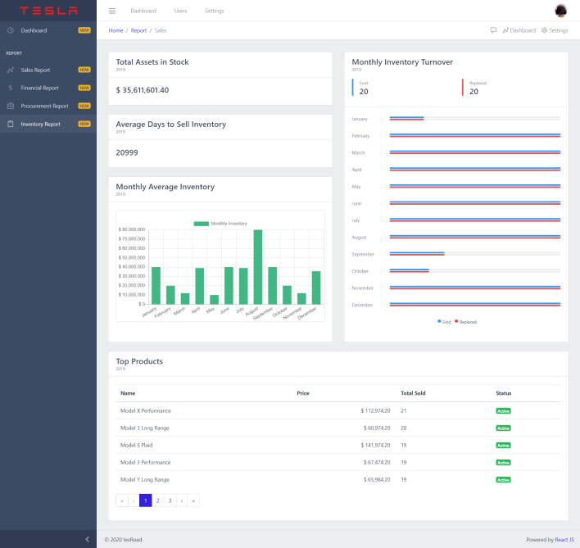**3.4** INVENTORY_REPORT

|  |  |  |  |  |
| --- | --- | --- | --- | --- |
|  | | | | **Elements of the core** |
| BAR_02 | Bar chart | | Monthly Average Inventory | |
| LIST_01 | | List | Top Products | |

|  |
| --- |
| **Inward Paths / Trigger Words** |
| Aside navigation menus |

|  |  |  |  |
| --- | --- | --- | --- |
|  | **Elements of the core** | | |
| KPI_01 | | KPI | Total Assets in Stock |
| KPI_02 | | KPI | Average Days to Sell Inventory |
| BAR_01 | | Bar chart | Monthly Inventory Turnover |

|  |
| --- |
| **Outward Paths / Calls to Action** |
| Provide the user with a broad view for a given year/**period** information about the company’s products performance | |
| Dive deep into information about Products |

Fig 5 – Inventory page

**3­­. Information Architecture**

**User and Business Goals**

* Inventory overview (products, turnovers, ...)
* Detailed view of the company’s inventory situation
* Used as a management tool

**3.5** PROCUREMENT_REPORT

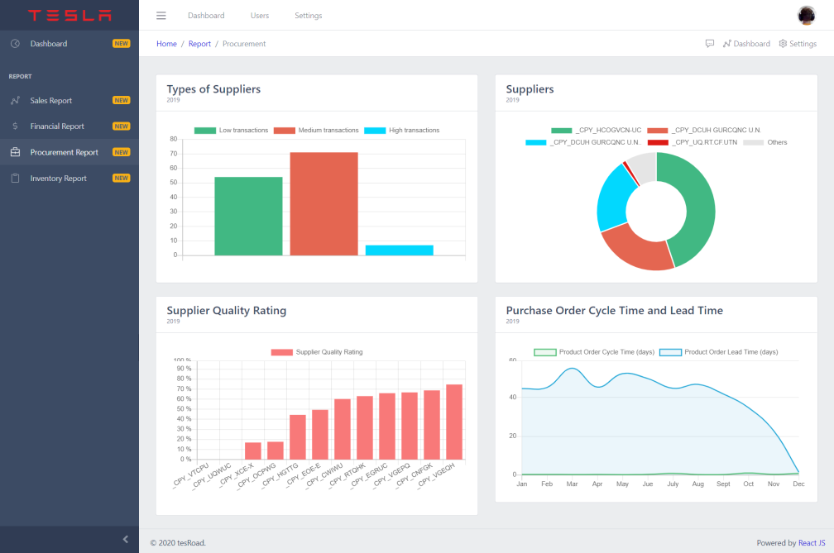

|  |  |  |  |
| --- | --- | --- | --- |
|  | **Elements of the core** | | |
| BAR_01 | | Bar chart | Number of Suppliers |
| KPI_01 | | KPI | Supplier Quality Rating |
| BAR_02 | | Bar chart | Purchases in Time and Budget |

|  |  |  |  |
| --- | --- | --- | --- |
|  | | **Elements of the core** | |
| PIE_01 | Pie chart | | Suppliers |
| LINE_01 | Line chart | | Purchase Order Cycle Time and Lead Time |

|  |
| --- |
| **Inward Paths / Trigger Words** |
| Aside navigation menus |

|  |
| --- |
| **Outward Paths / Calls to Action** |
| Provide year information about the company activity (sales, accounting, KPIs) | |
| Drill down to “know more” on Products, Customers, all KPIs (ex: Top products) |

Fig 6 – Procurement page

**3­­. Information Architecture**

**User and Business Goals**

* Product overview (product information, stock, clients, profit)
* Detailed view for each of the company’s products
* Used as a useful management tool

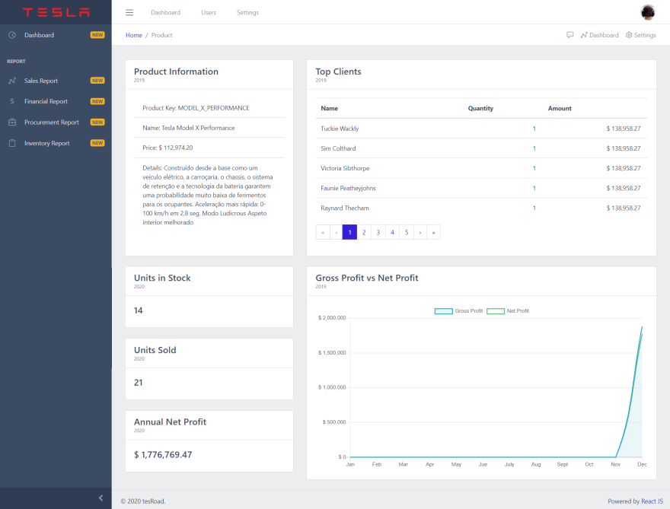**3.6** PRODUCT_VIEW

|  |
| --- |
| **Inward Paths / Trigger Words** |
| Aside navigation menus |

|  |
| --- |
| **Outward Paths / Calls to Action** |
| Provide the user with a broad view for a given year/**period** information about the company’s activity (sales, accounting, KPIs) | |
| Close look into the information of Products, Customers, all KPIs (ex: Top products) |

|  |  |  |  |
| --- | --- | --- | --- |
|  | **Elements of the core** | | |
| KPI_01 | | KPI | Sales gross total |
| KPI_02 | | KPI | Sales Net Total |

|  |  |  |  |
| --- | --- | --- | --- |
|  | **Elements of the core** | | |
| KPI_03 | | KPI | Gross Profit Margin |
| LINE_01 | | Line chart | Net Profit Margin |

Fig 7 – Product view page

**4. BPMN Flows**

**4.1 Sales BPMN**

Fig 8 - Sales BPMN diagram

The BPMN diagram above demonstrates the process that occurs when a client buys a product from Tesla. The client must first select a product from the available range of products and order it. Tesla then receives the order and waits for the client to pay. After payment is received, the product is delivered to the client and then the inventory is updated.

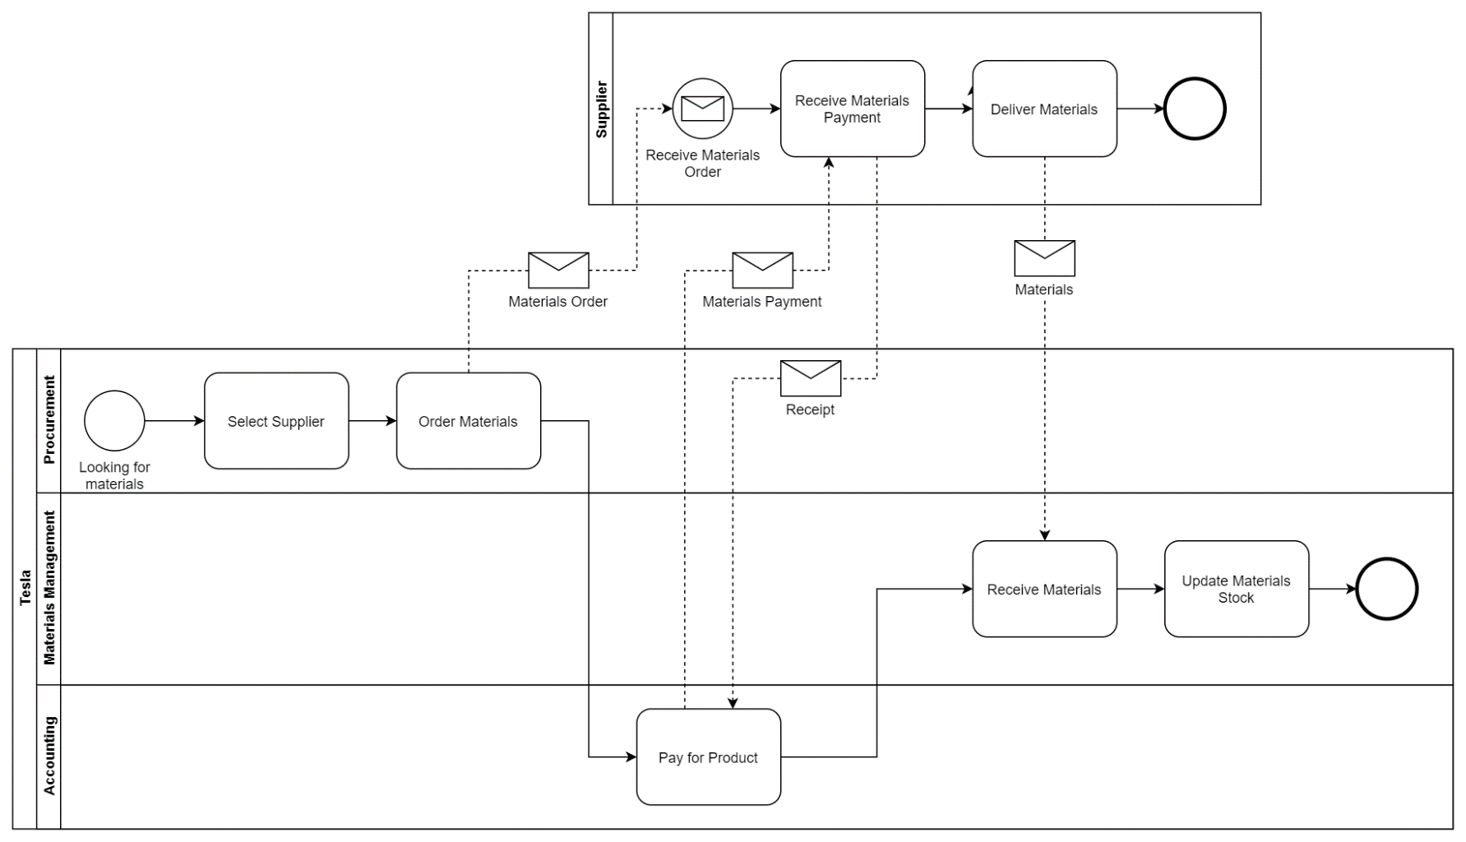**4.2 Suppliers BPMN**

Fig 9 - Suppliers BPMN diagram

The BPMN diagram above demonstrates the process that occurs when the procurement department buys materials from its suppliers. The procurement department must first select the supplier from which to buy the materials and then order them. The supplier then receives the order and waits for payment from the accounting department of Tesla before sending the materials. The materials management team then receive the materials and update the stock of these materials.

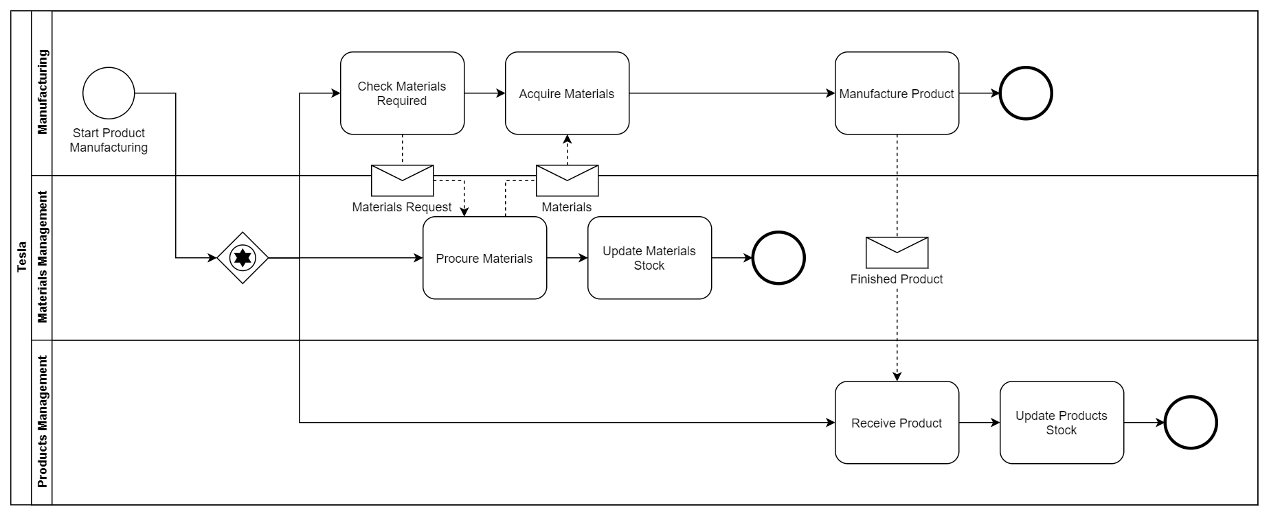**4.3 Manufacturing BPMN**

Fig 10 - Manufacturing BPMN diagram

The BPMN diagram above demonstrates the process that occurs when manufacturing of a product happens in the Tesla company. The manufacturing department first checks if it has the materials required, sending a request for materials to the materials management team and then receiving them before proceeding to the manufacturing of a product. The management team after sending the materials to the manufacturing department updates the materials stock. The products management team when receiving the product makes it available for purchase by updating the stock of the product received.

**5. Planning**

**Gantt Chart**

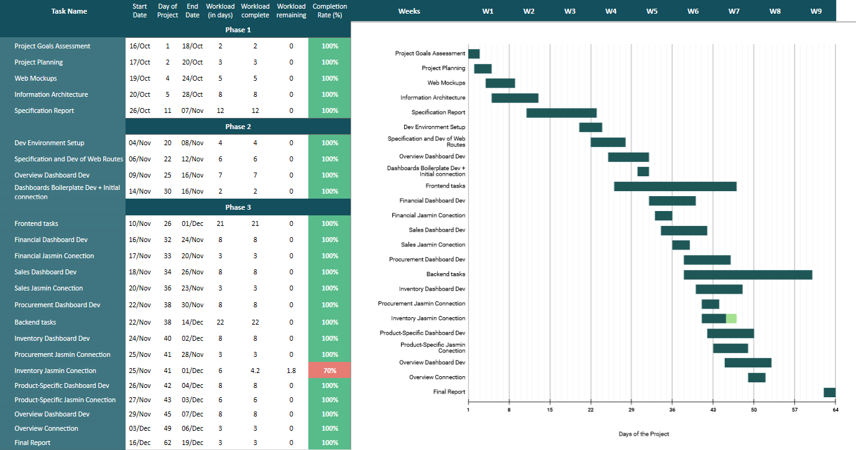

Fig 11 – Gantt chart

**6. Instructions**

In order to run the app, the user needs to have Node.js installed. Node.js is an open-source, cross-platform, back-end, JavaScript runtime environment that executes JavaScript code outside a web browser. To download Node.js access the following link <https://nodejs.org/en/> and press the green download button then after downloading the installation, execute it and install Node.js.

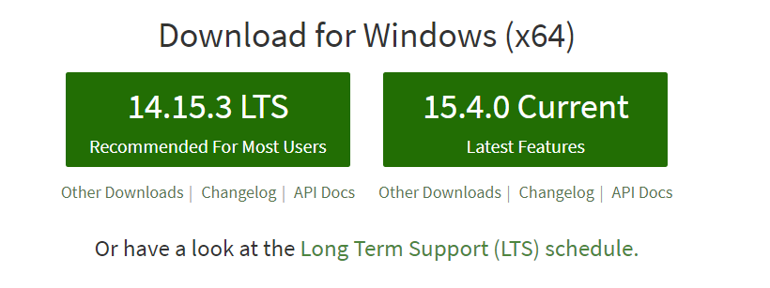

After the installation is complete, access the root folder of the project and run the following commands on the terminal (cmd, powershell, bash, …) by the following order:

> npm install

> npm start

The first command installs modules necessary to run the project

The last command starts the application on port 3000 of localhost and the Web API for the SAF-T information on port 5000 of localhost

Note: Don’t copy the > symbol and the information between parentheses.

After starting the app, open your preferred browser and type <http://localhost:3000> to access the app.

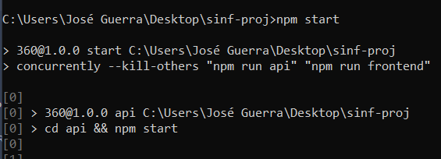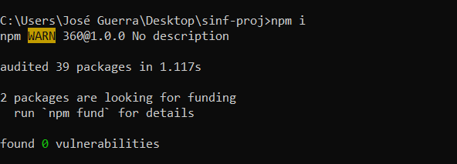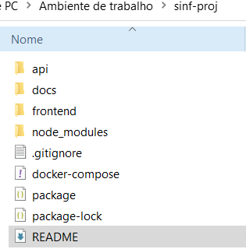

**7. Pages**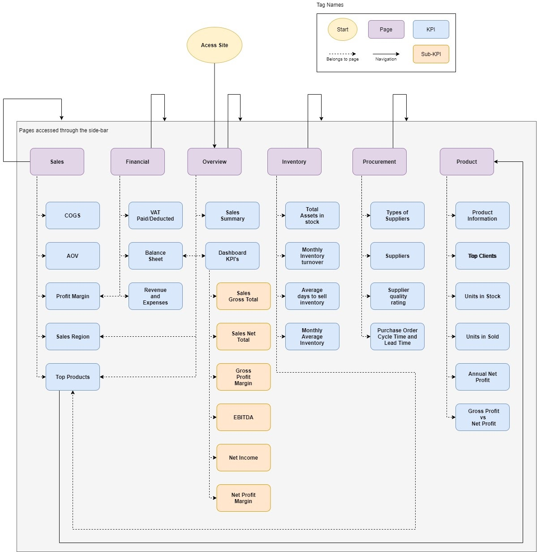

Fig 12 - Site paths

A user can access all of the pages by using the website’s sidebar, except the product page, that can only be accessed when pressing one of the entries on the top products table present on the overview, sales and inventory pages.

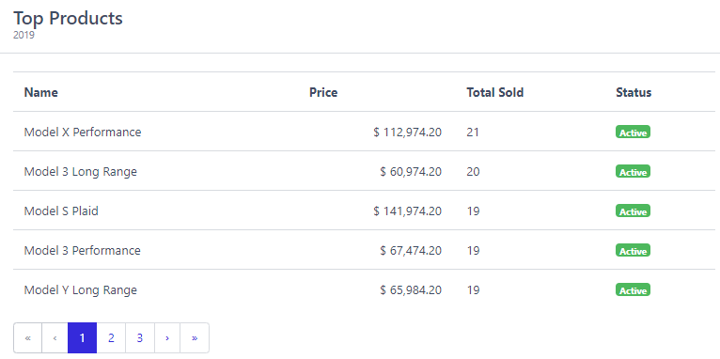  
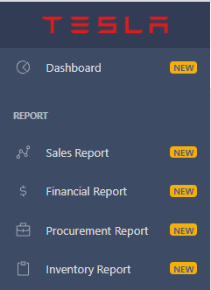

Fig 13 – Website sidebar

Besides this, the user can also access any page by their respective url:

* Dashboard - <http://localhost:3000/#/dashboard>
* Sales Report - <http://localhost:3000/#/report/sales>
* Financial Report -<http://localhost:3000/#/report/financial>
* Procurement Report - <http://localhost:3000/#/report/procurement>
* Inventory Report - <http://localhost:3000/#/report/inventory>
* Product Page - [http://localhost:3000/#/theme/products/{Product_Designation](http://localhost:3000/#/theme/products/%7BProduct_Designation)}

Example:  <http://localhost:3000/#/theme/products/MODEL_X_PERFORMANCE>

**8. Final Considerations**

In comparison with the project specification, we achieved all of what we planned, except for a small part of the inventory report. This was due to time constraints. We also improved on some aspects that were not previously mentioned on the project specification, to improve the overall project such as, but not only, changes in some chosen KPIs, UI/UX improvements, using backend to store the accounting SAF-T file, etc. We also tried to focus on every aspect of a company, making in the process a more difficult task to complete our project, including procurement, inventory and specific product information (it would be much easier to solely focus on financial and sales points), to make the development as rich as possible, since it required from us, attention to all parts of the company and not just one or two.

Learning how to work with a piece of software like Jasmin was definitely one of the highpoints of the project. Going through the process of understanding how a company stores and processes its most valuable data was very informative and allowed us to have a better understanding of the intricacies it takes to be able to manage a proper company.

Besides this, working with the accounting SAF-T and learning how to read and understand the taxonomy codes was also another highpoint. It was fascinating to learn the amount of information and content a file like this can harbour. This knowledge will be very useful, for the future, if some of us decide to start their own businesses and/or companies.

We managed to conclude the project with great success although some minor things are left to be improved in a possible future work. We believe the app in its current state could be used on the professional landscape, for a real company, and that makes us very proud.