# High-Quality Code Construction – Game “Battle Field”

Your task is to write an interactive **console-based implementation of the game “Battle Field”** in which the player tries to clean a matrix of numbers and empty cells by **series of explosions** which detonate areas of different sizes. At the start of the game, the program should read the **size of the battle field** **n** and should generate a **random battle field**: a matrix of size **n** x **n** (1 ≤ **n** ≤ 10). Each cell of the matrix should be initially filled with a random number in the range [**1**..**5**] (donating a mine of some size) or with an empty cell "**-**". The number mines should be **between 15% and 30% of the cells** in the battle field. At each step the player enters two coordinates **row** and **col** and depending on the number in the cell at the specified position **{row, col}** the computer **detonates an area of the matrix**. The detonated areas depend on the size of the detonated mine and follow the patterns below:

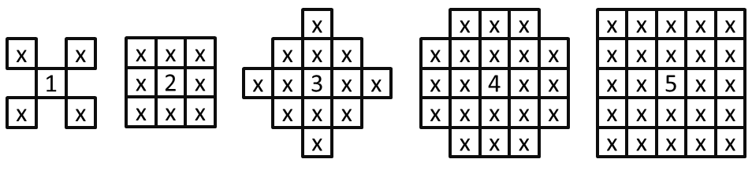

Write a program that **simulates the “Battle Field” game**. The game should print the battle field and sequentially read coordinates and perform detonations at the specified positions. If an empty or already detonated position or invalid cell is specified, print "**Invalid move!**". Otherwise detonate the specified mine and print the battle field after the explosion. When a mine is detonated it destroys all mines inside its detonated area **without causing chained explosions**. Visualize the mines as numbers, the empty cells as "**-**" and the detonated cells as "**X**". The game finishes when all mines are detonated. After the game is finished, you should print the total number of mines detonated by the player.

**Rows** are numbered from up to down (starting from 0) and **columns** are numbered from left to right (starting from 0). Coordinates are given in format row number followed by space followed by column number. Some players could try to cheat by entering **illegal moves**, so be cautious.

## Example Game Session

The player’s input is shown in *italic*:

|  |  |  |  |
| --- | --- | --- | --- |
| **Welcome to "Battle Field" game.**  **Enter battle field size: n = *10***  **0 1 2 3 4 5 6 7 8 9**  **-------------------**  **0|- 5 - - - - - - - -**  **1|- - - - - - - - 3 -**  **2|– 3 - 2 - - 4 - 1 -**  **3|- - - - – 3 – 5 - 4**  **4|– 4 - - - - 2 - 2 -**  **5|- - - - - - - - - -**  **6| - - - - - - - 3 -**  **7|- - - - - - 2 - 1 -**  **8|- - - - - 2 - 4 - -**  **9|- - - - - - 3 - 2 5** | **🡪** | **Please enter coordinates: *2 1***  **0 1 2 3 4 5 6 7 8 9**  **-------------------**  **0|- X - - - - - - - -**  **1|X X X - - - - - 3 -**  **2|X X X X - - 4 - 1 -**  **3|X X X - – 3 – 5 - 4**  **4|– X - - - - 2 - 2 -**  **5|- - - - - - - - - -**  **6|- - - - - - - - 3 -**  **7|- - - - - - 2 - 1 -**  **8|- - - - - 2 - 4 - -**  **9|- - - - - - 3 - 2 5** | **🡪** |
| **Please enter coordinates: *0 0***  **Invalid move!**  **Please enter coordinates: *2 2***  **Invalid move!**  **Please enter coordinates: *8 7***  **0 1 2 3 4 5 6 7 8 9**  **-------------------**  **0|- X - - - - - - - -**  **1|X X X - - - - - 3 -**  **2|X X X X - - 4 - 1 -**  **3|X X X - – 3 – 5 - 4**  **4|– X - - - - 2 - 2 -**  **5|- - - - - - - - - -**  **6|- - - - - - X X X -**  **7|- - - - - X X X X X**  **8|- - - - - X X X X X**  **9|- - - - - X X X X X** | **🡪** | **Please enter coordinates: *3 7***  **0 1 2 3 4 5 6 7 8 9**  **-------------------**  **0|- X - - - - - - - -**  **1|X X X - - X X X X X**  **2|X X X X - X X X X X**  **3|X X X - – X X X X X**  **4|– X - - - X X X X X**  **5|- - - - - X X X X X**  **6|- - - - - - X X X -**  **7|- - - - - X X X X X**  **8|- - - - - X X X X X**  **9|- - - - - X X X X X**  **Game over. Detonated mines: 3** |  |