

**Youth For Restoration  
Website**

Software Requirement Specification

**Team Members**

**Frederico Castro, Gabriel Miranda,**

**Sethu Sundaramoorthy, Cyril Barthelet,**

**Ivan Fernandes, Zhenkang Yao**

Change History

|  |  |  |  |
| --- | --- | --- | --- |
| Date | Version | Description | Updated By |
| 02-07-2015 | 0.1 | First Draft | SE - Team 5 |
| 02-17-2015 | 1.0 | Official Document | SE - Team 5 |

Document Approval

|  |  |  |
| --- | --- | --- |
| Name | Role | Signature |
|  |  |  |
|  |  |  |

**Table of Contents**

1. Introduction 4

1.1. Purpose 4

1.2. Scope 4

1.3. Definitions, Acronyms and Abbreviations 5

1.4. Technologies to be used 7

1.5. References 8

1.6. Overview 9

2. Overall description 9

2.1. Product perspective 10

2.1.1. Software Interfaces 10

2.1.2. Hardware Interfaces 11

2.2. Product functions 11

2.3. Mockups 16

2.3.1. Public 16

2.3.2. Admin Panel 17

2.4. User characteristics 24

2.5. Constraints 25

2.6. Assumptions and dependencies 25

3. Specific requirements 25

3.1. External interfaces 26

3.2. Functions 26

3.2.1. Main Functions 26

3.2.2. Use Cases 27

3.3. Security Requirements 53

3.4. Performance requirements 54

1. Introduction
   1. Purpose

The purpose of this document is to provide the specifications and requirements for developing a website for a non-profit organization named *Youth for Restoration*, yet to be published at the domain [*http://www.youthforrestoration.org*](http://www.youthforrestoration.org/).

Additionally, this document intends to describe the technical aspects involved in the development of website such as the features, hardware/software interfaces, and design limitations, testing methodology for both the public and the administrator sections.

This document is destined to the system administrators and developers.

* 1. Scope

The scope of the Youth for Restoration website is to provide a consistent and high quality user experience for the visitors and for the administrators.

The system will consist of two main sections:

***Public website:*** Intended to visits from any person with internet access;

***Administrator Panel:*** Private area where users may manage content from sections as blog, news and events schedule. Users have two levels of authorization, known as roles: Author and Administrator.

Since the potential visitors of the website may be very diverse in terms of their age and internet experience, the public pages of the website will be tailored to provide a clear and user-friendly environment. The primary objective of the design will be to promote the organization’s activities and to encourage the visitors to get involved with the cause.

The administration section will provide an environment for the system administrators to manage users, produce content and to update the website information.

The project will also include the design of a vector logo for the organization.

* 1. Definitions, Acronyms and Abbreviations

|  |  |
| --- | --- |
| **Admin Panel** | Administration panel - Private part of the system that requires login authentication. |
| **Administrator** | Any user with highest level of authorization, which provides ability to manage all the operations of the Admin Panel. Besides the management of the Author role, the administrator user role allows the management of users, sponsors, volunteers and the home page photo slider content. |
| **Author** | User role that allows managing blog posts, news, events. |
| **Client** | Web browser in the user's machine or plug-ins and helper applications that enhance the browser to support special services from the website. |
| **CSS** | Cascading Style Sheets (CSS) is a style sheet language used for describing the look and formatting of a document written in a markup language. |
| **Database** | Collection of all the information monitored by this system. |
| **Field** | A cell within a form. |
| **HTML (Hyper Text Markup Language)** | Markup language used to create web pages. |
| **HTTP - Hyper Text Transfer Protocol** | Transaction oriented client/ server protocol between a web browser and a web server. |
| **OS - Operating System** | Software that controls the operation of a computer and directs the processing of programs (as by assigning storage space in memory and controlling input and output functions). |
| **Product** | The website described by this document. |
| **Server or Web Server** | A computer that runs a Website. Using the HTTP protocol, the Web server delivers Web pages to browsers as well as other data files to Web-based applications. |
| **Session** | The session of activity that a user with a unique IP address spends on a Web site during a specified period of time. |
| **Stakeholder** | Any person with an interest in the project who is not a developer. |
| **System** | The whole application that involves the website. |
| **TBD** | (Abrev.) To be determined. |
| **User** | Anyone who is registered in the database that has login and ability to manage content. |
| **Visitor** | Anyone visiting the site. |
| **Widget** | An application or a component of an interface, which enables a user to perform a function or access a service. |

Table 1.1 - Definitions, Acronyms and Abbreviations.

* 1. Technologies to be used

The following table contains the list of technologies which will be used in the development of the website.

|  |  |
| --- | --- |
| **Technology** | **Description** |
| **HTML5** | Markup language used to create web pages. |
| **CSS3** | Style sheet language used for describing the look and formatting of a document written in a markup language. |
| **JavaScript** | Dynamic computer programming language used to allow client-side scripts to interact with the user, control the browser, communicate asynchronously, and alter the document content that is displayed. |
| **JQuery** | Cross-platform JavaScript library designed to simplify the client-side scripting of HTML. |
| **PHP** | Server-side scripting language designed for web development. |

Table 1.2 – Technologies to be used.

* 1. References

1. IEEE Recommended Practice for Software Requirements Specifications. (1998, June 25). Retrieved February 8, 2015, from <http://www.math.uaa.alaska.edu/~afkjm/cs401/IEEE830.pdf>
2. SRS Format. (n.d.). Retrieved February 4, 2015, from https://www.ibm.com/developerworks/community/wikis/form/anonymous/api/wiki/336d1dbb-5203-4eb3-8542-f4a2d1af056c/page/d9b0b712-ac9d-43ac-b430-0bc76b7edc31/attachment/921e2bcf-2349-42d3-976b-0e23f7d6ff61/media/srs format.pdf
3. Sommerville, I. (2012). *Introduction to software engineering* (9th ed.). Frenchs Forest, N.S.W.: Pearson.
4. Cascading Style Sheets. (n.d.). Retrieved February 8, 2015, from <http://en.wikipedia.org/wiki/Cascading_Style_Sheets>
5. JavaScript. (n.d.). Retrieved February 8, 2015, from <https://en.wikipedia.org/wiki/JavaScript>
6. JQuery. (n.d.). Retrieved February 8, 2015, from <https://en.wikipedia.org/wiki/JQuery>
7. PHP. (n.d.). Retrieved February 8, 2015, from <https://en.wikipedia.org/wiki/PHP>
8. Web server Definition from PC Magazine Encyclopedia. (n.d.). Retrieved February 8, 2015, from <http://www.pcmag.com/encyclopedia/term/54342/web-server>
9. Web client Definition from PC Magazine Encyclopedia. (n.d.). Retrieved February 8, 2015, from <http://www.pcmag.com/encyclopedia/term/54284/web-client>
10. (n.d.). Retrieved February 8, 2015, from http://www.merriam-webster.com/dictionary/operating system
11. Nielsen Norman Group. (n.d.). Retrieved February 8, 2015, from <http://www.nngroup.com/articles/response-times-3-important-limits>
12. W3C. (n.d.). Retrieved February 8, 2015, from <http://www.w3.org/standards/>
13. User Session Definition from PC Magazine Encyclopedia. (n.d.). Retrieved February 9, 2015, from <http://www.webopedia.com/TERM/U/user_session.html>.
    1. Overview

The subsequent section of this document brings to main sections, namely Overall Description and Specific Requirements. The former section states the general factors that affect the system and its requirements. The latter section is intended for the developers and it describes the functionalities in detailed technical terms.

1. Overall description

This section intends to describe the general factors that affect the system and its requirements in order to provide a background to the specific requirements brought by section 3.

* 1. Product perspective

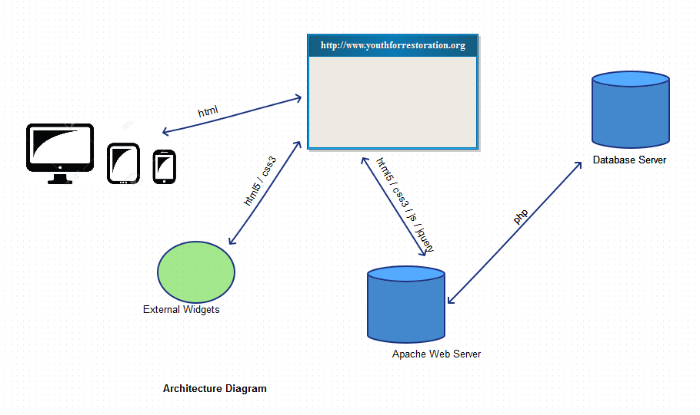

Figure 2.1 - Product Perspective.

* + 1. Software Interfaces
* Client on Internet: Web browser compatible with HTML5 for better experience, all Operating Systems;
* Web Server: TBD;
* Database Server: TBD;
* Development frontend:
  + HTML5;
  + CSS3;
  + JavaScript;
  + JQuery.
* Development backend
  + PHP.

**Supported browsers:**

|  |  |  |
| --- | --- | --- |
| **Minimum** | **Recommended** | **Full Support List** |
| Chrome (current version) | Chrome (current version) | Chrome (current version) |
| Internet Explorer 8 | Internet Explorer 11 | Internet Explorer 8/9/10/11 |
| Firefox (current version) | Firefox (current version) | Firefox (current version) |
| Safari 5 | Safari 8 | Safari 5/6/7/8 |

Table 2.1 - Supported Browsers.

* + 1. Hardware Interfaces
* Device with Internet connection.
* Devices supported: Computers, Phones and Tablets with browser application.
  1. Product functions

This section presents a summary of the major functions that the software will perform.

The *Youth for Restoration* website consists of two main interfaces, the public website and the Admin Panel.

**Public Pages: Main Use Cases**

* + - 1. **Use Case:** View home page.

**Brief Description:** Visitor types in [www.youthforrestoration.org](http://www.youthforrestoration.org/) on his/her web browser, which then takes them to the home page of the website.

* + - 1. **Use Case:** Send message to Youth of Restoration.

**Brief Description:** Visitor clicks the contact link and is directed to the contact page. At this page, a visitor enters valid data on the input fields and a message is sent to the organization email.

* + - 1. **Use Case:** View Facebook widget.

**Brief Description:** Visitor enters the home page and is able to view the Facebook widget.

* + - 1. **Use Case:** View Photo Slider on the home page.

**Brief Description:** Visitor enters the home page and shall see a photo slider.

* + - 1. **Use Case:** Become a volunteer.

**Brief Description:** The visitor enters Get Involved link and is able to send a form with his/her information to become a volunteer.

* + - 1. **Use Case:** Make donation.

**Brief Description:** The user enters the donation link and is able to see the address to send a check.

**Admin Panel: Main Use Cases**

* + - 1. **Use Case:** Authorized access to Admin Panel.

**Brief Description:** The user enters his/her credentials to access the admin panel of the website which allows them higher privileges on the system. Any unauthorized user/invalid credentials should be denied access to the Admin Panel.

* + - 1. **Use Case:** Manage Users.

**Brief Description:** Logged user with Administrator role enters the user section and is able to view, register, update and delete users.

* + - 1. **Use Case:**  Manage Sponsors.

**Brief Description:** Logged user with Administrator role enters the sponsors section and is able to view, register, update and delete sponsors.

* + - 1. **Use Case:**  Manage Events.

**Brief Description:** Logged user enters the events section and is able to view, register, update and delete events on the schedule.

* + - 1. **Use Case:**  Manage News.

**Brief Description:** Logged user enters the news section and is able to view, register, update and delete news.

* + - 1. **Use Case:**  Manage Blog Posts.

**Brief Description:** Logged user enters the blog posts section and is able to view, register, update and delete blog posts.

* + - 1. **Use Case:**  Manage Volunteers.

**Brief Description:** Logged user with Administrator role enters the volunteers section and is able to view, register, update and delete volunteers.

* + - 1. **Use Case:**  Manage Photo Slider contents.

**Brief Description:** Logged user with Administrator role enters the Photo Slider section and is able to view, register, update and delete photo slider contents.

**Public website**

Public web pages with content about the organization as follows:

* Home;
* About us;
* Get Involved;
* Contact;
* Blog;
* News;
* Donation;
* Become a sponsor.

**Admin panel**

* User actions (View, Register, Edit, Delete) for:
  + Blog posts;
  + News;
  + Events on calendar;
* Administrator actions (View, Register, Edit, Delete) for:
  + Users;
  + Sponsors;
  + Volunteers;
  + Blog posts;
  + News;
  + Events on calendar;
  + Photo slider contents.

The public pages section will have the following features:

* Photo slider for the home page;
* General search field for blog posts, news and events;
* Social media integration:
  + Social media widgets;
  + Share button for posts and news.
  1. Mockups
     1. Public

1. Home Page

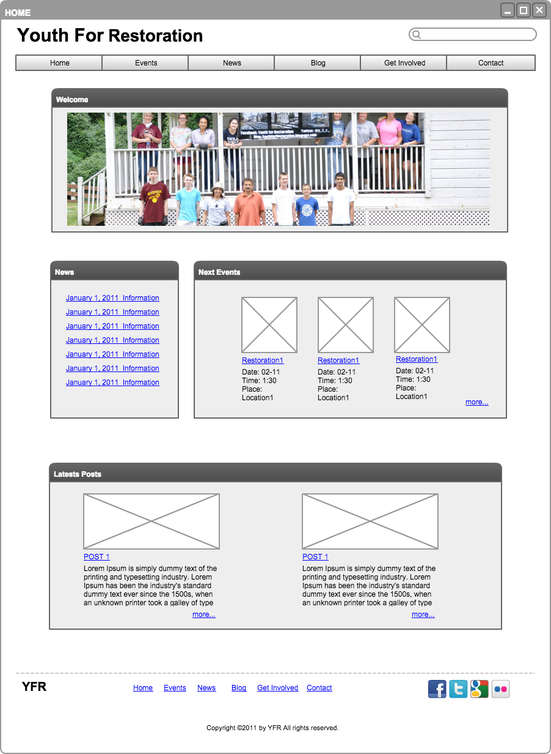

* + 1. Admin Panel

1. Login

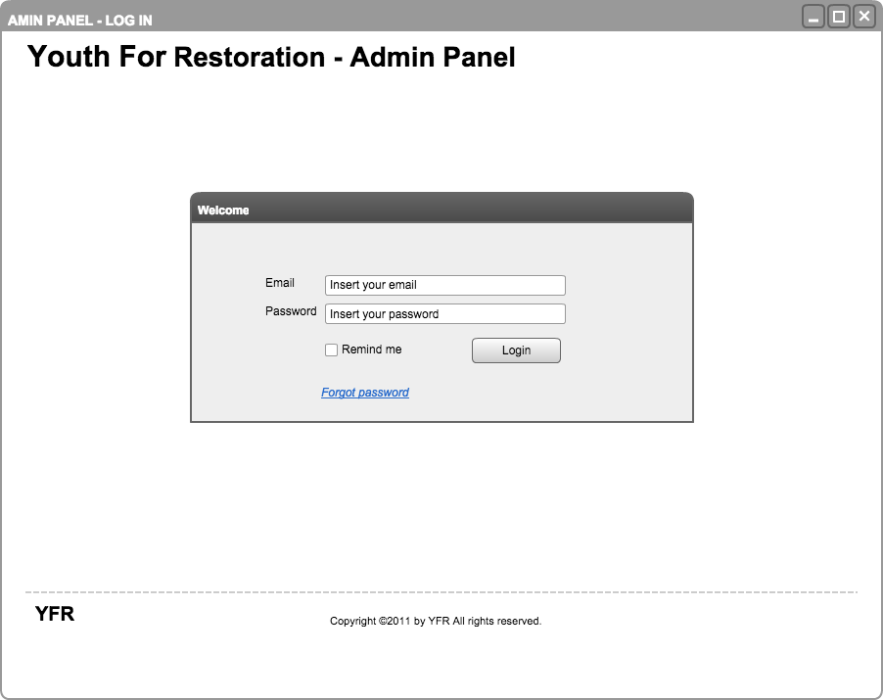

1. User New

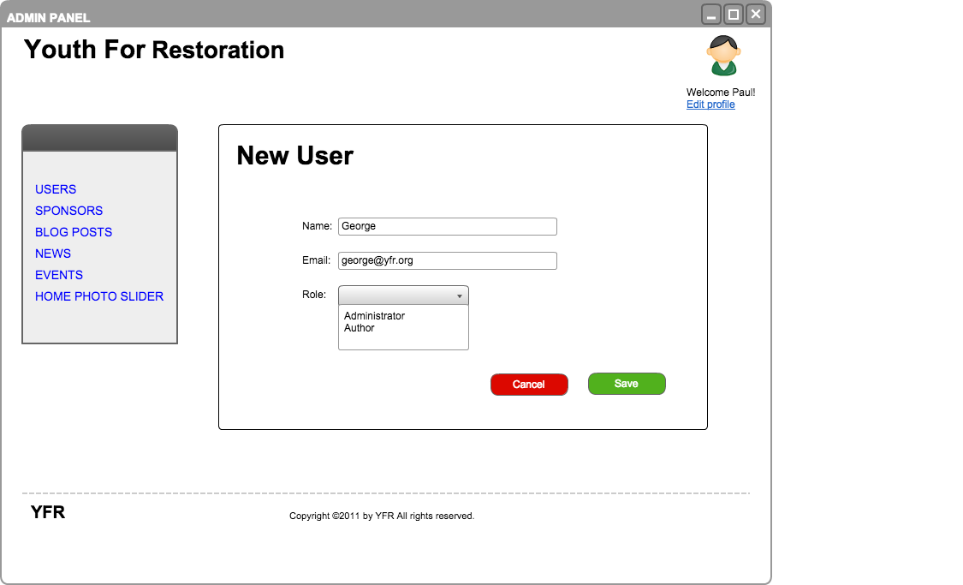

1. Users List

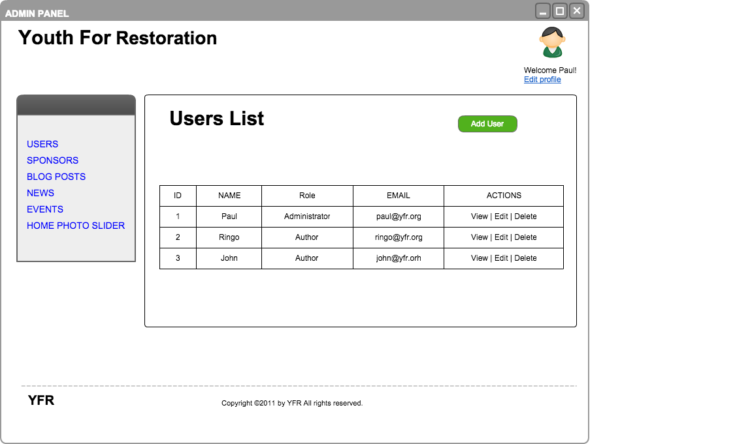

1. Users Edit

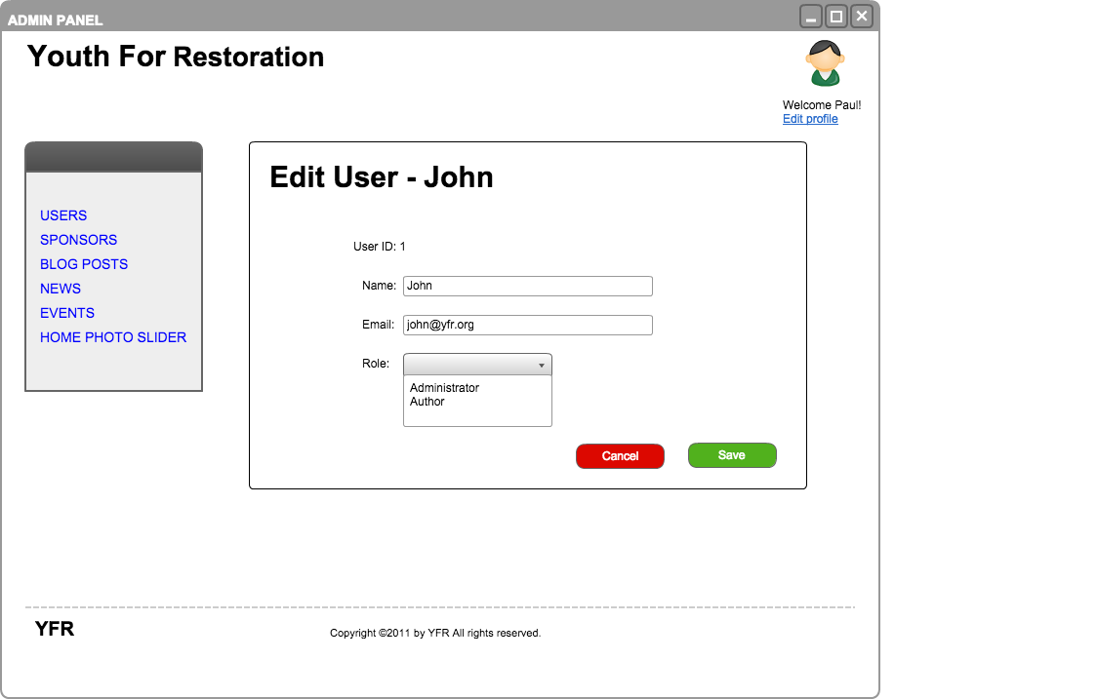

1. User Edit Profile

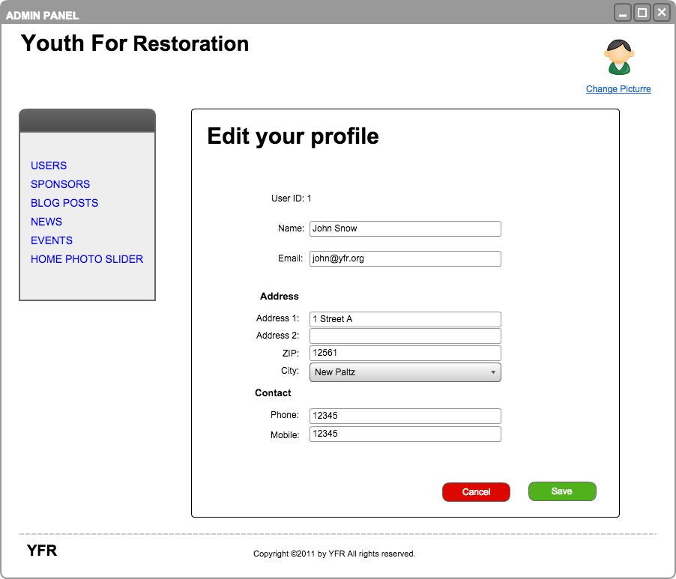

1. Events New

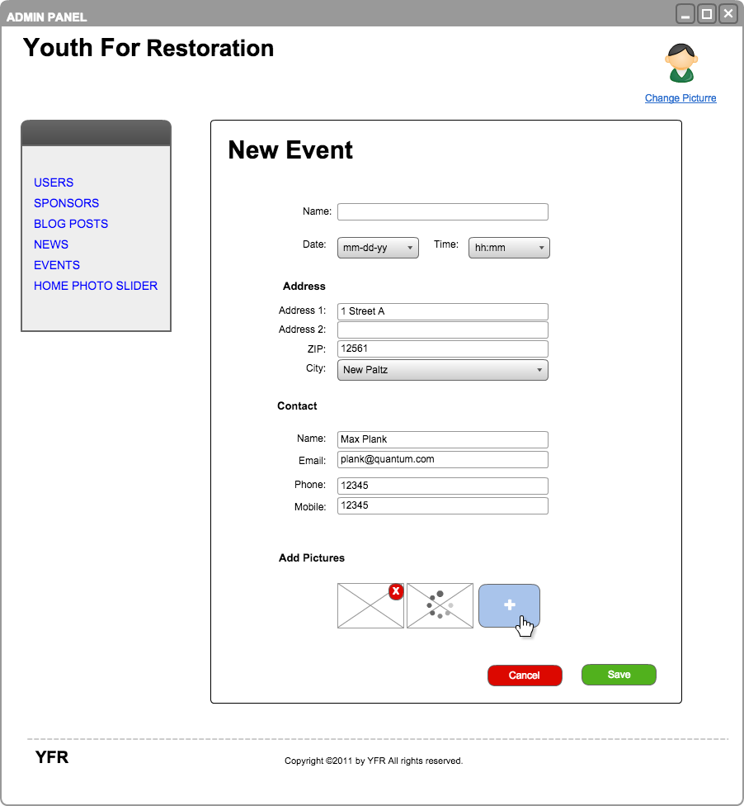

1. Events Show

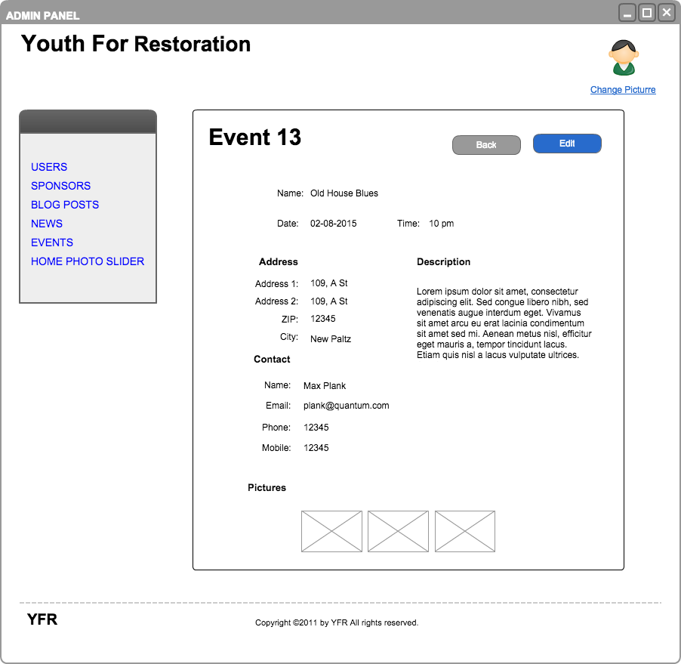

1. Even List

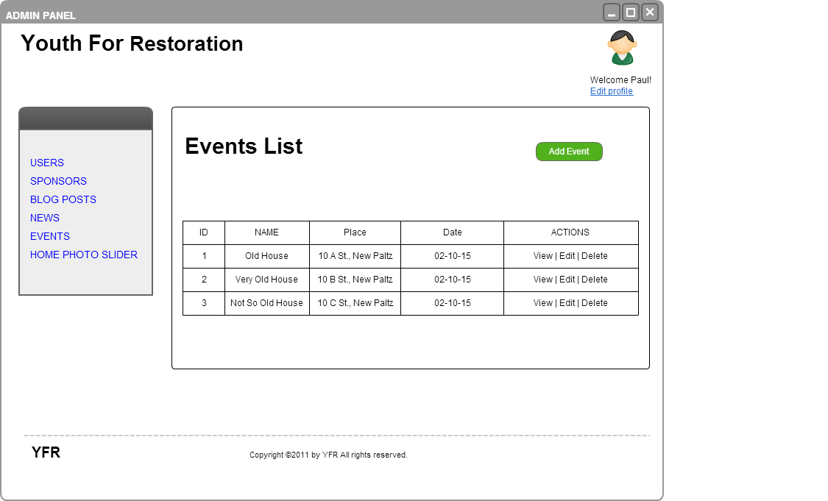

* 1. User characteristics

The baseline functionality of the proposed website is intended for users who are familiar with using basic Internet skills such as opening a web browser. However, the Admin Panel of the proposed website requires users with at least high school level education or some technical skills involving administering a website.

* 1. Constraints

1. Regulatory policies: The proposed website for Youth For Restoration shall adhere to all applicable State and Federal regulations in accordance with the 501(c) (3) non-profit status.
2. Interfaces to other applications: Certain features of the website at times could be impacted due to its reliability on interfacing with other applications such as social media, Payment processing sites etc.
3. Control functions: The contents of the website shall be administered by an authorized user with administrator privileges.
   1. Assumptions and dependencies

Certain advanced functionalities in the administration mode of the proposed website shall be developed under the assumption that there exists an administrator capable of managing it. Any changes to this condition shall require changes to the existing document.

1. Specific requirements

This section is about detailed requirements and it is intended to support web developers.

* 1. External interfaces

The software system of the Youth For Restoration website primarily resides on the Apache Web server. The system interfaces with the database server using PHP programming language to store and retrieve data, links with external widgets such as social media and payment related applications interface using JavaScript. Finally, it also interfaces with the client web browser using Hyper Text Transfer Protocol on any network enabled Windows or Mac client computers.

* 1. Functions

In this sub-section the functionalities that the website will offer are described in detail.

* + 1. Main Functions

**Public Pages:**

1. The website shall be accessible using most commercial browsers.
2. The website shall display the home page by default upon entry by the user.
3. The website shall prominently display the widgets for social media and payment related external interfaces.
4. The website shall have a drop-down menu option to choose additional features.

**Admin Panel:**

1. The website shall display a “The website is currently down for maintenance. Please check back shortly.” while undergoing upgrades.
2. The website shall allow an authorized user with higher privileges to edit or delete the contents of the website.
   * 1. Use Cases

**Public Mode**

1. **View blog page**

**Use Case Name**

View Blog.

**Trigger**

The visitor clicks on the blog menu button.

**Precondition**

The visitor is at the home page.

**Basic Path**

1. Visitor types in the www.youthforrestoration.org website URL in their web browser. System shows the home page in the browser.
2. Visitor clicks on the blog link which will then display the contents of the blog.

**Alternate Path**

**1a. Direct URL path to blog**

1. The visitor types types in www.youthforrestoration.org/blog directly into their web browser.
2. System takes the visitor to the blog page without having to navigate through the home page.

**2a. Blog page unavailable**

1. System does not show the home page of the www.youthforrestoration.org website due to connectivity or other technical issues.
2. System displays a “404 - Website not found” error message.

**Post condition**

The blog page has been displayed.

**Exception Path**

Visitor may abandon the process at any time.

1. **View news page**

**Use Case Name**

View News.

**Trigger**

The visitor clicks on the News menu button.

**Precondition**

The visitor has successfully accessed the home page which displays the menu button “News”.

**Basic Path**

1. The visitor types in the www.youthforrestoration.org website URL in their web browser.
2. Visitor clicks on the news link located at the center left, which will then display the content of the News section.

**Alternate Path**

**1a. News page unavailable**

1.The visitor is unsuccessful accessing the home page of the www.youthforrestoration.org website due to connectivity or other technical issues.

2. System displays a “404 - Website not found” error message.

**2a. Direct URL path to blog**

1. Visitor types in www.youthforrestoration.org/news directly into their web browser.
2. System takes visitor to the News page without having to navigate through the home page.

**Post condition**

The news page has been displayed.

**Exception Path**

Visitor may abandon the process at any time.

1. **View events page**

**Use Case Name**

View Events.

**Trigger**

Visitor clicks on the Events icon.

**Precondition**

Visitor has successfully accessed the home page which displays the icon “Events” at the center right part of the page.

**Basic Path**

1. Visitor types in the www.youthforrestoration.org website URL in their web browser.
2. The system displays the Home page of the website containing the Events menu button.
3. Visitor clicks on the Events menu button.
4. System displays the content of Events.

**Alternate Path**

**1a. News page unavailable**

1. Visitor is unsuccessful accessing the home page of the www.youthforrestoration.org website due to connectivity or other technical issues.
2. System displays a “404 - Website not found” error message.

**2a. Direct URL path to blog**

1. Visitor types in www.youthforrestoration.org/Events directly into their web browser.
2. System takes the visitor to the Events page without having to navigate through the home page.

**Post condition**

The Events page has been displayed.

**Exception Path**

Visitor may abandon the process at any time.

1. **Send email through contact form**

**Use Case Name**

Send email through contact form.

**Trigger**

Visitor clicks on contact tab located on the top right section of the home page.

**Precondition**

Visitor is at the home page.

**Basic Path**

1. Visitor types in the www.youthforrestoration.org website URL in their web browser. System shows the home page in the browser.
2. Visitor clicks on the Contact menu button.
3. System displays the Contact form page.
4. Visitor types in the name in the “Your name” field, a valid email address in the “Your email address” field and a brief message in the “Your message” field and clicks the “send email” button.
5. System sends email to contact email address of Youth For Restoration.

**Alternate Path**

**1a. Direct URL path to contact form**

1. Visitor types in www.youthforrestoration.org/contact directly into their web browser.
2. System takes the visitor directly to the contact form page.

**2a. Contact form unavailable**

1. System does not show the contact form page of the [www.youthforrestoration.org](http://www.youthforrestoration.org/) website due to connectivity or other technical issues.
2. System displays a “404 - Website not found” error message.

**3a. Invalid Characters**

Visitor types in invalid characters in the either the “Your name” or the “Your email address” field. This might prevent from the visitor from successfully complete the send email function.

**Post condition**

The send email function has successfully completed and the system displays the “Email has been sent” message.

**Exception Path**

Visitor may abandon the process at any time.

1. **View Facebook widget**

**Use Case Name**

View Facebook widget.

**Trigger**

Visitor enters the home page.

**Precondition**

Visitor is at the website homepage.

**Basic Path**

1. Visitor types in the www.youthforrestoration.org website URL in their web browser.
2. System shows the home page in the browser.
3. Visitor scrolls down to the bottom of the home page to locate the Facebook widget.
4. Visitor clicks on the Facebook icon which then redirects the visitor to the Facebook page of Youth For Restoration.

**Alternate Path**

**2a. Facebook Widget Inoperable**

1. The accessibility of the Facebook widget primarily depends on the system readiness of the external Facebook system which is independent of the *www.youthforrestoration.org* website. Therefore, the link might not provide the expected results sometimes due to external factors.
2. Visitor may have to verify the functionality of the www.facebook.com website separately.

**Post condition**

The Facebook home page of Youth For Restoration is displayed successfully in a new window.

**Exception Path**

Visitor may abandon the process at any time.

1. **See Twitter widget**

**Use Case Name**

See Twitter widget.

**Trigger**

Visitor clicks on the Twitter logo located on the bottom right corner of the home page.

**Precondition**

Visitor is at the website homepage.

**Basic Path**

1. Visitor types in the www.youthforrestoration.org website URL in their web browser.
2. System shows the home page in the browser.
3. Visitor scrolls down to the bottom of the home page to locate the Twitter widget.
4. Visitor clicks on the Twitter icon which then redirects the visitor to the Twitter page of Youth For Restoration.
5. Visitors might then be able to perform various functions enabled by Twitter.

**Alternate Path**

**1a. Direct path to Twitter page:**

Visitor may choose to view theYouth For Restoration Twitter page by typing in www.twitter.com/youthforrestoration on their web browser.

**2a. Twitter Widget Inoperable:**

1. The accessibility of the Twitter widget primarily depends on the system readiness of the external Twitter system which is independent of the *www.youthforrestoration.org* website. Therefore, the link might not provide the expected results sometimes due to external factors.
2. Visitor may have to verify the functionality of the www.twitter.com website separately.

**Post condition**

The Twitter home page of Youth For Restoration is displayed successfully in a new window.

**Exception Path**

Visitor may abandon the process at any time.

1. **Search for blog posts**

**Use Case Name**

Search blog posts.

**Trigger**

Visitor types in one or more keywords in the search field located at the top right corner of the blog page.

**Precondition**

Visitor is in the Blog page.

**Basic Path**

1. Visitor types in one or more keywords in the search field and clicks the search button.
2. System displays the results matching the keywords.

**Alternate Path**

**2a. No results are found**

1. “No matching results found” message.

**Post condition**

The Blog page search results has been displayed.

**Exception Path**

Visitor may abandon the process at any time.

1. **Search for News**

**Use Case Name**

Search News.

**Trigger**

Visitor types in one or more keywords in the search field located at the top right corner of the News page.

**Precondition**

Visitor is in the News page.

**Basic Path**

1. Visitor types in one or more keywords in the search field and clicks the search button.
2. System displays the results matching the keywords.

**Alternate Path**

**2a. No results are found**

1. System shows “no matching results found” message.

**Post condition**

The News page search results has been displayed.

**Exception Path**

Visitor may abandon the process at any time.

1. **Search for events**

**Use Case Name**

Search Events.

**Trigger**

Visitor types in one or more keywords in the search field located at the top right corner of the Events page.

**Precondition**

Visitor is in the Events page.

**Basic Path**

1. Visitor types in one or more keywords in the search field and clicks the search button.
2. System displays the results matching the keywords.

**Alternate Path**

**2a. No results are found**

1. System shows “no matching results found” message.

**Post condition**

The Events page search results has been displayed.

**Exception Path**

Visitor may abandon the process at any time.

1. **Share content on social networks**

**Admin Panel - User**

1. **Log in to Admin Panel**

**Use Case Name**

Admin Panel login.

**Trigger**

The user enters the Admin Panel login page at [http://www.youthforrestoration.org](http://www.youthforrestoration.org/)/admin.

**Precondition**

The User has accessed the Admin Panel login page.

**Basic Path**

1. System presents input fields for the login information.
2. User enters the information and click submit button.
3. System validates information.
4. System redirects User to the Admin Panel.

**Alternate Path**

**2a. Invalid input - Blank fields**

1. User leaves one or more blank fields.
2. System does not allow the transaction and prints a warning with the missing fields.
3. System enters the correct information.

**2b. Invalid input - Incorrect login information**

1. User enters a wrong combination of the login information.
2. System validates information.
3. System does not allow the login and prints a warning saying that the information provided is wrong.

**Post condition**

The User has logged in.

**Exception Path**

The User may abandon the operation at any time.

**Other**

The login information includes: Email, password.

1. **New user password setup**

**Use Case Name**

New user password setup.

**Trigger**

The new user receives an e-mail notifying that he/she has been registered as a user and clicks on the provided link to set up his password.

**Precondition**

One Administrator has successfully created a new user.

**Basic Path**

* + 1. User clicks the link on the email received and goes to the password setup page.
    2. System displays a form with two inputs “New password” and “New password confirmation”.
    3. User inserts the new password and re-type that password on a second box.
    4. System registers the user password in the database and and redirects user to the login page.

**Alternate Path**

**1a. Expired link**

1. User clicks the link after the expiration time.
2. System do not allow the user to proceed and notifies him.

**3a. Invalid input - Password mismatch**

1. User types a different password on the password re-type box
2. The system shows a warning saying that passwords does not match.
3. System return to the password setup page.

**Post condition**

The new user can login to the system with his registered password.

**Exception Path**

The user may abandon the operation at any time.

1. **Recover Password**

**Use Case Name**

Recover Password

**Trigger**

The user selects option in the page [http://www.youthforrestoration.org](http://www.youthforrestoration.org/)/admin which indicates that he/she wants to recover his password.

**Precondition**

The user has been registered in the database.

**Basic Path**

1. User clicks "forgot password" link presented by the system in the login page.
2. System sends an email with a temporary link to a password recovery web page.
3. User clicks the link in the received email.
4. System presents input fields for the user's new password.
5. User enters new password.
6. System stores new password.
7. System redirects user to the login page.

**Alternate Path**

**2a. Invalid input - Blank fields**

1. User leaves one or more fields blank.
2. System does not allow the transaction and prints a warning with the missing fields.

**2b. Invalid Input - Insufficient length**

1. User inserts a password with length inferior to 8 characters.
2. System does not allow the transaction and prints a warning.

**Post condition**

The User has changed his password.

**Exception Path**

The User may abandon the operation at any time.

1. **Edit profile**

**Use Case Name**

Edit profile

**Trigger**

The user clicks to edit his profile.

**Precondition**

User is logged in.

**Basic Path**

1. System shows input fields filled up with the user's stored profile information.
2. User edits the fields that he wants to edit and clicks save button.
3. System stores edited profile information on the database and shows a success notification.

**Alternate Path**

**2a. Invalid input - Blank fields**

1. User leaves some required fields blank, such as email, password.
2. System does not allow transaction and prints a warning message with the missing fields.

**Post condition**

User's profile is edited and still has content for the required fields.

**Exception Path**

The user may leave the operation before submitting the information.

1. **Manage Blog Posts**
   1. **Create**

**Use Case Name**

Create post.

**Trigger**

The user clicks to add a new post.

**Precondition**

The user is logged in and is in the Posts Management page.

**Basic Path**

1. System shows a blank form to be filled with the post content.
2. User fills up the form and clicks publish.
3. System stores the new post's content.

**Alternate Path**

**2a. Invalid input - Blank fields**

1. User leaves one or more required fields blank.
2. System does not allow the transaction and prints a warning with the missing fields.

**Post condition**

The new post has been published.

**Exception Path**

The user may abandon the process at any time.

**Other**

* 1. **List**

**Use Case Name**

List posts.

**Trigger**

The user clicks to list existing posts.

**Precondition**

The user is logged in and is in the Posts Management page.

**Basic Path**

1. System gets list of posts from the server.
2. System shows list of posts.

**Alternate Path**

None.

**Post condition**

The requested information has been displayed.

**Exception Path**

The user may abandon the process at any time.

**Other**

* 1. **Update  
     User Case Name** Update blog posts.  
     **Trigger** User clicks on an post on the blog posts list.  
     **Precondition** The user is logged in the system and is on the Blog Posts Management Section.  
     **Basic Path**
     1. System presents a blog posts editor and some fields filled with the selected news information to the user.
     2. User edits the blog post.
     3. User click on the submit blog post button.
     4. System saves changes to the database.

**Alternate Path**

**2a. Invalid Input - Blank field**

1. The user click submit the blog post with a blank body or title.
2. System detects blank input field and shows a warning.

**Post condition**

A new post is updated on the database.

**Exception Path**

The administrator may abandon the operation at any time before clicking submit.

**Other**

The post information includes: Title, body and tags.

* 1. **Delete  
     User Case Name** Delete blog posts.  
     **Trigger** The user clicks on the delete button next a blog post on the news articles list.  
     **Precondition** The user is logged in the system and is on the Blog Posts List Section.  
     **Basic Path**
     + 1. User clicks the delete button.
       2. System prompts the user about irreversible operation.
       3. User confirms blog post deletion.
       4. System erases the blog post from the database.

**Alternate Path**

**2a. Cancel deletion**

1. User cancels blog post deletion.
2. System returns to the blog post list page.

**Post condition**

A new blog post is deleted from the database.

**Exception Path**

The administrator may abandon the operation at any time before confirming the deletion.

1. **Manage News** 
   1. **Create**

**User Case Name** Create news.  
**Trigger** The user clicks on the Create News button.  
**Precondition** The user is logged in the system and is on the News Management Section.  
**Basic Path**

* + 1. System presents a blank news editor and some blank fields to the user.
    2. User creates a news article.
    3. User click on the submit article button.
    4. System saves the news article to the database.

**Alternate Path**

**2a. Invalid Input - Blank News**

1. The user click submit the article without typing anything.
2. System detects blank news and discard the article.
3. System warns the user.

**Post condition**

A new news article is stored on the database.

**Exception Path**

The user may abandon the operation at any time before clicking submit

**Other**

The news information includes: Title, body and tags

* 1. **List  
     User Case Name** List news.  
     **Trigger** The user enters the News Management Section.  
     **Precondition** The user is logged in the system.  
     **Basic Path**
     + 1. User clicks the News Managements on the Admin Panel menu.
       2. System retrieves articles from the database.
       3. System displays the articles titles to the user.

**Alternate Path**

None

**Post condition**

The requested information has been displayed.

**Exception Path**

The administrator may abandon the operation at any time

* 1. **Update  
     User Case Name** Update news  
     **Trigger** User clicks on an article on the news articles list.  
     **Precondition** The user is logged in the system and is on the News Management Section.  
     **Basic Path**
     + 1. System presents a news editor and some fields filled with the selected news information to the user.
       2. User edits the article.
       3. User click on the submit article button.
       4. System saves changes to the database.

**Alternate Path**

**2a. Invalid Input - Blank News**

1. The user click submit the article with a blank body.
2. System detects blank news and discard changes.
3. System warns the user.

**Post condition**

A new news article is updated on the database.

**Exception Path**

The administrator may abandon the operation at any time before clicking submit.

**Other**

The news information includes: Title, body and tags.

* 1. **Delete  
     User Case Name** Delete news.  
     **Trigger** The user clicks on the delete button next an article on the news articles list.  
     **Precondition** The user is logged in the system and is on the News Management Section.  
     **Basic Path**
     + 1. System prompts the user about irreversible operation.
       2. User confirms article deletion.
       3. System erases the article from the database.

**Alternate Path**

**2a. Cancel deletion**

1. User cancels article deletion.
2. System returns to the articles list page.

**Post condition**

A new news article is deleted from the database.

**Exception Path**

The administrator may abandon the operation at any time before confirming the deletion.

1. **Manage Events**

**a. Create  
User Case Name** Create events.  
**Trigger** The user clicks on the Create Event button.  
**Precondition** The user is logged in the system and is on the Events Management Section.  
**Basic Path**

* + 1. System presents blank fields to be filled with the event information.
    2. User enter event information.
    3. User click on the submit button.
    4. System saves the event on the database.

**Alternate Path**

**2a. Invalid Input - Blank Fields**

1. The user click submit before filling all the required fields.
2. System detects missing information.
3. System do not save the event and warns the user about missing information.

**Post condition**

A new event is created and stored on the database.

**Exception Path**

The administrator may abandon the operation at any time before clicking submit.

**Other**

The news information includes: Name, Description, Date and Location.

* 1. **List  
     User Case Name** List events  
     **Trigger** The user enters the Event Management Section  
     **Precondition** The user is logged into the system  
     **Basic Path**
     1. User clicks the Event Management on the system menu
     2. System retrieves future events from the database
     3. System displays a list with future events

**Alternate Path**

None

**Post condition**

The requested information has been displayed.

**Exception Path**

The administrator may abandon the operation at any time

* 1. **Update  
     User Case Name** Update events.  
     **Trigger** The user clicks on an event on the future events list.  
     **Precondition** The user is logged in the system and is on the Events Management Section.  
     **Basic Path**
     + 1. System presents fields filled with the selected event information to the user.
       2. User edits the event.
       3. User click on the submit button.
       4. System saves changes to the database.

**Alternate Path**

**2a. Invalid Input - Blank Fields**

1. The user click submit before filling all the required fields.
2. System detects missing information.
3. System do not save changes and warns the user about missing information.

**Post condition**

An event is updated on the database.

**Exception Path**

The administrator may abandon the operation at any time before clicking submit.

**Other**

The news information includes: Name, Description, Date and Location.

* 1. **Delete  
     User Case Name** Delete event.  
     **Trigger** The user clicks on the delete button next an event on the future events list.  
     **Precondition** The user is logged in the system and is on the Events Management Section.  
     **Basic Path**
     + 1. System prompts the user about irreversible operation.
       2. User confirms event deletion.
       3. System erases the event from the database.

**Alternate Path**

**2a. Cancel deletion**

1. User cancels event deletion.
2. System returns to the future events page.

**Post condition**

A new news article is deleted from the database.

**Exception Path**

The administrator may abandon the operation at any time before confirming the deletion.

**Admin Panel - Administrator**

1. **Manage Users**
   1. **Create**

**Use Case Name**

Create User.

**Trigger**

The Administrator clicks to add a new user.

**Precondition**

The Administrator is logged in the Admin Panel and is in the Users Management Section.

**Basic Path**

* + 1. System presents a blank form to be filled with the new user information.
    2. Administrator enters the informations and click submit button.
    3. System validates information.
    4. System generates temporary password.
    5. System updates the database.
    6. System sends an email to the new user with the login information.

**Alternate Path**

**2a. Invalid input - Blank fields**

* + - 1. Administrator leaves one or more blank fields.
      2. System does not allow the transaction and prints a warning with the missing fields.
      3. System enters the correct information.

**2b. Invalid input - Existing email**

* + - 1. Administrator enters a email that already exists in the database and click submit.
      2. System does not allow the transaction and prints a warning saying that the email is already in use.

**Post condition**

The new user has been added to the database.

**Exception Path**

The administrator may abandon the operation at any time before clicking submit.

**Other**

The user information includes: First name, last name, email.

* 1. **View**

**Use Case Name**

View User.

**Trigger**

The Administrator clicks to view the list of users.

**Precondition**

The Administrator is logged in the Admin Panel and is in the Users Management Section.

**Basic Path**

* + - * 1. Systems prints a list of all the registered users.
        2. Administrator clicks the view button on the row of the desired user.
        3. System shows the user information.

**Alternate Path**

None.

**Post condition**

The requested information has been displayed.

**Exception Path**

The administrator may abandon the operation at any time.

**Other**

The user information includes: First name, last name, email, phone number, address, picture.

* 1. **Update**

**Use Case Name**

Update User

**Trigger**

The Administrator clicks to view the list of users.

**Precondition**

The Administrator is logged in the Admin Panel and is in the Users Management Section.

**Basic Path**

* + - * 1. Systems prints a list of all the registered users.
        2. Administrator clicks the view button on the row of the desired user to be updated.
        3. System shows the user information.
        4. Administrator edits the information.
        5. System validates information.
        6. System updates the database.

**Alternate Path**

**2a. Invalid input - Blank fields**

* + - * 1. Administrator leaves one or more blank fields.
        2. System does not allow the transaction and prints a warning with the missing fields.
        3. System enters the correct information.

**2b. Invalid input - Existing email**

* + - * 1. Administrator enters an email that already exists in the database and click submit.
        2. System does not allow the transaction and prints a warning saying that the email is already in use.

**Post condition**

The new user has been added to the database.

**Exception Path**

The administrator may abandon the operation at any time before clicking submit.

**Other**

The user information includes: First name, last name, email.

* 1. **Delete**

**Use Case Name**

Delete User.

**Trigger**

The Administrator clicks to view the list of users.

**Precondition**

The Administrator is logged in the Admin Panel and is in the Users Management Section.

**Basic Path**

1. Systems prints a list of all the registered users.
2. Administrator clicks the view button on the row of the desired user to be deleted.
3. System shows the user information.
4. Administrator clicks the delete button.
5. System shows a confirmation alert.
6. User confirm submission.
7. System removes user from the database.

**6a. Cancel operation**

1. Administrator clicks the cancel button.
2. System cancels operation.

**Post condition**

The new user has been added to the database.

**Exception Path**

The administrator may abandon the operation at any time before clicking submit.

**Other**

None.

* 1. Security Requirements
     + 1. The Admin Panel access will require login authentication by user email and password. Each email will be unique, therefore there may not exist two users with the same email.
       2. For the security of the passwords storage on the database, the system will provide Advanced Encryption Standard (AES) encryption.
       3. The system shall not allow access if any or both inputs, namely email and password, are incorrect.
       4. The login session should logout the user in case of inactivity for 30 minutes. If the user comes back to the site within that time period, it is still considered one user session because any number of visits within those 30 minutes will only count as one session. If the user returns to the Admin Panel after the allotted time period has expired, then it is counted as a separate user session.
       5. If the user eventually forgets his password, the system will provide a link for a password recovery. After the input of the user email, if it is registered on the system’s database, the system will automatically send an email with a link for password recovery.
  2. Performance requirements

1. The website shall be available and accessible to users at all times with the exception of any scheduled maintenance.
2. The ideal response time of the proposed website shall up to 0.1 second. The acceptable response rate for most user functions on the website shall be between 0.1 to 1 second.
3. The website shall safely and securely store any user data if applicable.