**Assignment 1**

Name : Benjamin Xavier Tay Cheng Lim

ID : 6740510

1. *N* = (26 * 26 * (102) * 1 * (522) * (63))

Entropy = log2*N*

Entropy = log2(26 * 26 * (102) * 1 * (522) * (63))

Entropy ≈ 35.20

Including Hash Tiger function

The entropy before hash is Tiger(35.20)

The hashed value is 06cd91dbb456210ba3674ffb50c02b55



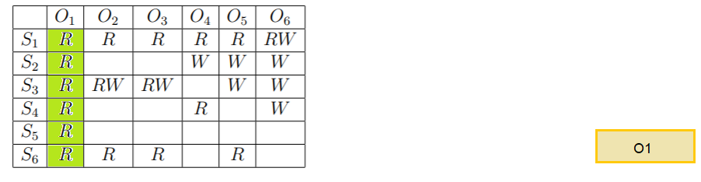

Subjects from every level can read object O1 therefore it is dominated by all subjects.

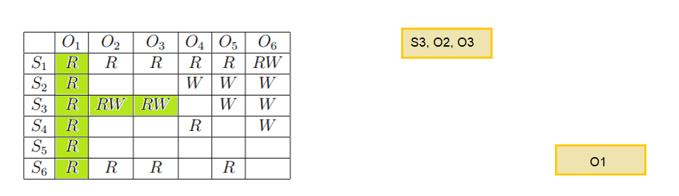

Subject S3 can read and write object O2 and O3, hence S3, O2 and O3 must be at the same level

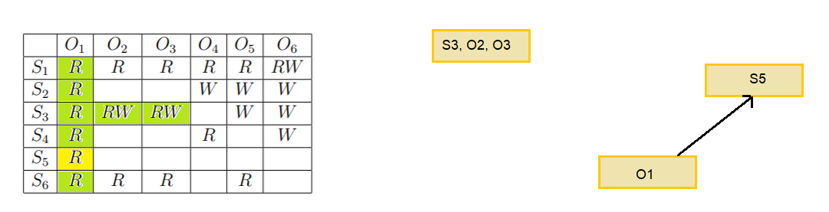

Subject S5 can read only object O1 hence subject S5 can only dominate Object O1

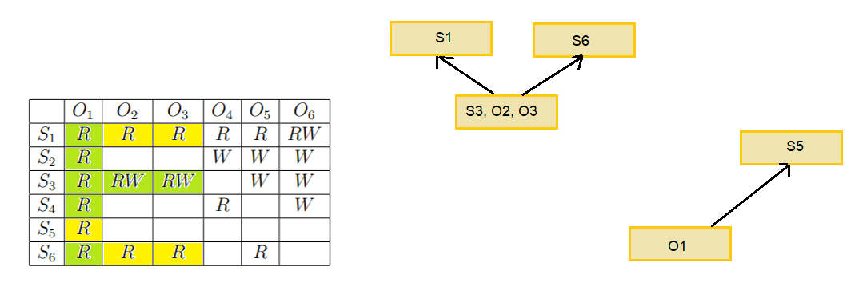

S1 and S6 must dominate Object O2 and O3 to be able to allow reading

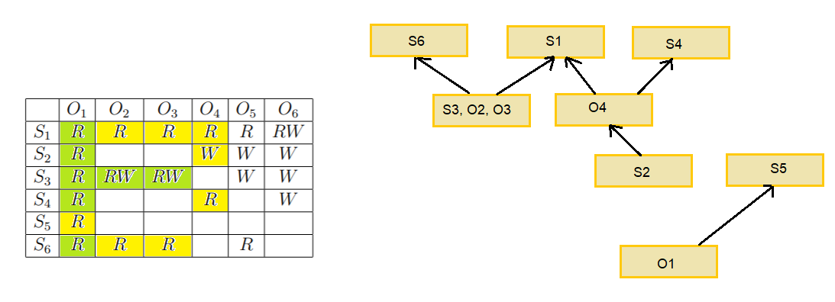

S4 and S1 must dominate object O4 to be able to allow reading, O4 must dominate S2 to allow reading

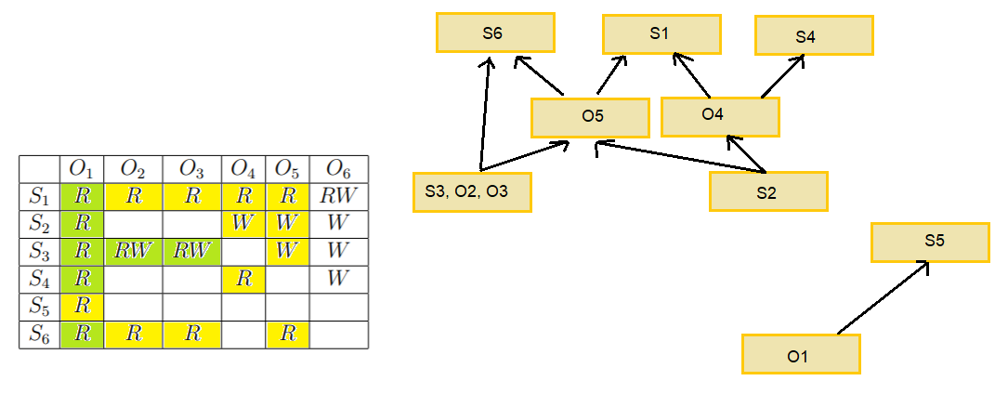

S1 must dominate object O5 to be able to allow reading and O5 must dominate S3 to enable writing

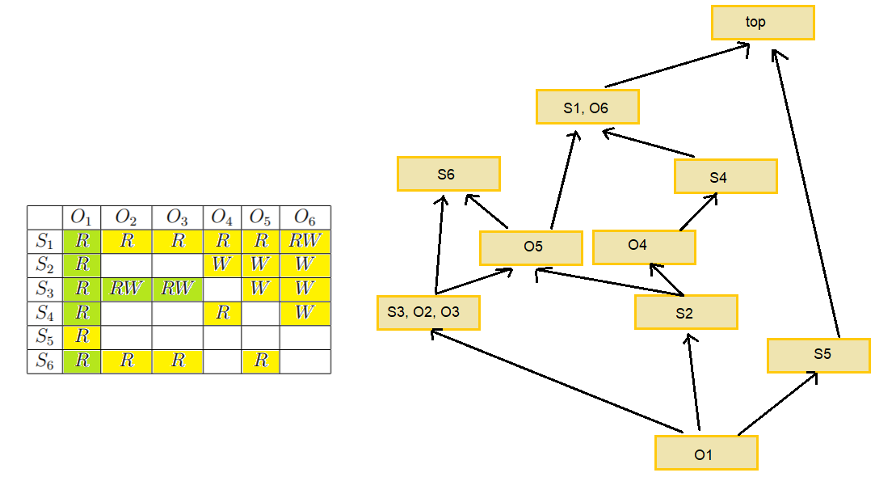

O6 must dominate S4 to allow writing and introduced a top level to complete the lattice



|  |  |  |  |
| --- | --- | --- | --- |
| **Statement** | **Subjects** | **Objects** | **Actions** |
| Alice can climb trees and eat apples. | Alice | Trees and apples | Climb, eat |
| Bob can climb fences, eat apples, and wave flags | Bob | Fences, apples, and flags | Climb, eat, wave |
| Trees can hurt apples | Trees | Apples | Hurt |
| Carol can jump waves and wave flags | Carol | Waves and flags | Jump, wave |

Access Control Matrix

Legend: Climb = C, Eat = E, Wave= W, Hurt = H, Jump = J

|  |  |  |  |  |  |
| --- | --- | --- | --- | --- | --- |
| Subjects/Objects | Apples | Fences | Flags | Trees | Wave |
| Alice | E |  |  | C |  |
| Bob | E | C | W |  |  |
| Carol |  |  | W |  | J |
| Trees | H |  |  |  |  |