Video used for testing:   
HLS format H.264 encoded, 2-1.5MB/s bitrate 3 mins 47 sec.  
  
HTTP test 1:  
  
Host on NGROCK sending video to 1 client with :

1. Total consumption: 451MB
2. Average speed: Consistent 2 MB/S with random drops
3. Experience: Stream can catch up and we rarely have video freezes or artifacts

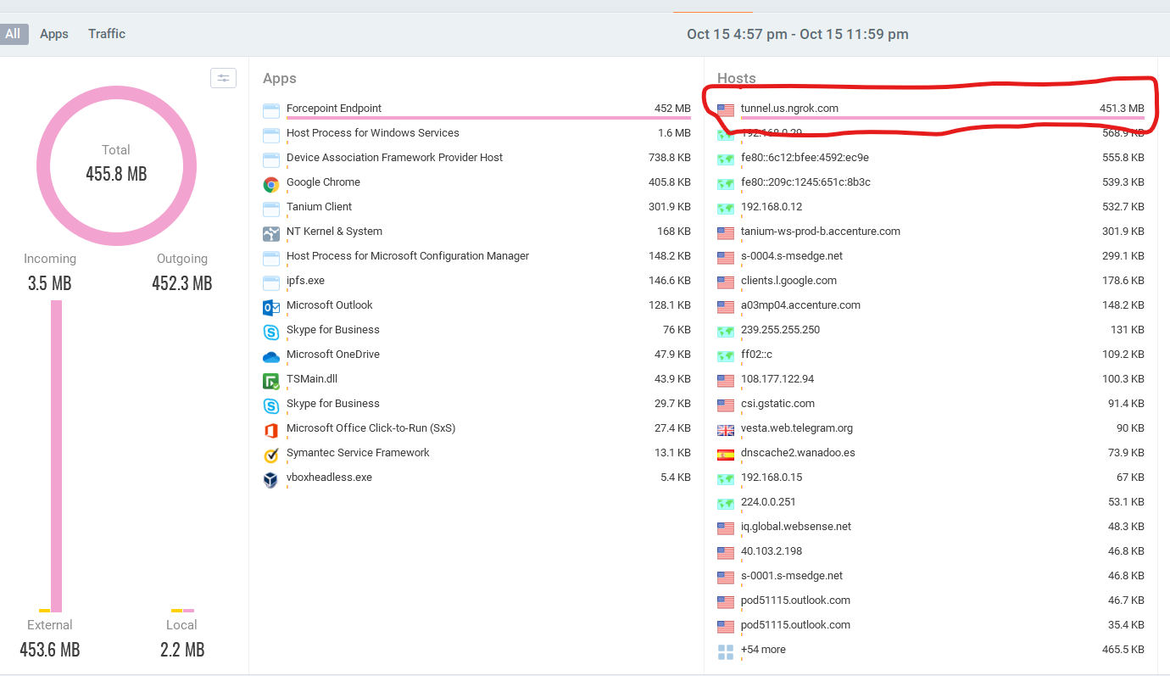

Host on NGROCK sending video to 2 client:

1. Total consumption:
2. Average speed: Consistent 4-3.5 MB/S with random drops
3. Experience: Stream can barely catch up and we have video freezes or artifacts