Developing a Performance Response Surface For Fossil Fuel-

fired Power Plants Under A Changing Climate

Aviva Loew†,*, Paulina Jaramillo†, Haibo Zhai†

†Department of Engineering and Public Policy, Carnegie Mellon University, Pittsburgh, PA

* Corresponding author. Tel.: +1 224 688 1767; Email address: aloew@andrew.cmu.edu

For Submission to Environmental Research Letters

Abstract
Thermoelectric power supply depends on the thermodynamics governing power plant operations. Climate change introduces an uncertain risk to power plant operations as ambient conditions potentially constrain generation. Previous studies aiming to quantify this risk have suggested a wide range of results, from minimal to disastrous capacity loss. In this analysis, we use power plant modeling software to study how a variety of power plant configurations respond to varying meteorological conditions. We also develop predictive tools that enable projections of power plant operating impacts for a spectrum of geographic situations and technological configurations. Our results indicate that a power plant’s vulnerability to weather-based risk hinges upon its cooling system and design conditions, but is less than suggested by previous analyses.

- Introduction and Research Objective
Climate change introduces multiple uncertainties and stressors to the electric power system. Meteorological shifts may impose difficulties to both the generation and cooling operations at power plants, limiting the grid’s ability to deliver electricity

(Bartos & Chester, 2015; Zamuda et al., 2013). In addition to hindering generation, climate change may further strain power systems by limiting transmission and simultaneously increasing demand through increased temperatures

(Harto et al., 2012; Lawrence Berkeley National Laboratory, 2012). Finally, in arid regions, the wet cooling systems of power plants may also contribute to water stress (Davies, Kyle, & Edmonds, 2013). To better forecast risks to electricity supply, and to predict the energy sector’s contribution to water scarcity, there is a need to examine how meteorological and plant design parameters interact to affect power plant operations.
At individual power plants, climate change may limit electricity supply by imposing efficiency penalties, capacity constraints from increased temperatures, and capacity constraints from reduced water flows or water temperature restrictions

(Macknick, Newmark, Heath, & Hallett, 2011; Ward, 2013; Zamuda et al., 2013). Indeed, prior work has found that water availability could severely limit available global capacity for hydropower and thermoelectric power plants (B. K. Sovacool & Sovacool, 2009; van Vliet, Wiberg, Leduc, & Riahi, 2016; van Vliet et al., 2012). Similarly, studies have found that elevated water temperatures may reduce or shutdown some cooling system’s functionality

(Harto et al., 2012; Lawrence Berkeley National Laboratory, 2012; Scanlon, Reedy, Duncan, Mullican, & Young, 2013). Finally, prior work has analyzed risk pathways stemming from increased air temperatures. For example, some studies relied on thermodynamic models to simulate the effect of air temperatures on power plant operations and found that increased air temperatures, along with water constraints, could reduce effective capacity at thermoelectric power plants by as much as 9-15% (Bartos & Chester, 2015; Lawrence Berkeley National Laboratory, 2012).
Cooling technologies are a key linkage between ambient conditions and electricity generation. Thermoelectric generation accounts for nearly 40% of water withdrawals in the U.S., largely due to cooling systems (Kenny et al., 2009). Consequently, water shortages have increasingly become a risk to thermoelectric power plant operations

(Roy & Chen, 2011). The types of cooling systems vary in their water intakes and discharges, but more traditional designs, or once-through systems, make plant operations vulnerable to low-flow periods. Once-through systems require extensive withdrawals from nearby water bodies, and use this water to absorb heat from steam exiting the turbine. While they discharge most of their water intake, once-through systems need to reduce or shut-down operations when there isn’t sufficient streamflow. Limited water availability in the U.S. and Europe has caused such events in recent years (Koch & Vögele, 2009; van Vliet et al., 2012).
At present, the main alternative to once-through cooling technology is recirculating cooling. Recirculating systems (also called cooling towers) operate by cycling a loop of water within a condenser that absorbs heat from exhaust steam exiting the steam turbine. The resulting condensate feeds into the boiler. At the same time, the heated loop of cooling water cycles back to a cooling tower. Evaporation, ambient temperatures, and fans within the cooling tower each function to lower the temperature of the cooling water. However, if adverse ambient air conditions do not allow sufficient cooling of the water to designated conditions, the power generating capacity has to be curtailed. This vulnerability has not received much targeted attention in the literature, despite the fact that recirculating systems are likely to become the predominant cooling technology in the future. More traditional once-through systems (relying on nearby water bodies) are phasing out, and more advanced dry-cooling technologies (relying on air-cooled condensers) remain costly.
Air-cooled condensers for dry cooling operate without water and instead cool the exhaust steam with convection and fans. Dry-cooling operations are not contingent on water availability, and do not worsen water shortage, but they do impose an efficiency penalty to power the fans, and are more affected by ambient air temperatures because of convection (Jiang, 2013). The prior literature has not thoroughly examined how increased adoption of dry cooling may affect electricity reliability, but our study offers a way to estimate potential impacts.
This study contributes to the growing discussion of how meteorological shifts will affect thermoelectric generation. Specifically, this paper presents mathematical models linking meteorological variables to key performance characteristics of coal and natural-gas based thermoelectric power plants employing different design configurations. The analytical tools we develop for this paper enable projections of power plant operating impacts, such as net capacity reduction and water use intensity, for a spectrum of geographic situations and technological configurations. Therefore, we diverge from previous literature in developing tools that can facilitate future climate risk modeling. For example, such analytical tools could later be incorporated into power capacity expansion and unit dispatch models to improve energy planning and power system operations under a changing climate, especially in water-stressed regions.
- Methods
Our modeling framework integrates global climate models and a power plant modeling program. We use output from downscaled general circulation models to represent a range of potential meteorological scenarios under climate change. With the climate variables as input, the power plant model provides operational output for a range of power plants. We first categorize the power plant configurations in terms of the types of power generation, cooling systems, and design parameters, and then run a set of ambient conditions for each plant configuration. The operational output then pairs meteorological scenarios with performance metrics, such as net capacity and water withdrawal intensities. Finally, we develop regression models for the marginal changes in operation characteristics of different power plants under climate constraints. The independent variables in these regressions include dry bulb air temperature, air pressure, relative humidity, and cooling water intake temperature. The dependent variables include power plant efficiency, percentage reduction in net capacity, and water withdrawal intensity. The water withdrawal intensity includes water use for cooling, boiler blowdown, and desulfurization.

  - Climate Scenarios
To determine meteorological variables used to simulate power plant operations, we used downscaled data from five General Circulation Models (GCMs) corresponding to Representative Concentration Pathway (RCP) 8.5 (van Vuuren et al., 2011), as described in the Supporting Information (SI). The downscaled climate data include air temperature, precipitation, and wind speed. Aggregating daily data from the period between 1950 and 2099 provided a wide range of potential weather variables. Since RCP 8.5 is a scenario in which greenhouse gas (GHG) emissions continue to rise throughout the 21st century, our analysis includes changes likely to happen in the absence of dramatic GHG restrictions, as well as historical data, and encompasses the range of possibilities in between.
To generate the relative humidity and air pressure from the downscaled climate data, we relied on the Variable Infiltration Capacity (VIC) Macroscale Hydrologic Model (Liang, Lettenmaier, Wood, & Burges, 1994). The VIC model includes a disaggregator that can output average daily temperature, relative humidity, and air pressure from inputs of daily precipitation, maximum and minimum air temperatures, and wind speed. Finally, to arrive at discrete weather combinations, we binned the parameters within each range at certain intervals. We grouped the ranges of air and water stream temperatures into 1°C increments, the humidity at 5 percent increments, and the air pressure at 1 kPa increments. These combinations therefore cover likely ranges of air temperature throughout the continental U.S., and associated meteorological variables that would be feasible under a particular air temperature.

  - Power Plant Model
To estimate meteorological effects on power plant operations, we used the Integrated Environmental Control Model (IECM), a computer program developed by Carnegie Mellon University for power plant modeling and assessment (Carnegie Mellon University, 2016). IECM allows the user to configure power plants according to a variety of characteristics, including plant type, pollutant controls, cooling technologies, boiler type, and coal ranks. IECM allowed us to input a host of weather conditions and configurations to observe the resulting operation characteristics including power plant efficiency, power capacity, and water use intensities. Our analysis includes both pulverized coal plants and natural gas combined cycle (NGCC) plants with different cooling technologies, as described in Table 1. In pulverized coal plants, coal combustion in a boiler generates steam to run a turbine that generates electricity. Combined cycle plants primarily generate electricity from a gas combustion turbine, but also have a heat recovery steam generator that enables a relatively smaller steam cycle than in a pulverized coal plant. Though both plant types require cooling systems, the cooling systems in a natural gas combined cycle plant, which has heat recovery, are smaller than in a pulverized coal plant (Arrieta & Lora, 2003; Ibrahim, Rahman, & Abdalla, 2011; Singh & Kumar, 2012).

Table 1: Power plant characteristics
Plant Characteristics | Technological Option
Plant type | Pulverized coal (PC) with supercritical boiler
Plant type | Natural gas combined cycle (NGCC)
Fuel Type | Sub-bituminous coal
Fuel Type | Natural gas
Cooling system type  (PC and NGCC) | Once through cooling
Cooling system type  (PC and NGCC) | Recirculating cooling tower
Cooling system type  (PC and NGCC) | Air-cooled condenser
Sulfur dioxide control technology (PC only) | Wet flue gas desulfurization (FGD)

High ambient temperatures may increase boiler efficiency while lowering steam cycle efficiency at thermoelectric power plants

(Cleaver-Brooks, 2013; Zhou, Deng, Turner, Claridge, & Haberl, 2002). This steam cycle penalty stems from increasing turbine backpressure, which could be thought of as ‘resistance’ pressure that hampers the efficacy of the steam cycle. Currently, IECM captures the increase in boiler efficiency due to high temperatures but not the steam cycle penalty. To incorporate this effect, we adjusted the steam cycle heat rate we input into IECM as a function of ambient temperature. We determined the relation of steam cycle heat rate to ambient temperature by using empirical data that examine turbine backpressure versus ambient temperature, and net plant efficiency penalty versus turbine backpressure

(Ashwood & Bharathan, 2011; Jiang, 2013). Using the steam cycle heat rate as a proxy to adjust for relative changes in net plant efficiency, we derived the relationship between ambient temperature and the steam cycle heat rate. The relationship between steam cycle heat rates and backpressures vary by cooling system and boiler type; the SI includes our calculations linking ambient temperature to steam cycle efficiency for specific combinations of cooling and boiler technologies.

  - Cooling System Models
In IECM, the performance models of wet and dry cooling systems are mainly based on mass and energy balances to estimate their size, water use, and parasitic load (Zhai & Rubin, 2010; 2016; Zhai, Rubin, & Versteeg, 2011; Zhai et al., 2009). Thus, the models can quantify the combined effects of the ambient environment and cooling system design on performance metrics. For a given plant, IECM determines the cooling duty in terms of plant size, steam cycle heat rate, and auxiliary cooling load. In addition to the cooling duty, the required cooling water depends on the difference between the intake and discharge water temperatures for once-through cooling, and the inlet and outlet cooling water temperatures for wet cooling towers. The cooling capacity of a wet cooling tower is also constrained thermodynamically by the ambient wet bulb temperature. In contrast, no cooling water is used for air-cooled condensers. The dry cooling system size and parasitic load depend on the initial temperature difference (ITD), a design parameter that measures the difference between the exhaust steam temperature and the ambient dry bulb temperature. To cope with potentially adverse situations, a cooling system could be overdesigned to some extent, depending on the cooling technology type and site-specific conditions (Electric Power Research Institute (EPRI), 2002; 2004).
To assess the operation of power plants using different cooling technologies under a changing climate, we modified default values of some key parameters in IECM to model a range of typical process designs for each cooling technology. The modeling procedure is summarized in Figure 1 and further described in the SI. Table 2 summarizes the ranges of key design conditions for each cooling technology, which were the basis of the IECM simulations.

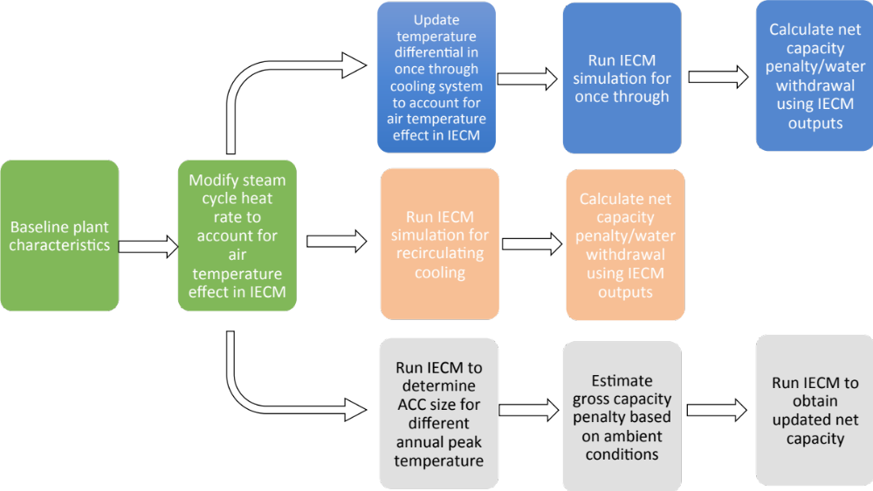
Figure 1: Modeling steps for cooling system operations in IECM. The top row delineates the steps for modeling once-through systems, the middle row delineates the steps for modeling recirculating systems, and the bottom row delineates steps for modeling systems with dry-cooling.

Table 2: Cooling system design parameters modeled. Cooling system design parameters are a choice based on climatic conditions and cost.
Cooling technology | Design parameter
Once-through | Condenser differential: in once through cooling system the difference between the intake water temperature and the discharge water temperature determines the functionality of the cooling system. We separately modeled cooling systems with condenser differentials of 10°F, 20°F, 30°F
Recirculating | For recirculating systems, we separately modeled power plants with inlet/outlet cooling water temperatures of 90°F/70°F, 95°F/75°F, 100°F/80°F
Dry cooling | For the dry cooling system, we separately modeled power plants with different annual peak temperatures that determine a design ITD. This ITD is the difference between steam temperature and an annual peak air temperature. For this analysis, we simulate operations for plants with design ITDs of 25°F, 35°F, 45°F, 55°F

  - Regression Models
Using the output from the modeling steps described above, we apply a regression method to develop response functions for operation characteristics of different power plants under climate constraints. The independent variables in these regressions are dry bulb air temperature, air pressure, relative humidity, and water intake temperature in the case of once-through systems. The dependent variables are net capacity reduction and water withdrawal intensities. We initially intended to develop a regression model for the efficiency of the power plant. However, we found no meaningful impact in net power plant efficiency driven by meteorological conditions, a finding is consistent with empirical studies (Henry & Pratson, 2016). Table 3 summarizes the regression formats, and the SI includes coefficients. It should be noted that coefficients are unique for each combination of dependent variable, plant configuration, and design parameter. The fit of the regression equations to the data is generally high, with R-squared values typically above 0.8 and high t-values for the coefficients. The SI includes the values for these coefficients so that other researchers can use the results for their own modeling purposes.
Table 3. Format of regression equations for key variables influenced by meteorological change. Here, y is either available capacity (% of installed capacity) or water withdrawal intensity (gal/MWh); $β_{T}$ and T are the coefficient and value for air temperature (°F); $β_{P}$ and P are the coefficient and value for air pressure (psia); $β_{RH}$ and RH are the coefficient and value for relative humidity (%);$β_{WT}$ and WT are the coefficient and value for intake water temperature (°F); and $ε$ is the intercept.
Cooling Type | Variable | Equation
Once-Through | Capacity Available (%) | $${y=β}_{WT}WT+ β_{T}T+ε$$
Once-Through | Withdrawal Intensity (gal/MWh) | $${y=β}_{WT}WT+ β_{T}T+ε$$
Recirculating | Capacity Available | $$y=β_{T}T+β_{RH}RH+β_{T:RH}(T*RH)+ε$$
Recirculating | Withdrawal Intensity | $$y=β_{T}T+β_{RH}RH+ε$$
Dry-Cooling | Capacity Available | $$y=β_{T}T+β_{P}P+ε$$

- Results
Though we evaluated over 50 different plant configurations listed in the SI (boiler types, desulfurization technologies, and coal ranks), the primary determinant of a power plant’s susceptibility to meteorological conditions was the cooling system and its design parameters. For each configuration, we ran approximately 2,000 meteorological scenarios to fit regressions. The coal cases presented below are for a plant with a supercritical boiler, wet flue gas desulfurizer, and bituminous coal. Results for other coal plants did not significantly differ. NGCC cases, with each cooling system, are also summarized below. The figures indicate changes that occur in the dependent variable according to changes in air temperature, relative humidity, air pressure, or intake stream temperature.
Figure 2 details net capacity reductions and water withdrawal intensity for a coal plant with once-through cooling, with respect to water intake temperature and air temperature. Capacity reductions in once-through systems are overall minimal because we are not accounting for strict regulatory discharge temperature control or water supply limitations. While discharge regulations do force capacity curtailments, their enforcement varies widely by state and the duration of extreme conditions

(Henry & Pratson, 2016; Liu, Hejazi, Li, Forman, & Zhang, 2017; Macknick et al., 2016). Supply limitations are highly site-specific, varying according to water source and competing uses, in addition to meteorology. In this paper we therefore focus on the thermodynamic principles underlying operational constraints.
Counter-intuitively, as air temperature rises, the exhaust steam temperature rises because of higher backpressure, so the intake cooling water is able to efficiently cool steam cycle exhaust at higher water temperatures. Therefore, in absence of strict regulatory discharge enforcement, the cases of operation stress fall only in the unlikely event of moderate air temperature and high intake water temperature. For example, at an air temperature of 75°F and water intake temperature of 85°F, we would expect to see little to no operable capacity in this coal power plant, depending on the design conditions, and extremely high withdrawal intensities, if the plant is operating. However, in the case of ambient air temperature at 100°F and water intake temperature at 85°F, we would expect to see full operating capacity and design condition withdrawal intensities (in absence of regulated curtailment).
A smaller design temperature differential across the condenser improves plant resilience in the coal plant, since this means that there is less necessity for significantly lower temperature intake water to absorb heat from exhaust steam. However, the tradeoff is that smaller design differentials increase the necessary volume of water withdrawals. The SI discusses our modeling method further.

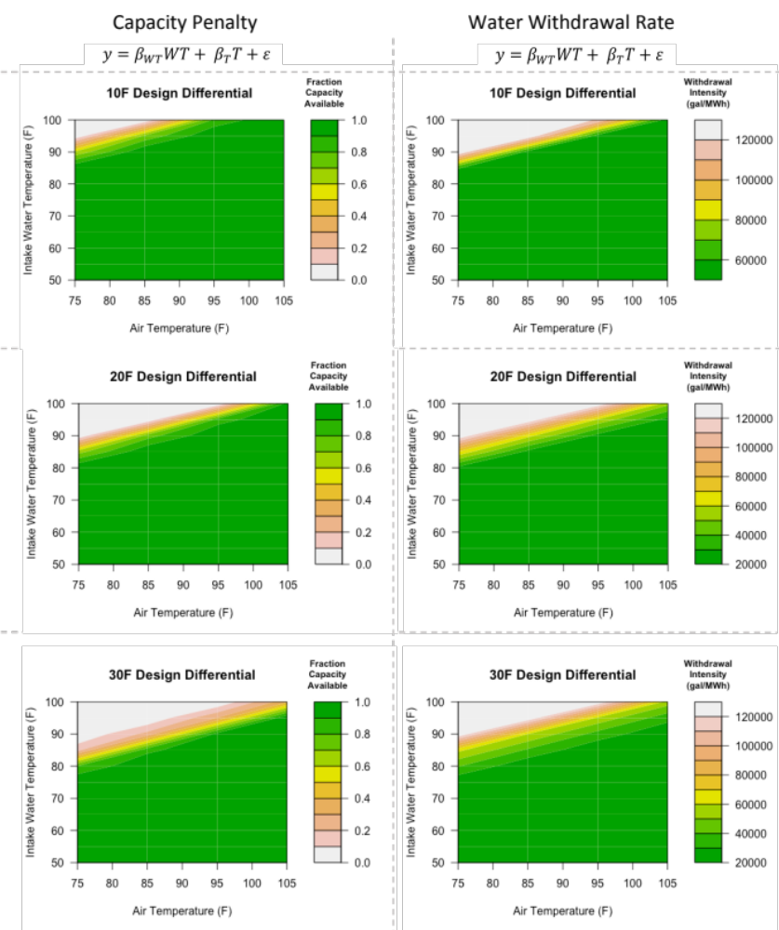
Figure 2. Available capacity (left) and water withdrawal intensity (right) as function of water intake temperature and air temperature for pulverized coal plants with once-through systems. The SI includes the values for coefficient in the regression equations. Rows show results for power plants designed with a 10°F (top), 20°F (middle), and 30°F (bottom) differential between the cooling water intake and discharge. In the regression equation, WT signifies the intake water temperature, and T is the ambient air temperature.

Figure 3 presents net plant capacity reductions and water withdrawal intensity for coal plants with recirculating cooling systems, with respect to relative humidity and air temperature. Capacity reductions are highly contingent on cooling system design conditions. Inlet temperature refers to the water temperature of cooling water entering the cooling tower, while outlet temperature refers to the water temperature of cooling water exiting the cooling tower and returning to the condenser, where it will again absorb heat from exhaust steam. The lower the outlet temperature, the increased likelihood that the ambient wet bulb temperature will not allow for the designed temperature drop within the cooling tower. The 90°F inlet - 70°F outlet case, for instance, faces capacity reductions at much lower air temperatures and humidities than the 100°F inlet and 80°F outlet. At 95°F ambient air temperature and 60% relative humidity, for example, the 90°F inlet - 70°F outlet case would see marked capacity reductions of approximately 50%, while the 100°F inlet and 80°F outlet case could continue operating at full capacity. However, the impact of design conditions on water withdrawal volume is less drastic, since all of these design conditions maintain the same temperature differential of 20°F.
High humidities coincident with high ambient air temperatures expose a vulnerability for net plant capacity at coal power plants with recirculating cooling. The designated inlet-outlet temperature pairings of power plants are not publically available, but since we do not repeatedly experience drastic curtailments during summer months, we assume that to some extent, power plants are already designed to accommodate heat waves (ASHRAE, 2008). Nevertheless, even a conservatively-designed coal plant might face capacity losses upwards of 5% during a particularly hot and muggy day. As recirculating cooling towers replace once-through systems and more frequently are present at baseload plants operating at full capacity, precautionary tower design measures are increasingly critical

(Electric Power Research Institute (EPRI), 2007; 2012; Macknick et al., 2016).
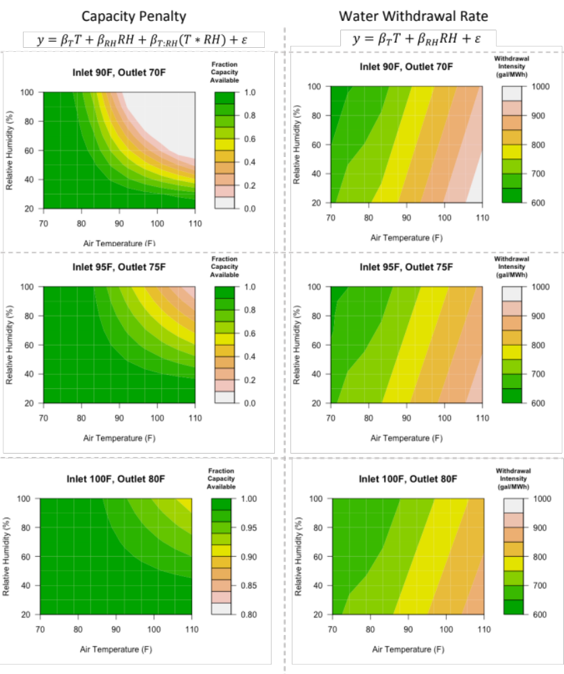
Figure 3. Available capacity (left) and water withdrawal intensity (right) as functions of air temperature and relative humidity for pulverized coal plants with recirculating systems. The SI includes the values for coefficient in the regression equations. Rows show results for power plants designed with 90°F - 70°F (top), 95°F - 75°F (middle), and 100°F - 80°F (bottom) inlet-outlet temperatures in the cooling tower. In the regression equation, RH signifies the relative humidity, and T is the ambient air temperature.

Figure 4 shows how the designed ITD for dry cooling systems in coal power plants determines risk under high ambient air temperatures. Low pressure exerts some negative impact on the percent of capacity available, but most capacity reduction is driven by increased air temperature. This is because higher ambient temperatures reduce the ability of cooling cells to dissipate heat from the steam passing through the coils exposed to ambient air. Furthermore, higher ambient temperatures exacerbate the parasitic load from the cooling fans. Note that the lower design ITDs have lower capacity penalties, as these plants have been designed for hot weather. However, the lower the design ITD, the larger the cooling system baseline footprint area (summarized in the SI) and the higher the capital costs (Zhai & Rubin, 2010).
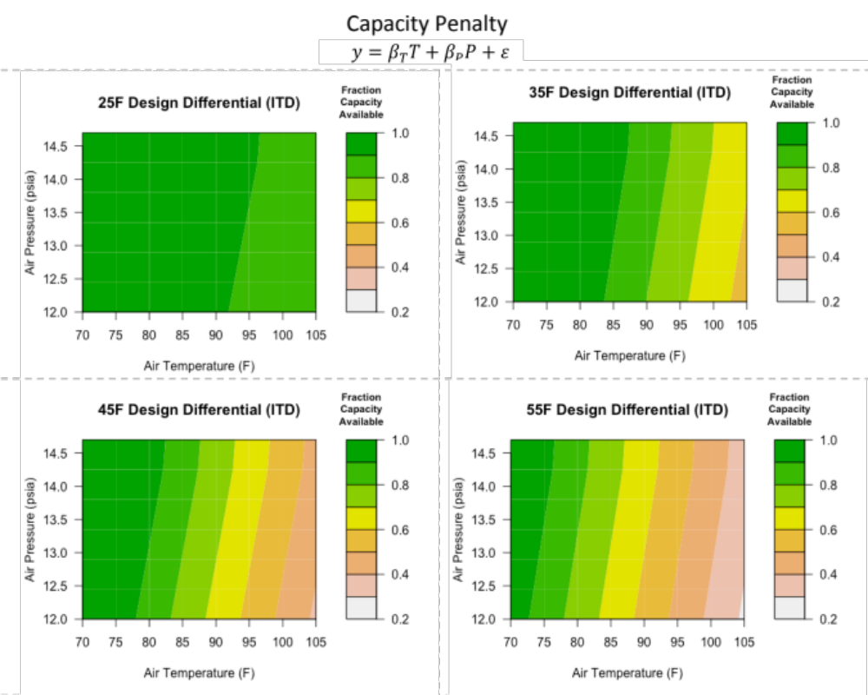
Figure 4. Available capacity as function of air temperature and air pressure for pulverized coal plants with dry cooling systems. The SI includes the values for coefficient in the regression equations. Results are for power plants designed with ITDs of 25°F, 35°F, 45°F and 55°F. In the regression equation, P is the ambient air pressure, and T is the ambient air temperature.

Figure 5 is the output of our analysis of NGCC plants with once-through systems. NGCC plants have both a gas combustion turbine and a steam cycle turbine, so our results reflect their combined response to meteorological conditions. While air temperature and pressure do affect the gas turbine generation, which accounts for the largest share of generation in a NGCC plant, the effects are less significant for gas turbine capacity than for the steam cycle capacity (Ibrahim et al., 2011). With smaller steam cycles, NGCC plants are therefore generally less susceptible than pulverized coal plants to extreme ambient conditions affecting steam generation. The water withdrawal intensities are also smaller.

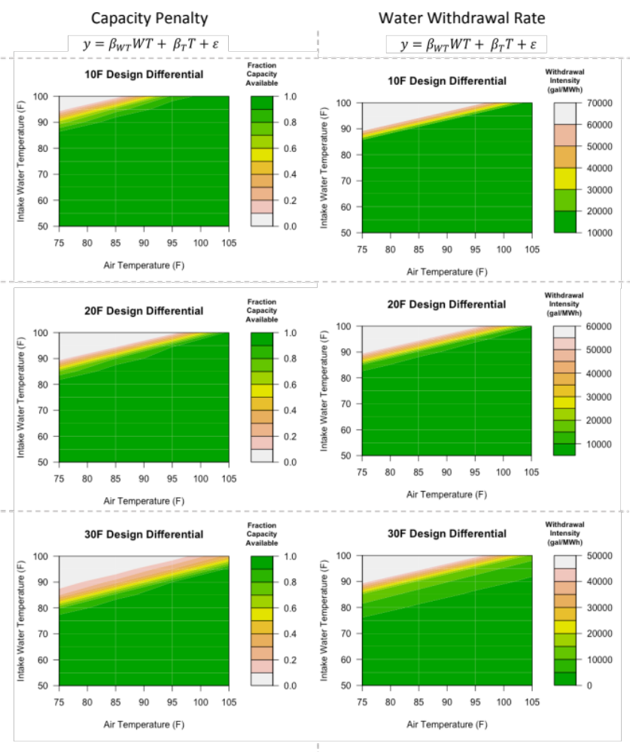
Figure 5 Available capacity (left) and water withdrawal intensity (right) as function of water intake temperature and air temperature for pulverized coal plants with once-through systems. The SI includes the values for coefficient in the regression equations. Rows show results for power plants designed with a 10°F (top), 20°F (middle), and 30°F (bottom) differential between the cooling water intake and discharge. In the regression equation, WT signifies the intake water temperature, and T is the ambient air temperature.
Figure 6 shows the NGCC plants with recirculating systems. The capacity penalty in these plants is lower than in coal plants, where the steam cycle exclusively provides power generation. In high temperature and high humidity situations, however, there remains sizable risk to generation capacity at NGCC plants. Water withdrawal intensity does not meaningfully vary between inlet-outlet design parameter temperatures.
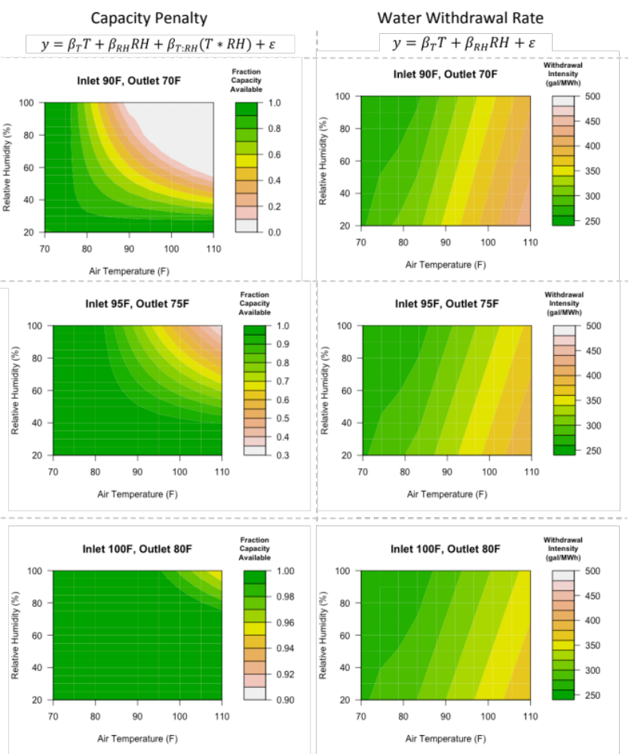

Figure 6 Available capacity (left) and water withdrawal intensity (right) as functions of air temperature and relative humidity for NGCC plants with recirculating systems. The SI includes the values for coefficient in the regression equations. Rows show results for power plants designed with 90°F - 70°F (top), 95°F - 75°F (middle), and 100°F - 80°F (bottom) inlet-outlet temperatures in the cooling tower. In the regression equation, RH is relative humidity, and T is the ambient air temperature.

Finally, Figure 7 demonstrates how ITDs for NGCC plants with dry cooling affect the capacity reduction imparted by changes to air temperature or pressure. As in coal plants, lower ITDs greatly reduce the potential for meteorologically-forced curtailment. A lower ITD corresponds to conditions in hotter weather, where the ability of the ambient air to cool the exhaust steam is lower. However, lower ITDs correspond to larger cooling systems and parasitic loads, increasing capital and operating costs. We do not analyze cost in this study but this would be a tradeoff in practice.
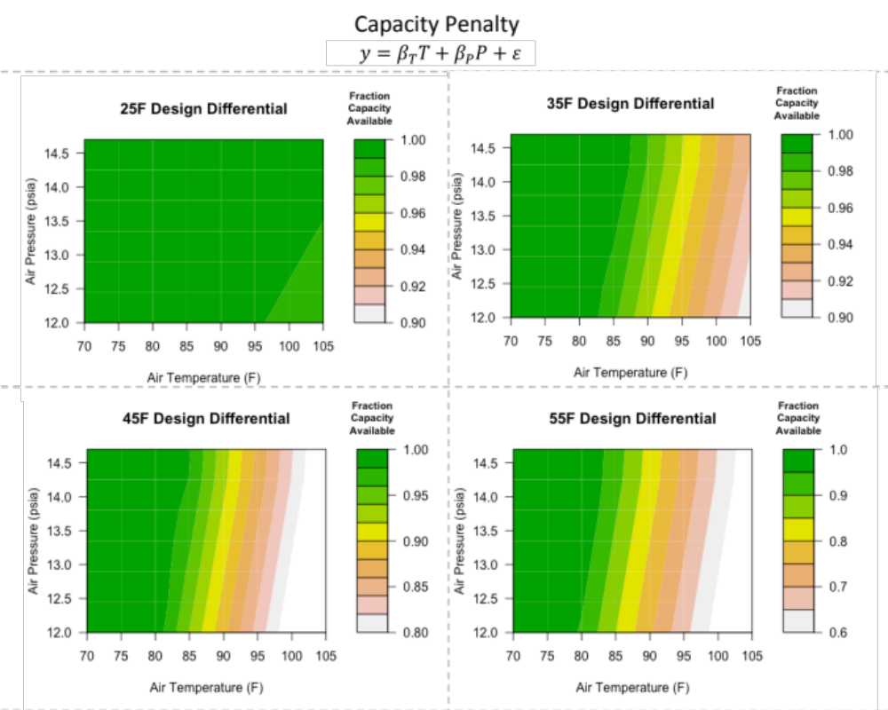
Figure 7. Available capacity as function of air temperature and air pressure for NGCC plants with dry cooling systems. The SI includes the values for coefficient in the regression equations. Results are for power plants designed with ITDs of 25°F, 35°F, 45°F and 55°F. In the regression equation, P signifies ambient air pressure, and T is the ambient air temperature.

4. Discussion
We have examined pathways through which ambient conditions affect individual power plants, finding that cooling systems and their design parameters drive the degree to which a power plant’s operations shift according to weather. Among performance metrics, we observed that capacity and water use shifted according to meteorological conditions. Despite incorporated functionality between temperature, backpressure, and efficiency penalties, our model indicates no significant increase in heat rate due to meteorology.
Our results do indicate the critical importance of considering climate in cooling system design. While more conservative design conditions come with increased capital and operational costs, they can buffer against climate-mediated vulnerabilities to capacity loss, improving resilience. For example, a cooling tower designed to cool water to 75°F could expect to see 5% net capacity loss in air temperatures of 90°F, while a tower designed to cool water to 80°F might only see a fraction of a percent of capacity loss. High latitude geographic locations may be able to safely forgo conservative design measures, but meteorology will likely be less forgiving in warm, humid climates. In changing weather patterns, engineers will need to allow for a wider margin of peak temperatures to avoid capacity loss in critical conditions.
We do not wish to trivialize the increased capital and operational costs associated with more conservative design conditions. In this study we do not estimate the financial investment required by each cooling technology and design condition, though this is certainly a critical parameter for a decision-maker. The lower the ITD in an air-cooled system, for example, the greater the construction costs and the greater the parasitic load in operational costs. A decision-maker would need to contrast these tradeoffs. We intend that our models help to weigh potential operational benefits or risks against potential savings or costs.
Comparing the natural gas combined cycle plants to pulverized coal plants, the NGCC plants demonstrated reduced sensitivity to air temperature and relative humidity, but increased sensitivity to air pressure. This is observable across all dependent variables. The relatively smaller air temperature and humidity coefficients are attributable to the steam cycle, which is more susceptible to climate than the gas turbine, accounting for a comparably smaller portion of generation in a combined cycle plant. However, since there are two turbines in a combined cycle plant (combustion and steam), there is amplified response to changes in air pressure.
We present our models as a predictive tool. We acknowledge that individual plants may demonstrate a range of performance responses to meteorological conditions, the variance of which is not fully expressed in our equations. Our intent is to provide a method for simplified modeling at the generator level that can also be applied to a fleet. Our models could help model existing fleets under future climate scenarios, or future fleets with additional capacity and cooling system retrofits under varying climate scenarios. The results may be able to highlight or dispel potential risk to power generation under climate stress.
Our analysis suggests rather minimal risk to power capacity and efficiency across all cooling technologies, given appropriate design parameters. While we do not wish to understate the risks to infrastructure posed by climate change, the presented study does not indicate that rising air temperatures will seriously threaten capacity and efficiency at power plants, provided that wet recirculating and dry cooling systems are designed adequately. This is consistent with the findings of several more recent predictive and historical studies (Bartos & Chester, 2015; Henry & Pratson, 2016; Liu et al., 2017), though climate change may nevertheless bear impact on power plants via reduced water supply, flooding, or storms. Power plants are not immune to meteorology, but we hold that they are more resilient than previously suggested.

Acknowledgements
This project was supported by the National Science Foundation via Grant Number EFRI-1441131; and the National Oceanic and Atmospheric Administration via Award Number A14OAR4310249. Dr. Bart Nijssen and Yifan Cheng at University of Washington were instrumental in providing climate data, and guidance on its use. We also acknowledge Dr. Kelly Klima for her input on our modeling framework and insight into meteorological interactions. Dr. Michael Craig generously helped us gather empirical data to validate our regressions. The results and conclusions of this paper are the sole responsibility of the authors and do not represent the views of the funding sources.

Citations
Arrieta, F. R. P., & Lora, E. E. S. (2003). Influence of Ambient Temperature in Combined Cycle Power Plant Performance (pp. 1–8). Presented at the International Congress of Mechanical Engineering.
ASHRAE. (2008). Chapter 39: Cooling Towers. In ASHRAE Handbook.
Ashwood, A., & Bharathan, D. (2011). Hybrid Cooling Systems for Low-Temperature Geothermal Power Production (pp. 1–74). NREL. doi:10.2172/1009690
Bartos, M. D., & Chester, M. V. (2015). Impacts of climate change on electric power supply in the Western United States. Nature Climate Change, 5(8), 748–752. doi:10.1038/nclimate2648
Carnegie Mellon University. (2016). Integrated Environmental Control Model (IECM) Version 9.5. Retrieved from http://www.cmu.edu/epp/iecm/index.html
Cleaver-Brooks. (2013). Boiler Efficiency Guide (pp. 1–24). Cleaver-Brooks.
Electric Power Research Institute (EPRI). (2002). Comparison of Alternate Cooling Technologies for California Power Plants (No. 500-02-079F).
Electric Power Research Institute (EPRI). (2004). Comparison of Alternate Cooling Technologies for U.S. Power Plants (pp. 1–270).
Electric Power Research Institute (EPRI). (2007). Issues Analysis of Retrofitting Once-Through Cooled Plants with Closed-cycle Cooling (No. TR-052907). Palo Alto, CA.
Electric Power Research Institute (EPRI). (2012). Program on Technology Innovation: Tradeoffs Between Once-Through Cooling and Closed-Cycle Cooling for Nuclear Power Plants (pp. 1–148). EPRI.
Harto, C. B., Yan, Y. E., Demissie, Y. K., Elcock, D., Tidwell, V. C., Hallett, K., et al. (2012). Analysis of drought impacts on electricity production in the Western and Texas interconnections of the United States. (pp. 1–161). doi:10.2172/1035461
Henry, C. L., & Pratson, L. F. (2016). Effects of Environmental Temperature Change on the Efficiency of Coal- and Natural Gas-Fired Power Plants. Environmental Science & Technology, 50(17), 9764–9772. doi:10.1021/acs.est.6b01503
Ibrahim, T. K., Rahman, M. M., & Abdalla, A. N. (2011). Optimum Gas Turbine Configuration for Improving the performance of Combined Cycle Power Plant. Procedia Engineering, 15, 4216–4223. doi:10.1016/j.proeng.2011.08.791
Jiang, M. (2013). Integrating Water Use and Water Quality into Environmental Life Cycle Assessment: Limitations and Advancements Derived from Applications (pp. 1–299).
Kenny, J., Barber, N., Hutson, S., Linsey, K., Lovelace, J., & Maupin, M. (2009). Estimated Use of Water in the United States in 2005 (pp. 1–60). US Geological Survey.
Koch, H., & Vögele, S. (2009). Ecological Economics. Ecological Economics, 68(7), 2031–2039. doi:10.1016/j.ecolecon.2009.02.015
Lawrence Berkeley National Laboratory. (2012). Estimating Risk to California Energy Infrastructure From Projected Climate Change (No. CEC‐500‐2012‐057) (pp. 1–88). California Energy Commission.
Liang, X., Lettenmaier, D. P., Wood, E. F., & Burges, S. J. (1994). A simple hydrologically based model of land surface water and energy fluxes for general circulation models. Journal of Geophysical Research, 99(D7), 14415–14428. doi:10.1029/94JD00483
Liu, L., Hejazi, M., Li, H., Forman, B., & Zhang, X. (2017). Vulnerability of US thermoelectric power generation to climate change when incorporating state-level environmental regulations. Nature Energy, 2, 17109. doi:10.1038/nenergy.2017.109
Macknick, J., Newmark, R., Heath, G., & Hallett, K. C. (2011). A Review of Operational Water Consumption and Withdrawal Factors for Electricity Generating Technologies (pp. 1–29). doi:10.2172/1219149
Macknick, J., Zhou, E., O'Connell, M., Brinkman, G., Miara, A., Ibanez, E., & Hummon, M. (2016). Water and Climate Impacts on Power System Operations: The Importance of Cooling Systems and Demand Response Measures. doi:10.2172/1338177
Roy, S., & Chen, L. (2011). Water Use for Electricity Generation and Other Sectors: Recent Changes (1985-2005) and Future Projections (2005-2030) (No. 1023676) (pp. 1–94). Palo Alto, CA: EPRI.
Scanlon, B. R., Reedy, R. C., Duncan, I., Mullican, W. F., & Young, M. (2013). Controls on Water Use for Thermoelectric Generation: Case Study Texas, U.S. Environmental Science & Technology, 47(19), 11326–11334. doi:10.1021/es4029183
Singh, S., & Kumar, R. (2012). Ambient Air Temperature Effect on Power Plant Performance. International Journal of Engineering Science and Technology, 1–8.
van Vliet, M. T. H., Yearsley, J. R., Ludwig, F., Vögele, S., Lettenmaier, D. P., & Kabat, P. (2012). Vulnerability of US and European electricity supply to climate change. Nature Climate Change, 2(9), 676–681. doi:10.1038/nclimate1546
van Vuuren, D. P., Edmonds, J., Kainuma, M., Riahi, K., Thomson, A., Hibbard, K., et al. (2011). The representative concentration pathways: an overview. Climatic Change, 109(1-2), 5–31. doi:10.1007/s10584-011-0148-z
Ward, D. M. (2013). The effect of weather on grid systems and the reliability of electricity supply. Climatic Change, 121(1), 103–113. doi:10.1007/s10584-013-0916-z
Zamuda, C., Mignone, B., Bilello, D., Hallett, K. C., Lee, C., Macknick, J., et al. (2013). U. S. Energy Sector Vulnerabilities to Climate Change and Extreme Weather. U.S. Department of Energy.
Zhai, H., & Rubin, E. S. (2010). Energy Policy. Energy Policy, 38(10), 5653–5660. doi:10.1016/j.enpol.2010.05.013
Zhai, H., & Rubin, E. S. (2016). A Techno-Economic Assessment of Hybrid Cooling Systems for Coal- and Natural-Gas-Fired Power Plants with and without Carbon Capture and Storage. Environmental Science & Technology, 50(7), 4127–4134. doi:10.1021/acs.est.6b00008
Zhai, H., Rubin, E. S., & Versteeg, P. L. (2011). Water Use at Pulverized Coal Power Plants with Postcombustion Carbon Capture and Storage. Environmental Science & Technology, 45(6), 2479–2485. doi:10.1021/es1034443
Zhai, H., Rubin, E. S., Versteeg, P. L., Kietzke, K., Berkenpas, M., McCoy, S., & Mantripragada, H. (2009). IECM Technical Documentation Updates: Final Report (No. DE-AC26-04NT41917).
Zhou, J., Deng, S., Turner, D., Claridge, D., & Haberl, J. (2002). Improving Boiler Efficiency Modeling Based on Ambient Air Temperature (pp. 1–13). Presented at the Thirteenth Symposium on Improving Building Systems in Hot and Humid Climates.

