*Jordyn Lemer, Kate Hancuch, Kiki Higuchi, Jane Wiertel, and Siobhan Esposito*

**I. SUMMARY OF OBSERVATIONS**

**Introduction:**

Focus group participants and the moderator, Karen, logged into the Zoom call and engaged in conversation to establish a comfortable atmosphere for both participants and the moderator. After introductions which included names, ages, pronouns, and favorite social media apps, respondents and the moderator engaged in an icebreaker activity that helped foster mental focus and creativity. This specific icebreaker activity asked participants to do a “Tik-Tok Review” of a certain product. The moderator began with her own product, a Pony-O, which prompted the participants to engage and respond with their own products. Their responses included a disposable camera, a book, wireless earbuds, a desk planner, Adidas slide shoes, milk frother, Trader Joe’s seasoning, and a Penny board. Respondents appeared to have fun engaging in this activity and notably became more relaxed despite the virtual format of this focus group. As they reflected on their answers to the icebreaker activity, the group found that their answers centered around the ideas of practicality, home, and comfortability, which is representative of the general population at large. This was reassuring because the focus group wasn’t chosen exactly according to the respondent screener and not from a random sample of the population, but from a class cohort with similar interests (same academic interests, same school and same city of residence)

Next, the moderator Karen, noted that because this is an unconventional way for a focus group to take place, there will be some leniency throughout the process, but that it will still be a meaningful learning experience for both Kohl’s and the students. With that being said, it was time to begin the focus group activities.

**Activity One: Alien Shopping Center**

The first group activity was called *Alien Shopping Center* and was designed to take 20 minutes to complete. The activity was created in order to gain a better understanding of how consumers weigh brand characteristics when deciding between brands they have not yet tried. For this activity, participants were split off into Zoom breakout rooms in groups of two to discuss ten different stores that were part of a newly opened retail shopping center. The stores’ attributes varied in terms of style, prices, and features. It was up to the participants to discuss each store and which two they would be the most attracted to and why. After five minutes in the break out rooms, participants returned to the main session in their pairs, ready to discuss their answers.

This activity forced participants to establish a hierarchy of values they possess when shopping. When asked if the activity was easy or difficult, some participants found it to be a relatively easy activity, but sometimes it was difficult to distinguish between some of the stores. There also seemed to be some dissonance between partners and what they prioritized based on gender. Style was not as important to male-identifying participants as it was to female-identifying participants. Based on the respondents’ answers, it is evident that sustainability is of priority to the participants as two groups (four people) prioritized this quality as they were looking at these hypothetical stores. The moderator further questioned the participants on this point: does sustainability denote higher quality or durability in our cultural context? Price was another attribute that was important to participants as they looked at these stores; one group even noted that they wouldn’t look at any of the stores that were outside of their price range. Furthermore, style and trendiness were two other attributes that respondents considered, although that was only mentioned by one group.

**Activity 2: Perceptual Map**

Karen presented to the participants a map that had an X axis stating “Not trendy” on the left, and “Trendy” on the right, and a Y axis indicating “Low value” on the bottom and “High value” on the top. Karen gave the group a list of large retailers, including Target, Nordstrom, Urban Outfitters, Pacsun, Madewell, Nike, and Kohl’s. Each participant put each retailer into the quadrant they saw best fit and then rejoined the group for questioning. Karen then presented each graph edited by participants and asked the group to elaborate on their opinions.

For almost all participants, Kohl’s was considered a low trend store. Most said that Kohl’s was for more everyday, durable products. A common idea repeated by several participants was that Kohl’s was a “store for moms.” Many of the participants' moms shopped at Kohl’s and often the only contact they had with Kohl’s products was through things their mother had bought for them. Participants reacted differently to Kohl’s based on this association with their mom. One participant saw Kohl’s as a sensible store with functional products, because her mother became less concerned with style as she grew older. Another participant never wanted to shop at Kohl’s because his mother always made him shop at Kohl’s. For him, the association of Kohl’s with his mother made it a low trend store that he didn’t want to be caught dead at. On the opposite end of the spectrum, one participant heavily relied on her mom for both fashion advice and store choice. She would only shop at stores that were recommended by her mom.

Karen further questioned the participants on whether or not they felt it was important for Kohl’s to be trendy. Most said no, considering the current segment they thought Kohl’s served did not necessarily prioritize style. Additionally, most felt that considering the products they mapped Kohl’s under, style was not important. Trendy pajamas weren’t that important to the participants.

One participant was especially concerned with the goals of each store and the mission that the store stood for. She mentioned that if Kohl’s could have a mission to separate itself from the competition it might be more beneficial for the store. This participant suggested that the store leverage some type of social meaning to better promote its brand personality.

**Activity 3: The Online Experience**

In order to gain a better understanding of online reviews/experiences that influence a consumer, Karen provided the focus group with Instagram links and asked the focus group to determine their attitude toward the specific retailer. To make the activity inclusive, and consider that not all participants have access to Instagram, the website link was provided as well. The participants were also provided two reviews, which were different for each participant, to read after they had surfed the web page or scrolled through their Instagram for a few minutes.

Participants were asked to reflect on their initial impressions after looking at just the website/Instagram. Many of the f female-identifying participants found the copy of the website to be condescending (i.e. “Girly girls” or “girls only”) and the male-identifying participants felt alienated from the brand. Some participants found the brand to be sexist and off-putting. One person described the advertising of the brand to be “off-putting” and “tone-deaf,” especially given the current times.

Karen then asked the participants to consider the reviews they had just read. All participants agreed that the layout of the website was all over the place and overwhelming. Reading the reviews reinforced their thoughts because many reviews talked about the overwhelming nature of the physical store. The male participants didn’t relate to the female oriented advertising, however the brand’s portrayal of a family run business was appealing to most. Overall, everyone also agreed that it was aesthetically concentrated. One participant thought the best aspect was that the social media platform allowed them to better portray different representations of who they are: a small business, family-owned, albeit perpetuating outdated gender norms. Instagram gave the family run business an opportunity to highlight their small, community based business.

**II. IMPLICATIONS & INSIGHT**

**Three Implications:**

When discussing the participants’ perceptual map of Kohl’s, a common theme was that Kohl’s is a “mom store.” The moderator then asked in a later discussion if it was possible for Kohl’s to be both a mom store *and* a store for centennials. There were two main reactions to this perception of Kohl’s, some students developed a negative attitude towards the store because they didn’t want to shop where their mom shopped and some really valued their moms opinion and would shop at Kohl’s if their mom shopped there or at least be willing to interact with products their parents bought for them at Kohl’s. This perception of Kohl’s as a “mom store” suggests it might be easier to get Kohl’s products to centennials through the adults in their life. Through the label of a “mom store,” Kohl’s can cater to the extended self of these centennials, providing products that serve the “adult” role of this consumer group. By giving Kohl's this label, it attributes to the fact that many of their customers fit into the category of a consumer tribe, which is a group of people who share similar lifestyles and are able to relate to each other due to their shared liking of a company or product. Marketing Kohl’s as a store for parents to shop at for themselves and for their kids might be the most successful approach to bringing Centennials into the Kohl’s market segment. Changing Kohl’s perception as a “mom store” would be pretty difficult and might alienate some of Kohl’s current consumer base. Using this perception to Kohl’s advantage may be more efficient. While some Centennials might react negatively to products associated with their moms, a great many others will also react positively and consider Kohl’s as a viable retail choice. Mom’s, and most parents, do hold some referent power over their children; kids want to be like their parents, which Kohl’s could use to their advantage. Parents also hold information power over their kids; they have coveted knowledge about what it means to be an adult and they share their knowledge by raising their kids. Using parents’ social power over their kids to sway their retail choices is an example of conformity, as Centennial shoppers would have a change in behavior or opinion as a result of their moms, or other older influences, shopping at Kohl’s. However, Kohl’s should beware not to play into the mom stereotype that often comes up in gendered marketing. It can alienate other parents and different family structures. They should instead just emphasize that they have products for parents and products for parents to buy their kids.

Additionally, during the perceptual map activity, it was clear that all participants recognized that Kohl’s isn’t known for being trendy. Even so, it’s accepted that trend doesn’t have to be their main goal, and that Kohl’s should focus on quality and durability. One participant described Kohl’s as a place to buy pajamas, which many participants heartily agreed with. Most felt that pajamas didn’t have to be trendy, but they should be comfortable and last a long time. Consumers utilize mental heuristics, or shortcuts that make the purchasing decision a faster process when it comes to choosing Kohl’s products, which tend to consumers’ utilitarian needs. Knowing simply that Kohl’s products are of quality and durability is a mental heuristic. These characteristics of Kohl’s products are valued by consumers and can assist in relationship marketing in which Kohl’s establishes lifelong engagement and a lasting relationship between consumers and the brand. Since Kohl’s is known to have functional and lasting products, this is the area of comfort that they should stick to. They should not try to tackle the risk of becoming trendy when their audience defines them as the opposite. Instead they should market themselves as a retailer that sells high-quality, everyday-use items that will ultimately prove to be dependable for the consumer.

Lastly, from the research conducted, a final implication learned is that Kohl’s needs a distinctive attribute to differentiate themselves from other large retailers. In the three step process of segmentation, targeting, and positions (STP), the “what” is the brand attribute that matters most to the consumer. Though our participants categorize Kohls to have durable and practical products, they don’t know what the mission or purpose of the brand is. One participant thought, especially in this time when social issues are at the forefront of our cultural context, Kohl’s should leverage some social meaning in order to give their brand a noticeable personality or presence in the marketplace. She suggested that Kohl’s should differentiate itself as the sustainable brand or even the social justice brand by donating to causes or having promotions. In order for Kohls to make a lasting impression and have a notable presence amongst their competitors, they should make an effort to better emphasize their family friendly and community focused brand personality with a clear social vision. One way to do this would be to find a brand archetype that best fits Kohl’s. For example, Kohl’s could pursue the Mother Earth archetype. Both to play on its “mom store” persona and to emphasize the dependability of its products. Additionally, the Mother Earth archetype would allow Kohl’s to bring in a sustainable aspect to their brand (something we found correlated with quality for many in the focus group.) Finally, people also buy products that have similar attributes to themselves, this is called self-image congruence. By giving Kohl’s a clearer brand identity Centennials might be more interested in shopping at a retailer that identifies with their own goals of sustainability or body positivity.

**Two Insights:**

**Statement:**

People want the products they use everyday to be dependable.

**Connection to Research Goals:**

Through this focus group, Kohl’s was looking to better understand what draws Centennials to engage with new retailers. Based on our insight statement, it is evident that dependability is an important factor when Centennials are considering which retailers to engage in.

**Statement:**

A parent’s opinion is more important and more dependable than anyone else’s.

**Connection to Research Goals:**

Kohl’s is undeniably established as a “mom store.” However, instead of shying away from that label, Kohl’s should lead into it and use the social power parents have over their children to bring younger generations into their consumer base. By pulling in more parents and marketing Kohl’s as a great place to buy products both you and your kids will love, Kohl’s can stimulate brand loyalty within younger generations; because most people love their parents and value their opinions.

**Statement:**

You identify with and like people that have similar goals and visions as you.

**Connection to Research Goals:**

By giving Kohl’s a more pointed mission, the store can find a better way to identify with its consumers. Especially in this cultural context where younger generations are more interested in social issues and supporting causes that align with their own goals. If Kohl’s can identify themselves with one of these goals they can better identify with old and new customers which will ultimately strengthen their customer base.

**III. APPENDIX**

* **Introduction:**
  + Karen begins by stating “Looking for honest answers, the good, the bad and the ugly.” She wants everyone to be honest and truthful
  + Karen starts by outlining the way in which the focus group unfolds: starting with an icebreaker and explaining the purpose of it (to loosen up/get comfortable with the group in general)
    - Talking about her hair accessories during pandemic→ trying to be relatable during her icebreaker, allows other group members to want to open up too
* Generally, Karen’s style of moderating is friendly, welcoming, while keeping it formal and structured
  + She shows appreciation for the participants’ time and commitment to getting involved
* Participants
  + Margot Present, 20, she/her/hers
  + Emi Silverstein, 20, she/her/hers
  + Lucia Shorr, 20, she/her/hers
  + Eric Epstein, 20, he/his/him
  + Sarah McGrath, 20, she/her/hers
  + [Kiki Higuchi](mailto:kikihiguchi2023@u.northwestern.edu), 19, she/her/hers
  + Trey Reed, 20 ,he/him/his
  + Isabelle Kenagy, 19 , she/her/hers
* **Icebreaker Activity:**
  + Tik-Tok style review of a product for an icebreaker→ trying to appeal to the Gen Z participants
    - Each participant will present a 15-30 second “Tik-Tok style” review of their favorite product
    - Good way to see what products group members like and what this generation of consumers gravitate towards
  + *Activity Responses:*
    - Emi: Reviewed a book she read
    - Eric: $20 wireless earbuds
    - Isabelle: Desk planner
    - Margot: Disposable film cameras
    - Kiki: Adidas slides
    - Sarah: Milk Frother
    - Lucia: Trader Joe’s seasoning
    - Trey: Penny board
  + Karen addresses how this is an unconventional focus group due to Coronavirus, so there will be some leniency in the process, however, it will still be a meaningful learning experience
  + Answers of participants reflect Centennial consumers at large: Practical, Home, Comfy
    - All of the answers above are an accurate reflection of items each participant uses often along with items they trust
    - Karen expresses these similarities in answers to the general population and consumers
* **First Activity: Alien Shopping Center** 
  + With a partner in a breakout room, the participants were to decide the top two stores that they would want to visit,and the two stores they would avoid and have no interest in visiting.
    - This activity allows Karen to see what stores Centennials gravitate towards. This activity also goes hand-in-hand with the ice breaker, as both activities give insight to personal preferences of the greater age group that the participants represent.
    - The following document provided by Karen:
* 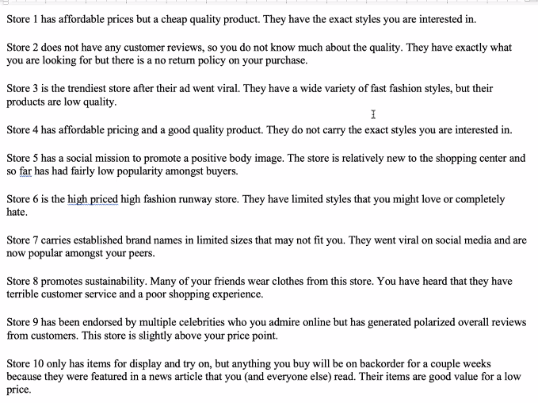
  + - Participants were told to pick what’s qualities of the stores were important to them and what qualities were less important to them
    - Throughout activity, Karen responded to group members and summarized their answers while also asking follow up questions
  + Two groups prioritized sustainability, one group prioritized style and trends, and the last group prioritized price and quality.
    - Many centennials find sustainability, price, and quality important as clothing will often be higher quality as “instant gratification [of clothing, style, and trends] aren’t necessarily important.”
* **Second Activity: Perceptual mapping**
  + Karen presented a map to the participants that had an X axis stating “Not trendy” on the left, and “trendy” on the right, and a Y axis indicating “Low value” on the bottom and “High value” on the top.
  + Karen gave the group a list of large retailers, including Target, Nordstrom, Urban Outfitters, Pacsun, Madewell, Nike, and Kohl’s.
    - Each participant put each retailer into the quadrant they saw best fit and then rejoined the group for questioning.
    - Karen then presented each graph and asked the group to elaborate on their opinions

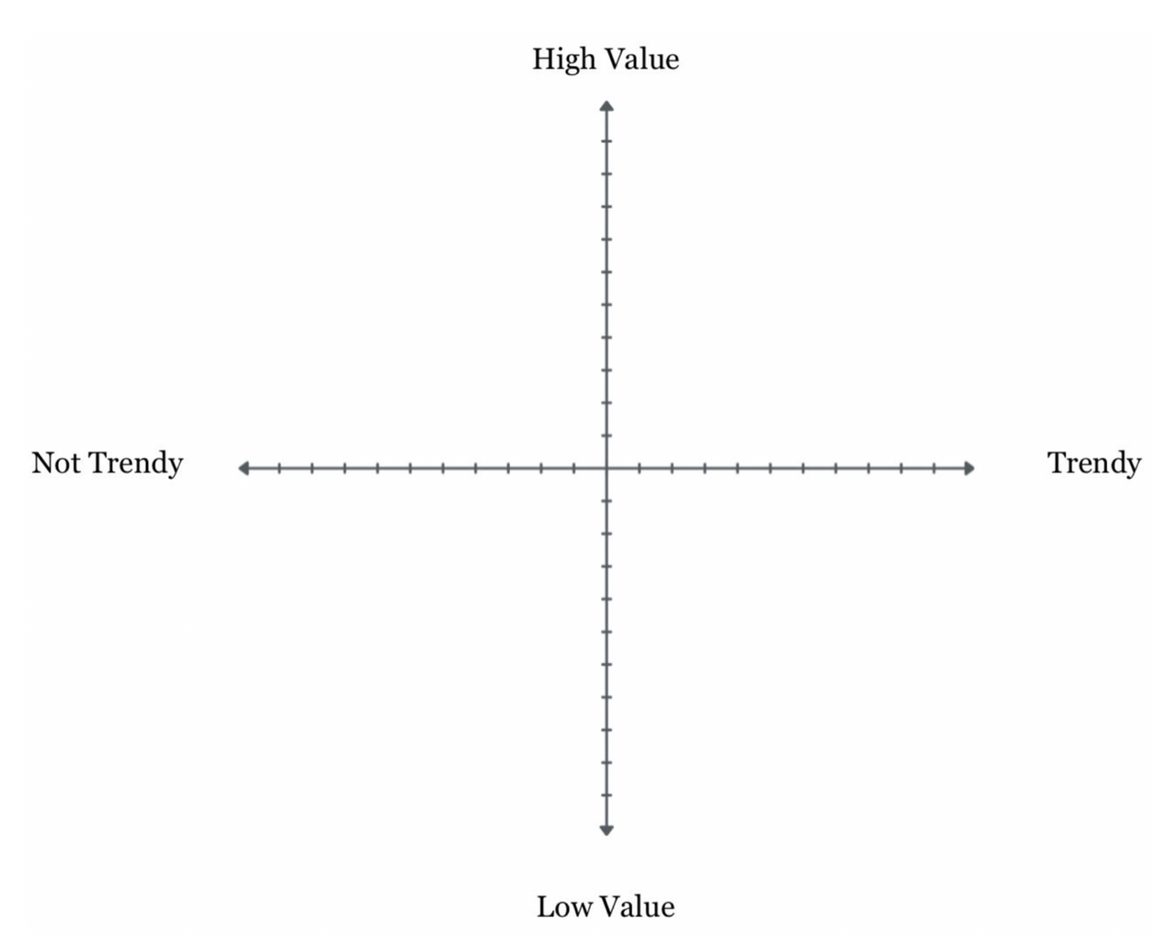

* + Going through each groups maps and summarizing→ when going through each groups map, asking good follow up questions and asking why each group to elaborate on their opinions of Kohl's (ex: why they don’t consider Kohls “trendy”) → question: “is it a bad thing that Kohls doesn’t stand for “trend?”
  + Kohl’s is found to be low-trend
    - Not trendy, high value:
    - Lucia: pajamas, casual (similar to target or Old Navy)
      * Not “going-out” clothes
      * Mostly thrifts her clothes
    - Margot: expressed similar to Lucia
* What do you envision Kohl’s for? Is it a bad thing that Kohl’s doesn’t stand for trends?
  + Isabelle:
    - Kind of depends on the segmentation strategy
    - If the goal is to appeal to Gen Z, maybe go towards trends
    - If the goal is to appeal to millennials and Gen X → age appropriate, stylish but more quality
* Karen: When you think of Kohl’s right now and what kind of products that retailer stands for? Durability or Style?

*\*Professor Franks takes over as moderator → Karen left\**

* How difficult was it to negotiate with your partner to come up with the two stores?
  + Sarah/Eric: definitely some degree negotiation among two genders. You've made a different choice if she was by herself. Sarah cares more about being trendy than Eric does - resembles the gender stereotypes when shopping.
  + Emi/Trey: The difference in gender didn’t change their opinions about sustainability. Values were aligned but fashion was a difference.
  + Isabelle/Margot: They can trade off quality for being more on trend. There was value alignment outside of the breakout room so there was more conformity in that way. They have similar shopping habits and value on trend.
  + Kiki/Lucia: They have different values going into it. The both of them are big on sustainability and body positivity. There were different things they thought weren’t going to align, but they ended up going together nicely
* *Next Question*: When trying a new retailer, do you find that people impact your decision to try the new retailer? Friends, Influencers, Family? Or are you independently making those choices?
  + Trey: Still influenced by external things, but if he goes to try something he would rely more independently to make a certain decision to trying something new compared to how he was growing up (much more dependent)
  + Eric: similar to Trey (heavily influenced by family) but finds himself more impacted by friends, would try things out because friend suggested and had a positive experience
  + Emi: follows a lot of influencers, sometimes they release their own clothing line, targeted ads from influencers: (revolve), more inclined to buy based on those influencer advertisements
  + Sarah: So much time with peer groups made up of friends → trust and conformity with friends, valuing friends’ opinions over family & influencers
  + Margot: Agreed with Sarah, ties into Isabelle: tying into trends & lifestage → “I love your shirt, where did you get it?”, thinking about values in our shopping experiences
* Reflecting again on the perceptual map → understanding why Kohl’s was placed with its competitors (ie Target) instead of different retailers (ie Sephora)
  + Lucia: understanding Kohl’s values/mission more may help her change her perception of the brand
    - Focusing on sustainability
* Question: Can Kohl’s be a brand for a centennial AND somewhere your mom shops at?
  + Trey: only wanted to shop at Target because Mom forced Kohl’s on him, although Kohl’s had name brands like Nike or Adidas
  + Kiki: Different experience to Trey, not fashion-forward, will rely on mom because she is fashion forward, relies on mom’s opinion, if mom says it’s a good store, Kiki values her opinion and will shop there
  + Lucia: not saying Kohl’s should try to be Free People, but if Kohl’s utilized its range of what it can reach in terms of social meaning, it should try to be the department store that can be sustainable, can be fashion forward, can be body positive
* **Third Exercise:****The Online Experience**
  + *Karen provides the Instagram/Website link to the focus group → asks them to use it to determine their attitudes towards the specific retailer. → also provides link to website (inclusive to those who don’t have instagram)*
  + What were initial impressions as participants looked at Instagram pages?
    - Isabelle: found copy on website to be a little condescending: “Girly-girls” → turned off by the brand
    - Emi: Agrees with Isabelle, think “girls only” concept is bad, to have it be a separate room is especially interesting
    - Lucia: weird and off putting → sexist (girly girls), association with little girls but sorority girl merch (thinking drinking, college age), a weird age mix & tone deaf
  + Thinking about Reviews:
    - Margot: opinion was reinforced after reading reviews, layout was all over the place & overwhelming
    - Agreement across the participants
    - Eric: didn’t relate to the female oriented advertising, family business (saw this from the reviews), appealing that it is a family run & small business
    - Trey: felt similar to girls and Eric, agreed with Margot’s perception of how it is overwhelming, aesthetically concentrated, best aspect: social media (allowed them to better portray different representation of who they are, highlighting family run business)
    - Kiki: leaning into family business → “that’s sweet”