**How Butler College Prep Cultivates Black Excellence**

**Butler College Prep promotes a culture of Black excellence through a pioneering college tour program for its students.**

Kiarra Tate is graduating from Howard University with a degree in psychology in two months. But for most of her early life, the Englewood native had never even thought about going to college; it just wasn’t the norm in her neighborhood.

That changed when she enrolled at Butler College Prep, a charter school within the Noble Network. It was something she discovered at Butler that drew her to Howard, starting with an African American literature course and ending with a week-long college tour.

 “I really like the idea of Black excellence,” Tate says. “All these different types of Black people in one setting who have the same goal: to be successful… I want to be able to look over and see someone that looks like me that is just as successful as me,” (*Good comment – shows effect.)*

Since 2016 Butler College Prep has been sending 60-80 students of its senior class on a weeklong tour of historically Black colleges and universities (HBCUs) throughout the Southeast and Midwest. It’s the only program of its kind on the South Side and the only HBCU-centered experience within the Noble Network.  (*Good! You get to your nut graph quickly!)*

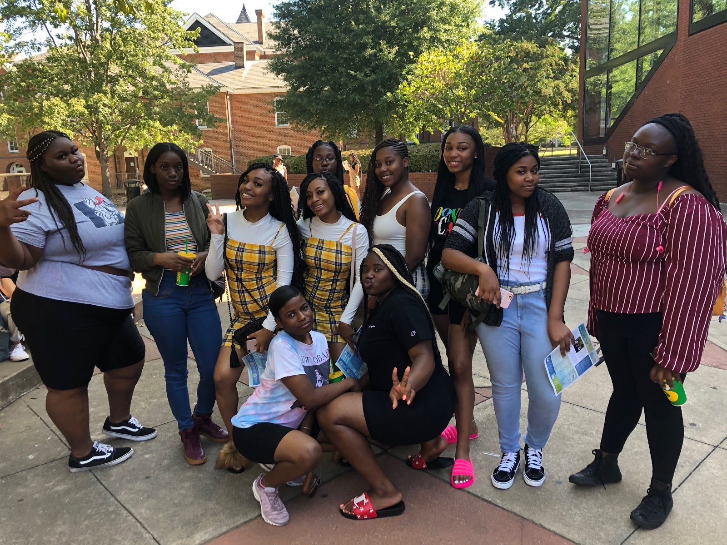

Students on the 2019 HBCU Tour (courtesy Camielle Taylor)

Butler sets aside some of its budget to subsidize part of the program and students pay around $300 out-of-pocket. However, Butler is able to provide some financial assistance to those who need it. Camielle Taylor, the Dean of College and head of the program, says they often reserve money for students the college team thinks stand to benefit the most from the tour to make sure they attend. Taylor and her team choose students who think they won’t succeed in college or aren’t thinking about college at all.

Each HBCU provides unique programming for Butler’s students when they visit. Meharry Medical College at Nashville’s Fisk University puts on a panel for students to discuss being Black in medicine. Other schools might send a current student from Chicago or even a Butler alumni to curate the tour.

Students don’t just visit schools. Taylor says they try to look back at history when the students aren’t focused on their future on different campuses to make the tour more robust. Last year, students went to Selma, Alabama to visit the National Voting Rights Museum and walk across the Edmund Pettus Bridge.

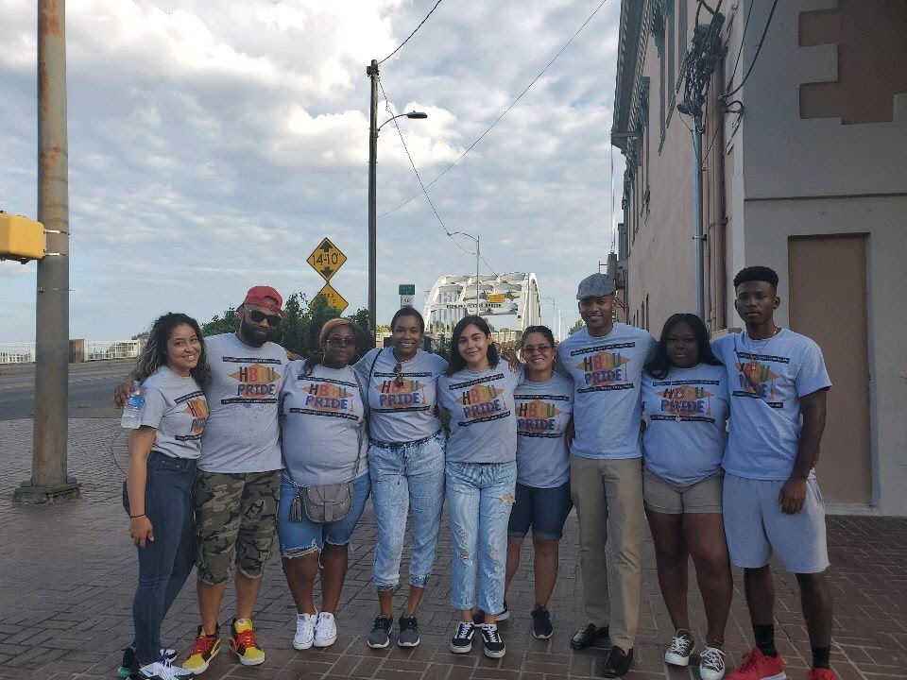

Students on the 2019 tour in front of the Edmund Pettus Bridge (courtesy Camielle Taylor)

The tours have a demonstrable effect on students, even the students that didn’t think college was for them come back ready to start applying. According to Brian Riddick, the current principal, on average 27% of Butler alumni go on to HBCUs; the highest percentage of any Noble Network school.

Riddick was inspired to start the program for two reasons: a personal priority and a problem Noble Network schools were struggling to address. Riddick, a North Carolina native, had exposure to both HBCUs and predominantly white institutions (PWIs); he wanted his students to have the same choice.

At the same time, Riddick noticed that there were lots of conversations about difficult transitions Noble Network graduates were experiencing. However, no one was talking about HBCUs, and Riddick wanted to bring that into the discourse. “We had to address that, for a lot of the students, the cultural shock of it all was a reality,” he says.

Riddick planned the first tour shortly thereafter and Tate was in attendance. When it came time to visit Howard, Tate didn’t even talk to her friends — she spent her time diligently taking notes about everything the tour guide said and everything she saw. She knew wanted to go to Howard University before she went on the HBCU tour, but that wasn’t always the case.

Initially, Tate wanted to attend a PWI because she thought it would be more like the real world. Butler taught her about the diversity she would experience at Howard, helping her reach a more nuanced understanding of the differences between PWIs and HBCUs. When Tate first got to Howard, she was confronted with new definitions of Black culture she had never experienced before: different clothes, different attitudes and different language lingos.

Kayla Lucas, another Butler alumna and business administration major at Clark Atlanta University, had a comparable experience. “We don’t really see that much here [Chicago], so it’s great to be exposed there [college],” Lucas says. “Actually being put in that environment and learning about all the different cultures around you really helps form your own identity. It’s like there’s more to just being Black.”

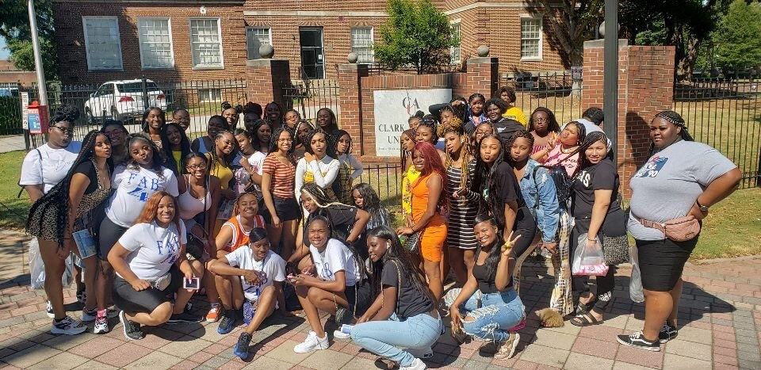

Students on the 2019 tour visiting Lucas’ school, Clark Atlanta University (courtesy Camielle Taylor)

Tate and Lucas also chose their respective HBCUs for similar reasons. Lucas felt Clark Atlanta better represented what she wanted from college and she felt a deeper connection to all the HBCUs she applied to. Tate felt Howard connected to a sense of success she had found in her time at Butler.

In her junior year, Tate took an African American literature course that changed her life. “At that moment I knew how important my success as a Black woman meant to me. I’m learning all these things that I’ve been through, what I’m going through now, where I could be in the future,” she says. “All that mattered to me was representing Black excellence.”

The final push that led Tate to Howard was the HBCU tour. When she saw the campus, she found it much easier to envision herself there and really get a feel for the school. She saw what Black excellence could look like for her and the possibilities that Howard might offer.

Lucas says she felt the same way at Clark Atlanta. She wanted to be one of those students she saw walking down the promenade. Taylor finds that to be the most important impact the HBCU tour has on students. “It shows kids that they can be college students,” she says. “It allows them to see iterations of themselves on college campuses.”

Both Tate and Lucas both think programs like Butler’s HBCU tour should be more common. According to Taylor, multiple schools reached out to her about planning an HBCU tour, but nothing ever came of it.

Tate says, “Imagine the success rates if kids had these opportunities or even know that it’s possible. When you have places like Butler that not only talk to you about these opportunities but help you visit, get a real feel and perspective… your mindset changes completely.”

**Source List:**

* Brian J. Riddick, [briddick@butlercollegeprep.org](mailto:briddick@butlercollegeprep.org)
* Camielle Taylor, [ctaylor@butlercollegeprep.org](mailto:ctaylor@butlercollegeprep.org)
* Kiarra Tate, (872)212-8200
* Kayla Lucas, (772)301-7355
* <https://nobleschools.org/about/>
* <https://chicagounheard.org/blog/butler-college-prep-cultivates-black-excellence-prepares-grads-for-hbcus/>

*Really good story, Kiki, and a personal revelation for me. I didn’t know about these tours, and I think a general audience wouldn’t either, or how important they are to Black high school students and those from low-income background, specifically, who might have never considered college. You make that experience real for them in this story. You allow them to speak for themselves, and also add in comments from administrators, including the teacher who innovated this program, to show its motivation and effect. That’s good story telling. I think what you show more than anything here is that the time-honored reason for the establishment of HBCU’s was to educated African Americans, and that they are still carrying on that tradition. And through the efforts of the staff at Butler, your story shows that they are doing their part to create more working Black professionals who can carry this nation farther into the 21st Century.*

*It also resonated personally with me. My mother spent her first two years in college at Fisk before she transferred and finished up at Northwestern. She always spoke highly of her time at Fisk and came away from it with lifelong friends, including our family doctor, who was a graduate of MeHarry. I made some minor edits, but you get the full 20 points for this story. It’s was a good choice to pull out of your education beat.*

*And it was a pleasure working with you again.*