The improvements of “the situation of China’s higher education”

Abstract

The story of the graph

九月份是中国高校的开学季，许许多多的中国青年走进了高等院校的校园。中国的高等院校培养出了一代代年轻有为的中国青年，投身于中国发展的各行各业。

September is the back-to-school season for Chinese colleges and universities. Many Chinese young people go to the campus of colleges and universities. China's institutions of higher education have produced generations of promising young Chinese people who have devoted themselves to all walks of life in China's development.

中国现代高等教育波澜壮阔发展的序幕正式开启可以追溯到1895年10月２日，天津大学的前身北洋大学在天津诞生。

The spectacular development of China's modern higher education can be traced back to October 2, 1895, when the predecessor of Tianjin University, Imperial Tientsin University, was born in Tianjin.

中华人民共和国成立之初，中国仅有普通高等学校205所，经过数十年发展，尤其是1999年中国高等院校开始实行扩大招生之后，高等院校的数量、招生人数、在校生人数、毕业生人数以及学校的规模都有了爆炸式的增长。

At the beginning of the People's Republic of China, there were only 205 general colleges and universities in China. After decades of development, especially after the Chinese general colleges and universities began enrollment expansion in 1999, the number of general colleges and universities, the number of students, the number of graduates and the size of schools have all exploded.

为了了解相关情况，我们找到了一张图表（<http://www.news.cn/datanews/20211015/C999058529900001C39214B0FE601D68/20211015C999058529900001C39214B0FE601D68_1211351537_1630390571638_title.jpg>）。

然而，再研究图表的相关数据时，我们团队发现了很多该图再可视化方面很多不合理的地方。

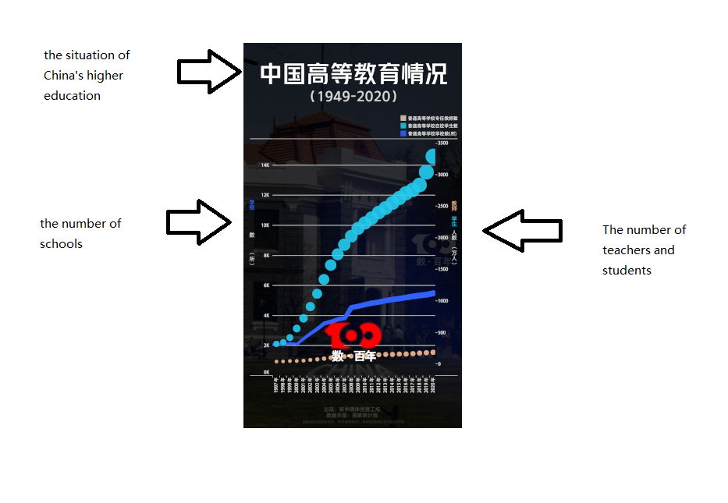

In order to understand the specific information, We found a graph (<http://www.news.cn/datanews/20211015/C999058529900001C39214B0FE601D68/20211015C999058529900001C39214B0FE601D68_1211351537_1630390571638_title.jpg>)

However, when reviewing the data of the graph, our team found a lot of inadequacies in the visualization of the graph.

该图的X轴是年份信息，从1997年一直到2020年。Y轴则分为左右两边，左侧表示学校的数量；右侧表示教师和学生的人数，单位为“万人”。左侧Y轴对应的是图表中一条深蓝色的折线，代表普通高等学校数；右侧的Y轴对应的是图表中的两条散点，蓝色的散点表示普通高等学校在校学生数，棕色的散点表示普通高等学校专任教师数。

On the X-axis is the year information, from 1997 to 2020. The Y-axis is divided into the left and right sides, the left side represents the number of schools. On the right, indicates the number of teachers and students. The unit is ten thousand. The Y-axis on the left corresponds to the dark blue broken line in the graph, which represents the number of general colleges and universities; The Y-axis on the right corresponds to the two scatter points in the graph. The blue scatter points indicates the number of students in general colleges and universities, and the brown scatter points indicates the number of full-time teachers in general colleges and universities.

这些数据看上去井井有条，但实际上在可视化方面却有着一些不足。首先，我们团队发现，它的X轴的相对长度短，导致表示年份的X轴坐标垂直了，不便于我们查看。其次，散点表示人数时，变化趋势并没有特别直观，并且散点太大，不便于我们直接观察不同年份的具体人数数据。最后，两侧的Y轴坐标的原点高低不同，左侧的Y轴坐标区间太大（6K~14K的坐标甚至没有任何作用），右侧的坐标没有直线引导不便于观察数据。

The data looks neat, but it actually has some shortcomings in visualization. First, our team found that the relative length of its X-axis was short, which made the X-axis coordinates representing the year vertical and not convenient for us to observe. Secondly, when the scatter points represent the number of people, the change trend is not particularly intuitive, and the scatter points are too large for us to directly observe the specific data of the number of people in different years. Finally, the origin’s height of the Y-axis coordinates on both sides is different, the coordinate interval of the left Y-axis is too large (the coordinates of 6K~14K even have no effect), and the coordinate on the right is not guided by a straight line, which is not convenient for data observation.

针对上面的这些问题，我们的团队决定改进这张可视化图表。

In response to these problems, our team decided to improve the visualization graph.

这张图表展示了中国现代高等教育（1997~2020）从精英化走向大众化再走向普及化，成为世界上最大规模的高等教育大国的趋势，是了解、研究中国现代高等教育发展的重要图表材料。因此，对该图进行改进具有重大的意义。

This graph shows the trend of China's modern higher education (1997-2020) from elitism to popularization and then to popularization. China becomes one of the largest countries of higher education in the world. It is an important graph material for understanding and studying the development of China's modern higher education. Therefore, it is of great significance to improve the graph.

Improvements

Summary