**GROUP-4 REPORT**

**SPACE VEHICLE FOR TOURISTS**

**INTRODUCTION**

Space tourism is the activity of traveling into space for **recreation**, leisure, or business purposes. Since the trip of the world’s first space tourist, **Dennis Tito**, space tourism has achieved new heights. With its rising demand, many space-based companies are developing space vehicles capable of carrying tourists to outer space and returning safely.

There are mainly 2 types of space tourism-

* **Sub-Orbital Space Tourism**- Suborbital flights go into space, but then **their trajectory carries them back to the earth (traversing a parabolic path)**. These flights reach an altitude of about 100km and give tourists a few minutes in space. This requires **much less energy** and is a **fraction of the cost** compared to sending it to orbit or ISS.

Examples of such sub-orbital space tourist vehicles are-

* Blue Origin’s **New Shepard**
* Virgin Galactic’s **VSS Unity**
* **Orbital Space Tourism**- Unlike suborbital flights, orbital flights reach an altitude of over **400 km** and spend days or even weeks in space. They are much **more expensive** than the sub-orbital ones and thus are limited to a few flights to the ISS operated by SpaceX and NASA.

A few Examples of orbital space vehicles are-

* SpaceX’s **Crew Dragon**
* Boeing’s **Starliner Capsule**

**BRIEF WORKING**

Here, we are going to explain the brief working of Blue Origin’s **New Shepard** which is a suborbital space vehicle.

The New Shepard is a **reusable**, vertical take-off, vertical landing space vehicle composed of two main parts: a pressurized **crew capsule** and a **propulsion module**. The New Shepard is controlled entirely by onboard computers, without ground control or a human pilot.

For a normal flight, New Shepard launches vertically and rises for about 2.5 minutes before the main engine cuts off and the crew module **separates** from the propulsion module. The propulsion module performs a controlled landing back to the ground. Passengers are **weightless** for about **4 minutes** during the **11-minute flight** and are at an altitude of about **100 km** to see the curvature of Earth. The spacecraft glides for a few minutes in space before re-entering the atmosphere with the crew module landing under parachutes.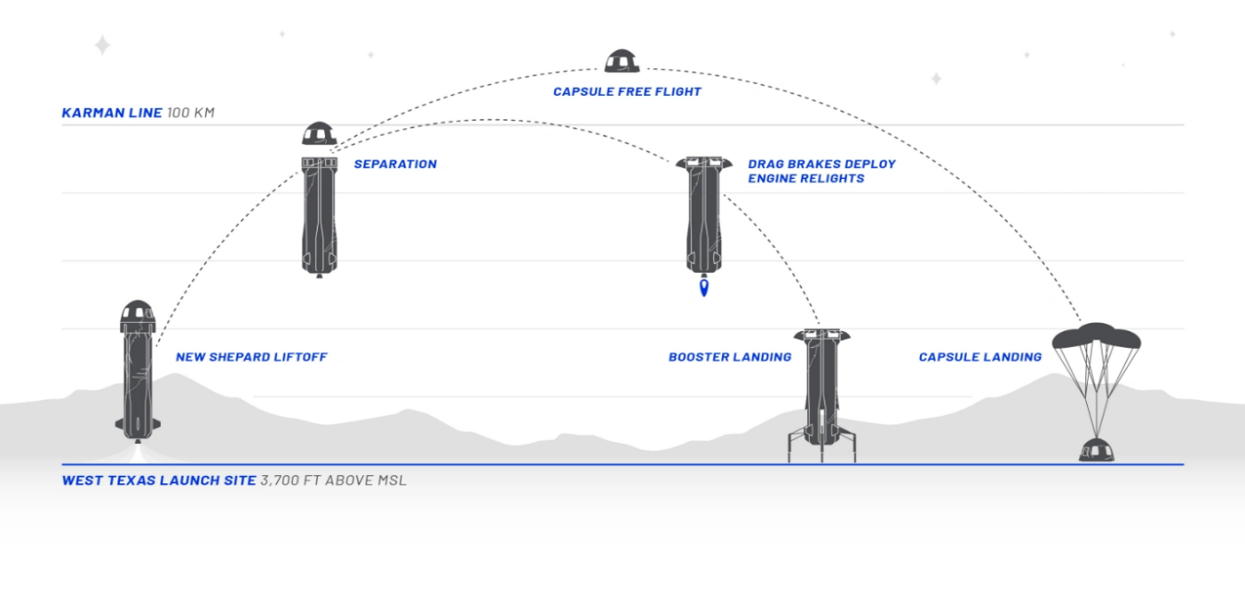

Text BoxThe crew module can also separate in case of **vehicle malfunction** or other emergency using solid propellant separation boosters and perform a parachute landing.

**PHYSICS BEHIND LAUNCH VEHICLES:**

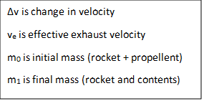The basic principle behind the launch vehicles is **Newton’s third law of motion**, action-reaction pair of ejection of mass downwards and thrust in the upward direction. The mass ratio requirements are further obtained from the rocket equation:

Δv = velnm0m1 *∆v = veln⁡m0m1*

on rearranging we get

m0m1= eΔv/ve*m0m1= e∆v/ve*

m0m1*m0m1*

is called **mass ratio**.

After taking aerodynamical drag and other factors into consideration the typical mass ratio to attain the required velocity is in the range of 8 to 20.

**MECHANICAL INTERFACE**

**STRUCTURAL SYSTEM:**

The structural system includes the parts like the body, control fins etc. that make up the overall framework of the rocket.

**Requirements for take-off:**

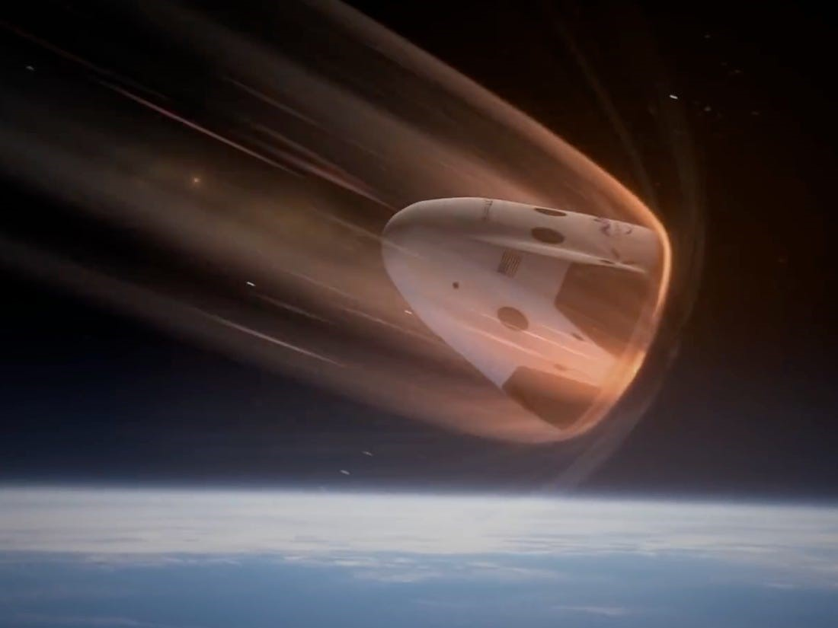The launch vehicles have a ‘nose cone’ structure to minimize drag. The body is made of materials such as Al, Ti, Al-Li alloy which being strong and lightweight, can withstand the pressure developed during the flight. Nowadays, the metals are replaced with lighter and durable carbon fibre materials, but the bulkhead is still made of metals to withstand high amounts of pressure and heat.

**Requirements for re-entry:**

The spacecraft is a ‘bluntly shaped nose cone’ and re-enters the atmosphere at an angle of 40°. The drag causes an enormous amount of heat, raising the temperature to 3000°F. Thus, it is made of reinforced carbon which can withstand high temperatures. After the speed has been reduced to about 350 miles/hour, parachutes are deployed to further reduce the speed to ensure a soft landing for the passengers.

**Payload and Life Support System:**

Payload refers to the cargo of the spacecraft, in this case, it is the passengers. The safety of the cargo is the priority of any space mission.

For humans to survive in the extreme conditions of an outer-space life support system is necessary. The life support system provides oxygen and proper air pressure needed for

Text Boxsurvival. Space food and water are generally stored. Water is recycled meticulously to meet the requirements. Oxygen is sometimes obtained through the electrolysis of water.

**PROPULSION SYSTEM:**

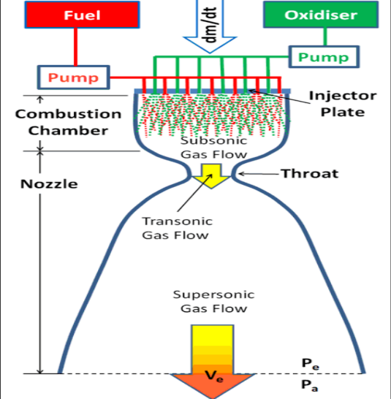The system includes the parts which make up the rocket engine, the tanks, propellants, and the rocket nozzle. In the rocket engine, fuel and oxidizer (propellant) are mixed and exploded in a combustion chamber to produce a hot exhaust which is passed through the rocket nozzle to accelerate the flow and produce the thrust.

Different types of rockets and space vehicles have different types of engines and propellants used for propulsion like for New Shepard (Blue origin) -

* It has Blue Origin's BE3 rocket engine.
* Propellants -Liquid hydrogen (LH2) and Liquid oxygen (LOX)

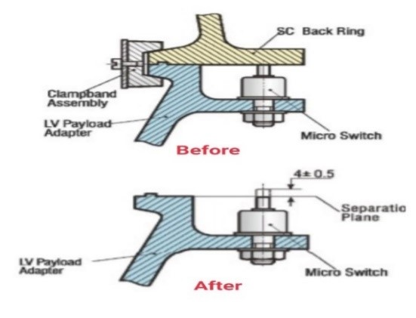**SEPARATION:**

* The separation mechanism consists of a clamp band, explosive bolts, and springs.
* The separation system uses a clamp band to release the Spacecraft (SC) from the launch vehicle.
* The separation mechanism provides the relative separation velocity between the capsule and launch vehicle via springs.

**ELECTRICAL INTERFACE**

**POWER SYSTEM Determining power source is crucial and usually depends upon the mission of the flight. In space vehicles, power can be generated by fuel cells, solar arrays, or nuclear reactors. APU also provides primary power to various systems.**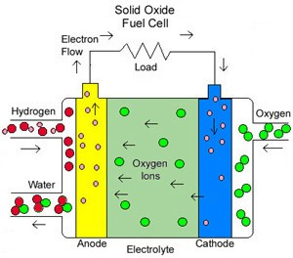

**Working:** Fuel cells convert chemical energy into electrical energy by performing a chemical reaction. No moving parts are needed for their operation making it independent of gravitational changes. Fuel cells work by reacting an oxidizing agent with fuel, mostly hydrogen. The chemical reaction generates a current that flows between cathode and anode. For tourist vehicles, the working of solar cells is well understood, but their occupancy makes it uncertain. Nuclear reactors are heavy and inefficient for near-earth space voyages. A power failure in any orbit can be catastrophic to both the crew and the capsule. Thus, an impeccable power system is mandatory.

**AUXILIARY POWER UNITS (APU)**

**Function:** APU is a turbine-driven power unit that usually works using hydrazine as fuel to produce energy (other than propulsion module). This power is used for the functions like flying up, re-entry, and landing back. The APUs in huge vehicles are comparable to electric motors in small vehicles.

**Working:** The APU is equipped with an extra electrical generator to create enough power. It has its own controller which gives a go-ahead before the APU is started. The controller detects the malfunction and controls the unit’s turbine gearbox pressurization and fuel pump when APU is not in operation. Sometimes, the APU is used as an emergency electrical power source while the space vehicle is airborne.

Text Box**COMMUNICATION AND DATA ACQUISITION SYSTEM**

On a basic level, any communication system depends on a **transmitter** and a **receiver**. This basic framework is expanded to a **massive** scale for space vehicles to communicate with us on earth. The transmitters **spread across the world** widens the range of communication, while the radio receivers are huge.

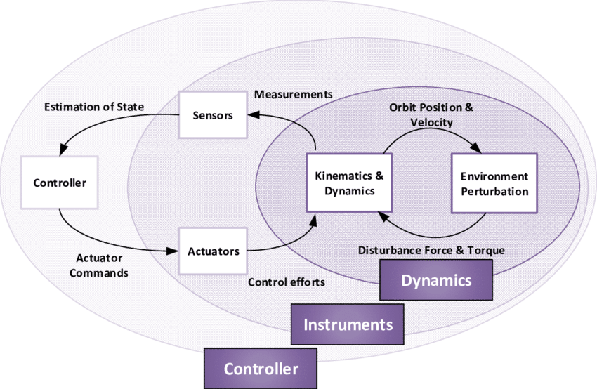**Telemetry** is the communication of data from remote systems to a required place. This is usually done using **radio waves**. Due to **bandwidth limitations**, pieces of data are sent quickly one after the other. In the past, the order of these ‘pieces’ was predefined, however at present, **‘packetizing’** is used, in which one ‘packet’ of data is sent after another, with each ‘packet’ having an identification of its information so that there is no need for a specific order. Better systems like **laser communication system**, are being explored to **reduce time lag**. This encodes the data onto laser beams, which operate in wavelengths 104 times shorter than the radio waves meaning more data can be sent per second. Lasers also maintain better signal strength across large distances.  
  
GUIDANCE, NAVIGATION, CONTROL SYSTEM:

* **Guidance:** It determines the reference trajectory, which describes the desired path of travel of the spacecraft. It determines the changes in velocity, rotation, acceleration necessary to follow that path.
* **Navigation:**Navigation tracks the spacecraft's position (velocity, attitude). It includes orbit reconstruction (where the spacecraft has been), orbit determination (where it currently is), and orbit prediction (future).
* **Control:**It manipulates the forces to execute commands from the guidance system to bring the spacecraft back on track, while maintaining the stability of the spacecraft.

The GNC subsystem includes the devices used for determining the position and those used by the **ADCS** **(Attitude Determination and Control System).**

ADCS has **sensors** (like angular rate sensors) to determine attitude. It also has **actuators** (magnetic torquers, reaction wheels, thrusters) that can change the attitude of the spacecraft. It can stop the manoeuvres when the desired change is achieved.

**INTERACTION AMONG SUBSYSTEMS-**

* The Attitude Determination and **Control Systems** (ADCS) and **propulsion systems** work side by side to position and control the space vehicle.
* The **command and data handling** facilitates as well as control all the internal **communication**
* The **control systems** are also responsible for antenna positioning**(communication)** of the space vehicle.

**IMPROVEMENTS**

* A better propulsion system capable of interplanetary (such as Mars or the Moon) or interstellar travel to reduce time duration for space tourists.
* Improvements in the structure of space vehicles for the planetary environment.
* Safety factors to reduce the number of high risks for space tourists. For example, long durations for tourists with a gravity lower than earth may cause serious health issues.

Text Box

**PROSPECTS**

**Near future scenarios**:

* 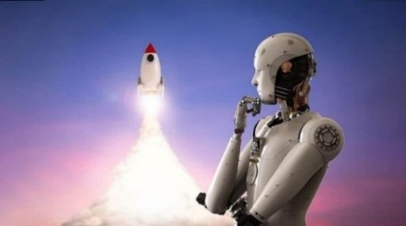**AI operated systems** that can read and process data from space, reveal some deviations in space travel if occurred and use cognitive video to make more efficient communication networks.
* As the **electric propulsion systems** have low thrust characteristics, the use of large lasers may enhance the effectiveness for a short travel distance. **Nuclear rocket propulsion** instead of electric propulsion engines and conventional chemical systems can provide much higher specific impulses.
* **Radiation biology** (pharmacological bio protection) is constantly progressing towards human radiation protection from galactic cosmic radiations, solar particle events (SPE), etc. to reduce long-term radiation effects.

**Far-fetched scenarios**:

* Generating localized gravity inside space vehicles.
* Human teleportation i.e., transmitting all information about a person at the speed of light.

However, physicists predict this prospect may take about one hundredth the age of the universe.

**CONTRIBUTIONS:**

* **Anand Mathapati (EE21BTECH11033)**: Improvements, Prospects, Interconnection between subsystems
* **Jacky Meena (EE21BTECH11025)**: Research on Propulsion System, Bibliography
* **Kartik Agrawal (EE21BTECH11030):** Introduction, Brief working, Editing
* **Komaragiri Sai Pranav (EE21BTECH11032)**: Physics behind launch vehicles, Structural System, Payload and Life Support system, Power System image, Editing
* **Rayani Venkat Sai Rithvik (EE21BTECH11043):** Communication and Data Acquisition system
* **Riya Ann Easow (EE21BTECH11044):** Guidance, Navigation, Control System, Editing, Formatting
* 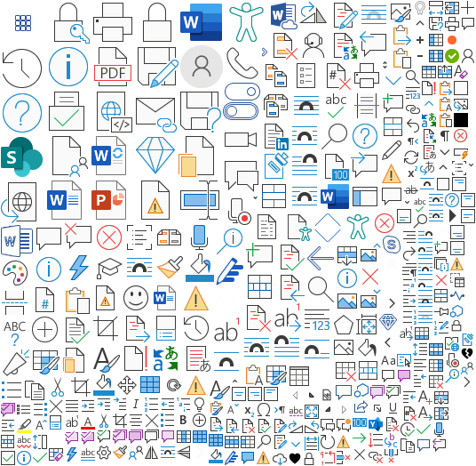
* **Sandhi Sai Sujith Reddy (EE21BTECH11048)**: Propulsion system (Research and Writing), Separation
* **Sai Manasa Veena (EE21BTECH11031):** Power system, Auxiliary Power Units, Editing

**BIBLIOGRAPHY**

* <https://en.wikipedia.org/wiki/SpaceX_launch_vehicles/>
* <https://www.nasaspaceflight.com/2021/01/dragon-departs-iss-with-science/>
* <https://www.mpoweruk.com/images/rocket_motor.gif>
* <http://www.cgwic.com/launchservices/download/manual/Chapter%205%20Mechanical%20&%20Electrical%20Interfaces.pdf>
* <https://americanhistory.si.edu/fuelcells/basics.htm>
* <https://www.qrg.northwestern.edu/projects/vss/docs/communications/zoom-messages.html>
* <https://www.oxfordreference.com/view/10.1093/oi/authority.20110803100300431>
* <https://www.researchgate.net/figure/Three-layer-functions-of-AOCS-GNC-system_fig1_289486402>
* [https://www.mouser.com/blog/7-things-to-know-about-spacecraft-subsystems-before-your- next-trip-to-mars](https://www.mouser.com/blog/7-things-to-know-about-spacecraft-subsystems-before-your-next-trip-to-mars)
* <https://ocw.tudelft.nl/wp-content/uploads/1.0-Command-and-Data-Handling-Lecture-Notes.pdf>
* <https://indico.cern.ch/event/650860/contributions/2654764/attachments/1521358/2376772/MEDICIS-Leuven-Baatout.pdf>
* <https://media.springernature.com/full/springer-static/image/art%3A10.1038%2Fs41526-020-00124-6/MediaObjects/41526_2020_124_Fig1_HTML.png>
* Books referred – Space Tourism — From Dream to Reality

**REFERENCES**

* Introduction, Brief Working-
  1. Wikipedia- <https://en.wikipedia.org/wiki/Space_tourism>
  2. Space.com- <https://www.space.com/40372-new-shepard-rocket.html>
* Physics behind launch vehicles, Structural System-
  1. K
  2. l
* Propulsion system, Separation-
  1. <https://www.grc.nasa.gov/www/k-12/rocket/rocket.html>
  2. <http://www.cgwic.com/launchservices/download/manual/Chapter%205%20Mechanical%20&%20Electrical%20Interfaces.pdf>
* Power System, APU-
  1. 1
  2. 2
* Communication and data acquisition system -
  1. <https://www.qrg.northwestern.edu/projects/vss/docs/communications/zoom-messages.html>
  2. <https://www.oxfordreference.com/view/10.1093/oi/authority.20110803100300431>
* Guidance, navigation, control system

1. <https://solarsystem.nasa.gov/basics/chapter13-1/>
2. <https://www.nasa.gov/smallsat-institute/sst-soa/guidance-navigation-and-control>

* Interaction among subsystems –
  1. 1
  2. 2
* Improvements and Prospects-

1. <https://ocw.tudelft.nl/wp-content/uploads/1.0-Command-and-Data-Handling-Lecture-Notes.pdf>
2. <https://indico.cern.ch/event/650860/contributions/2654764/attachments/1521358/2376772/MEDICIS-Leuven-Baatout.pdf>
3. <https://media.springernature.com/full/springer-static/image/art%3A10.1038%2Fs41526-020-00124-6/MediaObjects/41526_2020_124_Fig1_HTML.png>
4. <https://www.analyticsinsight.net/wp-content/uploads/2021/01/The-Future-of-Space-Explorations-is-in-the-Hands-of-AI-and-Robotics.jpg>

Book referred – Space Tourism — From Dream to Reality.