SXPD-C Unit Test Plan

Introduction
This document is development unit test plan for the SXPD daemon on linux platform. The test plan will address testing SXP daemon functionality.

What Will Be Tested
This test plan will cover SXP functionality between multiple SXP daemon instances and/or between SXP daemon on linux.
- Learning of IP-SGT mapping from other peers
- Conflict resolution among IP-SGT mappings
- Update of IP-SGT mapping after advertisement/configuration change
- Propagation of learnt IP-SGT mappings to SXP peers
- SXP connection recovery
- SXP protocol specification conformance

Test topologies

Simple topology
Simple topology is used for test cases where only 2 SXPD instances are required:
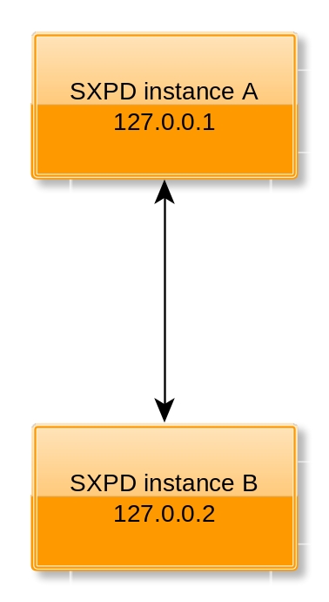
Figure 1 - simple topology

Complex topology
This topology is used where more than 2 instances are required, e.g. for snake tests. In this topology SXPD instance A is a speaker for SXPD instance B, SXPD instances B & E are speakers for SXPD instance C and SXPD instance C is speaker for SXPD instance D.
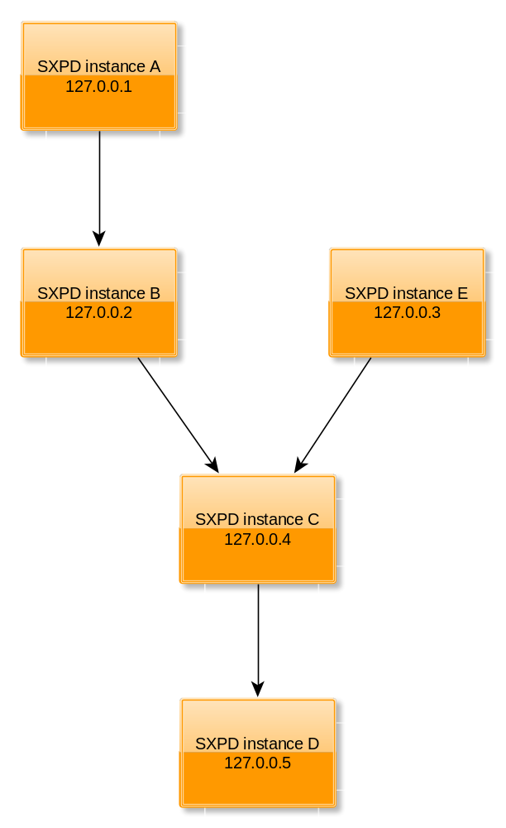
Figure 2 - complex topology

Test cases

Default settings

Default setting - retry timer
Description | Verify that the default setting for retry timer is 120 seconds
Test Setup | Linux SXPD instance
Procedure | - Create valid configuration file for instance A without global option retry_timer  - Start the topology
Pass/Fail Criteria | - In step 2., the default value of 120 seconds is used for retry timer by instance A

Default setting – reconciliation timer
Description | Verify that the default setting for reconciliation timer is 120 seconds
Test Setup | Linux SXPD instance
Procedure | - Create valid configuration file for instance A without global option reconciliation_timer  - Start the topology
Pass/Fail Criteria | - In step 2., the default value of 120 seconds is used for reconciliation timer by instance A

Default setting – speaker minimum hold time
Description | Verify that the default setting for speaker minimum hold time is 120 seconds.
Test Setup | Linux SXPD instance
Procedure | - Create valid configuration file for instance A without global option speaker_min_hold_time.  - Start the topology
Pass/Fail Criteria | - In step 2., the default value of 120 seconds is used for speaker minimum hold time by instance A

Default setting – listener minimum hold time
Description | Verify that the default setting for listener minimum hold time is 90 seconds.
Test Setup | Linux SXPD instance
Procedure | - Create valid configuration file for instance A without global option listener_min_hold_time.  - Start the topology
Pass/Fail Criteria | - In step 2., the default value of 90 seconds is used for listener minimum hold time by instance A

Default setting – listener max hold time
Description | Verify that the default setting for listener maximum hold time is 180 seconds.
Test Setup | Linux SXPD instance
Procedure | - Create valid configuration file for instance A without global option listener_max_hold_time.  - Start the topology
Pass/Fail Criteria | - In step 2., the default value of 180 seconds is used for listener maximum hold time by instance A

Default setting – keep alive timer
Description | Verify that the default configuration value for keep alive timer is is that the keepalive mechanism is unused
Test Setup | Linux SXPD instance
Procedure | - Create valid configuration file for instance A without global option keepalive_timer  - Start the topology
Pass/Fail Criteria | - In step 2., the default value of keepalive_timer is set to unused

Default setting – subnet expansion limit
Description | Verify that default setting for subnet expansion limit is 0
Test Setup | Linux SXPD instance
Procedure | - Create valid configuration file without global option subnet_expansion_limit.  - Run the SXPD instance
Pass/Fail Criteria | - In step 2., the default value of subnet expansion limit is set to 0

Default setting – default_connection_passwd
Description | Verify that default connection password is none
Test Setup | Linux SXPD instance
Procedure | - Create valid configuration file without global option default_connection_passwd.  - Run the SXPD instance
Pass/Fail Criteria | - In step 2., the default value of default connection password is set to none

Default setting – bind ip
Description | Verify that default bind ip is 0.0.0.0
Test Setup | Linux SXPD instance
Procedure | - Create valid configuration file without global option bind_ip  - Run the SXPD instance
Pass/Fail Criteria | - In step 2., verify using netstat that the SXPD instance is bound to 0.0.0.0 address

Default setting – port number
Description | Verify that default port is 64999
Test Setup | Linux SXPD instance
Procedure | - Create valid configuration file without global option port  - Run the SXPD instance
Pass/Fail Criteria | - In step 2., verify using netstat that the SXPD instance is bound to port 64999

Default setting – node id
Description | Verify that the default node id is the highest IP address available on the system
Test Setup | Simple topology
Procedure | - Create valid configuration file without global option node_id  - Run the topology
Pass/Fail Criteria | - In step 2., the node id used by the SXPD instances is the highest IP address available

Default setting – enabled setting
Description | Verify that by default the SXPD is disabled
Test Setup | Linux SXPD instance
Procedure | - Create valid configuration file without global option enabled  - Run the SXPD instance
Pass/Fail Criteria | - In step 2., the SXPD instance is disabled and warning message is printed

Configuration

Configuration validation/load/reload/change of global options - retry timer
Description | Verify that valid configuration is successfully parsed and validated
Test Setup | Linux SXPD instance
Procedure | - Create valid configuration file with global option retry_timer  - Create 2nd configuration file covering the same option but with different value  - Load the 1st config  - Load the 1st config again  - Load the 2nd config
Pass/Fail Criteria | - In step 3., the config is parsed and validated without error and the setting is loaded with the correct value  - In step 4., the config is parsed and validated without error, but no callbacks are called, since no option has changed  - In step 5., the config is parsed and validated without error, and callback is called for the changed value

Configuration validation/load/reload/change of global options – reconciliation timer
Description | Verify that valid configuration is successfully parsed and validated
Test Setup | Linux SXPD instance
Procedure | - Create valid configuration file with global option reconciliation_timer  - Create 2nd configuration file covering the same option but with different value  - Load the 1st config  - Load the 1st config again  - Load the 2nd config
Pass/Fail Criteria | - In step 3., the config is parsed and validated without error and the setting is loaded with the correct value  - In step 4., the config is parsed and validated without error, but no callbacks are called, since no option has changed  - In step 5., the config is parsed and validated without error, and callback is called for the changed value

Configuration validation/load/reload/change of global options – speaker minimum hold time
Description | Verify that valid configuration is successfully parsed and validated
Test Setup | Linux SXPD instance
Procedure | - Create valid configuration file with global option speaker_min_hold_time  - Create 2nd configuration file covering the same option but with different value  - Load the 1st config  - Load the 1st config again  - Load the 2nd config
Pass/Fail Criteria | - In step 3., the config is parsed and validated without error and the setting is loaded with the correct value  - In step 4., the config is parsed and validated without error, but no callbacks are called, since no option has changed  - In step 5., the config is parsed and validated without error, and callback is called for the changed value

Configuration validation/load/reload/change of global options – listener minimum hold time
Description | Verify that valid configuration is successfully parsed and validated
Test Setup | Linux SXPD instance
Procedure | - Create valid configuration file with global option listener_min_hold_time  - Create 2nd configuration file covering the same option but with different value  - Load the 1st config  - Load the 1st config again  - Load the 2nd config
Pass/Fail Criteria | - In step 3., the config is parsed and validated without error and the setting is loaded with the correct value  - In step 4., the config is parsed and validated without error, but no callbacks are called, since no option has changed  - In step 5., the config is parsed and validated without error, and callback is called for the changed value

Configuration validation/load/reload/change of global options – listener max hold time
Description | Verify that valid configuration is successfully parsed and validated
Test Setup | Linux SXPD instance
Procedure | - Create valid configuration file with global option listener_max_hold_time  - Create 2nd configuration file covering the same option but with different value  - Load the 1st config  - Load the 1st config again  - Load the 2nd config
Pass/Fail Criteria | - In step 3., the config is parsed and validated without error and the setting is loaded with the correct value  - In step 4., the config is parsed and validated without error, but no callbacks are called, since no option has changed  - In step 5., the config is parsed and validated without error, and callback is called for the changed value

Configuration validation/load/reload/change of global options – keep alive timer
Description | Verify that valid configuration is successfully parsed and validated
Test Setup | Linux SXPD instance
Procedure | - Create valid configuration file with global option keepalive_timer  - Create 2nd configuration file covering the same option but with different value  - Load the 1st config  - Load the 1st config again  - Load the 2nd config
Pass/Fail Criteria | - In step 3., the config is parsed and validated without error and the setting is loaded with the correct value  - In step 4., the config is parsed and validated without error, but no callbacks are called, since no option has changed  - In step 5., the config is parsed and validated without error, and callback is called for the changed value

Configuration validation/load/reload/change of global options – subnet expansion limit
Description | Verify that valid configuration is successfully parsed and validated
Test Setup | Linux SXPD instance
Procedure | - Create valid configuration file with global option subnet_expansion_limit  - Create 2nd configuration file covering the same option but with different value  - Load the 1st config  - Load the 1st config again  - Load the 2nd config
Pass/Fail Criteria | - In step 3., the config is parsed and validated without error and the setting is loaded with the correct value  - In step 4., the config is parsed and validated without error, but no callbacks are called, since no option has changed  - In step 5., the config is parsed and validated without error, and callback is called for the changed value

Configuration validation/load/reload/change of global options – default_connection_passwd
Description | Verify that valid configuration is successfully parsed and validated
Test Setup | Linux SXPD instance
Procedure | - Create valid configuration file with global option default_connection_passwd  - Create 2nd configuration file covering the same option but with different value  - Load the 1st config  - Load the 1st config again  - Load the 2nd config
Pass/Fail Criteria | - In step 3., the config is parsed and validated without error and the setting is loaded with the correct value  - In step 4., the config is parsed and validated without error, but no callbacks are called, since no option has changed  - In step 5., the config is parsed and validated without error, and callback is called for the changed value

Configuration validation/load/reload/change of global options – bind ip
Description | Verify that valid configuration is successfully parsed and validated
Test Setup | Linux SXPD instance
Procedure | - Create valid configuration file with global option bind_ip  - Create 2nd configuration file covering the same option but with different value  - Load the 1st config  - Load the 1st config again  - Load the 2nd config
Pass/Fail Criteria | - In step 3., the config is parsed and validated without error and the setting is loaded with the correct value  - In step 4., the config is parsed and validated without error, but no callbacks are called, since no option has changed  - In step 5., the config is parsed and validated without error, and callback is called for the changed value

Configuration validation/load/reload/change of global options – port number
Description | Verify that valid configuration is successfully parsed and validated
Test Setup | Linux SXPD instance
Procedure | - Create valid configuration file with global option port_number  - Create 2nd configuration file covering the same option but with different value  - Load the 1st config  - Load the 1st config again  - Load the 2nd config
Pass/Fail Criteria | - In step 3., the config is parsed and validated without error and the setting is loaded with the correct value  - In step 4., the config is parsed and validated without error, but no callbacks are called, since no option has changed  - In step 5., the config is parsed and validated without error, and callback is called for the changed value

Configuration validation/load/reload/change of global options – node id
Description | Verify that valid configuration is successfully parsed and validated
Test Setup | Linux SXPD instance
Procedure | - Create valid configuration file with global option node_id  - Create 2nd configuration file covering the same option but with different value  - Load the 1st config  - Load the 1st config again  - Load the 2nd config
Pass/Fail Criteria | - In step 3., the config is parsed and validated without error and the setting is loaded with the correct value  - In step 4., the config is parsed and validated without error, but no callbacks are called, since no option has changed  - In step 5., the config is parsed and validated without error, and callback is called for the changed value

Configuration validation/load/reload/change of global options – enabled setting
Description | Verify that valid configuration is successfully parsed and validated
Test Setup | Linux SXPD instance
Procedure | - Create valid configuration file with global option enabled set to true  - Create 2nd configuration file covering the same option set to false  - Load the 1st config  - Load the 1st config again  - Load the 2nd config
Pass/Fail Criteria | - In step 3., the config is parsed and validated without error and the setting is loaded with the correct value  - In step 4., the config is parsed and validated without error, but no callbacks are called, since no option has changed  - In step 5., the config is parsed and validated without error, and callback is called for the changed value

Connection management

Connection setup
Description | Verify that SXPD connects to and accept connections from configured peers
Test Setup | Simple topology used
Procedure | - Create configuration file for instance A which contains peer entry representing instance B and vice versa  - Run the SXPD instances  - Try the same setup for different combinations:  - instance A is SPEAKER, instance B is LISTENER  - instance A is LISTENER, instance B is SPEAKER  - Both instances have BOTH setting
Pass/Fail Criteria | - Connection is established  - If only one connection is required and both instances connect at the same time, the connection originating from the instance with higher IP address is kept and the other connection is torn down

Connection error handling
Description | Verify that SXPD reconnects to and accept connections from configured peers when error occurs
Test Setup | Simple topology
Procedure | - Create configuration file for instance A which contains peer entry representing instance B and vice versa  - Run the SXPD instances  - Stop instance B  - Start instance B  - Try the same setup for different combinations:  - instance A is SPEAKER, instance B is LISTENER  - instance A is LISTENER, instance B is SPEAKER  - Both instances have BOTH setting
Pass/Fail Criteria | - In Step 2., connection is established  - If only one connection is required and both instances connect at the same time, the connection originating from the instance with higher IP address is kept and the other connection is torn down  - In Step 4., connection is re-established

TCP-MD5 signing
Description | Verify that SXPD connects to and accept connections from configured peers with tcp-md5 signing option enabled
Test Setup | Simple topology used
Procedure | - Create configuration file for instance A which contains peer entry representing instance B and vice versa, configure connection password for both instances  - Run the topology  - Try the same setup for different combinations:  - instance A is SPEAKER, instance B is LISTENER  - instance A is LISTENER, instance B is SPEAKER  - Both instances have BOTH setting
Pass/Fail Criteria | - Connection is established  - If only one connection is required and both instances connect at the same time, the connection originating from the instance with higher IP address is kept and the other connection is torn down

Bindings management

Configuring bindings
Description | Verify that bindings are read from configuration and exported accordingly
Test Setup | Simple topology used
Procedure | - Configure IPv4 & IPv6 bindings, both subnets and host entries in configuration file of instance A  - Start topology  - Use debug prints/debug dump/gdbus interface to assert that bindings were exported from instance A and received by instance B
Pass/Fail Criteria | - All bindings are successfully received by instance B

Re-exporting bindings
Description | Verify that received bindings are re-exported to listener
Test Setup | Complex topology used with 3 SXPD instances enabled – A, B & C and 2 instances disabled(unused) – D & E  a.k.a. “snake test”
Procedure | - Configure IPv4 & IPv6 bindings, both subnets and host entries in configuration file of SXPD instance A  - Start all three instances  - Use debug prints/debug dump/gdbus interface to assert that bindings were exported from instance A and received by SXPD instance B and then re-exported to instance C
Pass/Fail Criteria | - All bindings are successfully received by SXPD instance C

Conflict management
Description | Verify that shortest peer-sequence rule is used
Test Setup | Complex topology used
Procedure | - Configure IPv4 & IPv6 bindings for instances A and E with same subnets but different tags  - Run the topology
Pass/Fail Criteria | - Instance C applies shortest peer-sequence rule when selecting binding for export and instance D receives bindings from instance E’s configuration

Binding withdrawal
Description | Verify that binding is withdrawn from the master database once all contributing bindings have been removed
Test Setup | Complex topology used
Procedure | - Configure IPv4 & IPv6 bindings for instances A & E with same subnets but different tags  - Run the topology  - Remove the bindings from configurations of instances A & E
Pass/Fail Criteria | - In step 2., instance C exports the bindings to instance D  - In step 3., instance C sends delete for the bindings to instance D

Bindings expansion
Description | Verify that bindings expansion works
Test Setup | Simple topology used
Procedure | - Configure instance A to contain bindings:  - 192.168.1.1/29 = 29  - 192.168.1.1/30 = 30  - 192.168.1.1/32 = 32  - Run topology.
Pass/Fail Criteria | - Using debug logs/debug dump/gdbus interface verify that all expanded bindings are successfully received by SXPD V1 instance B according to preference, so that the expanded host entries are:  - 192.168.1.1 = 32  - 192.168.1.2 = 30  - 192.168.1.3 = 29  - 192.168.1.4 = 29  - 192.168.1.5 = 29  - 192.168.1.6 = 29

Timers

Retry timer
Description | Verify that connection is retried according to retry timer
Test Setup | Simple topology used
Procedure | - Configure instance A to contain retry timer setting  - Run only instance A  - Wait for retry timer to expire a few times
Pass/Fail Criteria | - In step 3., whenever retry timer expires, instance A attempts to contact instance B and when the connection attempt fails, retry timer is re-armed and the whole process repeats again

Keep-alive timer
Description | Verify that connection is keep-alive messages are sent periodically with jitter
Test Setup | Simple topology used
Procedure | - Run topology  - Wait for keep-alive timer to expire a few times
Pass/Fail Criteria | - In step 2., whenever keep-alive timer expires, instance A sends KEEP-ALIVE message to instance B and then re-arms keep-alive timer and the whole process is repeated. The keep-alive timer is armed with random jitter so that it’s between 75%-100% of 1/3 of configured hold-time

Hold-down timer
Description | Verify that binding is withdrawn from the master database once all contributing bindings have been removed
Test Setup | Complex topology used
Procedure | - Configure IPv4 & IPv6 bindings for instances A & E with same subnets but different tags  - Run the topology  - Kill instances A & E
Pass/Fail Criteria | - In step 2., instance C exports the bindings to instance D  - In step 3., once hold-down timer expires, instance C sends delete for the bindings to the instance D

Hold timer
Description | Verify that connection is torn down if hold timer expires
Test Setup | Simple topology used
Procedure | - Configure instance A to contain IPv4 subnet binding  - Run topology, but launch instance A in debugger  - Break instance A to pause execution  - Wait for hold timer to expire  - Wait for hold-down timer to expire
Pass/Fail Criteria | - In step 2., instance A exports the binding to instance B  - In step 4., once the hold timer expires, instance B sends ERROR message to instance A, tears down the connection and arms hold-down timer  - In step 5., once hold-down timer expires, instance B deletes all bindings from instance A from both its peer & master databases

Reconciliation timer
Description | Verify that bindings which were not re-advertised after peer reconnects are removed when reconcile period expires
Test Setup | Complex topology used
Procedure | - Configure IPv4 subnet binding, IPv6 subnet binding and IPv6 host binding in instance A’s configuration with tag = 10, configure the same bindings in instance E’s configuration with tag 14  - Run the topology  - Modify configuration of instance A – remove IPv6 subnet and host entries so that only IPv4 entry remains, modify configuration of instance E – remove IPv4 entry and IPv6 subnet entry so that only IPv6 host entry remains  - Kill and restart instances A & E  - Wait for reconnection and reconcile period to expire
Pass/Fail Criteria | - In step 2., instance D contains all the configured bindings with tag = 14 (from instance E) due to shorter peer sequence  - In step 5., instance D contains only IPv4 subnet entry with tag = 10 (from instance A) and IPv6 host entry with tag = 14 (from instance E)

Negative cases

Configuration validation – negative case
Description | Verify that invalid configuration is not accepted
Test Setup | Linux SXPD instance
Procedure | - Create invalid configuration files with  - Syntax error (e.g. missing comma)  - Invalid values (e.g. out of range number)  - Invalid types (e.g. string instead of number)  - Load the configuration files
Pass/Fail Criteria | - In step 2., configuration parsing stops and error message indicating the problem is displayed to user

Mode mismatch
Description | Verify that connection cannot be established if roles are incompatible
Test Setup | Simple topology
Procedure | - Configure both instances A & B to be LISTENERs  - Run the topology  - Retry the scenario with both instances being SPEAKERs
Pass/Fail Criteria | - After parsing OPEN message, ERROR message is generated and connection is torn down

Expansion limit too low
Description | Verify that expansion limit is respected
Test Setup | Single SXPD instance
Procedure | - Configure SXPD instance with 2 IPv4 subnets – one which has less host entries and one which has more host entries than the configured expansion limit  - Run the instance
Pass/Fail Criteria | - Subnet which has less host entries is expanded, while the other subnet is not. Alert message is logged into syslog warning the user about this condition

SXP protocol

SXP message size limit
Description | Verify that the SXPD respects the SXP message size limit
Test Setup | Simple topology
Procedure | - Configure instance A as SPEAKER with 1000 IPv4 bindings, instance B as LISTENER  - Run the topology
Pass/Fail Criteria | - Instance A exports bindings to instance B in chunks/messages no longer than maximum allowed size 4096 bytes

END OF DOCUMENT

