Testing Project for Guru Bank

The scope of the final project for ITF Manual Testing Course is to use all gained knowledge through the course and apply them in practice, using a live application

Application under test: Guru Bank

Tools used: Jira, Zephyr Squad.

Functional specifications:

The below stories:

* Guru Bank Manager must be able to have have access to all module functionalities.
* 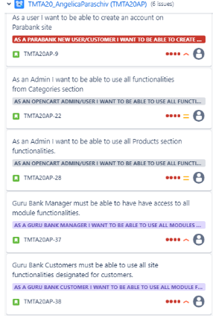Guru Bank Customers must be able to use all site functionalities designated for customers.

Were created in Jira and describes the functional specifications of the GURU BANK TMTA20_AP module, for which the final project is performed upon. daca aveti mai mult de doua recomand sa descarcati story-urile din jira si sa le incarcati ca fisier**

Here you can find the releases that were created for this project:

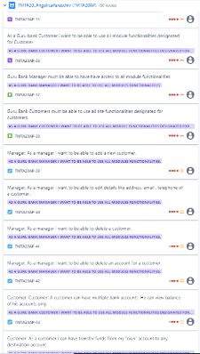

Testing process

The test process was performed based on the standard test process as described below.

1.1 Test planning

The Test Plan is designed to describe all details of testing for all the modules from the Guru Bank application.

The plan identifies the items to be tested, the features to be tested, the types of testing to be performed, the personnel responsible for testing, the resources and schedule required to complete testing, and the risks associated with the plan. The test plan that was created for this project can be found here: https://demo.guru99.com/V4/

1.1.1. Roles assigned to the project and persons allocated:

Project manager: John Smith

Product owner: Miguel Fernandez

Software developer: Angi Paraschiv

QA Engineer: Angelica Paraschiv

1.1.2 Entry criteria defined

**Product Analysis:**

* Understand the product/application in detail that is going to be tested.
* Identify functionalities, requirements, and associated risks.

**Testing Strategy:**

* Define how you will approach testing.
* Determine the types of tests (functional, performance, security, etc.) and priorities.

**Testing Objectives:**

* Specify what you want to validate through testing.
* Examples of objectives: correct functionality, performance, security, compatibility, etc.

**Testing Criteria:**

* Suspension criteria: conditions under which testing should be stopped (e.g., unresolved critical defects).
* Exit criteria: expected test results (e.g., 95% of critical cases must pass).

**Resource Planning:**

* Determine the human and system resources needed for testing.

**Testing Environment:**

* Configure the testing environment to reflect the production environment.

**Scheduling and Estimation:**

* Set the schedule for testing activities and estimate the required effort.

1.1.3 Exit criteria defined

1. **Completion of All Test Cases:**
   * All planned test cases should be executed.
   * This ensures comprehensive coverage of requirements and functionalities.
2. **Defect Closure:**
   * Critical defects should be resolved.
   * A bypass strategy should be in place for any remaining medium-priority defects.
   * Low-priority defects that do not significantly affect software usage can remain open.
3. **Meeting Target Dates or Budget Constraints:**
   * The project should meet its target date or stay within the allocated budget.

1.1.4 Test scope

Tests in scope:

1. Module Manager
2. Module Customer

* **Usability Testing**:
* **Integration Testing**:
* **Unit Testing**:

Tests not in scope:

**Non-Functional Testing:**

* Some non-functional aspects, such as usability, accessibility, and localization, will be out of scope initially.

1.1.5 Risks detected

Project risks:

* Not enough time
* Not enough People assigned to the project

Product risks:

1. **Unreliable Software:**
   * Frequent failures or unreliability in the software’s behavior.
   * Users might encounter unexpected errors or crashes during normal usage.

1.1.6 Evaluating entry criteria

The entry criteria defined in the Test Planning phase have been achieved and the test process can continue.

<h3>1.2 Test Monitoring and Control<h3>

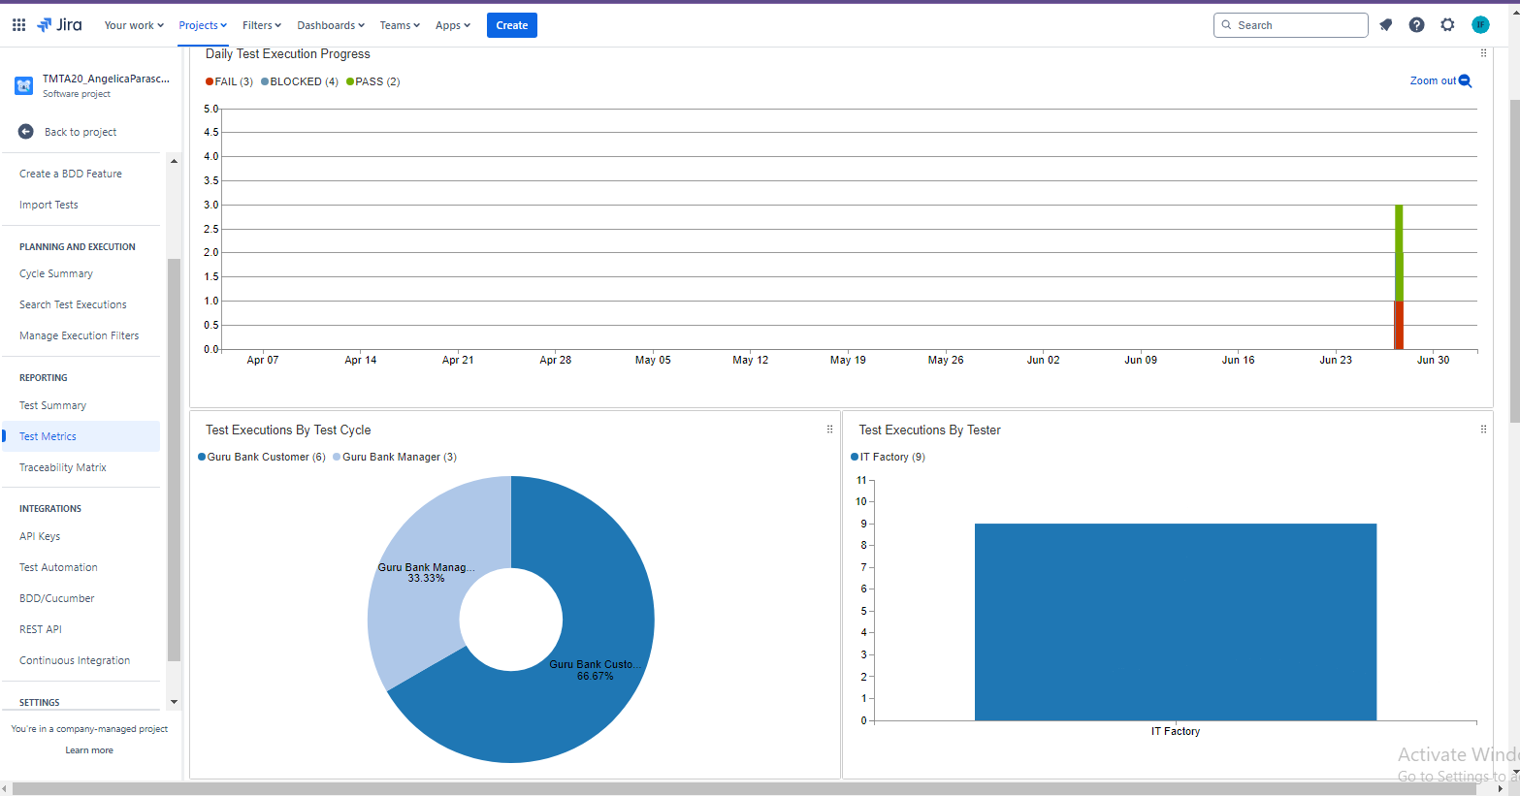

**(inserati aici motivul pentru care a fost facuta etapa de monitorizare si control si respectiv cum s-a facut aceasta etapa. Aici veti insera de asemenea si raportul de status (test status report) din zephyr - test metrics - primul din lista care sa reflecte activitatea si evolutia testarii. Recomand aici sa executati teste aproape in fiecare zi ca sa vada angajatorul implicarea voastra in testare)**

1.3 Test Analysis

The testing process will be executed based on the application requirements.

<b>(The requirements analysis has been done in order to implement the

<i>early testing</i> test principle and the results can be found here - inserati linkul catre documentul de review.

Parte asta specificata intre paranteze o puneti doar daca aveti cerinte si daca ati facut review)</b>. <br><br>

The following test conditions were found:

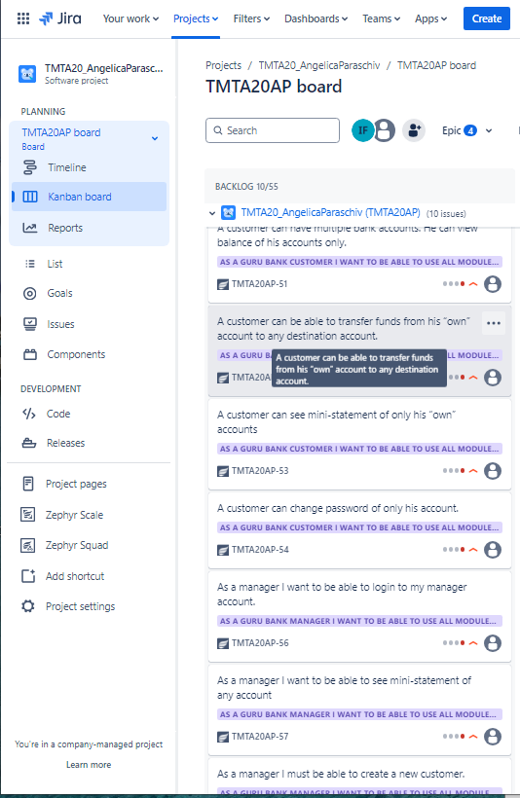

<h3>1.4 Test Design</h3>

Functional test cases were created in Zephyr Squad based on the analysis of the specifications. The test cases can be accessed here **(inserati linkul catre fisierul cu testele, in format pdf, word sau csv)**

1.5 Test Implementation

The following elements are needed to be ready before the test execution phase begins:

1. **Test Cases and Test Scripts:**

* **Creation of test cases**
* **Test script preparation**

1. **Test Environment Setup**
2. **Test Data Preparation**
3. **Test Strategy and Priorities**
4. **Test Execution Schedule and Resources**

1.6. Test Execution

Test cases are executed on the created test Cycle summary:

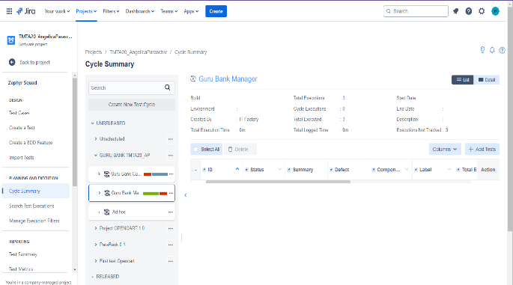

Bugs have been created based on the failed tests. The complete bug reports can be found here: **(inserati aici fisierul cu bug-urile pe care le-ati identificat)**

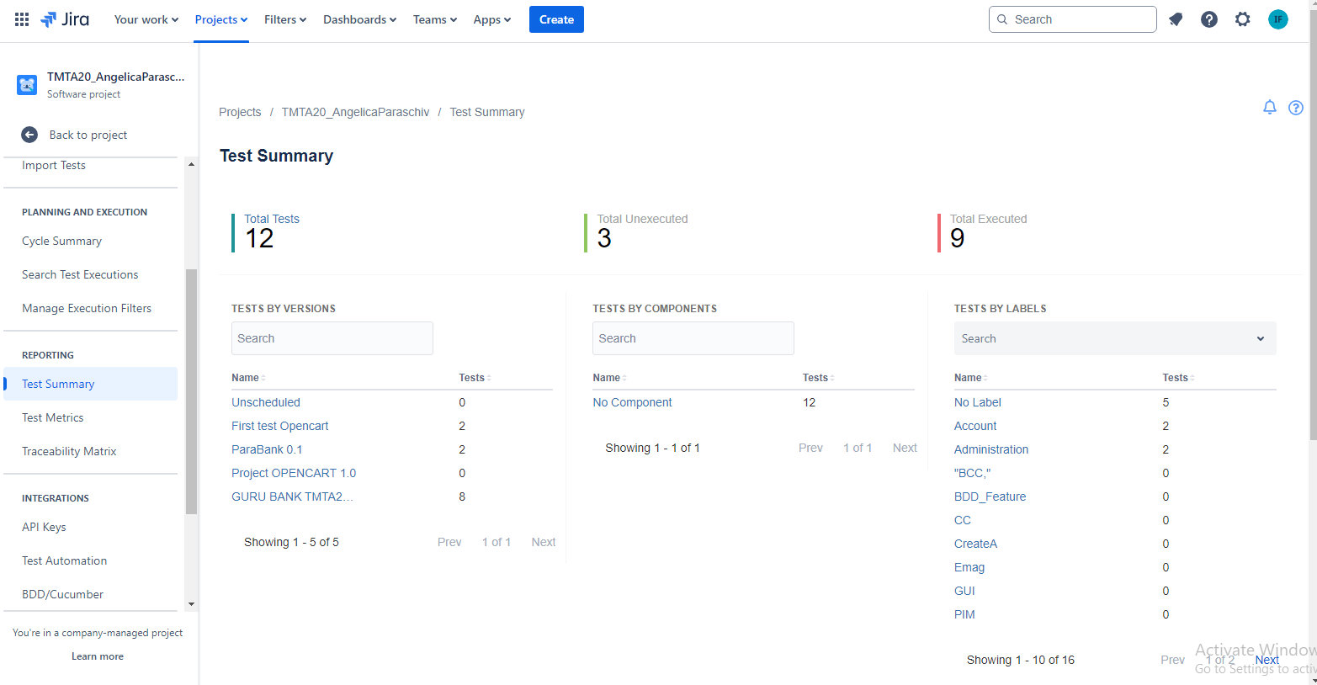

The following is a summary of the bugs that have been found

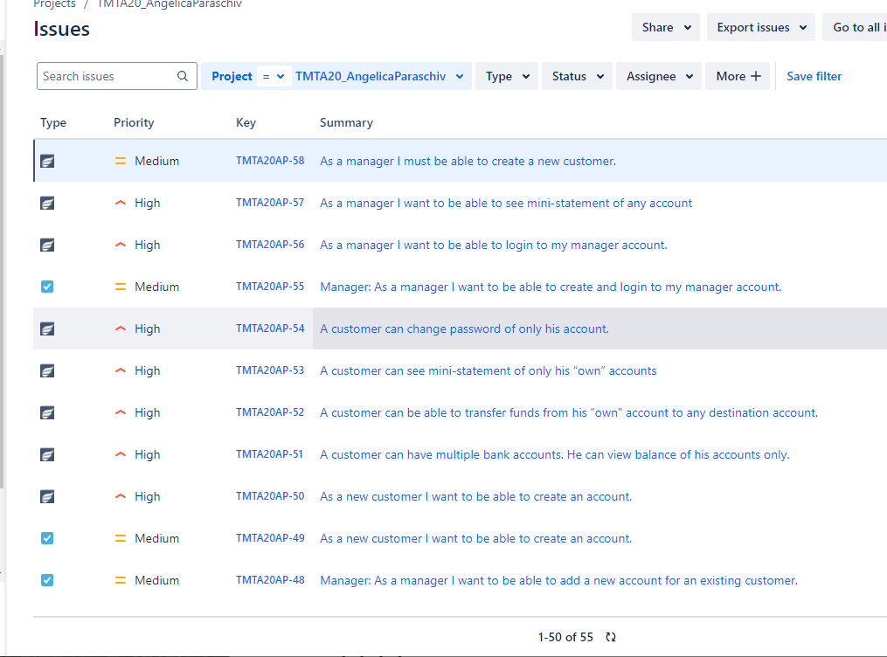

**(inserati o lista cu titlurile bug-urilor identificate impreuna cu prioritatea si severitatea fiecaruia)**

Full regression testing is needed on the impacted areas after the bugs are fixed and retesting will be done for every functionality that was previously failed.

1.7 Test Completion

As the Exit criteria were met and satisfied as mentioned in the appropriate section, this feature is suggested to â€˜Go Liveâ€™ by the Testing team

The traceability matrix was generated and can be found here: **(inserati aici fie o poza cu matricea de trasabilitate din jira, fie linkul catre fiserul excel exportat din jira cu matricea de trasabilitate. Nu uitati sa faceti filtrare dupa type = story)**

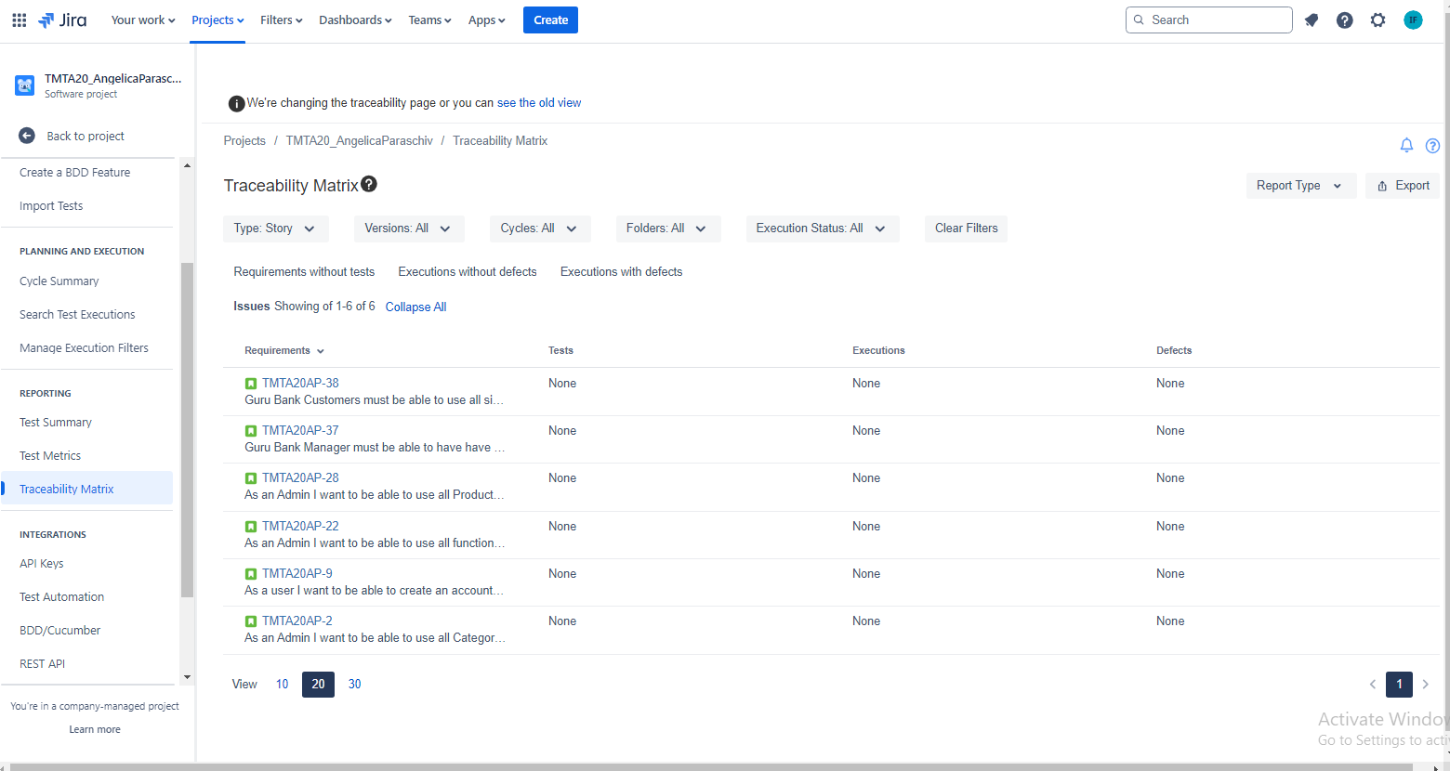

Test execution chart was generated and can be found below.

**(inserati aici raportul de executie generat din jira din sectiunea de dashboards)**

The final report shows that a number **(inserati numarul de teste)** tests have failed of a total of **(inserati numarul de teste)**

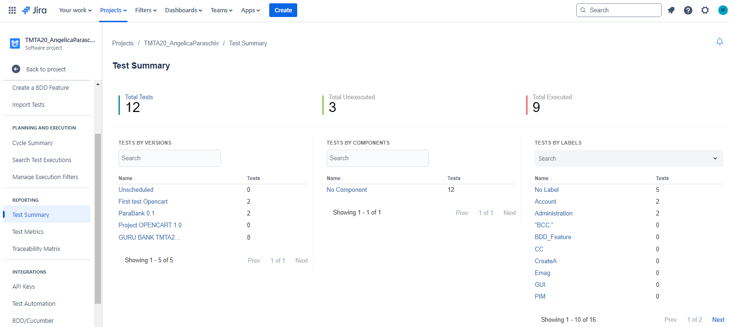

A number of **(inserati numarul de bug-uri)** total bugs were found, from which the priority is: **(inserati numarul de bug-uri)** are high and **(inserati numarul de bug-uri)** are medium.

**(inserati aici o concluzie generala a testarii care sa cuprinda cate teste au fost create si executate, ce procentaj aproximativ din cerintele in scop au fost acoperite, daca exista vreo functionalitate pe care nu ai apucat sa o testezi, daca bug-urile gasite impacteaza lansarea produsului in productie sau se pot fixa si ulterior, daca ai identificat riscuri de produs care trebuie mitigate, daca e vreo reecomandare pe care vrei sa o faci pentru lansare, daca sunt ceva lessons learned de care trebuie sa se tina cont la proiectele viitoare etc.)**