University of Eswatini
Practices in Software Engineering - CSC392

SMART ATTENDANCE SYSTEM
Software Design Document (SDD)
Prepared using the attached SDD template and aligned with IEEE Std 1016-2009 design description guidance

Item | Description
Team Name | Smart Attendance Development Team
Project Title | Smart Attendance System
Names and Roles | Wakhile Mabuza - Team Manager  Sean Rodrigues - System Architect  Njabulo Simelane - UI/UX Designer  Sakhiwo Magongo - Programmer (Backend and Integration)
Lab Section | Not specified
Workstation | Not specified
Date | 05/13/2026
Document Status | Draft Version 1.0

Document Control
Version | Date | Author / Owner | Description
1.0 | 05/13/2026 | Smart Attendance Development Team | Initial SDD draft based on the project plan, SDD template, and IEEE Std 1016-2009 guidance.

Table of Contents
1. Introduction
1.1 Purpose
1.2 Scope
1.3 Overview
1.4 Reference Material
1.5 Definitions and Acronyms
2. System Overview
3. System Architecture
3.1 Architectural Design
3.2 Decomposition Description
3.3 Design Rationale
4. Data Design
4.1 Data Description
4.2 Data Dictionary
5. Component Design
6. Human Interface Design
6.1 Overview of User Interface
6.2 Screen Images
6.3 Screen Objects and Actions
7. Requirements Matrix
8. Appendices

1. INTRODUCTION

1.1 Purpose
This Software Design Document (SDD) describes the architecture, components, interfaces, data design, and user interface design of the Smart Attendance System. It is intended to guide the implementation team in transforming the project requirements into working software and to support communication between the team manager, system architect, UI/UX designer, programmer, lecturers, testers, and other stakeholders.

1.2 Scope
The Smart Attendance System is a software-hardware integrated solution that automates student attendance recording using barcode scanning technology. The system will allow lecturers to authenticate, create or start attendance sessions, scan student ID barcodes, validate students against course enrolment, store attendance records, and generate attendance reports.
The scope includes the following major design areas:
- Web-based lecturer interface for login, session management, scanning, and reporting.
- Backend API for authentication, validation, attendance recording, and reporting.
- PostgreSQL relational database for users, students, courses, sessions, and attendance records.
- Barcode scanner or webcam input integration for capturing student ID barcodes.
- Basic administrative support for managing courses, students, enrolments, and schedules.
The scope does not include payment systems, admissions processing, a full learning management system, or advanced biometric recognition. The current design focuses on barcode-based attendance with a scanner or webcam alternative.

1.3 Overview
This document follows the structure of the attached SDD template. Section 2 gives a system overview, Section 3 describes the system architecture and decomposition, Section 4 explains the data design, Section 5 describes component-level logic, Section 6 presents human interface design, Section 7 maps requirements to design components, and Section 8 provides supporting appendices.

1.4 Reference Material
Reference | Description
IEEE Std 1016-2009 Software Design Description | Reference standard used for design description concepts, design viewpoints, stakeholders, design concerns, views, and rationale.
SDD_Template.pdf | Attached class template used to structure this document into introduction, system overview, architecture, data design, component design, human interface design, requirements matrix, and appendices.
Project Plan - Smart Attendance | Attached project plan used for project background, objectives, team roles, risks, technology stack, functional requirements, testing, resources, quality assurance, and change management.

1.5 Definitions and Acronyms
Term / Acronym | Meaning
API | Application Programming Interface; the backend endpoints used by the frontend.
Barcode | A machine-readable representation of a student identifier printed on a student ID card.
DB | Database; the PostgreSQL data store used by the system.
ERD | Entity Relationship Diagram; a visual representation of database entities and relationships.
FR | Functional Requirement.
HTTP/JSON | Communication format used between the React frontend and Express backend.
NFR | Non-Functional Requirement.
REST | Representational State Transfer; the API style used for system endpoints.
SDD | Software Design Document / Software Design Description.
UML | Unified Modeling Language; design notation used for diagrams such as use case, sequence, and class diagrams.
UI | User Interface.
UUID | Universally Unique Identifier; recommended format for internal database primary keys.

2. SYSTEM OVERVIEW
The Smart Attendance System replaces manual paper-based attendance recording with a digital solution that uses barcode scanning to identify students and automatically store attendance data. The system improves accuracy, reduces duplicate or proxy attendance, speeds up classroom attendance taking, and provides real-time tracking and reporting.
The primary users are lecturers and students. Lecturers provide attendance rules and reporting needs, create or start attendance sessions, and generate reports. Students participate by presenting student ID cards with barcodes during class. Administrative users may maintain user accounts, courses, enrolments, and schedules.
Typical attendance workflow:
- A lecturer logs in to the system through a web browser.
- The lecturer selects a course and starts an attendance session.
- A student presents a student ID card with a barcode.
- The scanner or webcam captures the barcode value.
- The backend validates the barcode, checks the student record, verifies course enrolment, and prevents duplicate scans.
- A valid attendance record is saved in the PostgreSQL database.
- The lecturer views the live attendance list and later generates a report.
The system will be developed using React for the frontend, Node.js with Express for the backend API, PostgreSQL for persistent data storage, and a barcode scanner or webcam for input.

3. SYSTEM ARCHITECTURE

3.1 Architectural Design
The proposed architecture is a layered client-server design. It separates the user interface, API processing, business logic, hardware input, and data storage. This separation makes the system easier to develop, test, maintain, and extend.
The major architectural layers are:
- Presentation Layer: React web interface used by lecturers and administrators.
- Hardware Input Layer: barcode scanner or webcam that sends barcode values to the frontend.
- API Layer: Node.js and Express REST API that receives requests from the frontend.
- Application Services Layer: authentication, session management, scan validation, attendance recording, reporting, and auditing logic.
- Data Layer: PostgreSQL database containing users, students, courses, enrolments, attendance sessions, and attendance records.
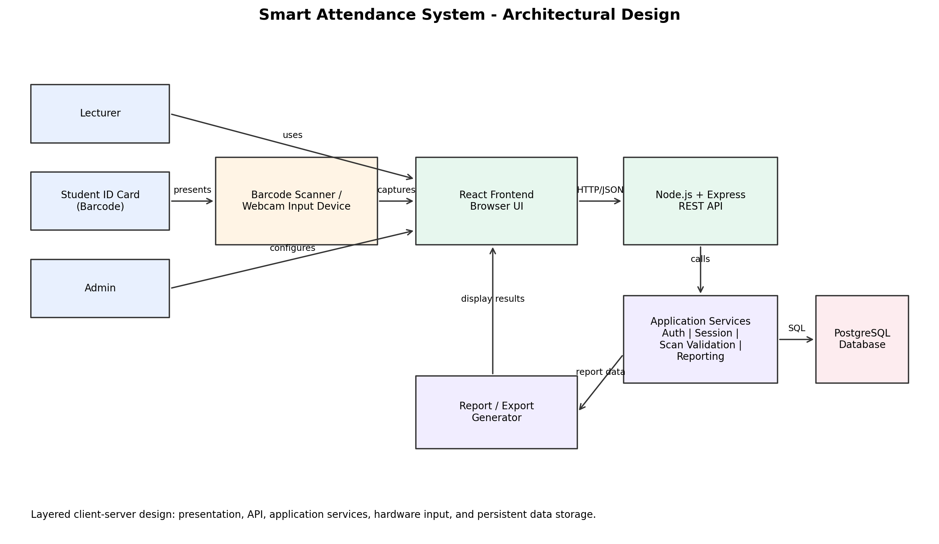
Figure 1. Architectural design of the Smart Attendance System.

3.2 Decomposition Description
The system is decomposed into modules according to responsibility. This modular structure supports independent development and testing while keeping clear interfaces between components.
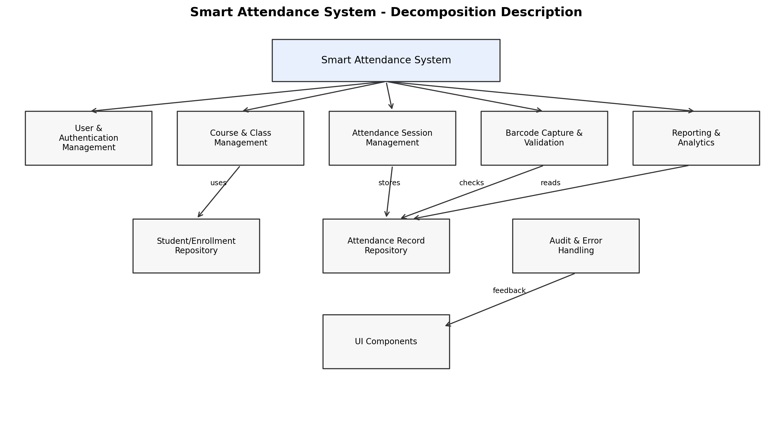
Figure 2. Decomposition of major Smart Attendance System modules.
Subsystem / Module | Main Responsibility | Collaborates With
User and Authentication Management | Authenticates lecturers and administrators, manages user roles, and protects secured pages and APIs. | React UI, Express API, PostgreSQL Users table
Course and Class Management | Maintains courses, lecturers assigned to courses, class schedules, and venues. | Admin UI, Course tables, Session Management
Student and Enrolment Management | Stores student identity, barcode value, and course enrolment records. | Barcode Validation, Attendance Recording
Attendance Session Management | Creates, opens, closes, and tracks attendance sessions for a selected course and class date. | Lecturer UI, Attendance Recording, Reports
Barcode Capture and Validation | Captures scanned barcode values and validates each scan against student and enrolment data. | Scanner/Webcam, React UI, Express API, Database
Attendance Recording | Creates attendance records, prevents duplicate records, and stores time-in/status information. | Session Management, Barcode Validation, PostgreSQL
Reporting and Analytics | Generates attendance summaries by course, student, session, and date range. | Attendance Records, Course Data, React UI
Audit and Error Handling | Logs important actions and provides clear feedback for invalid scans, duplicate scans, or inactive sessions. | All backend services

Interaction View - Attendance Scan Sequence
The sequence below shows the main interactions when a lecturer records attendance using a barcode scan.
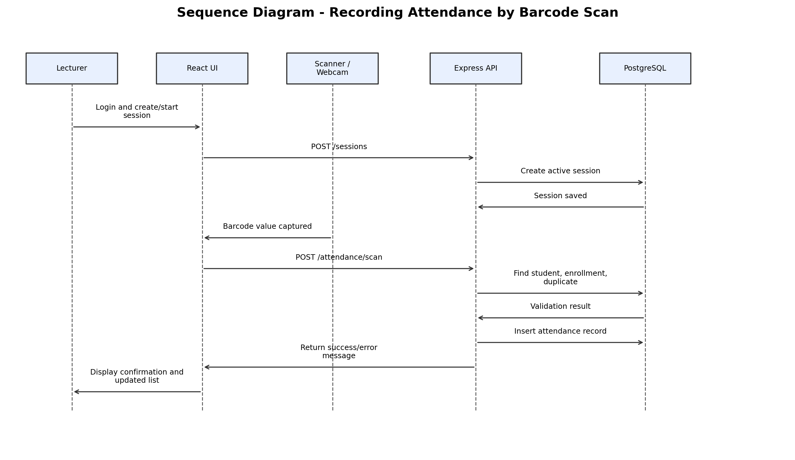
Figure 3. Sequence diagram for recording attendance by barcode scan.

3.3 Design Rationale
The selected architecture is appropriate because the project requires a user-friendly web interface, reliable data storage, and integration between hardware input and software services. A layered client-server model keeps the barcode capture interface separate from the validation and persistence logic.
The main design decisions are:
- React is selected for the frontend because it supports modular UI components and responsive web interfaces.
- Node.js and Express are selected for the backend because they provide a lightweight and flexible API layer suitable for JSON-based web applications.
- PostgreSQL is selected because attendance records, courses, enrolments, users, and sessions are relational and require data integrity constraints.
- Barcode scanning is selected over manual entry because it reduces time and typing errors during class attendance capture.
- A webcam alternative is included to reduce the risk of hardware failure or scanner unavailability.
- The system uses validation checks to reduce duplicate scans, invalid students, and attendance records for students not enrolled in the selected course.
Alternative designs considered include a desktop-only application and a fully mobile-only application. A desktop-only system was not selected because it limits accessibility and future deployment flexibility. A mobile-only system was not selected because lecturers may need larger screens for dashboards and reports. A web-based approach supports both desktop browser use and future mobile adaptation.

4. DATA DESIGN

4.1 Data Description
The system stores persistent information in a PostgreSQL database. The main data entities are users, lecturers, students, courses, enrolments, class schedules, attendance sessions, attendance records, devices, audit logs, and reports. The data model is designed to support authentication, course attendance validation, duplicate prevention, reporting, and traceability.
Important data integrity rules include:
- Each barcode value must uniquely identify one student.
- A student must be enrolled in a course before an attendance record can be accepted for that course.
- Each attendance session belongs to one course and is opened by a lecturer.
- A student should have at most one accepted attendance record per attendance session.
- Attendance records must store the scan time and status for auditing and reporting.
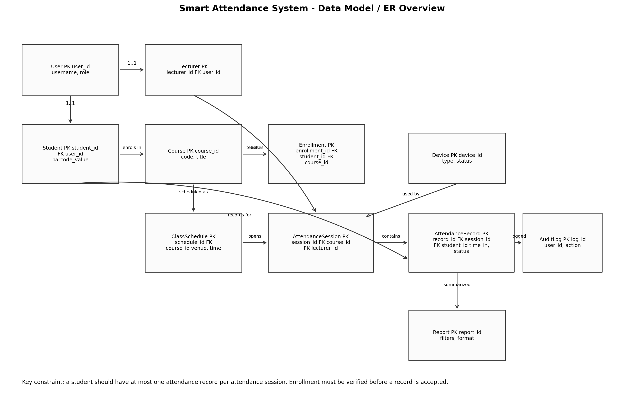
Figure 4. Data model and relationships for the Smart Attendance System.

4.2 Data Dictionary
Entity | Main Attributes | Description
User | user_id (PK), username, password_hash, role, full_name, email, status, created_at | Generic system user account for lecturers, administrators, and possible student access.
Lecturer | lecturer_id (PK), user_id (FK), staff_number, department | Lecturer profile linked to a user account.
Student | student_id (PK), user_id (FK, optional), student_number, barcode_value, programme, year_level | Student identity and barcode information used during scanning.
Course | course_id (PK), course_code, course_name, semester, academic_year | Course or module for which attendance is captured.
Enrollment | enrollment_id (PK), student_id (FK), course_id (FK), status | Links students to courses and is used to validate attendance eligibility.
ClassSchedule | schedule_id (PK), course_id (FK), lecturer_id (FK), day_of_week, start_time, end_time, venue | Stores scheduled class meetings for courses.
AttendanceSession | session_id (PK), course_id (FK), lecturer_id (FK), schedule_id (FK), session_date, start_time, end_time, status | A specific attendance capture period opened for a course.
AttendanceRecord | record_id (PK), session_id (FK), student_id (FK), scanned_code, time_in, status, validation_message, recorded_by | Stores one attendance result for a student in a session.
Device | device_id (PK), device_type, device_name, location, status | Optional record of scanner or webcam devices used for attendance capture.
AuditLog | log_id (PK), user_id (FK), action, entity_name, entity_id, timestamp, details | Records important changes, errors, and system actions for accountability.
Report | report_id (PK), generated_by (FK), report_type, course_id (FK), date_range, generated_at, export_format | Stores report generation metadata and export settings.

5. COMPONENT DESIGN
This section describes each major component in a systematic way. The design focuses on the inputs, processing responsibilities, outputs, and error handling expected from each component.
Component | Inputs | Processing | Outputs / Errors
Authentication Component | Username/email and password. | Checks credentials, verifies account status, creates authenticated session/token, applies role-based access. | Successful login, failed login message, access denied for unauthorised users.
Attendance Session Component | Lecturer ID, course ID, schedule ID/date/time. | Creates a new session, ensures lecturer is allowed to manage the course, changes session status to active or closed. | Active session record, closed session status, error if invalid course or duplicate active session.
Barcode Capture Component | Barcode value from scanner or webcam. | Captures raw barcode input, cleans input, and submits the value to the backend scan endpoint. | Barcode scan request, scanner not ready message, unreadable barcode feedback.
Scan Validation Component | Session ID and barcode value. | Finds student by barcode, checks active session, verifies enrolment, checks duplicate record. | Validation accepted, invalid barcode, not enrolled, duplicate scan, inactive session.
Attendance Recording Component | Validated student, session, timestamp, status. | Creates attendance record in database and returns updated list/count. | Saved attendance record or database error message.
Reporting Component | Course, date range, report type, output format. | Aggregates attendance records and calculates totals/percentages. | Attendance report displayed on screen or exported.
Audit/Error Component | System event, user ID, entity affected, error details. | Stores audit log and standardises user-friendly error responses. | Audit log record and consistent feedback messages.

Core Algorithm - Record Attendance Scan
The core algorithm below shows the main logic for validating and storing attendance after a barcode is scanned.
function recordAttendanceScan(sessionId, barcodeValue, lecturerId):
session = findAttendanceSession(sessionId)
if session does not exist or session.status != "ACTIVE":
return error("Attendance session is not active")
if session.lecturer_id != lecturerId:
return error("Lecturer is not authorised for this session")
student = findStudentByBarcode(barcodeValue)
if student does not exist:
saveAuditLog("INVALID_BARCODE", barcodeValue)
return error("Student barcode not recognised")
enrollment = findEnrollment(student.student_id, session.course_id)
if enrollment does not exist or enrollment.status != "ACTIVE":
return error("Student is not enrolled for this course")
existing = findAttendanceRecord(session.session_id, student.student_id)
if existing exists:
return warning("Attendance already recorded", existing)
record = createAttendanceRecord(
session_id=session.session_id,
student_id=student.student_id,
scanned_code=barcodeValue,
time_in=current_timestamp(),
status="PRESENT",
recorded_by=lecturerId
)
saveAuditLog("ATTENDANCE_RECORDED", record.record_id)
return success(record)

API Interface Summary
Endpoint | Method | Purpose | Main Data
/api/auth/login | POST | Authenticate a user. | username/email, password
/api/courses | GET | Return courses assigned to the logged-in lecturer. | lecturerId, role
/api/sessions | POST | Create/start an attendance session. | courseId, scheduleId, date/time
/api/sessions/{id}/close | PATCH | Close an active attendance session. | sessionId
/api/attendance/scan | POST | Validate a barcode and create attendance record. | sessionId, barcodeValue
/api/attendance/session/{id} | GET | Return live attendance list for a session. | sessionId
/api/reports/attendance | GET | Generate attendance report. | courseId, date range, format

6. HUMAN INTERFACE DESIGN

6.1 Overview of User Interface
The user interface will be designed for lecturers and administrators. It should be simple enough for use during class, where speed and clear feedback are important. The main lecturer workflow is login, select course, start session, scan student cards, view live attendance list, close session, and generate reports.
The interface must provide immediate feedback for the following situations: successful scan, invalid barcode, student not enrolled, duplicate scan, scanner disconnected, inactive session, and report generation success or failure.

6.2 Screen Images
The following wireframes represent the expected user interface screens. These can be refined into final mock-ups during UI implementation.
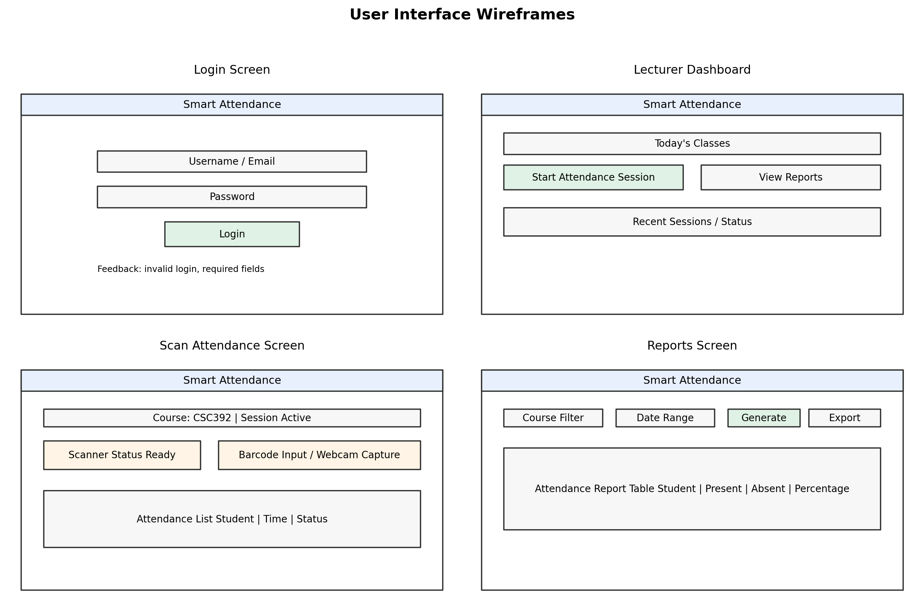
Figure 5. Wireframes for login, dashboard, scanning, and reports screens.

6.3 Screen Objects and Actions
Screen | Object | User Action | System Response
Login | Username/email field, password field, Login button | Lecturer enters credentials and clicks Login. | System authenticates user and opens dashboard, or displays login error.
Lecturer Dashboard | Course list, Today's Classes panel, Start Attendance Session button | Lecturer selects course and starts session. | System creates active session and opens scan screen.
Scan Attendance | Scanner status indicator, barcode input/capture area, attendance list | Lecturer scans student ID barcode. | System validates scan, saves attendance, updates list, and displays success/error feedback.
Reports | Course filter, date range, Generate button, Export button | Lecturer selects filters and generates report. | System displays attendance summary and allows export.
Admin Management | User, student, course, enrolment, and schedule forms | Administrator adds or updates data. | System validates and saves configuration records.

7. REQUIREMENTS MATRIX
The matrix below traces the main functional and non-functional requirements to the design components and data structures that satisfy them. Requirement numbering is assigned for this SDD based on the functional requirements listed in the project plan.
Req. ID | Requirement | Design Components | Data Structures / Notes
FR-01 | Lecturer authentication | Authentication Component, React Login UI, Express Auth API | User, Lecturer, AuditLog
FR-02 | Attendance session creation | Attendance Session Component, Lecturer Dashboard, Session API | AttendanceSession, Course, ClassSchedule, Lecturer
FR-03 | Barcode scanning for student identification | Barcode Capture Component, Scan Validation Component, Scan Screen UI | Student.barcode_value, Device, AttendanceSession
FR-04 | Attendance recording and storage | Attendance Recording Component, PostgreSQL Data Layer | AttendanceRecord, Student, Enrollment, AttendanceSession
FR-05 | Report generation | Reporting Component, Reports UI, Report API | AttendanceRecord, Course, Student, Report
NFR-01 | System must be fast and responsive | React UI, Express API, indexed database fields, modular services | Use indexes on barcode_value, session_id, student_id, course_id.
NFR-02 | High reliability and accuracy | Validation checks, duplicate prevention, enrolment verification, audit logging | Unique constraints and validation rules.
NFR-03 | Easy-to-use interface | Simple lecturer workflow, clear feedback messages, screen objects and actions | UI wireframes and usability testing.
NFR-04 | Maintainability and traceability | Layered architecture, GitHub version control, code reviews, modular design | AuditLog, documented API, project standards.

8. APPENDICES

Appendix A - Design Viewpoints Used
The following design viewpoints from the IEEE-style design description approach are applied to this SDD to ensure that stakeholder concerns are addressed from multiple perspectives.
Viewpoint | Design Concern Addressed | Representation in This SDD
Context | Actors, system boundary, services offered by the system. | System overview and lecturer/student/admin workflow.
Composition | Subsystems, modules, and major responsibilities. | Architectural design and decomposition diagram.
Logical / Structure | Internal components, classes, objects, and relationships. | Component design and data model.
Information | Persistent information and data relationships. | Data design, ER overview, and data dictionary.
Interface | Service access, user interface, valid inputs, and outputs. | API summary and human interface design.
Interaction | Messages exchanged between actors and components. | Attendance scan sequence diagram.
Algorithm | Processing logic for detailed operations. | Record attendance scan pseudocode.
Resource | Hardware/software resources and performance concerns. | Scanner/webcam, web browser, server, database, and resource assumptions.

Appendix B - Quality Assurance and Testing Summary
The project quality assurance approach includes code reviews before merging changes, GitHub version tracking, continuous testing during development, bug tracking and resolution, and proper documentation of all modules. Testing will include unit testing for individual components, integration testing for combined modules, and system testing for the full application.
Test Type | Purpose | Examples
Unit Testing | Verify individual functions and components. | Authentication function, barcode validation function, report calculation logic.
Integration Testing | Verify combined modules and API/database interaction. | Scan endpoint validates barcode and writes AttendanceRecord.
System Testing | Verify the complete application workflow. | Lecturer logs in, starts session, scans students, closes session, generates report.
Usability Testing | Verify ease of use for lecturers and students. | Check whether lecturers can record attendance quickly during a class.
Hardware Testing | Verify barcode scanner or webcam behaviour. | Valid scan, unreadable barcode, disconnected scanner, fallback device.

Appendix C - Risks and Design Mitigations
Risk | Design Mitigation
Scanner or camera failure | Provide alternative device support such as webcam or phone-based scanning where possible.
Hardware-software mismatch | Prototype scanning early and isolate scanning logic from the backend validation logic.
Incorrect scans or duplicates | Use validation checks, duplicate detection, and audit logs.
Time constraints | Use modular development and Agile weekly milestones.
Team coordination issues | Use GitHub commits, pull requests, weekly meetings, and documented responsibilities.

Appendix D - Change Management
Any proposed change should be communicated to the team manager and discussed by the team before implementation. The team manager reviews and approves changes before they are applied to the main project. All changes should be implemented through GitHub commits and pull requests to maintain traceability. Before implementation, the impact of a change on the timeline, functionality, and other components should be evaluated and documented.

