**Gun Related Incidents in the U.S.**

Thomas Marianos

6/5/2021

**Introduction**

The debate between gun rights and gun control has been a hot topic for many years now. A polarizing topic that splits Americans into many different points of view, but the two dominating thoughts are “government needs to intervene and regulate guns with stricter laws to cut down on gun related incidents and crime”, contrast to “government regulations and gun control would impede on the second amendment rights of U.S. citizens. The federal government has not signed any sort of gun control related legislation into law since the 2005 Protection of Lawful Commerce in Arms Act, pushing the responsibility of legislation onto state and local governments.

Without taking a stand for either side, this analysis will look at gun related incidents reported by police departments all over the nation between 2014 and 2017 and try to understand trends in gun related incidents, where most of these incidents occur, effectiveness of gun legislation, and public interest in the topic.

**About the Data:**

This experiment utilizes two sources of data. The main source, found on Kaggle, is the Gun Violence Data, which includes police report gun-related incidents across the United States between 2013 and 2018.



The second source of data was obtained from Twitter using the TWINT package. We configured the TWINT search to gather a sample of tweets containing “@JerryBrownGov” in 2014, 2015, 2016, and 2017 and then loaded each tweet set into a JSON file.

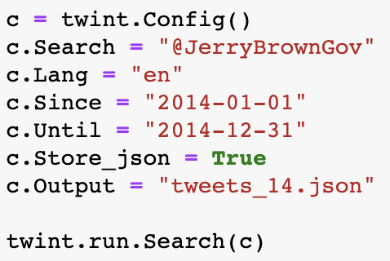

**Questions for Analysis:**

* Between 2014 and 2017, were the number of gun related incidents across the country evenly dispersed or concentrated to a smaller collection of regions, states, or cities?

# Did the passage of gun control legislation impact the trends of gun incidents within a state?

# Can we identify the amount of public interest surrounding gun control/legislation over this period using Twitter?

# **Gun Violence Dataset**

**Data Cleaning:**

To clean the data, we removed all the fields we would not be using for analysis. This left us with a unique identifier for each incident, the date of occurrence, the address (including city and state), n_killed, n_injured, and we left gun type which could be used for further exploration later, but for our current purposes won’t be used. We then just renamed the ‘incident_id’ column to ‘id’ for legibility.

**Analysis:**

Our first step in analysis was looking at the data covering the nation as a while. The overview tallied up the number of incidents each year and summed the number of injuries and deaths. The most notable values within the table initially were those aligned to 2013 and 2018. Most likely since the data collection started some time during 2013 and ended during 2018 rather than after, the data for these years skewed the data trends with extremely lower counts for incidents, injuries, and deaths. To compensate, we decided to drop the data associated with these years and focus on 2014-2017.

Now with our data narrowed down we get a more accurate depiction of gun incident trends. The table shows that there was a steady increase in incidents, injuries, and deaths over the four years observed.

From here, we will explore the data further and see which states in the country have the highest number of incidents, injuries, and death.

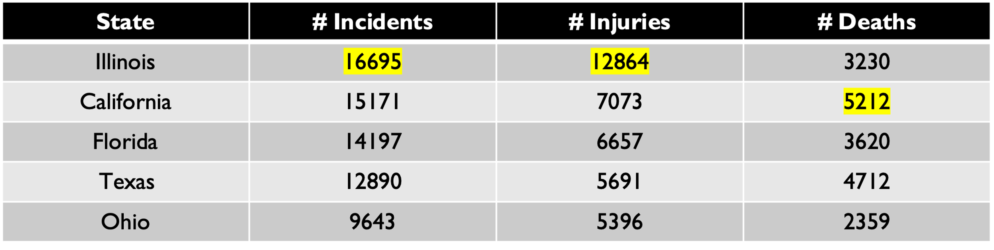

Our first table shows us that Illinois, California, Florida, Texas, and Ohio had the highest numbers of incidents between 2014 and 2017, with Illinois leading in incidents and injuries and California leading in deaths.

Since the initial look at the states gave us a summary of statistics over the four-year period, we then took a look at the states with the highest incidents each year to see if any of these states had a sudden spike on year, or if there has been consistency in these stats over the years.

The top states each year confirmed that there is a consistent level of incidents within each of the top 5 overall states each year, but even more notably, we see that Illinois, California, and Texas appeared in the top 5 all four years. Comparing these three states to the national measures, we can see that they make up over **18%** of the nation’s gun related incidents between 2014 and 2017.

Noting the significance of these three states, we decided to explore each further and see how many cities or counties within each of these states make up the highest measured incidents through the nation. Chicago IL was the only city from the three states to appear in the top list and additionally it was the city with the highest number of incidents over the four-year period.

Comparing Chicago’s stats to the state of Illinois, we found that the city of Chicago made up **~62%** of the gun related incidents observed in the state over the four years. With Illinois making up ~7.4% of the national incident measures, this means that the city of Chicago alone is responsible for **~4.6%** of national gun incidents recorded in this dataset.

With some information of where the Illinois incidents are occurring, we wanted to look at California and Texas cities to see if there was a similar outlying city or if the incidents are more dispersed over a couple of cities or counties.

First, looking at California, we can see that there is a bit more dispersion across the cities and counties. One thing noted is that the top three cities for this state make up at least double the percent of incidents the other two top 5 cities do.

Looking at the Texas city/county breakdown, we can see that it is still more dispersed than Illinois, but there is a notable larger percent of incidents within Houston and San Antonio, the two making up **~30%** of the state’s reported gun related incidents.

Now that we understand the trends in gun related incidents and where most of these incidents are occurring, we began researching gun legislation within those states between 2014 and 2017. Our research found that the state of California passed many gun-related bills during the period observed.

* November 2014 - Prop 47 passes, changing certain low level-crime from felonies to misdemeanors
* January 2015- Firearm Safety Certificate replaced the Handgun Safety Certificate, applying the needed certifications to all firearms
* July 2016 - 6 bills are to be enacted which limit magazine capacity, require background checks for purchasing ammunition, restrict the lending of firearms, and close many other “loopholes”

|  |  |
| --- | --- |
| * + Assembly Bill 1135   + Senate Bill 880   + Assembly Bill 1511 | * + Assembly Bill 1695   + Senate Bill 1235   + Senate Bill 1446 |

To study the impact (if any) of these pieces of legislation, we broke out the number of incidents in California over the years by month and identified the points of these gun control related bills being enacted or signed. Additionally, we took note of any other events that could have impacted the data, which ended up being the wildfires of ’14 and ’17 and the terror attack in 2015.

**6 major gun control bills signed**

The charted data showed that there is a possibility that these legislative actions did not have any notable impact on the incident occurrences in the short term observed. Prop. 47 passed during a down-tick in incidents following the’14 wildfires, which seems to have also triggered a rise in incidents (maybe due to the fear and panic set in due to the conditions). The passing of Prop. 47, shortly followed by the implementation of the Firearms Safety Certificate, did not prove to have a significant impact on the gun related incidents, seeing that the trends returned to similar levels as 2014 pre-wildfires. It should be noted that Prop. 47 was not directly related to firearms, but more towards general crime.

Following the terror attack in 2015, the number of gun related incidents tapered off and then declined significantly. This could be related to stricter enforcement following the attack or public fear. The significant uptick in the crime rate in Spring 2016, seemingly would have brought the state to incident levels rivaling the wildfires of 2014 but is suddenly curbed by the signing of the six major gun control bills by Governor Jerry Brown. The signing of the bills only seemed to taper off the amount of gun related reports over the following 6 or so months but did not spur any drop in stats. This “plateau” of occurrences suddenly ends Spring 2017 with the spread of another devastating wildfire throughout the state.

# **TWINT Twitter Pull**

**Data Cleaning:**

To identify public interest in the legislation surrounding California gun control, we pulled tweets between 1/1/2014 and 12/31/2017 that were directed at or included the state governor, Jerry Brown (@JerryBrownGov). The pull gave us an extensive amount of data, so we first removed fields that wouldn’t be necessary for analysis. We then narrowed down the tweets to only those written in English, reformatted the date field, and created fields for month and year. Additionally, we reformatted all the characters in the tweets to lower case to assist with analysis.

**Analysis:**

With our Tweets collected, we first looked at each year individually and broke down the number of tweets by month as well as the total number of tweets collected that year. We then identified a function to flag the number of times certain key words appeared in the collection of tweets. For our analysis, we searched ‘gun control’ and ‘gun rights’ each year to try to gather a balance of tweets from either side of the conversation. We also identified a unique term for years 2014, ’15, and ’16 to correlate with legislation passed that year that may influenced gun control or general crime rates.

* 2014 – ‘prop 47’
* 2015 – ‘Firearm Safety Certification’
* 2016 – ‘bills’

Charting the tweets against the incident reports, we can see some correlation in the number of tweets directed towards the governor and the occurrences of gun related incidents. We can also see an uptick in tweets proceeding and following the signing of each of the pieces of legislation.

# **Conclusions**

**Between 2014 and 2017, were the number of gun related incidents across the country evenly dispersed or concentrated to a smaller collection of regions, states, or cities?**

After analysis of the Gun Violence Data set, we found that between 2014 and 2017, there was a steady increase in the number of reported gun related incidents across the country and, subsequently, a rise in associated injuries and death throughout the nation. When examined more closely, we found that the incidents reported during the observation period were not only unevenly distributed, but a significant number of the incidents occurred in Illinois, California, and Texas consistently each year. Comparing these states’ measures to the national total, we found that these three states alone accounted for roughly 20% of the incidents reported throughout the nation. While California’s stats were more evenly distributed across cities and counties, two cities, Houston and San Antonio made up a large portion of Texas’ incidents each year. In contrast, Illinois had one single city responsible for about 60% of their stats: Chicago. The comparative statistics thus attribute almost 5% of the nation’s gun related incidents to this one midwestern city.

**Did the passage of gun control legislation impact the trends of gun incidents within a state?**

Since the federal government has not passed any gun related legislation since 2005, and nothing restrictive since before that, we had to focus on state level laws passed and their possible effects on the number of gun related incidents there. California is currently considered one of the strictest states when it comes to owning firearms, so we decided to compare the passing of laws during our observed years against the reports included in the dataset. To identify a relationship between the two variables, we charted the incident occurrences across the months of each year and marked where on the timeline the legislation was signed or enacted. The chart showed that the passing of these bills had little impact on lowering the occurrences of gun related incidents and when any impact was noted, it was only curbing the rise in numbers momentarily. This may just signify that these laws will have more of an effect in the long-term, but for the period observed there was very little improvement with each law.

**Can we identify the amount of public interest surrounding gun control/legislation over this period using Twitter?**

Through our collection of Twitter data using TWINT, we were able to identify a significant public interest in gun related legislation, whether pro or against. Over the four years observed, there were 598,493 tweets collected that included or were direct towards the California Governor’s handle. Within the collection of tweets gathered, ‘gun control’ was mentioned 6,455,576 times and ‘gun rights’ was found 5,870,163 times throughout. This not only signifies a public interest in gun legislation, but also highlights the divisiveness of the topic in the state. Reinforcing this conclusion of public interest is that combining tweets relating to legislation passed between 2014 and 2016, the legislative bills were referenced 5,798,633 times in tweets directed towards the governor.