Proteins with multiple G protein-coupled receptor domains

Keywords: G protein-coupled receptor, GPCR, sequence and structure analysis, coevolution analysis

Note: all the averages should be given with the error/SD.
In the subsection Phylogenetic Profiles, the claim “Most multi-GPCRs appear in mammals, birds, reptiles, and amphibians. The minority of the multi-GPCRs appear in fish.” might be misleading since we hand-picked the 57 GPCRs that were most likely to be real hits. The distribution of multi-GPCRs cannot be inferred from our selection of 57 hits. This sentence has the meaning of saying that fish did not develop as many multi-GPCRs due to a lack of selective pressure in their internal system/habitat/etc.
A proposal for the problem with the linker segment: this is a long shot, but we saw multi-GPCRs that didn’t fit the N*7 amounts of helices. Maybe, since the linker would be harder to evolve by random addition of amino acids, maybe a duplication of one helix could create a linker that would satisfy the conditions for a linker. Maybe we could look for N*7+(N-1), N >= 2 amount of helices in a multi-GPCR, and this would satisfy the linker problem noted here.

I don’t know if this should be included in the article, but determining the orientation of a multi-GPCR could be done by tagging multi-GPCRs with bleach-inactivated photochemicals in a lyposome experiment, where the total reduction of the signal means they are both positioned outwards, a partial reduction in signal would confirm they are in opposite orientation, and no signal reduction would mean they are both positioned inwards.
Abstract
Currently known G protein-coupled receptors (GPCRs) comprise a single transmembrane domain. Many GPCRs form dimers, with two bound domains (one per protein), and there are indications that this dimeric interaction is functionally meaningful. Here, based on sequence analysis and structure predictions, we report the existence of 57 multi-GPCR proteins, of two, three, and four GPCR domains within the same protein chain. We analyze their structures to show that almost all feature the DRY/NPxxY motifs, a strong indication of signaling activity. By homology, most of the multi-GPCRs that we introduce are olfactory-related and a few are chemokine-related. Multi-GPCR candidates are found in various Chordata species including fish, camel, marmite, Chinese hamster, and new world monkeys. The discovery of receptors with multi-GPCR domains discloses a new layer of complexity to signal transduction, with additional possibilities for signal regulation and amplification within the receptor, revealing another step in GPCR evolution.

Introduction
GPCRs, also known as G protein-linked receptors, are by far the most diverse and broadly distributed family of membrane receptors (Pierce, Premont et al. 2002). They constitute 1-5% of vertebrate genomes (Fredriksson, Lagerstrom et al. 2003, Bockaert 2009, Hanlon and Andrew 2015) and have nearly 900 paralogues in the human genome (Bjarnadottir, Gloriam et al. 2006). Their diversity facilitates response to a large variety of external messengers from proteins and peptides, via small molecules, to ions and photons. GPCRs mediate many different cellular and physiological processes, including development, cell growth, migration, and neurotransmission (Wettschureck and Offermanns 2005). Many diseases and pathological syndromes, such as hypertension, stroke, cancer, and neonatal hyperparathyroidism are linked to GPCR inactivation, over-activation, or overexpression (Sliwoski, Kothiwale et al. 2014).
Structurally, GPCRs comprise a single domain with seven transmembrane helices arranged as an up-down oval-shaped serpentine helix bundle with an extracellular N-terminus and cytoplasmic C-terminus (Kessel and Ben-Tal 2018). Some GPCRs also include large extra-membrane domains, but so far none were known to include more than a single GPCR domain. GPCRs are grouped into six classes based on their amino acid sequences and functional similarities (Attwood and Findlay 1994, Kolakowski Jr 1994). The largest and most diverse of these classes is class A (rhodopsin-like, ECOD family 7tm_1), which includes receptors that are activated by external and internal signals, including photons, small molecules, peptides, and proteins.
The GPCR domain relays outer signals into the cell across the membrane by undergoing conformational changes that alter their interaction with the corresponding cytoplasmic G (guanine nucleotide-binding) proteins (Kessel and Ben-Tal 2018). The conformational changes are mediated by molecular switches and locks formed by several evolutionarily conserved sequence motifs, such as DRY and NPxxY (Zhou, Yang et al. 2019, Hauser, Kooistra et al. 2021). To induce a cellular response, the activated GPCR transduces a signal by activating its cognate G protein, which in turn activates downstream effectors, such as enzymes (adenylyl cyclase and phospholipase C-β) and ion channels. Many GPCRs form homo- or hetero-dimers, and in some cases the dimeric interaction contributes to proper signaling. For example, in class A GCPRs, dimerization is used for regulation, whereas in class C GPCRs mGlu and GABA_{B} receptors, it is mandatory for activity (Ferre, Casado et al. 2014, Faron-Górecka, Szlachta et al. 2019, Pin, Kniazeff et al. 2019).
Here, we set to search for proteins with two or more GPCR domains concatenated one after the other on the same chain. Our reasoning lies in our recent discovery of another class of multi-domain membrane proteins – bacterial outer membrane proteins with multiple beta-barrel domains (Solan, Pereira et al. 2021). There, we modelled all structurally characterized outer membrane beta-barrels as hidden Markov models (HMMs) and searched in the UniRef database for proteins with non-overlapping matches to two or more beta-barrel HMMs. Here we use a similar computational pipeline, starting with all structurally characterized GPCR domains in the ECOD domain database.
We present a total of 57 hits: 50 with two GPCR domains, 6 with three GPCR domains, and 1 with four consecutive GPCR domains linked to each other in the same protein chain. We predicted the three-dimensional structures of these proteins with AlphaFold, a machine learning tool that predicts structures at near-experimental accuracy (Jumper, Evans et al. 2021). AlphaFold uses deep networks to mine and integrate signals from internal correlations between amino acids positions of the query protein and its homologues, models the three-dimensional structure, and provides local and global estimates of the model accuracy. AlphaFold confidently predicted the structures of the putative multi-GPCRs, and the predicted structures are consistent with our inference based on the homology to single GPCR domains. These putative multi-GPCRs are found in various eukaryotes including fish, amphibians, birds, and mammals and specifically rodents, camels, and new world monkeys.

Results
Based on preliminary examination we estimated that there may be many proteins with multi-GPCR domains in UniProt. Because such proteins have not been documented to date, our goal was not to detect all candidates with multi-GPCR domains, but rather focus on a smaller collection of hypothetical proteins that can be convincingly shown to be multi-GPCR domains. We designed our search strategy accordingly. We searched for long hits that match two or more HMMs build from ECOD-classified GPCR domains (X-group 5001) in the protein sequence database UniRef90 (UniRef90 is the 90%NR UniRef with over 130 million sequences). Out of the 262,168 UniRef90 matches to any one of the GPCR HMMs, only matches to 2,240 proteins spanned sufficiently long segments to accommodate multiple GPCR domains. We clustered these based on their sequence similarity with CD-HIT (Li and Godzik 2006). To reduce the risk of including erroneous hits in our dataset (e.g., due to sequencing errors), we kept only proteins whose variants were found multiple times. Thus, we included only the proteins in the 51 clusters with more than 5 members each: 463 proteins in total. Because CD-HIT produces clusters that may be heterogeneous in terms of sequence lengths (Li and Godzik 2006), i.e., grouping together proteins with different number of GPCR domains, we further split each of the clusters to sub-clusters of similar sequence lengths.
We applied another final filter to these clusters: We plotted the number of aligned ECOD GPCRs for each residue as a function of its position in the sequence (see Figure 1S). Then we visually inspected the resulting plot to verify that there are multiple stretches, each longer than 200 residues, where the residues are aligned to (many overlapping) GPCRs. Figure 1S shows one representative for each of the sixteen clusters that satisfy this. Figure 2S shows an example of a protein that does not satisfy this requirement and was thus excluded. There are two segments along its sequence that align (many overlapping) GPCR HMMs. However, only one has ~200 residues, while the other, of only ~100 residues, is too short to accommodate a full GPCR domain. Table 1 lists the 57 proteins, in 16 clusters, that passed all these tests.
Structural details from AlphaFold predictions
We predicted the structure of the 57 multi-GPCR proteins in Table 1 using AlphaFold (Jumper, Evans et al. 2021). In the seven proteins where an unknown amino acid (X) was listed, we replaced it by a G (glycine) for the prediction. We ran AlphaFold with the pTM (predicted TM-score) models, as these give the pLDDT and the predicted pairwise aligned errors and selected the model with the highest pTM score. The model structures are predicted to be accurate (i.e., high pTMs) overall: in 55 of the 57 the pTM score is above 70 (very good), and in 40 it is even above 80; the average is 81.6. Figure 1 shows colormaps of the pairwise aligned errors, namely, for any position (x, y), AlphaFold’s expected position error at residue x if the predicted and true structures were aligned on residue y. We see that the confidence of AlphaFold is generally restricted to blocks of approximately 300 residues. These are the different GPCR domains along the chain. However, AlphaFold is far less confident about its positioning of the GPCR domains relative to one another. Inspecting these 57 predicted structures in a molecular viewer, we see 50 chains with two predicted GPCR domains (clusters #1-#9), 6 chains with three predicted GPCR domains (clusters #10-#15), and 1 chain with four predicted GPCR domains (cluster #16). Note that there are four proteins in which there are GPCR-like segments that we did not mark as full domains because they have less than 7 helices. In cluster #5 protein L5K5K3 has 3 helices and 6 helices before the two GPCR domains, and protein S9XRQ8 has 4 helices before the two GPCR domains; in cluster #7 protein A0A3L7HF35 has 5 helices before the two GPCR domains; and in cluster #10 protein A0A3L7GLK1 has 6 helices between the second and third GPCR domains. Focusing only on full-fledged 7-helices domains there are a total of 122 GPCR domains in the 57 proteins.
Table 1 also lists for each of the 57 proteins in the 16 clusters the number of amino acids, the number of GPCR domains, their organism, and AlphaFold pTM score for the best predicted model. The PDBs of the best AlphaFold predicted models are available online. We identified the linkers between the GPCRs and list these in Table 1S. Also, we calculated the (average) internal similarity among the GPCRs in the same chain and verified that GPCRs in the same chain are not nearly identical, which would have indicated a recent duplication or sequencing error. Figure 3S shows histograms of the sequence identity/similarity (the averages are 57%/66%) and linker lengths (the average is 34).
Phylogenetic profiles
For each of the 57 multi-GPCR proteins we searched for close homologues in UniRef90 to extract the list of species in which they appear. Figure 2 shows a matrix of the occurrences of the 57 proteins and the species in which we found their close homologs. The clustered proteins are plotted along the x-axis in the same order as in Table 1, with vertical lines to indicate cluster boundaries. The 106 species (leaves) in the calculated phylogenetic tree in which we found close homologues are positioned along the y-axis. For every protein, we mark the species with a close homolog by a colored dot. Apart from one case (A0A3L7GLK1 in cluster #10 with three-GPCR domains), all proteins have homologues in at least two Chordata species. Most multi-GPCRs appear in mammals, birds, reptiles, and amphibians. The minority of the multi-GPCRs appear in fish. Receptors of the two-GPCR domains of the first cluster (#1) are, in essence, exclusive to fish. The second two-GPCR cluster (#2) appears in all species families: mammals, birds, reptiles, amphibians, and fish. The proteins of the rest of the two-GPCR clusters are generally not found in fish. We found homologues of the three-GPCRs and four-GPCRs proteins (clusters #10-16) only in a few of the mammals, reptiles, and fish. Figure 4S plots the number of species vs. sequence length. The most commonly found multi-GPCR protein with three predicted GPCRs is detectable in 17 species, and with two predicted GPCRs in 66 species.
The multi-GPCRs found are olfactory- and chemokine-related
The domains detected in multi-GPCR proteins are only homologous to ECOD’s muscarinic acetylcholine receptor M3 (5001.1.1.1), adenosine receptor (5001.1.1.22), rhodopsin (5001.1.1.32), and orexin receptor type 2/ chemokine receptor type 4 (5001.1.1.33). This holds true even though our search started with HMMs of the GPCR domains of all solved structures in ECOD. In particular, even though their HMMs were included in our search, we did not find any multi-GPCRs with homology to the glucagon receptor (5001.1.1.5), metabotropic glutamate receptor 5 (5001.1.1.6), rhodopsin (5001.1.1.7), cytochrome b562 (5001.1.1.8), and progestin and adipoQ receptors (HlyIII) (5001.1.1.12).
Table 1 lists for each protein the functional receptor type and subtype, as annotated by the InterPro database (Blum, Chang et al. 2021) or the Gene Ontology (GO) resource (Consortium 2021). Based on GO and InterPro annotations in UniProtKB and UniParc, almost all the proteins for which we found a functional annotation are olfactory receptors. The only exception are the chemokine receptors (CR) of cluster #1. CR are involved in the immune response in all vertebrates (Juan, Pedrosa et al.) with regulatory roles in fish immune response and development (Bird and Tafalla 2015, Sommer, Torraca et al. 2020). Notice that cluster #1 is unique not only in function, but also in being almost entirely restricted to fish (see Figure 2).
Conserved functional motifs support signaling activity of the multi-GPCR proteins
DRY and NPxxY are evolutionarily conserved GPCR motifs, known to participate directly in receptor activation (Zhou, Yang et al. 2019, Hauser, Kooistra et al. 2021). The arginine in DRY forms a salt bridge (‘ionic lock’), which stabilizes the inactive state and breaks upon receptor activation. The majority of the multi-GPCR proteins feature both the conserved DRY (Table 2S) and NPxxY motifs (Table 3S), or their close variants. 100 of the 122 GPCR domains in the 57 proteins feature the DRY motif, ten feature the DRF variant, four the DRL variant and three more feature the XRY, ERY, and DRC variants. The five remaining cases are only found in four multi-GPCR proteins: A0A7J5XRY7, UPI0015E1EB90 (cluster #1, second GPCR), A0A5N4D1C3 (cluster #3, both GPCRs), and UPI000FFD56A3 (cluster #8, first GPCR), which contain the motifs QRF, DCY, DHL, DWY, DHF. Namely, 53 of the 57 multi-GPCR proteins manifest either the DRY motif, or a close variant thereof in all their GPCR domains. The NPxxY motif is found in 115 of the multi-GPCR proteins. In the chemokine proteins of cluster #1 there are three cases where the second GPCR has an RPxxY motif and one with an RPxxC motif. In two proteins from cluster #3: in the first GPCR of UPI0013F2086D the motif is NAxxY, the second GPCR of L9KKD4 NPxxS, and the abovementioned protein from cluster #8, UPI000FFD56A3 the first GPCR SPxxY. The presence of both motifs in almost all the GPCR domains strongly supports that all these domains have signaling activity.
Do the inter-GPCR linker segments cross the membrane?
The GPCR domain has an uneven number of transmembrane helices, and for proper signaling function, it is oriented with its N-terminus in the outer side of the cytoplasmic membrane and its C-terminus in the cytoplasm. Thus, the linker between two consecutive and similarly oriented GPCR domains in a multi-GPCR protein should span the membrane to connect the cytoplasmic C-terminus of one domain to the extracellular N-terminus of the next domain. For this, the linker must be sufficiently long and hydrophobic. Table 1S lists the linker lengths and boundaries which we identified from segments in the proteins that are not aligned to GPCR queries. Not all the linkers in the proteins we found are sufficiently long to cross the membrane: in six cases the linkers are less than 15 residues, (Table 1S, highlighted in red). Furthermore, to cross the membrane, the linkers must be sufficiently hydrophobic. We calculated the hydrophobicity of a sliding window of 15 consecutive residues within the linkers using the Kessel & Ben-Tal scale (Kessel and Ben-Tal 2002) and identified the most hydrophobic window in each linker (Table 4S). The Kessel & Ben-Tal scale estimates the water-to-membrane transfer free energy, with negative values favoring membrane partitioning. Surprisingly, even the most hydrophobic window within almost all linkers was too polar to cross the membrane, with calculated values larger than 1 kcal/mol and an average of 16.9 kcal/mol. For comparison, the most hydrophobic 15-residue segment in the whole protein (including the GPCR parts, which evidently cross the membrane), averages -18.0 kcal/mol over the whole dataset.
The one case with a sufficiently hydrophobic window is the linker between the two GPCR domains of A0A3L7HXX2 (positions 342-through-356 with a calculated value of -4.2 kcal/mol by Kessel & Ben-Tal scale). Figure 3(A) shows the AlphaFold predicted structure of this two-GPCRs receptor, colored by pLDDT confidence values. Panel (B) shows the predicted pairwise errors (as in Figure 1), highlighting that AlphaFold is far more confident about the structures of the two GPCR domains than their relative positioning or of the structure of their linker. Thus, we modelled the linker manually: the first 20 positions, which contain many polar and charged amino acids, are organized as a random coil, mostly outside the membrane. The remaining, mostly hydrophobic, 25 amino acids, span the membrane in an ideal alpha-helix conformation. Panels (D-E) show the hydrophobicity of the residues in the predicted structure and in the identified linker.
Case study: the conservation of functional residues in both GPCR domains of S7QBY2
We describe in detail the sequence and AlphaFold-predicted structure of S7QBY2 – a three GPCR domains protein. S7QBY2 is (automatically) annotated as an olfactory receptor in InterPro (Blum, Chang et al. 2021). The three domains are homologous to a known olfactory receptor, OR7A10, with 81%, 80%, and 76% sequence identity, respectively. Sequence motifs that are associated with functionally active olfactory receptors are present and conserved in all three domains, supporting that all three domains function as GPCRs; otherwise, random drift may have washed away this sequence signal. In all three domains of S7QBY2, the most significant conserved motifs for GPCR activation (Zhou, Yang et al. 2019, Hauser, Kooistra et al. 2021) are 3.49-D/ERY-3.51 and 7.49-NPxxY-7.53 (The numbers before/after the motif refer to the first and last position, by the Ballesteros–Weinstein numbering scheme (Ballesteros and Weinstein 1995), with the first digit representing the number of its TM helix) (Tables 2/3S). All three domains include other known olfactory receptors-associated motifs as well (de March, Kim et al. 2015, Behrens, Briand et al. 2018): The first is 6.38-FYG-6.40 motif, which resides just below the binding pockets of olfactory receptors; it is thought to be part of the mechanisms that senses agonist binding. The second and third motifs are 3.52-VAICxPLxY-3.60 and 6.24-KAFSTCASH-6.32, which are located near the G protein-binding site of known GPCRs, and may participate in the transfer of signal from the GPCR to the G protein (Kato, Katada et al. 2008, de March, Kim et al. 2015). Three additional olfactory receptors-associated motifs are also conserved in all three domains: 2.34-LHxPMY-2.39, 2.46-LSxxD-2.50, and 3.46-MAY-3.48.
Figure 4(A) shows the AlphaFold-predicted structure of the three-GPCRs protein S7QBY2: the three domains are oriented in the same direction, with the N-termini facing the extracellular environment and the C-termini facing the cytoplasm. The positively charged residues lysine and arginine are asymmetrically distributed in all three domains, manifesting enrichment of these residues in the cytoplasmic loops, in agreement with the so-called positive-inside rule (Von Heijne 1992). This distribution allows both sides of each domain to interact favorably with the head-groups of the lipid bilayer. Figure 4(B) shows the inferred G protein-binding cavity in the intracellular side of the three domains, which would allow these domains to transduce the external signal to their respective cytoplasmic G-proteins. The abovementioned VAICxPLxY and KAFSTCASH motifs are not only conserved, but also face the approximated location of the G protein’s α5 helix in all three domains. The parallel orientation of the three domains in the AlphaFold-predicted structure is made possible by the two long linkers between them. However, while we expect the linkers to contain segments of at least 15 residues that are sufficiently hydrophobic to cross the membrane, our analysis failed to find these (Table S4). Notice that even if the domains were positioned in the same and correct orientation, each pair of adjacent domains would most likely be able to bind only a single G protein molecule at a time, due to the large size of the latter. Thus, at any given moment, an activated, three-domain GPCR, is expected to bind two G proteins at the most.
Multi-GPCRs can also be found in primates
We were particularly interested in multi-GPCRs in primates and tailored a somewhat more lax search to this end, as described in Methodology below. Thus, we identified five proteins that AlphaFold predicted to be multi-GPCRs (Figure 5S): B0VXB0 in Callithrix jacchus (White-tufted-ear marmoset), B1MT73, B1MT94, B1MT94, and B1MT76 in Plecturocebus moloch (Dusky titi monkey and Callicebus moloch).

Discussion
Our work expands the knowledge regarding the repertoire of GPCRs in Nature. We found many examples of protein chains stringing two-to-four GPCR domains and refer to them as multi-GPCR proteins. To date, GPCRs, the largest and most common family of membrane receptors, were only known to exist with a single GPCR per chain (occasionally including also water-soluble domains, but not with additional and autonomous transmembrane domains). We offer evidence in support that the proteins we identified are indeed multi-GPCRs. First, we found several homologues for each of the proteins. Second, the proteins were found in multiple species, and third, their (high confidence) AlphaFold structure predictions support that these are indeed multi-GPCRs. Furthermore, important function-related residues in the multi-GPCRs are conserved, attesting to signaling activity. That sequence motifs related to function in the single GPCRs are conserved, suggests that the functional mechanisms of the multi-domains GPCRs may be similar to those in their known single-domain homologues. Finally, our homology-based search also detected several fragmented GPCR domains (see Figure 1). One may wonder if these are involved in signal regulation or if they are active nevertheless, especially when present next to an intact GPCR domain.
The multi-GPCRs that we found appear only within Chordata species, in mammals, birds, reptiles, amphibians, and fish. Almost all multi-GPCRs comprise two consecutive GPCRs, a few are three consecutive GPCRs, and one is four GPCRs. Based on the function of the single-domain GPCRs that are homologous to the ones in the multi-GPCRs, in almost all cases, the latter are olfactory related. This is despite searching with single-domain GPCRs that have other functions as well. This is further supported by the conservation of olfactory-related motifs in them. Having multiple olfactory domains coupled to one another may contribute to the ability of the protein to detect and response to various agonists, explaining the superiority of the sense of smell in some species. Evolution may have taken advantage of the diversity among GPCR domains within the same chain in a combinatorial manner. For one cluster of multi-GPCR proteins, found in fish (cluster #1), the function is likely chemokine related. Chemokines mediate the response of the immune system (Juan, Pedrosa et al. , Bird and Tafalla 2015, Sommer, Torraca et al. 2020), and one can also imagine the opportunities provided by combinatorial mixes of chemokine receptors.
We have recently identified chains of multi-domains of another class of membrane proteins – multiple outer membrane beta-barrels (OMBBs) (Solan, Pereira et al. 2021). There, we discovered more than 30 architectures of multi-OMBBs in Gram-negative bacteria, some with up to 11 domains in one chain. For OMBBs as well, cases in which multiple membrane protein domains assemble were known, yet it was assumed that these need to be from different chains. Because single domain OMBBs have an even number of beta strands, the N- and C-termini of each domain are on the same (periplasmic) side of the membrane. Thus, when stringing multiple barrels, consecutive barrels are placed automatically in the same orientation with respect to the membrane, as the end of the one domain is on the same side of the membrane as the beginning of the following one.
In contrast, GPCR domains with their seven helices, cross the membrane an odd number of times, placing their N- and C-terminals on opposite sides of the membrane. The known functional mechanism of GPCR domains necessitates that they be oriented in the membrane with the N-terminus facing outward and the C-terminus facing inward, so that they can bind their external ligands and transduce signal to their cognate G proteins in the cytoplasm (Kessel and Ben-Tal 2018). Thus, if the first GPCR domain is positioned properly within the membrane, the linker between the two domains must cross the membrane so that the N-terminus of the next domain will also be on the outward side of the membrane. For that, the linker(s) must be sufficiently long, and sufficiently hydrophobic. However, we failed to detect such putative transmembrane spans in almost all linkers, even though we used a window of only 15 residues, far shorter than the 20 perhaps required to span the 30 Å thickness of the hydrocarbon region of the lipid bilayer in an alpha-helix conformation (Kessel and Ben-Tal 2002). Alternatively, if the linker does not cross the membrane, consecutive GPCRs in the same chain will be positioned in opposite orientations with respect to the membrane (in agreement with many of AlphaFold’s prediction, albeit AlphaFold is not confident about these relative positionings). This is puzzling, and we speculate about possible resolutions for this discrepancy, focusing on the most common case of a receptor with two consecutive GPCR domains.
One possibility is that the two consecutive GPCRs reside in opposite membrane topologies in the intact protein. With that, the overall number of arginine and lysine residues in the two sides of the entire protein will be similar, and the positive-inside rule would not dictate any preferred membrane topology. Thus, the protein population may evenly partition in opposite membrane topologies, and in each protein only one of the GPCR domains is positioned at a functionally competent membrane topology at any given time, but never both (akin to a reversible jacket). Without clear topology preference, there is evolutionary pressure to retain the functional sequence motifs of both GPCR domains. The possible evolutionary advantage of this setting is that GPCR activity is robust to membrane topology changes, and the inter-domain interaction may increase thermal stability, as is the case in protein oligomers (Marianayagam, Sunde et al. 2004).
Alternatively, the segment linking the GPCRs may be post-translationally cleaved, allowing the two domains to assume the same, biologically active, orientation within the membrane. An advantage here could be having two GPCR domains in close vicinity to each other, ready to conduct joint functions. A (yet to be discovered) enzyme could carry out the cleavage, and this enzyme could serve as a regulatory measure that facilitates the activation of the additional domain as an individual GPCR. Thus, the regulated cleavage of multi-GPCRs may be yet another means used by organisms to amplify specific GPCR activities in certain cells/tissues.
A third possibility is that the two GPCR domains reside in different cellular membranes, with the intact linking segment not passing through any membrane. That is, the first domain partitions into the plasma membrane, and the second domain partitions into the membrane of an adjacent internal, vesicular organelle (e.g., lysosome, peroxisome), with its ligand-binding site facing the cytosol and its G protein-binding site facing the organelle’s lumen. This hypothetical process could be part of a signaling event that relocates an organelle close to the plasma membrane and then affects the internal environment of the organelle. Indeed, GPCRs have been found in all membranous organelles, and in some of them (e.g. mitochondria, endoplasmic reticulum and Golgi apparatus) the resident GPCRs have also been shown to exert signaling cascades into the cytoplasm or organelle lumen (Mohammad Nezhady, Rivera et al. 2020). The latter case requires that the organelle lumen contains the other components of the signaling pathway, including G proteins (Mohammad Nezhady, Rivera et al. 2020). The overall membrane asymmetry is retained also in internal organelles, where the cytoplasmic-facing end is enriched with acidic lipids (Sharpe, Stevens et al. 2010, Baker, Wong et al. 2017). Notice that the second GPCR domain would partition into the organelle membrane with its “positive side” in the organelle’s interior (i.e., lumen), which is deprived of acidic lipids. It is however unclear whether a “positive in the cytoplasm” rule exists for membrane proteins in organelles.
Finding receptors with multiple GPCR domains linked to each other in the same protein chain introduces a new layer of complexity in cellular signaling, providing multiple opportunities for amplification and regulation, which are yet to be revealed.
Methods
We constructed HMMER profiles for all 92 GPCR domains in the 99% NR ECOD dataset (X-group 5001; we removed e2lotA1 because it has only 64 residues). To do this, we searched for each of these sequences with HHblits vs. Uniclust30 (with -cov 90 -qid 30 flags), converted the resulting alignment to Stockholm format, and built from it an HMM (with hmmbuild command). Then, we searched (using hmmsearch and default parameters) for each one of these 92 HMMs vs. UniRef90. We parsed the output files to filter out cases for which the range of the matching residues in the GPCR query and in the UniRef90 target are both greater than 150 residues. We chose this threshold because the shortest of the 92 GPCR domains has 196 residues.
To identify protein sequences with sufficiently long matches, we counted the total number of residues in the UniRef90 target that were matched to any of the HMMs, the number of matching HMMs, the average matched length, and the average and maximal E-values. We then kept for further consideration only ones where the difference between the index of the greatest matched residue (which would correspond to the end of the C-terminal GPCR domain) and the smallest matched residue (beginning of the N-terminal GPCR domain) was greater than 550. These amino acid segments are long enough to accommodate at least two GPCR domains separated by a linker. Then, we clustered these 2,240 sequences with CD-HIT and using default parameters, only the sequence identity cutoff was changed to 0.5. We then selected the 51 clusters with more than 5 sequences from the total 1395 clusters.
Searching for multi-GPCRs in primates: We further searched against all ~1.4 million primates’ sequences (taxonomy:"Primates [9443]" in UniProt). Because we were more interested in these organisms, we relaxed the filter so it requires only 500 of the residues in the sequence aligned to any of the GPCRs. We found 63 preliminary candidates. These candidates did not pass the filter of having more than five homologues, but we nonetheless predicted their AlphaFold model structures. By inspecting the model structures and the heatmaps of the predicted pairwise aligned errors, we identified five proteins that AlphaFold predicted to be multi-GPCRs (Figure S5). Of these, four were already present in our previous dataset (of sequences found when searching UniRef90) in three singleton clusters and in a cluster of three sequences. The singletons were: B0VXB0_CALJA in Callithrix jacchus, B1MT73_PLEMO in Plecturocebus moloch, B1MT94_PLEMO in Plecturocebus moloch. B1MT76_PLEMO in Plecturocebus moloch also features two GPCR domains. This one was in a cluster of 3 sequences, with Cricetulus griseus (chinese hamster) and Lynx pardinus. The additional one found is A0A1D5QNK2 from Macaca mulatta (Rhesus macaque; 2 GPCR domains).

Figures:

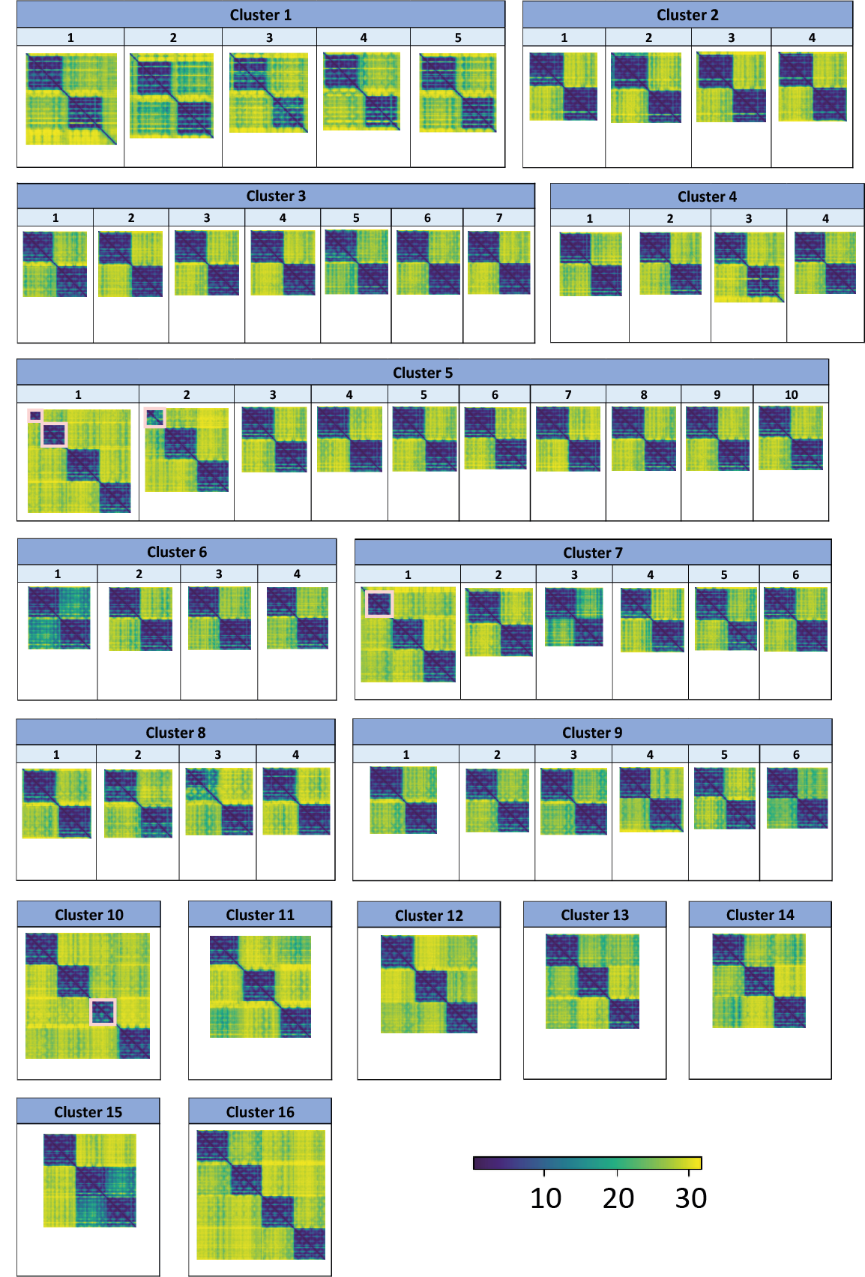
Figure 1: AlphaFold predicted aligned errors for the 57 multi-GPCR proteins. The estimated accuracy of the relative positions of the predicted structures. In the colormap of the n×n matrix of predicted aligned errors for a protein of n residues, the color at (x, y) indicates AlphaFold’s expected position error at residue x if the predicted and true structures were aligned on residue y. AlphaFold assigns high confidence to relative amino acid positions within the individual GPCR domains (blue shades), and low confidence to the relative orientation of the domains with respect to each other (yellow shades). The colormaps are grouped by their clusters.
In four of the multi-GPCRs (cluster #5, first two multi-GPCRs, cluster #7 first multi-GPCR, cluster #10) there are segments that have less than 7 helices. These are marked by a pink rectangle.

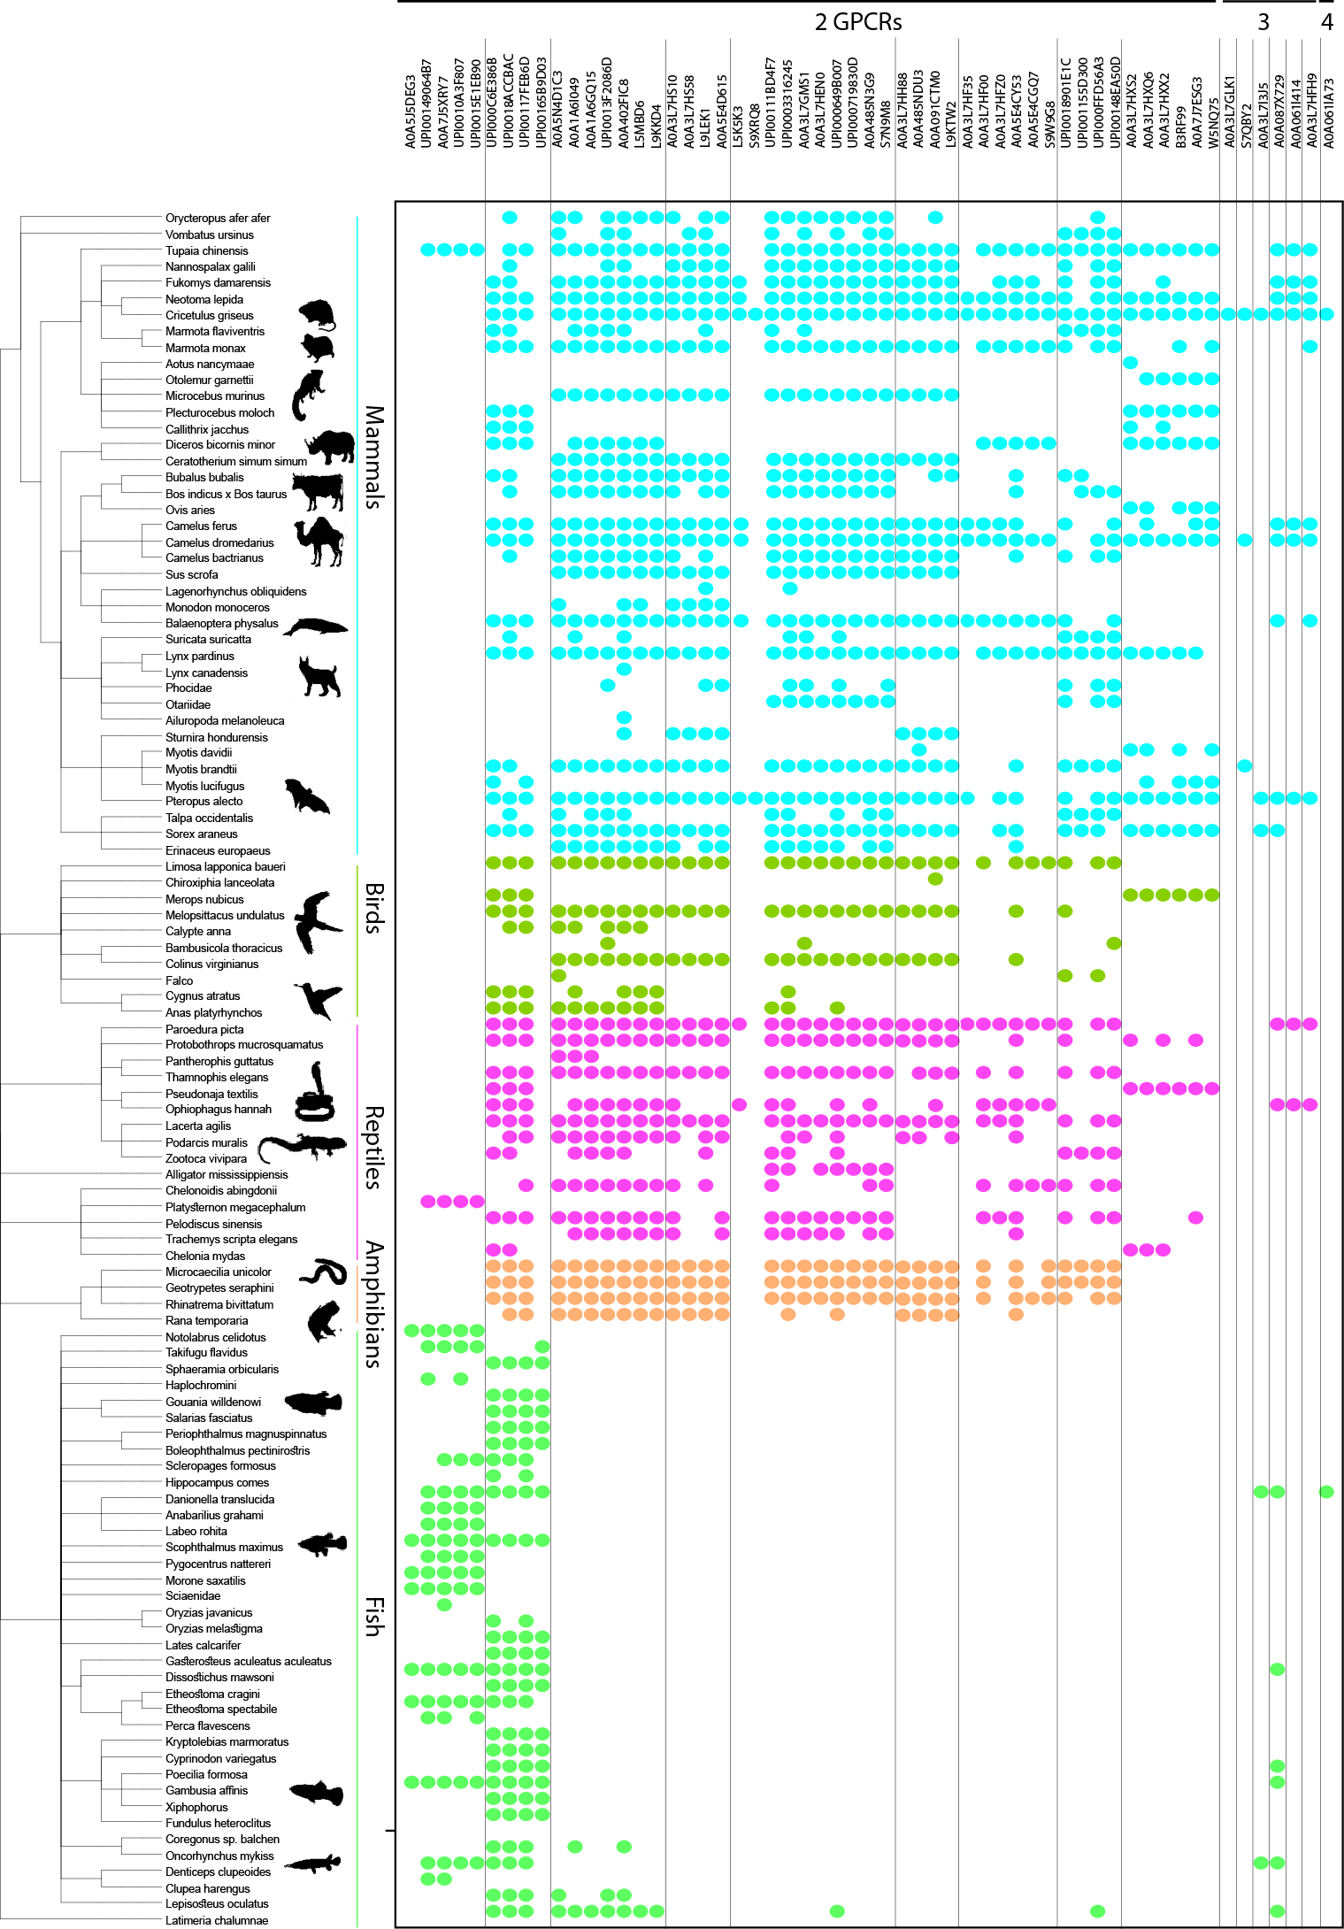
Figure 2: Tree of life distribution of homologues of the 57 multi-GPCR proteins. The proteins are plotted along the x-axis (first two-GPCR domains, then three-GPCR domains, then the four-GPCR domains), ordered as in Table 1. We found homologues in 106 species, and we show them as leaves of a phylogenetic tree along the y-axis. Colored dots mark the species found with a homologue of a protein: cyan for mammals, green for birds, pink for reptiles, orange for amphibians, and light green for fish. Most multi-GPCR proteins have homologues in mammals, birds, reptiles, and amphibians, and a minority of the multi-GPCRs have homologues in fish.

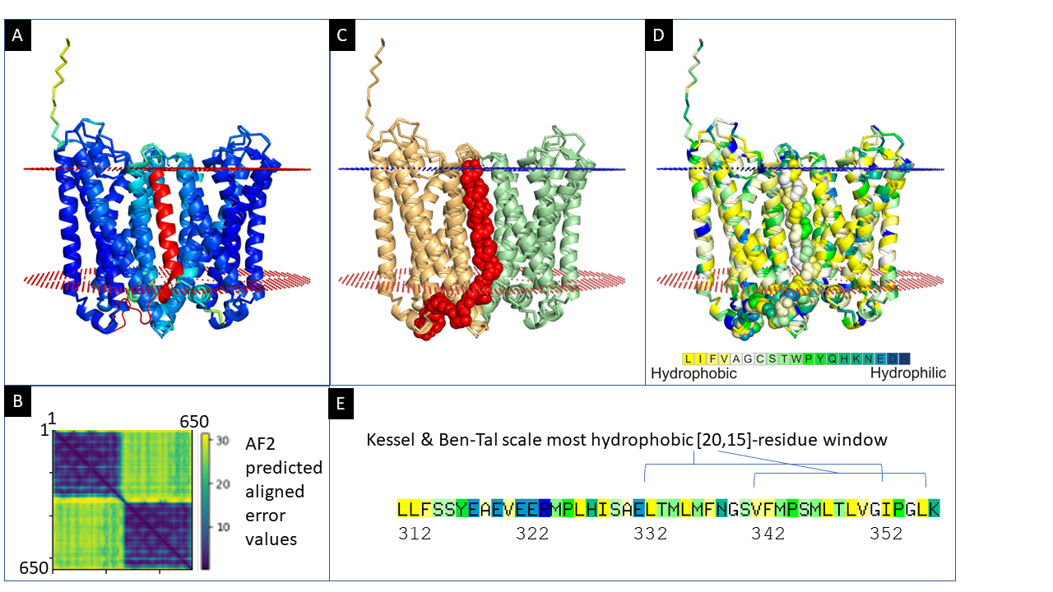

Figure 3: AlphaFold structure prediction for the sequence A0A3L7HXX2 of the Cricetidae rodent family with two-domain GPCRs (with homologues found in 21 species). (A) The most confident model (pTM 81.5), colored by the pLDDT confidence measure. We modelled the (red-colored) linker manually: the first 20 positions, which contain many polar and charged amino acids, are organized as a random coil mostly outside the membrane, and the remaining mostly hydrophobic 25 amino acids, as an alpha-helix that crosses the membrane. The extracellular (small blue spheres) and intracellular (small red spheres) boundaries of the membrane are also shown (predicted by the OPM web server). (B) A heatmap visualization of the predicted error in the pairwise positioning of the residues by AlphaFold. The positioning of residues within each of the GPCR domains is predicted to be accurate, while AlphaFold is not confident in the relative positioning of the two domains. (C) The two GPCR domains are colored wheat and pale green and the linker region of 46 residues (312-358) is shown as red atoms-spheres model. (D) The predicted structure colored by the Kessel & Ben-Tal hydrophobicity scale. The linker crosses the membrane back to the N-terminus side, placing both GPCRs in the same orientation. (E) We identified within the amino acids of the linker region the most hydrophobic segments of 15/20 residues using the Kessel & Ben-Tal scale.

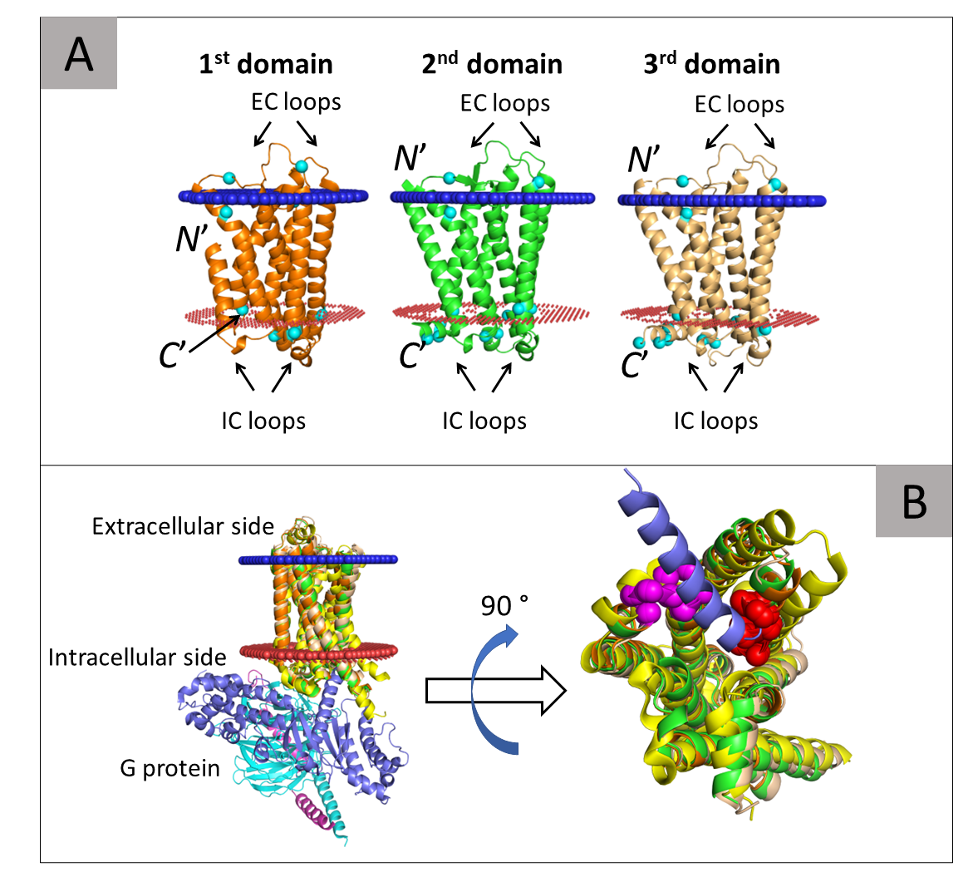
Figure 4: (A) The parallel orientation of the three domains of S7QBY2. The first, second, and third successive domains of the protein are colored orange, green, and wheat, respectively. The inferred extracellular and intracellular membrane boundaries are also shown (calculated by the PPM web server [Nucleic Acids Res., 2012, 40 (Database issue):D370-376]), as blue and red spheres, respectively. The membrane topology of the domains is shown by noting their N- and C-termini, and the intracellular (IC) and extracellular (CE) loops. The arginine and lysine residues (cyan spheres) are asymmetrically distributed in keeping with the positive-inside rule (Von Heijne 1992). (B) The G protein-binding sites in the three domains of S7QBY2. Left: a side view. The three domains are superimposed onto the structure of the G protein-bound (activated) β2-adrenergic receptor (β₂-AR, PDB ID: 3sn6). The β₂-AR receptor is colored yellow and the α, β, and γ subunits of the G protein are colored blue, cyan, and magenta. Right: a blown-up view of the G protein-binding site. The β₂-AR and superimposed domains of S7QBY2 are rotated 90° to show the binding site. For clarity, most of the G protein is hidden, only the α5 helix is shown, which directly interacts its binding site in the GPCR. The image clearly shows that all three domains of S7QBY2 contain a cavity that corresponds to the G protein-binding site of the β₂-AR. Moreover, all domains contain the VAICxPLxY and KAFSTCASH binding site motifs (pink and red spheres, respectively), which directly interact with the α5 helix of the G protein.

Table 1: The 57 multi-GPCRs that we found. The 1st to 7th columns of the table specify, respectively, the cluster to which the protein belongs, the serial number of the protein in UniProt or UniParc, the number of amino acids in the protein, the source organism, the functional receptor type/subtype of the protein, the number of GPCR domains predicted in the protein, and pLDDT (confidence measure) of AlphaFold’s the most accurate model of the protein.
# | Proteins¹ | #aa | Organism | Functional subtype² | #gpcr domains | AF max  (pLDDT)
1 | A0A5J5DEG3 | 861 | Etheostoma spectabile | CXCR3* | 2 | 68.0
1 | UPI00149064B7 | 793 | Notolabrus celidotus | CR (1) | 2 | 72.1
1 | A0A7J5XRY7 | 749 | Dissostichus mawsoni | CR | 2 | 64.3
1 | UPI0010A3F807 | 738 | Denticeps clupeoides | ? | 2 | 72.1
1 | UPI0015E1EB90 | 734 | Morone saxatilis | CR (1) | 2 | 71.9
2 | UPI000C6E386B | 640 | Xiphophorus | OR | 2 | 86.6
2 | UPI0018ACCBAC | 663 | Kryptolebias marmoratus | OR | 2 | 86.6
2 | UPI00117FEB6D | 661 | Sphaeramia orbicularis | OR | 2 | 84.3
2 | UPI00165B9D03 | 655 | Fundulus heteroclitus | OR | 2 | 84.0
3 | A0A5N4D1C3 | 640 | Camelus dromedarius | OR4D1 | 2 | 77.5
3 | A0A1A6I049 (4X) | 637 | Neotoma lepida | OR | 2 | 83.7
3 | A0A1A6GQ15 (2X) | 631 | Missing organism name | OR | 2 | 85.2
3 | UPI0013F2086D | 631 | Chelonoidis abingdonii | OR | 2 | 87.2
3 | A0A402FIC8 | 629 | Paroedura picta | OR4D1 | 2 | 83.5
3 | L5MBD6 | 622 | Laurasiatheria | OR4D2 | 2 | 87.6
3 | L9KKD4 | 617 | Tupaia chinensis | OR4D1 | 2 | 87.0
4 | A0A3L7HS10 | 620 | Cricetulus griseus | OR143 | 2 | 84.1
4 | A0A3L7HS58 | 612 |  | OR8G5 | 2 | 85.6
4 | L9LEK1 | 693 | Tupaia chinensis | OR145 | 2 | 75.0
4 | A0A5E4D615 | 613 | Marmota monax | OR | 2 | 86.1
5 | L5K5K3 | 1002 | Pteropus alecto | OR1J2 | 2: 3H-6H-G-G | 80.1
5 | S9XRQ8 | 814 | Camelus | OR | 4H-G-G | 76.9
5 | UPI00111BD4F7 | 632 | Nannospalax galili | OR | 2 | 82.3
5 | UPI0003316245 | 630 | Sorex araneus | OR | 2 | 83.1
5 | A0A3L7GMS1 | 629 | Cricetulus griseus | OR  OLFR50 | 2 | 83.0
5 | A0A3L7HEN0 | 608 | Cricetulus griseus | OR  OLFR50 | 2 | 84.9
5 | UPI000649B007 | 629 | Sorex araneus | OR | 2 | 87.2
5 | UPI000719830D (1X) | 629 | Ceratotherium simum | OR | 2 | 81.7
5 | A0A485N3G9 | 623 | Lynx pardinus | ~OR1j2 | 2 | 84.2
5 | S7N9M8 | 621 | Myotis brandtii | OR1j2 | 2 | 83.7
6 | A0A3L7HH88 | 610 | Cricetulus griseus | OR8J3 | 2 | 83.9
6 | A0A485NDU3 | 618 | Lynx | OR~8k1 | 2 | 80.9
6 | A0A091CTM0 | 618 | Fukomys damarensis | OR8k1 | 2 | 83.8
6 | L9KTW2 | 601 | Tupaia chinensis | OR8K5 | 2 | 80.2
7 | A0A3L7HF35 | 930 | Cricetulus griseus | OR4F3  OR4F15  OR4K3 | 5H-G-G | 78.6
7 | A0A3L7HF00 | 666 | Cricetulus griseus | OR4F3  OR4F15  OR4K3 | 2 | 82.3
7 | A0A3L7HFZ0 | 571 | Cricetulus griseus | OR4F3  OR4F15  OR4K3 | 2 | 88.6
7 | A0A5E4CY53 | 627 | Marmota | OR4K3 | 2 | 79.4
7 | A0A5E4CGQ7 | 610 | Marmota monax | OR | 2 | 80.6
7 | S9W9G8 | 625 | Camelus | OR | 2 | 85.7
8 | UPI0018901E1C (1X) | 682 | Talpa occidentalis | OR | 2 | 79.9
8 | UPI001155D300 (1X) | 667 | Suricata suricatta | OR | 2 | 78.3
8 | UPI000FFD56A3 (2X) | 656 | Vombatus ursinus | OR | 2 | 74.5
8 | UPI00148EA50D | 656 | Marmota flaviventris | OR | 2 | 79.7
9 | A0A3L7HXS2 | 656 | Cricetulus griseus | OR52D1 | 2 | 79.6
9 | A0A3L7HXQ6 | 614 |  | ? | 2 | 84.0
9 | A0A3L7HXX2 | 650 | Cricetidae | OR52A5 | 2 | 81.5
9 | B3RF99 | 626 | Sorex araneus | OR | 2 | 85.8
9 | A0A7J7ESG3 (4X) | 602 | Diceros bicornis | OR | 2 | 78.0
9 | W5NQ75 | 597 | Ovis aries | OR | 2 | 87.3
10 | A0A3L7GLK1 | 1218 | Cricetulus griseus | OR4D1 | 3: G-G-6H-G | 81.0
11 | S7QBY2 | 985 | Myotis brandtii | OLF4 | 3 | 75.3
12 | A0A3L7I3J5 | 948 | Cricetulus griseus | OR52E5 | 3 | 87.5
13 | A0A087X729 | 917 | Poecilia formosa | ? | 3 | 84.3
14 | A0A061I414 | 912 | Cricetulus griseus | OR | 3 | 84.5
15 | A0A3L7HFH9 | 907 | Cricetulus griseus | OR8J3 | 3 | 83.9
16 | A0A061IA73 | 1250 | Cricetulus griseus | OR | 4 | 82.8
¹The number of ‘X’ amino acids in the sequence is listed in parentheses following the protein name (e.g., A0A1A6I049 in cluster #3 has 4X).
²OR – odorant receptor, OR4D1 – odorant receptor type 4, subtype D1, CR – chemokine receptor, CXC – a type of chemokine receptor, ~OR1j2 – a OR1j2-like protein, ? – no annotation of receptor type in UniProtKB. In cases where the annotations refer to only one of the domains composing the multi-GPCR, the number of the said domain is noted in parenthesis.

Acknowledgements
This research has been supported by grant 1764/21 of the Israeli Science Foundation (ISF). NB-T’s research is supported in part by the Abraham E. Kazan Chair in Structural Biology, Tel Aviv University.

References
334. Bockaert, J., G Protein-coupled Receptors, in Encyclopedia of Life Sciences (ELS). 2009, John Wiley & Sons, Ltd: Chichester.
335. Fredriksson, R., Lagerstrom, M.C., Lundin, L.G. and Schioth, H.B. (2003) The G-protein-coupled receptors in the human genome form ﬁve main families. Phylogenetic analysis, paralogon groups, and ﬁngerprints. Mol. Pharmacol. 63: 1256–1272.
336. Hanlon, C.D. and Andrew, D.J. (2015) Outside-in signaling – a brief review of GPCR signaling with a focus on the Drosophila GPCR family. Journal of Cell Science. 128: 3533-3542.
337. Bjarnadottir, T.K., Gloriam, D.E., Hellstrand, S.H., Kristiansson, H., Fredriksson, R. and Schioth, H.B. (2006) Comprehensive repertoire and phylogenetic analysis of the G protein-coupled receptors in human and mouse. Genomics. 88: 263-73.
338. Wettschureck, N. and Offermanns, S. (2005) Mammalian G proteins and their cell type specific functions. Physiol Rev. 85: 1159-204.
339. Sliwoski, G., Kothiwale, S., Meiler, J. and Lowe, E.W., Jr. (2014) Computational methods in drug discovery. Pharmacol Rev. 66: 334-95.
340. Fang, Y., Kenakin, T. and Liu, C. (2015) Editorial: Orphan GPCRs As Emerging Drug Targets. Frontiers in Pharmacology. 6: 295.
341. Salon, J.A., Lodowski, D.T. and Palczewski, K. (2011) The Significance of G Protein-Coupled Receptor Crystallography for Drug Discovery. Pharmacological Reviews. 63: 901-937.
342. Garland, S.L. (2013) Are GPCRs still a source of new targets? J Biomol Screen. 18: 947-66.
Attwood, T. K. and J. B. C. Findlay (1994). "Fingerprinting G-protein-coupled receptors." Protein Engineering, Design and Selection 7(2): 195-203.

Baker, J. A., et al. (2017). "Charged residues next to transmembrane regions revisited: “Positive-inside rule” is complemented by the “negative inside depletion/outside enrichment rule”." BMC Biology 15(1): 66.
Transmembrane helices (TMHs) frequently occur amongst protein architectures as means for proteins to attach to or embed into biological membranes. Physical constraints such as the membrane’s hydrophobicity and electrostatic potential apply uniform requirements to TMHs and their flanking regions; consequently, they are mirrored in their sequence patterns (in addition to TMHs being a span of generally hydrophobic residues) on top of variations enforced by the specific protein’s biological functions.

Ballesteros, J. A. and H. Weinstein (1995). [19] Integrated methods for the construction of three-dimensional models and computational probing of structure-function relations in G protein-coupled receptors. Methods in neurosciences, Elsevier. 25: 366-428.

Behrens, M., et al. (2018). "Structure-Function Relationships of Olfactory and Taste Receptors." Chem Senses 43(2): 81-87.

Bird, S. and C. Tafalla (2015). "Teleost chemokines and their receptors." Biology 4(4): 756-784.

Bjarnadottir, T. K., et al. (2006). "Comprehensive repertoire and phylogenetic analysis of the G protein-coupled receptors in human and mouse." Genomics 88(3): 263-273.

Blum, M., et al. (2021). "The InterPro protein families and domains database: 20 years on." 49(D1): D344-D354.

Bockaert, J. (2009). G Protein-coupled Receptors. Encyclopedia of Life Sciences (ELS). Chichester, John Wiley & Sons, Ltd.

Consortium, G. O. (2021). "The Gene Ontology resource: enriching a GOld mine." Nucleic acids research 49(D1): D325-D334.

de March, C. A., et al. (2015). "G protein-coupled odorant receptors: From sequence to structure." Protein Science : A Publication of the Protein Society 24(9): 1543-1548.

Faron-Górecka, A., et al. (2019). Chapter 10 - Understanding GPCR dimerization. Methods in Cell Biology. A. K. Shukla, Academic Press. 149: 155-178.

Ferre, S., et al. (2014). "G protein-coupled receptor oligomerization revisited: functional and pharmacological perspectives." Pharmacol Rev 66(2): 413-434.

Fredriksson, R., et al. (2003). "The G-protein-coupled receptors in the human genome form ﬁve main families. Phylogenetic analysis, paralogon groups, and ﬁngerprints." Mol. Pharmacol. 63: 1256–1272.

Hanlon, C. D. and D. J. Andrew (2015). "Outside-in signaling – a brief review of GPCR signaling with a focus on the Drosophila GPCR family." Journal of Cell Science 128(19): 3533-3542.

Hauser, A. S., et al. (2021). "GPCR activation mechanisms across classes and macro/microscales." Nature Structural & Molecular Biology 28(11): 879-888.

Hauser, A. S., et al. (2021). "GPCR activation mechanisms across classes and macro/microscales." Nature structural & molecular biology 28(11): 879-888.

Juan, M., et al. Chemokines and Chemokine Receptors. eLS.
Abstract Chemokines (CKs) are a family of small proteins secreted by a great variety of cell types. Their name (derived from chemoattractant cytokines) is due to their ability to induce directed chemotaxis in nearby responsive cells. Some CKs are considered proinflammatory and can be induced during an immune response to promote cells of the immune system to a site of infection. Furthermore, they have different functions under physiological conditions such as homoeostasis, development, tissue repair and angiogenesis and also in pathological disorders including infectious and autoimmune diseases, cancer, metastasis, allergic process and organ transplantation; in fact, in any situation where immune components are involved. CKs are found in all vertebrates, some viruses and in some bacteria. These proteins exert their biological effects by interacting with G protein-linked transmembrane receptors called CK receptors (CKRs) that are selectively found on the surfaces of their target cells. Although their role in human immunodeficiency virus infection is still the main aspect of relevance, other applications have been appearing during the past years, as to establish new therapeutic compounds able to target the CK/CKR system. Key Concepts: Chemokines (CKs), as chemoattractant cytokines, are pivotal elements for defining immune cell localisation and, therefore, efficient immune responses. Beyond their role in chemotaxis, CKs and their receptors develop several physiopathological functions: angiogenesis, haematopoiesis, growth regulation, embryologic development, evolution of tumours, etc. CKs have three types of receptors: ‘classical’ G protein-coupled receptors (GPCRs), decoy receptors and glycosaminoglycans (GAGs). After activation, GPCRs become either partially or totally desensitised to repeated stimulation with the same or other agonists; desensitisation is critical for maintaining the capacity of the cell to sense a chemoattractant gradient. Decoy receptors are ‘silent’ receptors that control the CK activity through regulation of CK levels in the body. CK immobilisation through the GAG interaction stabilises the formation of CK gradients and enhances their concentration at the site of production. All CKs have a common structure, being the first couple of cysteines (Cs) a distinctive element that allows classifying them into CC, CXC, CX3C and C CK families. Most of the inflammatory CK genes are clustered in two main chromosomal regions: the CXC cluster, located in chromosome 4q12–21 and the CC cluster, located in chromosome 17q11.2. The ‘evolutionary choice’ of HIV-1 to exploit CKRs as cellular entry gateways has turned their CK ligands into endogenous antiviral factors that can variably modulate viral transmission, disease progression and vaccine responses.

Jumper, J., et al. (2021). "Highly accurate protein structure prediction with AlphaFold." Nature 596(7873): 583-589.

Kato, A., et al. (2008). "Amino acids involved in conformational dynamics and G protein coupling of an odorant receptor: targeting gain-of-function mutation." J Neurochem 107(5): 1261-1270.

Kessel, A. and N. Ben-Tal (2002). "Free energy determinants of peptide association with lipid bilayers." Current topics in membranes 52: 205-253.

Kessel, A. and N. Ben-Tal (2018). Introduction to proteins: structure, function, and motion, CRC Press.

Kolakowski Jr, L. F. (1994). "GCRDb: a G-protein-coupled receptor database." Receptors & channels 2(1): 1-7.

Li, W. and A. Godzik (2006). "Cd-hit: a fast program for clustering and comparing large sets of protein or nucleotide sequences." Bioinformatics 22(13): 1658-1659.

Marianayagam, N. J., et al. (2004). "The power of two: protein dimerization in biology." Trends in biochemical sciences 29(11): 618-625.

Mohammad Nezhady, M. A., et al. (2020). "Location Bias as Emerging Paradigm in GPCR Biology and Drug Discovery." iScience 23(10): 101643.

Pierce, K. L., et al. (2002). "Seven-transmembrane receptors." Nature Reviews Molecular Cell Biology 3(9): 639-650.

Pin, J. P., et al. (2019). "GPCR interaction as a possible way for allosteric control between receptors." Mol Cell Endocrinol 486: 89-95.

Sharpe, H. J., et al. (2010). "A Comprehensive Comparison of Transmembrane Domains Reveals Organelle-Specific Properties." Cell 142(1): 158-169.
Summary The various membranes of eukaryotic cells differ in composition, but it is at present unclear if this results in differences in physical properties. The sequences of transmembrane domains (TMDs) of integral membrane proteins should reflect the physical properties of the bilayers in which they reside. We used large datasets from both fungi and vertebrates to perform a comprehensive comparison of the TMDs of proteins from different organelles. We find that TMDs are not generic but have organelle-specific properties with a dichotomy in TMD length between the early and late parts of the secretory pathway. In addition, TMDs from post-ER organelles show striking asymmetries in amino acid compositions across the bilayer that is linked to residue size and varies between organelles. The pervasive presence of organelle-specific features among the TMDs of a particular organelle has implications for TMD prediction, regulation of protein activity by location, and sorting of proteins and lipids in the secretory pathway.

Sliwoski, G., et al. (2014). "Computational methods in drug discovery." Pharmacol Rev 66(1): 334-395.

Solan, R., et al. (2021). "Gram-negative outer-membrane proteins with multiple β-barrel domains." Proceedings of the National Academy of Sciences 118(31).

Sommer, F., et al. (2020). "Chemokine receptors and phagocyte biology in zebrafish." Frontiers in immunology 11: 325.

Von Heijne, G. (1992). "Membrane protein structure prediction: hydrophobicity analysis and the positive-inside rule." Journal of Molecular Biology 225(2): 487-494.

Wettschureck, N. and S. Offermanns (2005). "Mammalian G proteins and their cell type specific functions." Physiol Rev 85(4): 1159-1204.

Zhou, Q., et al. (2019). "Common activation mechanism of class A GPCRs." Elife 8.

Zhou, Q., et al. (2019). "Common activation mechanism of class A GPCRs." Elife 8.

https://trachel-srv.cs.haifa.ac.il/rachel/MGPCR/Table1.html

